Sheridan Linnell, Jean Rumbold, Debbie Horsfall, Robyne Latham, Suzanne Perry, Jill Westwood, Josephine Pretorius and Olga Nebot
‘Palliative care for the planet’
Group exhibit; opening night reading and performance

Palliative Care for the Planet weaves together what the participating artists and writers make of our memories and experiences, in coming together around the almost impossible theme of how to relate to the impending end of life, at least human life, on this planet. What we make of this theme - and what it makes of us – is enacted through art, poetry and storytelling. We regard this as one conversation starter among many in the emergent ethic of how we might understand and contribute to ‘palliative care for the planet’.
This proposal draws on two distinct yet overlapping projects and involves eight artist/ researchers, whose complementary practices of visual arts, performance arts, creative writing, memoir, arts therapies and arts based-research open up seemingly impossible spaces.
A collaborative arts-based enquiry into the theme of ‘palliative care for the planet’’ was initiated by Jean Rumbold following the Arts and Health Conference at Latrobe University in October 2013. As three visitors to and one indigenous inhabitant of this land, Rumbold, Horsfall, Latham and Linnell write and create together and apart, blending the ‘I’ and the ‘we’, in ways that are personal, lateral and yet collective. They experiment with the tensions and connections between different art materials and between feminist, new materialist, ecological and indigenous perspectives, in an attempt to open up a space in which to begin to make sense of extremity. The artworks, stories and poems they have produced so far on the theme of ‘palliative care for the planet ‘ are central to this proposal. These works are explored by the collaborating artists in a recent co-authored research paper but have not previously been exhibited.
Westwood, Linnell, Perry and Pretorius are art therapists, art therapy educators and performance artists whose ongoing joint project examines themes of subjectivity, relationship, marginalisation and abjection. Their most recent performance, The Uninvited, brought the ghostly, abject figures of orphaned girls and monstrous ‘hybrid creatures’ into an official UWS celebration of 20 years of art therapy at UWS. The performance was photo-documented by professional photographer, Olga Nebot.
The Uninvited took on an unexpected resonance with climate change and the ecological ‘tipping-point’ when the performance coincided with devastating bushfires in the Blue Mountains. Consequently, in the weeks following the performance, a photograph from The Uninvited, accompanied by a poem exploring these resonances, became increasingly central to Linnell’s contribution to the previously described arts-based enquiry into ‘palliative care for the planet’.
We hope to continue to explore the emerging resonances between these two projects through a collective contribution to the Art-Nature-Wellbeing Exhibition.
Dimensions: We can present the exhibit in various ways (e.g. photographic prints plus original artworks or smaller prints of all contributions; framed text on walls or in a book form on a plinth.)

Contact person: Sheridan Linnell: Email s.linnell@uws.edu.au Phone 0247360605

Participating artists

Debbie Horsfall is Associate Professor in the School of Social Sciences and Psychology at the University of Western Sydney, where she devised and taught the capstone research unit of the Master of Art Therapy. Debbie is a passionate leader with extensive scholarly research in the field of inclusive, creative, democratic, qualitative research in health, human services and community development. Her transformative agenda privileges people’s voices during challenging life events and most recently centres on ‘dying at home’.
Email: debbie.horsfall@uws.edu.au

Robyne Latham is a Yamtaji woman originally from Western Australia, though she has now lived in Melbourne some 27 years. Professionally she wears two hats; one that of an artist, and the other that of an academic/researcher. Latham’s art practice traverses a number of mediums from ceramic, to bronze to copper fabrication and egg tempera on canvas. She works with a strong emphasis on the object in space, where space itself resides in a metaphysical realm. Her works are widely collected both nationally and internationally.
Email: robynelatham@netspace.net.au Website:www.robynelatham.com

Sheridan Linnell leads the Master of Art Therapy and Graduate Programs in Counselling at the University of Western Sydney, Australia. Her doctoral and postdoctoral work explores how subjectivity is formed and performed within contemporary regimes that situate moral responsibility primarily with the individual. . She is a published poet and collaborative artist and has written a book about her experience of practitioner research in art therapy.
Email: s.linnell@uws.edu.au

Suzanne Perry currently works as an art therapist with children who have been abused and as a sessional art therapy educator at the University of Western Sydney, where she held an ongoing position for six years. She is a painter and performance artist whose work explores ‘the abject’.
Email; s.perry@uws.edu.au

Olga Nebot is a professional photographer whose work with clients accurately and empathically documents the special occasions of their lives. Her photographs of the 20th Anniversary of Art Therapy at UWS celebrations have recently been included in the University of Western Sydney’s 25-year time capsule and will feature significantly in a forthcoming book about art therapy at UWS.
Email: olga.nebot@gmail.com

Josephine Pretorius is a retired art therapist and art therapy educator who previously worked at UWS. She has a strong interest in the resonances between meditative and spiritual traditions, object relations theory and artistic and writing practices.
Email: j.pretorius@gmail.com

Jean Rumbold is a lecturer in the Department of Public Health at La Trobe University supervising doctoral research. She has worked in private practice as a counselling psychologist and family therapist and helped establish MIECAT (previously Melbourne Institute for Experiential and Creative Arts Therapy), where she supervises in the professional doctorate. Her research interests focus on arts and health, reflective practice, and arts-based and co-operative forms of inquiry. Her artwork includes the innovative creation and exchange of postcards.
Email: j.rumbold@latrobe.edu.au
Jill Westwood is the Convenor of the Master of Arts (Art Psychotherapy) at Goldsmiths College, University of London. She was the Program Leader of the Master of Art Therapy for thirteen years at UWS, where she retains adjunct status. Her doctoral thesis investigated the history and praxis of art therapy education in Australia. Westwood is a practising contemporary artist with a particular interest in installation, performance and film.
Email: j.westwood@gold.ac.uk

A sample of artworks and writing are included on the next two pages, and more can be provided on request.
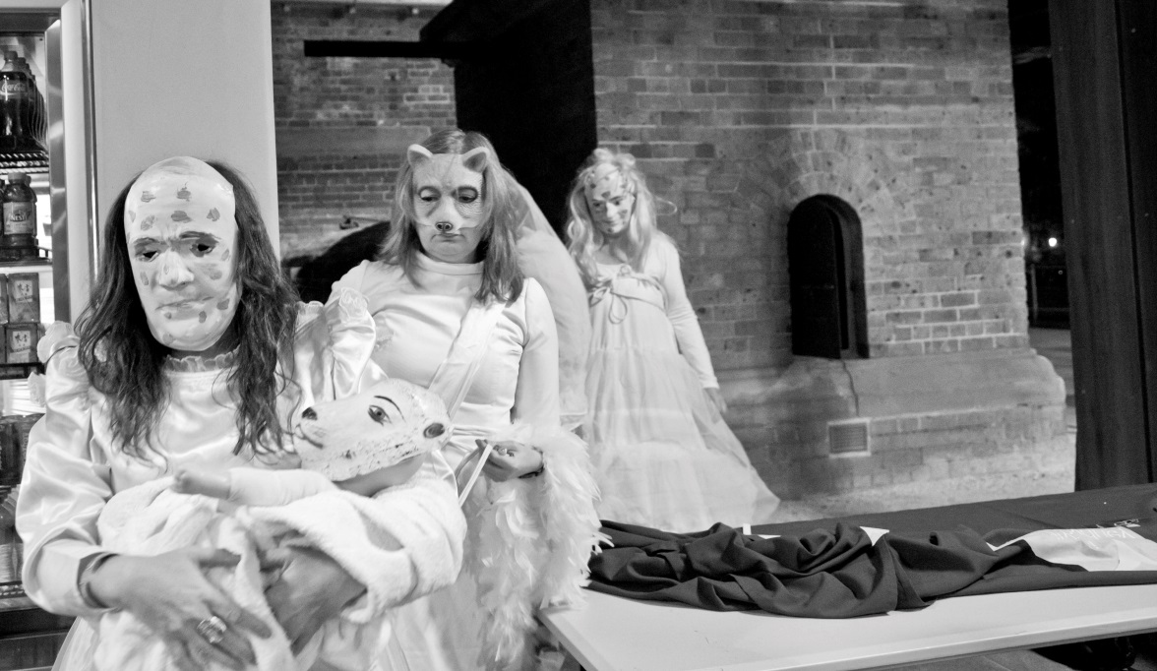
The uninvited. Perry S, Linnell S, Pretorius J & Westwood J, 2013. (Photograph by Olga Nebot)
When the uninvited come to the party the real guests
do not notice. They might pull a pashmina
over a bare shoulder, loosen a knotted tie
lean into the circle. Go on talking
arts health raising funds writing for journals climate
change the increasing frequency of extreme
weather. That kind of conversation
is very absorbing. Death of a species tipping
points the edge of the city on fire how we are burning
the geological past how we are flushing
away the future. The uninvited move closer.
A heart attack for the planet,
someone says, isn’t this hollowing out
and sense of impending doom
a clinical symptom of distress?
Her companion holds the glass up to the light
turns it around before tasting then
spits out the excess.
Sheridan Linnell
The Tree Yarn: Robbie Latham

I later reflected on the afternoon, thinking of where we sat, under the tree, shaded, yarn’n about so many thoughts. Fragments of thoughts remained suspended in the atmosphere, some settled, some morphed into another thought. Stitched seamlessly by the song of a bird, time stretched from the ancient to the present, to the future. I listened; we all listened. I tried to listen/feel to the patterns that connect. All were strangers to me, and me to them, yet sitting under the tree defined us as a group. A group with a common thread, that of ‘palliative care for the planet’. I wondered what the old folk would have thought. I felt and indeed was child-like, with an Elder’s responsibility...

