Hidden Histories of Human Hair in Global Fashion
Emma Tarlo

Human hair has long been valued as a fibre for its qualities of fineness, strength and elasticity. This article provides details of how hair from Asia has been used to produce textiles for the European and American markets at different moments of the nineteenth and twentieth centuries. It focusses in particular on the production of hand knotted hair nets made from Chinese combings and the making of interlinings for men’s suits made from waste hair clippings from India. It also gives insights into how comb waste is still collected and sorted by hand on a massive scale today in countries such as India, Myanmar and China using techniques which have changed little since the nineteenth century.

When the concentration camp at Auschwitz was opened up in 1945, 7000 kilos of human hair were found packed up for transportation to German factories where it was intended for use in the manufacture of industrial felt. Observers were shocked not only by the brutal circumstances under which the hair had been taken but also at the idea that something as intimate and personal as human hair could be amassed in bulk, traded and used in the production of mundane goods like cloth. Yet the mass accumulation of human hair and its use in textiles is not unique to this unsavoury moment of European history. Today hair is collected on an industrial scale throughout Asia for use in the manufacture of wigs and hair extensions for export worldwide. But long before the recent fashion for hair extensions, waste hair from Asia was being recycled into a variety of artefacts including textiles for the Western market. What is offered here is a brief glimpse into the history of two very different types of textile produced out of human hair: ladies’ hair nets which became popular in Europe and America from the 1890s onwards interlinings for men’s suits which were manufactured in South Korea and Japan in the 1970s and 80s. A description of the collecting and sorting of comb waste in contemporary workshops in India and Myanmar provides insight into how waste hair is recycled today using methods which have changed little since the nineteenth century.
Fig. 1
The mass collection and recycling of comb waste has always been a lengthy and arduous business as early descriptions of pedlars unhooking globs of comb waste out of French and Italian gutters show. Yet throughout Asia this trade persists, relying on vast networks of hair collectors who circulate on foot, bicycle or scooter in rural and urban neighbourhoods calling out for waste hair. Many long haired women in India, China, Myanmar, Bangladesh and Pakistan save the hair that falls from their combs until they have accumulated enough to sell to petty traders who come to the door. These matted and often dirty clods of comb waste are exchanged either for trinkets (bracelets, hair clips, toys) or for small amounts of money and are then sold on to networks of hair merchants who accumulate up vast stocks of combings. In Myanmar a hair merchant told me it had taken him two weeks to accumulate the huge 20 kilo sack of hair that was leaning against the wall of his shop but his business was small by comparison to some of India’s major waste hair barons who claim to export several tons of waste hair balls per month. The hair is destined for China where most of it will be made up into wigs, hair extensions and false eyelashes before being exported to every continent. But before reaching China it has to go through the arduous task of being untangled and sorted in other countries since China has banned the import of raw unsorted waste hair on the grounds of pollution.
The sorting of comb waste is a back-breaking and eye-straining job performed by many thousands of women and children in poor regions of countries like India, Bangladesh, Pakistan, the Philippines and Myanmar. It takes over 50 hours for a person to untangle one kilo of waste hair balls either with bare fingers or with the help of a needle. After this the hair has to be sorted into lengths, puffed up, hackled several times on beds of iron needles, de-liced, weighed, bunched and neatly tied for export. Such activities take place in homes and workshops where workers sit in rows on the floor surrounded by hair. In the rural villages around Pyaw Bwe in Myanmar waste hair balls are regarded as the local cash crop and almost every household has some family members engaged in the activity. Some of the hair has been gathered locally by Burmese hair collectors; the rest has been imported in bulk from hair merchants in India. Once untangled, sorted and aligned into perfect bunches of ‘double drawn hair’ (bunches in which all the hairs are exactly the same length) it is sold or smuggled over the border to China.
Fig 2.
In the comb waste workshops of Asia it is not difficult to gain a sense of how hair becomes depersonalised and treated as mere fibre. It is a fibre that has particular qualities – elasticity, fineness and strength – and it is precisely these qualities along with the cheap availability of comb waste that have alerted entrepreneurs and traders at different moments of history to the wide range of uses to which hair might be put. The strength of hair fibre has been exploited locally in Asian countries for making rope and saddle cloths and has been traded internationally for making industrial strainers used for filtering oil in the seed crushing industry in Germany and the United States, whilst hair’s fineness and flexibility has been valued and exploited in the production of women’s hair nets and interlinings for men’s suits. But why was it Asian hair that was used for these purposes and how did it find its way into items of apparel worn as far away as Europe and America? To answer these questions one needs to look briefly at the economic, political and aesthetic forces that combined to stimulate hair circulation.
Fig. 3
In the late 19th century fashionable ladies in Europe began to replace their silk hair nets with hair nets that were hand-knotted out of human hair. Initially these were made by poor women and children in the rural villages of Alsace and Bohemia but production later spread to the Shantung province of China which became the most important centre of hair net manufacture, employing as many as 500,000 workers. By the early 1920s the human hair net had become an item of mass consumption, with American women consuming over 180 million nets in the year 1921-22. The appeal of the human hair net was that it was invisible, blending with or adding subtle highlights to a woman’s own hair. What is interesting is that wherever they were produced the nets were made exclusively from Chinese hair – much of it collected up from men’s combings. In the late 19th and early 20th centuries most Chinese men wore their hair shaved at the front and in a long plait or ‘pigtail’ at the back in a style which had been imposed by the ruling Manchu dynasty two and a half centuries earlier under penalty of death. When itinerant barbers tended to these pigtails, they saved the combings many of which ended up recycled into hairnets for the Western market. ‘No other hair possesses the right degree of coarseness and resilience to give that peculiar elastic spring to the mesh that a good hairnet requires’ argued the Textile Mercury in 1912, suggesting that the hair of the northern blonde races was too fine and soft, the hair of Italians and Spaniards a little more suitable owing to its coarser texture, the hair of the Japanese too stiff and the hair of yaks inadequate.
Fig 4 a and b
However when the bob became a fashionable hair style in Europe and America the hair net industry in China suffered a severe blow. Attempts were made to revive it with some success in the 1930s and 1940s when double mesh hair nets became popular. Using two rather than one hair at a time these nets were longer lasting and some of them were designed specifically for bobbed hair styles. But soon this fragile and ephemeral artefact, which had always been valued largely for its invisibility, had disappeared from European and American heads, replaced in many cases by nylon alternatives.
Chinese hair however, continued to flow into the European market – not only in the form of combings but also whole ‘pigtails’. When the Manchu dynasty was overthrown in 1911, revolutionary China was filled with men either cutting off their own long plaits as a sign of emancipation or having them forcibly removed by enthusiastic members of the revolutionary guard. And it seems to have been this sudden surge in the influx of Chinese men’s hair into the European market that triggered new types of usage. At any rate it was in the aftermath of the Chinese Revolution of 1911 that a Bradford wool merchant began weaving cloth that was made entirely from human hair that had been disinfected, spun and woven into widths of 20 – 30 inches and lengths of 90 yards. The cloth was, he boasted, ideal for the interlinings of men’s suits and coats owing to the fact that it was unbreakable, unshrinkable and uncreasable. Traditionally interlinings for men’s clothes were often made using horse hair canvas which was good for retaining form but sometimes caused discomfort when brittle strands of horse hair poked through the fabric. By substituting human hair the Bradford merchant was recognising the close affinities between human and animal fibre whilst simultaneously suggesting the superiority of human hair which was softer and finer than horse hair.
It is difficult to tell whether the use of human hair interlinings ever took off in Britain in any substantial way. Trapped between the inner and outer fabric of a garment, interlinings are invisible and their history obscure. But looking at old patents it is clear that throughout the 20th century some entrepreneurs and designers were experimenting with the use of both human and animal hair in interlinings for neckties, suits and coats. Some proposed weaving long hair; others proposed compressing short human and animal hair fibres into non-woven structures held together with a rubber or resin-based composite. It seems that by the 1970s and 80s human hair was being used in interlinings on an industrial scale in factories in Japan and South Korea which relied on supplies of waste hair not only from their own populations but also from India. Many of the established hair merchants I met in Chennai (formerly Madras) recall having exported regular shipments of short hair clippings collected from barber shops and Hindu temples in in the 1970s and 80s. The hair was apparently in high demand both for the extraction of amino acids for use in the food and pharmaceuticals industries and for the production of interlinings used mainly in men’s suits. It seems likely that many of these suits were for the export market and would have ended up on the backs of European business men and office workers without their being aware that they contained human hair.
Today the long hair combings collected throughout Asia are used predominantly for making wigs and hair extensions, not hair nets. Meanwhile the export market for short hair clippings has declined although some short hair is recycled into rope and used for reinforcing walls in India. Yet the little known stories of the human hair net and hair interlinings are interesting for what they tell us about the global economy which has long relied on cheap labour in one part of the world servicing the fashions and agendas of people elsewhere. What is striking in the case of these two examples is that what is consumed is not only the bodily labour of Asian workers but also something as physically intimate and personal as hair. Most striking of all is the fact that both the labour and the hair were largely invisible and have left very little trace in established histories of Western fashion.

IMAGES and credits
Fig. 1 Comb waste airing on the ground, Mandalay, Myanmar/Burma 2015 (photo: Emma Tarlo)
Fig. 2 Waste Hair sorting workshop, Koppal, India 2013 (photo: Emma Tarlo)
Fig. 3 Invisible fringe net as advertised in the Hairdressers’ Weekly Journal, September 22, 1906. This style of net was later replaced by round cap shaped nets (credit: Hairdressers Journal International)
Fig 4 a and b Sarbon human hair net envelope with detail of the cap shaped net it contains, c. mid 1920s. The net is hand knotted using single strands of hair. By the 1930s and 40s most of the human hair nets on the market used a double mesh. (photo Piet Noorderneer)

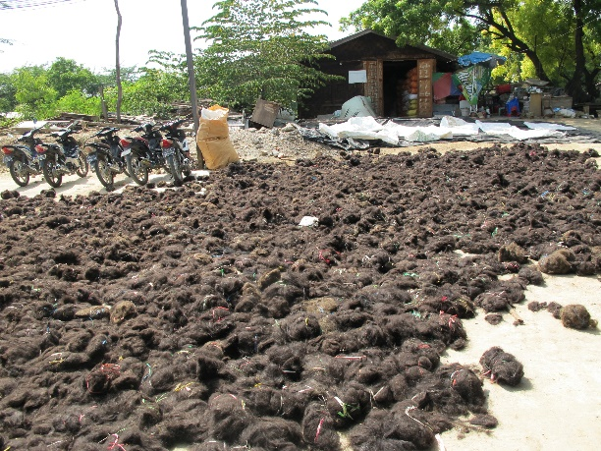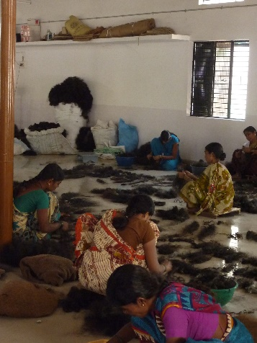
Fig 1 Fig 2

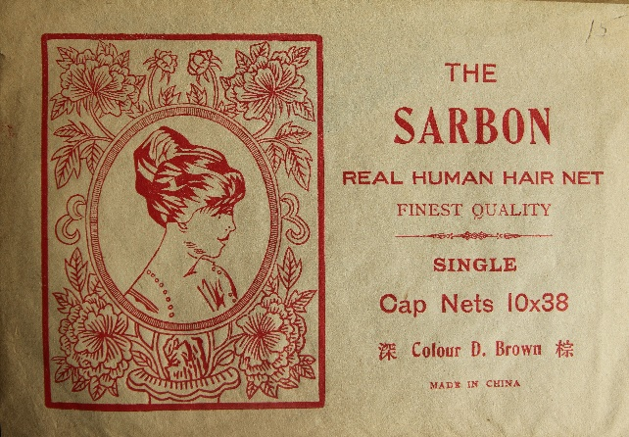
Fig 3 Fig 4a

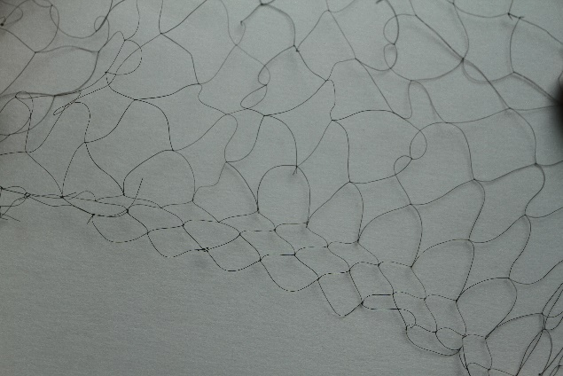
Fig 4 b

This article draws on research for my book Entanglement: The Secret Lives of Hair, London: Oneworld. The research was conducted in India, China, Myanmar, West Africa, the United States and Europe between 2013-2016 and was generously funded by the Leverhulme Trust.
‘Human Hair Supplies’, New York Times 13 December 1874 and ‘The Curiosity Shop’ Los Angeles Herald 6 Sept 1891
‘Making Hair Nets A Big Industry: How the Chinese have come to have a virtual monopoly of the manufacture’, New York Times, August 19, 1923.
‘The German Hair-Net Industry’ article from the Textile Mercury reproduced in the Hairdressers’ Weekly Journal, July 6, 1912.
‘Tons of human hair used in Interline Coats,’ article from the Yorkshire Post June 3rd 1911, reproduced in the Hairdressers’ Weekly Journal, July 1st 1911.
For examples see ‘Method of Producing Interlinings’, US 1528453, published 3 March 1925 and ‘Garments with Interlinings’, US 2774074 A, published 18 December 1956

