Multimodal Ethnography and the Possibilities for an Engaged Anthropology
Ethiraj Gabriel Dattatreyan, Arjun I. Shankar

As junior scholars, we have embarked on finding a balance between anthropological theory-building and meaningful social engagement. To do so, each of us have found ourselves utilizing digital technology – small, inexpensive cameras and social media platforms – to create our respective ethnographic projects. Our turn towards digital engagement began during graduate school when we, along with faculty and fellow graduate students across the university, imagined and developed camra (camrapenn.org), an organization based at the University of Pennsylvania dedicated to multimodal and community engaged research. In this short piece we discuss the ways in which digital technology can offer new directions in which to take the discipline that create a more engaged anthropology. Specifically, we focus on how digital audio-visual production has the capacity to foster explicit collaboration in ethnographic projects. Collaboration, as an ethos and working method, has been part and parcel of our discipline since its early days. As Luke Eric Lassiter has argued, the co-production of knowledge inherent in our methodology has always required fostering a dynamic intersubjectivity with our participants. The digital, we suggest, offers a way to explicitly broaden the scope of collaborative engagement in ways that allow not only for greater participant involvement but also foster cross-disciplinary projects that put anthropologists in meaningful conversation with colleagues in the academe and beyond around the pressing issues of our time.
camra (camrapenn.org) was initially launched in 2011 as a forum to bring together like-minded graduate students and established scholars interested in legitimizing non-textual production. Our small collective began by organizing a speaker series and, soon after, a media festival at UPenn (now in its 5th year) that sought to celebrate scholarship at the intersection of ethnography and the audio-visual. Very early on opportunities presented themselves that allowed those of us at the center of camra’s efforts to clarify how the digital could enhance and support collaborative research endeavors. It became clear that scholars from around the university and in Philadelphia community based organizations were eager to learn, partake in, and integrate our digital approach to ethnographically grounded knowledge production. Various institutional actors within and outside of the University of Pennsylvania began to reach out to us to see if students and faculty involved with camra were interested in partnering to create audio-visual work. Several projects developed out of these early conversations, projects that allowed doctoral students involved with camra the opportunity to experiment with a digitally enhanced methodology before they began their dissertation work.

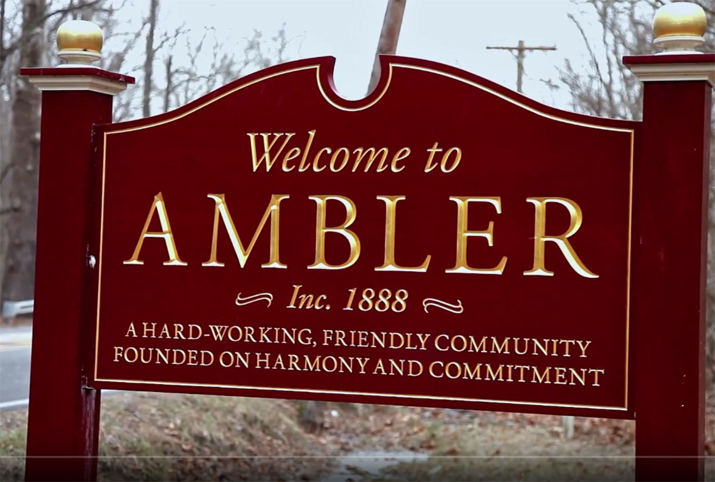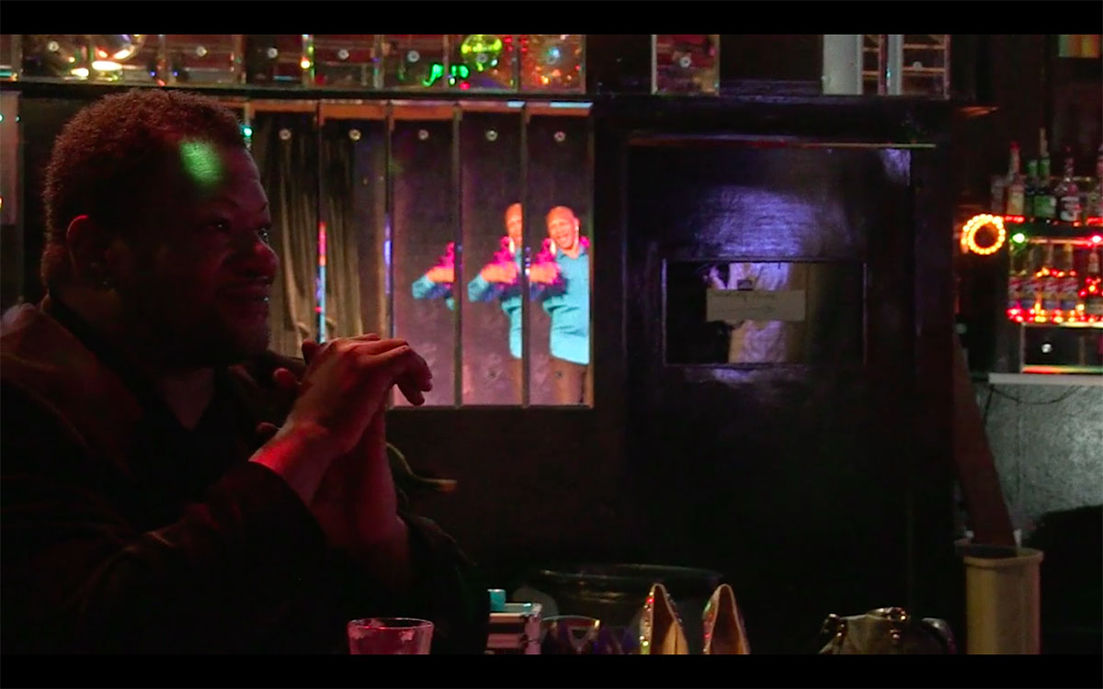
Figure 1 Figure 2

For instance, in 2013 two camra members developed a short filmic and photographic essay on the ecological, health, and economic after-effects of an asbestos plant in Ambler, Pennsylvania (Tarditi and Zuberi). Similarly camra-members worked with the Penn School of Design and the Ward, a Duboisian youth education organization, to create two short oral history films about the Tindley Temple Church, one of the oldest Black methodist churches in Philadelphia (Laughlin, Ziv, Shankar). Other completed and ongoing projects include an HBO-funded short documentary series (Zambon, Ristovska, Chaparro, LaDue, Saini), two experimental metafilms following the travels of a small group from the Rastafarian community in South Africa (Durrani and Shankar), a PEW-funded film on the Morton Skull collection and the history of scientific racism (Skolnick, Hudson, Shankar), the film project Sweet Tea that engages with E. Patrick Johnson’s innovative, performative scholarship documenting the lives of Black gay men in the south (Gross, Stephens), and a curated installation in collaboration with Ethnographic Terminalia. Through such projects, graduate students training in several different disciplinary traditions across the university had the opportunity to work together to think through the affordances of photo, video, and web based platforms. Moreover, these students had the opportunity to engage with established scholars, artists, and community leaders to co-develop shared knowledge projects and grapple together with the complicated task of speaking to multiple audiences.

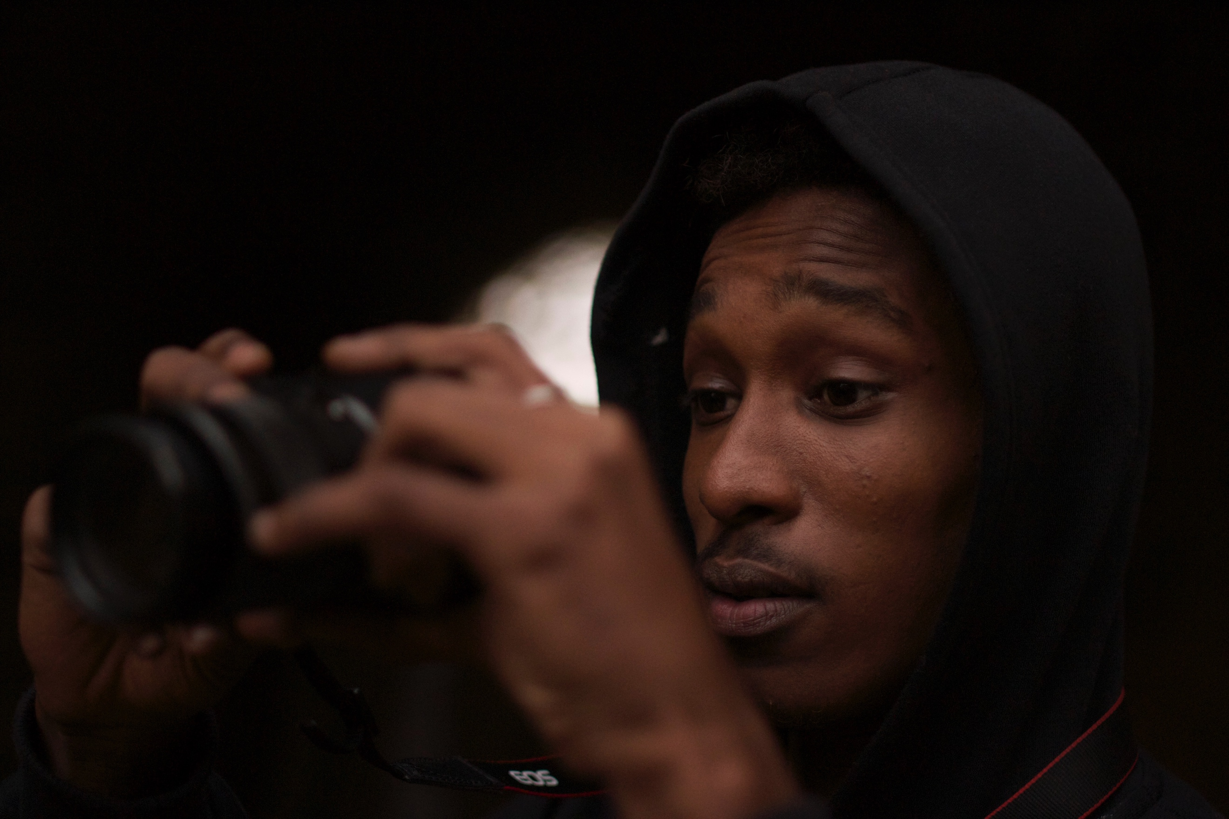
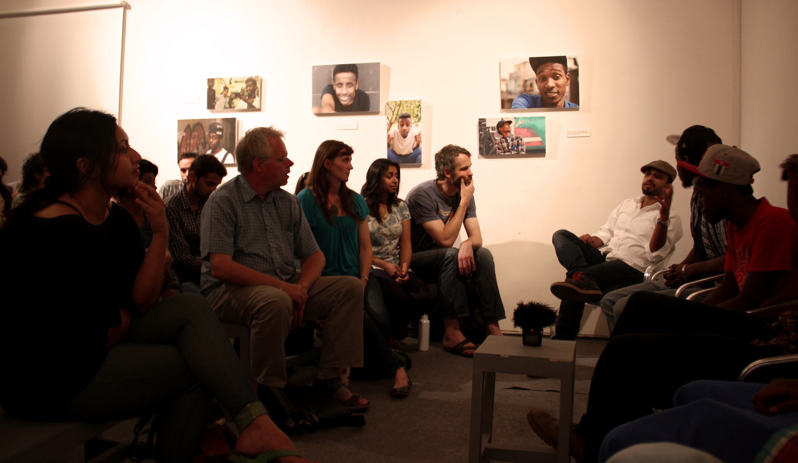
Figure 3 Figure 4

These early lessons with camra became the basis for each of our unique audio-visual ethnographic projects. In 2012 Dattatreyan embarked for Delhi, India where he conducted an 18 month long ethnography with young migrants who have come of age in the era of post-economic liberalization that has radically changed the city. During his time in Delhi he produced several music videos with the young men and women he got to know in the field and, towards the tail end of his time in the city produced a collaborative feature length film with a group of young Somali refugees that focused on the racialization of Africans who make the city their home. Dattatreyan and his team screened the film at Khoj Arts in South Delhi to a large audience after a series of highly publicized, violent racialized incidents against Africans living in Delhi (Dattatreyan, Wide Screen, forthcoming). The screening fostered a necessary dialogue around the politics of difference amongst a broad spectrum of South Delhi’s diverse residents. His forays into the audio-visual in his ethnographic projects not only allowed him to develop participant driven ethnographic opportunities and create public discussion around pressing social issues but fostered ongoing collaborative projects with Delhi based artists and academics around the growing salience of race and racism in urban India.
Shankar’s research took him to Bangalore, India, where he worked with both NGO personnel and rural youth to understand the changing nature of “development” given the emergence of transnational diasporic networks, the increased use of digital technologies, and human rights discourses that together influence how social change can and should occur. As part of his work he conducted a participatory film and photography project intended to complicate simplistic representations of village life in light of Bangalore’s massive expansion. Youth in one of his field sites worked in groups of three to articulate what they themselves found curious about their rapidly changing lives, effectively reversing a dominant gaze that traditionally saw them as impoverished, deficient, and “in-need-of-development”. The result of this work was a photography exhibit presented both at their school for their community and in several university contexts elsewhere. Shankar’s own theoretical insights were also heavily influenced by these visual co-productions, shifting how he articulated ideas of aesthetics, auteurship, and value. Specifically, this entailed taking the images produced by his participants seriously as works of art, created by auteurs who were not merely capable of documenting reality, but were always consciously constructing realities at the same time (Shankar, Visual Anthropology Review, 2016).

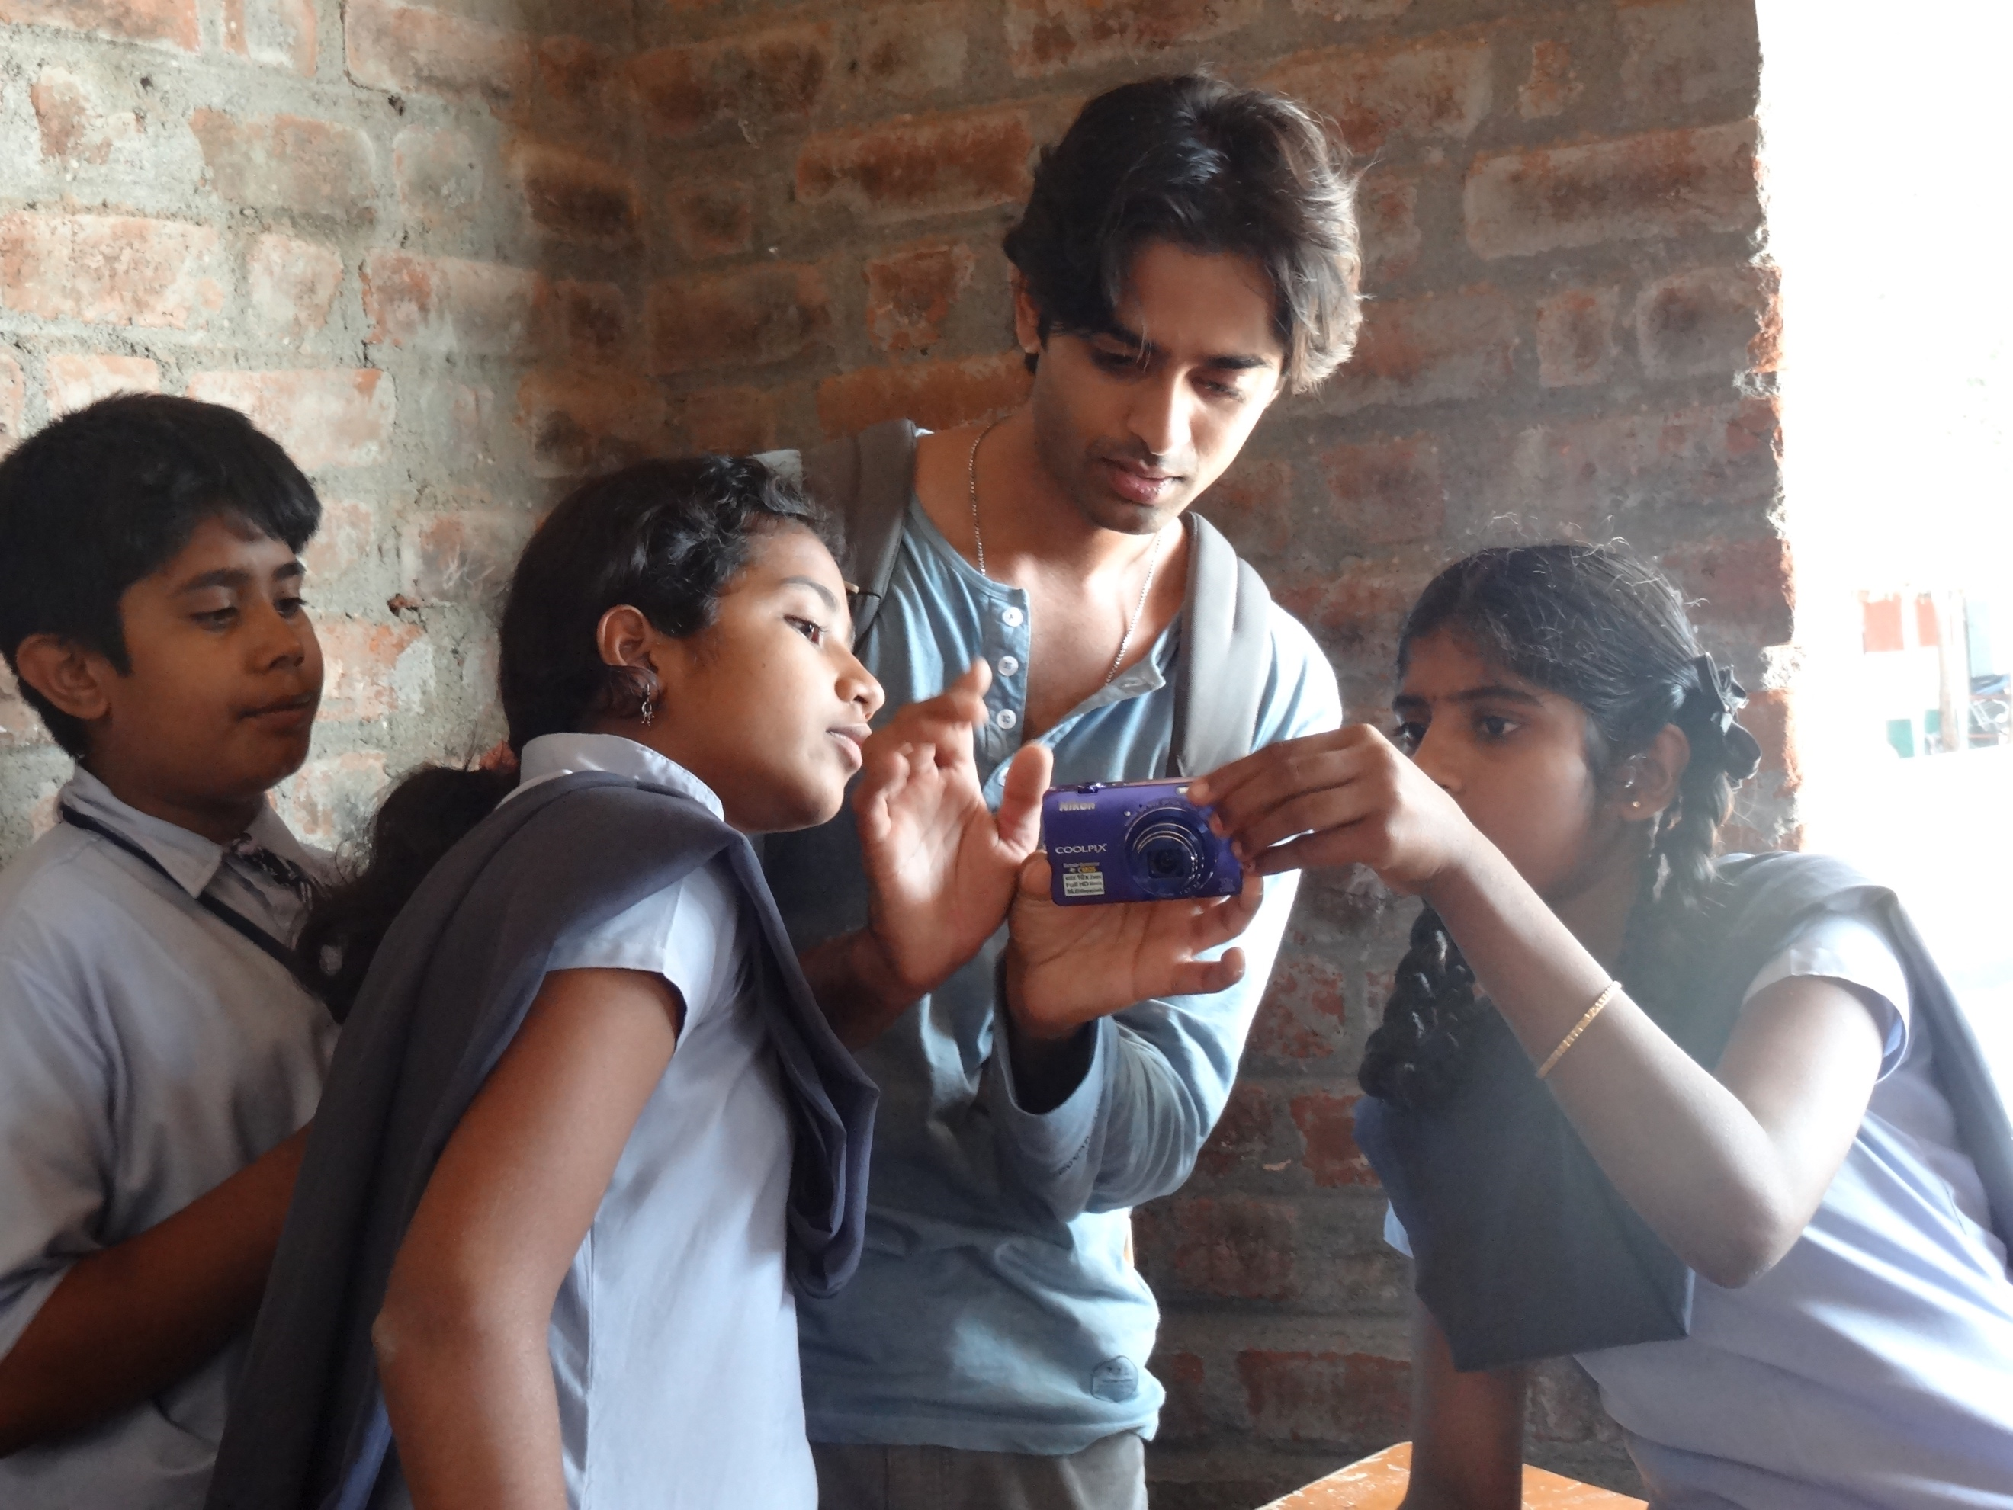
Figure 5 Figure 6

Our turn to digital tools and the founding of camra at the University of Pennsylvania, when seen in relationship to senior anthropologists ventures with multimodality – and here we are thinking of Kim Fortun’s and Anna Tsing’s innovative web based work – speaks to the ways anthropology is changing in the 21st century. Ethnography, as a method by which to understand and engage the world, can create tremendous opportunities for explicitly collaborative knowledge ventures. The advent of inexpensive digital technology and the ubiquity of social media has the potential to democratize ethnographic co-production without the tensions of expert and novice that are inherent to textual production. We premise this argument on the social fact that the digital image is opening the aperture of social life in a way we haven’t seen before: what we once perceived as bound and local is now clearly saturated with global connection. Here we use aperture and saturation to point the relationship between the ways we “see” as anthropologists and the choices we make when we take photographs or film, an apt analogy for the methodological choices we make as ethnographers and the kinds of insights we might therefore create. What our work with camra (and the camera) has pushed us to confront is the question of how our discipline should grow as we explicitly and consciously open its aperture in a media saturated world as we strive to consciously integrate voices and ways of seeing that challenge our disciplinary understandings to engage with the pressing problems that plague our world. Perhaps one of the questions that arises, then, is how might we open the aperture of anthropological knowledge without risking oversaturation? One answer, as we have suggested here, is to consciously integrate the digital into our anthropological imagination, both as theory and practice, a scholarly approach that forces us to attend to global circulation, audience, collaborative praxis, and the ethical and engaged possibilities therein.

Note: camra members involved in projects listed above include Sandra Ristovska, Emily LaDue, Kate Zambon, Shashank Saini, Mariam Durrani, Matt Tarditi, Jabari Zuberi, Tali Ziv, Corrina Laughlin, E. Gabriel Dattatreyan, Nora Gross, Arjun Shankar, Andrew Hudson, Melissa Skolnick

References
Dattatreyan, E. Gabriel (Forthcoming). Critical hip hop cinema: Racial logics and ethnographic remixes in Delhi, India. Special Issue: Cinema and the Production of Space, Katy Hardy (Ed.). Wide Screen.

Fortun, Kim. "The Asthma Files." http://theasthmafiles.wikispaces.com/
Brief Description: The Asthma Files is an electronic archive of text, still images, video and audio that illustrate multiple perspectives on asthma– from the vantage point of affected people in different locales and communities, heath care providers, and scientists from many different disciplines.

Lassiter, Luke Eric (2005). The Chicago Guide to Collaborative Ethnography. Chicago: University of Chicago Press.

Shankar, Arjun (2016). "Auteurship and Imagemaking: A (Gentle) Critique of the Photovoice Method." Visual Anthropology Review.

Tsing, Anna. "Matsusake Worlds Live." http://www.matsutakeworlds.org/
Brief Description: This website gathers stories from around the world of matsutake scientists, forest managers, pickers, buyers, grocers, chefs, and consumers. They tell us of lively worlds emerging from every matsutake forest and marketplace. Their stories tell us of many kinds of lives. These lives are simultaneously distinctive and connected across the globe.

