New Technologies of the Observer: #BringBack, Visualisation and Disappearance

Keywords: surfaces, vision, rendition, double blind, double bind

Abstract:

This paper explores two examples of non-visibility as a way of describing
the specificity of contemporary surfaces of visualization. The two cases
are the disappearance of Malaysia Airlines Flight 370, the
scheduled passenger flight from Kuala Lumpur to Beijing, which lost
contact with air traffic control on 8 March 2014 at 01:20 MYT, and the 276
Nigerian girls who went ‘missing’ at about the same time. The analysis is
developed through an exploration of these examples in terms of the
patterning of vision produced in recursive relations, or relations of
feedback with the environment. We argue that changes in the
organization of this feedback, which we describe as
‘rendition’, equip contemporary observers with both the capacity to see
‘close up at a distance’ and the capacity to be situated adjacent, next to or
‘beside from above’.

When [Wittgenstein] says, “if the color changes you are no longer looking at the one I meant,” the ground is suddenly pulled out from under you. How did the color change? Who, or what, was the agent? (Bochner, 2008: 202)

Introduction
In her book Close Up at a Distance, Laura Kurgan discusses a well-known series of images of the planet earth that began with The Blue Marble, a photographic view of the earth as seen by the Apollo 17 crew travelling towards the moon in 1972, and ended with the 2012 digital versions of this image. She describes these later versions as being,
… assembled from data collected by the Visible/Infrared Imager Radiometer Suite (VIIRS) on the Suomi NPP satellite in six orbits over eight hours. These versions are not simply photographs taken by a person traveling in space with a camera. They are composites of massive quantities of remotely sensed data collected by satellite-borne sensors. … This is not the integrating vision of a particular person standing in a particular place or even floating in space. It’s an image of something no human could see with his or her own eye … because it’s a full 360-degree composite, made of data collected and assembled over time, wrapped around a wireframe sphere to produce a view of the Earth at a resolution of at least half a kilometer per pixel – and any continent can be chosen to be at the center of the image. [Moreover] … it can always be updated with new data. (2013: 11-12)
As a patchwork or composite of satellite data, this image has no (visible) edges: it is boundless and, as such, might lead us to imagine that contemporary visualization has no limits. Yet there are very many ways in which in-visibility or non-visibility can be achieved today, as Hito Steyerl’s deadpan film How Not to be Seen: A Fucking Didactic Educational.MOV File (2013) demonstrates.

Partly set in a now disused photo calibration test site in a Californian desert How Not to be Seen presents itself as an instructional video, educating viewers about how to remain invisible in an age of surveillance. Various possible strategies are identified, including camouflaging oneself (to demonstrate, Steyerl smears green paint on her face), cloaking and hiding in plain sight. Additionally, so a voice-over announces, you can be rendered invisible if you are poor, undocumented, living in a gated community or in a military zone, a woman over 50, if you own an ’anti-paparazzi handbag’, are disappeared by the authorities, eradicated or annihilated, or if you are ‘a dead pixel’. To demonstrate this last possibility, several people appear on the screen, wearing black boxes on their heads, only to be faded out. Digitally rendered ghosts dance in the desert landscape as The Three Degrees' When Will I See You Again? plays on the soundtrack.

In this article, we analyse two very different examples of disappearance in terms of relations of observation: the disappearance of Malaysia Airlines Flight 370, and the 276 Nigerian girls who went ‘missing’ at about the same time in 2014. By focusing on relations of observation, we hope to explore how these events have been taking place without downplaying their gravity. We use the term surface to draw attention to the ways in which relations of observation are constantly shifting, implying and sometimes precluding points of view, and providing ever-changing conditions for visibility and invisibility across situations. However this attention to processes of ‘surfacing’ is not to deny or minimize the importance of the complex materialities of contemporary observation. Following Crary, we believe that observation is not the purposeful, perceptual practice of an individual; rather, our presumption is that the observer is ‘the effect of an irreducibly heterogeneous system of discursive, technological and institutional relations’ (1990: 6).

Observation commonly implies vision and cognate terms such as visibility or visualization, all of which provide holding terms for many functions: ‘a physical sense, a set of practices and discourses, and a metaphor that translates between different mediums and different communications systems’ (Halpern 2014: 21), such as ‘knowledge’. As Halpern points out, ‘Vision is … a discourse that multiplies and divides from within’ (Halpern 2014: 21). In this regard, the history of the term ‘visualization’ is instructive: a relatively recent term, it only appeared in the Oxford English Dictionary in 1883, and was used initially to depict the formation of mental images of things ‘not actually present in sight’ (Halpern 2014: 21). In the decades that followed, however, it has come to mean any ‘action or process of making visible’:
Visualization slowly mutated from the description of human psychological processes to the larger terrain of rendering practices by machines, scientific instrumentation, and numeric measures. Most important, visualization came to define bringing that which is not already present into sight. Visualizations, according to current definition, make new relationships appear and produce new objects and spaces for action and speculation. (Halpern 2014: 21)

We live now in an environment of large-scale automated data collection and surveillance. Not only have the technical mechanisms of observing or collecting data multiplied in the recent past but so too have the opportunities for feeding back or sharing these observations. As we have argued elsewhere (Day and Lury 2016), these opportunities for feedback have produced new opportunities for a variety of forms of tracking, all of which involve the repeated folding of data, or looping of observation, into analysis at defined intervals in time. This ongoing analysis turns traces into tracks as data are related, linked, or connected to each other, so allowing feedback to ‘feed forward’. As a consequence, at the same time that ‘knowledge is decentralized and distributed across persons, practices, documents and information infrastructure’, the question becomes ‘not simply ‘who knows whom?’ or ‘who knows what?’ but ‘who knows who knows what?’’ (Contractor, quoted in Stark 2009: 174). Indeed, some commentators have gone as far as to suggest that ‘modern society has moved - in every field - from first-order observation to second-order observation’ (Esposito 2013: 4). We put forward instead an analysis focusing on composition (Day, Lury and Wakeford 2014) as a way to explore the many layers, moving ratios and multiple dimensions of the surfacing of visualization. We ask about ‘the nature of what becomes visible’ (Jiménez 2014: 28) without assuming that the visible and invisible are opposites.

We frame our discussion of in- or non-visibility in terms of Flusser’s gesture of photography in the following section, which shows how observers are inside as well as outside a situation. We apply this approach to the two examples in order to demonstrate some of the variety and complexity to relations among observers and observations, drawing particular attention to the lability of these shifting relations today. Given this instability, we ask whether Flusser’s insights into the gesture of photography might be developed further to show how relations of observation work ‘across’ situations to produce events. His three aspects to the gesture of photography: finding a position from which to observe; adapting the situation to that position and evaluating the success of this relative positioning, become more complex with multiple, mobile observers using proliferating technologies of observation. In many circumstances, relations are stabilized through what have been described as hierarchies (first and second order) of, or directions to, observation. But, the two examples we introduce suggest continual processes of editing or speculating, which we describe as rendering. Rendering invites questions about the grounds for observation which may no longer exist a priori, but instead are constantly surfacing in re-visionings. In such circumstances, we argue, observations can only be partial. Our emphasis on composition is helpful, we hope, in drawing attention to a constantly shifting surface in which observations may be related, ordered or positioned next to, above or below each other.

Composing a surface of visualization
To illustrate our compositional approach we begin then with Flusser’s nested analysis of ‘the gesture of photography’ (2014), which indicates how relations of observation create an expanding surface within which events take shape. Flusser starts with a quotidian situation: that of a man positioning a camera so as to take a photograph of another man sitting in a chair, smoking a pipe. He points out that even in such an apparently straightforward situation it is hard for the photographer to know where to position himself so as to get the right perspective, and give the object being photographed – in this case, the man with the pipe – the depth of vision that it requires to be seen. Describing this struggle, he observes,
The center of this situation is the man with the apparatus. He is moving. Still, it’s awkward to say of a center that it is moving in relation to its own periphery. When a center moves, it does so with respect to the observer, and the whole situation then moves as well. We must therefore concede that what we are seeing when we watch the man with the apparatus is a movement of the whole situation, including the man sitting on his chair. (2014: 74-5)
In other words, while the photographer might believe that he is positioning the camera so as to find the best standpoint from which to photograph a fixed situation, he is, if he is performing the gesture of photography rather than taking a picture, looking for the position that best corresponds to a situation that is moving.

Flusser then adds a further observation. He notes that we too are part of the moving situation. More specifically, he recursively folds himself - and us - into the gesture of photography:
… the man with his apparatus is the center of the situation only for us, watching him, not for himself. He believes himself to be outside the situation, for he is watching it. For him the man on the chair, at the center of his attention, is the center of the situation. (2014: 75)
In short, Flusser suggests that what is required of the photographer by the gesture of photography – moving to find a position from which to take a photograph of a situation which is changing as he moves - is also true of us as observers of the gesture: ‘we, too, are located in the space, watching the man with the apparatus’ (2014: 75). While we too might believe ourselves to be outside the situation, we are (also) inside. Although ‘our’ location could ‘mislead us’ into supposing that there are two different situations, ‘one in which the man with the apparatus, whom we transcend, is at the center and another in which the man on his chair is at the center and in which we are involved’, this is not the case. Instead, so Flusser asserts, ‘The two situations are different yet bound up with one another’ (2014: 75). A surface of visualization, we suggest, includes components or relations that may be moving in different directions at different rates and it will ‘expand’ to include recursively future observers.

Flusser’s analysis of the gesture of photography is captured in the photograph we reproduce here (Figure 1). The image shows the positioning of the camera deemed necessary by the police to record the scene of a crime in the late nineteenth and early twentieth century: ‘[the image’s] center will pass exactly between the eyes of the cadaver – at the root of the nose’ (http://www.vice.com/en_uk/read/crime-and-death-in-paris-philippe-charlier-photography-876). This position - directly above the object of concern – has since been institutionalised in a variety of forms of surveillance, including the aerial viewpoint of the bomber or the drone (Virilio 1989). This image might thus appear to demonstrate better than many others that photography is produced from a position that is above or outside the situations that it observes. Yet the photograph is (also) an observation of an observation, and makes it clear that the position of the observer above or outside the situation is also, recursively, part of the situation. The assumption of a fixed position in a stratified hierarchy of observation is shown to be unstable since, from outside the image, we are already drawn into the context of observation.

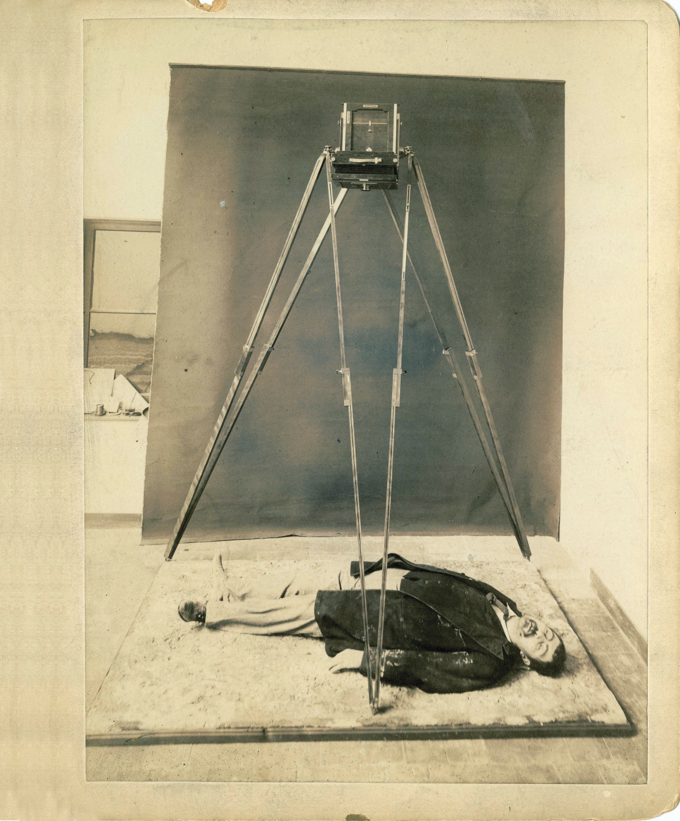
Figure 1: Studio Demonstration of Bertillon’s ’bec à gaz’ camera technique, La Musée de la Préfecture de Police, Paris. (Image posted at VICE website)

Observation in this image is orthogonal to the vertical ‘god’s eye’ view, and so it makes visible how the gesture of photography creates a surface in motion across situations.

Drawing on this analysis, we suggest that the gesture described by Flusser is not restricted to photography but is enabled by a whole array of technical supports. We note, for example, the way in which the constantly changing organization of the relations established across the three sites of television - the place of recording, the place of reception, and the place of transmission – continually remake situations as (geo-political) events (Weber 1996). And we suggest that the event-making capacities of observation are rapidly changing across relations that now routinely, recursively and massively take place between the military, governments, corporations and everyday users of location-based devices and applications. In short, we propose that the recursive binding together of situations described by Flusser in terms of the gesture of photography is fundamental to reconfiguring visualisation as a shifting surface. We turn now to two examples to illustrate and develop this claim.

The case of the disappearing plane
It was widely reported that Malaysia Airlines Flight 370, a scheduled passenger flight from Kuala Lumpur to Beijing, lost contact with air traffic control on 8 March 2014 at 01:20 Malaysian time (MYT), less than an hour after takeoff. The aircraft was carrying 12 Malaysian crew and 227 passengers from 14 nations. No explanation of this disappearance has yet been officially confirmed although – at the time of writing in 2015 - debris from the plane had been found, including a wing piece on a beach of the Pacific Ocean island, Réunion. In relation to this, our first case, we ask: how can a plane, tracked by technologies of global surveillance, ‘disappear’? In a discussion elsewhere (2016), we proposed that the ‘disappearance’ is a consequence of a combination of ‘double blind’ and double bind and we explore this proposition further in order to investigate how relations of observation are composed in an expanding surface of visualisation.

Heinz von Foerster (1995) used the term double blind to draw attention to the instability and contingency of vision. when he argued that we do not see ‘everything’, including our own ‘blind spots’. A blind spot, or scotoma, is an obscuration of the visual field. A particular blind spot known as the physiological blind spot, or punctum caecum, is the place in the visual field that corresponds to the lack of light-detecting photoreceptor cells on the optic disc of the retina where the optic nerve passes. Since there are no cells to detect light on the optic disc at this point, the brain interpolates the blind spot based on surrounding detail and information from the other eye, with the result that the blind spot is not normally perceived. Von Foerster draws on this understanding in his presentation of the double blind; indeed, he sums up the long-established finding that each of our two eyes has a blind spot with the aphorism: ‘We do not see what we do not see’ (or as he put it elsewhere, ‘We do not see that we do not see’). A consequence of this double negative, we suggested, is a (false) positive, that is, a belief that we can see everywhere, as illustrated for example by contemporary versions of The Blue Marble (introduced above). As we pointed out, however, the plane’s disappearance demonstrated that ‘we’ cannot see always and everywhere (Figure 2), even with the aid of the huge technical complex of GPS, civilian and military satellites, drone cameras, GoogleMap and so on. The disappearance revealed that there are edges (which might appear as gaps, corridors, or out-of-focus patches) in today’s apparently boundless surface of visualization, even if we do not always know where they are or how they operate, where or when we might fall into a crevice or over an edge.

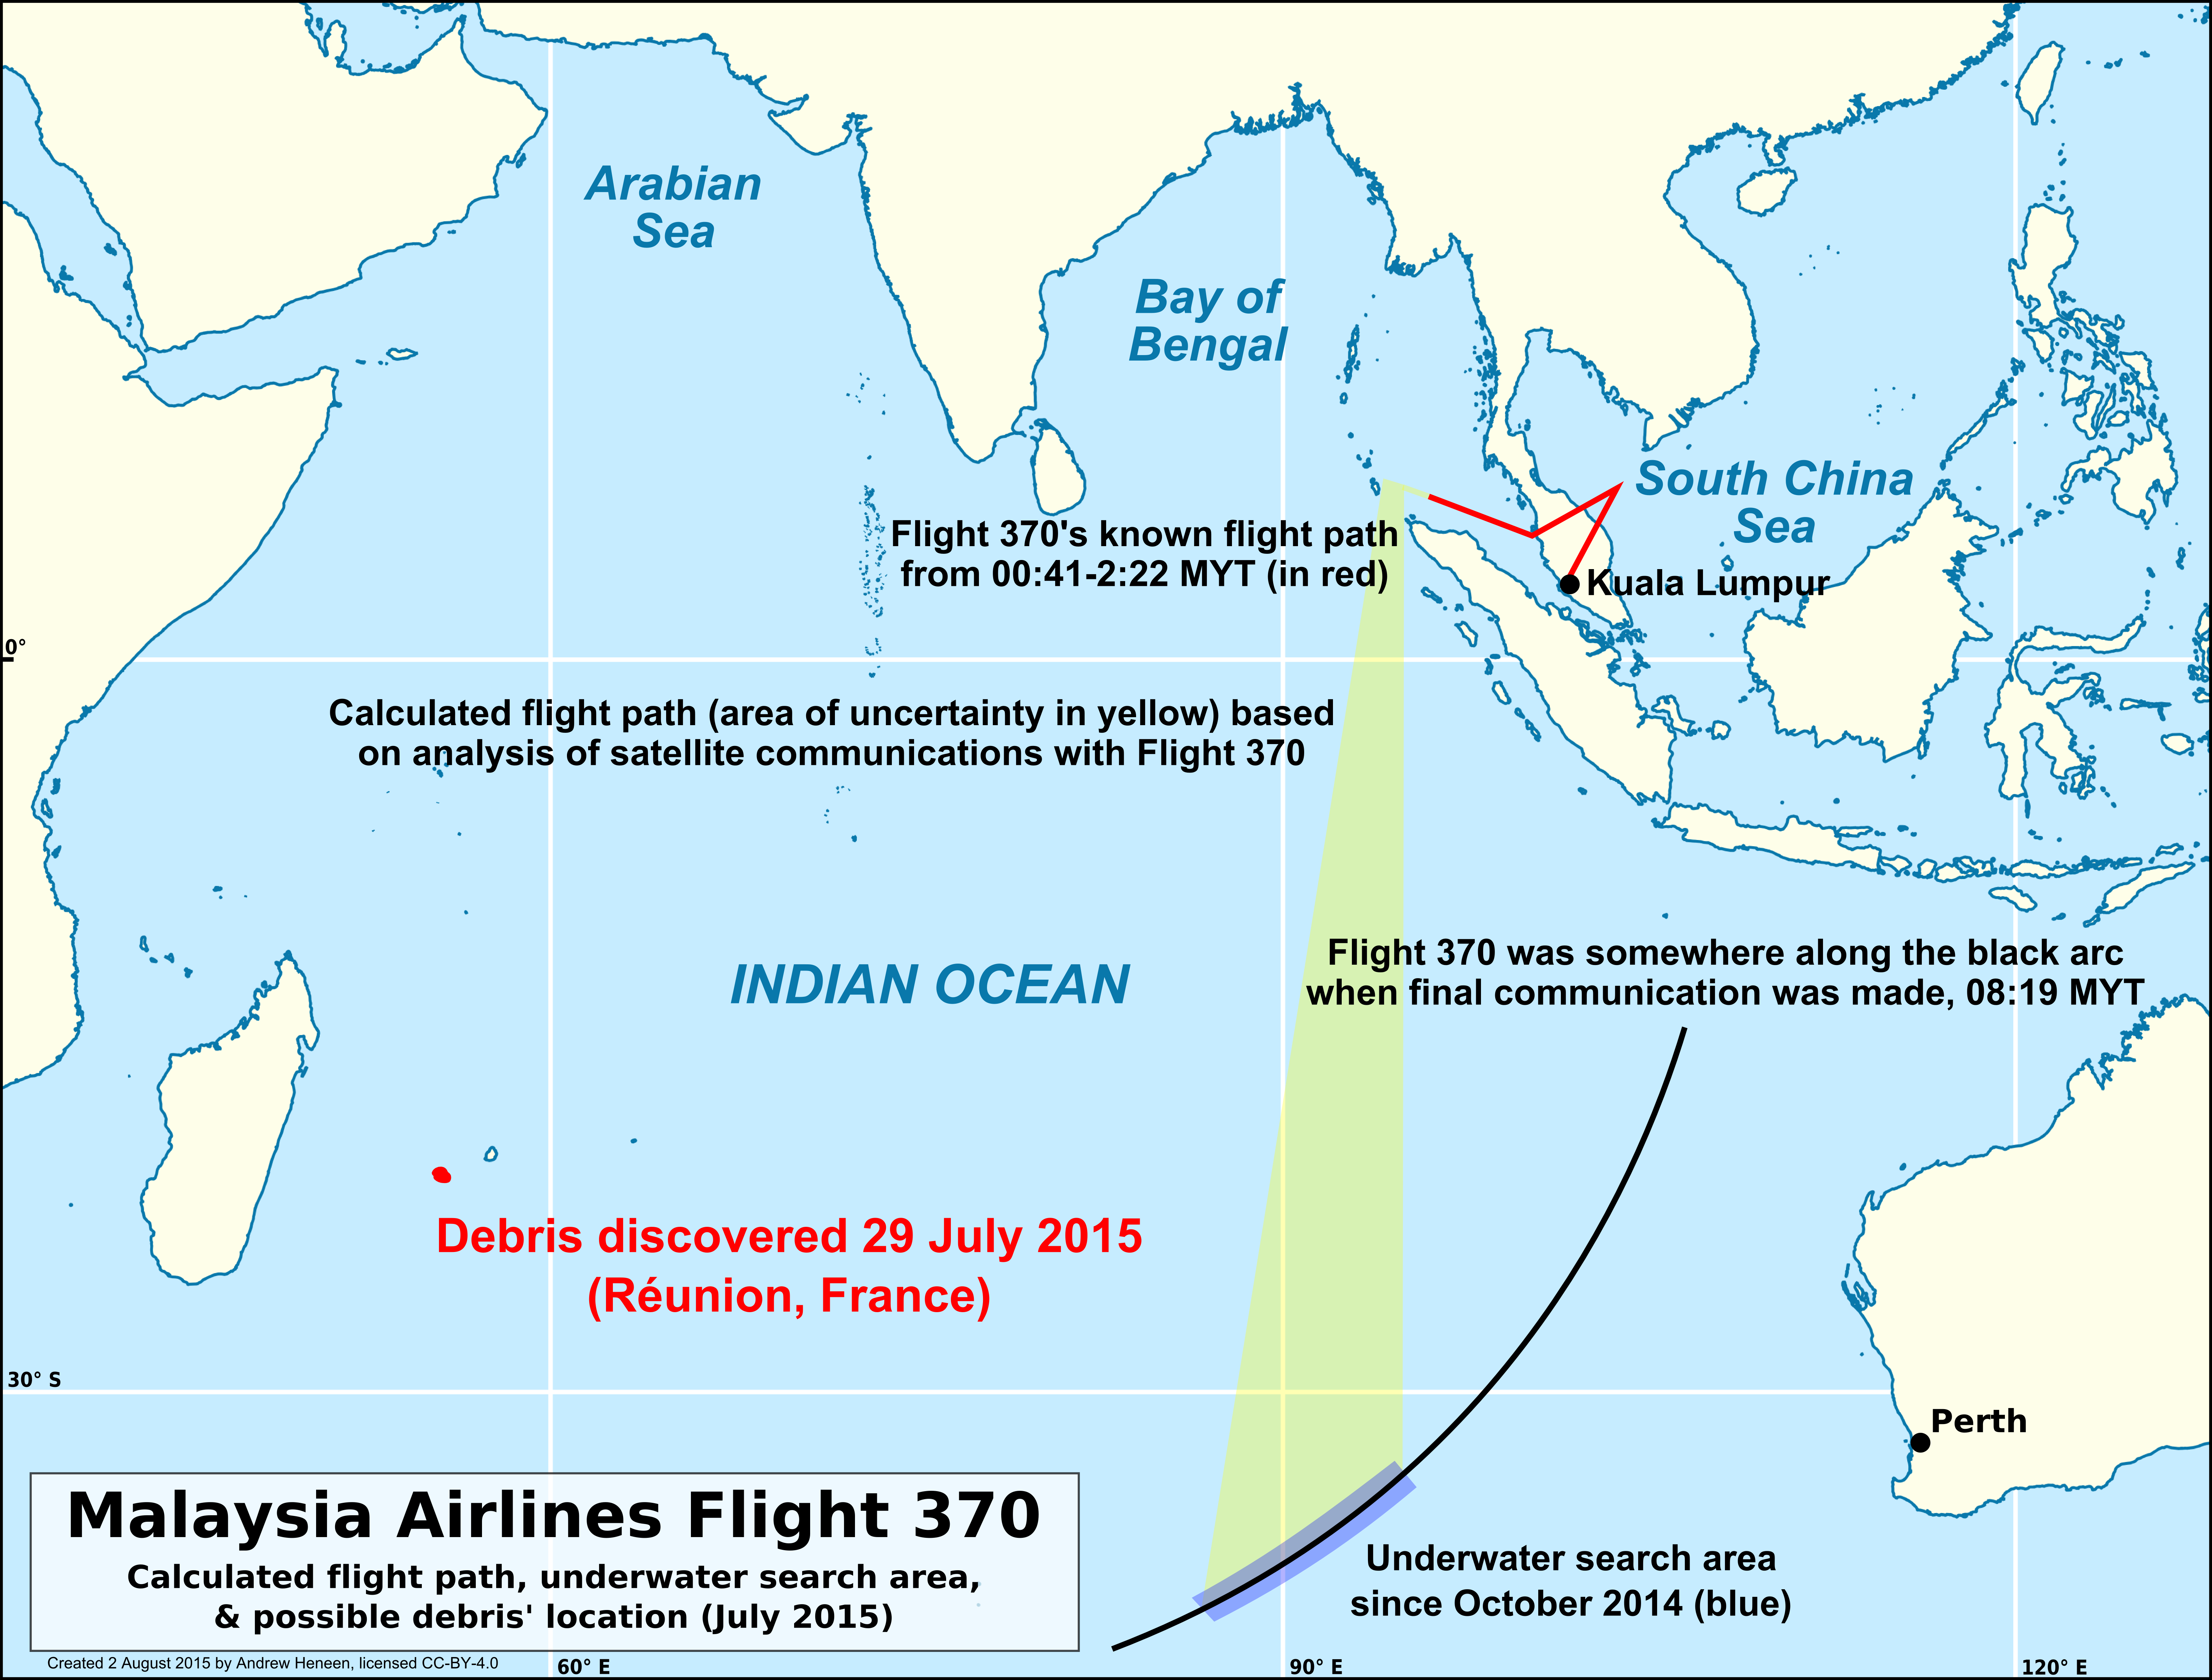
Figure 2: Map plotting the disappearance of Malaysia Airlines Flight 370 after debris was found in Reunion, compared with MH370 flight paths and underwater search area. By Andrew Heneen, created with public domain data from NaturalEarth (CC by 4.0 licence).

It is fundamental to our argument that this disappearance was visible even as the plane itself disappeared. Its visibility, as we have suggested elsewhere (Day and Lury 2016), was a consequence of the operation of double blind and double bind, a phenomenon described by the anthropologist, Gregory Bateson ([1956]). Bateson suggests that double bind – which he describes as ‘an experienced breach in the weave of contextual structure’ - is a characteristic of all adaptive change. Such change, he says, depends upon feedback loops, ‘be it those provided by natural selection or those of individual reinforcement’. He continues, ‘In all cases, then, there must be a process of trial and error and a mechanism of comparison.’ Significantly he further notes, ‘trial and error must always involve error, and error is always biologically and/or psychically expensive. It follows therefore that adaptive change must always be hierarchic’. The introduction of hierarchy is necessary (and beneficial) for Bateson since, ‘There is needed not only that first-order change which suits the immediate environmental (or physiological) demand but also second-order changes which will reduce the amount of trial and error needed to achieve the first-order change’. Here Bateson argues that the introduction of hierarchy is a consequence of a recursive process that is necessary for learning and for the adaptation of an entity to its environment: as he says, ‘And so on’ (1987: 201).

In observing some of the responses that made the disappearance of the plane visible, we suggested that the double bind in operation for some, especially state observers, involved the co-existence of the injunction to ‘see everything’ (or at least the injunction, ‘do not see what you do not see’) and the contradictory injunction to ‘see nothing’ (which is to say, ‘do not see what you see’). Relatives of the missing passengers and crew personify the imperative to see everything; they focus the minds of state actors who do not want to admit the failure (of the fantasy) of total planetary observation that is the double blind hypothesis. However, in order for this double blind hypothesis to be preserved, observers who are differently situated in relation to the context(s) of observation needed to reveal to each other what they had (not) seen. But such comparison, as Bateson notes, has significant political ‘costs’ for such observers, especially for those observers acting on behalf of states who might reveal their own positions as they compare their observations with those of others. This dilemma intensifies a situation in which such observers simultaneously feel compelled to observe the injunction to not see what they do not see and to not see what they do see. These twin injunctions inform a slow dance of observe and (don’t) tell, the outcome of which, we suggested, was the creation of unstable hierarchies of first and second orders of observation. Yet the costs and opportunities of comparison can lead to other outcomes, as we suggest with reference to our second case.

The case of the Chibok abduction
On April 14, 2014, 276 girls were kidnapped from a school in the north-east of Nigeria. This violence was attributed to Boko Haram, an organisation antagonistic to both the Nigerian regime, which is associated with the south of the country, and western powers: their name is commonly translated as ‘western education is sinful’. In this example too, we suggest, a disappearance is rendered visible, but the situations that are bound together in this case do not establish the grounds for any, even unstable, hierarchies of observation.

We indicate the myriad range of observations in this case by noting some local, national and international reports: citizens took to the streets of Abuja in protest and demanded the return of the girls, fifty-nine of whom had managed to escape shortly after their abduction; there was a rally in Cardiff, UK and hundreds of other cities across the world; church congregations joined in prayer, and international church leaders in negotiation. One by one, the girls were individually named. Speculation about their fate, about Boko Haram and the Nigerian state was rife.

The political impetus to find the girls was amplified globally in a hashtag campaign on Twitter, #BringBackOurGirls, which attracted commentary in turn. The campaign started in Nigeria and attracted the support of Malālah Yūsafzay, the Nobel Prize laureate and activist from Pakistan, and many others, who were bound together in outrage at the abduction of the young women. The support of Michelle Obama (Figure 3) gained particular prominence and it is significant to our argument that the First Lady’s address of May 10th 2014 was given on the US holiday for honouring mothers.

Figure 3: Michelle Obama, #BringBackOurGirls, posted to her official Twitter account (Wikipedia, Chibok Schoolgirls Kidnapping, accessed May 2015)

One of the most powerful posters attached to #BringBackOurGirls was tweeted by rapper Chris Brown (who was named in a police report for assaulting his then partner Rihanna) as well as the US embassy in Madrid, Kim Kardashian and global girls’ rights activist Becky Makoni among many others (Figure 4). The story acquired an additional twist when we were told that the picture is of a girl from Guinea Bissau, a country more than 1,000 miles away from Nigeria, taken by photographer Ami Vitale in 2000, some considerable time before the abduction. The girl in question, Jenabu Balde, was not abducted and the teardrop running down her cheek was photoshopped in (Felicity Morse, 13 May 2014). By 7th May 2014, more than one million people had signed up to the Twitter campaign and, according to Wikipedia’s hashtag activism entry, the photo has received over two million retweets.

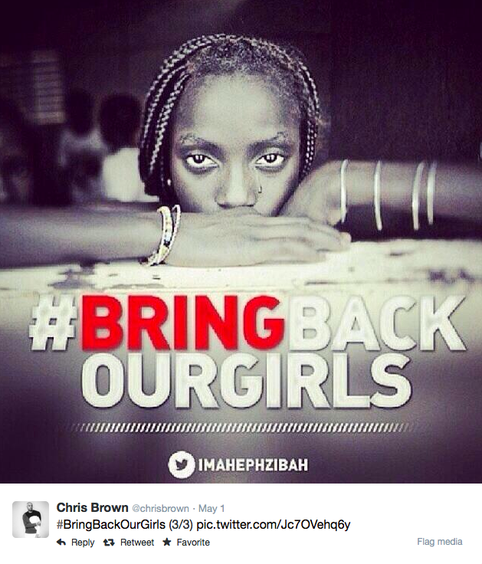
Figure 4: #BringBackOurGirls image, shared by Chris Brown on Twitter, 1 May 2014

It only became clear slowly to many international observers that the kidnapping was far from an isolated event. For example, just over a month before the girls were abducted in Chibok, 59 boys were shot or burned to death by Boko Haram at a secondary school in Yobe, Nigeria. To many observers from the ‘outside’ at least, it seemed unclear whether the Nigerian state would hold. On CBS News, the US Defence Secretary, Chuck Hagel asserted that it was an open question whether Nigerian forces were capable of rescuing the girls. The audience were told that the Muslim north would never vote for a Southern Christian president and so electoral mathematics could not justify a ‘disproportionate’ response. As the US deployed surveillance aircraft over the area with and without crew, White House spokesperson, Jay Carney, said there would be no active deployment of US forces in Nigeria because, ‘we’ don't know enough yet… what to recommend to Nigerians, where they need to go, what they need to do, to get those girls back’ (Smith, Sherwood and Soal, 16 May 2014).

Kidnappings, executions and destruction continued in the north of Nigeria throughout 2014. A ceasefire announced in October did not last, and it was not until February 2015 that concerted military interventions by the Nigerian army in collaboration with neighbouring countries led to the reclamation of much of the territory held by Boko Haram, leaving them only the Sambisa forest. Many people were also rescued from this forest, including a group of nearly 300 women and children (BBC News, 4 May 2015). Some of those freed came from villages close to Chibok, but they did not include the missing young women.

On the anniversary of the abduction, April 14 2015, the Nigerian President Elect acknowledged, ’we do not know if the Chibok girls can be rescued. Their whereabouts remain unknown. As much as I wish to, I cannot promise that we can find them….’ (Dearden, 14 April 2015). Around the world, vigils and marches were staged once more. In New York, the Empire State Building was lit up in red and purple in honour of the missing girls. Supporters from New Zealand to the United States again posted online, using the hashtags #365DaysOn, #ChibokGirls and #NeverToBeForgotten. Since then, sporadic reports, associated with videos and messages from Boko Haram, variously assert that the disappeared young women converted to Islam, now hate their parents, have been married off, sent into sexual slavery, or trained as suicide bombers (Nayar 2015).

To develop our analysis of the difficulties of observation, we consider the Bringback hashtag campaign a little further. While commentators agree that the observations on Twitter were made largely from the global north and west, and were often articulated from the position of mothers (including the above example of Michelle Obama), analyses of the campaign highlight the complexity of different situations of observation and the difficulty of establishing relations across these situations. Nayar (2015), for example, suggests that the victims of abduction ‘were kidnapped for being girls.’ She observes that the BringBack rhetoric in the USA ‘shrewdly notes that educated girls are a rarity in Nigeria (5% of the total population)’, and argues that the posts imply ‘that by kidnapping them Boko Haram has stalled modernisation itself’. She argues that the role of maternal and filial testimonies was instrumental in harnessing the personal to the political, and the affective history (primarily of loss and anguish) of the family to the social history of the nation. Khoja-Moolji (2015) further claims that hashtag feminism implies a certainty about the lives of ‘girls’ in the global south and its own role (from the global north) in alleviating their suffering, rearticulating longstanding colonial relations with campaigns of redress. These and other analyses demonstrate the difficulty of establishing a ground from which to make observations or to which the young women could be returned, let alone a ground in relation to which a hierarchy between first and second order observations could be established.

Indeed we suggest that a radical uncertainty is always introduced into visualization by the gesture of photography, and this uncertainty has only been compounded by the growth in observation technologies. Would a hashtag #BringBackOurBoys have the ability to refer to what commentators see as homeland racist killings in the US, or campaigns for the return of US soldiers from one or more of the US military interventions taking place in other parts of the world, or the Israeli social media campaign that was launched in June 2014 by students of the University of Haifa? This Israeli campaign called upon the international community for action after three teenage Israeli boys were abducted by pro-Palestinian militants and was directly inspired by the #BringBackOurGirls campaign.

Rendition
Having introduced our two cases, we now bring them together in a practice of comparison so as to ‘learn’ how relations of observation, including our own, operate across changing contexts in a surface of visualisation. First, we return to Flusser’s analysis of the gesture of photography to highlight the way in which three aspects of this gesture are recursively linked. Flusser says,
A first aspect is the search for a place, a position from which to observe the situation. A second aspect is the manipulating of the situation, adapting it to the chosen position. The third aspect concerns critical distance that makes it possible to see the success or failure of this adaptation. (2014: 77)
It is the links across these three aspects, we suggest, that produce a surface in which the recursive doubling of the position of observer is neither mere duplication nor hierarchical subsumption of one position by the other, but something more complicated. In other words, the gesture of photography, as it is implemented in multiplying feedback loops, produces a surface that is always being made, un-made and re-made and, as such, is never coincident with itself. Put simply, we understand the doubling of observation in Flusser’s account of the photographic gesture to describe observation as (re-)entry into a surface of visualization that is changing, not least because it is itself the object of observation.

Flusser proposes that, ‘This view of ourselves in a situation (this ‘reflexive’ or ‘critical vision) is characteristic of our being-in-the-world, and we see it, we ‘know’ about it’ (2014: 75). He does not consider that this reflexive position is an objective one. However, while he characterizes the photographic gesture, and more widely any gesture, as a release from a particular role he also suggests that this release is just as available to the man with the apparatus inside the photograph as to the observer outside the image. Both, he suggests, are bound to a ‘place’ from which we can assert that ‘we are experiencing the same situation twice’. He says that this ‘place is ‘the basis for a consensus, for intersubjective recognition. If we encounter the man with the apparatus on this basis, we don’t see the situation ‘better’: rather, we see it intersubjectively, and we see ourselves intersubjectively’ (2014: 75-6). Our examples suggest, to the contrary, that ‘we’ are not experiencing the same situation twice, and are often unable, therefore, to see ourselves intersubjectively.

Our first case suggests that double bind, double blind and first and second order observation may emerge as the outcomes of this process of recursion. As they happen, ongoing processes of observation may organise and – partially and differentially - reveal the surface in which they take place. Insofar as they involve a halting, pausing or momentary suspension for evaluation in the process of recursion, they may permit (collective) contemplation of what is visible and what is invisible and even support speculation about how visibility and in- or non-visibility are inter-related and from which positions. But our second case demonstrates that these are not the only possible outcomes.

To develop an analysis that is adequate to both examples, we turn to consideration of doubling as recursion – ‘And so on’ as Bateson puts it. In this respect, it is worth noting that recursion may have a variety of effects, in part because it always comprises several operations, and not simply doubling. Weizman (2012), for example, argues that vertical sovereignty emerges from the recursive splitting of space into stacked horizontal layers, separating airspace from the ground, and the ground from the underground, multiplying sites of conflict and violence. As our discussion of the gesture of photography suggests, surfaces of visualization are themselves continually de- and re-composed through the making of partial connections (Strathern 2004). A (dis-)proportional scaling of events is constantly emerging as relations of comparison are established across sites of observation, sometimes only to disappear. Indeed, our examples suggest that what is above and what is below or adjacent to us cannot always be stabilized. As Steyerl notes, while many,
aerial views, 3D nose-dives, Google Maps, and surveillance panoramas do not actually portray a stable ground … they create a supposition that it exists in the first place. Retroactively, this virtual ground creates a perspective of overview and surveillance for a distanced, superior spectator safely floating up in the air. Just as linear perspective established an imaginary stable observer and horizon, so does the perspective from above establish an imaginary floating observer and an imaginary stable ground. (2011)
In other words, the grounds of observation may only retrospectively be established and even then only temporarily.

In both the cases we discuss, many different contexts or grounds were brought into play in attempts to make visible the disappearances. Just as the disappearance of the plane made some layers or orders visible and others invisible, the disappearance of the young women from Chibok silenced some and caused others to speak (see Figure 5). But, in the case of the missing girls, no stable ground could be established to cover up or blank out the others entirely. This failure to establish the degree zero of a ground of comparison across contexts meant that the layers could not be lined up in an orderly fashion; the interference or patterns of diffraction produced across their non-aligned edges created turbulence rather than shared orders of observation.

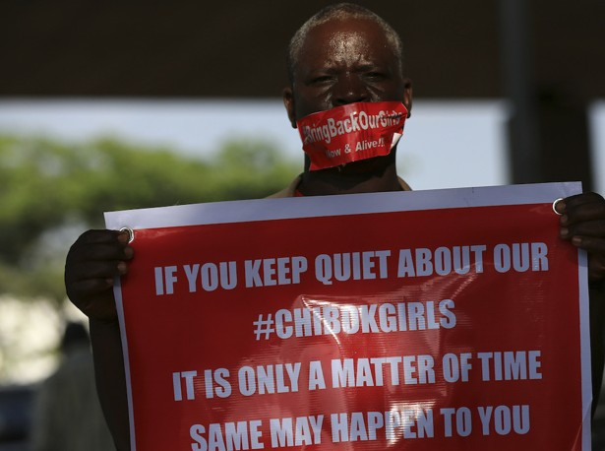
Figure 5: Afolabi Sotunde, Reuters, in Adam Chandler, Nigeria's Violent Year Since 'Bring Back Our Girls'. The Atlantic, 14th April 2015 (courtesy of Reuters Pictures)
Indeed, we suggest that the contingency of comparison introduced by the gesture of photography across changing situations or contexts is fundamental to the patterning of observation as surfaces of visualisation. Chow makes a similar argument in her discussion of the inter-relationship between the conduct of war on the basis of knowledge production and the production of knowledge on the basis of war. Specifically, she proposes that the spatial logic of the grid is giving way to,
an archaeological network wherein the once assumed clear continuities (and unities) among differentiated knowledge items are displaced onto fissures, mutations, and subterranean genealogies, the totality of which can never be mapped out in taxonomic certitude and coherence. Knowledge production [is] … a matter of tracking the broken lines, shapes and patterns that may have been occluded, gone underground or taken flight. (2006: 81)
She further suggests that, in the absence of an a priori secure ground from which to observe, comparison becomes an act of judging the value of different things ‘horizontally, in sheer approximation to one another’. For Chow this act is necessarily speculative rather than conclusive because it is inseparable from history. She writes,
… comparison would also be an unfinalizable event because its meanings have to be repeatedly negotiated – not only on the basis of the constantly increasing quantity of materials involved but more importantly on the basis of the partialities, anachronisms, and disappearances that have been inscribed over time on such materials’ seemingly positivistic existences.’ (2006: 81)

A breakdown of the composite nature of recursive functions, as we have attempted above, provides some analytical resources for an exploration of the contingent politics of the ‘unfinalizable’ (Chow 2006) composition of events. However, we want to introduce a term drawn directly from the vocabulary of composition to sum up the ways in which Flusser’s analysis of the gesture of photography is telling for an analysis of ‘surfacing’ today. Rendering or rendition is a term with many everyday as well as technical definitions, including: a performance, a translation, an artistic depiction, a representation of a building or an interior executed in perspective, as well as to return, to make a payment (in money, kind or service) as by a tenant to a superior, and to pay in due (a tax or tribute). The origin for all these uses of the term is the Latin reddere: ‘to give back’. There are also more specialised meanings. In computer science, rendering refers to techniques, including chroma key compositing. In law, rendition is surrender or a handing over of persons or property, particularly from one legal jurisdiction to another. For criminal suspects, extradition is the most common type of rendition. Extraordinary rendition or irregular rendition is the government-sponsored kidnapping and extra-judicial transfer of a person from one country to another.

Working across the meanings of rendition in these two cases, we propose rendering as a key compositional process today. Steyerl’s account provides a way to recognise the skills of editing. Editing, she says, is:
… being expanded by techniques of encryption – techniques of selection – and ways to keep material safe and to distribute information. Not only making it public, divulging or disclosing, but really finding new formats and circuits for it. I think this is an art that has not yet been defined as such, but it is, well, aesthetic. It’s a form. … Now it's not only about narration but also about navigation, translation, braving serious personal risk, and evading a whole bunch of military spooks. It's about handling transparency as well as opacity, in a new way, in a new, vastly extended kind of filmmaking that requires vastly extended skills. (Steyerl and Poitras, 2015: 311)
In line with our emphasis on composition, Steyerl proposes that the question of how information is ‘stored, secured, circulated, redacted, checked, and so on … [the] entire art of withholding and disseminating information and carefully determining the circumstances’ is a ‘formal decision’. She too emphasizes that this formal decision has an unstable temporality:
When I'm working with After Effects, there is hardly any real-time play back. So much information is being processed, it might take two hours or longer before you see the result. So editing is replaced by rendering. Rendering, rendering, staring at the render bar. It feels like I'm being rendered all the time.
What do you do if you don't really see what you edit while you're doing it? You speculate. It's speculative editing. You try to guess that what it's going to look like if you put key frames here and here and here. Then there are the many algorithms that do this kind of speculation for you. (Steyerl and Poitras, 2015: 312)
In dialogue with Steyerl, the filmmaker Laura Poitras discusses the programme TREASUREMAP used by the US National Security Agency (NSA) to provide analysts with ‘a near-real-time map of the Internet and every device connected to it’. She suggests that at the core of the NSA's approach to data collection is ‘retrospective querying - how to see narrative after the fact’ (Steyerl and Poitras, 2015: 312). In our terms, even though the feedback loops of the photographic gesture may be consistently paused for contemplation, ‘real-time developments’ constantly render each framing ‘merely’ historical. As Kurgan says, the map that emerges from contemporary practices of composition is neither a top-down view, nor a bottom-up account, but both.
Identify an area. Zoom in and examine the specific conditions. Zoom out and then consider both scales at the same time. The resulting image is no longer hard data. It is a soft map that is infinitely scalable, absolutely contingent, open to vision and hence revision. (2013: 204)

In practices of rendition, an appearance may rest upon a disappearance: the Chibok girls appear as the disappeared but their missing neighbours do not. However, even when something appears, it can change colour, become blurred or smeared as the ground is suddenly pulled out from under the observer. As Bochner says in relation to certain recent art, frustration is an understandable response:
Frustration because the viewer is looking for a complete ‘idea’ and is foiled. What is thought and what is experienced continually replace each other. The concealed is the source of thought. And thought, which we hoped to use to ‘fill in the gaps’, is in itself bottomless or … incomplete. (2008: 49)
In the unstable circuits of the contemporary surfaces of visualisation that emerge in the gesture of photography, it seems that what we once could see but is no longer visible is rendered co-existent with what is not yet, but can be visualised. Techniques of pre-emption make loops in time that secure a ground which is not stable, and frustration mutates into ‘insecurity’ in the highly contingent relations of proximal intimacy emerging across situations.

Conclusion: ‘I want to show that there is no resolution, no firm ground. Everything that is given is immediately taken away.’ (Bochner, 2008: 166)
In this paper, we have investigated two very different examples of disappearance in terms of composition. We drew on Flusser’s account of the gesture of photography, an account that led us to focus on the recursive organisation of a tri-partite set of relations: the search for a place or position from which to observe a changing situation; the change or manipulation of the situation, adapting it to the chosen position; and the setting up of a relation from which to judge the success or failure of this adaptation. By drawing attention to the changing inter-relationships of changing positions of observation in changing environments in terms of composition, we showed how surfaces of visualisation emerge in a patterning of relations of observation that we described as rendition. We showed that relations of observation are both formal and constitutive of events.

An interest in the constitutive role of knowledge practices (including observation) is evident in a range of recent approaches. In a discussion of ratings in finance, for example, Esposito argues that the economy has ‘evolved towards an increasing abstraction of its criteria and its operations (expressed by finance), abandoning any reference to the world and its data’ (2013: 3). She then generalizes her analysis to make the claim we introduced earlier, namely that ‘modern society has moved in every field from first-order observation to second-order observation’. In her discussion of the field of genetics, Franklin discusses Rabinow’s prediction in 1992 that we would see the ‘truly new form of autoproduction called biosociality’ involving ‘the formation of new group and individual identities and practices arising out of . . . [the] new truths’ of the human genome project. She suggests that one of the distinctive features of biosociality is that the direction of analogical flow – from nature to culture – is ‘reversed, so it flows backwards’ (2014: 245). The change, she says, is not only ‘one of relationalities (biosocial identities, connections and groups) but also of context and perspective (molecularization)’ (2014: 245); indeed, her proposal is that ‘context itself can change, and be changed’ as the result of what she calls analogic return (2014: 244).

These examples from finance and the biological sciences demonstrate the way in which the travel of analogies or comparisons constitutes operations, identities and hierarchies of specific forms of expertise. However, our examples indicate that the way in which comparisons routinely operate across multiple contexts with extreme lability makes it difficult to generalize understandings of hierarchical orders of observation or directions of traffic flow. While the examples we have discussed differ in many respects, they both speak to the emergence of surfaces of visualisation, in which each dis/appeared and re/appeared is composed as a generic singularity – an event that emerges, fractionally, across time and space. The recursive operation of ‘across’ locates observers both inside and outside the image that they (we) see, requiring us to refocus and re-proportion our vision (Jiménez 2014). As both a preposition and an adverb, ‘across’ can imply one or all of: moving from side to side or crossing a space; a width or spaces as a whole and relative positions in that space; and the process of moving as when a smile spreads across a space. ‘Across’ thus describes techniques of observation that do not operate between fixed positions, but constitute the contexts they bring in relation to each other, partially and (dis-)proportionally, in and as a particular form of relation with particular consequences for ‘people’s capacity to hold and make their history present’ (Jiménez, 2014: 28). Not only are we up close at a distance, as Kurgan puts it, we are also beside, or next to, from above. It is to capture the compound, distributed and consequential nature of this relation that we have proposed a vocabulary of composition, rather than either that of first and second order observation or the language of analogic return. It is only when we acknowledge that not all scales can be matched or directions reversed that the blue planet, whose centre is everywhere but whose circumference is nowhere (Borges 1993), can come into view.

One final observation can be made as if from the position of the object observed, from Žižek’s The Parallax View. As is well known, parallax describes the displacement or difference in the apparent position of an object viewed along two different lines of sight. It thus provides a way to consider the position of the subject observing. It is said, for example, to be the basis of depth perception and can also be used to establish the distance between seer and seen. Žižek suggests further that the relation established in a parallax view is not unidirectional:
… the subject's gaze is always-already inscribed into the perceived object itself, in the guise of its 'blind spot,' that which is 'in the object more than object itself', the point from which the object itself returns the gaze. Sure the picture is in my eye, but I am also in the picture. (2006: 17)
As Chow would put it, the blue planet is the age of the world target.

These sites were constructed in the 1950s and 60s to test the resolution of airborne cameras and drones. According to the Center for Land Use Interpretation (http://www.clui.org) most of them follow the same general lay-out: a rectangular concrete or asphalt pad constructed flat on the ground, coated in heavy black and white paint. The pattern painted on the targets comprises sets of parallel and perpendicular bars, and, sometimes, a large white square: the smallest group of bars marks the limit for the optical instrument that is being tested. They have been described by Michael Connor as ‘a kind of optometrist's chart for the ancestors of drones’ (http://rhizome.org/editorial/2013/may/31/hito-steyerl-how-not-to-be-seen/).
Esposito draws on the distinction made by Luhmann (1988), namely, that while first order observation observes things, second order observation observes things, including other observers, in their environment of observation.
In the introduction to a collection of essays in which he discusses a whole series of gestures, Flusser says that ‘gesture is a movement of the body or of a tool connected to the body for which there is no satisfactory causal explanation’. He continues, ‘And I define satisfactory as that point in discourse after which any further discussion is superfluous’ (2014: 2).
A serial number inside the wing piece found on the beach corresponds with that recorded by the Spanish company that supplied the piece to Boeing, which built the plane in 2002. On its own, this discovery and the others that have followed at the time of writing neither confirm nor contradict crash investigators’ beliefs, based on radar data and satellite signals, that the plane went down somewhere in an empty stretch of the Indian Ocean, southwest of Australia.
At https://en.wikipedia.org/wiki/Search_for_Malaysia_Airlines_Flight_370#/media/File:Reunion_debris_compared_to_MH370_flight_paths_and_underwater_search_area.png (consulted January 2016)
The provenance of #BringBackOurGirls is widely contested. In one account, the first use was on April 23 2014 by Ibrahim Abdullahi, a corporate lawyer in Abuja, Nigeria. He, however, credits the phrase to a former vice president of the World Bank for the Africa region, Obiageli Ezekwesili, who said the four words in a TV appearance. NBC News covered the so-called hashtag wars in which Kimberly C. Ellis claimed that Ramaa Devi Mosley, a Los Angeles filmmaker, ‘essentially stole an African woman’s voice, a Nigerian woman’s voice, who started the phrase and started the movement’ (http://www.nbcnews.com/tech/social-media/hashtag-wars-whos-behind-nigeria-bringbackourgirls-movement-n100771).
According to Amnesty International, 2,000 women were kidnapped in Nigeria during the first four months of 2015.
Similarly, Murphy (2013) has traced the spiralling investments in what she calls the ‘Girl Effect’, that is, the use of the girl as an ascendant ‘transnational figure of rescue and investment’, charged with speculative futures.
This Israeli campaign aims to ‘Stop the terrorism against Israel & help us #BringBackOurBoys! A search for ‘#bringback’ in Twitter (May 2015) yielded, first, #bringbackourgirls, second, in reference to the Charlie Hebdo shooting in Paris, #bringbackcharlie, third, #bringbackcrystalpepsi and, in fourth place, #bringbackthenhs. Each of the terms is constituted in and constitutive of many and sometimes partially overlapping grounds of observation.
To illustrate the way in which movement and position need not be either subsequent or anterior to observation, but may be already included, consider the history of axonometric projection as described by the art historian Yve-Alain Bois and discussed by Kurgan. An axonometric drawing shows an object in ways that cannot be seen simply by looking at it from a single position. To achieve this projection, an object is typically rotated along one or more of its axes such that the surface of the top and two sides are in view simultaneously. This mode of projection has been variously employed by computer scientists, as well as architects and artists, who use graph theory to produce ‘flat’ networks with ‘non’-perspective.
The use of search terms provides a related illustration of de- and re-composition of hierarchical orders of observation, of the ground being pulled from under the feet of the observer. In a discussion of metadata, Boellstorff (2015) shows how these terms, which he considers to be a prototypical example of ‘metadata’, can become ‘data’ in some social practices. One example he provides concerns the use of searches to track possible influenza outbreaks. Another example occurred when LGBT activists responded to the heterosexist stance of former Pennsylvanian congressman Rick Santorum by consistently using his name as part of a search string for sexual fluids, temporarily pushing a ‘spreadingsantorum.com’ Website to first place in Google’s results for the term ‘santorum’. In instances like these, Boellstorff argues, phenomena typically classed as meta-communication act as forms of communication. In our vocabulary, the way in which search terms perform comparison across contexts can be understood as an instance of the gesture of photography such that ‘above’ is always in tension with ‘beside’.
This is a post-production technique for joining two or more images or video streams together based on colour hues.
The United States and the United Kingdom are known to have ‘renditioned’ prisoners to nations that practice torture, which is known as torture by proxy.
Adobe After Effects is a digital visual effects, motion graphics application developed by Adobe Systems. It is used in the post-production process of filmmaking and television production. Among other things, After Effects can be used for keying, tracking, rotoscoping, compositing and animation. It also functions as a basic non-linear editor, audio editor and media transcoder. Acknowledgements We would like to thank Rebecca Coleman and Elizabeth Oakley-Brown, editors of this special section, for their comments, and acknowledge research support from the NIHR Imperial BioMedical Research Centre (Sophie Day), and the ESRC, Grant no: ES/K010689/1 (Celia Lury).​ References Bateson, G., Jackson, D. D., Haley, J. & Weakland, J. (1956) ‘Towards a Theory of Schizophrenia’, Behavioral Science, 1: 251–264. Bateson, G. (1987 [1972]) Steps to an Ecology of Mind: Collected Essays in Anthropology, Psychiatry, Evolution, and Epistemology, Chicago: University of Chicago Press. BBC News, ‘Nigeria's Chibok girls seen with Boko Haram in Gwoza', 14 April 2015, URL (consulted May 2015):http://www.bbc.co.uk/news/world-africa-32292854 BBC News, ‘Boko Haram freed Nigerian women tell of captivity horror’, 4 May 2015, URL (consulted May 2015):http://www.bbc.co.uk/news/world-africa-32574777 Bochner, M. (2008) Solar System and Rest Rooms: Writings and Interviews, 1965-2007, Cambridge, Mass.: The MIT Press. Boellstorff, T. (2015) ‘Making Big Data, in Theory’, pp. 87-108 in T. Boellstorff and B. Maurer (eds.) Data, Now Bigger and Better!, Chicago: University of Chicago Press. Bonnici, T. ‘Kidnapped Boko Haram girls make long walk to freedom.’ The Times, Africa, 12 October 2014, cited in Wikipedia. Borges, J. L. (1993) ‘Pascal’s Sphere’, URL (consulted May 2015) http://www.filosofiaesoterica.com/ler.php?id=1355#.Vo1fhPmLTcs. Chow, R. (2006) The Age of the World Target: Self-Referentiality in War, Theory, and Comparative Work. Durham, North Carolina: Duke University Press. Crary, J. (1990) Techniques of the Observer: On Vision and Modernity in the Nineteenth Century. Cambridge, Mass.: The MIT Press. Day, S. and Lury, C. (2016) ‘Biosensing: tracking persons’, in D. Nafus (ed.) Biosensors in Everyday Life. Cambridge, Mass.: The MIT Press. Day, S., Lury, C., and Wakeford, N. (2014) ‘Number ecologies: numbers and numbering practices’, Distinktion, 15(2): 123-154. Dearden, L. (2015) ‘Chibok kidnappings: Schoolgirls may never be brought home, Nigeria's President-elect admits’, The Independent, 14 April 2015. Esposito, E. (2013) ‘Economic circularities and second-order observation: the reality of ratings’, Socologica, no. 2, URL (consulted 2015): http://www.sociologica.mulino.it/doi/10.2383/74851 Flusser, V. (2014) Gestures, Minneapolis: Minnesota University Press. Foerster, H. von (1995) Anthology of principles, propositions, theorems, roadsigns, definitions, postulates, aphorisms etc., URL (consulted September 2015): http://www.cybsoc.org/heinz.htm). Franklin, S. (2014) ‘Analogic return: the reproductive life of conceptuality’, Theory, Culture and Society, vol. 31 no. 2-3: 243-261. Halpern, O. (2014) Beautiful Data. Durham and London: Duke University Press. Jiménez, A. C. (2014) ‘The form of the relation, or anthropology’s enchantment with the algebraic imagination’, http://digital.csic.es/bitstream/10261/98307/1/the%20form%20of%20the%20relation.pdf. Khoja-Moolji, S. (2015) ‘Becoming an “Intimate Publics”: Exploring the Affective Intensities of Hashtag Feminism’, Feminist Media Studies, 15, 2: 347-50. Kurgan, L. (2013) Close Up at a Distance: Mapping, Technology and Politics, New York: Zone Books. Luhmann, N. (1998) Observations on Modernity. Stanford, California: Stanford University Press. Morse, F. ‘The Bring Back Our Girls Campaign is working: Boko Haram should be scared of a hashtag’. The Independent, 13 May 2014. Moskatova, O. (2013) ‘Re-inscriptions: microscopy of time and motion’, pp. 96-116 in C. Taban (ed.) Meta- and Inter-Images in Contemporary Visual Art and Culture, Leuven: Leuven University Press. Murphy, M. (2013) ‘The Girl: Mergers of Feminism and Finance in Neoliberal Times’, The Scholar and Feminist Online, 11.2., URL (consulted 2014): http://sfonline.barnard.edu/gender-justice-and-neoliberal-transformations/the-girl-mergers-of-feminism-and-finance-in-neoliberal-times/ Nayar, P. K. ‘The Violence of Disappearance: Reading the Boko Haram Kidnapping’, URL (consulted September 2015): http://www.esocialsciences.org/Articles/ShowPDF/A20155495757_41.pdf Smith, C. (2015) The technology of hope: twitter and the #BringBackOurGirls campaign. MA Dissertation, Royal Roads University, Canada, URL (consulted September 2015): https://dspace.royalroads.ca/docs/handle/10170/842 Smith, D., Sherwood, H., and Soal, J. (2014) ‘Nigerian schoolgirls' home town in despair after president cancels visit.’ The Guardian, 16 May 2014. Stark, D. (2009) The Sense of Dissonance, Princeton NJ: Princeton University Press. State Department Daily Press Briefing 14 April 2015, URL (consulted September 2015): http://iipdigital.usembassy.gov/st/english/texttrans/2015/04/20150414314665.html?CP.rss=true#axzz3bi7EP2bq Steyerl, H. (2011) ‘In free fall: a thought experiment on vertical perspective’, e-flux journal #24, URL (consulted May 2015): http://www.e-flux.com/journal/in-free-fall-a-thought-experiment-on-vertical-perspective/ Steyerl, H. and Poitras, L. (2105) ‘Techniques of the observer’, Artforum, May, pp. 306-317. Strathern, M. (2004 [1991]) Partial Connections, Updated Edition. Walnut Creek: Altamira Press. VICE Acid, Passion and Dried Blood: Photos from Murder Scenes in 1880s Paris, March 31, 2015, photos by Glenn Cloarec, URL (consulted May 2015): http://www.vice.com/en_uk/read/crime-and-death-in-paris-philippe-charlier-photography-876 Virilio, P. (1989) War and Cinema: The Logistics of Perception. London: Verso. Weizman, E. (2012) Hollow Land: Israel’s Architecture of Occupation. London: Verso. Wikipedia, Chibok Schoolgirls Kidnapping, URL (consulted May 2015): https://en.wikipedia.org/wiki/Chibok_schoolgirls_kidnapping Žižek, S. (2006) The Parallax View. Cambridge, Mass.: The MIT Press. Sophie Day (http://www.gold.ac.uk/anthropology/staff/s-day/) is Professor of Anthropology at Goldsmiths, and Visiting Professor at the School of Public Health, Imperial College London. She is currently working on personalisation in medicine within Imperial BioMedical Research Centre’s Patient Experience Research Centre. Department of Anthropology Goldsmiths London SE14 7NW s.day@gold.ac.uk Celia Lury (https://www2.warwick.ac.uk/fac/cross_fac/cim/people/academic/celia-lury/) is Professor and Director of the Centre for Interdisciplinary Methodologies, Warwick University. The topic of her ESRC Professorial Fellowship is ‘Order and Continuity: Methods for Change in a Topological Society’, ES/K010689/1. Centre for Interdisciplinary Methodologies Warwick University Gibbet Hill Coventry CV4 7AL. c.lury@warwick.ac.uk

