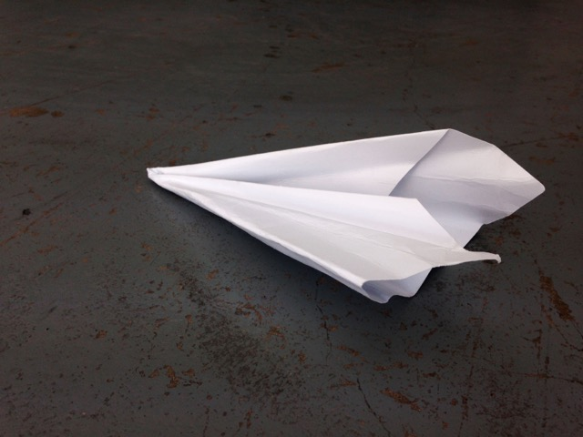

MARION COUTTS

AIMING OR HITTING

10 March – 13 April

Preview Thursday 9 March
6.30 – 8.30pm

T I N T Y P E

107 Essex Road London N1 2SL
info@tintypegallery.com www.tintypegallery.com

Wed – Sat, 12 – 6pm

Image: Paper Plane 305, Marion Coutts, 2017, Archival pigment print

