From Village Protest to Transnational Solidarity
Green Olive Tours Blog http://www.toursinenglish.com/
by Brian Callan 2015
Over the last four years or more I’ve had the privilege to live in Jerusalem, where I studied the world of Palestinian Solidarity Activism. It is, like all the social worlds that people create, rich and complex. But what struck me most is the impressive breadth of nationalities, creeds, genders, generations and political persuasions taking part. For over ten years now people have come from near and far, week-after-week, to join Palestinians in protest and civil disobedience in neighbourhoods in East Jerusalem and villages across the West Bank.
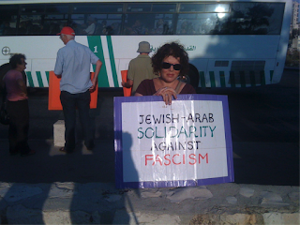
The weekly protest Sheik Jarrah
in East Jerusalem (Photo: Brian Callan)
For millennia Jerusalem has been a crossroads and a destination, where armies triumphed and retreated, merchants gave their toll and kept their piece, migrants and pilgrims came and went and stayed. The city is a repository of the unending cultural accretion of thoughts, tongues, texts, deaths, and lives that touch upon its hills. Social theorists like Arjun Appadurai call such movements of people, things, ideas, money and technology transnationalism, for by and large, national authorities and borders are not really driving, controlling or defining these processes . Nations do of course have power and influence but they do not have total control of what people think, who they meet, or the stories they tell each other.
Today, the Palestinian struggle is one of the most prominent and recognisable issues on the planet. From the people I’ve learnt from in my research, I have no doubt that the dedication to unarmed resistance, of a few hundred Palestinians in no more than a dozen locations, have been integral to the creation of a global community of transnational dissent.
The Western media (though accused by some of being pro-Palestinian and anti-Semitic) has tended to reinforce the idea of Palestinian resistance as being exclusively violent, by focusing on armed resistance, suicide bombings, and rocket attacks. As Greg Philo and Mike Berry point out in Bad News from Israel, Western reporters have also tended to disseminate the premise that Israel only uses violence to defend itself, in retaliation to some form terrorist of attack . This premise completely ignores the historical fact, that violent dispossession and oppression has always produced violent resistance. For six hundred years generation after generation of my fellow Irish men and women took up the sword, the pike, the flintlock musket, gunpowder, grenades and M15 Armalites, in revolt against the imperialism of the ‘English Crown’. But the media focus on Palestinian violence, both in Israel and the West, is more tendentious in that it completely ignores the entire history of Palestinian civil resistance going back to the 1920s, which Mazen Qumsiyeh meticulously details in his book Popular Resistance in Palestine.
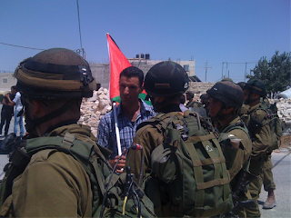
Face-to-face with the military occupation at al Maasara
in the West Bank (Photo: Brian Callan)
Since the turn of the millennium the Palestinian tradition of unarmed resistance has been driven by the Popular Committees, in struggles against the construction of the ‘security barrier’ in villages like Bil’in, Ni’ilin, al Walaja and al Maasara, against dispossession and violent attacks across the Jordan Valley and the South Hebron Hills, or the creeping annexation and ethnic cleansing in Nabi Saleh, Tulkarem, Nablus, Qalqilya and East Jerusalem. Yet, after ten years or more, few of their instrumental aims have been realised. Local movement leaders are constantly harassed and arrested, some have been killed but beyond that Israeli society pays them little heed. Barrier construction continues, settlements expand and the right-wing becomes more emboldened.
When I first arrived in 2011, the effectiveness of Popular Committee protests were being questioned, even from some Palestinian quarters. The Boycott movement (BDS) was a sister tactic seen has having a potential for global impact. But since their inception the local Popular Committees have had a transnational agenda. They have called upon peoples of all creeds, colours and places to witness and experience a decade of repression of peaceful protest. At these protests people normally distant from life under occupation, have the opportunity to see and feel its craziness for themselves. They get to see ordinary people who do extraordinary things to secure the most basic of rights. Away from the protests, on bus tours, coffee shops and private homes, they learn from experienced activists and meet novices who, like themselves, are struggling to grasp the magnitude of the mechanisms of oppression. This can be a daunting task, but time again solidarity activists told me how they had been changed by their visits.
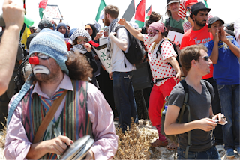
Serious clowning with the people of Susiya
in the South Hebron Hills (Photo: Brian Callan)
The Palestinian tactic of emplacing others within the experience of oppression has galvanised a community of civilians across the globe, which includes young American anarchists, English grandmothers, Japanese computer-techies, Israeli legal experts, Dutch politicians and hundreds and thousands of others . Just how many have come and gone, and been moved to agitate in far-flung corners of the world is difficult to ascertain but the local struggles against dispossession now have a global audience. Who would have imagined ten years ago that 5 Broken Cameras would bring the tiny village of Bel’in to centre stage at the Oscars?
This is the enduring success of solidarity activism, a rich and diverse reservoir of people across the globe, connected to the land and lives of Palestine. They are a resource which BDS and other Palestinian campaigns continue to draw upon. The dedication and bravery of a few hundred Palestinians, in the face of concerted oppression, has been fundamental in the growth of a global phenomenon. Their example is one of the most important lessons that we can drawn upon, in the struggle against oppression everywhere.
__________
Brian Callan has recently been awarded a PhD from Loughborough University in the UK for his thesis, Transnational Dissent. He writes about the ordinary lives of activists and on how Weirdness, Wrongness and Love & Betrayal help shape the dissenting soul.
__________
[1] Appadurai, A. 1996. Modernity at Large. London: UMP

[1] Philo, & Berry. (2004). Bad News from Israel. London: Pluto Press
[1] Qumsiyeh, M. B. (2010). Popular Resistance in Palestine: A History of Hope and Empowerment. London: Pluto Press.

[1] Callan, B. (2014). Something’s wrong here: transnational dissent and the unimagined community. Contemporary Social Science, 9(1), 106–120.

