Francis Gilbert/NATE Magazine/March 2017

Dreaming of a Better World

The thing is, Mr Gilbert thinks I’m good at English because I always keep quiet, and copy off Jasmin, who is good, but I can barely read or write. I just copy. I am very good at copying but there was no one to copy off. I looked at the test, which was to analyse a poem. I could barely read the title, which was ‘Ozymandias’… I felt sick, very sick, and put my head against the desk. There was only one way out…ah, ah! And I flung myself to the floor and started rolling around on it.
Gan, the fictional Year 8 student who gives this monologue in my script Dreaming of a Better World (p. 41), is having a terrible time. As well as struggling with his school he is also being bullied, and has a difficult home life: his father has been executed for protesting at the destruction of his native land, and his mother has brought Gan and his two other siblings over to the UK as asylum seekers. The situation is entirely imagined but based upon the lives of children in similar situations during my 25 years of teaching English in various secondary schools.
Since September 2015, I have been course leader for PGCE English at Goldsmiths and I’m now Head of the MA in Creative Writing and Education (MACWE) as well; a big part of my job now is to consider creative ways of nurturing and teaching reading skills. One thing we like to do on the MACWE is to get practitioners sharing their creative writing with students. So, putting my money where my mouth is, I worked with Deptford Green school to produce a play script for Key Stage 3 set in the local area. It is a “fantasy” script in the sense that Gan is knocked out by Kay, the school bully, and finds that he is now in contact with his late father, who brought Gan and siblings up in a magical forest in his homeland –- the precise area is never specified. His father guides Gan to see things as he did: this is a world where everything has a spirit; the trees, the plants and the birds. Gan is helped by the presiding spirit of Folkestone Gardens (a real park in Deptford) which is situated at the end of Woodpecker Road. The Wise Woodpecker assists Gan in resolving his problems in a dramatic denouement.
I wrote the play because I thought the students at Deptford Green would like the “bullying” narrative, which aims to be exciting, and having the local area name-checked. I also thought that it might help them perceive the area differently and get them thinking about the “presiding spirits” of the place. Collaborating with three wonderful English teachers at DG, Vikki Prescott, Lucy Tollman and Tom Watt, we taught the script by getting Year 8 to read it in groups of six over the space of three weeks in June-July 2016; as a finale, we filmed a very abbreviated, improvised version and a documentary about it which can be found here on YouTube:
The script had a different name then, My Dreams, My World:
https://youtu.be/YDRNRu2Hjxo
https://youtu.be/Lr8bQI597Nw

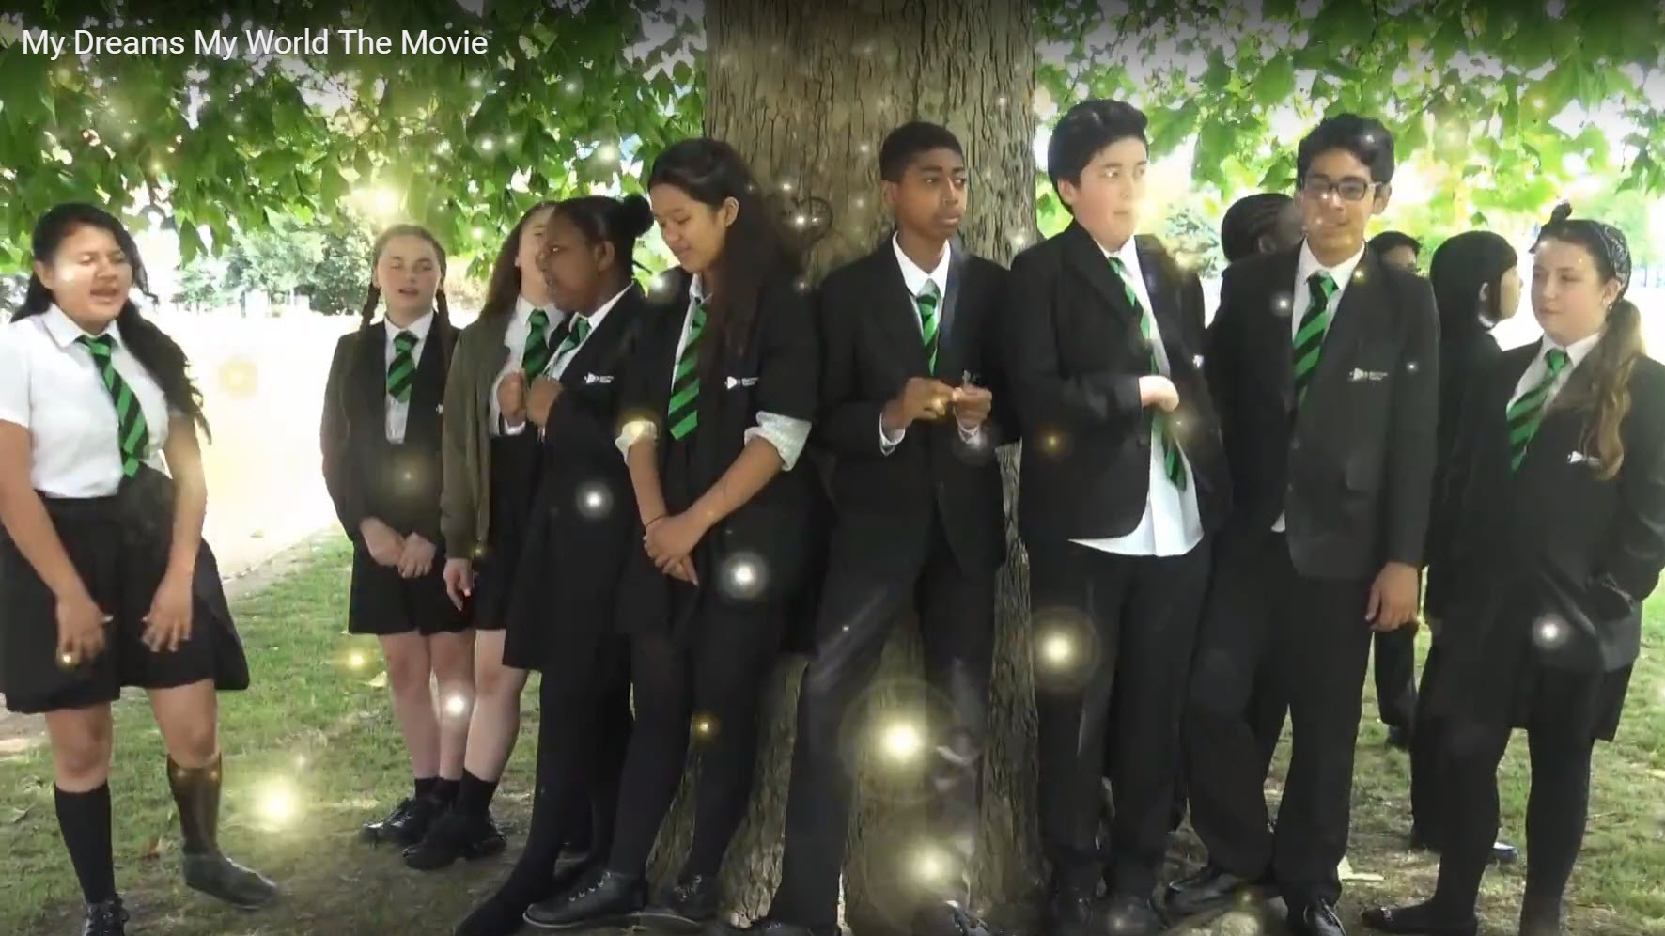
Figure 1 Deptford Green students perform a scene where Gan talks to tree spirits!

Figure 2 Two DG students speak in role in a ‘fake’ documentary as friends of Kay, the person who bullies the protagonist
Feedback from students and teachers was very positive. Many students enjoyed reading in groups, and liked being able to give their different views; the script was full of opportunities for them to air their own views and reflect upon their learning. Some students progressed a great deal with their reading; one student, A., who had been very reluctant at the beginning because of EAL/Speech impairment issues, found working in a small group very liberating, and his confidence was greatly boosted. A year on, his teacher reports the gains made have lasted, and he is now much better than reading than could be expected.
Vikki Prescott has also found that she has become much more confident in teaching reading in groups. This is partly because Vikki appreciated the way the script is “framed” by a “teaching script” where students take on the roles of various teachers and learn to do what is known as Reciprocal Teaching (RT). I’ve written about RT in previous issues of NATE (June 2015/2016) so I won’t explain it in depth here, but the following extract from the script will give you a good idea about how it works. The “teachers” (all played by students as they read in a group) are asked, having read about Gan’s reaction to Ozymandias, to consider how he might productively read the poem in a group.
TEACHER: OK, what we’re going to do now is to use Reciprocal Teaching to read the difficult poem that Gan found so hard to understand.
QUESTIONER: As the Questioner, I would have to ask: What do you think made it so difficult for Gan, do you think?
MOTIVATOR: As the group Motivator, I would guess it was partly linked to his motivation to read it; he looked at the title and some of the words like “antique” “trunkless” “visage” etc. and thought there was no way he could read the poem, and his motivation just left him. He gave up.
ASSESSOR: That’s very interesting. As the Assessor, I would have to agree with you. I was assessing his body language and he slumped when he looked at the poem.
UNDERSTANDER: So, OK guys, how is he going to understand this poem though?
SUMMARIZER: Do you think he should look up the difficult words FIRST of all?
TEACHER: He could do that. That’s one strategy, which we could do because we’re not in a test, but what do you do if you’ve got no dictionary/Google?
MOTIVATOR: Not give up! He’s needs to tell himself: ‘This is interesting work, Gan. You can solve it!’
QUESTIONER: How will that help him understand better?
ASSESSOR: It might give him the confidence to work out WHAT HE DOES KNOW! He needs to honestly ASSESS his true knowledge because I bet with a bit HARD thinking, he can work out bits of the poem.
UNDERSTANDER: Yes, let’s look at the poem again and highlight what we DO know.
SUMMARIZER: And make some notes around the poem.
TEACHER: OK, let’s take it line by line, and work it out together.
MOTIVATOR: Togetherness, man! This is about being resilient learners!
TEACHER: OK, team, let’s go for it!
UNDERSTANDER: Right, the title — what does it mean?
But why write a script like this, which “frames” the real “fictional” script? Surely a “real” teacher can tell students how to do Reciprocal Teaching and you don’t need a script for it? A combination of factors led to me to write the script. Working with my own classes, with Rodillian Academy (see June 2016), and delving into the research (Oczkus, 2010:Palincsar and Brown, 1984) made me realise that while many English teachers are keen to adopt the strategy and are persuaded of its value, they don’t feel confident teaching it without an “expert” there to guide them. The central problem is that to get Reciprocal Teaching “off the ground”, it needs to be “modelled” by the teacher to small groups so that students can then start “doing it for themselves”. Based as it is on the theory of Lev Vygotsky (Vygotsky and Cole, 1978), the modelling is a vital stage; there needs to be an expert modelling the approach before students can confidently begin reading in groups.
In my experience, either English teachers don’t feel that confident modelling the strategy themselves or they have big classes and feel that they can’t work intensively with small groups over a series of lessons.
Feedback on Dreaming of a Better World indicates that I was partially successful at modelling Reciprocal Teaching within the script, but there is still work to be done. To that end, Vikki and I have another go at writing an entirely new script. This time we’ve worked with the National Maritime Museum, Deptford Green and creative writers at Goldsmiths; much of the fictional script is set in the National Maritime Museum and the aim is for Year 8 DG students to read the script in June-July of this year, and then do some performances in the NMM in July as a finale. We’ve now written a draft which is entitled The Time Devil; it’s a sort of Nights at the Museum/‘Dr Who’ fantasy with plenty of violence and real historical events featured. It’s quite mad, but we’re pleased with it; I think it better models Reciprocal Teaching, and the script itself is stronger than DOABW.
At our NATE conference workshop, Vikki Prescott and I will be discussing the project and how Reciprocal Teaching can improve results in our workshop which is entitled ‘The Joy of GCSE’.

N.B.
You can read a full transcript of the Reciprocal Teaching script where students discuss Ozymandias here: https://creativewritingandeducation.wordpress.com/2017/04/03/improving-students-reading-using-reciprocal-teaching/

References
Dreaming of a Better World: A Collaborative Reading Script for Key Stage 3 English: Volume 1 (Teaching Scripts): Amazon.co.uk: Dr Francis Gilbert: 9781541318267:
Oczkus, L.D., 2010. Reciprocal teaching at work: powerful strategies and lessons for improving reading comprehension, 2nd ed. ed. International Reading Association, Newark, Del.
Palincsar, A.S., Brown, A.L., 1984. Reciprocal Teaching of Comprehension-Fostering and Comprehension-Monitoring Activities. Cogn. Instr. 1, 117–175.
Vygotsky, L.S., Cole, M., 1978. Mind in Society. Harvard University Press.

