Smokescreens to Smokestacks: True Detective and the American Sublime

In Nick Pizzolatto’s True Detective Series 1 and 2, a seemingly bleak and relentless view of the American South and Southern California, appears to lend itself to a post-modern reading of the detective genre. After all, if the nihilistic oft quoted commentary by the detective Rustin Cohle in Series 1 and the gangster Frank Semyon in Series 2 is anything to go by, Pizzolatti’s dialogue is primarily marked by an incredulity towards master-narratives; a firm belief that behind the façade of American democracy lies a series of conspiratorial and often violent attempts to abuse the American people. However, the fact that the series consistently references not only on the disenfranchised inhabitants of Mississippi and the immigrant workers of Southern California, but the American landscape itself indicates that something more fundamental is a foot. It is, in fact, within the representation of the natural landscape in both Series 1 and 2 of True Detective, and its references to geo-politics, the abuse of natural resources and an attendant pollution consistently marked as both psychological and ecological that a series of morality tales are struggling to emerge. These ‘morality tales’ are not only configured along the lines of various classical narrative models, in Series 1 primarily Gothic terms, and in Series 2 in terms of Greek tragedy, they are highly modernist models of interrogation; interrogations into the figure of the detective as an emblem for modern alienation and its often tragic resolution.
To read both series in the context of such models enables some understanding of why Series 1 was universally acclaimed while Series 2 was seen as a failure in comparative terms. While the near universal acclaim of Series 1 seemed to rely on the empathy created for the two main protagonists: detective Rustin Cohle and Martin Hart, and the audiences’ desire for them to retain their position as “true detectives” uncompromised by the corruption surrounding them, Series 2 was critiqued as being too bleak, too dark to accommodate such desire. While both Series figured protagonists embittered and banished from the domestic sphere to varying degrees, the plots nonetheless capitalised on their potential re-incorporation into some semblance of family life. Similarly, Series 1’s willingness to provide a redemptive ending relying less on the capture of the murderer and more on the epiphany of the main characters, seemed to provide a narrative where the internal psychology of the protagonists – rather than the solving of the crime - took precedence. Paradoxically, much of the criticism of Series 2 seemed equally to rest on the show’s unwillingness to render a satisfactory narrative resolution to the crimes committed. However, in this instance, the muddled nature of the plot was augmented by the complex interior psychology of the characters rather than redeemed by it. Configured in much more overt terms as a tragedy in the classical sense, Series 2 failed to create the necessary catharsis for the tragic elements to cohere.
Such readings, nonetheless, take as their starting point the use of characterisation and dialogue; leaving the question of what importance – if any –the highly stylised use of landscape has in the respective series. A major question thus remains unanswered: what is the purpose of the much-commented on opening credits, which at 1 minute and 38 seconds act more like introductory segments? And to what extent do they influence the ways in which the subsequent narratives operate? It is possible, that the use of landscapes in these sequences not only enables the subsequent settings to function as stages for the ‘morality’ play, they allow for a reading of the series in a social and political context that places them in a longer lineage of modernist work rather than ‘outside’ it. It is no coincidence that the two intro segments rely heavily on the work of two American landscape photographers: Richard Misrach and David Maisel, two artists who have been instrumental in reinvigorating the epic qualities of American landscape photography towards the sublime. Rather than see the palimpsest of photography and characters that characterise the intros as referential in a post-modern sense, the alignment between landscape and human form is in effect a highly political gesture. It takes the sublime nature of the post industrial landscape of True Detective as a way into modernism’s use of detective fiction as a way to critique the status quo, rather than a way out. If nothing else, True Detective takes its title seriously in this respect, by positing that there are ‘false’ and ‘true’ investigations, good and evil, and that the detective genre is a genuinely modernist model for the investigation of both.
Of course True Detective can be seen as one of many contemporary television series capitalising on the audience’s knowledge of genre conventions and their desire to have these conventions re-fashioned. Nonetheless, the use of discernibly regional landscapes, moving away from the urban detective and the mean streets of New Orleans and L.A., allows True Detective to use the tropes and conventions of film noir and to do so within a landscape both hyper real and sublime. Or as ? writes regarding the aesthetics of Robert Misrach:
Insert quote
This sense of the sublime, whilst part of a longer tradition of American landscape painting, is primarily rendered here through the cinematography; a cinematography reliant on the presence of the industrial and/or toxic sublime. It is the consistent referencing to the presence of toxicity and pollution within an otherwise placid landscape that brings the focus on the alienation and discomfort of the principal characters into place. If the characters are systematically marked by their environment, past and present, the crime drama similarly becomes tangibly marked by the effects of geo-political damage, and as such, part of a wider modernist critique of the effects of American capitalism.
This rather blatant and even at times overtly hostile rendering of the South in Series 1 nonetheless fell under the radar of most reviews of the series. Largely because of the strange murmurings towards the fantastical and the gothic, both Series 1 and 2 of True Detective was seen in populist terms as another post-modern version of noir, rather than something seeking to insert itself into a longer lineage of modernist detective fiction. However, in True Detective, the modernist credentials of the detective are enabled by their place in the landscape and the persistence of the sublime as a metaphor for the detective’s attraction to and horror of that landscape is paramount. If the sublime in the work of Misrach and Maisel is emblematic of the rampant often violent capitalism that the detectives labour under, it is also a sign of our continued attraction to the American landscape as a transformed and transformative place. Both series, are as such characterised by the struggle between aesthetics – rendered most visible in the depiction of landscape – and ethics – rendered primarily through the moral choices of the main characters. Likewise, both narratives work effectively along the lines of modernist dystopias; focusing not on the ultimate triumph of humanity and government, but presenting instead a society marked by the suffering caused by human and political evils, an evil which in this case is visualized as a form of sexual and geo-political abuse.
Nic Pizzolatti, credited as the chief writer and creator of the series, has been open about his methodology. Less intent on the persuasive nature of the solving of the crime or crimes in each instance, he is more concerned with how we correlate the existential and theological questions inherent in modern literature to narrative myths that both indicate and range beyond national specificity. A paradox is thus at play in True Detective in which the specificity of the landscapes, unmistakably American and regional, are nonetheless staging grounds for a series of sublime moments that are meant to take on more universal implications. According to David Nye in The American Technological Sublime: ‘The human relation to this new nature is not, as Barthes suggests, that of beauty or romance, it is that of power. … providing a spectacular perch from which to contemplate the manufactured world as a total environment. As though one were above or outside it.’ (insert ref)
True Detective consistently duplicates this sense of “being above or outside” the “manufactured world”, replete with aerial shots that punctuate the individual scenes it provides birds’ eye views of the landscapes traversed by the detectives, one the most noticeable tropes of the series. If the ground inhabited by detectives and criminals is usually configured as a maze of dead ends in most film noir – this vision of the sublime casts an ambiguous look at an industrial landscape made abstract and overpowering. In Series 2 the final shoot-out between detective Ray Velcoro and the corrupt law-enforcement takes place in a landscape directly in opposition to the industrialized suburbs of L.A. – a verdant nearly primordial forest of evergreens – just as the death of the gangster Frank Semyon take place in a desert devoid of any human markers. As Semyon Christ-like wanders towards his death and possible redemption, the landscape becomes nothing more than a flat canvas seen from above, the complete antithesis to the urban sprawl that he has hitherto sought to rule over.
In this respect, True Detective shares more with the politics of such neo-noirs as China Town (Roman Polanski (1974)) and John Boorman’s Point Blank (1967) than it does with television detective dramas.
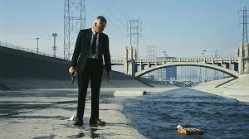

As in Boorman’s Point Blank, the existentialist alienation of the detective is created primarily through the atmosphere of the locations. The reception of Series 2 and the criticism levelled at the incomprehensible plot assumed that the stories of the four main protagonists would be resolved in a way that gave them some agency, even if posthumously. However, the fact that the culprits are left unpunished seems to be almost pre-ordained, foretold by the inevitability of the economic expansion that sets the various crimes in motion. As the settings themselves become more and more expansive, as the built environment, transport routes, etc. take over the entire region, the environment also becomes more and more alienating, spiralling outwards rather than inwards to shelter the detective. In this way territory rather than something primarily contested, as for instance in The Western, instead seems to disappear as it evaporates into shots of endless freeways and unfettered horizons. In visual terms Series 1 uses the light and glare of the American South to indicate that the detectives are blinded by their own internal malaise, as much as by the environment under investigation. When Hart and Cohle finally encounter the murderer it is in jungle like place inhospitable to human habitation.
If things are hiding in plain sight in Series 1 in Series 2 darkness and artificial lighting take over as places become subsumed in a vast suburban conspiracy. Scenes in nightclubs and darkened bars are juxtaposed with the pulsating lights of cars and buildings but even the freeways seem perpetually to be wearing off into darkness. It is no coincidence that both series incorporate the figure of a returning soldier or veteran in order to reference an ideology whose effects are tantamount to a form of post-traumatic-stress disorder. In Series 2 the detective Woodrugh is rendered maniacally depressed in part due to his suppressed homosexuality, as well as to his past involvement in Iraqi war-crimes. The sound scape also adds to the oblique, but fairly consistent, referencing a a post Vietnam and post Iraq environment. The hum of choppers can be heard in the distance as the detectives move in on the lair of the culprit in the last episode of Series 1 just as the greenery of the jungle constitutes a return to a form of heart of darkness. If evil is endemic to the American landscape, it is intimated that it is because of the history of colonisation that has taken place there. As the ‘Yellow King’/serial killer reminds Cohle, he too belongs in the inner sanctum as a direct product of the environment into which he was born. Similarly, it is no coincidence that a temple like structure is where the final confrontation takes place, a temple replete with obscure writing and signs, totems and sacrificial offerings. While the piles of clothes that the detectives encounter as they move towards the interior of the structure are reminiscent of Nazi gas-chambers, the fact that the site is an abandoned underground cathedral seems a fitting reminder of the connection between religion and ideology, and in this context, abuse and sacrifice.
The uncanny similarity of Rustin Cohle in this last episode, as he undergoes a near death experience and a moment of religious epiphany, to that of Christ on the cross adds to this connection. As his partner carries him out of the hospital the iconography is unmistakeable:

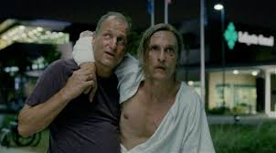

Telling Rustin that “it occurs to me that you are un-killable” Cohle’s return from the dead allows the series to end with his sermon and the realisation that “there’s only one story, the oldest”. For Cohle, as he says in episode 2 ‘vision is meaning’, thus establishing himself as the antidote to his partner’s pragmatism and sense of societal complacency.
The politics of violence in True Detective is in this sense, not only incorporated into the various ways that the detectives navigate the landscape, it is entirely governed by it. To the extent that the lack of borders and or any discernible gravitational pull is incorporated directly into the aerial perspective of the cinematography it is worth returning to Misrach and Maisel’s photographs. It is through their perspectives that the detectives’ lack of necessary moral and physical grounding is rendered, particularly in Series 2 where the mumblings of the detectives become a form of short-hand for general misunderstanding rather than the longer monologues of the detectives in Series 1.
In the photographs of Robert Misrach and David Maisel, landscapes are rendered as polluted spheres indicative not only of the relation of violence to community but of how this may become a staging area for spectacles of violence as well. In Series 1 Misrach’s grey tonal shots of the Mississippi Delta shows us the state’s consumerism of natural resources as simultaneously horrifying and sublime.
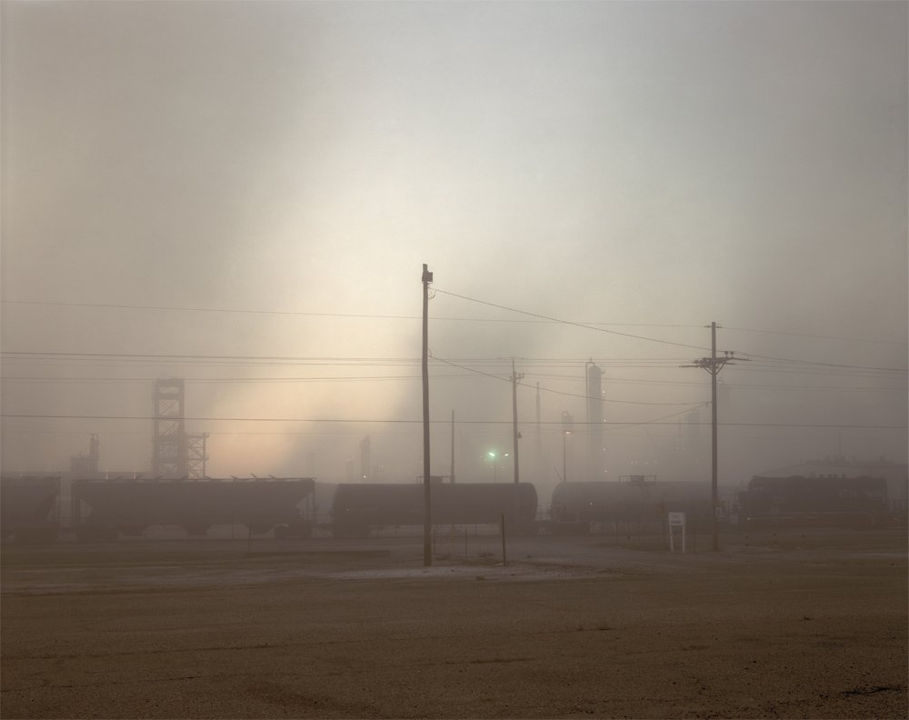
© Richard Misrach, courtesy of Pace/MacGill Gallery, New York; Fraenkel Gallery, San Francisco; and Marc Selwyn Gallery, Los Angeles; from Petrochemical America.

While Misrach’s images are directly superimposed into the opening credits, the sense of something palpably hyper-real and simultaneously fantastic – as in the photographs – operates throughout the series at various levels. On one hand, the fantastical elements are in keeping with the more dystopian elements of science fiction, but it also renders a nearly palpable tactile sense of elemental change. Throughout Series 1, the Christ like figure of Rustin Cohle suffers from psychedelic flashbacks, his eye is continuously drawn upwards in a gesture both reminiscent of pietas – the ultimate gesture of devotion – and of Misrach’s camera eye swooping upwards into a polluted and yet sublime sky. Stars and their constellations reappear as a parable of faith in the last episode where the permanence of the constellations becomes a marker for both human insignificance and the possibility of grace.
In this respect, it seems significant that Series 1 and 2 end in locations where the upward glance of their protagonist (in the last episode of Series 2 Ray Velcoro looks upwards in a gesture of supplication at the sky seconds before he is shot in the forest) indicates an alignment between camera and the point of view of someone on the verge of death. It marks both Series as operating within a territory where the fear or even fantasy of extinction seems palpable, both on a human level but also in a more geo-political sense. In both Series the extinction of communities, displaced people, migrant workers, the trafficking in children and prostitution etc. are all significant subplots. On a psychopathological level this is played out in the fascination with sacrificial behaviour, a return to primitive notions of bartering and exchange and a fetishization of signs and emblems that seem to render something beyond linguistic comprehension.
To a certain extent, the reliance on a variety of Gothic tropes in Series 1 could be seen as a way to counter the inherent risk of the sublime simply aestheticizing the landscape overall. The fact that the quotidian and everyday aspects of the south quickly give way to an undercurrent of violence, incest and grotesque behaviour, draws us away from the potential beauty of the Mississippi Delta, just as the looming presence of the power plants in Misrach’s photographs inflects the natural surroundings. The home of the ‘Yellow King’ – the murderer - is predictably rendered as a stereotypical repository of every cliché regarding the southern gothic, replete with wimpering dogs, collections of broken dolls, and a serial killer quoting classical literature while engaging in incest.
In this sense, it seems crucial that the killer’s hidden home is away from the wide expanse of Misrach’s endless horizons, the decrepit pre-war state of the killer’s lair is the antithesis of the corporate structures that now embody both the police station and the corrupt reverend’s church organisation. This, then, seems a necessary pre-requisite for Rustin Cohle’s epiphanous near death experience. Capitalism – rather than seen through the alienating shots of super structures and power-plants in Misrach’s photographs, is here mired in ancient ritual, a series of exchanges through acts of violence and child sacrifice that are meant to mimic the expenditure of natural resources on a human scale.
Thus, while the two Series dramatize different versions of primitivism, one barbaric and pre-industrial, the other corporate and distinctly multinational, they share an interest in rendering a sense of corporeal transcendence as that which encroaches on the psyche and landscape of the detectives. The first episode of Series 2 entitled ‘The Western Book of the Dead’, not only foretells the immanent dissolution of the characters it establishes it in a long line of failed attempts at civilizing the west. In the office of the gangster/night club owner Semyon, an image of a Roman style mosaic of a mythical serpent wrestling with a crocodile is repeatedly shown, a reference to the hostile take over by outsider gangsters into Semyon’s downward spiraling empire. Such heavy handed signifiers aside, other more subtle visual markers hint at the discrepancy between Simion’s crass business ways and his desire to be part of a progressive, enlightened form of capital venture. His house, both the interiors and the manicured external grounds is a paradigm of modernist architecture, the floor to ceiling glass partitions and doors a sign of his wish to for transparency.
As Michael Szarley points out, Semyon’s anxieties are mired in the relation and oftentimes discrepancy between broadly defined cultural values and economic value: ‘ “Exclusively Industrial,” reads the seal of Vernon, California, the township upon which the second season of True Detective’s Vinci is based; but in the drama, the motto changes to “Towards Tomorrow.”’ If, as Szalay also points out, ‘the series offers repeated images of polluted liquids in storm drains streaming into poisoned fields no longer usable for agricultural production,’ it is not to render the landscape barren but rather about to be transformed into something distinctly post-industrial, namely shopping malls and free-ways. …
‘In the first season of True Detective, the camera frequently surveys landscapes ruined by the petrochemical industry. Meanwhile, Rust Cohle’s first name gestures to the rusting steel that might be considered, with the coal implied in his second, atavistic remnants within the ostensibly post- industrial. What do these remnants say about Cohle’s relation to liquidity? (24) Szalay’s reading is based on a wider analysis of HBO Television as emblematic in a variety of ways of the network’s attempts at colonizing media outlets and viewing numbers. Nonetheless, by examining the use of a distinctly economic discourse in the series, Szalay rightly points out that ‘ontological authority remains banished to the margins of the world, present only in murderous form.’ In so far as this works for Szalay’s argument regarding HBO’s failure to regain its authority in economic terms, Szalay’s reading does not, or cannot, take into account the religious impulse that draws the series back into a more modernist fold. In Szalay’s defense, the very issue of transcendence is flawed in True Detective 2, precisely because it refuses to offer the religious imperative as a way out, thus undermining the possibility of redemption – be it physical or spiritual – for the narrative overall. This poses an interesting question in relation to Series 1’s relationship to Series 2 in particular; if Series 1 posits the backwards regionalism of a traumatized south as the landscape of redemption, is the industrialized urban sprawl of Series 2 as marked by Maisel’s aerial shots simply too marked by the sublime? Has earth at a distance simply become too beautiful to be critical in any political sense?
If we return to the opening credits of True Detective’s first season where human forms containing landscapes: factories, truck stops, highway overpasses, deserted play- grounds, and ruined towns are depicted in ondulating shapes and sizes, the human shapes are in Series 2 are more abstract, Maisel’s oversaturated colors bleeding in and out of the forms that render them distinctly organic. In this sense, they are open to the same critique that Max Kozloff articulated in his piece on American Landscape photography in relation to Misrach:
“Everything that appears in his work is perceived as if from an indefinite mental space of our own. Yet in the end, … the spectacle … visualized in the melted colors of a kind of pastoral sublime, overwhelms our understanding of its evil. This work is too deliberately ingratiating to be critical, …” (Kozloff, p.123)
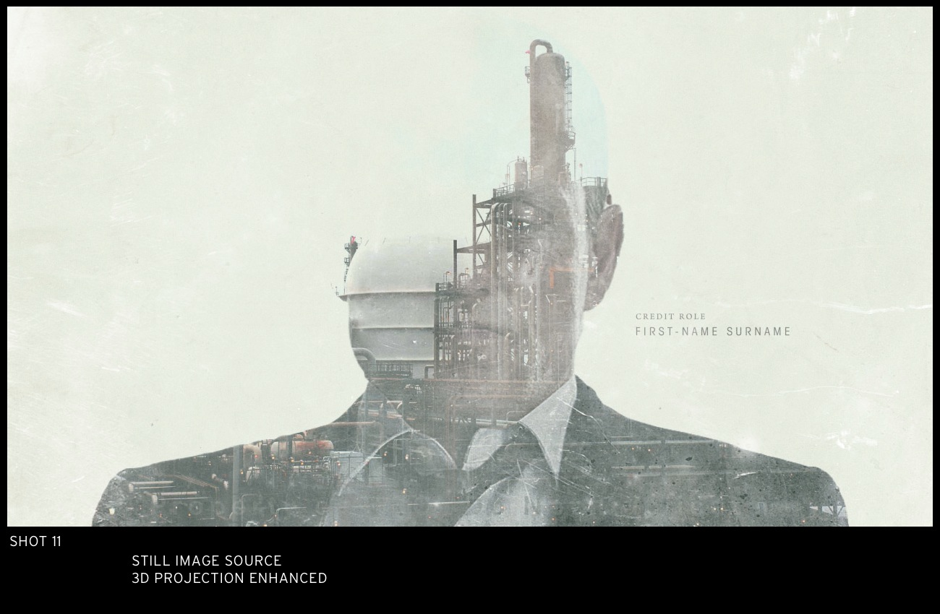

While Kozloff is keen to render the dangers in aesthetic terms as well as political aptitude of the new landscape photography, Pizzolatto’s interest in both Misrach and Maisel is precisely because of their ability to render “a kind of pastoral sublime that overwhelms our understanding of its evil.”
According to Pizzolatto, ‘If landscape is a character for me, … then it helps if I'm familiar with it and I already have a take on it … the aim is to try to capture a certain psychosphere ambiance of the place much like we did in season one.”
These statements, from a longer Vanity Fair Interview (insert date) have Pizzolatto comparing the material from his first foray into detective fiction in his novel Galveston (2010), with the vision of True Detective:
“The descriptions in Galveston are what we filmed in True Detective … “That’s one of the reasons I consider the works so connected. The [characters] inhabit a poisoned dystopia. It’s literally toxic…. These stories take place in areas where the revelation has already happened. The apocalypse has come and gone, and no one’s quite woken up to that fact.”

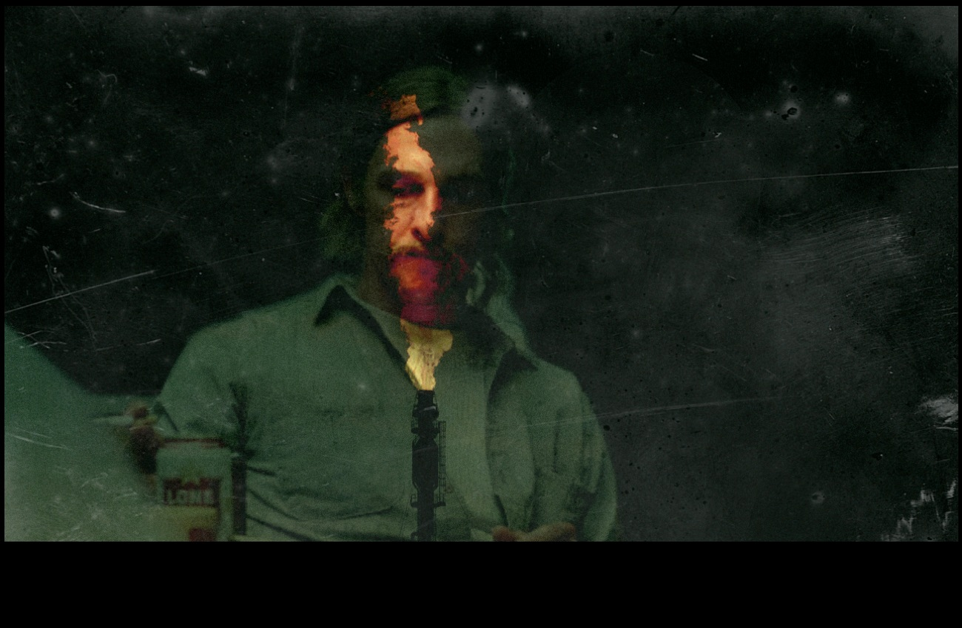

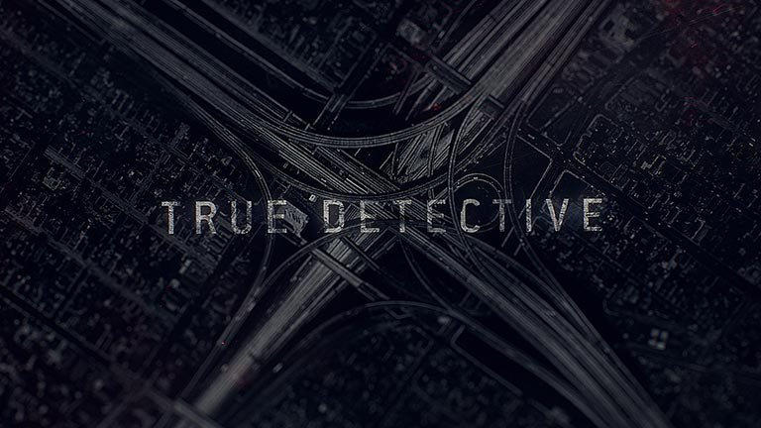

It is no coincidence that the images that proliferate in both Series tend to center around hubs, transport intersections, and points of exchange. As in the use of one of Maisel’s most iconic photographs, from the series Oblivion (2004), the nearly abstract cross formed through the knot of free-ways visually creates a center where there is none, to – as Pizzolatto puts it – render a revelation in figurative terms where one might least expect it. Like Misrach’s use of open vistas and seemingly limitless horizons in Series 1, Maisel’s L.A. and environment resists visualization precisely because of the endless nature of the freeway system with its the vast nodes of intersections. As Alan Rapp puts it in ‘Cities of Forgetting’, this is ‘the ultimate typology of nonplace’. (Black Maps, 130) Using a high speed black and white film to impart graininess, Maisal used the negatives themselves to make the images, thus adding the sense that the ‘images are not just turned inside out so much as photographs, interrupted….’ (Rapp, 131). Thus the process for the Oblivion images bears certain similarities to the process by which the title-sequences themselves were constructed, through a slowing down of the editing process, a use of extreme slow-motion to give the viewer, as the director put it, of being inside the photographs.
Of course using topographic photography as a way to intimate what is buried and hidden in American history has in and of itself a long history – both in terms of cartography and as a way to colonize the West. What the use of these photographs indicate is perhaps Pizzolatto’s desire to obliterate the division between a ‘sacred’ and ‘profane’ landscape, nature is not automatically idyllic and nor is the man made environment necessarily inhospitable. What he does want is to create a scenery in which the co-existence between blind faith and abject superstition is still palpable.
Maisel himself intuits in interviews that the main aim of the director was to blur the distinction between different spheres, different landscapes: “What was interesting to see is that some of the images are used upside down, others have things bleeding through them. That was great, because I want my work to have a kind of metaphorical quality and Elastic (the title production company) was responding to that. … The original impetus for the work was informed by looking really closely at 19th-century exploratory photography.” Maisel’s awareness of the iconic potential of a post-industrial American landscape is clearly in evidence and more importantly, he sees the potential of such landscapes as residing in their ability to render something intrinsic about Americans as a people: “I think that these kind of sites correspond to something within our own psyches. … maybe these are all self-portraits. There’s something — we collectively as a society have made these places, that’s my take on it. And so, they really do reflect us. And so, it’s not ‘them’ making these places, it’s us.”
Interview for Time March 27th 2013
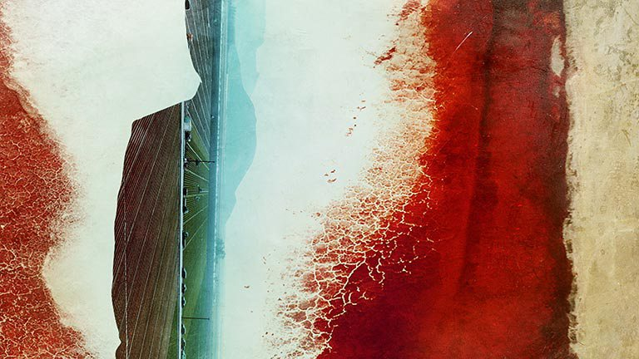

In interview, the director of the title sequence Patrick Clair also accentuated the use of the photographs as a way to superimpose the landscape onto the psyche of the characters in a quite literal fashion:
‘One way that I like to do it is to just be really super-literal. So when I was first on the phone with Nic for season one, he said, "What we’re trying to do is to use the landscape of Louisiana, the way that it’s poisoned, the way that it’s broken, the way that it’s polluted, to show how these people are poisoned and broken and polluted." So I kind of interpreted that in this really straightforward way. I was like, "Oh, why don’t we make portraits out of broken landscapes?" And they can be broken portraits with poisoned landscapes.’
The idea of creating “broken portraits” within “poisoned landscapes” seems once again to bring the Series back to a redemptive angle, even if Pizzolatto stays clear of bringing in any overtly religious references in interviews. According to Pizzolatto: ‘I write best about people whose souls are on the line. Whatever we mean when we use that word. I certainly don’t use it in a religious sense. But the essence of who you are—that’s on the line. At its simplest level, everything I’ve ever written about, including this and Season One, is about love. We transpose meaning onto a possibly meaningless universe because meaning is personal. And that question of meaning or meaninglessness really becomes a question of: What do you love? Nothing? Then you’ve got a good shot at a meaningless existence. But if you love something—how do you love within the necessities of life and the roles you have to play? I can see that that’s been one of the defining questions of my adult life and work: How do you love adequately?” (ref?)

If Season 1 worked because audiences were swayed by Cohle and Hart as characters worth redeeming Season 2 struggled to create 4 characters for whom the same would be true. Pizzolatto told a reporter that the coming season would be about “hard women, bad men, and the secret occult history of the United States transportation system” but more tellingly, that it would be a detective story in the manner of Oedipus Rex, outlining an essentially modernist model in which “the detective is searching and searching and searching, and the culprit is him. …That’s why detectives are great engines for stories. They go everywhere. A detective story is really just the way you tell a narrative—you start with the ending. At the end, this person is dead. Now I’m going to go back and piece together the story that led to it…. It’s about the final un-knowability of any investigation.” Ref?
This sense of “un-knowability” is present from the beginning of Season 2. While the exteriors are mostly viewed from above, interiors give the appearance of being shared spaces even though both Semyon’s hyper modern home and his nightclub are more reminiscent of panopticons of surveillance and the enforcement of power. The retreat/treatment home in Season 2 is aptly called the Panticapaeum Institute (after a Greek City along the Crimea destroyed by the Huns), another oblique reference to L.A. as a city on the brink of extinction, accentuated by the Latin inscription at the retreat: "irae autem tacere, in die novissimo," loosely translated as “wrath and then silence on judgment day”.
By calling episode 1 in Season 2 the Western book of the dead the reference to the Egyptian version of the book of the dead constitutes a not so subtle reminder that we are already in territory occupied by the living dead. Like Cohle in series 1, Semyon and Velcoro’s survival seems more a matter of supernatural fate than actual probability, Semyon’s memory of being incarcerated in the cellar as a child because of his father’s alcoholism a cipher for a much more endemic sense of entombment.
If these rather heavy handed markers for hubris and tragedy figure from the beginning in the plot of Season 2, it is nonetheless the settings and landscapes that once again direct the events. The very first shot is tellingly not of the customary “scene of the crime” but of the actual crime at the heart of the narrative, namely the deliberate polluting of the ground water in areas ear-marked for development. As the camera pans across the sticks that mark the sites of pollution the overall look is more akin to the graves of the unknown soldiers, a tacit alignment as in Season 1 between geo political misuse, ecological contamination and human sacrifice. As in Season 1, the paternal and patriarchy is here from the beginning questionable, flawed and violent. At multiple levels the issue of paternity becomes – as is often the case in tragedy – the sword that balances precariously over the heads of all the characters both male and female. Conveniently, Maisel’s use of heavy reds, bleeding in organic shapes and droplets forewarns us of the bloodshed to come, in the same way that the industrial sublime renders the city abstract through a variety of grids and lights – not unlike the motherboard of a computerized landscape. As Frank Semyon confesses to his associates, the only ‘true’ history is the one ‘paid for,’ the only true history of California is in other words one of money rather than biological lineage.
The alienation of the characters in Season 2 is problematic in this respect because it prevents rather than facilitates the shared intimacies of the main protagonists in Season 1. Instead, the lives in Season 2 are rendered isolate, nearly more alien than the actual illegal alien workers that detectives are meant to occasionally police. As Bezzerides looks at online pornography sites for clues, and Paul Woodrugh out of his balcony at the gay revelers below, we know that displacement governs the gaze of the characters. They are as blind to their own frailties as we are to the details of toxic contamination in Maisel’s spectacular landscapes.
The first Season’s popularity prompted an endless series of questions regarding the oblique references throughout to novels, philosophy, and other sources. Pizzolatto’s use of the legend of Carcosa, a mythical city first chronicled by Ambrose Bierce, seemed a particularly apt metaphor for the Gothic elements of the series, as did the horror writer Thomas Ligotti’s The Conspiracy Against the Human Race. Nonetheless, when asked about his influences, Pizzolatto returned again to the issue of geography: ‘I tend to be influenced by places as much as anything … You look around and notice details and it starts to form a world and then you find characters to inhabit this world.’ (ref?) Vanity Fair Interview

Conclusion

While this chapter has sought to argue that the two existing series of True Detective both rely on the representation of landscape to present a sublime yet horrifying vision of post-industrial America, they nonetheless engage in two fundamentally different literary tropes in order to do so.
To a large extent, the success of Season 1 relied on to what extent the somewhat over the top redemptive resurrection of Cohle tempered the ramifications of the more gothic elements of the narrative. Whether we see this as a necessary but unpersuasive attempt to present the overwhelming nihilism of the narrative as more palatable or whether one sees it as Pizzolatto’s desire to posit survival and continuance as at the heart of the American dream, is – in this respect – inconsequential. More tellingly in terms of modernist tropes, is Pizzolatto’s statement that once you’ve formed a world ‘you find characters to inhibit this world’, a reminder of how much the narrative trajectory of the characters relies on the environment they occupy. With this in mind, the success of Season 1 can be credited – in simple terms – with our existing familiarity with the South that the characters inhabit. We are by now used to a wide array of Southern Gothic narratives and the regional stereotype of the murderous inbred back water inhabitant, revivalist con artists etc. allows for a landscape that may be unsettling but not so unsettling as to not allow for some sort of redemptive ending. When asked, following the success of Season 1, whether he contemplated killing off his two main protagonists, Pizzolatto responded: ‘It was something I considered, but the trajectory of their arcs and where the journey took them was much more interesting to me with them left alive and altered in some way. … The only other ending I considered, but [it] was never put on the page, was something more mysterious, where you're not sure what happened to them. In the end, I felt that was too diffuse and moved us away from the hard realism of the show. The macabre aspects of it are grounded in a reality, this kind of poisoned dystopia.’
Interview in Vanity Fair
The continuing fascination with a “poisoned dystopia” is clearly in evidence in Season 2, which might be all the more reason to applaud Pizzolatto for refusing rather than duplicating Season 1’s redemptive ending. After all, Season 2 presents an overwhelmingly bleak vision of a society in which the burnt out eyes of the city manager becomes just one of many metaphors for a blind refusal to face what is already a devastated civilization. As a Greek version of the tragic, one in which the involuntary and voluntary sins of the main protagonists causes their downfall the fact that the female detective Bezzerides (at various points also called by her other names, Antigone and Athena) is the only one left alive to testify, adds to the tragic trajectory. By casting the female detective as the surviving witness, True detective 2 moves relentlessly towards an attempted cathartic ending where the sacrificial deaths of the two male detectives are underscored by the female detective’s role.
If the decent into the heart of darkness is configured in highly militaristic and religious terms in Season 1 as Cohle and Hart, like paramilitaries, enter the sacrificial site, the “poisoned dystopia” of the South, in Season 2, Bezzerides entry into the underworld in the brothel episode clearly indicates an unavoidable collapse between bodies as commodities, commodities as transactions, and in the end all economic transactions as corruptive. Maisel’s photographs, despite their ephemeral qualities, are the perfect backdrops for such transactional narratives. In interviews Maisel speaks of how he is fascinated visually with ‘the unfolding of secret synchronicities’ when he views landscapes from above. In this context, the similarities between the attempted high speed California central rail corridor is not so very different from the soon to be defunct Mississippi oil corridor, because they both share an overwhelming fascination with the sublime qualities of a landscape irreversibly altered.
The 2007 collection from which the photographs for True Detective 2 were taken, Black Maps – American Landscape and the Apocalyptic Sublime, shows the spread of infrastructures much like a contagion, a virus like thing that will unalterably change the American landscape. In both Seasons, the use of the landscape, one sparsely populated and polluted to the extent that is rendered post-apocalyptic and barren, the other a motherboard of twinkling lights but devoid of genuine social interaction, forms a transitory space for the respective redemption/tragedy to unfold. Nearly all action scenes are punctuated by shots of wide expanses in Season 1 just as nearly all scenes in Season 2 are punctuated by aerial shots of Southern California at night. If in Season 2, the proliferation of characters and their problems made the viewers’ need to empathize too difficult, it may have been because the characters were so conspicuously placed in a vast landscape of corruption and defilement. Nonetheless, this also allowed a very specific form of the sublime to operate. The shots of expansive vistas, the Pacific, the winding freeways, all render a tantalizing bridge between a modernist desire for illumination, for being taken away and for the realization to occur that this is no longer possible.
The fact that the proper boundaries between things become increasingly blurred, both visually and through a re-colonization of the American landscape for financial reasons, does not automatically make True Detective a post-modern rather than modern opus. If Pizzolatto’s problems in Season 2 were caused by an inability to tie the various characters’ problems to one overriding sensibility, this might paradoxically render the series more modernist in its aims rather than the opposite. The classical allusions to tragedy rather than override the geo-political context in favor of individual angst and existential crisis, in fact makes the series even more akin to the sort of film noir witnessed in China Town (1967). In both True Detectives, the photograph offer a vision of the results of an ingrained capitalist paradigm, intent on cannibalizing whatever natural resources it needs. In the end, any genuine sense of catharsis and redemption in True Detective has to rely on the landscape that facilitates it; a landscape mired in the horror and beauty of the sublime.

Kermode, Frank, Continuities (London: Routledge & Kegan Paul, 1968)
Kermode, Frank, The Sense of an Ending (Oxford: OUP, 2000)
Ed. by Kermode, Frank, Selected Prose of T. S. Eliot (London: Faber, 1975)
Ed. by Lash, Scott and Friedman, Jonathan, Modernity and Identity (Massachusetts: Blackwell, 1992)
Lyotard, Jean-Francois, The Postmodern Condition: A Report on Knowledge, trans. By Bennington, Geoff and Massumi, Brian (Manchester: Manchester UP, 1986)

Pimps and Pied Pipers: Quality Television in the Age of Its Direct Delivery
MICHAEL SZALAY
Journal of American Studies / FirstView Article / October 2015, pp 1 - 32 DOI: 10.1017/S0021875815001759, Published online: 07 October 2015

As coined by Jean-François Lyotard in his ‘Introduction to The Postmodern Condition: A Report on Knowledge’ 1979: xxiv-xxv.
Nic Pizzolatto’s Galveston (2010) – a Southern Noir novel charts very similar territory with an alcoholic ex-detective on the run as its main protagonist.
An oblique reference to Point Blank is provided in Episode 2 of Series 2 when Semyon stays home with his wife to watch anything “with Lee Marvin” in it.
A few critics have taken both series 1 and 2 to task over the representation of women visa vi Pizzolatto’s depiction of female characters. For more on this see:
For more on how the aestheticization of such narratives and how they function as allegories for wider capitalist systems of exchange see: Michael Szalay,
‘a work can become modern only if it is first postmodern. Postmodernism thus understood is not modernism at its end but in the nascent state, and this state is constant.’ Lyotard
In technical terms, the opening credits used de-saturated double-exposed imagery within the bounds of silhouetted characters and objects in Series 1, while in Series 2 a more textural approach, with detailed topographic imagery undulating across the entire frame in reds and blues gradually gives way to black and white vignettes.
Stills from Title Sequence of Series 2, Produced by: Elastic Creative Director: Patrick Clair Lead Animation and Compositing: Raoul Marks Animation and Compositing:David Do Design: Patrick Clair, Paul Kim, Kevin Heo, Jeff Han Associate Producer: Danny Hirsch Producer: Carol Collins Executive Producer: Jennifer Sofio Hall
A significant subplot in Season 2 concerns the DNA testing of Velcoro to ascertain whether he is the genuine father of his estranged son.
The town of Vinci is, according to Pizzolatti, based on Vernon, California, a tiny industrial city a few miles south of downtown Los Angeles. Vernon, which, as of 2013, had just 114 inhabitants, is home to factories, slaughter houses, and chemical plants. Used as a dodge and a tax haven, it’s been controlled by just two families for most of the last century and recently came under intense scrutiny, with press and prosecutorial interest in public officials who seemed never to stand for election.
The California high speed rail project also shares much of the iconography of an actual historical project, namely Obama’s plans for the building of a high speed rail network.
The Cultural Logic of Late Capitalism Fredric Jameson from Fredric Jameson's Postmodernism, or, The Cultural Logic of Late Capitalism. Duke UP, 1991. As I have said, however, I want to avoid the implication that technology is in any way the "ultimately determining instance" either of our present-day social life or of our cultural production: such a thesis is, of course, ultimately at one with the post-Marxist notion of a postindustrial society. Rather, I want to suggest that our faulty representations of some immense communicational and computer network are themselves but a distorted figuration of something even deeper, namely, the whole world system of a present-day multinational capitalism. The technology of contemporary society is therefore mesmerizing and fascinating not so much in its own right but because it seems to offer some privileged representational shorthand for grasping a network of power and control even more difficult for our minds and imaginations to grasp: the whole new decentered global network of the third stage of capital itself. This is a figural process presently best observed in a whole mode of contemporary entertainment literature--one is tempted to characterize it as "high-tech paranoia"--in which the circuits and networks of some putative global computer hookup are narratively mobilized by labyrinthine conspiracies of autonomous but deadly interlocking and competing information agencies in a complexity often beyond the capacity of the normal reading mind. Yet conspiracy theory (and its garish narrative manifestations) must be seen as a degraded attempt--through the figuration of advanced technology--to think the impossible totality of the contemporary world system.

