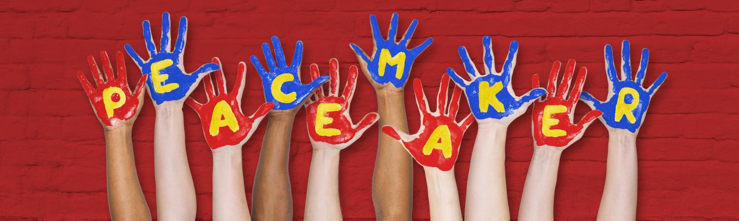
Wednesday 21st February
Performance, Research and Celebration
11.00 Peacemaker by David Holman (Studio Theatre)
12.00 Research Symposium (Studio Theatre)
Panel chaired by Danny Braverman
An Introduction to Peacemaker by David Johnston read by Ava Hunt
David Holman : Peacemaker 35 years on – would it be written today?

Paul Harman : Paper: How did we get here? Children’s Theatre in wider International/historical context.

Dr Jo Robinson : Paper: Playing Around: A Regional Historical Context: What is the future for Theatre in Schools?

UOD CTP Students reflect on schools tour, questions to panel and discussion

1.30 LUNCH – Bistro (Upper foyer)
Exhibition of Dr Jo Robinson’s Playing Around panels, and tributes to David Johnston
2.00 Peacemaker by David Holman (Studio Theatre)
2.00 Open Space chaired by Danny Braverman (Bistro)
3.00 Teas & Coffees (Bistro)
3.15 Legacies & Epiphanies: David Johnston (Studio Theatre)
Hosted by Lin Coghlan (playwright)
      - Sharing of Open Space discussions
      - Footage/ David’s Legacy / Reflections /Memories
….. closing thoughts……
4.00 Finish

Peacemaker Cast List
11.00 Performance 2.00 Performance
Simp – Ellie Williams Simp – Chloe Williams
Franny – Charlie Ayers Franny – Achusla Vih-Bolger
Mrs Man – Kira Barnett Mr Man – George Binns
Bluey – George Frost-Gilbert Bluey – Josh Wykes
DSM - Hannah Arnott DSM - Rhiannon Fitzpatrick
Peacemaker Creative Team
Director – Ava Hunt Musical Director – Chris Preece
Choreography – Nathan Geering Music composition – Nathan Hart
Clowning – Gerry Flanagan Lighting Design - Dominc Murray
Puppet/School Liaison – James Naughton Set Design - Leann Dawkes
Technician - Jordan Stych Set Painters - Emilia Stoddart
Thanks to: Amanda Wallace, Leann Dawkes, Paul Goldsmith Jahliss Fridye-Harper
Keala-Ann Woolley
James Simpson
Panel Speakers
Danny Braverman is a theatre-maker and Lecturer in Theatre at Goldsmiths. He has worked extensively in theatre by and for young people at, amongst others, Theatre Centre and Stratford East. His solo show “Wot? No Fish!!” won the Brian Way Playwriting Award and continues to tour internationally.
Paul Harman started as an actor at Belgrade Theatre, Coventry in 1962. Founder Artistic Director of Merseyside Young People’s Theatre (1978-89). AD of CTC, now Theatre Hullabaloo (1994-2008). Executive Committee of ASSITEJ International 1989-1993 & 2008-2011. Editor with Vicky Ireland of 50 Best Plays for Young Audiences (Aurora Metro).
David Holman is a dramatist, writing plays, operas and films for young audiences. His work has been produced on every continent, and, by the Royal National Theatre, the RSC, the Young Vic, by the Ito company in Tokyo, Chung Ying in Hong Kong, the State Theatre of South Australia, by Green Thumb in Canada and many more. The plays are, however, as likely, thank the Lord, to be seen in a drafty school hall - where it all began. David is also available for dog walking.
Jo Robinson is Associate Professor in Drama and Performance in the School of English at the University of Nottingham. Her research focuses on the relationships between performance, place, community and region; her 2015 exhibition, ‘Playing Around: Taking Theatre to Communities across the East Midlands' at Nottingham Lakeside Arts looked at the work of New Perspectives and Roundabout as exemplary companies working with and for their local communities.
Donations in memory of David to Derby Theatre’s charity Plus One
Please make a donation in the collection bucket as you leave the theatre or online at: www.derbytheatre.co.uk/plus-one
Plus One is an organisation within Derby Theatre which provides children in care with opportunities to see and experience live performances, films, workshops, and a host of further arts and culture related opportunities, throughout the city and beyond.

