a) Correlated factor solution | b) Independent pathways model | c) Common pathway model
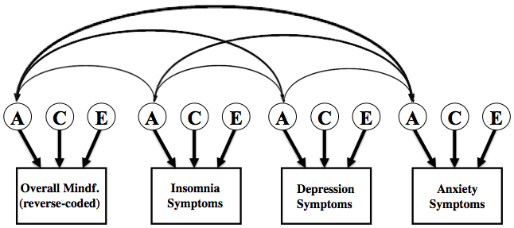 | 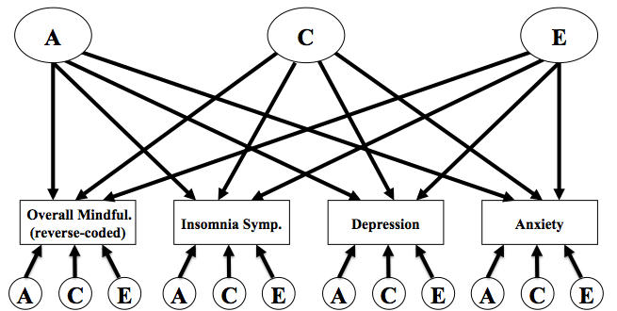 | 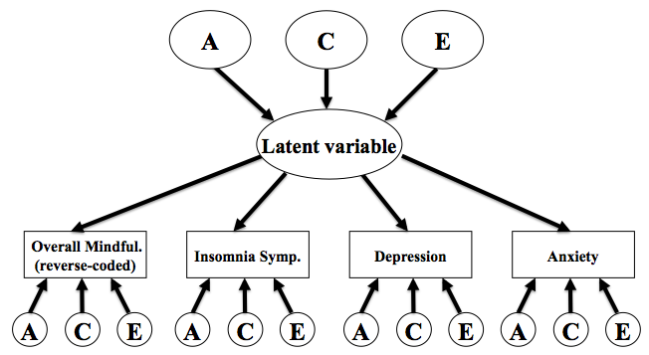

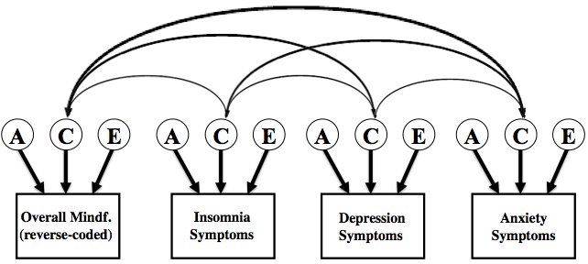

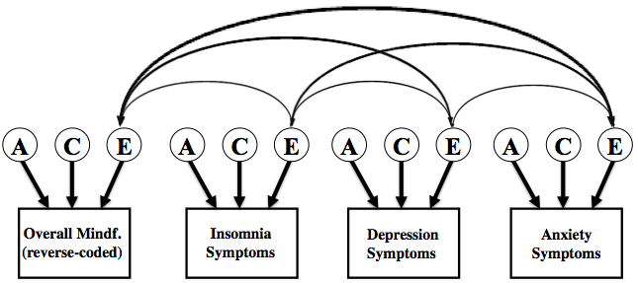

Figure 1: Examples for path diagrams, explaining correlated factors solution, independent pathway model and common pathway model

Note: A = additive genetic; C = shared environmental; E = non-shared environmental; Overall Mindful. = overall score of mindfulness (FFMQ), reverse coded, higher score indicating lower mindfulness; Insomnia Symptoms = insomnia symptoms (ISQ), higher scores indicating more insomnia symptoms; Depression Symptoms = symptoms of depression (MFQ), higher scores indicating more symptoms of depression; Anxiety Symptoms = symptoms of anxiety (RCADS), higher scores indicating more symptoms of anxiety.

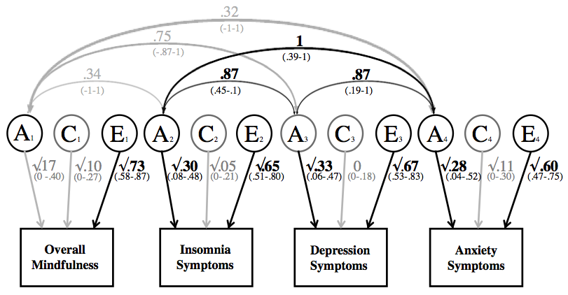

Figure 2 a: Path diagram of the genetic correlations in the correlated factors solution, including overall mindfulness, insomnia symptoms, depression and correlations

Note: A = additive genetic, C = shared environmental; E = non-shared environmental. Significant paths are shown in black. Paths with confidence intervals spanning 0 are depicted in grey. Overall mindfulness = overall score of mindfulness (FFMQ), reverse coded, higher score indicating lower mindfulness; Insomnia Symptoms = insomnia symptoms (ISQ), higher scores indicating more insomnia symptoms; Depression Symptoms = symptoms of depression (MFQ), higher scores indicating more symptoms of depression; Anxiety Symptoms= symptoms of anxiety (RCADS), higher scores indicating more symptoms of anxiety.

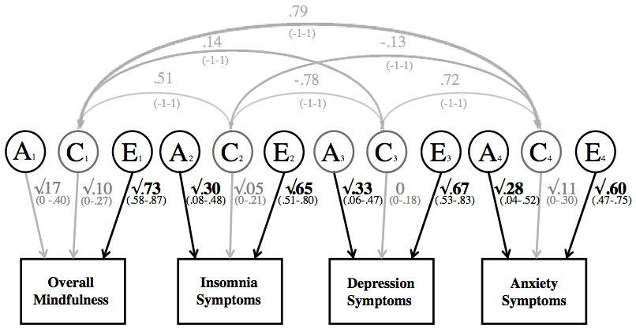

Figure 2 b: Path diagram of the shared environmental correlations in the correlated factors solution, including overall mindfulness, insomnia symptoms, depression and correlations

Note: A = additive genetic, C = shared environmental; E = non-shared environmental. Significant paths are shown in black. Paths with confidence intervals spanning 0 are depicted in grey. Overall mindfulness = overall score of mindfulness (FFMQ), reverse coded, higher score indicating lower mindfulness; Insomnia Symptoms = insomnia symptoms (ISQ), higher scores indicating more insomnia symptoms; Depression Symptoms = symptoms of depression (MFQ), higher scores indicating more symptoms of depression; Anxiety Symptoms = symptoms of anxiety (RCADS), higher scores indicating more symptoms of anxiety.

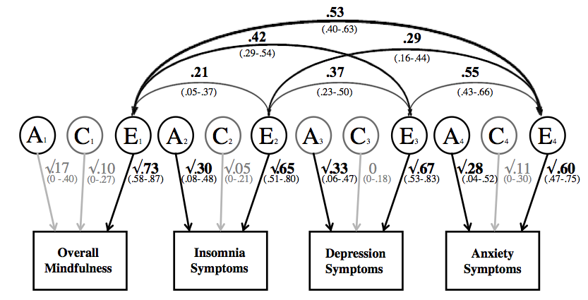

Figure 2 c: Path diagram of the non-shared environmental correlations in the correlated factors solution, including overall mindfulness and insomnia, depression and anxiety symptoms correlations

Note: A = additive genetic, C = shared environmental; E = non-shared environmental. Significant paths are shown in black. Paths with confidence intervals spanning 0 are depicted in grey. Overall mindfulness = overall score of mindfulness (FFMQ), reverse coded, higher score indicating lower mindfulness; Insomnia Symptoms = insomnia symptoms (ISQ), higher scores indicating more insomnia symptoms; Depression Symptoms = symptoms of depression (MFQ), higher scores indicating more symptoms of depression; Anxiety Symptoms = symptoms of anxiety (RCADS), higher scores indicating more symptoms of anxiety

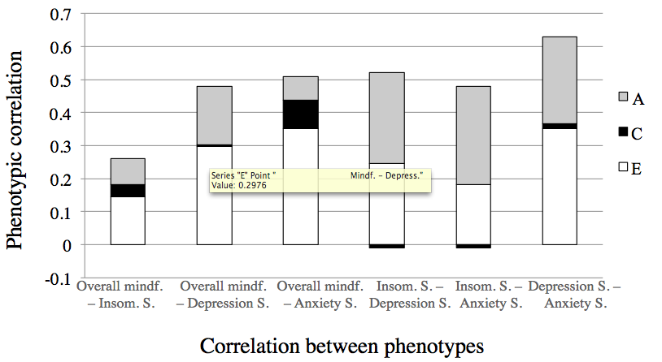
Figure 3: Relative contributions of A, C and E to the overall phenotypic correlations
Note: A = additive genetic, C = shared environmental, E = non-shared environmental. Overall mindf. = overall score of mindfulness,
(FFMQ), reverse coded, higher score indicating lower mindfulness; Insom. S. = insomnia symptoms (ISQ), higher scores
indicating more insomnia symptoms; Depress. S. = symptoms of depression (MFQ), higher scores indicating more symptoms of depression;
Anxiety S. = symptoms of anxiety (RCADS), higher scores indicating more symptoms of anxiety. This statistic shows how much A, C and E
contributed proportionally (highlighted in grey, black and white) to the phenotypic correlations of two traits (shown on the x-axis). A black bar
underneath the column indicates a negative correlation for C.

