Psychological characteristics of children with visual impairments: Learning, memory and imagery

Abstract

The performance of children (and sometimes adults) with visual impairments (VI) on a range of tasks that reflect learning, memory and mental imagery is considered in this contribution. Sometimes the evidence suggests that there are impairments in performance in comparison with typically developing children with vision and sometimes some advantages emerge. The author’s aim is to describe some of her own and others’ findings and explore what they tell us about the cognitive characteristics of such children, so that progress with practical interventions can be advanced through understanding. The paper starts by focussing on social-cognitive development and in particular to consider the potential benefits of language in that development. This is followed by a review of some studies of learning and memory performance which provide a coherent picture of development without vision and finally ends with a consideration of spatial mental imagery.

Social-Cognitive Development
There has been increasing interest in the process by which children acquire social understanding and develop social relationships. Mothers, siblings, best friends – early life involves from the outset interactions with others and these ‘others’ often provide the richest source of knowledge from which to learn about the world. Theory of Mind (ToM) understanding is the term used to encapsulate young children’s ability to understand the thoughts, beliefs and desires in another person's mind. We can predict behaviour because we know what people are thinking. The mind of a mother retrieving a ladder and a new light bulb, following a loud bang from the direction of a light fitting, can be completely transparent when ToM ability is acquired and incomprehensible if it has not. Sighted children of about 4/5 years can master simple Theory of Mind tasks in quite explicit ways. Their development in this respect seems very much to depend on vision and researchers have emphasised the roles of eye-gaze, pointing, and joint visual attention as the early important precursors of this ability. ToM deficits can have serious consequences for children - this is seen not least in autism, where it is a defining feature. A visual impairment restricts the chance to associate emotional and mental states with their behavioural correlates, since it is generally through watching others, and other situations, that such associations are learnt. This reasoning leads us to predict that children with VI may have difficulty with ToM development (see Pring, 2005 for a review).

Theory of Mind development and children without vision

The majority of children with profound visual impairment certainly have a delay in developing ToM, and this can mean that many do not show comparable ability to their sighted peers until about 12 years of age. A subset of such children with low verbal abilities may have longer-term difficulties when followed up individually and as a group (Peterson, Peterson & Webb, 2000; Green, Pring & Swettenham, 2003; Brown, Hobson, Lee & Stevenson, 1997).

Outcomes following this delay are uncertain and some of the potential risks include.

social development and friendships may be harder to achieve,

it may be harder to read and give social signals,

personal style may be less empathic,

play will be less likely to include pretence (this is because imaginative play may be dependent on understanding mental states),

learning may be problematic at school, partly because of the literal interpretation of language, and because of difficulties in adjusting learnt behaviour to the context- see Rita Jordan (2005) for more about this and other educational implications.

Vision is not the only critical channel for ToM development. Tager-Flusberg (1993) suggests that the primary way in which children get to know the contents of other people’s minds is through language. Language can be seen as a mechanism for sharing attention. Thus in this context it explains why Harris (2000) saw the role of conversation as being so critical for social understanding. Dunn’s work with young children and the content of their language has also provided a great deal of insight into these early social-language mechanisms (e.g. Dunn, 2000; Cutting and Dunn, 1999; Hughes & Dunn, 1998; Brown, Donelan-McCall N & Dunn, 1996). Her research suggests that in some ways parent-child language interactions are not as critical for social understanding as child-child interactions, where more mental-state language is used. Caregivers’ language has a particular quality: ‘eat your peas’, ‘time for the bath’, while a child may mention ‘I wish….’, or ‘pretend you’re a princess!’. So early social and conversational experiences in sighted children, even with members of the wider family, may have a positive impact on social understanding. Sibling conversations provide an enriched environment for children learning about others' minds: friends playing in pairs and siblings use more imagination and mental state terms than do mothers and teachers. This effect is particularly true for children who are verbally less able. It is interesting to note that similar results have been found with children with hearing impairments, where ToM is delayed (e.g. Woolfe, Want and Siegel, 2003) and in this study, the quality of sibling relationship also had an impact. Clearly the quality of language input and language understanding is critical, as well as early social understanding, and this is being followed up in current research with Valerie Tadic (Tadic, Pring: Goldsmiths, London University; Dale & Salt: Developmental Vision Research team, UCL Institute of Child Health/Great Ormond Street Hospital London).

Memory & Learning

Moving on from social understanding and language to a consideration of more general aspects of cognitive function, it is unsurprising that many aspects of development in children with VI seem to show initial lags. Fortunately these children often learn to compensate for vision loss and achieve similar levels of intellectual and educational attainment to their sighted counterparts. However, there are some areas of research that have yielded somewhat less predictable findings and these can be unexpected and not so easy to account for. There are specific contexts where performance was found to be both superior and perhaps surprising. The first concerns the research on memory for different types of information and the second concerns spatial mental imagery.

Memory Performance

It was during some research with blind children learning Braille that the author first began to see signs of superior memory performance in children with vision loss. She argued that the children’s ‘sound-based’ approach to learning to read explains their relative facility with developing literacy but it was not so easy to understand why their short-term memory seemed so good. Indeed over the years she noticed that there are many memory-related situations where children (and adults) who are blind outperform those with sight.

There are no definitive explanations for why such memory advantages should occur. However it would seem persuasive that relatively greater resources are allocated to auditory processing for those without vision and this greater attentional effort is likely to lead to better retention of the material. An outcome of the increased attention to such material may be to store it for longer-term retrieval in a ‘verbatim form’: a memory strategy that might be far less common amongst the sighted. Extra processing resources in the auditory channel could lead to a ‘seeing ear’ as French put it in 1952 (in Blau, 1964). Certainly recent studies of individuals with congenitally profound visual impairment show processing of speech is faster than in sighted people (Röder, Rösler and Neville, 2000) and there is also better discrimination of speech in the context of a noisy room when compared to sighted people (e.g. Muchnik, Efrati, Nemeth, Malin and Hildesheimer, 1991). This may well be related to, but does not provide an explanation for, some of the memory advantages which are listed below and briefly discussed.

Short term memory advantages

Number order in digit span tasks (Smits and Mommers, 1988; Pring et al, 1990)

Remembering the sequence of items, for example in a list of numbers, is particularly important in human memory. Without this ability information that depends on sequence such as spoken language cannot be properly retained and later understood and analysed. In other words verbal learning is dependent on this ‘short-tem working memory’ component that stores sequential information ready to be further analysed by semantic and conceptual processing mechanisms that organise knowledge into our long-term memories.

Prose comprehension task advantage (literal and inferential ability)

(Edmonds and Pring 2006).

In this task there was an overall advantage shown with the verbal material but additionally there was some suggestion that the literal prose memory, i.e. the verbatim memory for the text, was particularly accurately recalled.

Recall of taped (auditory presentation) and brailled words and tactile pictures (Pring, Freestone and Katan, 1990).

Amongst other methods in this study, simple raised line drawings of objects were presented along with their names for the children to comprehend. It was interesting to find that their memories for the names were significantly better than their sighted controls.

Pitch (of voice speaking a word) (Pring and Painter, 2002)

In this study adults with and without congenital vision loss were compared on their memory for a long list of words presented on an auditory tape. After their attempts at recalling the names they were asked if they could report whether the voice that spoke the words was a man’s (i.e. low pitch) or a woman’s voice (i.e. higher pitch). The participants who were blind were significantly better at accurately recalling this ‘perceptual’ information while the control participants had lost this information. The people with VI had superior pitch memory.

More accurate recollections of personal semantic memory (Pring & Goddard, 2002)

This study was part of a larger series of investigations on autobiographical memory. In one part of the memory test there was a clear advantage in favour of the blind participants in that they were far more fluent in generating names of friends and teachers from semantic long-term memory and this pattern was particularly marked in the case of distant memories from primary school days.

Thus we have seen that memory advantages exist and can be helpful in a variety of settings for children and aduilts with VI but we are uncertain how to capitalise on them. Accurate recall is not the same thing as greater intellectual knowledge — it is a different kind of knowledge. Nevertheless this memory recall advantage is probably related to the fact that children who are visually impaired often do have interests in music (Pring & Ockelford, 2006), good pitch memory (as seen above) and potentially absolute pitch abilities. This may go someway to explaining the abilities of a prodigious musical savant who is also congenitally and profoundly blind that Adam Ockelford and the author have been studying (see Pring, 2007).

At the outset of this paper it was mentioned that learning, memory and imagery would be considered in an attempt to understand better the psychological characteristics of children and adults with visual impairments. Research findings in social understanding and memory have suggested that there are strengths and weaknesses associated with visual impairment. The following section attempts to restrict the area of enquiry to the nature of the internal mental representations constructed from touch-based perceptions. For people with vision it is often difficult to think of objects, scenes and experiences without assuming that a visual mental world has to be involved. Yet research clearly shows us that whether individuals are blind or sighted, they often use spatial mental codes, and not visual ones, to represent thoughts that are spatial in nature (as in the game of chess).

Using Spatial Mental Imagery

Like many mothers the author has found the sharing of books with babies and toddlers as well as older children a profoundly satisfying activity. It was therefore a shock to discover, early in her research career, that there were almost no ‘picture’ books for children who were blind. Subsequently she explored how children with VI could gain from raised line and raised picture materials. For example Pring and Rusted (1980) asked children to feel raised-line drawings of rare animals and to listen to a text about these animals. What they found was that having a picture present aided memory recall for the text - a result already known in the context of education of sighted children. Indeed, not only did the children remember more of the information represented in the picture itself (eg. long neck) but also the abstract textual information (eg. lives in Africa). How were the raised lines understood? Research with raised line maps as well as drawings of objects has shown that people with VI tend to use featural analysis strategies rather than a global strategy approach (see Ungar, Blades & Spencer, 1995). Pathak & Pring (1980) reported that blind children could confuse a raised picture of a daffodil with a toothbrush, or a watch (with strap) for a roundabout. This error pattern emphasised the structural nature of the representations as well as the featural approach.
Recently elegant studies by Vecchi and colleagues (e.g. Vecchi, Tinti and Cornoldi, 2004) in Italy have shown how effectively sequentially perceived tangible material can be integrated into stable spatial mental representations. Such research has helped educationalists both at school and in museums and galleries to consider the best ways to utilise such materials.

Imagery and imagination

Although it has been argued that individuals born without sight can understand tangible materials and form spatial mental representations, it has been said that they are impaired on ‘active’ spatial imagery tasks (e.g. Vecchi, 1998). A consequence of this would be a difficulty in creating novel forms using imagery alone. The creative imagination of children and adults with VI in the context of spatial imagery was the subject of a series of studies that Alison Eardley and the author conducted. The idea was to show the participants (twelve congenitally blind individuals and fifteen blindfolded sighted participants) a set of shapes and ask them to imagine the shapes in their minds, moving them around in order to form a new but recognisable form out of the four parts. They were told that the new form could be anything – such as an object, a letter, a number or a picture. They were also told that they could vary the size, position or orientation of each of the parts but that they were not allowed to bend or otherwise alter the form of the individual parts. Some examples of shapes and the generated forms are given in Figure 1 below.

Place Figure 1 about here

The investigators showed the participants the different shapes in 2 dimensional (2D) and 3 dimensional (3D) forms. They wanted to see how well they could construct a novel form with the shapes and whether there were differences if they were dealing with 2D (reliefs) or 3D shapes. See Figure 2. Would both groups produce similar number of re-constructed images? Would they produce different images?

Place Figure 2 about here

Findings
First, there was no way found to differentiate the two groups’ imaginative reconstructions; they seemed to fall into the same categories. However, as can be seen in Figure 3 below the pattern of the performance across the two groups of participants did differ when it came to the number of legitimate responses they constructed.

Place Figure 3 about here

Interestingly, the same number of novel shapes was generated in the 3D condition across the groups but there was a highly significant interaction, with the participants who were blind producing significantly more legitimate shapes with 3D materials than with the 2D materials and the reverse being true for the blindfolded sighted group. No doubt this is partly because of familiarity with the materials. Yet the overall results of this experiment suggest that the ability to generate something novel using imagery is common to both those born with and without sight and pose interesting questions concerning the imagination and the role of our senses (further information about the nature of the mental codes involved e.g. visual or spatial, is tested and discussed in Eardley & Pring, 2007).

Conclusions
Research on the psychological characteristics of children and adults with VI reveal that we cannot readily predict performance. In terms of social understanding there is likely to be a need to support development in order to avoid impaired performance. Yet we also need to be aware of memory advantages that allow children to display significant strengths in certain contexts. In the future it is hoped that both research and practical considerations can best guide teachers to design child-specific programmes for children with VI, hopefully bearing in mind their not inconsiderable abilities with tangible materials.

Acknowledgements
I would like to take this opportunity to acknowledge the collaboration past and present of my PhD students, Sarah Green (nee Cupples), Alison Eardley, Valerie Tadic & Kamalesh Pathak. I would also like to thank the children, adults and often the teachers who have participated and helped in this research.

References

Blau, S. (1964). An ear for an eye: Sensory compensation and judgements of affect by the blind. In J.R. Davitz (Ed.), The communication of emotional meaning (pp. 113-127). New York: McGraw-Hill.

Brown JR, Donelan-McCall N & Dunn J (1996). Why Talk about Mental States? The Significance of Children's Conversations with Friends, Siblings, and Mothers, Child Development, Vol 67 (3), 836-849.

Brown, R., Hobson, R. P., Lee, A., and Stevenson, J. (1997). Are there “autistic-like” features in congenitally blind children? Journal of Child Psychology and Psychiatry, 38 (6), 693-703

Cutting AL & Dunn J (1999). Theory of mind, Emotion understanding, language, and family Background: Individual Differences and Inter-relations, Child Development, Vol 70 (4), 853-865.

Dunn, J. (2000). Mindreading, emotion understanding and relationships. International Journal of Behavioral Development, 24, 2, 142-144.

Eardley, A. and Pring, L. (2007) Spatial processing, mental imagery and creativity in individuals with and without sight. European Journal of Cognitive Psychology, 19(1), 37-58.

Edmonds, C. J. and Pring, L. (2006) Drawing inferences from written and spoken language: A comparison of children with visual impairment and children with sight. British Journal of Developmental Psychology. Vol 24(2), pages 337-352

Green, S., Pring, L., & Swettenham, J. (2004). An investigation of first-order false belief understanding of children with congenital profound visual impairment. British Journal of Developmental Psychology, 22, 1-17.

Goddard, L. and Pring. (2001) Autobiographical memory in the visually impaired: Initial findings and impressions. British Journal of Visual Impairment and Blindness Sept ,19(3), 108-112.

Harris, P. (2000) The Work of the Imagination. In the Understanding Children’s Worlds Series, Blackwell, Oxford, UK.

Hughes C & Dunn J (1998). Understanding Mind and Emotion: Longitudinal Associations With Mental-State Talk Between Young Friends, Developmental Psychology, Vol 34 (5), 1026-1037.

Jordan, R. (2005). Educational Implications of Autism and Visual Impairment. In Pring, L. (Ed.), Autism and Blindness: Current Research and Reflections. London: Wiley.

Muchnik, C., Efrati, M., Nemeth, E., Malin, M., & Hildesheimer, M. (1991). Central auditory skills in blind and sighted subjects. Scandinavian Audiology, 20, 19-23.

Pathak, K. & Pring, L. (1989) Tactual picture recognition in congenitally blind and sighted children. Applied Cognitive Psychology, 3, 337-350.

Peterson CC, Peterson JL & Webb J (2000). Factors influencing the development of a theory of mind in blind children, British Journal of Developmental Psychology, 18, 431–447.

Pring, L. (2005) (Ed.) Autism and Blindness: Research and Reflections Wiley, London/Philadelphia

Pring, L. (2007) Memory in savants. In D. Bowler and J. Boucher (Eds.) Memory in Autism. Cambridge University Press, Cambridge, UK.

Pring, L., Freestone, S. E. and Katan, S. A. (1990) Recalling Pictures and Words: Reversing the Generation Effect. Current Psychology: Research and Review. 9, 35-45.

Pring, L. & Ockelford, A. (2006) Focus on Music: A survey of parents of children with septo-optic dysplasia. British Journal of Visual Impairment and Blindness. Vol 23(2): 58-66.

Pring, L. and Painter, J. (2002) Recollective experience in the visually impaired:The role of sensory and conceptual processing. British Journal of Visual Impairment and Blindness Jan 20(1), 24-32.

Pring, L. & Rusted, J. (1985) Pictures for the blind : An investigation of the influence of pictures on the recall of text by blind children. British Journal of Developmental Psychology, 3,41-45.

Röder, B., Rösler, F., & Neville, H. J. (2000). Event-related potentials during auditory language processing in congenitally blind and sighted people. Neuropsychologia, 38(11), 1482-1502.

Smits, B.W. & Mommers, M.J. (1976). Differences between blind and sighted children on WISC verbal subtests. New Outlook for the Blind, 70, 240-246.

Tager-Flusberg, H. (2003). Language and communicative deficits and their effects on learning and behavior. In M. Prior (Ed.), Asperger syndrome: Behavioral and Educational aspects, (pp.85-103). New York: Guilford Press.

Ungar, S., Blades, M., & Spencer, C. (1995). Visually impaired children's strategies for memorizing a map. British Journal of Visual Impairment, 13, 27-32.

Vecchi, T. (1998). Visuo-spatial Imagery in Congenitally Totally Blind People Memory, 6, 91-102.
Vecchi, T, Tinti, C. & Cornoldi, C (2004) Spatial memory and integration processes in congenital blindness. Cognitive Neuroscience and Neuropsychology, Neuroreport, 15(18): 2787-2790.

Woolfe, T.W., Want, S.C. & Siegel, M. (2003) Siblings and theory of mind in Deaf Native Signing Children. Journal of Deaf Studies and Deaf Education, 8, 340-347.

Figure 1: The individual shapes used in the Eardley & Pring study (2007) along with the forms generated.

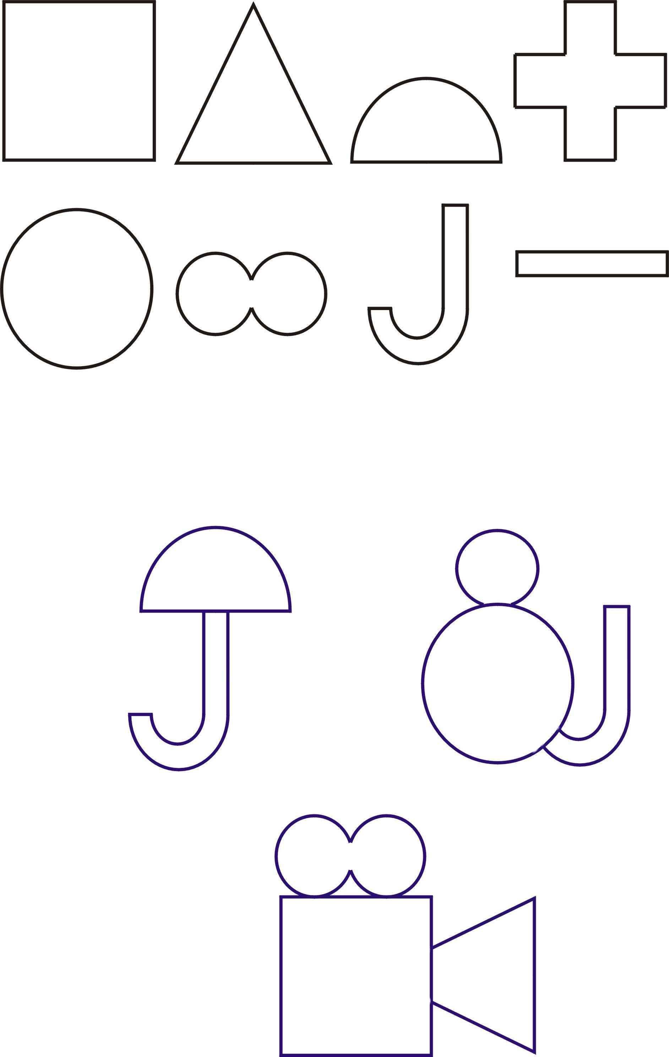

Shapes

Generated forms

Figure 2: Examples of two responses in the 2D and 3D conditions

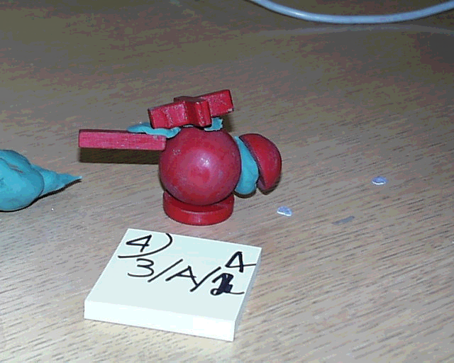
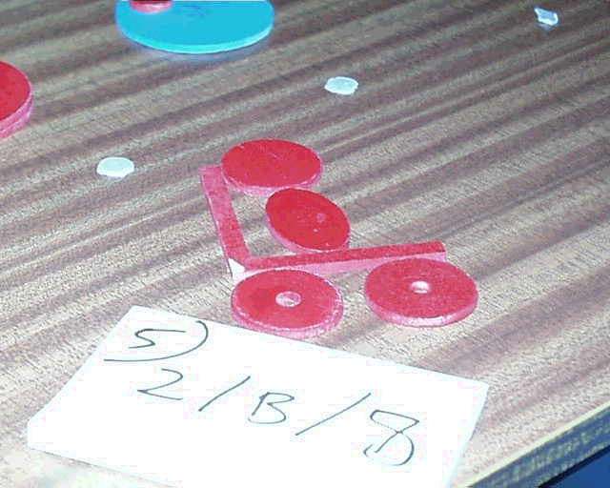
‘Bird’
‘Wheel-chair with person’
(“The circle is too big”)

Figure 3: Results of the Creative Imagery Task

