Supplemental Material

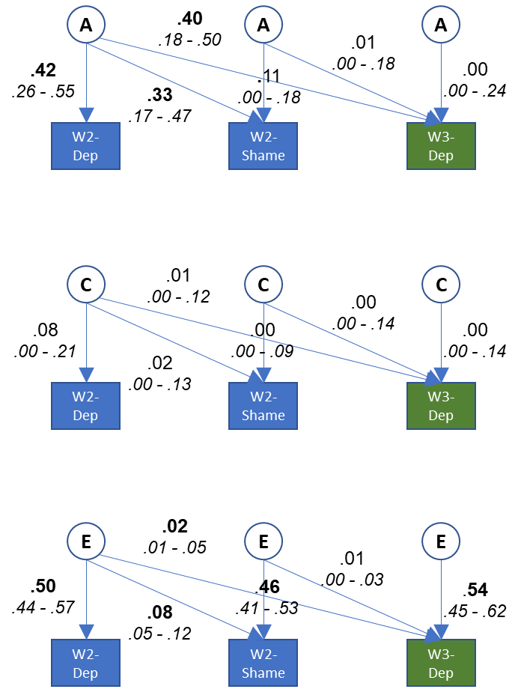
Figure 1A. Results from Cholesky decomposition of prospective associations between shame and later depression, accounting for earlier depression. Note. A genetic effects, C shared environmental effects, E non-shared environmental effects. Significant values in bold face.

