Energy Babble: Mixing Environmentally-Oriented Internet Content to Engage Community Groups

William Gaver1, Mike Michael2, Tobie Kerridge1, Alex Wilkie1, Andy Boucher1, Liliana Ovalle1, Matthew Plummer-Fernandez1

1Interaction Research Studio 2Department of Sociology and Social Policy

Goldsmiths, University of London University of Sydney

initial.surname@gold.ac.ukmike.michael@sydney.edu.au

# ABSTRACT

The Energy Babble is a kind of automated talk-radio that is obsessed with energy and the environment. We developed it with, and deployed it to, a number of existing ‘energy communities’ in the UK. The system gathers content from a variety of online sources, including Twitter™ feeds from the communities, from governmental departments, and from the National Grid, and chats about it continually using a number of synthesised voices interspersed with a variety of jingles and sound effects. Designed to playfully reflect and comment on the existing state of discourse and reports of practice in the UK, the Babble can be considered both as a *product* and as a *research tool*, in which role it worked to highlight issues, understandings, practices and difficulties in the communities with whom we worked.

## Author Keywords

Research through design; environmental HCI; ludic design; STS; energy communities

## ACM Classification Keywords

H.5.m. Information interfaces and presentation (e.g., HCI): Miscellaneous.

## General Terms

Design

Permission to make digital or hard copies of all or part of this work for personal or classroom use is granted without fee provided that copies are not made or distributed for profit or commercial advantage and that copies bear this notice and the full citation on the first page. Copyrights for components of this work owned by others than ACM must be honored. Abstracting with credit is permitted. To copy otherwise, or republish, to post on servers or to redistribute to lists, requires prior specific permission and/or a fee. Request permissions from [Permissions@acm.org](mailto:Permissions@acm.org).

*CHI 2015,* April 18 - 23, 2015, Seoul, Republic of Korea    
Copyright 2015 ACM 978-1-4503-3145-6/15/04…$15.00  
<http://dx.doi.org/10.1145/2702123.2702546>

# INTRODUCTION

In the UK, the government has committed to a 34% cut in carbon emissions, compared to 1990 levels, by 2020, and an 80% cut by 2050, despite a prediction that global energy demand will double by 2030 [15]. This ambitious target is being approached in a number of ways, including the pursuit of low-carbon energy production and new approaches to manufacturing. In particular, a significant proportion of the saving is expected to come from reductions in domestic energy use, and thus ‘energy demand reduction’ is a strong theme in current government policy, including policies around research.

This stance is congruent with recent trends in ‘environmental HCI’. On the face of it, the rationale for HCI’s involvement in energy demand reduction is simple and convincing: Demand reduction can be supported by realtime feedback about actual energy use, according to this logic, coupled with persuasive computing approaches to encourage people to reduce their demand. Since sensing, feedback, information visualisation, persuasive computing and domestic applications are all core issues for the HCI community, it seems apparent that it could play a leading role in supporting energy demand reduction.

Over the last several years, however, the potential for simple energy demand feedback to reduce consumption has been challenged in a number of ways. First, evidence suggests that interventions produce only small and short-lived effects [1], and are prone to ‘boomerang effects’ in which above-average consumers may reduce their energy use, while those below-average ones increase theirs [10]. Broader concerns are raised in critiques from the social sciences. For instance, focusing on reducing resource consumption (including energy) tends to overlook the culturally embedded practices within which consumption takes place [12] and portrays the consumer as ‘resource man’ [14] capable of and concerned with reducing consumption as an end in itself. Dourish [5] suggests that focusing on individual behaviour change casts people as individual rational actors in a classic new-liberal way, while Brynjarsdóttir et al. [2] link persuasive approaches to modernism and its limitations and also review and identify the shortcomings of many environmental HCI projects.

In sum, despite the apparent promise of resource demand monitoring, the approach seems constrained by several factors. First, addressing individual or household consumption overlooks larger social realities that can promote or inhibit sustainable practices. Second, a narrowly instrumental approach towards reducing energy consumption is insensitive to how energy use is part of situated practices that people are unwilling or unable to change. Finally, insensitivity to diverse settings tends to lead to one-size-fits-all designs that may not fit local circumstances.

## Energy, Design, STS and Communities

How can we go beyond individualistic, utilitarian and modernist approaches to design-led research on energy sustainability? The approach we describe here was conditioned by three factors that were significant in the project’s framing and pursuit. First, the design work was influenced by our work on *ludic design* [6], which promotes playful engagement with ideas to offer a wide scope for interpretation [11], as well as our previous research using speculative design as a form of public engagement with science, in which designers engage with ‘expert practitioners’ to explore possible futures for emerging technologies [8].

Second, the project was undertaken through collaboration between Design and Science and Technology Studies (STS), with leaders representing each perspective, and team members having variable expertise in either one or both domains. Explicitly linking design work to STS emphasised an appreciation of, and engagement with, a heterogeneous mix of actors at variable scales; more generally it reflected and resulted in a shared concern with how technologies are shaped by social actors, and conversely how social realities are shaped by technologies.

A third factor important in the framing of the project came from the funding programme for which we shaped a proposal and which ultimately funded the research. Jointly supported by the UK’s technology and social research agencies, the ‘Energy and Communities’ programme emphasised the potential importance of ‘community initiatives’, suggesting that ‘change in energy consumption is… not simply dependent on behavioural change at the individual level but on the co-evolution of communities and the emerging technology that is available’ [15]. In addition, the programme was arranged to partially and semiformally coincide and communicate with another initiative, the *Low Carbon Communities Challenge* (LCCC), which funded the work of 22 ‘test communities’ to reduce carbon use in various ways. This meant projects funded by the ‘Energy and Communities’ programme were supported and encouraged to engage with a variety of ‘energy communities’ spread across the UK.

The Energy and Communities programme thus provided a timely opportunity for us to explore environmental issues from a mixed STS and Design approach that we labelled ‘Ludic Action Research’ [17]. We approached the project with a commitment to exploring and querying certain assumptions and reified notions built into the call e.g. what counts as energy-practice, what are the issues and actors at play, indeed what counts as community. This approach also sensitised the team to an expanded view of ‘involvement’ in the design process (e.g. [3], [16]).

In the rest of this paper, we describe the trajectory the research took in engaging with communities via a number of design-led methods, conceptualising and implementing the Energy Babble, deploying it into the communities, and assessing their responses. Finally, we reflect on the results of our study to understand the nature of the Babble both as a product and a research tool, one that illuminated the conditions and difficulties faced by the energy communities with whom we worked.

# Process: From the communities to the babble

At the outset of the project we had no plans for the sort of device we might build; instead we wanted this to emerge from our interactions with the communities. In this section we describe how we engaged with members of a number of different energy communities from the UK, the design-led methods we used to shape our relationship with them, the design explorations that eventually led to the Energy Babble concept, and how we refined the concept through software development and product design.

## Forming a Network of Communities

Soon after the project was launched, we began to form a network with members of several energy communities around the UK. We met most of these at an event arranged jointly by our sponsoring research councils and the LCCC to introduce the initiatives and people involved in them to each other. Also at this event, we met representatives of the Department of Energy and Climate Change (DECC) who later took part in some of the project’s activities. During the meeting, a number of LCCC participants expressed an interest in our project. We followed up these initial encounters with short visits to each site, during which we met with key members of the groups and toured the areas to see some of the projects they were pursuing.

The seven ‘communities’ with whom we worked[1] were by no means coextensive with their geographical settings. Typically involving small numbers of committed members who see themselves as practitioners, innovators and transition advocates, they form and reform in response to policy and funding changes, seek to enrol the communities of their villages or towns or cities, and agonise over how they will involve more people in their plans. Some were extremely well organised and funded, while others were very ad hoc and quiet. Their engagement with and characterisation of environmental issues varied as well, with key issues for them ranging from global warming to fuel poverty, and from renewable energy to conservation.

## Design-Led Community Building

The initial networking meeting was effective at introducing community groups and academic researchers to each other. It also revealed potential tensions between the community groups and academic researchers, however. In discussions, it became clear that the energy communities questioned, and might resent, funding given to research that was not primarily aimed at producing direct environmental benefits, particularly given the government’s changing commitments to renewable energy and sustainability. In addition, most of the community groups were time and resource poor, and had already been subject to a great deal of scrutiny both from researchers and policy makers over the course of their operation. Now we were asking them to volunteer more time and energy to working with us. Not only did they appear somewhat jaded by the attention they had already received, it seemed that they had formed well-developed personas in presenting their work and beliefs.

These considerations influenced activities we designed to get to know more about the communities and to bring them together with each other and our research team. Most significantly, we held an ‘engagement workshop’ at a London museum, with participants including members of each community, and also other interested people including representatives from the funding agencies and the Department of Energy and Climate Change.

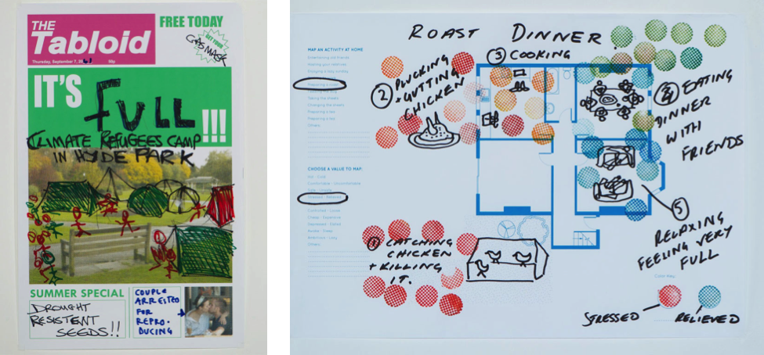 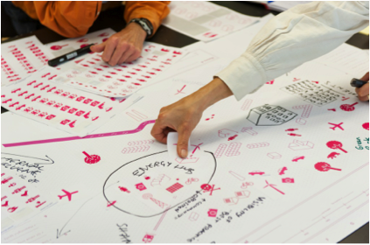

Figure 1. Engagement workshop tasks: a) imaginary periodicals; b) emotional trajectories; c) mapping communities.

### Engagement Workshop

For the workshop, we designed several playful and engaging activities, inspired by Cultural Probes, for group work. For instance, to explore participants’ expectations and fears about the future, we asked them to work together to complete partially-designed front pages for imaginary periodicals, offering templates for genres such as a tabloid newspaper, a more serious looking broadsheet newspaper, and a popular science magazine (Figure 1a). To investigate people’s emotional engagement with energy practices, we asked them to draw and use rubber stamps to describe the trajectory of a recent event, which resulted in annotated diagrams describing activities ranging from getting up in the morning to killing a chicken to serve at a dinner party (Figure 1b). To investigate communities both as they currently experienced them and as they imagined they might be, we gave them a diagrammatic map and a large number of stickers, asking participants to work together to create a fictional amalgamation of their communities (Figure 1c).

These activities occasioned a great deal of discussion that was informative about the participant’s communities and environmental work. The primary achievement of the exercises, however, was to configure the participants’ relationship with each other, and with us as researchers. By inviting the participants to engage with tasks intended to provoke creative exploration rather than to return clear social scientific data, we seemed successfully to encourage participants to forgo more formalised forms of self-presentation and to engage with us in a more personal and relaxed manner. In addition, the tasks worked to expose them to our methods and approaches as designers, and to set the tone for the design activities we pursued later.

### Cultural Probes

At the end of the engagement event, we gave each participant a number of Cultural Probes kits to work with themselves and to distribute to other members of their communities. Each kit contained several items, e.g.:

* A poster for writing ‘energy rules’, with prompts (“It’s strictly…”, “Never…”, “Always…”)
* A form for writing an obituary for an appliance
* An unfolded envelope with a request to “confess a guilty energy use secret” before sealing it for privacy
* Cards with two devices (e.g., a clothes iron and a wind turbine) with blank speech bubbles to be filled

Participants returned the probes after several weeks. Again, part of the purpose of the probes was to encourage an informal and playful relationship with the participants. This seemed effective in encouraging returns that were revealing of the participants’ attitudes and conflicts around energy use. Some (e.g. “*it’s strictly energy use that defines us*”) indicated that participants were zealous about sustainability. Others (e.g. confessing to *“leaving the door open and keeping the heating on”*) suggested a capacity for self-deprecating humour about the contradictions in their actual practices. In general, the Probes seemed to allow us, and perhaps our participants, glimpses of the complications involved in balancing everyday life with a commitment towards environmentalism.

Our view of these complications was reinforced by our research into current energy policies and the sustainable technologies that the communities were using. We also attended energy events in the communities, where we were struck by the many different voices, affiliations, concerns and agendas in which the community actions were entangled. These discussions, the workshop, probes and observations all set the scene for our design work.

## From a Design Space to the Babble

As our perceptions of the energy communities and their engagements began to settle, we started to work on ideas for the systems and artefacts we might make for them. As with many of our projects, we developed numerous ideas that we captured in the form of simple evocative proposals captured in a series of design workbooks [7]. Here we outline a few to indicate avenues we explored (Figure 2):

• *Energy tourism*. Increasing concerns about sustainability brings greater visibility to previously overlooked energy infrastructures (e.g. power stations, transmission networks). Could new or obsolete energy infrastructure become sites for new forms of sightseeing?

• *Insistent activism***.** Discourse about sustainability is often channelled into predictable forms (e.g. community meetings, energy exhibitions, etc.). This may make such concerns easier to hold separate from day-to-day life. Could we design systems that would insist on such issues even in seemingly inappropriate settings?

• *Energy awareness* The desirability of supporting energy communities to share their expertise and successes was central to the funding programme. Several proposals explored ideas both in terms of functions and in terms of the socioaesthetic experiences they would afford.

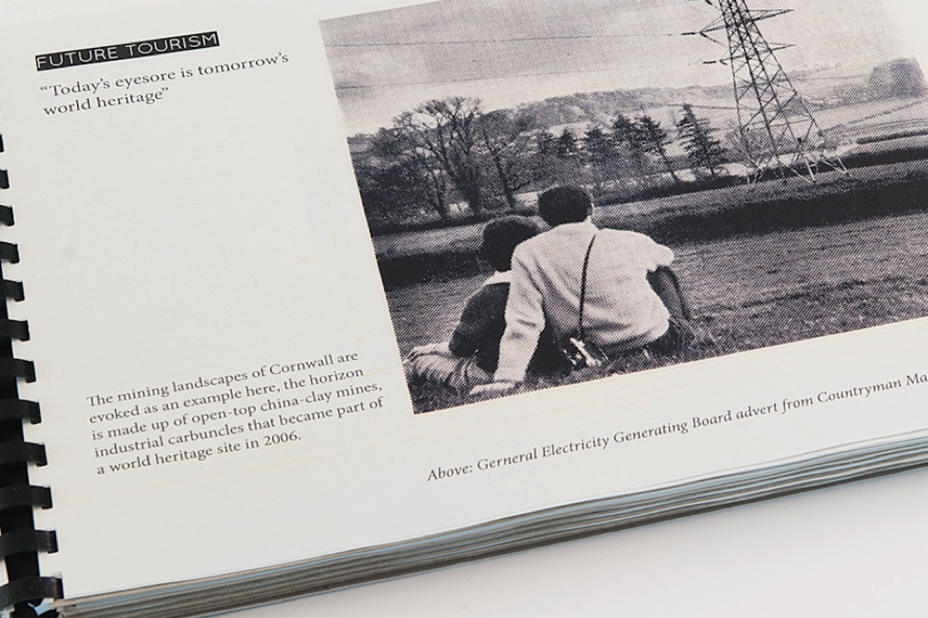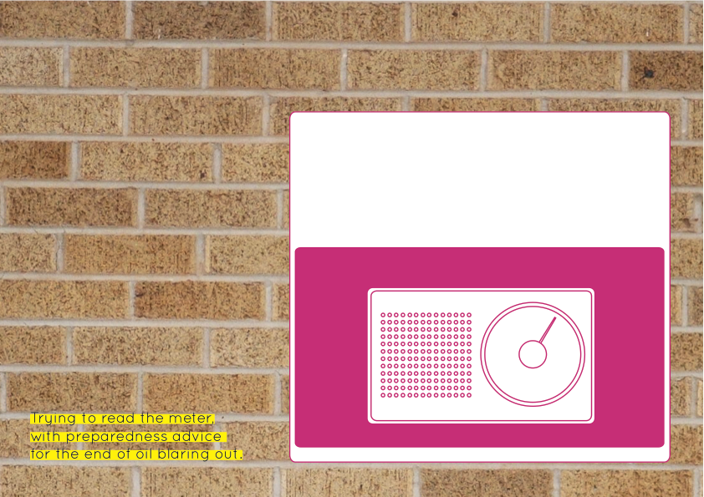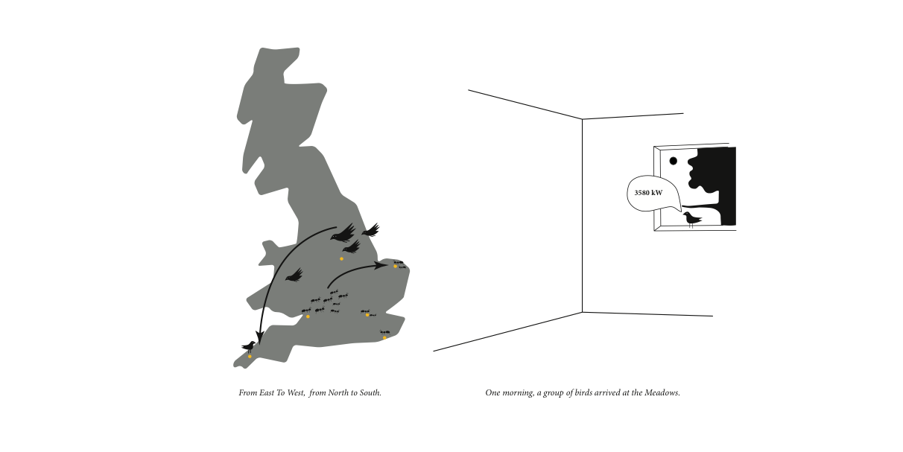

Figure 2. Proposals: a) energy tourism; b) activist meter reading; c) energy awareness

Our proposals evolved over a period of months, and both reflected and spurred discussions amongst us about which best reflected our insights into the communities, what might engage the communities, and what we wanted to achieve. These culminated in the first proposal for an ‘Eco Babble’ (Figure 3). This was conceived as a system that would gather input from a combination of web scraping and participant input to a central server, and organise the contents in multiple ways for replay from a variety of public and domestic devices.

## The Two Faces of the Babble

From the very beginning, and throughout its development and deployment, the Babble was motivated by a mixed and somewhat incommensurable set of intentions. At the time it was first suggested, our discussions did not tend to centre on what we wanted the system to achieve or how the participants might engage with it. Instead, we decided to develop it because we felt a kind of satisfaction in being able to reflect back to the participants, in a somewhat mischievous way, the complicated mix of discourse, priorities and suggestions with which we saw them contending.

As we developed the system, however, a more utilitarian perspective on its possibilities grew, as reflected by a written brief we developed to guide the work:

Design an Energy-Babble system that displays material, collected from some combination of individual, community and public sources, to open and promote constructive affect and involvement in energy reduction issues and orientations. More specifically, the system should support understandings of, and practices related to, energy demand reduction.

Thus on the one hand, the Babble was talked about as a tool for information and communication about practices and understandings related to energy production and conservation. On the other, it was a system for portraying and even parodying the complexities of energy-related discourse. Though seldom voiced, these mixed perspectives on the Energy Babble coloured its development, surfaced more explicitly later as we described it to the community members, and ultimately inform our discussion here of how volunteers related to the system and how we understand the project.

To foreshadow our discussion, we suggest that insofar as the Babble was presented and viewed as an information and communication device, it tended to serve and be assessed as a *product*. As a reflection of energy-related discourse, in contrast, it served as a *research tool* that helped us, and ideally the participants, better understand the existing situations within which energy communities work. The correlation between utility/products and reflection/research is neither perfect nor necessary; nonetheless, distinguishing two ‘faces’ of the Babble—one an instrumental product, the other a reflective research tool—is useful in orienting to our intentions and results.

# The Energy Babble

Months of work separated the decision to pursue the Babble and its eventual production as 28 fully working prototypes. We do not focus on the detailed design process here both because of space constraints and because we want to explore the communities’ engagement with the finished system and what this reveals both about the design and the communities (though see [18]. Instead, we fast-forward here to a description of the completed design, discussing only a few relevant aspects of our process.

## The Devices

The most visible manifestation of the Energy Babble is the devices that we distributed to participants (Figure 4). These comprise a combination of two custom blown-glass components set on top of an injection-moulded base. The base houses the device’s electronic components, including a Raspberry Pi microcomputer, various actuators, and a compact loudspeaker. The central glass piece serves to amplify the output of the speaker located beneath it—glass’s acoustic properties make it optimal for this function—while second glass piece supports it and holds a microphone attached to the base by a coiled cable. A prominent yellow knob rotates to control volume; if turned beyond its lowest setting it plays a recorded description of the system and its operation, using the same synthesised voices as the rest of the system.

The product design of the devices was the result of a great deal of exploration and development. Starting with explorations of birdhouses and nests (to develop the theme shown in Figure 3c), attention turned to a variety of containers, and ultimately labware such as test tubes, beakers, and retorts. The final result expresses the enclosure and release of data via the glass cone in a way that we believed to be both intriguing and harmonious for everyday settings such as homes or public spaces.

The audio design of what is primarily a sound-based device also received a great deal of attention. Much time was spent reviewing off-the-shelf voice synthesisers for understandability and aesthetic acceptability, crafting a series of jingles meant to evoke contemporary music as well as news broadcasts, and designing the audio introduction to reduce the need for written documentation. In operation, the Babble plays a varying stream of messages spoken by a number of synthetic voices, and punctuated by short musical jingles reminiscent of those used in news broadcasts. These are sent to the devices via the internet from a server located in our studio.

## The System

The audio stream played by the Babble devices is algorithmically constructed and represents the results of a number of modular processes. The first set of these seek new information from the web:

• *Twitter Scrape* The system scrapes messages from a variety of Twitter™ feeds, including those from the communities, from DECC, and from the National Grid.

• *Twitter Search* The system searches Twitter™ using a number of terms (e.g. 'climate change', ‘'energy bills', 'renewable energy') to find relevant content more broadly.

• *URL Following* If returned tweets contain ‘http’ and have been retweeted, the system follows the link and scrapes the first paragraph of text for output.

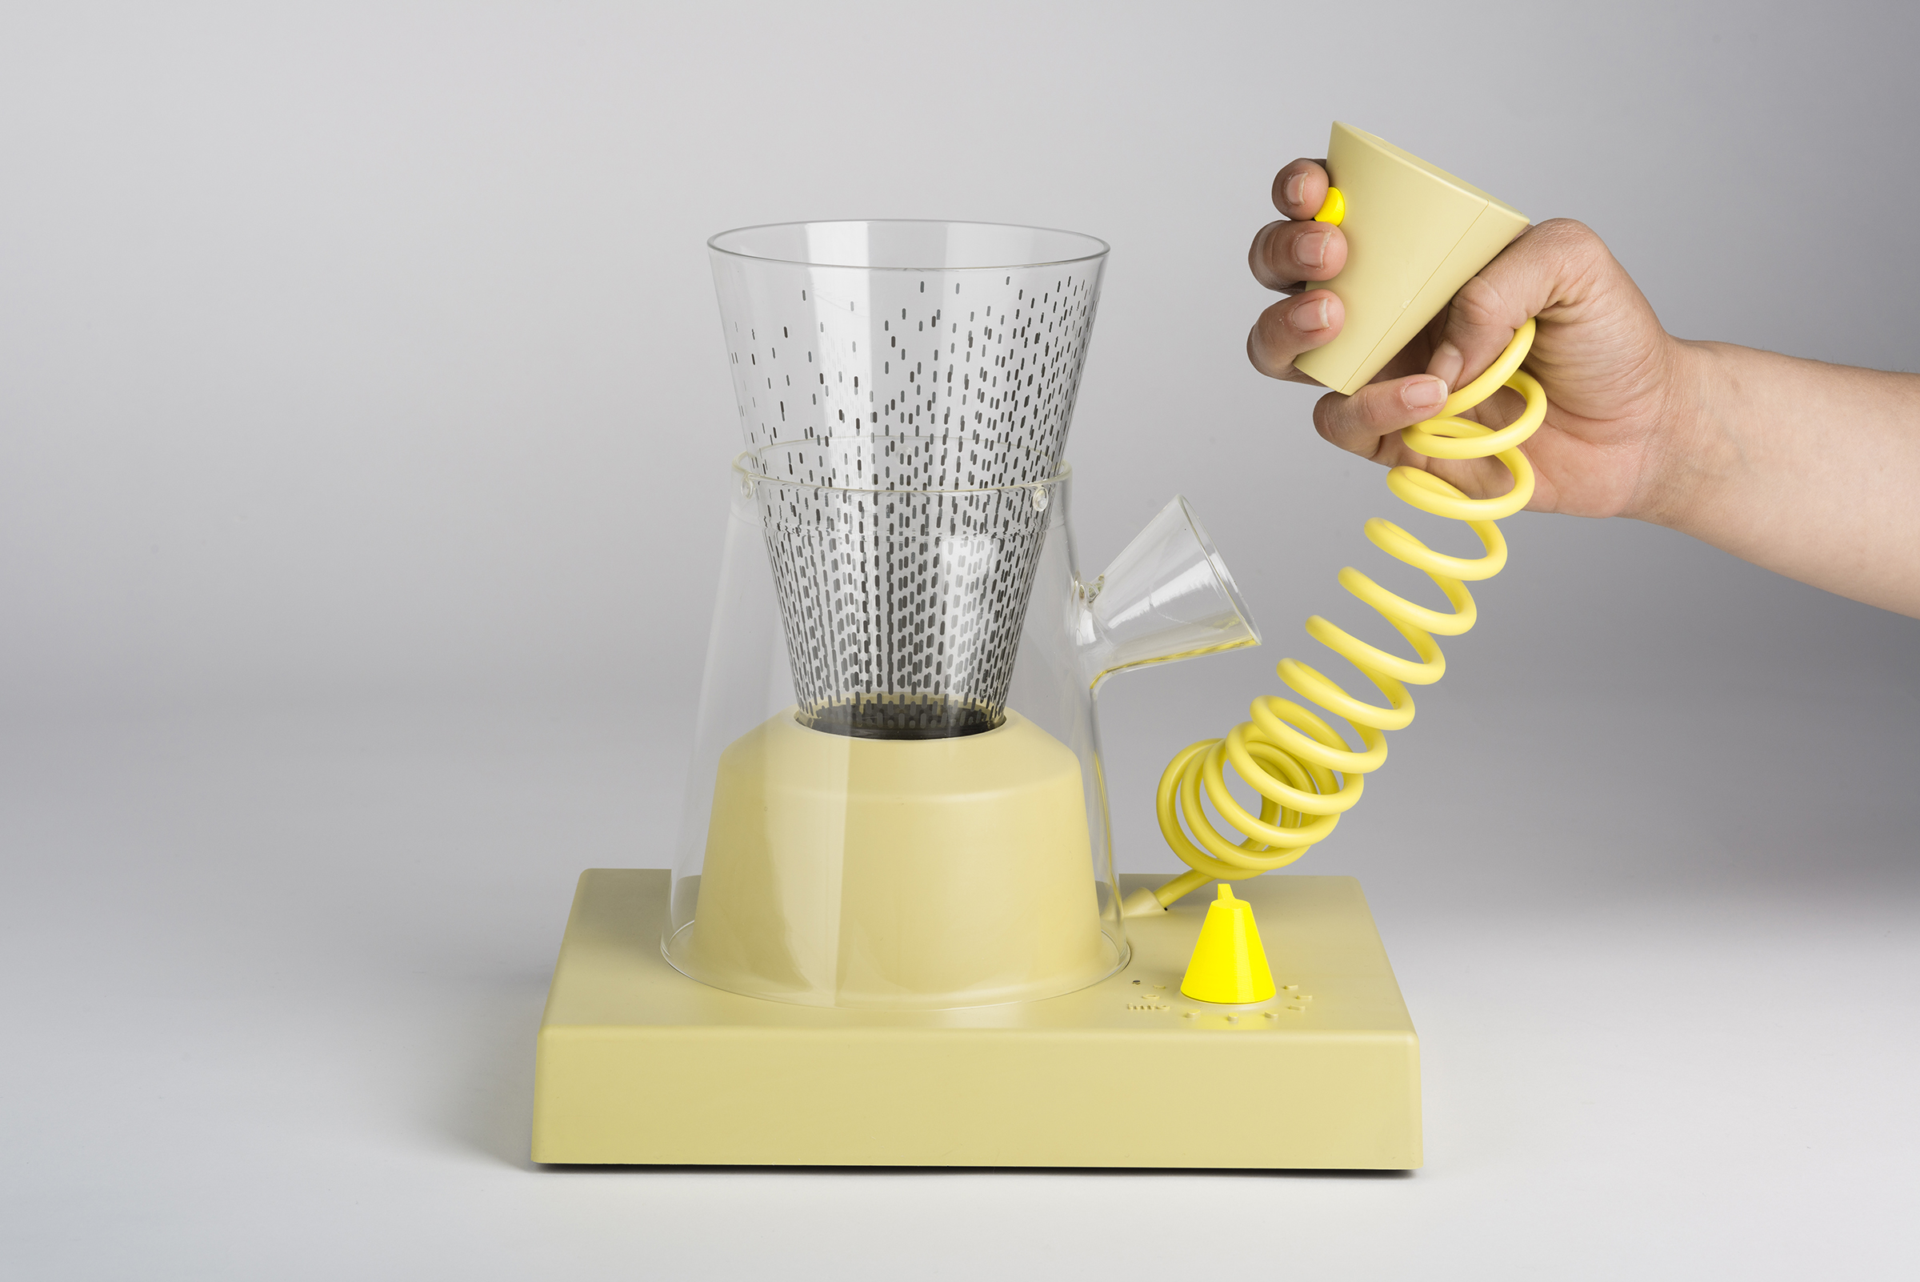

Figure 4. The Energy Babble device

• *Energy Reports* The system also tracks the National Grid, broadcasting information about current energy demand and carbon intensity, as well as changes in the amounts of energy generated by coal, gas, and wind.

• *Switched Off The…* reports hourly a list of things people tweet about having switched off (lights, heat, the internet).

A second set of modules accepts input from participants, or manipulates the existing content.

• *User Input* Users can input their own statements via the microphones on the Babble devices. Voice recordings are sent to the server, which passes them to a commercial service for speech-to-text translation, allowing them to be resynthesised both to anonymise inputs and make them congruent with the overall audio ecology. Text can also be entered directly via SMS text messaging.

• *Prompt Bot* We developed a string of generic questions (e.g. ‘how do you save energy?’) that were read out occasionally by the system to prompt participant responses.

• *The Voice of Babble* Markov algorithms are run on the content scraped from URLs, and separately on user inputs, to produce new text strings. Markov algorithms find word transition probabilities from a corpus; these probabilities can be used to generate new strings of words. The results tend to be locally sensible, but drift over time in a way we hoped would produce new ideas or at least be amusing.

The system orchestrated the content in a variety of ways. For instance user input was played as soon as possible, while energy reports only appeared hourly. Different voices were assigned to different streams of content, and content was repeated periodically. Distinct jingles signalled different streams of content. Finally, the output stream was arranged to be continuous but uneven, with occasional gaps followed by bursts of several messages.

## The Babble Experience

The experience offered by the Babble Devices, once they are properly connected to the server and operational, is something like listening to a continuous talk radio programme. A series of voices make statements, read news items, ask questions and report energy use, all interspersed with occasional musical interludes and lapses into nonsense. The majority of content is related to energy and the environment and thus the devices present themselves as strongly focused on sustainability, though a fair amount of ‘off-topic’ content also creeps in from Twitter™, from following links, or from participant inputs. Our question was how our participants, all committed to environmental concerns themselves, would engage the Energy Babble.

# Living with the Energy Babble

We deployed a total of 21 Energy Babbles to members of the communities in a series of meetings at their locations (Figure 5). Each community received 3 or 4 devices, which were usually given to volunteers present at the meetings, though in a few cases extras were left for later distribution. The remaining 5Babbles were distributed to team members, with 2 going to people more loosely connected to the project. Volunteers lived with the Babble for varying periods averaging about six months.

In the rest of this section, we briefly describe what our participants told us about their experiences with the Babbles. The majority of reports come from discussions when we deployed the devices, or several months later when we revisited the communities to pick up the devices. Others come from documentaries by an independent filmmaker hired to help us assess the field trial.

## Initial Expectations and Impressions

We packaged the Energy Babbles, associated documents and equipment in custom-made cardboard boxes for transport. During deployment events, these were usually positioned visibly, but unopened, during an introductory presentation in which we reviewed the project. Then we would unpack a Babble device and describe how it worked. Because it took some time to set up one of the devices for demonstration, during these initial descriptions the group had not yet heard the system. Typically, then, initial comments and questions revealed a mix of assumptions, expectations and responses to the devices.

Initially, many participants expected us to produce a tool that would directly help them reduce energy consumption — or as G, from the Meadows, put it: ‘*We thought we were going to get a gizmo to save energy’*. When it became clear the Babble did not serve this purpose, they looked for other utilitarian pay-offs. In Hastings, for instance, an engineer asked ‘*How does this improve the social operational wellbeing of the people who use it? If I make an investment how do get a payback*?’ and explained *‘I wanted it to solve a problem’.* These discussions tended to encourage the news/communication interpretation of the device, which mollified many skeptics. For instance, the engineer realised it could be used to broadcast the energy output of their renewables: ‘*Babble could bring this information to people*’. Similarly, in Laddock a group member championed the Babble for using the British Raspberry Pi technology, and because he saw potential for it to broadcast his car battery operated DIY domestic electricity system.

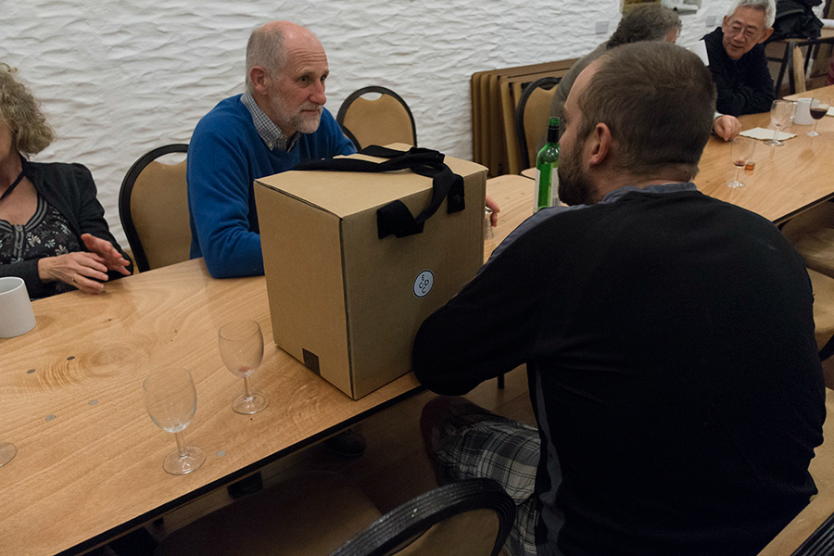

Figure 5. A deployment event.

Building on this, in several of the groups volunteers saw potential value in the Babbles as a kind of marketing tool for promoting their groups and environmental concerns more generally. The Hastings engineer, for instance, described broadcasting energy generation figures as *‘a very powerful sales tool’*. In Sidmouth, the group speculated about deploying the Babble in a local energy shop, or using it as a recruitment platform at an Alternative Energy Vehicle show. In Reepham, the group decided that one of the devices should be free to roam, initially to the Post Office and later to a variety of environmental events.

Some people were happier to relinquish a utilitarian interpretation of the Babbles during the deployment events. For instance, after listening to the device during the Meadows deployment, D decided that they would name their Babble ‘Finnegan’, in a reference to James Joyce’s Finnegans Wake. She explained that this was because the output is like ‘*a stream of consciousness*’. In New Cross, J sent an SMS message after her Babble started working: ‘*It’s amazing! I love it so much already. The messaging system reminds me of the barbed wire telephone system in Wild West. Seriously - Google it. Thanks guys. :)* ‘

## Installation and Accommodation

Installing the Babbles involved configuring the devices to local router settings, dealing with security, and setting it up to communicate using the router’s wireless network. In many instances this proved unproblematic, but in some cases, including deployment events, it proved more difficult. While none of the problems we encountered were insurmountable, they seemed to demonstrate to potential volunteers the possible inconveniences of borrowing a Babble. More serious problems arose with some of the devices we left behind. For instance, in Reepham problems with a local firewall prevented the Babble from being installed in a local primary school. Other devices were borrowed but never installed, possibly because of the perceived difficulty of set-up. Pragmatic issues were salient even for imagined deployments: for instance, in Sidmouth ideas for showing the device at the Alternative Energy Vehicle show involved thinking about powering it via a car with solar panels, and achieving mobile internet access.

## Visual and Auditory Aesthetics

The Babble has an idiosyncratic aesthetic that extends from its physical design to its auditory output. Most of the volunteers found this appealing. For instance, in Ladock, J said she and her husband appreciated the Babble because it was ‘*nice, funky looking thing*’. In the Meadows, P, an art tutor, said it was a ‘*really nice object*’ and that the microphone was a ‘*lovely visual element*’. This appreciation was mixed with some bemusement, however. Several people remarked on it having a ‘retro’ appearance, or as J from New Cross put it, the Babble looked ‘*like my gran could have had one*’. It also was compared to kitchen appliances. For instance G from Ladock, told us *'it looked like a food processor… a bit quirky*', while G in the Meadows told us that visitors to his home usually asked jokingly why he had a blender in his living room. The glass elements, too, attracted a mixed reception: R from Reepham described the Babble as ‘*beautifully made in hand blown glass*', but its fragility was a worry for the librarian of a secondary school where it was installed.

Despite some initial concerns, we received no complaints about the synthesised voices used by the Babble, and several people remarked favourably about their clarity. On the other hand, the fact of it being an audio device could be disruptive. G, in Ladock, told us he had moved it from the kitchen to the living room because it was a '*conversation stopper*’ for the family. L, in Reepham, the mother of a young baby, found it ‘*annoying and noisy… not really for a home*’. R, her husband, told us he had relocated it to his office because of this. In the Meadows, G said the Babble ‘*annoys everyone*’ so he turned it on when he was alone.

The intermittent nature of the output could also be unsettling. ‘*A few times it frightened the living crap out of me!*’, J in the Meadows told us. She elaborated that once when the office was completely silent at around 9pm, the Babble had given her a fright when it unexpectedly came on. She also complained that it ‘*didn’t talk on cue*’ when she showed it to visitors, and (like other volunteers) would have liked to be able to replay interesting outputs.

## Babble as a Source of Information

Volunteers often oriented to the Babbles as a potential source of information. This is not surprising given that the audio was designed in the style of an automated news broadcast, that many of the volunteers showed a propensity to seek utilitarian explanations for the device, and that we tended to encourage these explanations to reassure them about the system, rather than foregrounding a description and defence of the Babble as a playful, reflective system.

By the end of the field trial, however, many volunteers expressed disappointment in the Babble as a source of environmental news. In Ladock, G told us that he did hear information ‘*which was interesting*’, but explained that he did not follow many alternative sources of environmental news. In contrast, his colleague J told us that she welcomed the Babble as a source of new information, but ‘*disappointingly, not as much as I hoped’.* ‘*It seemed a bit sparse,*’ she explained, and ‘*very repetitious*’. In Reepham, R subscribes to DEC emails that he looks at in the morning: ‘*if they’re about something I’m interested in I read them*’. He told us that the Babble never provided relevant information of which he hadn’t been aware.

A recurring theme in discussing the Babble was that too much of its output was irrelevant. J, in Ladock, for instance complained that there was ‘*a lot more of the jumbly stuff* *and less of the straight stuff*’. ‘*I tend to be on the serious side*', she explained, and *'definitely the balance was wrong*'. Considerations such as these led to suggestions for filtering the output. For instance, R in Reepham speculated that the Babble could be more like a radio: ‘*you might have one stream about transport, another about food, about heating the home…*’, describing the result as ‘*far more relevant*’. To our suggestion that mixing streams might support serendipitous connections he was doubtful: ‘*people’s attention spans are getting shorter*’, he explained, so they would get bored before putting things together themselves. J, in the Meadows, also said that the Babble gathered too much irrelevant information and that it needed a ‘*filter*’ to focus on reporting news about communities and government, ‘*rather than oil and gas*’. G, also from the Meadows, echoed this, suggesting the Babble could be an app with buttons to switch on and off channels of information—a ‘*filtering mechanism*’.

There was no clear consensus across volunteers about which streams of information were worth hearing, suggesting that the ability to select among them would lead to a more utilitarian design. In the Meadows, for instance, P found the energy reports frustrating as they didn’t mean anything to him, while G, interviewed separately, said they were ‘*really really good*’. In New Cross, P reported that she couldn’t follow the ‘*technical information*’, referring both to the energy reports and the information on renewable systems. For her, ‘y*ou can connect more to personal comments, to the emotional side of energy’*

## Babble as a Medium for Communication

Volunteers had mixed reaction to the ability to input and hear comments using the Babble’s microphone and SMS facilities, and this was reflected in the relatively few messages they left on the system (about 35 over 5 months). There was an evident reluctance to enter messages. During the first weeks of living with Babble, for instance, J in New Cross made a few contributions using the microphone. Eventually her reaction became more of an ‘*internal conversation*’. She reported that when she reached for the microphone she felt nervous about saying something important to the system. Similarly, R from Reepham told us that he didn’t input much because he has ‘*controversial views*’ and didn’t want to ‘*upset anyone*’. He recounted how he had heard something on the Babble that he disagreed with, but refrained from expressing his views because he considers them quite controversial. ‘*I was aware that DECC might be listening, I want to come across as quite conservative, you don’t know who is listening*’. In the Meadows, G was concerned to prevent his daughter from saying silly things into the microphone (when asked what those might be he responded ‘*are there any fit hotties out there?*’). Nonetheless, many comments diverged from clear relevance for environmental concerns, and G was annoyed by messages he thought trivial.

The reluctance to contribute to the system ran counter to appreciation for the content that did appear. For example, J from the Meadows said she would have liked to hear more from the other communities, especially ‘*stories and tips on how they’re dealing with these issues*’. In New Cross, J enjoyed the comments: ‘*you can connect more to personal comments, to the emotional side of energy*’. Conversely, G in the Meadows would have liked to read out his household energy use, while P would have liked to broadcast his solar energy production; however there was little reflection about who the audience for these figures might be.

Finally, we had some indications that the lack of user inputs into the Babble reflected a lack of interest in communicating with other groups more generally. R, in Reepham, was clearest about this: he told us that while he occasionally kept track of what other communities are doing, differing circumstances meant that ‘*what might not be right for them, might be right for us*’. He might check for good ideas but unless something was ‘*revolutionary*’ there wasn’t much use in this. Equally, he liked telling people what worked in Reepham, but described this as ‘*reactive not proactive*’—his group doesn’t proselytise ‘*the way Transition Towns do*’.

## Appreciation for the Babble

Despite the lack of clear success for the Babble as a utilitarian information or communications product, all the volunteers we spoke with were largely positive about it. In part this reflected appreciation for it as a well-finished, device that could fit the home (Figure 6). In part, it stemmed from admiration for the Babble as a novel technical device. In Reepham, for instance, R found ‘*stimulating*’ the way it uses audio rather than visual/text as a way of encountering social media. In the Meadows, P speculated about extending the Babble’s technology, for instance to automatically tweet about his solar panels, or to nag him about his bad energy habits.

Admiration for the Babble as a novel technical and aesthetic device blended with its value as something to show to other people. C from Hastings, for example, was effusive about the Babble, describing the novelty of the device and the attention it had garnered at work, where she originally installed the device, and at home, where she took it later. R from Reepham described it as ‘*a curiosity for visitors*’ that he enjoyed to members of a number of other environmental organisations with whom he worked.

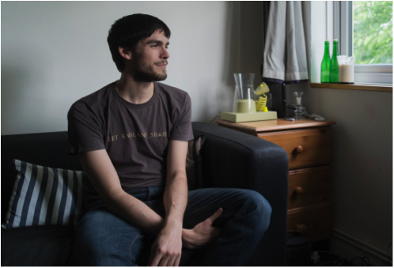

Figure 6. Babble in a volunteer’s home

Finally, several volunteers expressed appreciation for the Babble as a source of ambient awareness of environmental action. In New Cross, J told us it was reassuring to hear evidence of expertise: ‘*Thank God for people who know the technical bits, it’s strengthening to hear that there are people out there in charge*’, and more generally that the Babble gave her a sense of a larger community concerned with environmental issues: ‘i*t makes you think that you are not alone in thinking about saving the world*’. In the Meadows, J expressed a more abiding affection for the presence of the Babble: ‘*aw, I’ll miss him actually. It was nice to have him on in the background, I’m used to it now. Its quite aptly named, Babble*’.

## Babble and Wider Conversations

The accounts above all reflect discussions centred fairly closely on the Babble system as a product. What became striking to us, however, was the way that our conversations with the volunteers frequently opened from an initial concern with the Babble’s usability, functionality and aesthetics to encompass the broader and more particular issues, practices and controversies with which our volunteers were living. Though these discussions may be of questionable relevance for assessing the Babble as a *product*, we suggest that these conversations and the insights they revealed can be viewed as an outcome of the Babble as a *research tool*.

For instance, at the Meadows, during a suggestion that the Babble content should be filtered to focus on communities and government ‘*rather than oil and gas*’, J suddenly exclaimed ‘*except that British Gas are bastards!*’, and conversation with her diverged into lengthy complaints about DECC’s lack of support, British Gas call centres, and pigeon droppings building up under solar panels. In Ladock, our conversation with J about the Babble soon expanded to include her complaints about the hurdles involved in securing government funding for environmental work (‘*we think they’re rubbish*’), and the frustrations of not being able to give away radiator backdrops, energy monitors and LED down lighters at an Energy Fair she organized (‘*it was a total failure*’ that *‘didn't engage the people we set out to engage’*).

Also in Ladock, G described their attempts to put up a new wind turbine that was rejected by the council ‘*on spurious grounds*’. He attributed this to '*about half a dozen*' residents who spread '*a lot of misinformatio*n' about how the Low Carbon Living group were out to ‘*line their own pockets*', culminating in ‘*a minor punch-up*'. Like J, he expressed frustration at the difficulty in reaching out to dissenters within the community (there’s ‘*no forum to talk to those people*’), and also with the government: ‘*lots of businesses are starting up then going to the wall because the government keeps changing the rules'*. These complaints were mixed with pride in the group’s achievements. For instance, he referred to a *'story'* he put on the Babble about how on a sunny day he used his PV to charge his car and heat water: people were impressed that he could *'drive 75 miles and have hot water for absolutely nothing*'. He concluded that ‘*you can't depend on the government to do things, you can depend on the community to do things*'.

A notable theme that emerged from several volunteers had to do with the entanglement of energy concerns with other issues. For instance, R in Reepham told us he would be going to Buckingham Palace to be honoured for his contributions to energy efficiency, but said that he’d like to be recognised for the work he does that goes beyond that. The Babble should go beyond energy, he told us, to address fuel poverty, transport poverty, and take a ‘*holistic*’ view. “*Energy is a key part of it but the stories are stories about many other things*’ he said, ‘*It’s too sterile if you look at only energy*’.

Similarly, in Ladock J told us that her husband refuses to be involved with Low Carbon Living because he sees their efforts as futile. '*We should be lobbying*' she said, and mentioned the social networking activist groups Avaaz and 38Degrees as effective ('*though I understand their limits*'). She also does work with Christian Aid. *'You tend to see how it all fits together - the international aspects of climate change*'. For instance, when Christian Aid pointed out that climate change harms the poorest first, she thought they were off-topic, but then realised it was true. This led her to realise that '*how we treat the world and how we treat other people, they're all linked*'.

# Discussion: Understanding the Babble

Taking seriously the idea that the Babble played an important role in sparking the intense discussions we had with our volunteers suggests that we move beyond assessing the system according to the utilitarian characterisation of it as an information and communication product. Turning to the reflective interpretation of the Babble instead, as a system that gathers and ‘intensifies’ the existing state of discourse around energy practices, may give us another perspective on how the system worked as a research tool in our meetings with the participants, by serving as an independent actor that helped shape conversations leading to better understandings of the communities and their concerns.

A simple version of this account would suggest that the Babble should be understood as a research tool that was successful, rather than simply as a utilitarian information/communication product that was less so. The distinction between these roles is not clear-cut, however. The Babble was never seen purely as a prototype product, either by the volunteers or ourselves: we never planned to produce it commercially, and they were always aware of it as part of a research project. The Babble was never solely a research tool either: it was offered seriously for long-term use, and participants engaged with it not only to further their discussion with us but to engage with the material it offered in its own right. The product and research-tool faces of the Babble are interdependent. Here we discuss several conceptual handles on how this might be understood.

To start with, it is helpful to consider the Babble in terms of the conceptual character of the ‘idiot’, who, in Stengers’ [13] account:

resists the consensual way in which the situation is presented and in which emergencies mobilize thought or action. This is not because the presentation would be false or because emergencies are believed to be lies, but because "there is something more important". Don’t ask him why, the idiot will neither reply nor discuss the issue.... the idiot demands that we slow down, that we don’t consider ourselves authorized to believe we possess the meaning of what we know (p. 994)

From this point of view, the Babble can be seen to act as an idiot within the energy communities who used it (see [17] and Michael [9]), by confounding expectations of how technologies should contribute to the communities’ work. This was evident both during the deployments, when the Babble surprised and confused volunteers who were expecting some sort of demand reduction meter, or at least a clearly utilitarian design (‘*I wanted to solve a problem’)*, and throughout the project, as volunteers struggled to make sense of what it was doing. Instead of acquiescing to ‘the consensual way in which the situation is presented’, the Babble implicitly suggested that in the confused flow of messages about energy use, policy shifts, new technologies, and seeming irrelevancies “there is something more important”.

But what is that ‘something that is more important’? The Babble never says, but given its output this might include keeping in touch with emerging policy, sharing best practice, being aware of energy sources and demand, and joining with other communities—the very concerns identified as important by the funding programme that supported the project. But the Babble does this in the most literal, even stupid, way, and the volunteers resist it. They counter by insisting that policies are ever-changing and wilfully made difficult, that what works for one community may not work for another, that it is difficult to find meaning in statistics about energy, and that there is limited value in further contact with other communities. From this point of view, the roles are reversed: it is the Babble that presents the ‘consensual way in which the situation is presented’, and the community volunteers who are cast as idiots, asking the Babble, and us, and the policy-makers, to slow down, because we do not ‘possess the meaning of what we know.’

Our conversations with them at the end of the field trial, then, can be seen as reflecting their pent-up responses to the obduracy of the Babble. Yes, the Babble may be right in saying that there are larger concerns at play than can be addressed by energy demand meters, but what is needed is not simply more policy, more news, and more communications. On the contrary, they told us, we need better filtering, better ways to talk about energy, better situated ways to communicate, and recognition that energy use is situated in a wider landscape of local and global issues such as inequality and sustainability. And through this, they revealed their realities, helping us to understand that these ‘communities’ are shifting collections of people who constantly reconfigure themselves, and who do extraordinary work to negotiate changing policy opportunities and obstacles, to filter information about new technologies, to reach out within their own communities, and to understand when it is worth communicating more closely with others.

In the end, the Babble might be understood in terms of DiSalvo’s [4] account of how design can play a part in constructing publics. Following Dewey, DiSalvo suggests that publics form around issues, and that design can participate in this by bringing issues to prominence. He suggests two primary tactics for this: *projection*, in which designs suggest possible future manifestations of current trends, and *tracing*, in which design is used to make clear the history of current situations. To this, the Babble might add a third tactic: *concentration*, in which current accounts and discourses about an issue—in this case energy—are brought together to form, not just a neutral representation, but a focused stream that inundates listeners with the many different and potentially incompatible ways that that issue is discussed, legislated for, measured and worried about.

From this perspective, the Babble might form ‘a public’ not just via the issues that comprise it, but the issues raised by the incoherence of the babble itself. Thus the Babble begins to point toward a public that emerges out of an oscillation between different local and collective communities, variously in competition and united, informed and frustrated. Moreover, the discussions occasioned by the Babble suggests that support for situated, local communities requires better appreciation of the morass that the publics/communities must negotiate. This includes the competition/lack of communication between communities, as well as the commonalities of being placed in a relation of competition by the structure of government project funding. In highlighting these issues, the Babble may also help (re)configure a public of HCI researchers, funders and policy makers to concern itself with these realities of energy communities rather than, simply, technologies focused directly on energy demand reduction.

# Acknowledgments

We are deeply grateful to the energy communities for their participation in this research.This project was supported by the Economic and Social Research Council’s award no. ES/I007318/1 and by the European Research Council's Advanced Investigator Award no. 22652.

# References

1. Abrahamse, W., Steg, L., Vlek, C., & Rothengatter, T. (2005). A review of intervention studies aimed at household energy conservation. *Journal of environmental psychology*, *25*(3), 273-291.
2. Brynjarsdottir, H., Hakansson, M., Pierce, J., Baumer, E., DiSalvo, C., and Sengers, P. 2012. Sustainably unpersuaded. CHI 2012, 947-956.
3. Callon, M. (2004) The Role of Hybrid Communities and Socio-Technical Arrangements in the Participatory Design. Journal of the Center for Information Studies 5(3): 3–10.
4. DiSalvo, C. (2009). Design and the Construction of Publics. Design Issues, *25*(1), 48-63.
5. Dourish, P. 2010. HCI and environmental sustainability: The politics of design and the design of politics. DIS 2010, 1-10.
6. Gaver, W. 2009. Designing for Homo Ludens, Still. In (Re)searching the Digital Bauhaus. Binder, T., Löwgren, J., and Malmborg, L. (eds.). London: Springer, pp. 163-178.
7. Gaver, W. 2011. Making spaces. CHI’11, 1551-1560.
8. Kerridge, T. (Forthcoming). Designing Debate: The Entanglement of Speculative Design and Upstream Public Engagement with Science and Technology. PhD thesis, Goldsmiths, University of London, London.
9. Michael, M. (2012). “What Are We Busy Doing?” Engaging the Idiot. Science, Technology & Human Values, 37(5), 528-554.
10. Schultz, P. W., Nolan, J. M., Cialdini, R. B., Goldstein, N. J., & Griskevicius, V. (2007). The constructive, destructive, and reconstructive power of social norms, Psychological Science, 18(5), 429–434.
11. Sengers, P. and Gaver, W. (2006). Staying Open to interpretation. Proc. DIS 2006.
12. Shove, E. (2004). Comfort, cleanliness and convenience. Berg.
13. Stengers, I. (2005). The cosmopolitical proposal. Making things public, 994-1003.
14. Strengers, Y. (2013) Smart Energy Technologies in Everyday Life: Smart Utopia? Palgrave MacMillan.
15. UK Research Council (2010), Energy and Communities call for proposals. http://web.archive.org/web/  
    20100813103416/http://www.esrc.ac.uk/ESRCInfoCentre/opportunities/current_funding_opportunities/Energy_and_Communities_Collaborative_Venture.aspx (accessed 22.09.14).
16. Wilkie, A. (2013) Prototyping as Event: Designing the Future of Obesity, Journal of Cultural Economy: 1–17.
17. Wilkie, A., Michael, M., & Plummer‐Fernandez, M. (2014). Speculative method and Twitter. The Sociological Review.
18. Wilkie, A., Michael, M., Kerridge, T., Gaver, W., Ovalle, L,. DiSalvo, C., Gabrys, J., (2012). Design, STS and cosmopolitics: From intervention to emergence in participation and sustainability. Proc. EASST 2012.

1. The groups were: Energise Hastings; Greening Goldsmiths; Low Carbon Living Laddock; Meadows Partnership Trust; Reepham Green Team; Sid Valley Energy Action Group; Transition New Cross.