“Daughters are just like sons now”: Negotiating Kin-work and property regimes in Kolkata middle-class families
Henrike Donner
Goldsmiths, University of London
New Cross
London SE14 6NW
H.Donner@gold.ac.uk
Profile
Henrike Donner is an urban anthropologist with interests in kinship, gender and urban politics. Amongst her publications are Domestic Goddesses: Maternity, Globalization and Middle-class Identity in Contemporary India (Ashgate 2008) and the edited volumes The Meaning of the Local: Politics of Place in Urban India (with Geert De Neve, Routledge 2006) as well as Being Middle-class in India: A Way of Life (Routledge 2011).
Keywords: Property; Gender; Kolkata; Middle-Class; Family Change
Abstract
This article draws on two decades of fieldwork with middle-class families in Kolkata, India. It addresses property regimes with reference to inter-generational and gender relations, which leave women in an ambiguous situation with regard to ownership rights. Focusing on genealogies of different middle-class homes, the article examines how women’s rights in housing continue to be mediated through the joint family ideal and patrilocality. Whilst new ideals of homeownership and modern family life influence the middle-class imagination, talk about ‘homeownership’ does not necessarily reflect the realities of middle-class family life. Paying particular attention to the role of women at different lifestages, I argue that the current re-imagining of middle-class femininity through ‘modern homes’ remains deeply embedded in earlier discourses of the ideal family, the related residential patterns and modes of property transmission as well as domesticities. This draws attention to the way women can gain as demographic change favours single daughters as heirs to homeowners. Focusing on the family and women’s roles within it allows us to study how real estate markets are experienced from the bottom up and provides genealogical depth to an understanding of different forms of ‘modern’ middle-class homes in the city.

Introduction
Like other Indian metros Calcutta has not only changed its name, but the newly revamped Kolkata has seen its fair share of urban restructuring. Much government funding has been directed towards expanding housing for middle-class consumers, which has made the construction industry the most rapidly expanding sector of the local economy (Fig 1).
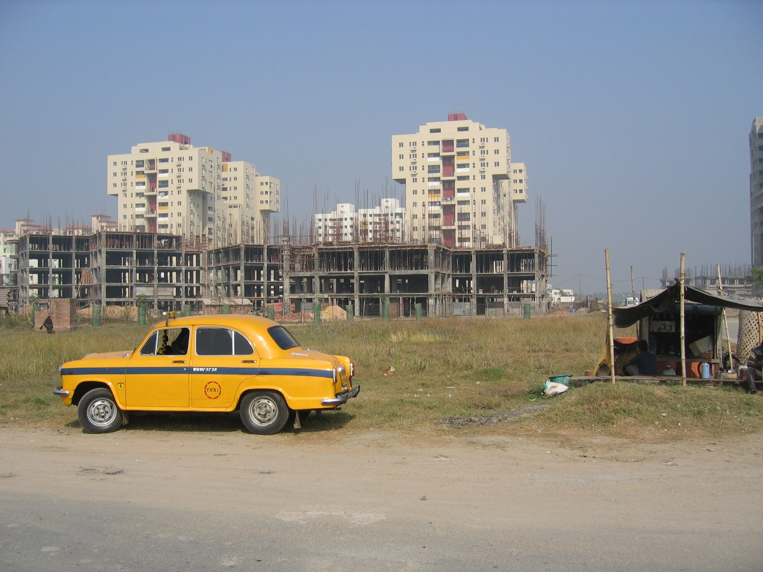
Figure 1 Construction site in Eastern Kolkata’s Rajarhat township 2005
Today, the imagery of condominium residences, malls and related markers of ‘global’ city status signify desired lifestyles, and middle-class Kolkatans are expected to see ‘owning a modern home’ as a an aspirational goal and a value in itself. Whilst urban planners struggle to accommodate the new developments and the demand for land, infrastructure and resources, a politics of appropriation and displacement has altered the politics of urban space. The resulting material transformations - flyovers, high-rises, special industry zones and exclusive housing developments - indicate deeper ideological transformations of the way middle-class residents see their own lives. It is the lifestyle of this section that drives the implementation of a specific kind of modern urbanism, exemplified by gated communities, ‘greening and cleaning’ drives, extensive leisure facilities and individualised transport, which all require a re-ordering of urban space.
The evolving spatial politics are re-shaping even the most intimate aspects of everyday life, including the homes that middle-class families occupy. Key among the means by which urban development is realised is the promotion of real estate, driven by the growing affluence of the middle-classes and the availability of new financial instruments. But such new possibilities and references meet older ideological and structural constellations that shape the way urban transformations appear on the ground. This article addresses two issues that affect how property is understood by middle-class families in Kolkata: the recent history of housing for middle-class families in the city and the intra-household negotiations around joint living.
Whilst there is no doubt that new ideals of homeownership influence urban landscapes as well as the middle-class imagination, I examine how talk about ‘buying an apartment’ and ‘homeownership’ are middle-class aspirations that do not necessarily reflect the realities of middle-class family life. Paying particular attention to the role of women at different lifestages, I argue that the current re-imagining of middle-class femininity through ‘modern homes’ remains deeply embedded in earlier discourses of the ideal family, the related residential patterns and modes of property transmission as well as domesticities. Focusing on the family and women’s roles within it allows us to study how real estate markets are experienced from the bottom up and provides genealogical depth to an understanding of different forms of ‘modern’ middle-class homes in the city.
The close connection between ideas about modernity, family and gender in West Bengal has been analysed in work ranging from the pre-colonial to the late colonial period, with particular reference to the rise of a discourse on ‘modern’ families. Earlier, women’s relationship with property varied considerably in terms of region, ethnic and religious group as well as stage in the life course, and powerful claims to property were inscribed in many local codes of conduct. Scholars have shown that debates about property and gender among Bengali Hindus were central to the emergence of nationalist aspirations of the nascent middle class. Even today, homeownership continues to reflect a powerful ideology of patrilineal joint family living realised most successfully in middle-class families, and the locally valued idiom of ‘putting the family first’. However, how this ideology and its related care arrangements work in practice for younger generations today is rarely analysed. Yet, tensions abound between older ideas about joint ownership and male succession, on the one hand, and emerging preferences for nuclear households and neo-local living arrangements, on the other hand. Key to these tensions are new conflicts over women’s legal rights in family property as well as their control over partner choice, residential patterns and relations with natal kin. In this context, a substantial body of literature on women, property and law, particularly with reference to the ways in which ownership was reformulated along patriarchal lines during the colonial period, exists. More recently, the extensive debate around various reforms of personal codes shows the importance attached to issues of property, kin relations and gender rights (Agnes et al., 2012). However, moving beyond the legal construction of rights, I will explore here how young women manipulate and strategize around notions of ‘joint’ living and expectations of patrilocality after marriage (Basu, 1999).
Whilst women’s rights have greatly improved and property rights in particular have been included in the revised versions of the Personal Codes, women’s actual access to property is more often than not still governed by older ideas about dependency, patrilineality and collective, but male controlled, ownership. Uberoi has rightly pointed out that the new ‘cosmopolitan, all-India middle and professional class is not conspicuously cosmopolitan in its kinship and marriage practices’ (Uberoi, 2006, p.22). The same holds for women’s rights in property, which continue to be mediated by the joint family ideology, even where nuclear families may proliferate in practice. The joint family ideology not only structures marriage negotiations and residential patterns but also shapes gender divisions of labour, decisions over reproduction, care arrangements for the young and elderly, and women’s overall agency in the home. It is to these ways of making homes, the social relations and built environment that the article draws attention.

The middle classes and urban change
The ethnography on which this article is based stems from two decades of fieldwork in Calcutta/Kolkata, mostly with Bengali-speaking Hindu middle-class families, many of whom I have known from when liberalisation policies came full circle in the 1990s. As has been widely acknowledge, urban transformations and the emerging spatial politics evident in large cities and smaller towns (see De Neve, this volume) play a pivotal role in the construction of contemporary Indian middle-class identity (Appadurai, 2000; Fernandes, 2006; Liechty, 2003). Middle-class ideas about the good life, desires for upward mobility and demands for services – ranging from leisure facilities to housing to transport - guide urban restructuring. Furthermore, middle-class discourses and values also inform the workings of legal and political institutions (see Raman and also Cook, this volume) that govern urban life, while middle-class practices of place-making reproduce privileges and exclusions (Liechty, 2003; Fernandes, 2004; Srivastava, 2012).
From the mid-1990s onwards, when I started working in the city, Calcutta came to be re-imagined by planners and politicians in the light of such middle-class lifestyles. This culminated in the reassignment of large swathes of land on the eastern periphery, known as the “wetlands,” for urban development, a process that gradually changed the planning, legal and political landscape of the city and its hinterland. As Dey, Samadar and Sen (2013) argue, the politics of misappropriation are based on crucial shifts in the way that land is understood and governed, capital is created and accumulated, and in the process, the interests of the state and local elites intersect. Or, as Bose (2015) has shown, the re-imagination of places like the former wetlands as sites for development is inextricably linked to hegemonic transnational middle-class discourses which feed into coalitions between planners, developers, and voters. Thus, a real need for housing, as well as the relentless promotion of consumerist global lifestyles and of the ideal figure of the apartment-owing non-resident Indian, created the basis for shifting ideas about property. Together with new workplaces in IT, leisure pursuits have shifted to up-market sites, and eating out and shopping have increased in importance. It is in the context of consumerist lifestyles that the purchase of an apartment became associated with the desired global lifestyles.
In a state and a city where the formerly ruling Left Front had earlier turned a blind eye on urban decay, such consumer desires were articulated only from the mid-90s, when middle-class votes began to be actively vowed. Whilst ‘modern’ housing had been introduced with the proliferation of small developments - usually under cooperative law -, increased attention was now given to high-profile investments in the vision of a ‘global city’ and housing for ‘a new era’. Large infrastructure projects and the perceived need for private developments allowed middle-class citizens to feel part of a new world. A number of scholars have shown how the notion of the ‘global’ city resonates with Indian middle-class sentiments and inspires the hegemonic politics of middle-class identity and consumer citizenship (Dupont, 2011; Baviskar, 2011; Ghertner, 2011). Indeed, urban middle-class lifestyles are driving processes of restructuring that bring together international and local capital, initiate new forms of exclusion, and lead to a rewriting of class-relations through segregated urban developments across India. These processes are based on large-scale evictions, but as Raman (this volume) shows, also gradual processes of displacement (Rao, 2013; Dey, Samaddar and Sen, 2013; Bose, 2015; Searle, 2013; Harvey, 2004; see also De Neve, this volume).
Amongst the most pertinent signifiers of such processes are high-end, luxury developments, which act as points of reference for a desired new urban modernity that middle-class citizens aspire to. While such exclusive projects may remain out of reach for the majority of residents, their very existence and associated aesthetics feed into middle-class imagination (Rajagopal, 2001; Anjaria, 2009; Ghertner, 2011). It is the very materiality of changing cityscapes that feeds middle-class desires to ‘own one’s own home’ and intensifies aspirations of private homeownership (Heller and Fernandes, 2006). While most families I work with will never live in ‘residences for the 21st century’, play golf on the lawn or use luxury spas, they are nevertheless encouraged to think about inhabiting different, ‘truly’ modern, spaces and to aspire to own a ‘home’ of their own (Fig. 2).
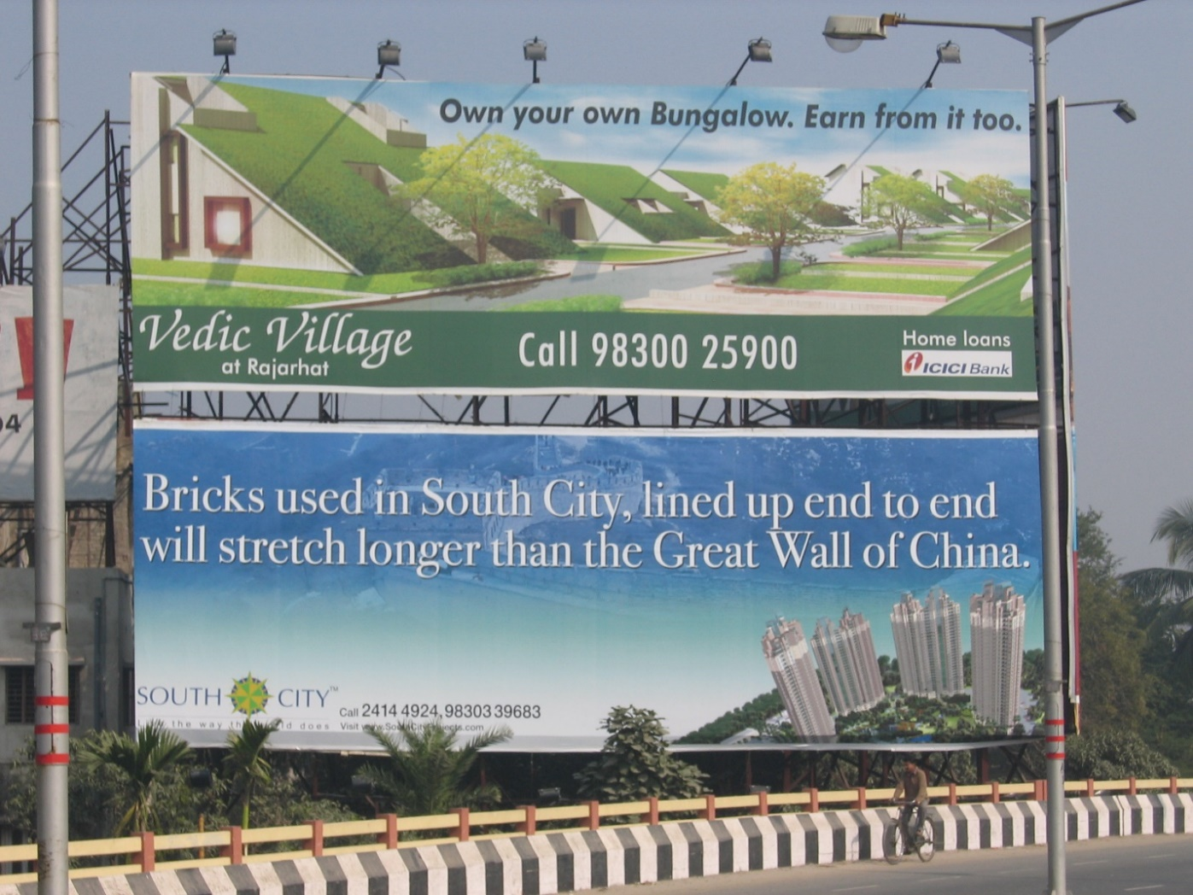
Figure 2 Advertisements for Luxury Developments
As Rao’s recent work (2012) on the genealogy of apartment life in Mumbai suggests, ‘flat living’ and ownership are not a natural progression from earlier forms of urban residential organisation. Rather, new modes of housing reflect changing state policies and notions of citizenship that feed off class-specific aesthetics and identities formation (see Brosius, 2013; Srivastava, 2012). Until quite recently, apartment living in fact retained negative connotations, associated as it was with ‘postings’ and badly maintained government housing in inconveniently distant suburbs. In Calcutta of the 1990s, though women sometimes described employer-provided accommodation as providing freedom from oppressive affines, my interlocutors remained rather critical of life in a ‘flat’. Today, however, significant shifts have taken place in the range of meanings attached to apartment living, and housing ‘developments’ in particular, with gated communities being viewed more favourably by younger couples than elderly relatives. In contrast, for the younger generation buying a flat has become a more attainable alternative, with banks, developers and popular media all contributing to the vernacularisation of real estate markets (Fig 3).

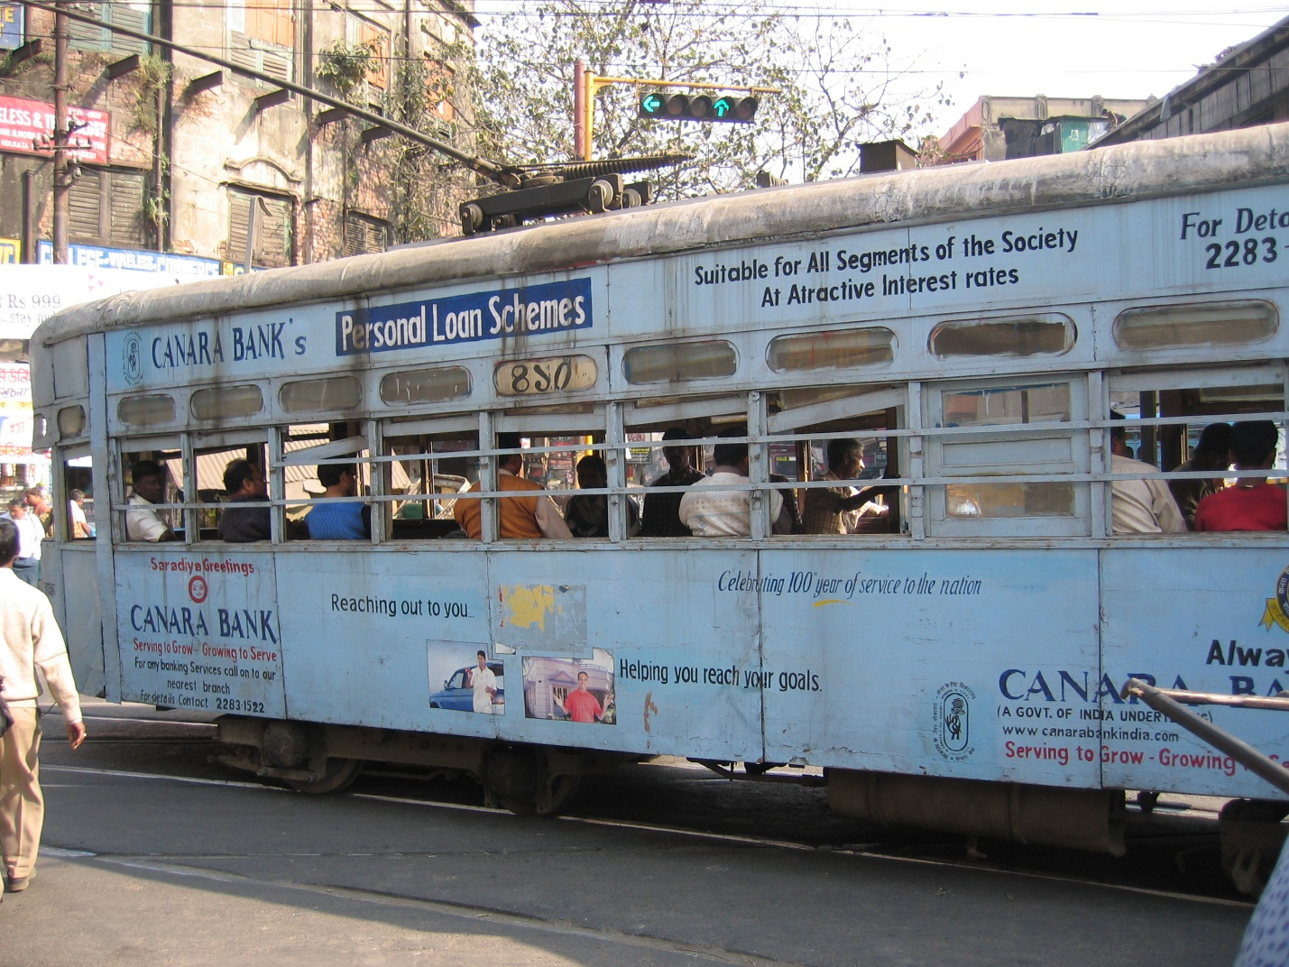
Figure 3 Advertisement for loans on tram in 2005

Property, Family and Gender
Alongside the post-liberalisation building boom in Indian cities, property has also experienced a come-back in anthropology. Whilst much current interest in property stems from questions regarding fluid, flexible forms of property and personhood (such as cultural property or DNA) (see Strathern, 1984; Maurer, 2004), the collapse of socialist regimes has also brought questions of land and real estate (Hann, 1998; Verdery and Humphrey, 2004). These studies challenge the primacy of economic rationality in the decision-making processes of communities, families and individuals. They also show how ‘possessive individualism’, whilst a powerful notion, remains contested and context-dependent. India is clearly not a post-socialist state but collective forms of ownership in housing are common and complex property regimes can be identified. Such arrangements are often at odds with new legal, financial and political notions of individualised ownership that feed into discursive constructions of ‘propertied citizenship’. The latter is embraced by government agencies and consultancy bureaus, like McKinsey, who advise the Indian government on how to embed global property regimes within local economic reforms (McKinsey Global Institute 2001).
With reference to India, studies of the pre-colonial period - like the seminal collection edited by Chatterji (2004) - provide fascinating insights into a variety of distinct arenas within which kin networks and property transmission were crucial to the construction of gender roles and status. The demise of women’s autonomous access to property in the colonial period has been charted by scholars who focused on the consolidation of specific ideas about marriage and the family. Reforms served as a way to legitimize claims to communal and national identities amidst socio-economic change. Chatterjee (1989) has shown that women came to represent the nation, whilst women’s culture and autonomy was marginalized (Banerjee, 1989). New laws governing marriage and property transmission resulted in separate civil codes for different religious communities. These codes embraced enshrined notions of ‘custom’ and tradition, and they solidified patriarchal kin relations (Sturman, 2012). With reference to Bengal, Majumdar (2009) discussed arranged marriages and patrilocality as pillars of the joint family ideal amongst the emerging middle classes. That these processes were not exceptional is proven by Sreenivas’s study of similar processes among members of an upwardly mobile, urbanizing South Indian caste (Sreenivas, 2008). Similarly, Agarwal (1994) charted the practical exclusion and legal marginalization, which deprive rural women from rights in land across the subcontinent. This body of research reveals how from the colonial time onwards, the dichotomy between individual and collective ownership enshrined in personal laws came to bear on the institution of the family. The emerging Bengali middle class adopted an ideological separation between the secular, public domain and the supposedly private, domestic and traditional sphere of the family. Womens’ domestic roles and the collective interests of the patriline determined their agency, and strict inter-generational and gender hierarchies were enforced. Thus, the legal conceptualisations of property became associated with the patriline, and various customary arrangements streamlined following upper-caste practices.
Most important to my argument is the gradual establishment of the ‘joint family’ as the norm, ideally defined as a patrilineal and patrilocal kin group sharing a household. Based on the pillars of arranged marriage and patrilocality, the joint family ideal remains a useful means to reproduce hierarchical gender and age-related roles within the home. In its wake, men and women alike are subjected to collective strategies. This ideology naturalised the patriline as a collective, property-holding unit, enshrined in law with ‘customary’ patriarchal values at its heart. In a rare study of middle-class property regimes in post-independence India based on data collected in the 1980s, Srimati Basu discusses the way such norms impact middle-class women, as they are systematically excluded from controlling property as daughters, sisters and wives (Basu, 1999). Dealing with the legal domain, Patricia Uberoi has shown how court cases further enforce this discrimination as (Hindu) women are defined as dependents of their fathers, husbands and sons (Uberoi, 1995; Basu, n.d.).
When I began to work with married women in Central and South Calcutta neighbourhoods in the 1990s, court cases revolving around property disputes were common. One of my first interlocutors was a married mother of one child in her mid-thirties called Sankari. I met her many times in her small two bedroom apartment, which formed part of one of the large family properties in this part of Central Calcutta. The property was owned by her husband and his two brothers, but she and her nuclear family had their own quarters. Sankari was at the time happily married and had no intention of leaving her affinal home. With only an ageing mother-in-law, husband and an almost 18-year-old son to look after, she had spare time and a degree of control over her affairs. She taught in a far-away government school and engaged in local politics with high hopes as an early associated of political newcomer Mamata Banerjee. But she also told me early on that she spent huge amounts of time and effort on a court case involving her two brothers, who shared her natal home and expected her to hand over her legal share to them. This, she refused flat-out, arguing that the days when sisters would just meekly hand over their share in inherited property were over. In common with others I met during my fieldwork, she saw this not only as her right, but also as a safety net in case things in her affinal home went wrong. As I quickly realised, sisters did not only routinely sign away their rights in parental property, but both parents and brothers saw this arrangement as fair. After all, the natal family had already invested in their marriages and thus a sister did no longer form a part of her natal household. Conflicts arose quite often and a considerable number of women admitted taking their brother(s) to court in order to gain access to family property.
In stark contrast, women who separated, divorced or were widowed, usually did not take the same kind of action and their ‘rights’ in property were highly insecure. This was the case with Hema, who I frequently visited in her affinal family home, a beautiful, large and old style house spread out over three floors around a courtyard. Childless and widowed a couple of years earlier, she had been forced to move into a dingy ground floor room, in which she kept all her belongings. Whilst her in-laws were influential players in the neighbourhood, she struggled to make ends meet. Shortly after her husband’s death she had been told that her days in the house were numbered, and since then battled to hold on to her room. For Hema, and others in her position, the fact that her husband had been coparcener in a joint family home did not in any way guarantee access to a legal share in the property. Clearly, what women were experiencing was the – illegal – claim that Hindu married women leave paternal homes accompanied by her their sole inheritance in the form of a dowry and have no right to property in her affines’ home. Clearly, in these cases, whilst legal provisions are made on the basis of individual rights, property is constructed in terms of exclusions and inclusions related to the family in accordance with the ideology of the patriline. Since women are never fully members of these bangshas (patrilines), all of the women I spoke to argued that women’s ambivalent status as members of affinal households makes them particularly vulnerable where property rights, rights to residence, and shelter are concerned. Thus, in the next section, I discuss how the ideal of the joint family frames the way women and their families negotiate old and new property regimes.

Moving out or staying put: Property and the joint family morality
With the current construction boom in full swing, it seems inevitable that more and more middle-class families invest in property and move into the small apartments that make up the bulk of the new housing. Especially in areas like conservative Taltala in Central Calcutta, housing is often in a dire state and it is no surprise that members of households sharing cramped two bedroom flats prefer more modern and practical accommodation. In the light of chronic shortage of space and the actual condition of residences, moving out seems to represent the only viable option to lead acceptable middle-class lives. But as Susewind argues too (this volume), despite widespread discourses associating suburbia with modernity, whole communities stay put in city centres. It is therefore important to ask why not all young couples move into apartments and how such decisions are negotiated. As mentioned before, in the 1990s as today, residents of old Calcutta neighbourhoods would highlight the disadvantages of life in suburban apartments. Older areas had in their view definite advantages. As in the case of ‘old’ Calcutta more generally, Taltala’s dwindling cultural relevance still signified positive values of middle-class Bengali culture, and growing up in the area was tied to notions of appropriate tradition. In areas like this, residents often stated that (middle-class) children were brought up in joint family homes, and women, in particular, were exemplary in their devotion to their roles as housewives and mothers. Unlike former refugee colonies, where women had joined the labour force and which had a reputation for more liberal educational ideals, to belong to a traditional inner-city family was a matter of pride and implied an embrace of the proverbial ‘orientation towards the family’. But such a distinction between modern homes and older residences in terms of the kind of families and female roles they produced was also common amongst interlocutors living in the suburbs. Mostly stemming from refugee Hindu families who came to Calcutta after partition, many had experienced the transformation of formerly ‘jungli’ sites into affluent, modern suburbs. Due to the settlement pattern such suburbs were extremely homogenous, a fact that made them desirable and particularly suitable to bring up daughters.
Here, many women were in employment, but as in Taltala, where women’s roles were circumscribed by their domestic roles, the value of an in-marrying woman is often described in terms of her ability to ‘adjust’ closely associated with the demands on her labour power made in the affinal home (Donner, 2008). Morally justified, but in reality often a thoroughly unpleasant phase of life for young women, the new daughter-in-law’s experience of joint family life differed starkly from that of the mother-in-law as they were expected to immerse themselves in the ‘customs of the home’, which included everyday rituals, culinary traditions and religious observances. It is therefore the younger women who mentioned the dream of living ‘separately’ most often. However, the same women realised quickly that their spouses were not likely to move out, as young husbands who grew up in these joint family homes were usually ill-equipped emotionally as well as financially to make such an ambitious decision.
Firstly, sons were brought up in homes which they were going to inherit, or take over (in the case of rented accommodation). Secondly, Bengali Hindus follow the Dayabhaga code of inheritance, property is only partitioned after the father’s demise, which means that generations of men are tied together for longer periods of time than is the case in other communities. Thirdly, in less affluent families, capital bound up in property - whether as a plot, a multi-storied building in the city centre or a small apartment in a cooperative housing complex - was held in the name of the older generation. Staying put, a husband avoids rupture to social relationships, including those extending beyond the close family, for example in the neighbourhood. Husbands were more often than not keen to save on rent, whilst wives may consider that a small price to pay for some independence. Moreover, husbands felt a great obligation to fulfil their filial duty. But it was the share in the family property that usually featured as the main incentive to remain ‘joint’. Even couples who could easily afford to rent elsewhere put up with a lack of privacy and control over their lives in order to stake a claim in the parental property in the name of their children.
Today, legal and demographic change has shifted conflicts over property away from problems between brothers and cousins towards problems between brothers and sisters. This enhances the likelihood of conflicts over the correct interpretation of customary obligations, practices of care, and discourses on rights. The field of gendered negotiations over property inheritance is shaped by the customary expectation that sisters will leave their share of the parental property to their brothers, and more recently by the legal elaborations of the Hindu Succession Act of 2005.
In Taltala, and in many other parts of old Kolkata, ‘ownership’, including tenancy rights, was often ill-defined due to the close entanglement of all members of the joint household with their multiple - and often opposed - needs and spatial practices. This spatial proximity and incoherent narrative of access and rights causes everyday tensions which cast a shadow over so many of my interlocutors’ lives, and made many of them imagine apartment life as easier. Especially women, who spend much of their time at home, may feel incarcerated in residences they have no stake in but cannot leave for the sake of their children. In contrast, homes in South Calcutta, whether in the older areas or the newer refugee colonies, were designed with smaller joint units and more obvious living arrangements in mind. Using modern materials and incorporating amenities like bathrooms and separate kitchens on each floor, self-builds were designed with independent units in mind. Initially, ‘modern’ homes had been the domain of the affluent professional elite, whose dwellings accommodated larger collaterally–related units, but provided space of privacy and independence from the households of brothers and cousins. Looking beyond these elite residences, the same concerns, claims to modernity and modern amenities were incorporated in a second phase of self-builds, on a smaller scale but distinct from Central and old Calcutta homes, which emerged in the refugee colonies. These much more simple designs belonged to upwardly mobile East Bengali families, and like the homes of professionals, still represented jointly held property. Thus, women’s access to property was in both ‘modern’ settings determined by their status as dependent daughters or married wives, and being a mother was the focus of all property discussions. Whilst even in the 1990s women would still argue that the indirect control over property via men hampered their own fulfilment, mothers increasingly referenced neoliberal values like choice and autonomy as key to negotiations about residence. At the same time, the most pervasive cultural construct that still prevented breaking up a joint family became issues related to the expectation of co-parenting with grandparents. As Bhaswati, a mother of a two-year old, who shared a ‘modern’ home with her in-laws and her husband, pointed out, although she resented her mother-in-law’s domineering attitude and longed for a separate nuclear unit, a single woman could not possibly take care of a child on her own. This is a widespread sentiment irrespective of the availability of domestic help (Donner,2015). Moreover, the ideology of filial duty and real concerns about care for an elderly parent often persuade the younger generation to stay put. Property is after all seen as an asset consciously transmitted, and access to a home is mediated by the perceived duty to care for elderly parents. As Lamb (2008) has shown, whilst the reality of international migration and changing demographics has led to the introduction of senior citizens’ residences in metropolitan Kolkata, these are still exceptional arrangements. Instead, as my own ethnography suggests, the current generation of elderly middle-class couples is often in a position to negotiate residence and support in later life through gendered inheritance patterns. It was with reference to women, children and the elderly, that the joint home was depicted as enabling moral forms of family life. However, as demographics change, financial opportunities evolve, and neoliberal ideas of the self take hold, competing values of coupledom, nuclear families, individualism and autonomy came to the fore. As women’s understanding of their own rights, their work in the home, and their role as daughters and wives began to change, their access to property is was re-negotiated in the light of new cityscapes. It is to these transformations and negotiations that we now turn.

Genealogies of homeownership and domesticity
In what follows I present genealogies of middle-class homeownership and domesticity in Kolkata, by focusing on three types of residences and forms of occupancy. I begin by tracing the residences built at the end of the 19th century by Bengali business families in Central and North Calcutta, near the still thriving bazaars. In areas like Taltala, the neighbourhood where I did my doctoral fieldwork in the mid-1990s, we can still find street after street of generously laid out, but now dilapidated, middle-class houses, often adjacent to small slums (Fig. 4). Such homes are often still owner-occupied, usually by multi-generational and often collaterally-extended households, with parts occupied by tenants. They often contain a significant number of separate units, with complex relationships between access to shelter and ownership between co-parceners. Often commercial activities and workshops could be found on the ground floor, with the owners’ families living higher up (Fig 5).
. 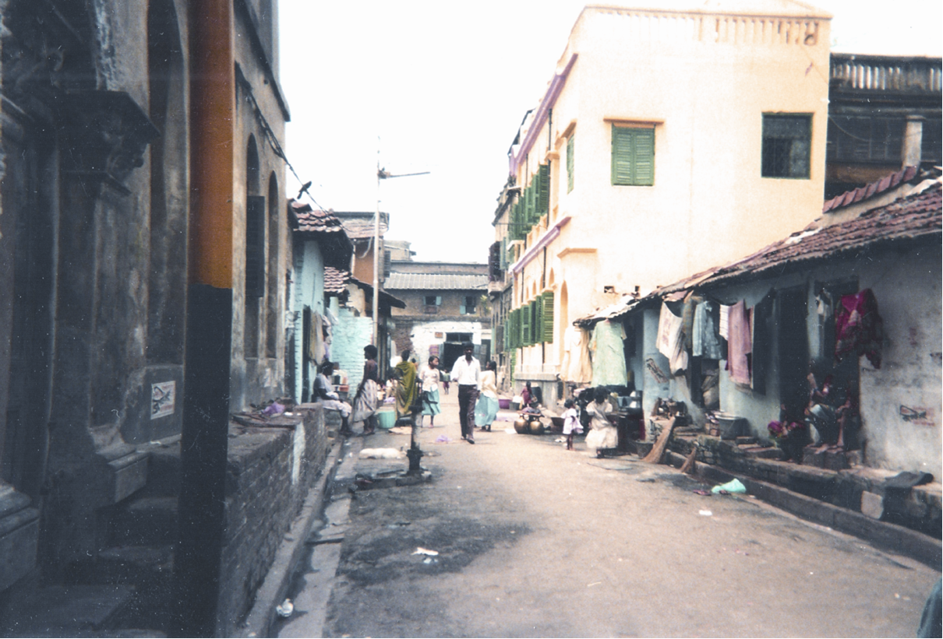
Figure 4 Street Scene Taltala
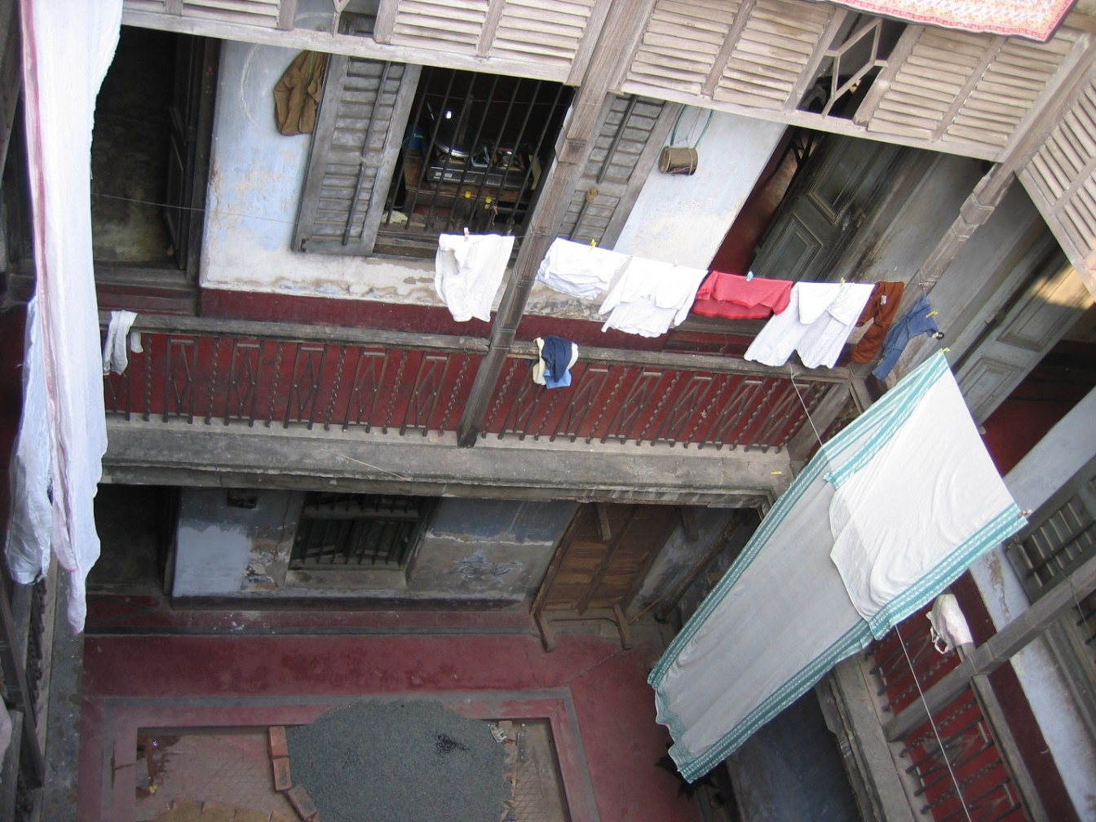
Figure 5 Taltala shared joint family home
For women I interviewed in the 1990s, such multi-level spatial arrangements were often the main cause of tension, as the daily routine of collaboration with other women shaped their experience of the home. In many such mansions, conflicts simmered across courtyards. Even then, fantasies about ‘modern’ families circulated, and some very dissatisfied daughters-in-law dreamed of moving out. However, at the time, few of the households I visited availed of the necessary funds to act on such desires. Furthermore, as far as the public image of it was concerned, many women were adamant that living in a flat as a nuclear family was not desirable and would seriously damage both individual and collective reputations.
By contrast - and as a second type of residence - the ‘modern’ homes built for the affluent, more cosmopolitan and professional, upper middle-class elites were explicitly designed to reflect ‘modern’ ideas without challenging ‘tradition’. A new separation between ‘private’ and ‘public’ space acknowledged parents and their children as a unit, but also the separation of home lives and business. Such houses were constructed in South Calcutta from the 1930s onwards, and were usually generously designed by owners and builders, and as McGowan (n.d.) points out, the blueprints for such self-builds reflected nascent ideologies of middle-class consumerism. The patriarchal family organisation took sons’ interests seriously, and whilst the ground floor housed clean occupations, like a doctor’s or lawyer’s practice, women’s quarters were segregated upstairs. In their own way, these buildings exemplify the circulation of new ideas about family and class, enabled by a modernised joint family ideology. Just like with current developments, novel materials too enabled and signified modernity. Concrete allowed amenities associated with Western middle-class lifestyles, like bathrooms, to shine and appear hygienic, while ventilated kitchens were a concession to the educated housewives, assisted by servants but literally standing above them. Here, an emerging cosmopolitan elite re-ordered domestic space in accordance with new parenting, affinal and gender relations, and created a vision of what an aspirational middle-class lifestyle should look like through homeownership and domestic architecture.
However, women’s ownership of homes remained insecure and contested, to say the least. The new priorities of companionate marriage and two-generation, rather than collateral living and parenting, reflect the diminished importance of fraternal links. However, daughters and sisters were still not given a stake in these properties. Crucially, their role of housewife took centre-stage: usually a mother-in-law and her single daughter-in-law worked together, and the spaces in which servants worked became more distinctive, i.e. roofs, courtyards, ground-level basins and the like. To add to the convenience and status of such affluent families, separate servant quarters were often added.
Figure 6 Owner-occupied home in former refugee colony
The third distinctive type of residence to shape today’s understanding of the ideal family home, is to be found in the former refugee colonies (Fig 6). These neighbourhoods are clearly close predecessors of the urban ‘developments’ of today, as they are largely homogenous, provide access to homeownership to broad sections of the middle classes, and are explicitly ‘modern’. Here, two-generation households dominate and the neighbourhood has a distinct community feel, so that second and third generation residents today are often reluctant to move. But given that families have grown, they might find themselves restricted in terms of space and privacy as such homes are laid out to keep together a couple and their sons’ families. Such arrangements, whether homes are owner-occupied or rented, provide the blueprint for the apartment buildings found across the city today.
The explicitly ‘modern’ character of these homes is manifest in the materials used, which include terrazzo floors and wide glass windows, and a design for two or more nuclear units to share the building. Such homes were erected from the late 1970s onwards, and were intended to accommodate two families comfortably on separate floors whilst connecting them through external staircases. Such houses - though usually much smaller than the ones built by professional elites earlier on - provide a definite sensitivity for modern amenities: their kitchens usually boast built-in cupboards and worktops, and larger, purpose-built bathrooms are equipped with ‘western’ toilets. And while they are a far cry from domestic splendour expected in luxury apartments today they too provided ‘an indispensable ground for the making of global modernity’ (Srivastava, 2012: 62).

Amenities of Domestic Life
In spite of all these historical variations in housing stock for middle-class residents, most of it was used by two or more generations simultaneously over prolonged periods of time. Housing was rarely seen as an investment, and income generated by rent was usually very limited. Given the low returns, housing stock in old areas of Calcutta is now in a state of disrepair and, if anything, tenants pay for repairs out of their own pocket. But by the end of the 90s, many residents began to invest in their properties, even those who rented. Thus, Sankari, a housewife in her 40s, proudly showed me the newly ‘refurbished kitchen’ of the flat she shared with her husband and adult son. This, as other such arrangements I have seen, consisted of a roughly tiled square acting as a splashback, a metal sink and a new tap, substituting the buckets her maidservant had used previously to wash the dishes. At the time, such alterations were already very much driven by a desire to appear modern and to mimic the concerns of those buying newly built flats. However, unlike Srivastava’s up-market residents in a Delhi gated community (2012), here efforts at modernising were usually extremely modest. In most instances, the refurbishment of flats in shared or rented houses remains limited to bathrooms and kitchens, and the odd lick of paint applied elsewhere every so often. More drastic changes are usually only embarked on in the run up to a wedding, and these can include whole storeys being added to an existing residence. Thus, Sankari’s family was not alone in investing in other amenities before redecorating the kitchen.
Though the many of my interlocutors occupied rented accommodation over at least two generations, even amongst those who owned their home, refurbishments have only very recently moved up the list of priorities. This has, as Srivastava and Brosius have pointed out, happened because ideas about what makes suitably middle-class housing are changing, not in the least due to media representations of upmarket housing, interior design, and ideals of individual homeownership (Brosius, 2013; Srivastava, 2012). However, the vast majority of middle-class citizens, and certainly middle-class Kolkatans, are not yet living in such environments. They take part by consuming media narratives created around such new domestic styles. Not surprisingly, the negative discourse around apartment living, which was prevalent in Central Calcutta and among the more privileged South Calcutta families up until the 1990s, has more recently given way to a general disdain for the state of old-school accommodation. The firm pride of those who had a stake, however fragile, in joint family properties, has now been dwarfed by discourses about privacy, coupledom and nuclear family life, all to be materialised through the built environment (Fig. 7). But it is crucial to note that these concerns are not new, but existed in the ‘modern’ suburbs for several decades. The important factor is that they have now spread as part of a generalised aspiration for appropriately middle-class consumption, which is inward rather than outward looking. Thus, whilst Srivastava rightly observes that creating a home through interiors is particularly important in situations where earlier meaningful neighbourly relations are diminishing, middle-class home remains informed by conversations about the family and its contemporary transformation (Srivastava, 2012).]
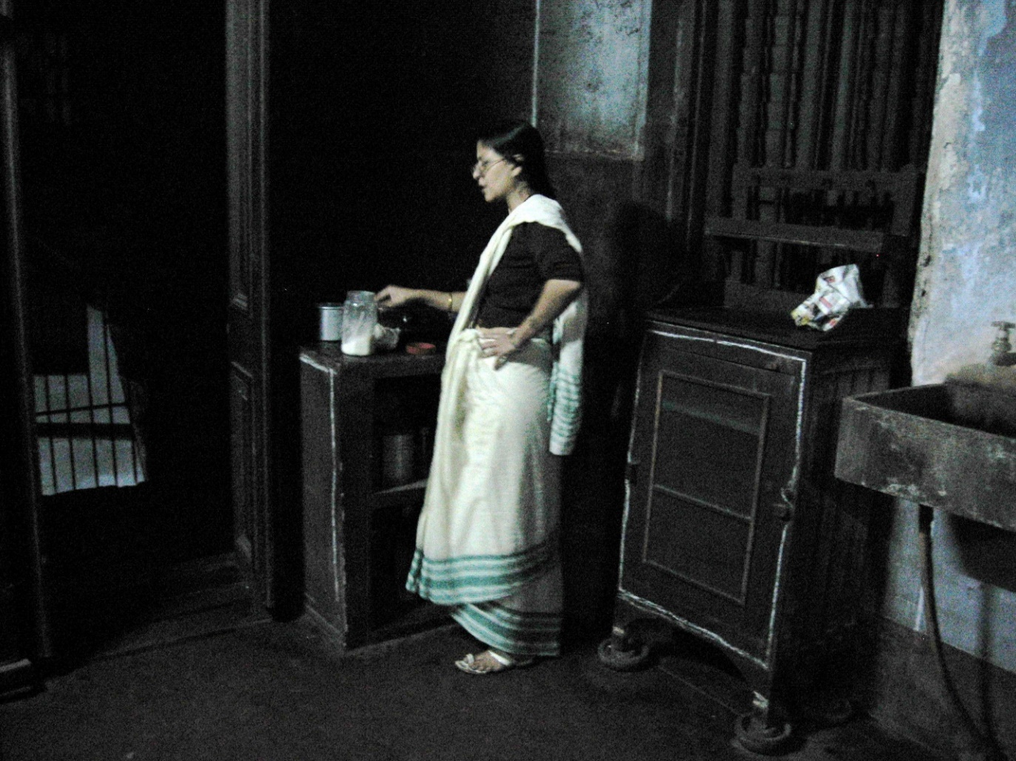
Figure 7 Kitchen in a Taltala home
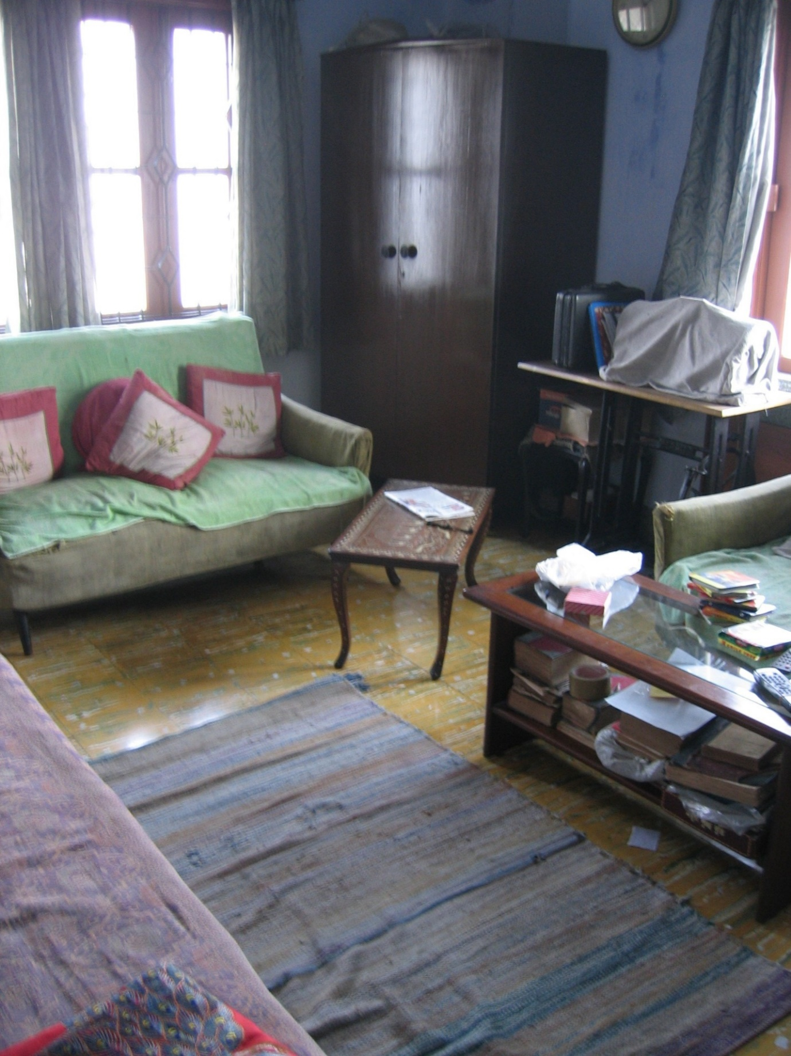
Figure 8 Living room in owner-occupied home in former refugee colony
It is therefore rarely homeownership as such that my interlocutors identify as modern or relevant. It is the ‘privacy’ afforded by homes laid out for nuclear families, the social life imagined, and the desired independence that were important to men and women alike. As Joya, one of my more affluent friends observed, the problem of sharing her affines’ residence, albeit having her own kitchen, was not that it was not her property, but that any decision was more or less collectively taken. Negotiations over space were therefore marred by inherently tense kin relations. In her case, as in many other instances, the arrangements in the in-laws’ home had changed multiple times as she grew from a young bride to become a mother of one, and then the second-oldest woman in the house. Her control over her environment had increased, but she had clearly no ownership rights. Very aware of this, she had persuaded her husband to invest in a flat, which the couple now jointly own but have no intention of moving into. Whilst Joya bemoaned the lack of privacy in her current home, she would not risk losing access to this prime property by shifting their household. Whilst, legally, she is entitled to a share of her husband’s inheritance, and therefore his parents’ property, practically she knew she needed to stay put to be able to realise such claims.
Even in much more conservative, but not necessarily less affluent, middle-class households in Taltala such discussions centre on privacy and modern amenities were common. However, here most living arrangements remain flexible due to the lack of space and the complex organisation of family homes. A couple’s ‘private’ bedroom, for example, doubled as a reception room during the day or school children were doing homework there in the afternoon. Expectations of flexible sharing arrangements are based on the understanding that, no matter how cramped the conditions, joint families should live together and couples should make do with only their bed for privacy. The importance of a ‘private’ space, however, cannot be overstated and is directly linked to the priority awarded today to conjugal relations and, even more importantly, to the intimate bond between parents and children. As the demands of intensive parenting (Donner 2008) conflict with idealised versions of the joint family, new spatial domestic politics emerge in the name of the single child. This means that arguments for and against investing in a flat, or moving away from affines, are increasingly expressed in the idiom of the ‘children’s needs’. The latter feeds into shared, global narratives of a distinctly Indian middle-class modernity (Giddens 2002) around coupledom and intensive parenting. And, as that precious single child might today actually be a daughter, ideas about filial duty, gender roles, inheritance patterns and what makes a joint family are rapidly changing as homeownership and property rights are being renegotiated and re-imagined.

Daughter are (almost) like sons now
A number of adolescent daughters I met in the 1990s told me at the time that they were keen to marry into a joint family home, implying they were happy to live with in-laws. They knew this meant giving up their rights in their parental property as their weddings were paid for by their parents. At the time, wedding expenses consisted of three kinds of transactions, namely gifts exchanged with relatives including the actual wedding costs, a trousseaux which contained an assortment of household goods moving with the daughter, and, most importantly and secretively, a cash dowry. Giving gifts to set up a home to brides moving into the fully equipped residence of in-laws always struck me as ironic, but it had a definite symbolic impact. It materialised the contradictions inherent in modern redefinitions of the family for women. Items like separate fridges, almirahs and settees were, so to speak, a claim and a promise to a different way of life never realised (Fig 8).
Young women were adamant that they would not make any further requests to parents, and vowed to adhere to the expected behavioural code. In many families daughters are encouraged to study, but their pursuit of education is closely monitored by elders and it is still not the norm that women should take up paid employment after marriage, apart from those with professional backgrounds. In the more progressive neighbourhoods, a career was aspired to by the majority of young women, but often only part-time or temporary employment was taken up after study. Whilst presenting themselves as progressive, south Kolkatan families promoted the ideal of the stay-at-home mother, with the older generation of working women often preferring non-working daughters-in-law.
With young women well educated and articulate, most were led to believe that they had exactly the same chances as their brothers or male cousins, in the 1990s as today. So when I asked about the pitfalls of joint family life, which the vast majority had experienced themselves as children growing up with grandparents, many argued that they would retain their independence as ‘times have changed’. However, over the years I have seen these same daughters become someone else’s daughter-in-law, and their view of joint family life changed. This was the case with Madhubanti, the daughter-in-law of a middle-class family residing in a spacious, owner-occupied suburban house when we met in the early 2000s. She had, after a love marriage, moved in with the in-laws and shared a room on the upper floor of the family house with her husband and son. Here she kept a huge number of items given at the time of her wedding, and she and her husband spent most of their evenings upstairs. For her husbands’ parents, this ‘separate’ living was already a compromise, but clearly one worth making, as it signified their economic standing and modern outlook. For Madhubanti, this arrangement signalled choice, privacy, her identity as a modern savvy consumer, and much-valued conjugality. But whilst she had initially been in employment and spent less time at home, the couple were asked to share the ground floor with her in-laws when she fell pregnant. It was at this point that her difficult relationship with her mother-in-law made her push for her dream of a separate top floor kitchen and bathroom. When her in-laws refused to give in to this demand, she began to spend more and more time upstairs and at her own mother’s house. Significantly, when asked why they did not buy a flat of their own, the couple argued that moving out would jeopardise their share in his family’s property. They thus laid claim to their share by staying put whilst not contributing to the household in any major way (Fig. 9). Finally, she moved her whole family to her mother’s home and only visited her in-laws sporadically.
Moving back to their natal home is a widely accepted traditional right of daughters. However, in practice it used to be neither encouraged nor practical. It may have been an option women resorted to in case of serious marital crises, and widows were often sent back to their parents’ house, especially when childless. After all, the home-coming of Goddess Durga during the major festival for Bengali Hindus celebrates Durga’s relationship with her parents and siblings, but clearly depicts a daughter’s annual visit to her natal home. However, what is apparent in my long-term fieldwork is that changing demographics have meant that single-child families with only a daughter are challenging such norms. In the course of demographic and with it social change, the relationship of young women with their parents has changed considerably, and this was already apparent in the 1990s, but has become much more pronounced since then. In terms of property rights such contestations mean that women are often more likely to be sole heirs, but also solely responsible for their parents’ well-being. Anthropologists have long maintained that Hindu women’s social worlds and agency cannot usefully be circumscribed in terms of affinal relations (see Roy, 1972; Raheja and Gold, 1994). Young middle-class women’s complex life-worlds in which they are asked to embrace education, careers, and prime-homemaker status are also often depicted as relatively independent of familial interference. However, though they may enjoy a privileged position vis-à-vis their less well-off counterparts, much closer relationships with their parents mean that they are more, rather than less, involved in family affairs. As pointed out earlier, for sons and their families, the new focus on apartment living, home ownership, conspicuous consumption and individualised budgeting threatens the joint family ideal. For single daughters, similar tensions may persist with reference to their parental home. Whilst often expressed in the age-old idiom of conflict between mothers- and daughters-in-law these are new faultlines. For single daughters, and those whose brothers have permanently migrated, additional push factors are added to decisions about where and how to dwell.
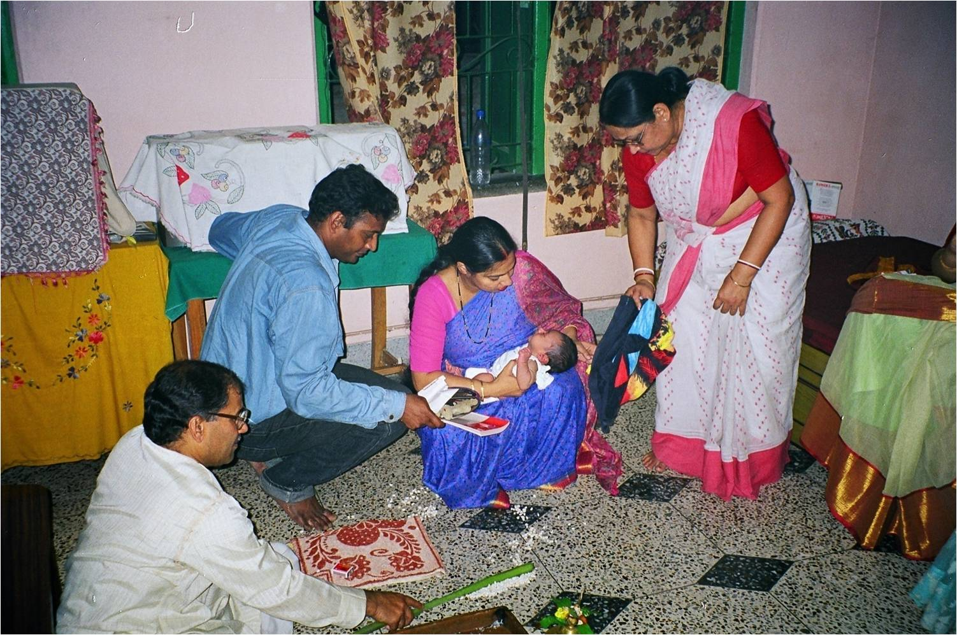
Figure 9 Mother- and Daughter-in-law at First Rice Ceremony
.
During my initial fieldwork in the 1990s, I found that some parents of only daughters would arrange a marriage with a local boy or embrace love marriages so as to ensure they stayed nearby (Donner, 2002). In some cases patrilocal customs were circumvented by choosing a spouse whose parents lived further away, or could not possible afford to host the couple. In many instances love marriages had the same effect and enabled daughters to look after their own parents (Donner, 2002). Today, many middle-class families command higher disposable incomes and parents of only daughters may be in a position to invest in a flat or to extend their own home upon her marriage. This happened in the case of Arunima, whose parents were very well-off and keen for her to stay close-by after her love marriage. They made a substantial contribution to a flat for the young couple in a nearby prestigious development. This enabled her to go out and earn a modest income, as - typically in these cases - the two households became very closely interrelated. Her mother managed servants and looked after Arunima’s children, whilst her father organised shopping, paid bills and ran errands that the working couple had little time for. For her parents, this extra investment in their daughter was not only a matter of pride but also a security against desertion in old age.
The second novel practice observed contravenes the patrilocal norm even more drastically and consists of the husband moving into his in-laws’ home, usually because his wife is an only child. Amrita, whom I met first in the 1990s and who by 2001 had married a young man belonging to a different community and of significantly lower status, clearly never intended to move in with her in-laws. In fact, it appeared she had picked a young man who was willing to move into the spacious three-story house her father had built. Though they remained childless, Amrita and her husband enjoy the considerable luxuries this home provides, whilst her mother is running the household for the young couple as well as her own. But with old age creeping up on her parents, Amrita and in particular her husband - who has become a ghor jamai (in-living son-in-law, often the butt of jokes) - had to provide more and more support to the elderly couple. Whilst the young couple’s income would have easily allowed them to purchase an apartment, they had no real incentive to move and in the absence of a son, Amrita’s husband took on that role in an honorary capacity.
My third case study exemplifies a much more common pattern, in which the lines between properties, ownership rights and residential claims are not as clearly drawn as in the cases presented above. It is in these situations that young women need to negotiate much more complex, but quite typical, moral dilemmas. Renu’s father and uncle had inherited a large house in Central Calcutta, which was occupied by tenants on the ground floor and the brothers’ respective nuclear families sharing the first floor, initially with the grandparents. Renu’s upbringing in this large family home had inculcated the idea of the ‘joint family’ as an important value, and she saw it as a precondition for respectability. Though conflicts existed, Renu acted as ‘sister’ to her two cousins, a girl and boy, with whom she shared all meals, available space, social relations and facilities. Fast forwarding a good decade to the mid-2000s, by which Renu had married and moved into her in-laws’ joint family home in a different part of the city. There she acted as the perfect daughter-in-law in public, whilst appearing desperately unhappy in private. Although she was a science graduate, she had been forced to take up a meagrely paid teaching job. This was only acceptable to her because the school was located near her parental home, which enabled her to visit her parents almost daily. Two years after her marriage, when she had a daughter herself, life at her in-laws became unbearable as her parents-in-law demanded her undivided attention and huge amounts of commitment. A case in point was the – entirely justified – demand that she cook lunch before leaving for work in the morning. All her relationships here, even that with her husband, were by now fraught with tensions. However, when her daughter was about one year old, Renu managed to secure a much more coveted job as a teacher in one of Kolkata’s most prestigious boys’ schools. Again, this job did not pay well enough for the couple to move out, but the prestige it carried and the proximity to her parents’ home made up for a low salary. In addition, her job gave her access to a much coveted nursery near her workplace.
In stark contrast, her younger cousin-sister, who from early on rejected the image of the traditional good girl and identified with a much more modern and challenging female role, became a software engineer and accepted a position in a high-tech company located in Hyderabad. While almost unheard of among most of my interlocutor’s families, this is not unusual for modern middle-class women elsewhere in the country, as Fuller and Narasimhan have documented for south India (2007). This was partly possible because her brother had always been presented by the whole family as the sole male heir and guardian of the older generations. As second cousin and sister to a male heir, she was allowed to fulfil her long-held ambition of becoming a member of the globalised IT elite and quickly adopted the new lifestyle this entailed. She also took on the role of provider for her parents, who with her help refurbished the decaying family home. They installed a new kitchen and bathroom, which allowed them to separate the two families,
Renu, on the other hand, finally moved back in with her parents once her daughter joined nursery by the late 2000s. She now only spent weekends at her in-laws, performing rather perfunctory her duties, while her husband visited the two of them in her natal home every evening before proceeding to his parents’ house. In spite of her in-laws dissent, this feisty young woman argued that ‘today, daughters are just like sons’. One meaning of this statement is obvious and indicates the newfound assertive tone many younger women have appropriated when talking about marriage, in-laws, housing and inheritance. The much less obvious meaning is related to their relationship with their parents and to changing understandings of filial duty in relation to daughters. Renu’s comparison of new roles for daughters with those traditionally attributed to sons implied that she would look after her parents and that therefore she felt entitled to her father’s property. In exchange for the promise of future care, her parents provided her with childcare, a home and full housekeeping. In this as in other cases not complicated by the presence of a cousin, a single daughter was encouraged and expected to look after her parents in the same way a son would do, and used her earnings to invest in her parental home. In this situation, the advantages of joint living and the drawbacks of individual ownership become obvious. By living in her parents’ house with her daughter, Renu was clearly staking a claim to the property that her ‘cousin-brother’ is customarily entitled to, and which she left upon marriage with her ‘customary’ share. Her parents and Renu herself saw this as an ambivalent situation, but justified it with reference to their daughter’s ‘filial’ duty. Clearly, in the absence of a son, Renu had to ensure her parents’ future wellbeing, and was therefore entitled to her father’s share in the ancestral home. But for many young women like Renu, this claim to autonomy vis-à-vis their in-laws comes at a cost. Not only was Renu’s relationship with her in-laws permanently damaged, but she also put her husband and her conjugal relationship under strain. As in other cases where a daughter insists on parental support at the expense of the customary rights associated with patrilocality and patrilineal joint families, all new arrangements remained fragile and in some ways exploratory. In Renu’s case, the future of the arrangement will depend heavily on the attitude of her male cousin. Furthermore, her agency and access to property were enabled through a flawless performance of the role of caring daughter, which meant she had to fulfil shoulder a double burden and expand her labour of love.

Conclusion
When Jean and John Comaroff speak of the magical economies that emerge with neoliberalism, the main themes they identify include social success based on self-transformation and excess material gain (Comaroff and Comaroff, 2000). Both of these can easily be associated with real estate markets and their imaginary. Just as Appadurai suggests with reference to Mumbai that real estate markets increasingly determine the terms of structural inclusion and exclusion in India (Appadurai, 2000), I would argue that citizens’ views of such markets are closely related to personal relationships in post-liberalisation urban settings. The options of new housing not only increase intra-class, it also transforms intimate family and gender relations.
This article has demonstrated that different kinds of property and ownership arrangements allow for different kinds of relationships with kin, neighbours and more generally, the state and the nation. However, it has also shown that two structural constraints continue to shape the discourse on gender and property among the middle classes in urban Kolkatta: the primacy of the joint family ideal and the norm of patrilocality. Where the ongoing transformations that reshape subjectivity, social relations and class-based identity have been described in terms of homeownership, and linked to explicitly neoliberal idioms of choice, self-interest, and aspirations for the future, genealogies of middle-class domesticity reveal the impact of earlier phases of a generalised appropriation of global ideas about modernity.
In the current climate, where neoliberal ideas of choice and individual fulfilment, but also of imagined futures and material aspirations redefine the private sphere through an engagement with real estate markets, the impact of other moralities associated with family life, which attributes ownership in accordance with gendered roles in the family, needs to be assessed. In the course of socio-economic change, specific domesticities come to bear on the way gendered subjectivities are formed and discussed, but the opposite is true as well, as new ideologies are appropriated they open an arena for contestations and re-negotiations. In relation to gender, homeownership and middle-class families I work with, women’s access to housing and property depends on the way they negotiate access to affinal and paternal homes. As shown, it is remarkable that most do not gain control over property as owners of new apartments, but as daughters who promise to undertake future care work: the needs of children and elders are estimated and that labour shouldered by women as flexible patterns of residence are established in order to expand claims to ownership.
In the given context, the joint family ideology provides the framework for those involved to negotiate new ideas about property ownership. As shown above, the joint family with its mechanism of arranged patrilocal marriage and limited practical ownership rights for women imposes severe constraints on the realisation of neoliberal values, for instance individualism, coupledom, and the focus on the nuclear family. Whilst a conscious effort to maintain that ‘traditional’ and ‘modern’ families function differently is an important part of local rhetoric, the changes this distinction indicates are much less substantial than is suggested. For instance, the ‘modern’ home, imagined through its material qualities, has become a site of desire and projection, but this does not necessarily indicate an embrace of liberal family values. Furthermore, imagery that unites the ‘traditional values’ of joint families and an entrepreneurial culture of individual gain and self-realisation are spreading (Gooptu, 2013; De Neve, this volume). In this context, the impact of new property regimes is not limited to those who actually own a flat or an apartment. As family life does evolve around questions of residence, and the built environment shapes domesticity, new ideas challenge existing inequalities of gender and of age, changes that can be subtle and unexpected. Whilst older forms of boundary making do still play a huge rule in the way middleclassness is constructed (see Kaviraj, 1997 and Dickey, 2000), new ideas about ownership and residential arrangements are shaped through media consumption, changing material and consumer cultures and thus impact on middle-class women’s life
A closer look at the genealogies of domestic space and middle-class lifestyles suggests a complex story which relates access to housing, women’s control over property and their vulnerability to the tension between their rights in property and the way regimes of care are framing the realisation of such rights. Thus, and this is a crucial finding, their labour power remains a most powerful bargaining tool to negotiate housing, ownership and ultimately new cityscapes. It is therefore crucial to ‘understand how the types of labour performed can transcend material relations and demand a highly dialectical class analysis that can account for ongoing transformations in reproduction/production and in production-exchange-consumption’ (Heiman, Freeman and Liechty, 2012b).
It is in this context that I would like to argue also that one of the values of long-term ethnographic fieldwork is that it prevents us from losing sight of earlier social formations, ideological and discursive shifts. In this case I have aimed to show that as ‘by promising unconditional acceptance, the modern family offers individuals a haven from the obligation to choose’ (Collier, 1997). But for women to become homeowners it is often necessary to shoulder even more labours of love as it is through a reformulation of domestic responsibilities that middle-class women’ are able to negotiate new property regimes.
Bibliography
Agarwal, Bina (1994). A field of one’s own: gender and land rights in South Asia. Cambridge: Cambridge University Press.
Agnes, Flavia, Ghosh, S.V. and Majlis (Eds) (2012). Legal domains, gender concerns, and community constructs. Delhi: Oxford University Press.
Anjaria, Jonathan.S. (2009). Guardians of the bourgeois city: citizenship, public space, and middle-class activism in Mumbai. City & Community, 8(4), 391-406.
Appadurai, Arjun (2000). Spectral housing and urban cleansing: notes on millennial Mumbai. Public Culture, 12(3), 627-651.
Banerjee, Hironmoy (1995). The Tagores of Jorasanko. Delhi: Gyan Publishing House.
Banerjee, Sumanta (1989). The parlour and the street: elite and popular culture in nineteenth century Calcutta. Calcutta: Seagull.
Basu, Srimati (1999). She comes to take her rights: Indian women, property and propriety. Albany: SUNY Press.
Baviskar, Amita (2003). Between violence and desire: space, power, and identity in the making of metropolitan Delhi, International Social Science Journal, 55(175), 89-98.
Bose, Pablo S. (2015). Urban development in India: global Indians in the remaking of Kolkata. London: Routledge.
Brosius, Christiane (2013).” Enclave gaze”: images and imaginary of neoliberal lifestyle in Delhi. In Spyer, P. and Steedly, M. (Eds) Images that move (pp. 73-99).. Santa Fe: School for Advanced Research Press.
Chatterjee, Partha (1989). The nation and its fragments: colonial and postcolonial histories. Princeton: Princeton University Press.
Chatterji, Indrani (2004). Unfamiliar relations: family and history in South Asia. Delhi: Permanent Black.
Cohen, Laurence (2000). No aging in India: Alzheimer's, the bad family, and other modern things. Berkeley: University of California Press.
Collier, Jane (1997) From duty to desire: remaking families in a Spanish village. Princeton: Princeton University Press.
Comaroff, Jean and and Comaroff, J.L. (2000).Millennial capitalism: first thoughts on a second coming. Public Culture, 12(2), 291-343.
Dey,I. Samaddar, R. and Sen, S. (Eds) (2013). Beyond Kolkata: Rajarhat and the dystopia of urban imagination. Delhi: Routledge.
Dreze, Jean and Sen, A. (2013) An uncertain glory: India and its contradictions. London: Allen Lane/Penguin.
Dickey, Sara (2000). Permeable homes: domestic service, household space, and the vulnerability of class boundaries in urban India. American Ethnologist. 27(2), 462-489.
Donner, Henrike (2002). One’s own marriage: love marriages in a Calcutta neighbourhood. South Asia Research. 22(1), 79-94.
- (2008). Domestic goddesses: maternity, globalisation and middle-class identity in contemporary India. Aldershot: Ashgate
- (2011). Introduction. In Donner, H. (Ed.) Being middle-class in India: a way of life (pp.1-22). London: Routledge.
- (2015). Domesticating the market: early-years education and middle-class parenting in India. In Flee,M. and van Oers, B. (Eds) Handbook of early years education (pp.).. Berlin/New York Springer.
Dupont, Vernique D.N. (2011). The dream of Delhi as a global city.International Journal of Urban and Regional Research. 35(3), 533-554.
Fernandes, Leela (2004).The politics of forgetting: class politics, state power and the restructuring of urban space in India. Urban Studies. 41(12), 2415-2430.

Fuller, C.J, and Narasihman, H. (2007).Information technology professionals and the new-rich middle class in Chennai (Madras). Modern Asian Studies. 41(1), 121–150.
Giddens, Anthony (2002). Runaway world. London: Profiles Books.
Ghertner, Asher (2011). Rule by aesthetics: world-class citymaking in Delhi. In Roy, A. and Ong, A. (Eds) Worlding cities: Asian experiments and the art of being global (pp.279-306). Oxford: Blackwell.
Goody, Jack (1998). Dowry and the rights of women to property. In Hann, C. M. (Ed.) Property relations: renewing the anthropological tradition (pp.201-203). Cambridge: Cambridge University Press.
Gooptu, Nandini (2013) Introduction. In Gooptu, N. (ed.) Enterprise culture in neoliberal India: studies in youth, class, work and media (pp.1-24). London: Routledge,.
Hann, Chris M. (Ed.) (1998a). Property relations: renewing the anthropological tradition. Cambridge: Cambridge University Press.
Hann, Chris M. (1998b). Introduction: the embeddedness of property. In Hann, Chris M. (Ed.) Property relations: renewing the anthropological tradition (pp. 1-47). Cambridge: Cambridge University Press.
Harvey, David (2004). The new imperialism: accumulation by dispossession. Social Register, 40, 63-87.
Heiman, Rachel, Freedman, C. and Liechty, M. (Eds) (2012a). The global middle class: theorizing through ethnography. Santa Fe: SAR Press.
- (2012b). Introduction. In Heiman, R., Carla Freedman, C. and Mark Liechty, M. (Eds) (2012a). The global middle class: theorizing through ethnography (pp. 3-29). Santa Fe: SAR Press.
Heller, Patrick and Fernandes, L. (2006). Hegemonic aspirations: new middle-class politics and India’s democracy in comparative perspective. Critical Asian Studies, 38(4), 495-522.
Kaviraj, Sudipta (1997). Filth and the public sphere: concepts and practices about space in Calcutta. Public Culture. 10(1), 83-113.
Lamb, Sarah (2000). White saris and sweet mangoes: aging, gender and body in North India. Berkeley: University of California Press.
- (2008). Elder residences and outsourced sons: the remaking of aging in cosmopolitan India . In Sokolovsky, J. (ed.) The cultural context of aging: world-wide perspectives (pp.418-440). Westport, CT: Praeger.
Maurer, Bill (2004). Cyberspatial properties: taxing questions about propietary regimes . In Verdery, K. and Humphrey, C. (Eds.), Property in question: value transformation in the global economy (pp.275-295). Oxford: Berg.
McGovern, Abigail (forthcoming). Consuming the home: creating consumers for the middle-class house in India, 1920-1961. In Bhattacharya, B. and Donner, H. (Eds), Making the Indian consumer: the politics of advertising and identity formation in twentieth century India. Delhi: Oxford University Press.
McKinsey Global Institute (2001). India: the growth imperative. Washington: McKinsey Global Institute.
Mukherjee, Neel (2014). The lives of others. London: Chatto and Windus.
Rajagopal, Arvind (2001). The violence of commodity aesthetics: hawkers, demolition raids, and the new regime of consumption. Social Text, 19(3), 91-113.
Raheja, GloriaG. and. Gold, A.G. (1994). Listen to the Heron's Words: Reimagining Gender and Kinship in North India. Berkeley: University of California Press.
Rocher, Ludo (ed.) (2002). Jimutavahana's Dayabhaga : The Hindu Law of Inheritance in Bengal. Oxford: Oxford University Press.
Roy, Manushi (1972). Bengali Women. Chicago: University of Chicago Press.
Sreenivas, Meenakshi (2008). Wives, widows, and concubines: the conjugal family ideal in colonial India. Bloomington: Indiana University Press.
Srivastava, Sanjay (2012). National identity, bedrooms, and kitchens: gated communities and new narratives of space in India. In Heiman, R., Freedman, C. and Liechty, M. (Eds), The global middle class: theorizing through ethnography (pp.57-84). Santa Fe: SAR Press.
Strathern, Marilyn (1984). Subject or object? Women and the circulation of valuables in Highland New Guinea. In Hirschon, R. (Ed.) Women and property, women as property (pp.158-175). London: Croom and Helm..
Sturman, Rachel (2012). The government of social life in colonial India: liberalism, religious law and women’s rights. Cambridge: Cambridge University Press.
Uberoi, Patricia (1995). When is a marriage not a marriage?: sex, sacrament and contract in Hindu marriage. Contributions to Indian Sociology, 29 (1-2), 319-345.
Vatuk, Sylvia (n.d). Indian Muslim women’s access to property: Shari’at, custom and local practice.

Earlier versions of this article were presented at the biannual conference of the European Association of South Asianists, Zűrich, June 2014; the workshop ‘The Making of Middle Classes: Social Mobility and Boundary Work in Global Perspective’, International Research Centre ‘Work and Human Lifecycle in Global History’, Humboldt University, Berlin, November 2014 and the Department of Anthropology, LSE. I am grateful for comments received on all these occasions and suggestions by anonymous reviewers. All the names of my interlocutors have been changed and the article mentions some composite characters to further anonymise the ethnography.
Depending on context I will use Calcutta and Kolkata interchangeably as much of my material was collected before the name changed.
Fieldwork in Calcutta began in the mid-90s and has continued since. Up until 2002 two localities were studied in much detail, since then the circle of participants has broadened to include families across the city.
The idea of ‘middleclassness’ (Donner, 2011) as a project has been forcefully promoted by Mark Liechty (Liechty, 2003), whilst Fernandes has shown how this project needs to be understood as a form of hegemonic politics with very local expressions (Fernandes, 2006). Srivastava’s analysis of life in a gated community in Delhi provides an example for new parameters of place-making in the global Indian metropolis (Srivastava, 2012).
This is an important point and makes for the main difference between Dayabagha and Mitakshara schools of law. The latter governs inheritance in most North Indian communities makes sons co-owners from birth and fathers cannot dispose of property at will whilst sons can demand their share before their father’s demise. This is often disputed in court.
For a fascinating fictional account of the social live inside a large Calcutta family home shared by a collaterally-extended family set in the 1960s, see Neel Mukherjee’s novel The Lives of Others (Mukherjee, 2014).
See for example the poet Tagore’s birthplace, the Jorasanko thakur bari, (Banerjee, 1995).

