Irit Rogoff

Who Do We Face?

Every few years it would seem, I must sit down to reconsider the notion of we—to think of what new political imperatives are recasting the notions of collectivity and mutuality, of critical collaborative initiatives, of the ability to be and do differently, and of a sense of solidarity born of recognizing shared conditions across differing circumstances. And here I am again, this time finding myself in a great dilemma of apparently having to choose between two models of we. The first is a philosophical model that has, for some time, informed my understanding of the fleeting communities that form a new we, detached from traditional identitarian markers. The second is a political model based on new concerns about constituting citizenship in the demise of Western constitutional democracy. The philosophical model was itself politically driven by the need to move beyond nationality, ideology, ethnicity, and kinship as grounding relations and allegiances, towards notions of singularization. At the same time, recent theorizations of citizenship characterize it as a state beyond the individual receipt of safeguards and benefits, and rather as something contingent and shared—what philosopher Étienne Balibar has called “co-citizenship.” Here Balibar is invoking two important aspects of his understanding of citizenship: one is to do with the need to split between the subject and their exclusive ownership of the rights and privileges afforded by their citizenship, in favor of a need to share these rights and privileges with those being denied them. The second point is that citizenship is not a passive state to be taken for granted, that it needs to be activated and to come into being through forms of insurrection that that posit an active rather tan passive form of citizenship to be wrested away from authroising structures.
The seeming need to choose between such models is so difficult because I am someone who does intellectual work within the art world and as such thinks of her terrain as the meeting point between the philosophical, the political, and creative practices. So why, I think to myself, must I choose? This text is an attempt to figure out whether such choices need to be made and how the tension between the two models recasts the operative notion of we.

Discussions of the we, the plural personal pronoun at the heart of all identification models, are currently suspended between the pull for declaring a collective identity grounded in a shared belief system and a set of common aspirations, and the push of defining this collectivity by drawing a defensive boundary around it, so as to separate itself from whatever it holds as dangerous challenges from the outside.

Over the past 25 years, since the end of traditional Cold War divisions between the so-called East and the so-called West, it has become an increasingly empty task to try and think of these entities as having been divided along the lines of fully articulated political and ideological identifications. Not because one side has succeeded and one side has failed but because the worn-out distinctions that separate them have been overwritten by much more urgent contemporary ones. Indeed two years of ever more visible and ever more desperate migration from both the Middle East and Africa have breached these contemporary divisions between the global north and the global south, while freedom of movement for people across the European Union has sharpened the boundary between those who are inside, close to the provision of some minimal support, and those who are outside and bereft of it. What we have been able to recognize is that the lack of such minimal support is not limited to an outside; it exists also within, whether in the form of impoverishment, expulsion, lack of legal status, or lack of access to education, housing, or medicine.

Writing this from within the great political upheaval that is the aftermath of the United Kingdom referendum on EU membership (on 23 June 2016), it has been impossible to revert to either definition, neither the one that coheres from within nor the one that coheres from without. One of the lowest moments in what has been a campaign driven by untruths, racism and xenophobia, treacherous ambition, and the lack of any long-term understanding of politics beyond the basic material conditions of certain individuals’ lives, was a poster by the UK Independence Party’s “Leave” campaign that showed a long line of Syrian refugees arriving at the Croatia-Slovenia border in 2015. The poster falsely intimated that these non-Europeans were attempting to storm British borders and make their way into the UK, articulating an intentional slippage between different orders of mobility: that of refuge seekers, EU nationals, global-elite financial players, and the formerly colonized long-residing in the UK and constituting some of its most dynamic sectors. Migration is depicted here as a swarm—not in the Deleuzian sense of the overlapping of pre-individuated subjectivities, but in the confused sense of an unbounded stream that does not recognize boundaries.
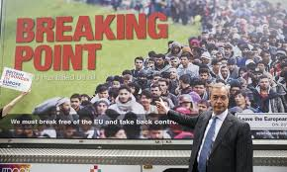

It is this complete inability to sustain definitions with their long socio-historical legacies that has been one of the most puzzling elements of the entire Brexit saga. In the UK the very specter of a large part of the population protesting the oppression of austerity politics and the abandonment of a non-financialized class—by, paradoxically, supporting the very same politicians who brought about these policies in the first place—demands a complete rethinking of the historical concept of we. And so it is imperative to ask ourselves: if a world view founded in resentment of every form of otherness and the emergent political subjectivity that draws in and isolates is not collectivity in any classical sense of the term. If such a position founded in the resentment of others is not solidarity, not identification, and not aspiration, how does it become that notion of we that demands political recognition? We’ve heard much in the past weeks about the pitfalls of populism, of disregard for facts, of disenfranchisement that cannot identify who is actually doing the disenfranchising, of the legitimation of nationalist and racist discrimination. What has not been extensively discussed is any speculation about the crisis of not knowing what authority, what legal system, what set of criteria we might actually be facing.

So at this stage it is clear that the current discussion of we is suspended between a philosophical legacy and a set of political imperatives. That these are not quite distinct models—not distinct in the traditional, disciplinary way in which one pathway follows a single, inevitable logic—could prove to be a productive suspension.. The philosophical legacy allows us to play, to layer and enfold identities in ephemeral atmospheres that in turn liberate us from the old identitarian criteria of the who, the what, and the where. It has been crucial for moving discussions away from nationality, ethnicity, regionality, ideology as the markers of who we are – from what Giorgio Agamben has called ‘Being French, Being Red, Being Muslim”. That, in turn, has allowed for the emergence of a multitude politics that ebbs and flows in relation to urgent issues, that converges in different sites and strikes fleeting alliances, that reoccupies existing structures with new meaning and protocols, and that allows for a form of cultural stakeholding we have not seen before. The move from a model of fixed identitarian markers to a recognition that we are constantly emergent political subjectivities who meet in fluid processes of singularization and re-singularization has been crucial for all of us working in the arts. It has allowed for what I have elsewhere called “ontological communities”—momentary convergences and collectivities that recognize mutual concern or mutual conditions without translating these into full-fledged political platforms. It is not necessary to reiterate here the exceptional importance of such a turn in how the complexity of what might be “audiences” might be understood in an art context—of the need to move away from cultural edification and political representation to a notion of having a stake in recognizing an urgency beyond what is being identified specifically before one’s eyes as its locus. Whether the urgency was one of financial crisis, military intervention, mass migration, or the collapse of the education system, the transition effected was one that moved away from representation and towards implication.

A philosophical genealogy of ontological communities might, roughly speaking, look something like this: for decades now, both philosophical and political discussions have distanced themselves from thinking about who we are. Have abstained from designating a stable identitarian understanding of we.

Perhaps an early move in the direction of ontological communities is political theorist Hannah Arendt’s designation of “spaces of appearance”—collective engagements that Arendt characterized as “speech and action,” loosely coming together for a momentary expression and then moving apart again. This space of appearance articulated by Arendt is neither concretely inhabited nor is it temporally constant; rather, it comes into being “whenever men are together in the manner of speech and action and therefore precedes and predates all formal constitution of the public realm and its various forms of government.” Arendt’s thought in Vita Activa and her foregrounding of speech and action as in and of itself being the political is an early theorization of singularity.

To unpack the idea of singularity, I will refer to philosopher Giorgio Agamben’s argument in his book The Coming Community, a series of linked essays that ask how we can conceive of a human community that lays no claims to identity; how a community can be formed of singularities that refuse any criteria of belonging, a community whose collective basis is neither the shared ideological principles nor the empathies of affinity and similarity.

The coming being is ‘whatever’ being. . . . The Whatever in question here relates to singularity not in its indifference with respect to a common property (to a concept, for example; being red, being French, being Muslim), but only in its being such as it is. Singularity is thus freed from the false dilemma that obliges knowledge to choose between the ineffability of the individual and the intelligibility of the universal.

In Agamben’s notion of the “whatever” (which, for the sake of clarity, is not the “whatever” of California teenagers, in which anything can be substituted by anything else—it’s more a distrust of speech itself) we have a twofold project of decentering. It’s not the repeated movement of return to a narrowing enclosure but rather the introduction of a logic of movement at whose core is a nonepistemic, or perhaps better a counterepistemic, arbitrariness. By this I mean an epistemological equivalent of Agamben’s whatever, in which both the what we know and the how we know it are fluid entities that settle in different areas according to the dictates of the moment, but receive equal amounts of attention and concentration regardless of their recognition or status in the world of knowledge.

Finally in this very brief genealogy of how we might be able to think of collectivity and to name it, I would like to follow in the footsteps of Jean-Luc Nancy in his book Being Singular Plural, in which he uses the “ripped apart identities of contemporary Europe”to argue the impossibility of a coherent or recognizable we or they. He is doing so in the name of a complex and very contemporary politics of what he calls
“the places, groups, or authorities (… Bosnian Serbs, Tutsis, Hutus, Tamil Tigers, Casamnce, ETA Militia, Roma of Slovenia….) that constitute the theatre of bloody conflicts among identities, as well as what is at stake in these conflicts. These days it is not always possible to say with any assurance whether these identities are intranational, infranational, or transnational; whether they are 'cultural' , 'religious' , 'ethnic' , or 'historical' : whether they are legitimate or not - not to mention the question about which law would provide such legitimation: whether they are real, mythical, or imaginary; whether they are independent or 'instrumentalised' by other groups who wield political, economic, and ideological power.

It is here that Nancy raises what is for me the central question: “what law do these identities face?” What law might legitimate them, recognize them, apply to them? What law can escape the narrow confines of its national location and be addressed by those who are not defined and sheltered by it? What law can be shaped by the needs of the day rather than simply produce categories that subjects might fit into?

While some might say that there are international courts of justice for precisely such supranational issues, these function as an extraterritorial dimension of existing international agencies and are part of a vast machinery that reproduces yet another dimension of the same at another scale, rather than recognizing the law in Jacques Derrida’s sense of the entire gamut of authorities both institutional and conceptual that regulate thought and conduct.

This philosophical understanding of community and collectivity detached from identitarian signifiers has enabled so much both within and without of the world of art. It has allowed an alternative understanding of what might be happening amongst those who share the spaces of art, who are able to connect with the thematics being shown in ways that are not simply representational but constitute an ontological community of temporary engagement. It has also further enriched and expanded our understanding of political life as processes of singularization that characterize emergent political subjectivities, ones that cannot be named within the existing criteria of political life but which nevertheless define its most contemporary issues in registers not recognized by political life : the bands, the fans, the artist collectives, the protests, the inhabitations, the new formations of acting in public space without operating within institutions or given categories.
Since 2011 and the rise of the culture of protest, Nancy’s question about these new formations of “being singular plural” is that of which law various identities face.has become increasingly urgent The protestors; the undocumented and thereby illegal migrants who try to avoid encounters with the law; the refugees trying to get somewhere safe; the over 40 million displaced inhabitants of camps across the globe; the groups who do not face the state or do so only partially such as the Roma or the Palestinians or the Tamils; the vast populations of the imprisoned who have been processed by the law and extracted from society; the factions of extreme resistance who resist the law; the financially expelled and the unemployed and those caught up in endless mechanisms of debt they cannot service—what law do they face? What law can address their conditions? What law emerges in response to their claims?

It is at this point that a set of thoughts about we that had opened up its nonidentitarian properties comes into collision with the necessary demands of the disenfranchised whose we may be post-identitarian in the conventional sense, but definitely demands a set of recognitions by the institution of the law. And it is around the changing understanding of citizenship that the tension between nonidentitarianism and the formation of new identities and new subjectivities comes into focus.

Saskia Sassen has stated that citizenship—“the formation of a rights bearing subject”—is an intentionally incompletely theorized contract between the state and its subjects.” And she asserts that this is its necessary condition given “the historically conditioned meaning of the institution of citizenship, a form of political membership authorized by the state.” This condition, maintains Sassen, is currently enabled by a range of emergent political practices by often silenced groups and organizations, which produce openings for new types of political subjects. “Today’s unsettlement,” says Sassen, “helps make legible the diversity of sources and institutional locations for rights, as well as the changeability and variability of the rights bearing subject that is the citizen, notwithstanding the formal character of the institution.”

A parallel argument has emerged from the work of Balibar and his many interlocutors, who critically interrogate the insufficiencies of the institution of citizenship when it is determined by the state and in which both needs and rights are a constant given. Such an understanding of the limitations of a static and privileged model of citizenship has shifted the focus onto several strata of recognition: firstly, t
- That citizenship as a national category has become the tool for a bio political management of illegality; secondly, t.
- - That we desperately need to articulate and recognize transnational subjects and post national institutions of the political; and thirdly, .
- tThat we ought to strive towards a category of co-citizenship.

It is this category of “‘co-citizenship”’ or “‘shared citizenship”’ as well as the introduction of the notion of partiality in relation to rights— – of the “‘the right to reside with rights”’ as Balaibar has articulated this partiality— - that leads us back to discussions of the WEwe.
Balibar’s eloquent proposals for a complex mode of transnational citizenship produced by processes of globalization, its mobilities, strictures, and blockages stem from two directions. – Tthe onefirst has is to do with the state- driven demonization of subjects on the move, propellingshifting their characterization from these from being “‘strangers”’ to being “‘enemies” who threaten the wellbeing of those amongst whom they attempt to settle—either at the level of security or of economic resources or of cultural values. The other circumstances from which his concerns stem is what he identifies as the sans-papiers crisis and the fact that the citizens of France owe the sans-papiers movement a great debt.

This is because they have refused the position of being clandestine and instead insist on being seen and heard. Secondly, as Balibar writes,

The Sans-papiers have demonstrated that the regime of illegality wasn’t reformed by the State, but actually created by it. They have shown that this production of illegality, destined for political manipulation, couldn’t happen without constantly violating civil rights (in particular, the security of persons, ranging from the non- retroactivity of laws to the respect of people’s dignity and physical well-being) and without constantly compromising with neo-fascism and the people who foster it. This is how they shed light on the main mechanisms of extending institutional racism, leading to a kind of European apartheid that combines emergency legislation and the spread of discriminatory ideologies.

Thirdly, we owe them gratitude for having recreated citizenship among those who have taken it for granted, “since the latter is not an institution nor a status, but a collective practice.”

One of the most interesting things about Balibar’s discussion, which is clearly driven by the recognition of both hardship and injustice, is that he does not think its redress is simply the materialization of legal documented status and of citizenship for those struggling without it. Rather it is activism of the sans-papiers that offers an opportunity to introduce a set of concepts that erode the simplicity of individually owned rights and privileges into a notion of shared citizenship, which recasts the relation between those within and those without and loosens the hold of the state as the only source for its granting.

Thus we in 2016 is a necessary amalgam of both bodies of thought—communities whose identity is not absolutely stable but constantly in the throes of being redefined in relation to specific urgencies and strata of society who cannot remain sheltered within a set of absolute rights that differentiate them from those without such assurances regardless of their investments, their labor, or their identification. To this end I thought it might be interesting to conclude with a discussion of practice that has sought to destabilize the certainties of cultural investment predicated on a set of illusions about culture’s ability to transcend material conditions. Such a practice is the Gulf Labor Artist Coalition. Composed of artists, critics, and other cultural actors, the Gulf Labor Artist Coalition has worked for six years to raise consciousness about the labor conditions under which Abu Dhabi’s Saadiyat Island is being built and whose construction has so far resulted in several hundred deaths among its largely migrant workforce. Its range of activities includes a weekly postings of small artistic reactions to the labor conditions in the Gulf’s gigantic building project, interventions at openings at the Guggenheim Museum in New York, and projections on the exterior of the Museum, as well as the less dramatic but more investigative work of producing reports and enlisting the support of numerous NGOs and human rights monitoring organizations.

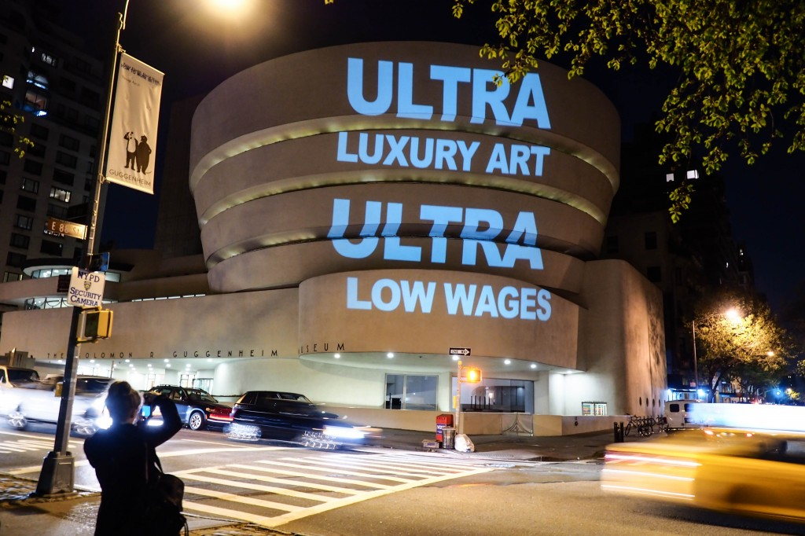Gulf Labor Artist Coalition. Projection on Guggenheim Museum, NY 2015.

The Gulf Labor Artist Coalition is a watchdog and an advocacy group that has been demanding fair wages for workers, compensation for recruitment debt, the right to self-organize, and access to mechanisms for addressing grievances connected to employment.

In the context of this discussion of we, the work of the Gulf Labor Artist Coalition has interested me in particular because of the ways in which it has echoed so many of the concerns that Balibar has voiced about the need for transnational citizenship, i.e., rights that are not guaranteed by birth or take the form of an inherited covenant. In the world of art, transnational rights and assurances and the sharing of such rights becomes a possibility through a multiple inhabitation of their convergence. Does the capitalization and financialization of institutions such as the Guggenheim through franchising operations mean that it is only through finance capital principles of growth, expansion, capital investment, media presence, and agile responses to market forces that they can be judged to be successful? Like other multinational corporate interests, their links to community both at home in New York and in the locations of their franchises in Bilbao, The Gulf, and soon in Helsinki, operates according to colonial principles of circulating resources by expanding markets.

By insisting on the connections between the ferocious financialization of the art world and its institutions in the West and the massive exploitation affected by its emulation in the Gulf, this project has stretched the notion of we, making it the interlinked site for both. The franchising of such institutions as the Louvre, the British Museum, and the Guggenheim for either immense sums of money, storage rights, or potential sponsorship from the region by necessity straddles several communities that cannot be divorced from one another. How do we highlight the mechanism of capitalization on the one hand and of exploitation on the other? How do we connect these and make them present at the heart of the culture that celebrates every form of expansion and brand recognition? How do we produce a plateau in which both are addressed by the same law?

Clearly we cannot make the arenas of art purely platforms on which we discuss conditions of labor related to the making and the running of these institutions. But we can think about citizenship within the realm of the art world, about what goes beyond the rich buying, displaying, and preening in front of ever more expensive work that registers more within investment economies than within cultural ones. We can think about visibilities and invisibilities within the art world, not just in relation to such conditions but also in relation to small-scale, provisional, ephemeral activities and concerns: the reading groups and study groups, the making of quickly printed products, the coalitions of artists with teachers and care workers and welfare institutions, and the hackers and squatters and circulators of permissions. Surprisingly the art world, beyond its famous behemoths, has actually been an exceptional location for the stretching of citizenship, for its sharing not as care work and advocacy but as form of relocations of the self. In the same way that so many political theorists have argued citizenship away from the state as its only sanctifier, I would argue for an art world in which the sharing of subjectivity and the recognition of emergent affective regimes takes precedence over market values.

We don’t have to choose between the community of singularities and the sharing of citizenship, these entities are not contradictory; they do not oppose an abstract affinity against material rights. They meet where we can be and do differently.

Etienne Balibar, Citizenship , Polity, London, 2015.
The Guardian, June 16th, 2016. Heather Stewart and Rowena Mason, “Nigel Farage’s anti-migrant poster reported to Police”.
For some thoughts The Brexit Crisis: A Verso Report. Ed. Verso Books, 2016. ebook https://www.versobooks.com/books/2352-the-brexitcrisis
Irit Rogoff, “Looking Away – Participations in Visual Culture” in Art After Criticism, ed. Gavin Butt, Blackwell 2005 pp. 117-135. And Irit Rogoff, ‘WE – Collectivities, Mutualities, Participations” in I Promise Its Political, Ed D. von Hantelsmann, 2002.
Hannah Arendt, The Human Condition, p. 198, University of Chicago Press, 1968.
Giorgio Agamben, The Coming Community, Minnesota, 1996. Pp. 1.
Jean Luc Nancy ‘Being Singular Plural”, Stanford university Press, 2000 pp. xii –xiii.
Saskia Sassen, Territory, Authority,Rights – From Medieval to Global Assemblages, pp.277-278, Princeton UP 2006.
Ibid, pp278-279.
. Étienne Balibar. Strangers as enemies: further reflections on the aporias of transnational citizenship. MCRI Globalization and Autonomy, 2006.
“What We Owe the Sans Papiers”. This is a speech Balibar gave in 1997 at the French Filmmakers Union in Paris. It is reproduced in eipcp Transversal publication, http://eipcp.net/transversal/0313/balibar/en
“What We Owe the Sans Papiers”. This is a speech Balibar gave in 1997 at the French Filmmakers Union in Paris. It is reproduced in eipcp Transversal publication, http://eipcp.net/transversal/0313/balibar/en

