Running head: STRUCTURAL SENSITIVITY
That Note Sounds Wrong! Age-Related Effects in Processing of Musical Expectation
Andrea R. Halpern^{a,#} , Ioanna Zioga^{b}, Martin Shankleman^{b}, Job Lindsen^{b}, Marcus T. Pearce^{c}, & Joydeep Bhattarcharya^{b}

ª Psychology Department, One Dent Drive, Bucknell University, Lewisburg PA, 17837, Email: ahalpern@bucknell.edu
^{b} Department of Psychology, Goldsmiths, University of London, New Cross, London, SE14 6NW, UK. Emails: iziog001@gold.ac.uk (IZ); martinshankleman@gmail.com (MS); jplindsen@gmail.com (JL); j.bhattacharya@gold.ac.uk (JB)
^{c} School of Electronic Engineering and Computer Science, Queen Mary, University of London, London, E1 4NS, UK. Email: marcus.pearce@qmul.ac.uk
#Corresponding author: Andrea R. Halpern, ahalpern@bucknell.du

Abstract
Part of musical understanding and enjoyment stems from the ability to accurately predict what note (or one of a small set of notes) is likely to follow after hearing the first part of a melody. Selective violation of expectations can add to aesthetic response but radical or frequent violations are likely to be disliked or not comprehended. In this study we investigated whether a lifetime of exposure to music among untrained older adults would enhance their reaction to unexpected endings of unfamiliar melodies. Older and younger adults listened to melodies that had expected or unexpected ending notes, according to Western music theory. Ratings of goodness-of-fit were similar in the groups, as was ERP response to the note onset (N1). However, in later time windows (P200 and Late Positive Component), the amplitude of a response to unexpected vs. expected endings was both larger in older adults, corresponding to greater sensitivity, and more widespread in locus, consistent with a dedifferentiation pattern. Lateralization patterns also differed. We conclude that older adults refine their understanding of this important aspect of music throughout life, with the ability supported by changing patterns of neural activity.

Keywords: musical expectations, aging, EEG, dedifferentiation
1. Introduction
Music is understood and appreciated by people of all ages and with all levels of musical training and sophistication. Understanding of music comes in part from implicitly learning the organizing principles that underlie the music to which a listener is exposed. In Western music, tonal relationships are well specified, such that a scale comprises a subset of notes on a piano keyboard, and melodies tend to use scale notes. In addition, there are statistical regularities governing the relationships between a note or chord and the preceding notes or chords in the music. These regularities allow listeners to learn the statistical structure of a musical style and generate probabilistic expectations about future musical events during musical listening.
Some notes of the scale are considered more stable than others within the key, and those notes tend to begin and end on well-formed melodies (Bharucha & Krumhansl, 1983; Krumhansl & Shepard, 1979). For instance, Twinkle Twinkle Little Star begins on the most stable note of the scale (the tonic), as does the last note of the first phrase (you ARE), and the last note of the entire melody. However, the middle two phrases end on the note just above the tonic (sky so HIGH), which is an unstable note in the scale. This signals the listener that the melody is not yet completed. Importantly, listener requires no formal knowledge in music theory in order to detect these tonal relationships, as quite young children are sensitive to these tonal hierarchies (Krumhansl & Jusczyk, 1990; Trehub, Thorpe, & Trainor, 1990).
Although humans and other animals are born predisposed to detect organizational rules, the learning of the particular rules underlying a given musical style requires exposure to many exemplars. We see this of course in language, where human infants are predisposed to learn any language they are exposed to, but within a few years, learn their native tongue with only implicit exposure, including rule-based phonology and syntax.
With more exposure to an implicit rule-based system like music, one would expect increasing mastery. Experience obviously conveys advantages in being able to recognize patterns and remember them, and experts typically show superiority over novices in these skills across many domains (e.g., chess: Gobet & Simon, 1996, and physics: Chi, Feltovich, & Glaser, 1981) although typically not in domain-irrelevant fields. For instance, a Japanese memorist, Hideaki Tomoyori, set a world record for reciting the first 40,000 digits of pi, but his letter memory span was ordinary (Takahashi, Shimizu, Saito, & Tomoyori, 2006). Another advantage of learning a set of rules, or probabilistic regularities is that one can generate more accurate expectations about what is coming next These expectations increase cognitive efficiency, as well as enhance continued learning. In this respect, expectations form a useful index of mastery of implicit rules or regularities – the more firmly the regularity is learned, the greater the degree of unexpectedness when it is violated. Furthermore, these rules need not be consciously learned; in fact, they are likely to be implicit, as shown by the fact that violation of syntactic rules can be shown in quite early ERP responses (100 ms, prior to conscious detecting of anomalies (Batterink & Neville, 2013)).
These relationships led to the primary interest in this study: whether lifetime exposure to music but not formal training would lead to enhancement, or at least stability, in older adults’ ability to implicitly generate tonal expectations in music, relative to younger adults. Music is an ideal domain to examine age-related patterns of expectation. We have already noted that musical listening is nearly universal, that musical styles contain structural regularities, that musical understanding depends on acquiring these regularities through implicit statistical learning and that such understanding may be assessed through expectation. In addition, the basic rules of Western tonality heard in popular music have not changed in the lifetimes of today’s youth and older generation in Western countries. Thus, generational or cohort effects are likely minimized in the structural understanding that older and younger listeners have acquired.
Another advantage in looking at age-related expectations in music is that music naturally extends in time, allowing expectations to be built up and even tracked over the time course of a melody. These expectations can be quantified quite precisely, in information-theoretic terms, using a computational model of auditory expectation (Information Dynamics of Music, IDyOM, Pearce, 2005). IDyOM learns dynamically through exposure about sequential dependencies in the musical sequences to which it is exposed and generates probabilistic predictions about the next event in a sequence given the preceding context. It is a sophisticated variable-order Markov model (Begleiter El-Yaniv, & Yona, 2004) which can combine information from short-term and long-term models, intended to reflect, respectively, dynamic local learning of repeated motifs within stimuli and long-term stylistic learning through exposure to large numbers of musical works. It can also combine information from multiple features of auditory sequences (e.g., the pitch of individual tones and pitch intervals between tones) in generating its probabilistic predictions. IDyOM has been found to accurately predict listeners’ melodic expectations in behavioral, physiological and EEG studies (e.g., Pearce, 2005; Pearce et al., 2010; Omigie et al., 2012, 2013; Egermann et al., 2013; Hansen & Pearce, 2014), as well as simulate auditory boundary perception and segmentation (Pearce, Mullensiefen, & Wiggins, 2010). IDyOM provides a more accurate model of listeners’ pitch expectations than rule-based models (e.g., Narmour, 1999; Schellenberg, 1996, 1997), suggesting that expectation does reflect a process of statistical learning and probabilistic generation of predictions (Hansen & Pearce, 2014; Pearce, 2005; Pearce et al., 2010).
The study of expectations in aging, with the prediction of stability or even enhancement, contrasts with numerous well-documented age-related declines in fluid processing. Although crystallized knowledge such as vocabulary grows with age (Verhaeghen, 2003), working memory and other executive functions that depend on speed and mental flexibility generally decline with age, sometimes as early as the third decade of life (Dobbs & Rule, 1989; Wang et al., 2011). This effect is likely related to decline of white matter efficiency with age, which has been shown to correlate significantly with executive performance in older adults (Gunning-Dixon & Raz, 2000; Kennedy & Raz, 2009). Furthermore, there is evidence, for younger adults, that individual differences in statistical learning ability for artificial grammars (i.e., rule-based expectation) is significantly related to the ability to use knowledge of word predictability to aid speech perception in noisy conditions, even when controlling for short-term and working memory, vocabulary, non-verbal intelligence, attention and inhibition (Conway, Bauernschmidt, Huang, & Pisoni, 2010). And in turn, at least one measure of executive function, verbal fluency, predicts whether older adults show young-adult like ERP patterns when reading sentences with unexpected continuations (DeLong, Groppe, Urbach, & Kutas, 2012). Thus, an examination of expectation in music allows us to examine whether the advantage of additional listening and, thus, greater passive exposure, will partly or completely offset age-related declines in fluid abilities, when processing musical passages.
We examined this question by presenting older and younger adults with unfamiliar short melodies newly composed for this study, where the ending note was either expected or unexpected, according to the Western tonal system. The melodies were initially written by a professional composer to conform to these two categories. They were then validated by naïve judges, and also by the IDyOM model described above. We presented the melodies in an EEG experiment, designed to elicit neural as well as behavioral responses to the expectedness (goodness of fit) of the final note.
Even though we predicted that older adults would be at least as discerning as younger adults in the behavioral tasks, we did not necessarily expect similar EEG patterns. As a general point, the information about timing and amplitude of neural signals can be a more sensitive indicator of differences in substages of processing, even in the face of similar behavior (Francois & Schön, 2011; Peretz, Brattico, Järvenpää, & Tervaniemi, 2009). Generally, older adults show reduced latency and amplitude of later EEG signals that are associated with the classification of meaningful stimuli (van Dinteren et al., 2014 meta analysis of P300) although not necessarily in earlier signals that index more preconscious processing (MMN meta-analysis, Bartha-Doering, Deuster, Giordano, Zehnhoff‐Dinnesen, & Dobel, 2015), and we would not be surprised to find those patterns in our task.
However, we were more interested in other questions. Violation of melodic expectancy has been shown to elicit several characteristic EEG responses. Unexpected notes elicit an enhanced N1 component peaking at around 100 ms at fronto-central sites, compared to expected notes (Carrus, Pearce, & Bhattacharya, 2013; Koelsch & Jentschke, 2010; Omigie et al., 2013; Pearce et al., 2010). Unexpected notes in melodies also elicit late positivities (“late positive components” or LPCs) with a parietal or posterior scalp distribution around 300 ms post-stimulus onset, the characteristics of which depend on the degree of melodic incongruity (larger amplitude and shorter latency for non-diatonic incongruities compared to diatonic incongruities) (Besson & Faïta, 1995). The LPC has been suggested to denote an integration process of the expectancy violation (Besson & Schön, 2001; Chen, Zhao, Jiang, & Yang, 2011).
One basic question was whether compared to younger adults, the older listeners would show greater, lesser, or the same amplitude and latency differences in the event-related potentials (ERPs) of unexpected compared to expected endings. The “experience matters” argument would suggest that older adults would show more differentiation in amplitude and/or latency in early (preconscious) and late (conscious) responses. However, to the extent that increasing experience selectively affects the more cognitive (integrative) aspects of processing, rather than more basic perceptual responses, older adults might show increased amplitude (compared to younger adults) only in late positive ERP components. As older adults do seem to have somewhat reduced behavioral emotional responses to music (Pearce & Halpern, 2015; Vieillard & Bigand, 2014), it is also possible that the overall reduction in neural response would result in smaller differentiations between melodic ending types. A third possibility is that a threshold of cultural knowledge is reached by young adulthood, and we might see no differences in response by older and younger listeners.
We were also interested in the neural loci of responses to unexpected vs. expected musical completions. In many domains, older adults show a dedifferentiation pattern, whereby neural response is less specific compared to younger adults (Park & Reuter-Lorenz, 2009). That is, in neuroimaging studies, more brain areas may respond in a given task, and connectivity may be more diffuse. This pattern has also been seen with EEG studies (Bellis, Nicol, & Kraus, 2000). Dedifferentiation is sometimes associated with a decline in performance, but in other cases, bilateral activation among older adults characterizes high performance, whereas the unilateral pattern shown by younger adults is seen in the lower-performing older adults (Cabeza, 2002). Thus we predicted that even in the face of similar behavioral ratings to the melodies, we might see ERP response in more diverse areas compared to younger adults. However, as our stimuli were not presented in the typical oddball or deviant paradigm, where anomaly is defined by local contingencies, it is not clear we would see this pattern in a task were the “deviants” are not defined by immediate context, but by lifelong cultural exposure.
2. Methods
2.1 Participants
Twenty-nine neurologically healthy adult human volunteers participated in a behavioural and EEG experiment. Participants were divided into two groups: younger adults (N = 14, 9 female, aged between 19 to 32 years old with mean ± SD age of 23.29 ± 3.43 years), and older adults (N = 15, 10 female, aged between 62 to 76 years old with mean ± SD. age of 66.79 ± 4.78 years). All participants reported normal hearing and normal or corrected-to-normal vision (self-reported) and gave written informed consent. The experimental protocol followed the guidelines of the Declaration of Helsinki and was approved by the local ethics committee of the Department of Psychology at Goldsmiths.
2.2 Materials
The melodies used in the experiment were written especially for this research by a professional composer who received a financial incentive for the compositions. All melodies contained eight isochronous notes, were in major mode, and played at a tempo of 120 beats per minute in a synthesized piano timbre. A quarter-note rest preceded the eighth note, to emphasize that the eighth note was the ending note. The melodies were matched in key and contour in sets of two with two possible alternative endings: 50 had an expected completion relative to the tonal hierarchy, and 50 had an unexpected completion with the last note unexpected relative to the tonal hierarchy. The direction (up or down) and size of the final interval (large or small) were counterbalanced over good (expected) and bad completions (unexpected). An example of a good and bad completion can be seen in Fig. 1.
Fig. 1 Here
To confirm the two stimulus categories, expected and unexpected, we performed two separate validations. The first validation procedure used IDyOM (Pearce, 2005), a computational model of auditory expectation, which was introduced above. Given exposure to a corpus of Western tonal music, the model returns the conditional probability of a note completion, given the preceding melodic context. Information content is the negative logarithm, to the base 2, of this probability and reflects the unexpectedness of the single note completion to the melodic context. The model suggests an inverse relationship between a note’s expectancy and its information content: notes with high information content are unexpected, while those with low information content are expected. The model has been tested extensively in previous research, and has been found to provide an accurate cognitive model of human melodic pitch expectations (Egermann, Pearce, Wiggins, & McAdams, 2013; Hansen & Pearce, 2014; Omigie, Pearce, & Stewart, 2012; Omigie, Pearce, Williamson & Stewart, 2013; Pearce, 2005; Pearce, Ruiz, Kapasi, Wiggins & Bhattacharya, 2010).
In the present research, the model was configured with its long-term component only since the stimuli are very short and we are interested primarily in effects of long-term exposure. Two representations were used: first, pitch interval, the interval in semitones between successive notes in a melody; second, scale degree, which represents the pitch of a note relative to the tonal centre reflected in the key of the melody notated by the composer (e.g., C, G or D). For both representations, the stimuli with expected completions exhibit lower information content (pitch interval: mean 4.64, SD 1.06; scale degree: mean 4.46, SD 0.49) than the stimuli with unexpected completions (pitch interval mean 7.48, SD 2.52; scale degree: mean 6.37, SD 1.38). The difference is significant for the pitch interval model, t(67.85) = -6.93, p < .01, and the scale degree model, t(61.15) = -9.18, p < .01 (using the Welch approximation for non-equal variance).
The second validation procedure asked six naïve young adult listeners to rate the melodies on a 3-point scale of expectancy (1: good or expected ending to 3: bad or unexpected ending). The set of expected melodies received a mean rating of 1.38 (SD = .21) and the unexpected melodies received a mean rating of 2.48 (SD = 2.48). Further, we also observed a significant positive correlation between the computationally provided information content and behaviorally obtained subjective ratings, r(98) = .60, p < .01.
Therefore, the validity of our carefully chosen stimulus categories was robustly confirmed by both computational model and behavioral responses on melodic expectancy.
2.3 Procedure
Participants were seated in front of a computer in a dimly lit room while listening to the melodies. At the end of each melody, they were prompted to rate the goodness-of-fit of the last note of the melody on a 4-point scale: 1 (very good) to 4 (very bad). There were four practice trials (two expected, and two unexpected melodies). Across participants, the presentation order of the melodies was randomized. The 100 melodies were presented for a second time in a different random order, and a short break (around 5 min) was provided between the two sets. The overall procedure lasted approximately 1 hr 40 min.
2.4 EEG recording and pre-processing
The EEG signals were recorded with sixty-four Ag-AgCl electrodes placed according to the extended 10-20 electrode system (Jasper, 1958) and amplified by a BioSemi ActiveTwo amplifier (www.biosemi.com). The vertical and horizontal EOGs were recorded in bipolar fashion, in order to monitor vertical (i.e. eye-blinks) and horizontal eye-movements. The EEG signals were sampled at 512 Hz and band-pass filtered between 0.16 and 100 Hz. MATLAB Toolbox EEGLAB (Delorme & Makeig, 2004) was used for data preprocessing, and FieldTrip (Oostenveld, Fries, Maris, & Schoffelen, 2011) for data analysis. EEG data were re-referenced to the algebraic mean of the right and left earlobe electrodes (Essl & Rappelsberger, 1998). Continuous data were high-pass filtered at 0.5 Hz and then epoched from -500 ms to 1000 ms time-locked to the onset of the last note. Artifact rejection was done in a semi-automatic fashion. Specifically, independent component analysis was run to correct for eye-blink related artifacts. Data from electrodes with consistently poor signal quality were removed and reconstructed by interpolation from neighboring electrodes. Subsequently, epochs containing amplitude exceeding ±75 μV were removed after visual inspection. One participant from the older group was removed due to poor EEG data quality (more than 25% of the trials rejected) (N_{older} = 14). Additional preprocessing included low-pass filtering the epoched data at 30 Hz, and baseline correcting to 200 ms prior to last note onset.

2.5 Statistical analysis
Behavioral data: Mean ratings for the endings of the melodic stimuli were calculated for expected and unexpected melodies across participants. First, a 2x2 mixed ANOVA was performed with melodic expectancy (expected, unexpected) as the within-subject factor, and age (younger, older) as the between-subjects factor. One older participant was removed due to a large number of missing trials (this was not the same participant who was removed from the EEG analysis).
ERP data: Mean ERP amplitudes were computed for 9 regions of interest (ROIs): right anterior (RA) (F4, F6, FC4, FC6), mid anterior (MA) (Fz, FCz, FC1, FC2), left anterior (LA) (F3, F5, FC3, FC5), right central (RC) (C4, C6, CP4, CP6), mid central (MC) (Cz, CPz, C1, C2), left central (LC) (C3, C5, CP3, CP5), right posterior (RP) (P4, P6, P8, PO4), mid posterior (MP) (Pz, POz, P1, P2), and left posterior (LP) (P3, P5, P7, PO3). The following time windows were used for the analysis, based on previous literature (Besson & Faita, 1995; Carrus et al., 2013; Regnault, Bigand, & Besson, 2001; Shahin, Bosnyak, Trainor, & Roberts, 2003) and visual inspection of the ERPs: N1 (80-130 ms), P200 (150-250 ms), and late positive component (‘LPC’) (500-800 ms). Mixed ANOVAs were carried out separately for individual time window with melodic expectancy (expected, unexpected), laterality (right, mid, and left) and region (anterior, central, and posterior) as within-subjects factors and age (younger, older) as between-subjects factor. All statistical analyses were carried out using the IBM Statistical Package for the Social Sciences (IBM Corp. Released 2013. IBM SPSS Statistics for Windows, Version 22.0. Armonk, NY: IBM Corp.)
3. Results
3.1 Behavioral Findings
We calculated mean subjectively perceived ratings for expected and unexpected melodies (Fig. 2); lower ratings reflect perceived better endings and high ratings reflect perceived worse endings. Indeed, participants rated expected melodies as having better endings compared to unexpected melodies (main effect of melodic expectancy: F(1,26) = 81.28, p < .001, η² = .76). Younger and older adults did not differ significantly in their expectancy ratings of the two types of melodies (no main effect of age nor melodic expectancy x age interaction, p > .05).
The mean expectancy ratings showed a significant correlation with information content generated by IDyOM using the pitch interval representation both for younger adults, r(48) = .69, p < .001, and older adults, r(48) = .55, p < .001. The difference in the correlations was significant, t(47) = 2.78, p < .01. For the IDyOM model using a scale degree representation, the correlation with information content was significant for younger adults, r(48) = .60, p < .001, and older adults, r(48) = .72, p < .001. The difference in the correlations was significant, t(47) = 2.46, p < .05.
Fig. 2 Here
3.2 ERPs
The grand average ERPs for all conditions for two groups, expected and unexpected melodies for younger and older adults, are shown in Fig. 3. Three ERP components are clearly visible and described below. A 2x2x3x3 mixed ANOVA was carried out for all time windows with melodic expectancy (expected vs unexpected), laterality (right vs midline vs left) and region (anterior vs central vs posterior) as within-subjects factors and age (younger vs older) as the between-subjects factor.
Fig. 3 Here
3.2.1 N1 time window (80-130 ms)
The N1 component was enhanced for unexpected compared to expected melodies in both age groups (main effect of melodic expectancy: F(1,26) = 7.09, p = .013, η² = .21) (see Figs. 4 and 5).
Fig. 4 Here
N1 (all units in µV) was also more negative at middle hemisphere sites (M = -2.71, SE = .40) compared to left (M = -2.43, SE = .32) and right (M = -2.12, SE = .28) (main effect of laterality: F(2,25) = 5.69, p = .009, η² = .31). Further, N1 was more pronounced at frontal (M = -2.99, SE = .42) and central (M = -2.58, SE = .35) compared to posterior (M = -1.70, SE = .25) sites (main effect of region: F(2,25) = 11.70, p < .001, η² = .48). Moreover, there was a significant melodic expectancy x region interaction (F(2,25) = 4.02, p = .031, η² = .24). Therefore, in the N1 time window, unexpected music elicited more negative ERP amplitudes in fronto-central brain regions, both for younger and older adults.
3.2.2 P200 time window (150-250 ms)
Older adults showed a broader and enhanced fronto-central positivity within the P200 time window compared to younger adults (age x region interaction: F(2,25) = 12.21, p < .001, η² = .50, Figs. 5d,e and f). Specifically, older adults showed a mean amplitude of 2.32 (SE = .57), whereas younger adults showed only .53 (SE = .37) (main effect of age: F(1,26) = 7.02, p = .014, η² = .21). The P200 amplitudes varied with laterality (F(2,25) = 31.92, p < .001, η² = .72), most pronounced in mid brain sites (M = 2.09, SE = .43), less in right sites (M = 1.22, SE = .35) and the least in left sites (M = .96, SE = .38). Further, the P200 also varied with electrode region (F(2,25) = 11.80, p < .001, η² = .49), with anterior regions being the most positive (M = 2.19, SE = .53), then central (M = 1.48, SE = .40) and followed by posterior regions (M =.61, SE = .30). There was a significant laterality x region interaction (F(4,23) = 13.21, p < .001, η² = .70). Further, neural responses to unexpected melodies were more positive than responses to expected melodies in left brain sites (melodic expectancy x laterality interaction: F(2,25) = 6.57, p = .005, η² = .34).
Fig. 5 Here
3.3.3 LPC time window (500-800 ms)
As shown in Fig. 6a and b, the late positive component (LPC) was elicited from a broader distribution of brain regions in older adults, extending to more frontal brain sites, compared to younger adults where it was mainly restricted to posterior brain regions (main effect of age: F(1,26) = 8.49, p = .007, η² = .25, and region: F(2,25) = 33.58, p < .001, η² = .73), and age x region interaction: F(2,25) = 8.34, p = .002, η² = .40). Specifically, younger adults show negative amplitude in the anterior regions (M = -2.69, SE = .68), which gets positive at the central (M = .22, SE = .72) and especially posterior regions (M = 2.90, SE = .92), while older adults show a broad positivity in all regions (anterior: M = 1.23, SE = .61), especially central (M = 3.08, SE = .61) and posterior (M = 3.78, SE = .55). Furthermore, ERP responses to unexpected melodies were shown to be more positive in left brain sites compared to expected melodies (marginal melodic expectancy x laterality interaction: F(2,25) = 3.16, p = .060, η² = .20). These results clearly indicate that the neural system for processing melodic expectancy is differently localized depending on age group: it is largely located in posterior regions in younger adults but is broadly distributed in older adults extending to more frontal regions.
Fig. 6 Here

4. Discussion
To review, our main purpose here was to investigate whether lifetime exposure to music would lead to age-related differences in behavioral and neural responses to unexpected endings in melodies. Because the melodies were newly composed, we were not investigating the detection of a change in a memory representation, but rather the on-line computation of expectations. This dynamic computation consumes resources, which might have resulted simply in overall reduction of responses (lower goodness-of-fit ratings and smaller EEG amplitudes) in older adults. However, given the lifetime of exposure to Western music, we anticipated that older adults would in fact be able to detect these violations, reflected in preserved or perhaps even a greater difference in ratings and EEG amplitudes to good and bad endings (quantitative differences), compared to young adults. We also looked at whether patterns of EEG response might show qualitatively different patterns in the two age groups, with one possibility being a dedifferentiation pattern.
The first behavioral finding was that both groups, younger and older adults, rated the melodies with unexpected endings as having much poorer fit compared to expected endings. The reported ratings difference was consistent with the intent of the composer, the initial ratings of pilot participants during the stimulus selection phase, and the difference in information content returned by the IDyOM analysis. This pattern shows that implicitly learned rules of Western music remain stable into older age. This learning was implicit for our participants because none of them were musically trained.
The significant correlation between Information Content and expectancy ratings provides further evidence in support of IDyOM as a model of auditory expectation (see Egermann et al., 2013; Hansen & Pearce, 2014; Omigie et al., 2012; Omigie et al., 2013; Pearce, 2005; Pearce et al., 2010). In particular, the present research extends the evidence to a new set of musical stimuli, created by a professional composer specifically to confirm and disconfirm the expectations of listeners enculturated within Western musical styles. It also extends the evidence to a new population of listeners who are very much older than the populations who have been examined in previous research. For the pitch interval IDyOM model, younger adults showed a stronger correlation with information content than older adults while for the scale degree IDyOM model, the older adults showed a stronger correlation with information content than the younger adults. While the behavioral results suggest no difference between the groups, this result suggests that older and younger listeners generate expectations in different ways. While the expectations of the younger listeners are more influenced by specific sequential melodic patterns, those of the older listeners are influence more by tonal patterns relative to the key. This is interesting since such tonal patterns are thought to reflect generalized, schematic influences on music perception acquired through extensive exposure to Western tonal music (Krumhansl, 1990).
Although this dynamic computation consumes resources, younger and older adult participants performed equally well in their subjective assessments of the melodic endings. This effect is particularly noteworthy considering the importance of processing a novel stimulus on cognition in general (Shomaker & Meeter, 2015). Although generation of expectancies is a complex process, and is certainly “executive” in the necessity of keeping all prior notes in the melody active in working memory, matching the probabilistic rules of tonality, and returning predictions, older adults do not show diminished performance, as is often seen in other executive functions (Dobbs & Rule, 1989; Wang et al., 2011). Of course, one difference between this task and other executive tasks, is that the process is below the level of awareness, draws on a vast repertory of prior experiences, and likely does not require the cognitively expensive inhibitory resources needed in situations like the Stroop Task. We emphasize that the musical experience of our participants was informal and thus “bottom up” (i.e., the rules were abstracted from instances) rather than “top down”, as would be conveyed in a formal class on music theory. Thus the experience was itself acquired with minimal cognitive expense through passive listening to music. It remains an open question whether older musicians would have an even more acute sense of goodness of fit than older nonmusicians or younger musicians.
The similarity in behavioral ratings between the two groups was also maintained at the neural level at the earliest stages of information processing. Consistent with prior work (Carrus, Pearce, & Bhattacharya, 2013; Koelsch & Jentschke, 2010; Omigie et al., 2013; Pearce et al., 2010), in the earliest EEG window, the N1 component with a right centro-parietal scalp distribution robustly differentiated unexpected from expected melodic endings in both groups. This suggests that the ongoing early computation of expectations is stable in older adults, and the basic perceptual response to a violation is also neither enhanced by experience nor diminished by biological slowing. We note that in other domains, such as speech monitoring, N1 amplitudes can be higher in younger than older adults (Rufener, Liem, & Meyer, 2013), suggesting that age effects in early auditory processing can depend on materials and tasks and are not thus not a generalized aging effect.
The two age groups started to differ robustly in their later ERP components. We saw an interesting pattern with both an enhanced magnitude of response and a dedifferentiation in the locus of the response, in the older adults. The P200 component to both unexpected and expected endings (with a greater amplitude to unexpected than expected in left sites) was higher in older adults. Again, this pattern is not uniformly seen in studies of aging and auditory processing, even in studies using musical materials (O’Brien, Nikjeh, & Lister, 2015). However, the enhancement of P200 amplitude in auditory tasks has been shown in studies comparing musicians to nonmusicians (Marie, Magne, & Besson, 2010) as well as in short-term training studies of nonmusicians in an auditory task (Tremblay & Kraus, 2002). Thus, we propose this pattern is consistent with an “experience matters” hypothesis: Presumably via a lifetime of listening, and mostly to music with expected patterns, the older participants have built up a more robust network or template of probable relationships of one note to the next and particularly attend to the final note of the sequence.
Similarly to the P200, we observed both an enhanced amplitude of the LPC in the unexpected and expected endings in older adults compared to younger, and the enhancement was observed over a multitude of brain regions in older adults. For example, the LPC extended to more frontal brain sites in older adults, compared to younger adults, where it was mainly focused around posterior regions. This dedifferentiation pattern has been noted in other, rather different tasks, such as memory encoding and retrieval (Park & Reuter-Lorenz, 2009; Cabeza, 2002). The dedifferentiation pattern is usually interpreted as a compensatory mechanism for less efficient brain processing, i.e. the brain is working “harder”. An alternative explanation would be that this widespread recruitment of brain areas is directly and causally related to the enhanced response in the older adults. As the current study is correlational, we cannot differentiate those possibilities, but a future study using causal methods like TMS or tDCS might be able to do so.
The LPC is taken to reflect more integrative, and conscious, cognitive processes particularly involving classification of a stimulus into a task-relevant category (Nieuwenhuis, Aston-Jones, & Cohen, 2005). It has been observed in many kinds of expectancy violations, including in musical contexts (Chen, Zhao, Jiang, & Yang, 2011; Besson & Faïta, 1995). Therefore, this finding supports the idea that older adults use less specific neural processing than younger adults, in a dedifferentiation pattern, at the integrative stages of processing melodic expectancy. We emphasize that this pattern is likely beneficial in two respects: the older adults are as sensitive to the expectancy violations as the younger in behavioral responses (thus the brain pattern is compensatory). And like the P200 window, the overall response is enhanced, suggesting greater sensitivity at the neural level.
Two features of this work may limit the conclusions we can draw about changes in the processing of musical expectancy with aging. First, we had only two types of melodic endings, expected and unexpected, yet expectancy varies on a continuum. Although our design is aligned with most of the previous studies on musical expectancy, varying the degree of melodic expectancy would illuminate preservation of melodic expectancy in aging brain. More ambiguous melodic endings would potentially increase processing load. Would that higher load still show the increased prefrontal activation in older adults or be reduced like in tasks associated with executive control under higher load (Cappell, Gmeindl, & Reuter-Lorenz, 2010; Schneider-Garces, N.J. et al., 2010). Second, the current study investigated the expectancy of the last note after it was played, but it does not provide any information on forming expectations about how music would unfold in time. Melodies may differ in the uncertainty they create about their continuation, thereby modulating the strength of the expectation that could be formed. Uncertainty involves the period before the note onset, whereas unexpectedness involves the period after note onset. One could hypothesize that with lifelong exposure to music, older adults may have formed a richer model of melodic continuity. Future research could examine this process of uncertainty of melodic continuation in aging brain, providing a more comprehensive picture of the dynamical aspect of musical expectancy. Recently, Hansen & Pearce (2014) reported that uncertainty in melodic predictions reflect the entropy of the probability distributions generated by IDyOM. In computational terms, therefore, we would hypothesize that older adults’ musical expectations would be characterized by lower entropy (i.e., greater certainty) than younger adults based on their greater experience.
In conclusion, the results suggest that although generation of expectancies is a complex process, and is certainly “executive” in the necessity of keeping all prior notes in the melody active in WM, matching them with probabilistic rules of tonality, and returning predictions, older adults do not show diminished performance, as is often seen in other executive functions.
The greater neural sensitivity of older adults to monitoring expectancy violations could be considered a “gain qua gain” in cognitive aging (Park & Schwartz, 2000). Even in the face of declining peripheral auditory sensitivity, this monitoring ability could be of great use in many situations, including detection of subtle speech inflections or discernment of aesthetic nuances in music (Egermann et al., 2013; Huron, 2006; Meyer, 1956) or the other arts. It also suggests that whereas the brains of older adults are generally held to be less plastic than in youth, the ability to detect such expectancy violations might assist them (given enough exposure) in learning new systems such as the music or art of an unfamiliar culture. At the very least, we might have some explanation for the intense interest in the arts shown by many older adults, both as observers and participants. The confirmation of many expectations combined with the occasional violation of expectations, is at the heart of the journey though emotions that is so engaging about music.
5. Acknowledgements
We thank Raquel García-Tomás for composing the melodies. The research was partly supported by EPSRC Research Grant EP/H01294X to JB and MTP, “Information and neural dynamics in the perception of musical structure”. ARH was partly supported by a Leverhulme Visiting Professorship during a sabbatical year.

6. References
Bartha‐Doering, L., Deuster, D., Giordano, V., am Zehnhoff‐Dinnesen, A., & Dobel, C. (2015). A systematic review of the mismatch negativity as an index for auditory sensory memory: From basic research to clinical and developmental perspectives. Psychophysiology, 52, 1115-1130.
Batterink, L., & Neville, H. J. (2013). The human brain processes syntax in the absence of conscious awareness. The Journal of Neuroscience, 33, 8528-8533.
Begleiter, R., El-Yaniv, R., & Yona, G. (2004). On prediction using variable order Markov models. Journal of Artificial Intelligence Research, 385-421.
Bellis, T. J., Nicol, T., & Kraus, N. (2000). Aging affects hemispheric asymmetry in the neural representation of speech sounds. The Journal of Neuroscience, 20, 791-797.
Besson, M., & Faïta, F. (1995). An event-related potential (ERP) study of musical expectancy: Comparison of musicians with nonmusicians. Journal of Experimental Psychology: Human Perception and Performance, 21, 1278–1296. doi:10.1037/0096-1523.21.6.1278
Besson, M., & Schön, D. (2001). Comparison between language and music. Annals of the New York Academy of Sciences, 930, 232–258. doi:10.1111/j.1749-6632.2001.tb05736.x
Bharucha, J., & Krumhansl, C. L. (1983). The representation of harmonic structure in music: Hierarchies of stability as a function of context. Cognition, 13, 63–102. doi:10.1016/0010-0277(83)90003-3
Cabeza, R. (2002). Hemispheric asymmetry reduction in older adults: the HAROLD model. Psychology and Aging, 17, 85 -100.
Cappell, K.A., Gmeindl, L., & Reuter-Lorenz, P.A. (2010) Age differences in DLPFC recruitment during verbal working memory depend on memory load. Cortex, 46, 462-473.
Carrus, E., Pearce, M. T., & Bhattacharya, J. (2013). Melodic pitch expectation interacts with neural responses to syntactic but not semantic violations. Cortex, 49, 2186–2200. doi:10.1016/j.cortex.2012.08.024
Chen, X., Zhao, L., Jiang, A., & Yang, Y. (2011). Event-related potential correlates of the expectancy violation effect during emotional prosody processing. Biological Psychology, 8, 158–167. doi:10.1016/j.biopsycho.2010.11.004
Chi, M. T., Feltovich, P. J., & Glaser, R. (1981). Categorization and representation of physics problems by experts and novices. Cognitive Science, 5, 121-152.
Conway, C. M., Bauernschmidt, A., Huang, S. S., & Pisoni, D. B. (2010). Implicit statistical learning in language processing: Word predictability is the key. Cognition, 114, 356-371.
DeLong, K. A., Groppe, D. M., Urbach, T. P., & Kutas, M. (2012). Thinking ahead or not? Natural aging and anticipation during reading. Brain and Language, 121, 226-239.
Delorme, A., & Makeig, S. (2004). EEGLAB: an open source toolbox for analysis of single-trial EEG dynamics including independent component analysis. Journal of neuroscience methods, 134, 9-21.
Dobbs, A. R., & Rule, B. G. (1989). Adult age differences in working memory. Psychology and Aging, 4, 500-503.
Egermann, H., Pearce, M. T., Wiggins, G. A., & McAdams. (2013). Probabilistic models of expectation violation predict psychophysiological emotional responses to live concert music. Cognitive, Affective and Behavioural Neuroscience, 13, 533-553. doi: 10.3758/s13415-013-0161-y
Essl, M., & Rappelsberger, P. (1998). EEG cohererence and reference signals: Experimental results and mathematical explanations. Medical and Biological Engineering and Computing, 36, 399–406. doi:10.1007/BF02523206
Francois C., & Schön, D. (2011). Musical expertise boosts implicit learning of both musical and linguistic structures. Cerebral Cortex, 21, 2357-2365.
Gobet, F., & Simon, H. A. (1996). Recall of random and distorted chess positions: implications for the theory of expertise. Memory & Cognition, 24, 493–503. doi:10.3758/BF03200937
Gunning-Dixon, F. M., & Raz, N. (2000). The cognitive correlates of white matter abnormalities in normal aging: A quantitative review. Neuropsychology, 14, 224–232. doi:10.1037/0894-4105.14.2.224
Hansen, N. C. & Pearce M. T. (2014). Predictive uncertainty in auditory sequence processing. Frontiers in Psychology, 5, 1052. doi: 10.3389/fpsyg.2014.01052
Huron, D. B. (2006). Sweet anticipation: Music and the psychology of expectation. Cambridge, MA: MIT Press.
Jasper, H. H. (1958). The ten twenty electrode system of the international federation. Electroencephalography and clinical neurophysiology, 10, 371-375.

Kennedy, K. M., & Raz, N. (2009). Aging white matter and cognition: Differential effects of regional variations in diffusion properties on memory, executive functions, and speed. Neuropsychologia, 47(3), 916–27. doi:10.1016/j.neuropsychologia.2009.01.001
Koelsch, S., & Jentschke, S. (2010). Differences in electric brain responses to melodies and chords. Journal of Cognitive Neuroscience, 22(10), 2251–2262. doi:10.1162/jocn.2009.21338
Krumhansl, C. L., & Jusczyk, P. W. (1990). Infants’ perception of phrase structure in music. Psychological Science, 1, 70–73. doi:10.1111/j.1467-9280.1990.tb00070.x
Krumhansl, C. L., & Shepard, R. N. (1979). Quantification of the hierarchy of tonal functions within a diatonic context. Journal of Experimental Psychology. Human Perception and Performance, 5, 579–594. doi:10.1037/0096-1523.5.4.579.
Nieuwenhuis, S., Aston-Jones, G., & Cohen, J. D. (2005). Decision making, the P3, and the locus coeruleusnorepinephrine system. Psychological Bulletin, 131, 510-532.
Marie, C., Magne, C., & Besson, M. (2011). Musicians and the metric structure of words. Journal of Cognitive Neuroscience, 23, 294-305.
Meyer, L. B. (1956). Emotion and meaning in music. Chicago, IL: University of Chicago Press.
Narmour, E. (1990). The analysis and cognition of basic melodic structures: The implication-realization model. Chicago, IL: University of Chicago Press
O’Brien. L. J., Nikjeh, D. A. & Lister, J. J. (2015). Interaction of musicianship and aging: A comparison of cortical auditory evoked potentials. Behavioural Neurology, doi/10.1155/2015/545917
Omigie, D., Pearce, M. T., Williamson, V., & Stewart, L. (2013). Electrophysiological correlates of melodic processing in congenital amusia. Neuropsychologia, 51, 1749-1762.
Omigie, D., Pearce, M. T., and Stewart, L. (2012). Tracking of pitch probabilities in congenital amusia. Neuropsychologia, 50, 1483-1493. doi: j.neuropsychologia.2012.02.034
Oostenveld, R., Fries, P., Maris, E., & Schoffelen, J.-M. (2011). FieldTrip: Open source software for advanced analysis of MEG, EEG, and invasive electrophysiological data. Computational Intelligence and Neuroscience, 2011: 156869, pp. 156869. doi:10.1155/2011/156869.
Park, D. C., & Reuter-Lorenz, P. (2009). The adaptive brain: aging and neurocognitive scaffolding. Annual review of psychology, 60, 173 -196.
Park, D. C. & Schwartz, N. (2000). Cognitive Aging: A Primer. New York: Taylor & Francis.
Pearce, M. T. (2005). The construction and evaluation of statistical models of melodic structure in music perception and composition. Doctoral Dissertation, Department of Computing, City University, London, UK.
Pearce, M.T. & Halpern, A. R. (2015). Age-related patterns in emotions evoked by music. Psychology of Aesthetics and Creative Arts, 9, 248- 253. dx.doi.org/10.1037/a0039279
Pearce, M. T., Müllensiefen, D., & Wiggins, G. A. (2010). The role of expectation and probabilistic learning in auditory boundary perception: A model comparison. Perception, 39, 1367-1391. doi:10.1068/p6507
Pearce, M. T., Ruiz, M. H., Kapasi, S., Wiggins, G. A., & Bhattacharya, J. (2010). Unsupervised statistical learning underpins computational, behavioural, and neural manifestations of musical expectation. NeuroImage, 50, 302–313. doi:10.1016/j.neuroimage.2009.12.019
Peretz, I., Brattico, E., Järvenpää, M. & Tervaniemi, M. (2009). The amusic brain: in tune, out of key, and unaware. Brain, 132, 1277-1286.
Regnault, P., Bigand, E., & Besson, M. (2001). Different brain mechanisms mediate sensitivity to sensory consonance and harmonic context: evidence from auditory event-related brain potentials. Journal of Cognitive Neuroscience, 13(2), 241–255. doi:10.1162/089892901564298
Rufener, K.S., Liem, F., & Meyer, M. (2013). Age-related differences in auditory evoked potentials as a function of task modulation during speech–nonspeech processing. Brain and Behavior, 4, 21-28.
Schneider-Garces, N.J. et al. (2010) Span, CRUNCH, and beyond: Working memory capacity and the aging brain. Journal of Cognitive Neuroscience, 22, 655-669.
Schomaker, J., & Meeter, M. (2015) Short-and long-lasting consequences of novelty, deviance and surprise on brain and cognition. Neuroscience and Biobehavioural Reviews 55: 268-279.
Shahin, A., Bosnyak, D. J., Trainor, L. J., & Roberts, L. E. (2003). Enhancement of neuroplastic P2 and N1c auditory evoked potentials in musicians. The Journal of Neuroscience, 23, 5545-5552.
Schellenberg, E. G. (1997). Simplifying the implication-realization model of melodic expectancy. Music Perception: An Interdisciplinary Journal, 14, 295-318. doi: 10.2307/40285723
Schellenberg, E. G. (1996). Expectancy in melody: Tests of the implication-realization model. Cognition, 5, 75-125. doi:10.1016/0010-0277(95)00665-6
Takahashi, M., Shimizu, H., Saito, S., & Tomoyori, H. (2006). One percent ability and ninety-nine percent perspiration: A study of a Japanese memorist. Journal of Experimental Psychology: Learning, Memory, and Cognition, 32, 1195 -1200.
Thorpe, L. A., & Trehub, S. E. (1989). Duration illusion and auditory grouping in infancy. Developmental Psychology, 25, 122 -127.
Trehub, S. E., Thorpe, L. A., & Trainor, L. J. (1990). Infants’ perception of good and bad melodies. Psychomusicology: A Journal of Research in Music Cognition, 9, 5-19.
Tremblay, K. L. & Kraus, N. (2002). Auditory training induces asymmetrical changes in c ortical neural activity. Journal of Speech, Language, and Hearing Research, 45, 564-572.
van Dinteren, R., Arns, M., Jongsma, M. L., & Kessels, R. P. (2014). P300 development across the lifespan: a systematic review and meta-analysis. PloS one, 9, e87347.
Verhaeghen, P. (2003). Aging and vocabulary score: A meta-analysis. Psychology and Aging, 18, 332-339.
Vieillard, S., & Bigand, E. (2014). Distinct effects of positive and negative music on older adults' auditory target identification performances. The Quarterly Journal of Experimental Psychology, 67, 2225-2238.
Wang, M., Gamo, N. J., Yang, Y., Jin, L. E., Wang, X.-J., Laubach, M., … Arnsten, A. F. T. (2011). Neuronal basis of age-related working memory decline. Nature, 476, 210–213. doi:10.1038/nature10243

6. Figure Captions
Fig. 1. Example melodies: (a) melody with a good completion (expected), and (b) melody with a bad completion (unexpected).
Fig. 2. Bar chart of mean ratings for expected and unexpected melodies for younger (white) and older adults (gray). Triple asterisks (***) denote statistical significance at p < .001. Error bars represent ± 1 standard error mean (SEM).
Fig. 3. Grand average ERPs (all ROIs) for all four conditions. (a) Grand average ERPs for younger adults presented with expected (dashed blue line) and unexpected music (dashed red line), and for older adults presented with expected (solid blue line) and unexpected music (solid red line). The time windows used in ERP analysis are indicated with a rectangle (N1, P200, and ‘LPC’). The grand average ERPs are displayed separately for the six ROIs in: (b) LA (left anterior), LC (left central), LP (left posterior), (c) MA (mid anterior), MC (mid central), MP (mid posterior), and (d) RA (right anterior), RC (right central), RP (right posterior).
Fig. 4. Grand average ERPs (all ROIs) within the N1 time window (80-130 ms). The dashed line represents ERPs in response to expected (blue) and unexpected music (red) for younger adults, and the solid line represents ERPs in response to expected (blue) and unexpected music (red) for older adults.
Fig. 5. Scalp maps for expected and unexpected music within the N1 time window (80 - 130 ms) in: (a) Younger and older adults, and their difference topoplot; (b) Mean amplitudes averaged over ROIs within the N1 time window for younger and older adults. Error bars represent +/- 1 standard error mean (SEM); (c) - (d) The same as (a) - (b), but for the P200 time window (150 - 250 ms).
Fig. 6. Scalp maps for expected and unexpected music within the LPC (‘late positive component’) time window (500 - 800 ms) in: (a) Younger adults, and their difference topoplot; (b) The same for older adults; (c) Mean amplitudes averaged over ROIs within the LPC time window in left (LA, LC, LP), mid (MA, MC, MP), and right (RA, RC, RP) ROIs for younger (left graph) and older adults (right graph). Error bars represent +/- 1 standard error mean (SEM). An asterisk (*) denotes statistical significance at p < .05 (two-tailed).

Figures

Figure 1
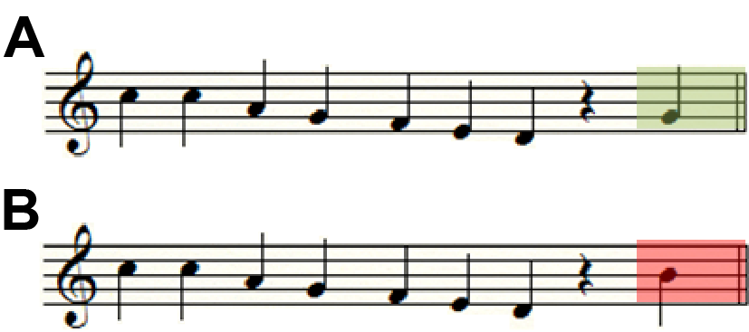

Figure 2

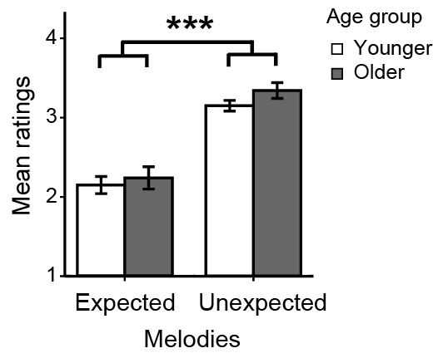

Figure 3

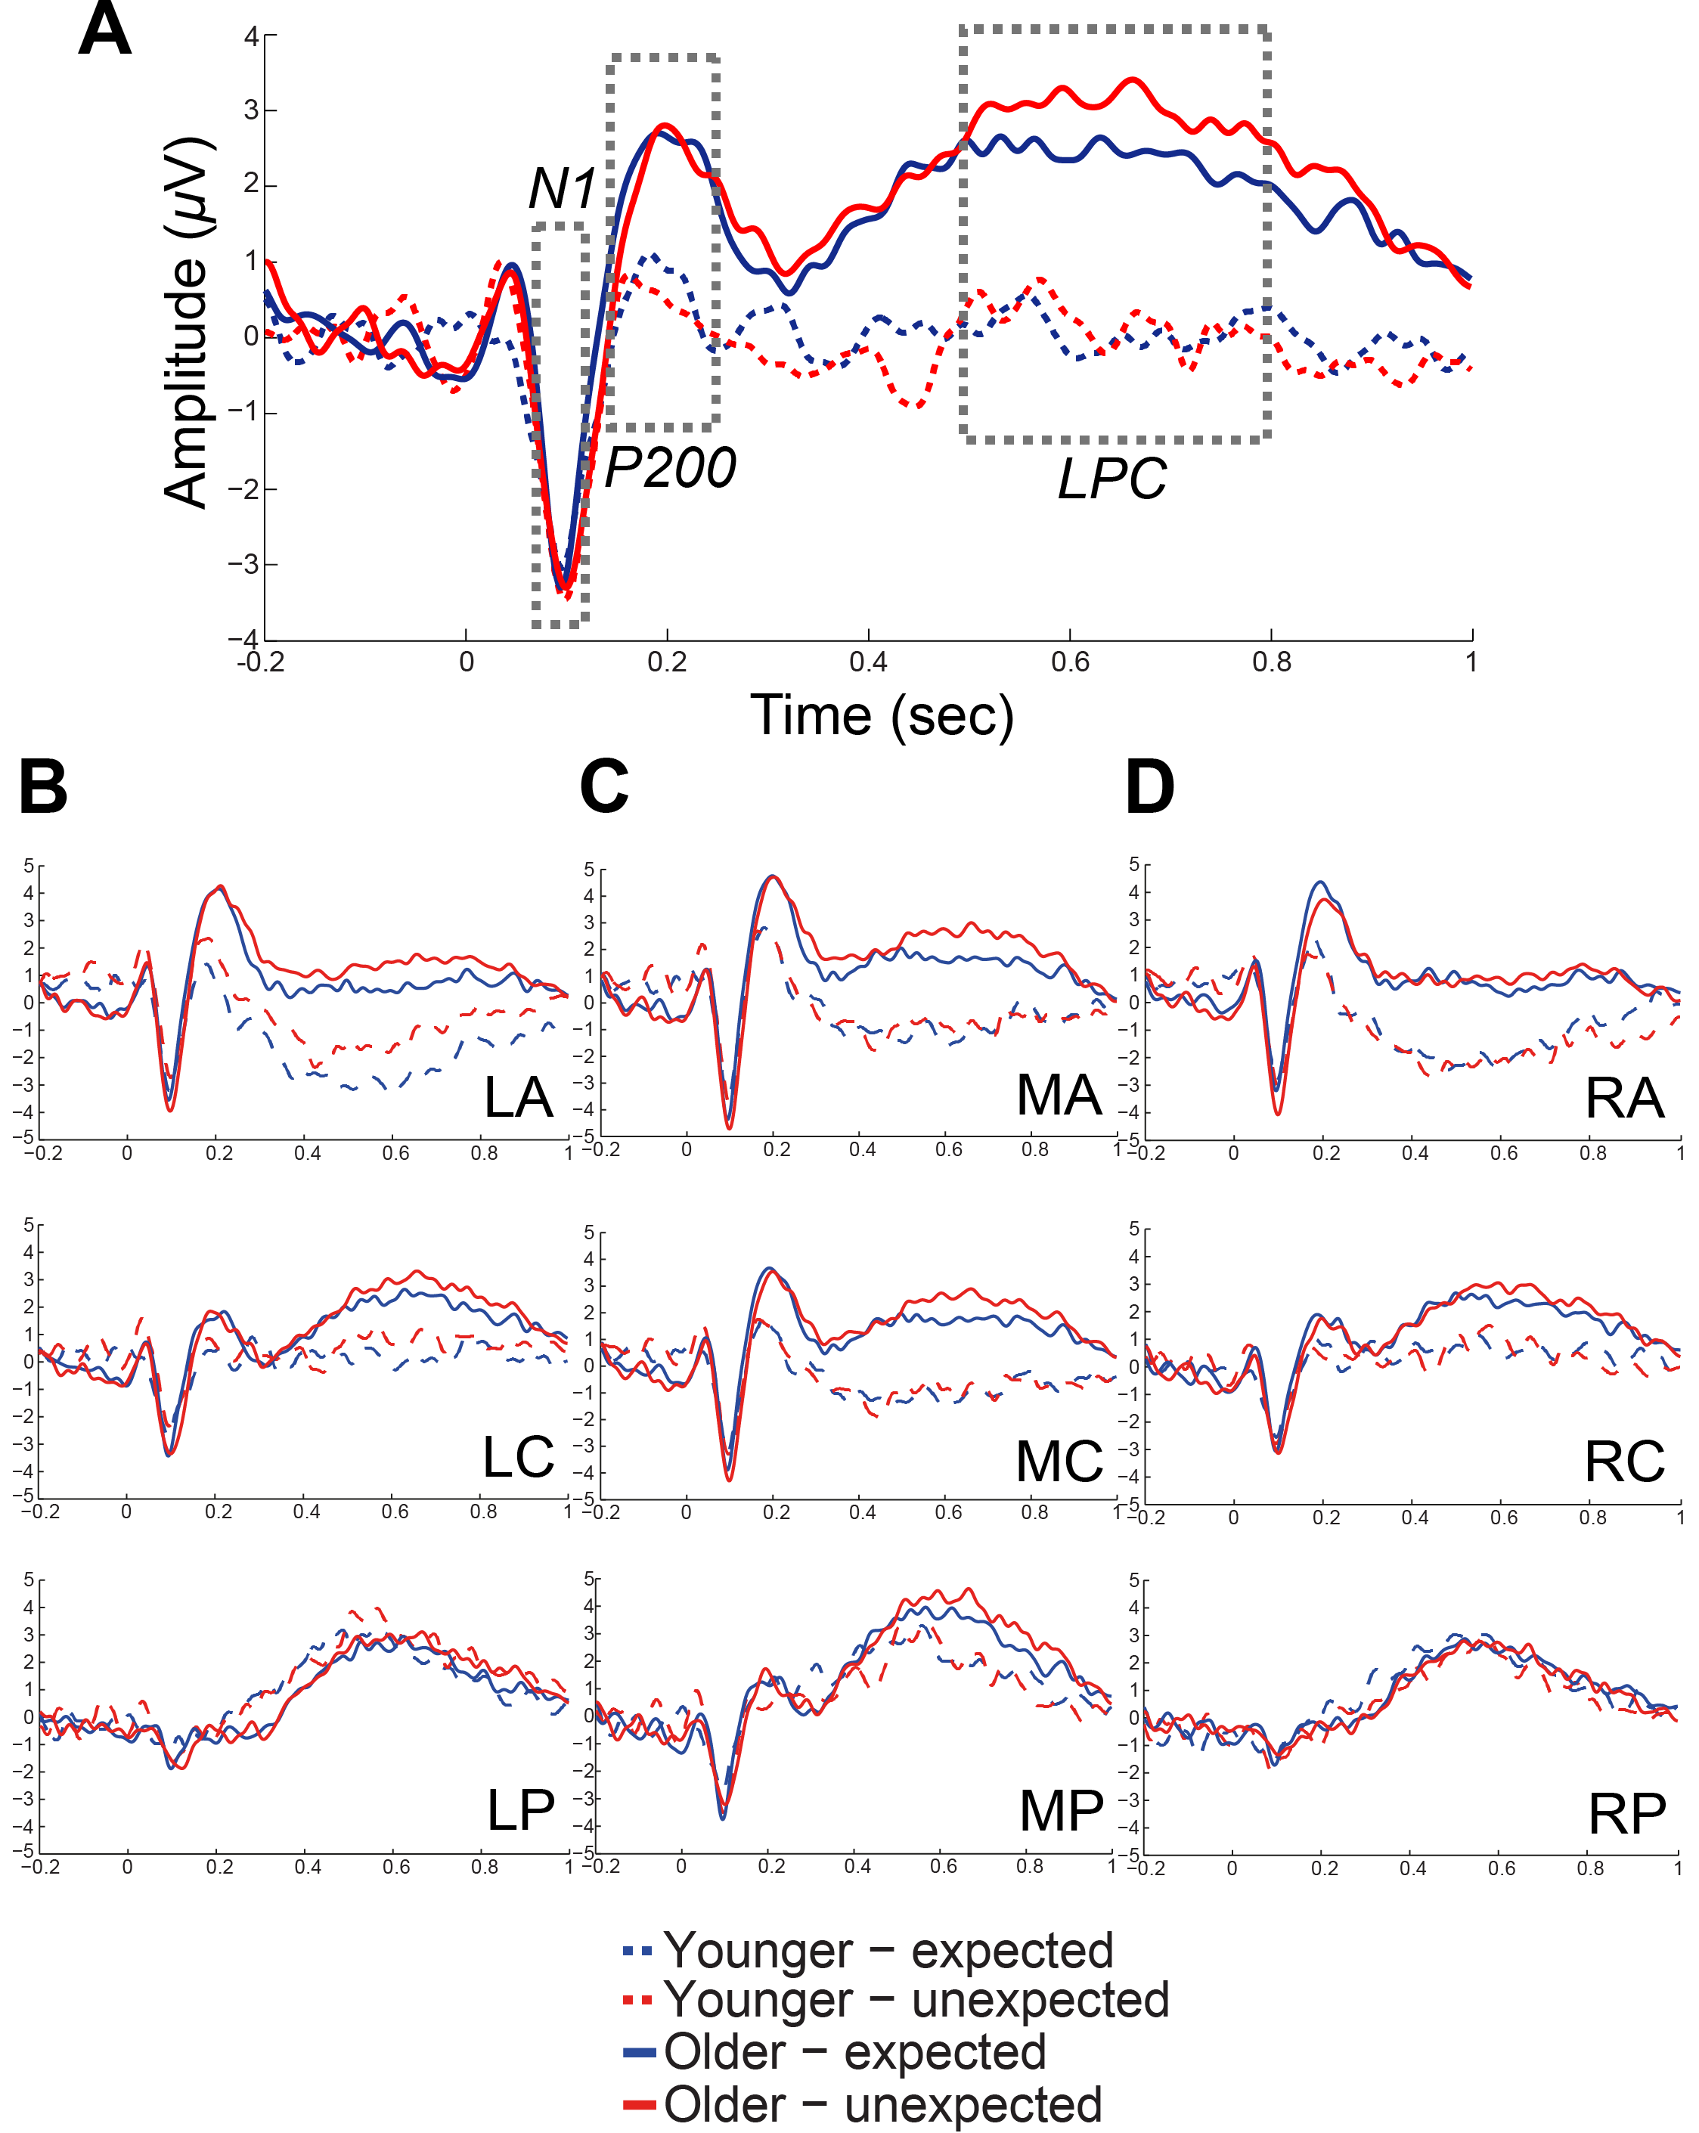

Figure 4

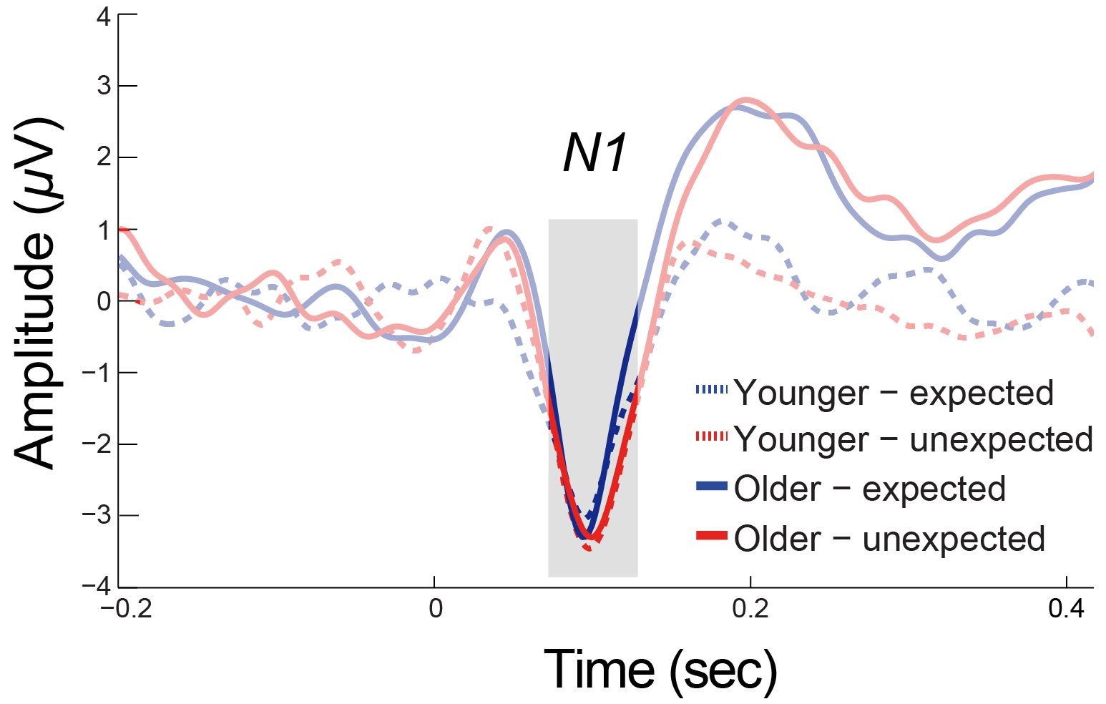

Figure 5

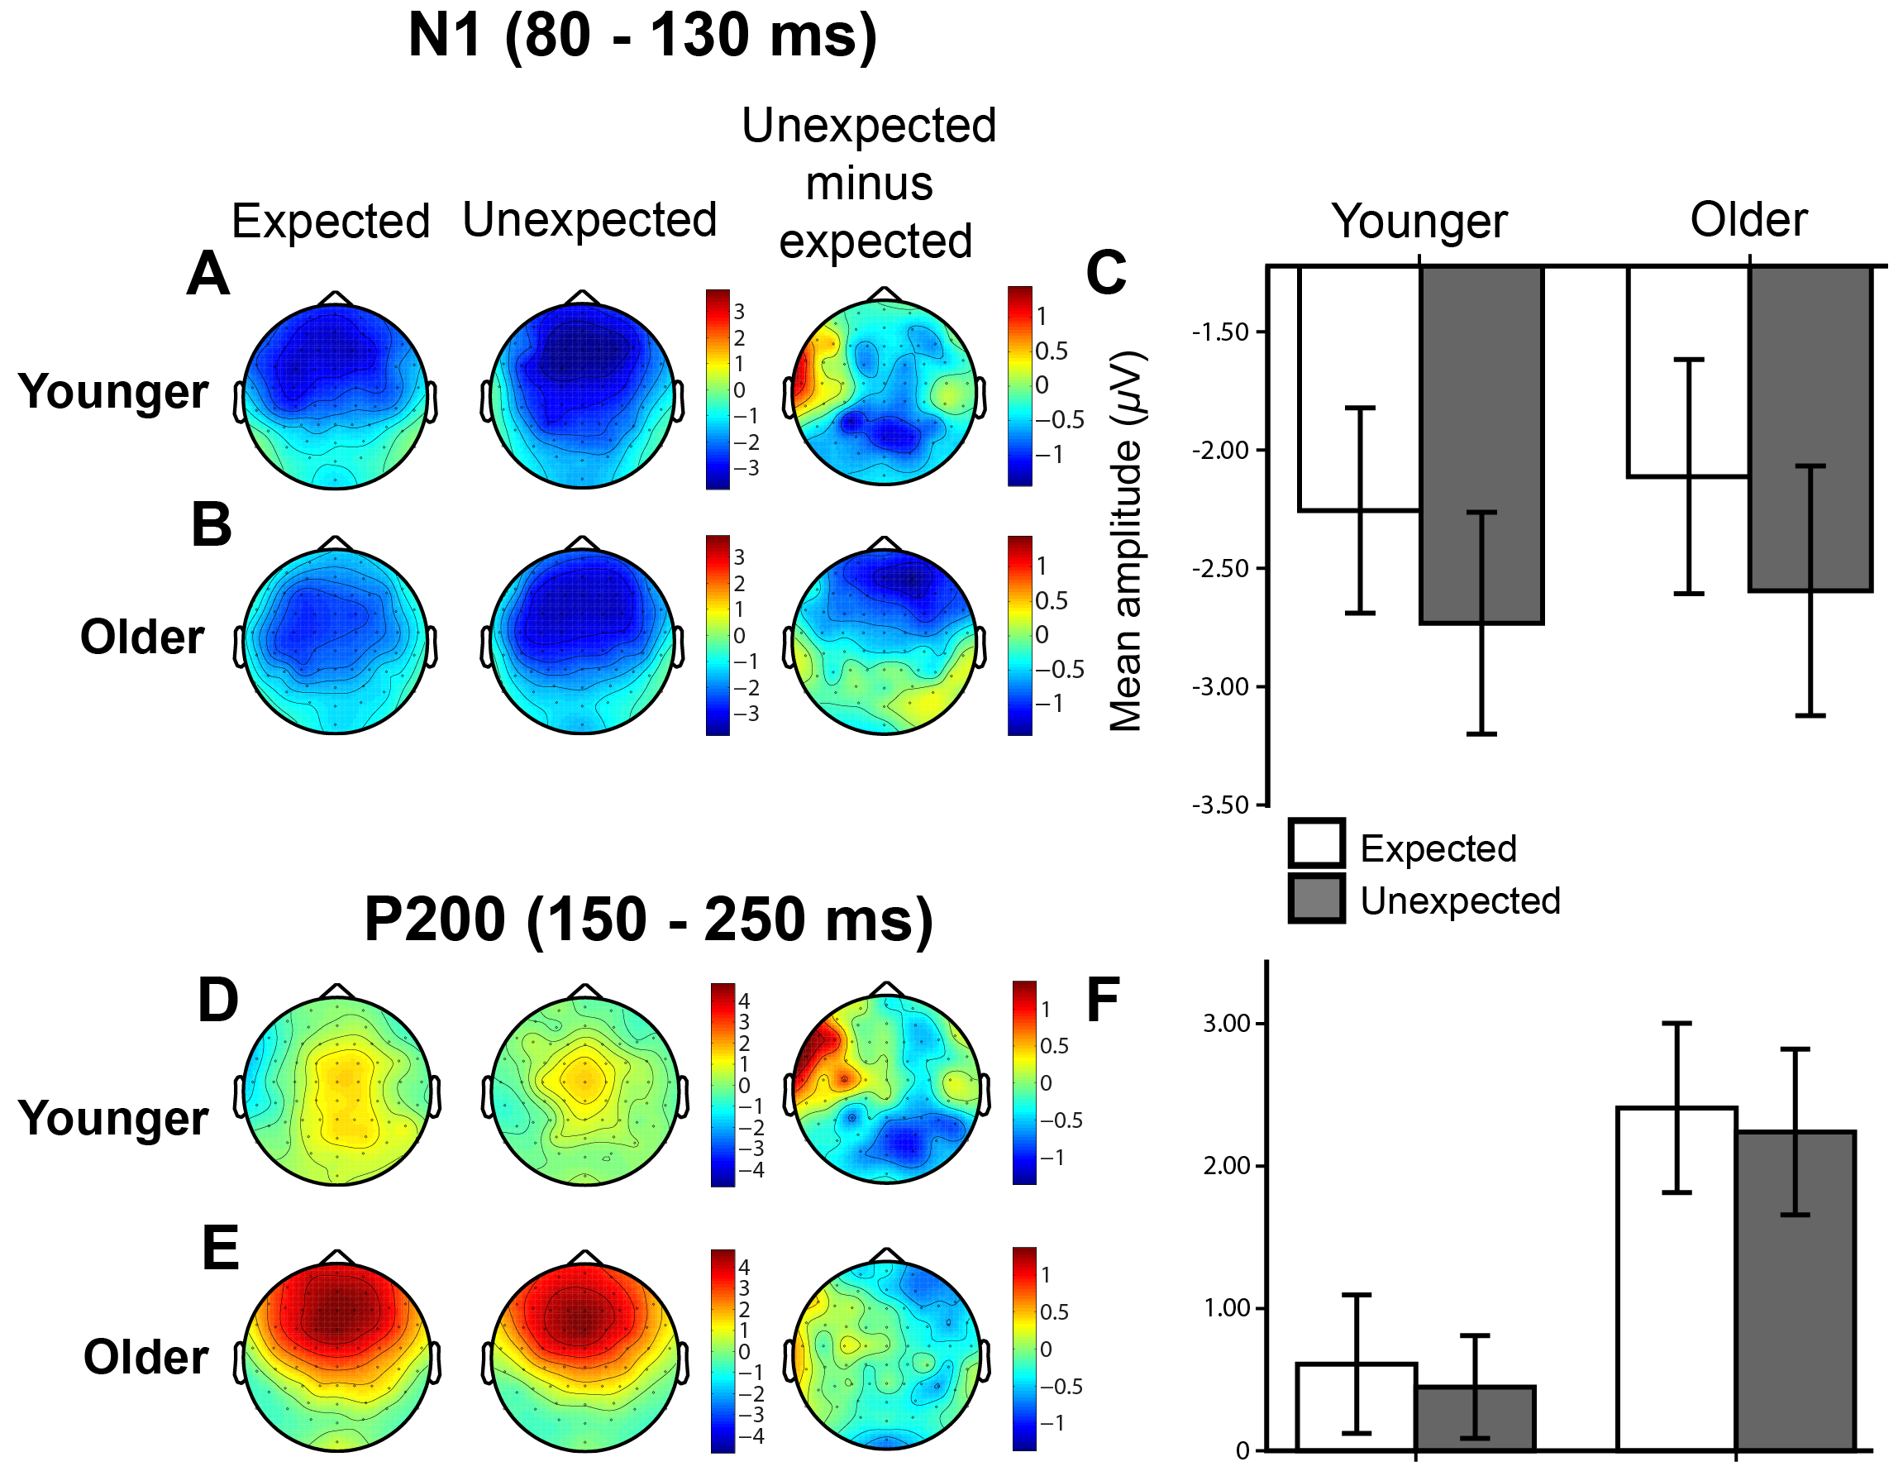

Figure 6

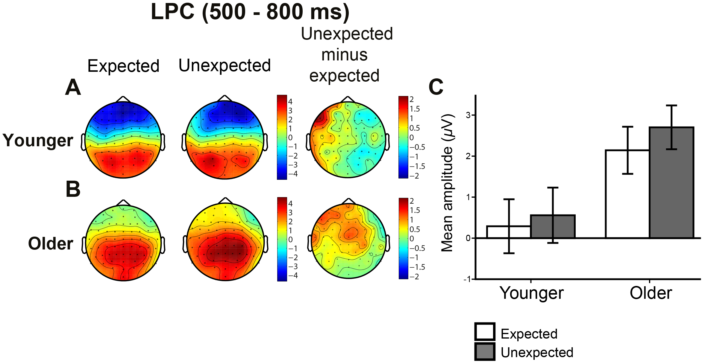

The IDyOM software and documentation are available from https://code.soundsoftware.ac.uk/projects/idyom-project

