Ethiraj Gabriel Dattatreyan
Goldsmiths, University of London
Department of Anthropology

Critical hip hop cinema: Racial logics and ethnographic ciphas in Delhi, India.

In this essay I discuss how a group of young Somali men and I produced a film about racism related to African students, entrepreneurs, and refugees residing in Delhi, India. The collaborative film project emerged out of field work I conducted in Delhi from 2012-2014 on the city’s emergent hip hop scene. As I spent time with rappers, dancers, and graffiti artists in the scene, it became evident that their interest in audio-visual production and circulation of their creative practices offered a platform for collaborative ethnographic projects to take shape. I use the term critical hip hop cinema to theorize the process that emerged out of my relationship with this particular crew of aspiring rappers from Somalia which culminated in the making of the film Cry Out Loud. This process, as I narrate below, remixed Jean Rouch’s ideal of a shared ethnography using the improvisational, aesthetic, and epistemological practices of hip hop. It also placed, front and center, the ways in which hip hop continues to provide a means for young people across the world to articulate their experiences and connect them to larger social processes. The making of Cry Out Loud shows that ethnographic engagement, when infused with popular cultural sensibilities, can create collaborations that offer a novel look at how a political economy of difference related to a particular place but linked to many others is imagined, produced, and contested.

We sat on the warm stones of Satpula, a dam built during the reign of Sultan Mohammed Shah Tughlaq in the 14th century. The dam, several hundred meters down the main road from Khirki, the urban village where I have conducted several years of fieldwork, is a decaying, poorly maintained monument that is a testament to Delhi’s former glory as the center of a regional empire. Satpula also stands barely a kilometer from a potent symbol of the newly rising global city of Delhi, the DLF Group’s 54-acre South Delhi campus consisting of five adjoining shopping malls, several office buildings, food courts, hotels, and movie theaters.
Here, a group of young Somali men would regularly gather in the late afternoons to smoke cigarettes and marijuana away from the prying eyes and harsh words of those on the street. In a cave-like space located inside the dam, hidden from their parents and elders in their community who told them, exaggeratedly, that they would kill them if they ever found them smoking; they told stories, laughed, and engaged in hip hop’s poetics, smartphone cameras always at the ready to broadcast a particularly good rap on Facebook or YouTube.
As a gentle breeze blew, Hanif, a 17 year-old Somali, began to rhyme a freestyle verse. On this day, he was particularly self-conscious, in part because of the professional camera equipment I trained on him but also because he was being recorded in front of an older MC in Delhi’s hip hop scene, MC Zan. Hanif knew Zan’s music intimately, through YouTube videos, Facebook, and the music site ReverbNation. But, he was hanging out with him for only the second time and was visibly nervous as he was invited to ‘spit some bars’ for the camera. He began briskly, his first acapella stanza a rehearsal of commercial hip hop bravado marked by an easy, effortless use of ‘nigga’ to punctuate his staccato lines:

What I’m saying is
Sitting in Delhi
Still smoking all the greatest
I’m fuckin’ the baddest
I will never take you to the top
Focus on the hocus
you niggas are jokers
Sipping that mojo
Bitch know me what I do
here with my nigga Z. sitting here
we smoking weed
with my nigga H. here we about to do the shit
All we do is smoke weed and go home

Then, perhaps because he didn’t get any feedback from his listeners (no head nods, no hands in the air, no audible sounds of appreciation), perhaps because the mainstream ‘American’ hip hop bravado from his initial verse didn’t quite fit the self-image he wanted to produce, his cadence slows. He began to tell a story in verse, to share something more personal of his life in Delhi:

Because we live in the blazing Delhi
It’s a place to live
I’ve been grown up here
I’ve been living here 9 years
I’ve been seeing shit
I’m with my family
pause
My father lives in Somalia
Works so hard to pay us for our bills
Audience: uhhuh, yeah.
I don’t give a shit
But still I am doing good
They think I am Black
Audience: yeah.
But my teeth are so white
But my smile is so bright
It’s a rap thing that’s all I can do

The scene I described above offers a glimpse of what is called a cipha amongst hip hop practitioners. The cipha is the improvisational space/time for sharing experience and demonstrating lyrical and dance skills. Hip hop ciphas appear in lived space as a circular formation of actors where a response from all participants is invited by the person who temporarily occupies the center of the circle. In this essay I discuss how my relationship in ‘the cipha’ with Hanif and his friends –all of whom are Somali refugees in India –developed into a collaboration that yielded a feature length ethnographic film that explored racism related to African migrants in Khirki. In so doing, I develop two interrelated arguments. First, that hip hop continues to be a “critical site for the negotiation of race, for the marking of racialized borders, and for their subsequent displacement and rearrangement.” Second, that ethnographic filmmaking can be renewed with a sense of collaborative purpose towards the goal of creatively documenting social and political issues as they unfold by harnessing hip hop’s dialogic and improvisational sensibility and young peoples’ interest in audio-visual capture for social media broadcast.
In the past decade, there has been an uptick in migration between sub-Saharan Africa and South and East Asia. Available statistical data indicates that tens of thousands of people representing over a dozen East and West African nations have travelled to China or India in the last five years to pursue their higher education goals, to establish their entrepreneurial ventures, or to seek asylum. This migratory flow from sub-Saharan Africa to India and China reflects the rising status of India and China in the global economy as well as the increasingly difficult proposition for migrants from the global south to gain entry into Europe and North America. As Africans find themselves living in the urban centers of Asia, they encounter localized versions of global discourses on racial difference where Blackness is positioned at the bottom of a racial order developed during colonial rule and refined in the postcolonial period. As Hanif subtly notes in his closing stanza, and as I intimately observed in my time in the city, Africans in Delhi experience a virulent anti-Black racism in a national context where caste, religion, class and language have historically been the categories that structure difference.
For many of the young people from Somalia, Nigeria, Ivory Coast, and the Congo that I got to know in Khirki and in other urban villages of South Delhi, consuming and practicing hip hop’s musical genre of rap was a way of engaging with and disrupting the racialized discrimination they experienced. Hip hop’s musical, dance, and visual aesthetic forms have been around since the late 1970s, emerging from African American diasporic arts traditions in the settler colonial and plantation capitalist contexts of the Americas. Hip hop, like the African diasporic art traditions that came before it, produces aesthetic forms that engage dominant “circuits of power and capital,” deriving its political, social, and market power through what Dick Hebdige (1991) calls “performances of significant difference.” In hip hop’s early years, young Black and Latinx youth in 1970s New York aestheticized and performed difference as a practice of self-determination and celebration. In the decades that followed, hip hop’s aesthetics have been commodified by a global industry that markets American Blackness as something to consume. Yet, even as hip hop has become commodified, its ethos of improvisation and dialogic exchange epitomized in the cipha lives on and is picked up by young people across the world as a means to generate alternate understandings and representations of self in relationship to place.
Place, as Michel de Certeau (1984) argues, is a curious entanglement of space and people that becomes the narrative and aesthetic ground for reproducing the status quo as well as for disrupting existing power relations. Anthropologists and critical geographers have, in the last decade, paid attention to the ways in which place-making projects in given socio-historical contexts are sites where we can apprehend social, political, and economic struggle. Setha Low recently suggested that social scientists’ theoretical and conceptual models locate place-making in a techno-materialist and discursive understanding of space in relationship to bodies. In this rubric, she argues, the person, as a unit of analysis and experiential locus, is left out. Place, in this formulation, is simply populated by bodies. As a corrective Low suggests that we include “the person as a mobile spatial field – a spatio-temporal unit with feelings, thoughts, preferences, and intentions” so we might see place differently from the perspective of people who socially create the spaces they inhabit. In the several years I have gotten to know Hanif and his friends, I have experienced Delhi from the vantage point of their everyday movements and moments “under the threshold of visibility.” I have also had the opportunity to witness how hip hop became a means for these young men to understand and represent Delhi.
In their cipha sessions, Hanif and his crew would take turns rhyming, inviting others they knew or had just met, whether Somali, Afghani, Bihari, or Nigerian, to participate by either contributing a verse or by talking about whatever the verse they heard prompted them to think. These moments of collective praxis were decidedly rooted in place. Rapping together in Satpula, for instance, became a means to collectively articulate the kinds of challenges they faced coming of age in Delhi while claiming a bit of Delhi for themselves. These exchanges were also mediatized. Young men rapping in a cipha would get filmed on smart phones by their peers, and clips of the footage would eventually find their way onto social media. Smart phones and social media became a means to broadcast their understandings of the city they call home to a select audience of friends, to cast a version of Delhi as a place steeped in their particular subjective understandings.
If the first concern of this essay is to discuss how Hanif and his crew used hip hop to negotiate their racialized experiences of Delhi, the second concern is to articulate the ways in which my Somali participants’ digital hip hop praxis became the basis for the collaborative ethnographic project we undertook. This project yielded Cry Out Loud, a feature length film that has since screened in India, the US, and the UK. I argue that Cry Out Loud offers an entry point to engage with what I call critical hip hop cinema – collaborative ethnographic filmmaking that relies on the improvisational space of the cipha and an interest and access to digital modes of production and circulation – to create artifacts that represent issues of social salience. Critical hip hop cinema borrows from and extends previous theorizations of hip hop infused ethnography, or hiphopography. For H. Samy Alim, James Spady, and Samir Meghelli (2006), hiphopography is a way of conducting research that takes seriously hip hop practitioners’ efforts to theorize and represent themselves in the world. Moreover, hiphopography is an approach to research that attempts to displace the power differentials between experts and participants found in typical social science endeavors, by harnessing hip hop’s aesthetic and epistemic sensibilities towards dialogue and improvisation such that all participants are imagined as experts. Critical hip hop cinema takes the improvisational and dialogic space of the cipha as the starting point for collaborative production. The cipha, as I showed in the opening vignette, offered an opportunity for Hanif and his friends to take up a critical and reflexive position about their experiences in and of Delhi.
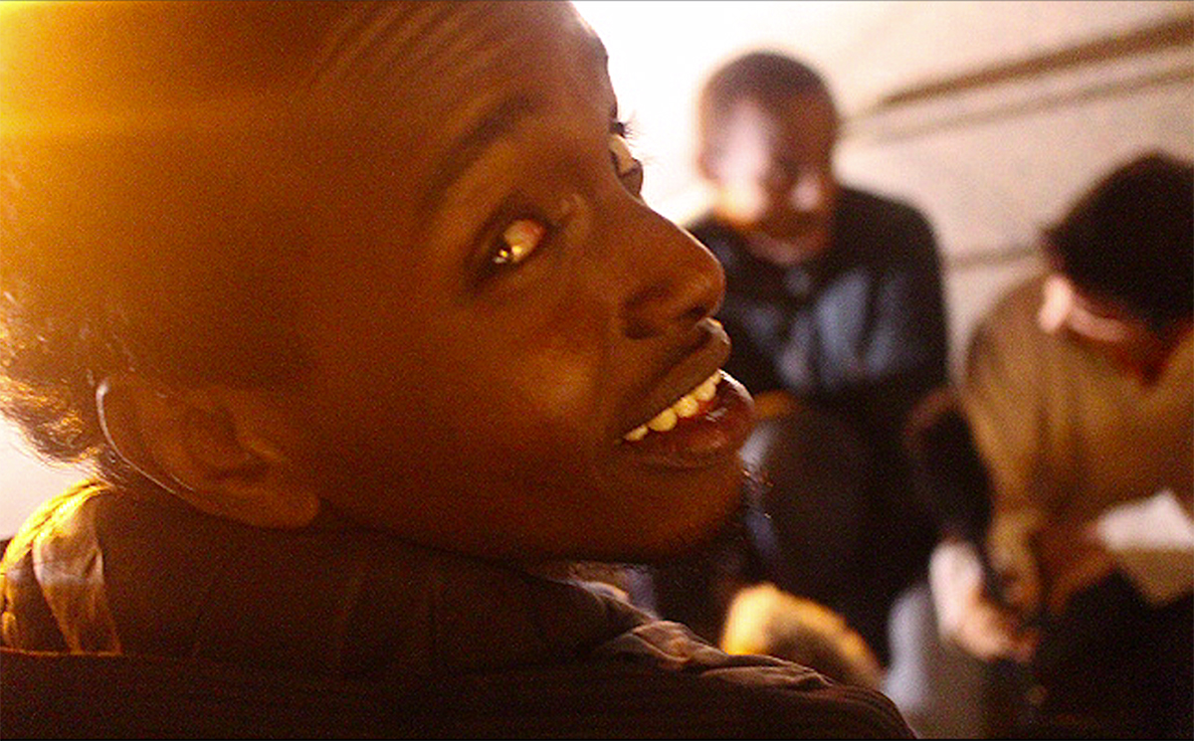
Figure 1 Hanif and his crew in the cipha, E. Gabriel Dattatreyan

Consider, first, that the move to share in the cipha in the surreal tunnels of Saptula shifted our semiotic register of engagement from the conversational cadences of ordinary communication to a hip-hop-determined sociocultural-linguistic framework. This reframing of dialogic interaction as a creative and critical exchange allowed Hanif and his crew to take on personae that effectively distanced them from the everyday Delhi they inhabit where they are seen as Africans, refugees, and outsiders. They did so, in part, by utilizing hip hop’s poetics to effectively claim a global Black subjectivity. For instance, Hanif’s use of hyper-masculine Black American vernacular English while in the removed recesses of Satpula allowed for a different engagement with place and space, one that interpenetrated his local experiences of anti-Blackness in Delhi with globally circulating understandings of a resistant Black (male) subject.
Yet, the distance he acquired from his local subject position through a voicing of ‘elsewhere’ and ‘otherwise’ dissolved when his audience didn’t fully ratify his poetics as a legitimate telling of experience. Recall that his friends in the cipha didn’t verbally or physically affirm his Hanif’s first verse. Hanif then switched his voice to one that located him in Delhi, elucidating his personal struggle and, in so doing, garnered the support of the cipha. His move to a more embodied poetics, in addition to emplacing his narrative in Delhi, disrupted the normative aesthetics of mainstream and commercially viable hip hop music formation that has become increasingly misogynistic and anti-Black. Indeed, the cipha – the circle of active listeners and imminent participants -- compelled Hanif to return to a reckoning with biography, biology, and place even as he held onto a hip hop infused global Black subjectivity that afforded him the tools and confidence to articulate himself in the world. It was these short moments of exchange within the cipha, often playfully filmed for social media circulation, that became the basis for our hiphopographic project. Their raps and the context in which they were produced, when captured on camera and put into conversation with ethnographic interviews and observational footage garnered in the spirit of the cipha, became the material from which we cut the feature length film Cry Out Loud.
Ultimately, my hope is that in conceptualizing critical hip hop cinema, I can point to the productive ways ethnography can co-articulate with vernacular digital practices to produce new collaborative possibilities and novel audio-visual artifacts. As young people across the globe engage with popular culture and digital technology to create and circulate renderings of self and place, it seems clear there is an opportunity for ‘ethnographic’ filmmakers to create alongside and with them. The opportunity to co-create is particularly evident within a global hip hop community where the African diasporic aesthetics of dialogic creation live on in the concept of the cipha. Critical hip hop cinema, however, is not the only path towards collaboration. It is a commitment to create collaboratively with people that generates representational projects that are as truthful to the complexity of the project as they are to those that we, as filmmakers and/or anthropologists, work alongside. This possibility hinges on what Dale Hudson (2008) calls ‘open modes’ of audio-visual production that privilege a shared aesthetic vision that emerges from dialogic encounters. A shared aesthetic vision, I argue, has the potential to change our capacity to see the world in a world. In what follows I discuss how Hanif, his friends, and I utilized the cipha to create ways of seeing and representing Delhi as a place where anti-Blackness circulates and makes visible a complex political economy of difference.

Delhi’s racial logics
Soon after Hanif has finished rapping for the camera and I have stopped recording, Salim, a 22 year-old Somali and the eldest in the crew of 10 young Somali men I spent time with in Khirki, begins to speak. “How can they call us cannibals? Say that that we eat people? I mean, maybe they found an organ somewhere in some Nigerian man’s fridge who is doing organ trading but how then do they think we are cannibals? That we eat people? They are racist.” He is visibly upset. “This is what we have to deal with every day as Africans in Delhi, and even we are not all the same.” Salim’s exhortation touches upon the kind of symbolic violence that occurs daily in Delhi against African nationals. These sorts of racialized and often gendered stories of difference, where contact with the Other is expressed in terms of inhumanity, are set in the working class context of Khirki where a large number of Congolese, Nigerian, Somali, Ivorian, and Ugandan nationals lived during the time I was in Delhi. While I expressed some degree of shock and surprise as Salim recounted his story, I had heard offhand accounts of Africans engaging in cannibalism and organ trading from other residents of Khirki before I met Hanif and his crew.
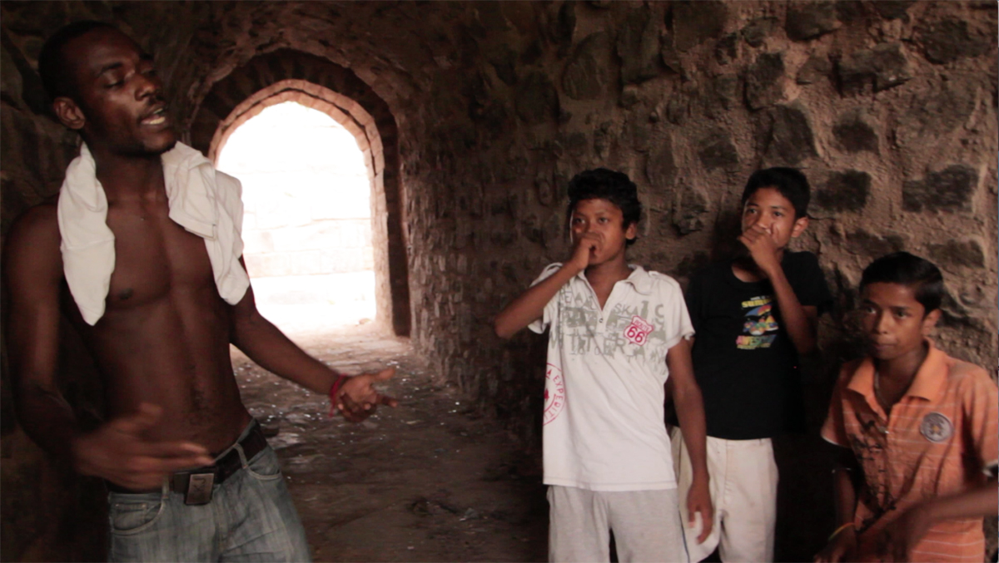
Figure 2 A cipha in Satpula, E. Gabriel Dattatreyan

The persistence and the reach of these stories relied on, at least in part, a lack of meaningful contact and inability to communicate between African and Indian residents. For most Africans living in Khirki, contact with India is circumscribed in their relationships with landlords, real-estate agents, shopkeepers, and neighbors. These relationships, for the most part, are transactional in the sense that the communicative practice that created them relied on conventional understandings of exchange and normative reckonings of misinterpretation grounded in perceptions of difference. Outside of their engagements with globally circulating Indian popular culture, these encounters were their main interactions with India and Indians. Conversely, for the majority of the Indians who live in Khirki, their passing contact with African nationals was their main contact with baharlog (outside people). Indians living in Khirki only had the minimal contact on the street and in shops as well as the rumors they heard to make their judgements. As importantly, Khirki also became the site first time contact amongst Africans from several different national, tribal, and religious backgrounds. Salim’s matter-of-fact suggestion that Nigerians were involved in organ trade rackets suggests the kinds of stereotypes of difference that were also produced and circulated about Africans by Africans who all found themselves together in Delhi.
I began to get a sense of this complicated terrain of difference as I got to know young people in Khirki from various ethnic, national, and linguistic backgrounds who were into hip hop music and dance. The Somali youth with whom I eventually produced Cry Out Loud were particularly open to sharing their experiences of the ways in which race, class, gender, and linguistic and cultural competence intersect with each other in the everyday life of the urban village. After high school or after their participation in the youth programs hosted by the local UNHRC (United Nations Human Rights Commission) office that catered to refugees in the area, they would meet. I would meet with them in various places in Khirki and, sometimes, in other parts of the city, where they went to iteratively and creatively narrate their experiences.
Their stories of everyday life in Delhi, their relationship to the Somali diaspora, their interactions with other African nationals, and their relationship to American Blackness surfaced during and after their and our creative exchanges through hip hop. Salim’s passionate narration of the cannibal story, for instance, emerged just after Hanif’s short rhyme with which I began this essay. During a cipha any number of stories, whether in verse form or in oral narration, might have followed the topic of cannibalism. They could have talked or rapped further about the everyday racism they faced in Delhi or, perhaps, shifted topics and talked about the latest hip hop music they had listened to, playing a video or track on YouTube for the group to share the experience. Or, they might have discussed or rapped about their ongoing petitions for asylum in Europe or the U.S. These stories, when taken individually and together, painted a tangled picture of movement and connection that offered the contours of the world system we live in today as well as the history that produces it.
The story of cannibalism related to Africans in contemporary Delhi, for instance, offers an entry point into how colonial discourses that entangle cultural and biological difference prefigure and produce racial hierarchies in Delhi. To be termed a cannibal in the colonial period was an accusation reserved for those relegated to what Michel-Rolph Truilliot (1991) calls the ‘savage slot,’ the position reserved for those outside White modernity. Cannibal, along with indolent, irrational, barbaric, and savage, formed the terminology that Viranjini Munasinghe (2001) calls the British ‘colonial idiom’ that established Africans and Indians as racialized subjects in relation to one and other and to their colonial masters. The cannibal narrative that Salim places in contemporary Delhi reveals how this history lives on in the present and shapes future relationships between southern geographies as eastward migration grows and urban centers like Delhi become the destination of students, entrepreneurs, and refugees from several countries in Western, Eastern, and Southern Africa.
In the time I spent in Khirki it became clear that these sorts of exceptional narratives of difference precipitated physical violence. In the months before and during shooting for Cry Out Loud there were several altercations in Khirki where local men targeted African students living in the area after an otherwise everyday event made difference intolerably visible. For instance, one violent attack was premised on the grounds that a young Congolese woman wore a dress that was deemed too short by Indian men who resided in Khirki, many of whom were migrants themselves who had relocated to Delhi from the agrarian heartlands of the Gangetic plains. African women and their clothing choices normally didn’t elicit a violent response. However, on this particular day men from the village attacked Congolese men who accompanied this woman through the village. These seemingly unpredictable eruptions of violence should be seen in direct relationship to the sorts of dehumanizing stories that circulated in Khirki. As Veena Das has argued, the circulation of rumors that perpetuate notions of radical Otherness often form the logic for brutal acts of physical aggression against those deemed to be outsiders.
In previous years, these instances of violence didn’t surface in mainstream media reportage. However, soon after we started production on the film, stories of violence against Africans began to receive mainstream news attention, not only in Delhi but across the country. I am not suggesting there was a causal relationship between our filming and the news media attention. Rather, at that moment, there was a confluence in interest around African subjects, generated around the sudden visibility of previously submerged narratives of difference related to African bodies. African subjects were overtly discursively connected to drug dealing, prostitution, organ trading, and cannibalism by local politicians, the residents of Khirki and Delhi, and these connections were amplified by the press as they recounted the violence directed at African nationals.
These journalistic accounts perpetuated the rumors that circulated in communities like Khirki, often recounted a single register of difference and therefore reified Africanness and Blackness as exceptional. For me, these flat renderings of difference that appeared in print and on TV, created an urgency to say something, to give a complex account from below that accounted for various frictions and narratives of difference, political economies of place, and violence in a more nuanced way. Put another way, these one-dimensional news circulations made my Somali interlocutors’ creative play and its layered complexity all the more important as they spoke not only of the experience of racialized violence and bias but also offered narratives of transnational longing, of families split across several national contexts, and pointed at the complex politics of difference found within the Pan-African communities of Delhi.

Critical hip hop Cinema – Fashioning a Collaborative Visual Ethnography
Hanif: And if it happens we will do the little documentary you told me about. It will be great doing something with you

Me: Yes. Lets do it. Lets start planning it together. I shared some ideas. I want to hear yours too.

Hanif: Alright we will sit and share ideas
(Facebook chat July 2013).

The connection that I made with the Somali crew through hip hop that led to our development of a film on the racial terrain of their urban village in Delhi can be likened to the quest of the anthropologist who searches for a key informant who will open the door to unknown worlds that connect to a particular subject of study. Here, in this narratological imaginary, the Somali youth appear unexpectedly and quite spectacularly as key informants who, in James Ferguson’s (1999) words, embody a ‘performative competence’ in the confoundingly complex social terrains of South Delhi. That is, their unique position as insiders and outsiders in Delhi, their intimate understanding of several overlapping cultural contexts, their fluency in several languages, and their relationship to Islam allowed them to straddle multiple worlds in the city. From the West African speakeasy bars of their settlement community, to the local mosque, to functions at the UNHRC (United Nations Human Rights Commission), to passing time with their working class Nepali, Bihari, Afghani, and South Indian school friends in Satpula, visiting the middle class homes of some of their school mates, or interacting with the wealthier refugees from Somalia who lived across town; these young men had a profound sense of the complex layers of the city and the community they resided in and the ways in which this knowledge linked to a broader understanding of the world. Their experiences, no doubt, provided an opening by which to engage with the complex politics of difference in Delhi.
Yet, as can often happen in an ethnographic détournement, I met these young men by accident. I had no plans, when I arrived to the city in 2012, to study racism related to the growing African population. Rather, I travelled to Delhi to begin fieldwork on the city’s emergent hip hop scene. From the few journalistic articles I had read and first had accounts I had from friends in the city before I arrived to conduct fieldwork in Delhi, many of the dancers and MCs (rappers) in the scene were from working class Indian backgrounds. Their families had arrived to the city from across India in search of jobs in the early 2000s. When I sought these dancers and MCs out I found myself in Khirki and in a couple of other urban villages in South Delhi, which, in the previous five years, had absorbed an influx of migrants from all over India and beyond. Initially, I met Bihari, Garwhali and Northeastern young people who went to school or worked as service laborers by day and practiced their hip hop dance moves or wrote raps by night.
During my first months in Delhi I also met some of the ‘stars’ of the Delhi scene. One of these stars was MC Zan, who appeared in the opening vignette. When I first met Zan, he had recently performed at an India/Africa event sponsored by the Indian Ministry of External Affairs. During the event he had met several East and West African youth who lived in Delhi. They immediately gravitated to him because, in his lyrics, he discussed his intimate relationship with Africa and India by way of his father, who is Sudanese, and his mother, who is Punjabi. Zan offered these young newcomers to India a way to think about being in-between worlds through his music. Hanif was one of the young people who Zan connected with at that show. Zan introduced me to Hanif and his crew during one of our trips together to Khirki. The opening vignette marked the second time that Hanif met Zan and the first time he had an opportunity to rap in front of him. My introduction to Hanif and his friends under the auspices of hip hop, a point that they constantly remind me of -- “we met because of hip hop” -- suggests a different entry point into urban social life. This entry point into ethnography, I would argue, offers a case for sincere inductive ethnographic engagements that take the popular cultural production and relational projects of its participants as the starting point for research. In this formulation hip hop is not an ‘object’ of study but rather an ethnographic opening by which to engage with concerns, dreams, and experiences of its practitioners.
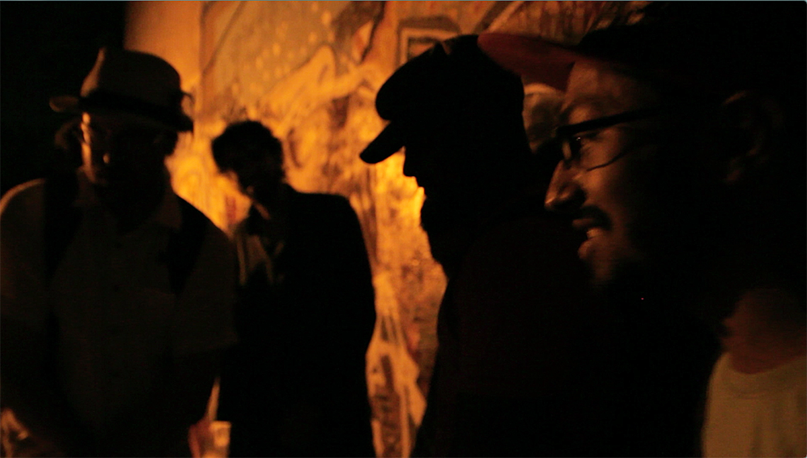
Figure 3 Inside the Delhi hip hop scene. E. Gabriel Dattatreyan

My relationship with Hanif and his crew eventually led us to the streets of Khirki, inside speakeasies (informal bars) run by African transnationals, and into their homes. Yet, our shared project that drew from and extended their already existing processes of creatively documenting racism in Khirki did not immediately materialize. Rather, it required a lengthy period of connection, conversation, and shared play within the practice based strictures of hip hop. Put more emphatically, for our film project to manifest we had to mutually invest in dialogue within the cipha. As importantly, our exchanges required the practical and symbolic value of my professional camera equipment.
When I first entered Delhi’s hip hop scene, I quickly became known as the New York-Indian with the camera. I was invited into interactional settings, in large part, as a documentarian and, eventually as a co-creator. I began to shoot videos, photos and so on, at the request of different groups of young people involved with hip hop I got to know in the urban villages of South Delhi. They felt (and expressed) that my professional equipment offered a more legitimate and legitimizing means for them to record the short videos and photographs that they circulated on Youtube and Facebook. As we shot footage for their music videos I also shot the interactions that we had in the various public and private places in which we met, without a clear plan for the footage. This casual and consistent shooting made my DSLR, initially an intimidating piece of equipment for my youthful interlocutors, an integral part of our shared interactions. In important ways the DSLR, then, became a way for us to connect ethnography with the creative digital renderings of place that they used their mobile phones to fashion. The DSLR served as a kind of technological bridge that allowed their practices and my practice to co-mingle and became the metonym for the digital/physical terrain that we interacted within.
I decided, after about eight months in Delhi, to head back to the U.S. for a short visit. When I let my interlocutors in the hip hop scene know I was going back to the U.S. and intimated I could bring things back for them, several young people requested snapback baseball caps and graphic t–shirts from the U.S. Another MC in the scene, when he found out I was visiting the U.S., requested studio equipment, a digital mixer to be precise, emailing me the exact specifications and also promising me reimbursement when I returned. Hanif and Sunil, a member of a mostly Garhwali dance crew from a nearby urban village, asked for cameras they could use for the time I was in Delhi.
When Hanif asked me for a camera, intimating that he and his crew would use it for music video production, I asked him if there was any interest in using cameras to make things other than music videos such as short films. If so, I asked, what sorts of stories were they interested in exploring and telling through film? Hanif immediately answered, “We should make a film about racism in India.” Our first conversation around this occurred while we were sitting in a classroom in the UNHRC satellite office in Khirki. Hanif had just finished helping to produce the yearly youth newspaper. It continued on Facebook some days later when Hanif reached out to me to share some of his new lyrics that focused on communal violence in Somalia. In our chat on Facebook he reframed the focus of our potential project slightly saying “we should show the experience of Africans living in Delhi.” These exchanges with Hanif before I left Delhi to visit the U.S. inspired me to purchase two reasonably high quality cameras, two microphones, and other necessary equipment to make up two full kits for ‘run-and-gun’ film projects.
When I returned to Delhi I met up with Hanif and his crew for a cipha at Satpula. A couple of MCs shared their latest lyrics as the sun set. Meanwhile, I passed the new camera around. The crew all took turns playing with it, shooting some of what unfolded in the intimate space of the tunnels. Later that evening, Hanif and a few others in the crew and I began to discuss plans. We decided to meet up later that week to begin planning a shooting schedule. The subsequent planning discussions for the film and the ways in which shooting began to unfold suggest that the cipha became not only a literal device by which Cry Out Loud was developed but a conceptual and pragmatic framework for creating a critical hip hop cinema.
Certainly, the cipha sessions themselves were integral to the film. The energetic exchange of lyrics and the discussions that followed eventually became the musical ‘spine’ of the narrative, a way to stitch together the varied observational and interview footage we assembled during the course of production with the refreshingly raw and improvised moments that the cipha provided. Raps in French, English, Hindi, and Somali that emerged out of ciphas in various public locations across Delhi made it into the final cut. However, as importantly, the cipha became an ethos that translated into a working model for collaboration. Put simply, the cipha became a model for how we would exchange ideas about the film with each other as well as a method by which Hanif and his friends gathered audio-visual material for the film. Our model also drew from the collaborative techniques I had borrowed from Jean Rouch’s filmmaking practices.
Jean Rouch was a noted anthropologist and filmmaker who in the 1950s and 60s pioneered what he called a shared anthropology through the camera by inviting his subjects to become participants in the process of filmmaking. His filmic body of work continues to inspire a particular genre of verité filmmaking where the truth of the film is not supposed to be in the veracity of the observation but in the depth of the relationships that produce the filmic account. Rouch sought to achieve truthful accounts of social life by bringing his ethnographic participants into his filmmaking projects in a variety of ways. One way he approached this was by what he called playback/feedback sessions.
The idea behind playback/feedback is quite straightforward. After a day of shooting, Rouch would invite his collaborators to sit with him and watch rushes of the footage. He invited critique and more importantly, he invited those involved in his project to suggest new avenues for exploration. In this formulation Rouch controlled the handheld camera that he used to take footage of his collaborators but invited them to enter a space of dialogue that was tethered to what was captured in his filmic incursions. In the projects I initiated in Delhi with the hip hop practitioners I met, I experimented with an inversion of this relationship. Instead of showing the crew footage I took of them, I gave the camera to the crew and we watched and discussed the footage they shot at the end of a week.
Their shoots, however, were not directionless. Initially, I asked them to develop a conceptual area for further inquiry. For instance, one of my early prompts was “Talk to each other on camera about Khirki. What kind of place is Khirki?” What became interesting was the way in which they interpreted my prompts. For instance, they took my prompt to ask “each other” about Khirki to talk on camera with a Bihari rickshaw puller and a local pradhan (leader) they knew from the neighborhood. Their willingness, even desire, to broaden the ‘we’ implied by my exhortation to interview each other translated into an extension of the cipha, an inclusion of voices who were at once hostile to Africans as a general category even as they recognized the Somalis as neighbors and even friends, in large part because they lived in close proximity to them, spoke Hindi, and were Muslim. The cipha was also extended when members of the crew enlisted family members to help them conduct interviews. For instance, Hanif had his sister help him interview their mom. Mohammed had his cousin operate the camera for an interview he conducted with UNHRC staff. In this sense, the cipha extended not only to include voices but to create makers.
Initially, I also reviewed with them the basic workings of the camera and very briefly described key rules for shooting – keeping the camera still, selecting subjects and foregrounding the cut in the editing room by shooting long shots, medium shots, and close ups and so on. This process, of course, was made easier because of the organic scaffolding some of them already had as YouTube and Facebook producers as well as the experience they had as they ‘played’ with the equipment I had brought along in my initial months in the field. The process of teaching filmmaking was also made easier because of the crew’s practice of hip hop’s poetics in ciphas. Their hip hop proficiency allowed them to approach improvisation in the field with ease, something that many of my university students whom I teach visual anthropology struggle with a great deal.
Because there was only one camera, the crew had to take turns operating the equipment. The turn-taking when they shot created a healthy competition amongst the group, as they playfully argued about what looked and sounded better between their rushes when we looked at them together at the end of the week. After a week or two of shooting, watching, and discussing, several formalistic filmmaking concepts began to emerge in our playback/feedback sessions. For instance, the idea of B-roll and A-roll and a debate around what constituted each category emerged after several weeks of shooting. B-roll is commonly understood to be footage that is utilized to visually tell a story, fill in the cracks, to create a mood. A-roll is commonly understood to be the interview and interactional footage of a film, the footage that forms the centerpiece of a documentary project.
Our debates around A-roll and B-roll allowed us to begin to think about post-production and narrative. In one instance, Mohammed argued that the observational footage of an ice cream shop he had shot had to be considered A-roll because there were so many good conversations he picked up. Salim, however, argued that there was no context for the conversations in the ice cream shop so the only parts of the footage where no one was yelling towards the camera could be used and, that too, only as B-roll. These conversations allowed them to think about what they were attempting to capture and to begin to shoot with a different eye, always thinking through the relationship between shooting and the final film.
Our delineation and debate around A-roll and B-roll also opened up the space for me to discuss ethnographic interviewing and participant observation – the methods by which anthropologists ply their trade as social scientists. The introduction of ethnography allowed participants to explicitly and critically reflect on the relationship between improvisation and planning. My youthful collaborators immediately related these sorts of conversations back to a hip hop cipha where rappers or dancers, while they improvise in the moment they enter the circle of practice, also bring lyrics or dance moves as a vocabulary by which to spontaneously create. “Ethnography is the fifth element!” Hanif said to me one day, referring to the five element discourse of hip hop, which consists of rapping, DJing, graffiti writing, bboying (dancing) and knowledge. In this discourse the fifth element — knowledge — is wide open and can include anything that fits into the paradigm of creating self-understanding and sharing self-understandings with others. They recognized that ethnography fit easily into the hip hop discourse on these grounds but also because ethnography allowed one to create within a recognizable genre, cite those who came before, but also create new and improvisational material.
Our discussions around the relationships between ethnography and hip hop prompted participants to try and develop interview questions that they felt they needed to ask those that they had chosen as their informants – various African nationals, Indians who lived in Khirki, family members — in order to get a story. Here, some interesting developments unfolded. First, some of their early interviews were reflective of the mass-media versions of interviewing that they consumed. Some of the crew members had taken on an almost MTV-like approach to conversation with their interviewees – an approach which positioned them as super-ordinate to the situation they were trying to understand. For example, Mohammed decided to interview Hanif’s sister and brought us back the rushes from the shoot a few days later. We watched the footage of this interview one evening while sitting in the UNHRC building eating biryani from the local shop. The opening shot is of Mohammed introducing the interview by intimately looking into the camera and dramatically saying, “I am here with a Somali woman. Let’s see what life is like for her…in India.” He then continues the interview as if he has never met her before even though he is Hanif’s best friend and spent time at his house interacting with his siblings daily. After watching this clip, the group laughed and teased Mohammed. “Do you want to work for TV? Why did you pretend you didn’t know her? Her answers were too simple. You should have just talked to her and recorded what you talked about.” Their comments led to some good discussions around reflexivity, positionality, and the chimerical nature of objective truth.
After three to four months of shooting, watching, discussing, and shooting some more, we moved into the editing stage. In part, our move towards editing was precipitated by the alarming increase in physical violence against Africans in Khirki and the necessity to develop and share a narrative that engaged with difference in Delhi in a nuanced way. In addition, my time in Delhi was running out and I wanted to be sure to work on all aspects of the film and create a final cut with my collaborators before I left. Once we began editing there was a drop off in involvement. Of Hanif’s nine-person crew, only Hanif and two other crew members faithfully showed up to the donated studio space I had established to produce the final cut. While this drop off created a more manageable group to take on the tedium of editing it changed the way in which we worked together and opened up several conversations that challenged the easy and productive exchanges we had during our production phase. In this sense post-production made readily apparent the power differential between me, a perceived elder in the hip hop community and their mentor in filmmaking, and them, a small group of young men learning the complex processes of narrative storytelling in digital forms by engaging with their personal and sometimes difficult-to-tell stories of social difference.
I dealt with this power differential by embracing the position I occupied. Throughout the process of editing the film, rather than impose the idea that they needed to be responsible for the final cut, I made it clear that I would take the lead around discussions regarding the narrative composition for the piece – how we would assemble all of our audio-visual data to tell a story, what was the story we wished to tell, and so on. Herbert Kölger (1995) argues in his work on the dialogic encounter that a ‘dialogic cross-reconstruction’ of context that utilizes the knowledge frameworks of the interlocutor and researcher in ways which elucidate rather than conceal a hierarchy of knowing can create new understandings for all involved. Our dialogic cross-reconstruction allowed us to move forward with the edit with the shared understanding that they knew Khirki and Delhi in a way I never would or could and that I knew filmmaking, at least for the moment, better than they did.
Yet, even though we had discussions regarding a delineation of responsibility and positionality, there were still challenging moments. As we began to sift through and watch the footage, conflicting interpretations of difference emerged in our dialogues which made it challenging to move forward with co-constituting a narrative. In one instance, Hanif and his crew were unsure of whether and how to be sympathetic to the many putatively Indian voices that we had captured who, in interviews with the Somali youth, cast blame on the Nigerians of the community as the main culprits for creating trouble. As they had close dealings with both the Indian migrants and the West Africans in Khirki, all of who were assumed to be Nigerian by the local Indian community, Hanif and his crew were, at least in some cases, prone to agreeing with the Indians that the Nigerians in Khirki were to blame for some of the harassment the rest of the Africans in the community received. As an example they reminded me of a young Nigerian man I also knew who had the tendency to hang out on the streets of Khirki in the evening while indulging in loud discussions and drinking beer, actions glossed by the local Indian community and the crew alike as culturally insensitive.
Their dilemma also stemmed from some of the experiences they had with Nigerians who saw the Somalis as ‘strange’ Africans, as outsiders in the larger African diaspora in Khirki. To a large degree the bias Nigerians had against Somalis stemmed from the fact that the Somalis had grown up in India, spoke fluent Hindi, and had access to a kind of vernacular localism that the Nigerians couldn’t access. For the Somali youth, this difference in performative competence sometimes led to negative experiences with Nigerians, creating a bias that came up several times in our editing sessions. The bias revealed itself most often in joking exchanges that the crew eventually included me in, where they mimicked the speech patterns of Nigerians as they spoke English, playing with key Nigerian Pidgin expressions and phonologies as a form of critique.
While productive insofar as they articulated the politics of difference within the African transnational community in Khirki, the conversations that we had around the Somali crew’s relationship with West Africans more generally, and Nigerians specifically, didn’t quickly translate into how to make collective choices regarding the narrative flow of the film. How would we narrate a story focusing on the politics of difference that impacted Khirki’s Pan-African community while also representing the kinds of friction that emerged within the community? In part, this challenge was diffused through my suggestion to include the intimate footage we had of a Nigerian man as a central component to the overall narrative of the film. I had begun shooting short interviews with Ola, a Nigerian national in his late 20s, early in my stay in Khirki. When I met the Somali crew it seemed obvious that we would continue to film him together. Ola was an aspiring actor and musician and was very interested in participating in ciphas. He began to join us for cipha sessions regularly.
The title of the film, Cry Out Loud, came out of a cipha at Satpula that Ola participated in. During the cipha Ola began spontaneously singing “cry out loud” as a chorus while a couple of Bihari beatboxers who frequented the heritage site made a beat over it. During editing, we decided to include Ola’s narrative to gel the story together by having him appear periodically throughout the film and offer, through an episodic recounting, an intimate tale of migration. We also included scenes where Ola interacted with Hanif and his friends in the cipha and playfully joked about their perceived differences. Between footage of the ciphas and Ola’s story, we had the beginnings of a narrative that Hanif and his crew felt was truthful to the kinds of experiences that they had initially wished to document. This narrative arc didn’t entirely cancel out the Indian voices who blamed ‘Nigerians’ for specific problems in the village nor create a flattened representation of West Africans. In addition to Ola’s story and footage of the cipha sessions, the final cut of Cry Out Loud represented various national, religious, gendered, and classed positions to offer a more complex story of how difference is produced within the Pan-African community of Khirki and in relationship to it. Ultimately, the addition of various voices nuanced the film’s narrative that focused on the African experience in Delhi by offering a rumination on the relationship between race and other registers of difference.
Another challenging impasse centered around whether and how to include a complex interaction on the main street of Khirki between me, Hanif, a friend who had come along for the day to shoot, and a peanut vendor. What initially started off as a conversation between the peanut vendor, myself, our friend, and Hanif, quickly turned into a mob scene largely because of the presence of the camera. An Imam from the local mosque appeared and took the opportunity to berate Africans, telling Hanif in Hindi to ‘lead’ the Africans of Khirki and help them find some sense of discipline and respect. A large crowd began to gather. Hanif’s face, throughout the twenty-minute exchange that we filmed, was tense. He was essentially given the charge by the local Imam to represent all Africans in Khirki. While he acquitted himself well in his on-camera conversation in front of a large audience by telling the imam that he wasn’t responsible for all Africans in Khirki or in Delhi, it was evident that he was uncomfortable challenging the authority of the Imam, especially in such a potentially volatile public setting.
When we showed the crew the footage a few days later, there were a couple of people who thought we should include it in the final cut. A couple of others thought the scene was too long and too complicated. Hanif was silent. When I asked him directly what he thought, he said “it’s up to you brother.” I ended up deciding to include parts of the scene because I felt that the imam’s voice, amplified by the camera, created a spectacle that was quite important to the narrative. Audiences in Delhi and beyond needed to see the ways in which racialized thinking, speech acts, and the potential for physical violence cohered in an instant. Ultimately, my relationship with Hanif didn’t suffer as a result of including the scene and I believe the final cut was more powerful as a result of its inclusion. Yet, the scene which revealed Hanif in an uncomfortable, even compromised position, contained an unsettling violence that opens up an ethical question regarding collaborative representational projects. Could Hanif have said no to the inclusion of the scene when I presented him with the choice or was he compelled to, given our relationship, consent to my wishes? Put in broader terms, does collaboration, regardless of how carefully considered the project might be, always create the danger of imposition?
It seemed clear to us that Cry Out Loud, once completed, needed to be screened in Delhi. The film, we felt, created a social text that could potentially provoke a more nuanced dialogue around perceptions of difference and its relationship to violence in the city. Delhi based screenings also offered an opportunity for the young Somali men with whom I collaborated to take the lead in conversations around discrimination and racially motivated violence in the city they called home. To this end, I developed relationships with a local arts organization, the local UNHRC office and a couple of universities in Delhi for the crew and me, and eventually for the crew alone, to screen the film and do talkbacks afterwards.
By extending the already collaborative and communal space of digital hip hop into the processes of filmmaking, we created a new site for struggle, a space to reflect upon the larger conditions and contexts that situate the lives of its makers. The screenings and talkbacks we scheduled further extended this site of exchange to various publics in Delhi and allowed Hanif and his crew to experience the impact of their labor by coming face to face with audiences who were interested in the stories we had to tell. Prior to the first round of screenings and talkbacks we met to prepare for the kinds of questions we might be asked. During these preparatory sessions I pushed them to articulate what their intentions, feelings, and hopes were during our process to create the film, as well as what sorts of things they learned in the process of making the film. In other words, I moved fully into the pedagogical space of the mentor or the teacher once it was time to publicly present the films. No longer were we a collective gathered together in the equalizing context of the cipha. Our collective participation in post-screening conversations in the gallery, university, and other institutional spaces we were invited to made my class position and expert status even more palpable as audiences interacted with me differently than with my youthful collaborators. While I felt this shift strongly, the young men took it in stride.
Yet, even as the social context of the talkbacks positioned us differently, they offered an opportunity for us to elucidate the collaborative process we engaged in that, while legible within the context of hip hop and its ciphas, was novel to our audience. The talkbacks also created the opportunity for audience members to see these young men and interact with them as experts of places that are, for all practical purposes, invisible to them. The talkbacks and the interactions they produced, however, signaled the end of our collaborative journey and posed for me the intractable question regarding ethical responsibility of the researcher when the time for exchange is over and it is time for us to leave the field we have constructed and inhabited. Put another way, how does the cipha continue?

Conclusion – The cipha, extended
As I write my concluding thoughts for this essay, Cry Out Loud is scheduled to be screened at the Tasveer Film Festival in Seattle, Washington. The decision to submit the film to festivals was one that I found difficult to make in the months that followed our screening in Delhi and my return to the United States. Because the film took the spatio-temporal presentness of the cipha and the digital praxis of my youthful participants as its starting point, I initially had misgivings about screening the film once we had shown it to a Delhi audience where we had been able to be present for a talkback afterwards. I imagined, quite pessimistically, the film circulating amongst audiences where directorial credits would be reduced to the singular, and that the film would simply tell another story to entertain. It seemed to me that, while the content of the film was important, what was even more important was the process by which the film had been made, a process that would never be evident to the audience that watched it without the presence of our collective to drive it home in a talkback session. My reluctance to screen the film beyond our initial screenings in Delhi resulted in a period of dormancy. That, however, changed in the latter part of 2015.
As racial discord and violence targeting Black bodies in the U.S. and the Black Lives Matter movement’s organized response to this violence began to receive media attention, several acquaintances in my network who had seen the film or knew about the process that created the film saw the need for Cry Out Loud to be screened in the U.S. The festival and university based venues where Cry Out Loud was eventually screened during late 2015 and 2016 were spaces that mobilized the film as an opening to discuss the current politics of race, locally and globally. They did so by inviting activists and scholars committed to social change to discuss the film afterwards.
In the latest example of this, Tasveer festival organizers and faculty at the University of Washington teamed up with the Seattle chapter of the South Asians for Black Lives Matter to engage the content and process of making the film as central to thinking through the role of the digital in organizing solidarity around the pernicious circulation of racial difference and its violent effects in the 21st century. This unforeseen development, where the film continues to open up spaces for deliberate and critical dialogue around difference in a moment of social uncertainty, creates new grounds regarding the efficacy of the sort of collaborative representational project of place that I have described in this essay.
Halifu Ousmare (2001) argued for the ways hip hop, and in particular, rap music, creates what she calls a connective marginality between young people across socio-historical contexts. Ousmare argues that the “social resonances between [U.S.] black expressive culture within its contextual political history and similar dynamics in other nations” allows young people in otherwise far-flung places to open a dialogue around common, unequal conditions. A turn to film, I argue, takes hip hop’s dialogic and critical potentiality into new realms in a historical moment where anti-Blackness continues to proliferate across geographies. Cry Out Loud, as it makes its way to audiences grappling with racialized discord in the U.S. and beyond, offers a means to imagine collaborative ethnographic film as an extension of a sincere and critical dialogue around perceived difference that starts within the cipha.

About the author: Dr. E. Gabriel Dattatreyan is a lecturer in the Department of Anthropology, Goldsmiths, University of London. He is currently completing a book project that focuses on non-elite hip hop practitioners in Delhi and the ways in which they use their creative talents and digital technology to create social and economic possibilities for themselves. His next project explores the ways African students, entrepreneurs and refugees living in Delhi and Pune, India imagine and experience postcolonial solidarity and its limits.
Email: g.dattatreyan@gold.ac.uk

In the Indian context, urban villages are pre-existing agrarian settlements that have been subsumed by the expansion of the city. Urban villages tend to fall outside of the jurisdiction of city planners due to legal precedents from the colonial era and, thus, take on a unique development trajectory.
James G. Spady, Samir Meghelli, and H S. Alim, Tha Global Cipha: Hip Hop Culture and Consciousness (New York: Black History Museum Press, 2006), p. 5.
Nadine Dolby, Constructing Race: Youth, Identity, and Popular Culture in South Africa (Albany: State University of New York Press, 2011), p. 9.
Daouda Cissé, “South-south migration and Sino-African small traders: A comparative study of Chinese in Senegal and Africans in China,” African Review of Economics and Finance, vol. 5:1. 2013, p. 17-30. Normam Lauzon, Mohamed Ibn Chambas, ‘Atlas on Regional Migration’ OECD, Accessed August 11, 2016, https://www.oecd.org/migration/38409521.pdf.
Antoinette Burton, Brown over Black: Race and the politics of postcolonial citation (Delhi: Three Essays Collective, 2014).
Tricia Rose, The Hip Hop Wars. What we talk about when we talk about hip hop and why it matters (New York: Perseus book, 2008).
Stuart Hall, Representation: Cultural Representations and Signifying Practices (London: SAGE, 1997).
Dick Hebidge, Subculture: The meaning of style (London: Routledge, 1991).
Tricia Rose, “The Hip Hop Wars,” 2008.
Michel de Certeau, The Practice of Everyday Life (Berkeley: University of California Press, 1984).
Setha Low, “Claiming Space for an Engaged Anthropology: Spatial Inequality and Social Exclusion,” American Anthropology 113(3), 2011, p. 390.
Ibid, 2011, p. 393.
Michel de Certeau’s famous phrase “below the threshold of visibility” points to urban life that escapes topographical knowledge, that can only be apprehended in situ.
Hanif and his crew did not include family members as friends on Facebook unless they were roughly the same age as them. This allowed Hanif and his friends to post anything they wanted without fear of reprimand.
James G. Spady, Samir Meghelli, and H S. Alim, “Tha Global Cipha: Hip Hop Culture and Consciousness,” 2006.
For a similar argument see Jennifer Gordon-Roth, “From Upstanding Citizen to North American Rapper and Back Again: The Racial Malleability of Poor Male Brazilian Youth”, in Raciolinguistics: How Language Shapes our Ideas about Race, ed. by H. Samy Alim, John R. Rickford, and Arnetha F. Ball (New York: Oxford University Press), 2013, p. 51-64.
Tricia Rose, “The Hip Hop Wars. What we talk about when we talk about hip hop and why it matters.”
Toril Jenssen, Behind the Eye: Reflexive Methods in Culture Studies, Ethnographic Film and Visual Media. Translated and edited by Peter I. Crawford (Denmark: Invention Press), 2009.
Dale Hudson, “Undisclosed Recipients: Database Documentaries and the Internet,” Studies in Documentary Film 2(1), 2008.
Michel Rolph Trouillot, “Anthropology and the savage slot: The poetics and politics of Otherness” In Recapturing Anthropology, R.G Fox editor (School of American Research Press, 1991), p. 17-44.
Viranjini Munasinghe, Callaloo or Tossed Salad: East Indians and the cultural politics of Identity in Trinidad (Ithaca: Cornell University Press, 2001), p. 43.
Veena Das, Life and Words: Violence and the descent into the ordinary (Berkeley: University of California Press, 2006).
James Ferguson, Expectations of Modernity: Myths and Meanings of Urban Life on the Zambian Copper Belt (Berkeley: University of California Press, 1999).
Northeasterner is a racialized term used in Delhi to describe the diverse people from the Northeast edge of India that borders China and Myanmar. Duncan McDuie-Rae, Northeast Migrants in Delhi: Race, Refuge, and Retail (Amsterdam: Amsterdam University Press, 2012).
Paul Henley, The Adventure of the Real: John Rouch and the Craft of Ethnographic Cinema (Chicago: University of Chicago Press, 2009), p. 37.
DJ Afrika Bambataa, one of the founding figures of hip hop in the Bronx, outlined the five pillars or elements early in the history of hip hop.
See Paul Atkinson, David Silverman, “Kundera’s immortality: The interview society and the invention of the self” Qualitative Inquiry 3(3) 1997, p. 304-325, for an account of the ways mass-mediated depictions of interviewing influence productions of self-understanding.
Hans Herbert Klöger, The Power of Dialogue: Critical hermeneutics after Gadamer and Foucault, translated by Paul Hendrickson (Boston: MIT Press, 1996).
Halifu Ousumare, “Beat Streets in the Global Hood: Connective marginalities of the hip hop globe” Journal of American and Comparative Cultures. 24(1-2), 2001, p. 172.

