Mothers want extraversion over conscientiousness or intelligence for their children

Rachel M. Latham & Sophie von Stumm,
Department of Psychology, Goldsmiths, University of London, UK

Acknowledgements
This work was supported by the Imagination Institute [grant number II-RFP-15-03]. SvS is the recipient of a Jacobs Foundation Research Fellowship award (2017-2019).

Corresponding author:
Rachel Latham,
Department of Psychology,
Goldsmiths, University of London,
London,
SE14 6NW,
UK
Email: R.Latham@gold.ac.uk
Telephone: +44 (0) 20 7717 3202

Abstract
Intelligence and conscientiousness are key predictors of all important life outcomes, such as socioeconomic success, marital status, health and longevity. It is unclear, however, if and to what extent lay people appreciate these dimensions of individual differences. Here, 142 mothers of 0-12 month old infants were asked to select from each of the Big Five personality traits the facets that they most liked their child to have. Afterwards, mothers rank-ordered the facets they had selected and ‘intelligence’ from most to least important for their child to have. Less than 10% of mothers rated intelligence and the conscientiousness facet as most important. By contrast, 51% rated the extraversion facet as most important, followed by 20% of mothers who favoured the agreeableness facet. Our results suggest that mothers preferred extraversion over intelligence and conscientiousness, despite their strong, empirically demonstrated predictive validity for important life outcomes.

Keywords: Big Five; Conscientiousness; Extraversion; Intelligence; Parenting; Personality

- Introduction
A wealth of research over the past century has substantiated that intelligence (IQ) and conscientiousness are the most important predictors of positive life outcomes. Individuals high on these traits achieve academically (Deary, Strand, Smith, & Fernandes, 2007; Laidra, Pullmann, & Allik, 2007; Poropat, 2009; Richardson, Abraham, & Bond, 2012; Trapmann, Hell, Hirn, & Schuler, 2007); succeed in the work place (Barrick & Mount, 1991; Schmidt & Hunter, 2004); are healthier (Bogg & Roberts, 2004; Gottfredson, 2004); and live longer (Batty, Deary, & Gottfredson, 2007; Friedman et al., 1993; Kern & Friedman, 2008; Whalley & Deary, 2001). In addition, IQ and conscientiousness have been associated with the duration, stability and pattern of marital relations (Roberts & Bogg, 2004; Taylor et al., 2005; von Stumm, Batty, & Deary, 2011).
Despite the empirically demonstrated significance of IQ and conscientiousness, it remains relatively unknown if – and to what extent – lay people appreciate these dimensions of individual difference. Understanding the views of mothers is especially critical in this regard because parenting informs the context in which children develop their personality (Shiner & Caspi, 2003). For example, maternal harsh and warm parenting have been shown to predict changes in children's conscientiousness and emotional stability across childhood and adolescence (Van den Akker, Deković, Asscher, & Prinzie, 2014). The influence of parenting on children’s personality occurs in concert with child effects on parenting, whereby parents typically model behaviours that their children then internalise and apply to different situations. More importantly, mothers’ own values inform the goals they have in parenting and socialising their child (Darling & Steinberg, 1993; Gonida & Cortina, 2014; Luster, Rhoades, Haas, 1989). For example, the extent to which parents value mastery motivation – the desire to learn and to value effort, perseverance and improvement – predicts the practices that parents use when assisting children with their homework (Gonida & Cortina, 2014), as well as the children’s own subsequent mastery motivation (Duchesne & Ratelle, 2010; Gonida & Cortina, 2014). This finding suggests that parents' values will be reflected in children's personality trait development.
The aims of the current study were to explore (a) what traits mothers value as being most important for their child to have; and (b) mothers’ beliefs regarding the degree of influence that they, as parents, have on their child’s character development. We focus here on mothers as – although the role of fathers’ is changing (Cabrera, Tamis-LeMonda, Bradley, Hofferth & Lamb, 2000) – even in two-parent families mothers typically spend more time with their children compared to fathers (Craig & Powell, 2012).

- Method
2.1. Participants
Overall, 142 mothers of infants aged 0-12 months were surveyed, of whom 84 were boys and 58 girls. We focused on mothers of infants so that children were too young to have developed the traits of interest in order to capture mothers’ desires for their children rather than reports of what their child is actually like. Mothers’ ages ranged from 22 to 46 years (mean = 33.92; SD = 4.52), the majority lived with a partner (N = 137) and typically had one (N=71) or two (N=55) children living in the home – few mothers (N = 15) had three or more children. The majority were full- or part-time employed (N = 89), and had achieved an undergraduate degree or higher qualification (N = 122). For Household net income, mothers endorsed on average the category of £30,000-£50,000 (range <£30,000 to >£70,000). Mothers were typically born in the UK or had a UK passport (N=125) and on average were resident in the UK for 30.12 years (SD = 8.59 years; range = 1 – 44 years).

2.2. Procedure
Mothers were recruited via web, social media and flier advertisements to report their views about their child’s personality as part of a larger online survey conducted in the UK. In return for their participation, mothers were entered into a prize draw to win one of five £50 shopping vouchers.

2.3. Measures
2.3.1. Demographic measures.
Participants indicated their age, employment status, highest education qualification, household income, relationship status, UK residency and the number of children that lived in the home with them.
2.3.2. International Personality Item Pool version of NEO-PI-R Facets (Goldberg, 2006).
Mothers were presented with the six facets of each of the Big Five personality traits: (1) Extraversion: friendliness, gregariousness, assertiveness, activity, excitement-seeking, cheerfulness; (2) Conscientiousness: self-efficacy, orderliness, dutifulness, achievement-striving, self-discipline, cautiousness; (3) Neuroticism: anxiety, anger, depression, self-consciousness, immoderation, vulnerability; (4) Agreeableness: trust, morality, altruism, cooperation, modesty, sympathy; (5) Openness to experience: imagination, artistic interests, emotionality, adventurousness, intellect, liberalism. For each Big Five trait, mothers selected the facet that they most liked their child to have. Following this, mothers rank-ordered the facets they had selected – together with ‘intelligence’ – from ‘most’ to ‘least’ important for their child to have.

2.3.3. Beliefs about influence.
Four items were adapted from DeBaryshe & Binder (1994), for the present study to measure mothers’ beliefs regarding their degree of influence on the development of their child’s character. Mothers were asked how much they agreed or disagreed with the following statements: (a) ‘As a parent I play an important role in the development of my child’s character’; (b) ‘As a parent I cannot influence the kind of person that my child will become’; (c) ‘My child’s character and aptitude are more defined by genes than by parents’ influence or teaching’; and (d) ‘As a parent, I have the power to encourage certain traits in my child, as well as the power to discourage others’. Responses were given on a 5-point scale (‘strongly disagree’ (0), ‘disagree’ (1), ‘somewhat agree’ (2), ‘agree’ (3), ‘strongly agree’ (4)). Negative items were reversed, and responses averaged such that a higher score reflected a mother’s stronger belief in her influence on her child’s character development. One item (My child’s character and aptitude are more defined by genes than by parents’ influence or teaching) was excluded to improve internal reliability (α = .51; mean inter-item correlation = .27).

- Results
Figure 1 (Panels A-E) displays the facets of the Big Five personality traits that mothers identified as being the one they would most like their baby to have. Mothers most commonly identified ‘cheerfulness’ and ‘friendliness’ from the extraversion facet (both identified by 37.32% of mothers); ‘achievement-striving’ (52.25%) from the conscientiousness facet; ‘self-consciousness’ (42.96%) from the neuroticism facet; ‘morality’ (40.14%) from the agreeableness facet; and ‘imagination’ (33.80%) and ‘intellect’ (33.10%) from the openness to experience facet. A series of ANOVAs revealed no main effect of child gender on mothers’ Big Five facet selections (significance value set at .002 based on the Bonferroni correction for n = 30 tests; F(1,141) >.02, p >.016 in all cases; Cohen’s d = .02 - .40).
- Insert Figure 1 about here -

Table 1 displays the descriptive statistics for mothers’ ratings of the importance of the five personality facets they selected together with intelligence. In this sample, less than 10% of mothers rated intelligence and the conscientiousness facet as most important. By contrast, 51% rated the extraversion facet as most important, followed by 20% of mothers who favoured the agreeableness facet (see Figure 1; Panel F also). Paired t-tests revealed that extraversion was rated as significantly more important than all other traits (t (144) > -28.30, p <.001 in all cases).

- Insert Table 1 about here -

One-way ANOVAs were conducted to test whether mothers’ mean importance ratings differed as a function of demographic characteristics. Adjusting for multiple comparisons (significance value set at .008 based on the Bonferroni correction), there was no significant effect of child gender, (F(1,141) > 0.53, p > .027 in all cases; Cohen’s d = .09-.36. See supplementary material also), household income (F(3,138) >.71 , p >.116 in all cases; η² = .01-.03), mothers' education (F(3,138) >.07 , p >.012 in all cases; η² = .01-.08) or the number of children in the home (F(2,138) >.10, p > .072 in all cases; η² = .02-.05). Correlation analyses were used to examine associations between mothers’ ratings and their age and length of UK residency. These revealed no significant correlation between mothers’ age or their residency and their mean ratings of personality characteristics (r = -.09-.11 and -.17-.20 respectively).
Overall, mothers in this sample agreed that they have influence on the development of their child’s character (mean = 3.15, SD = .65, range 1.67 to 4). Correlations between mothers’ belief of their influence and their importance ratings were, however, small and inconsistent across traits (r = .02 – .18) and did not reach significance.

- Discussion
Despite the predictive validity of IQ and conscientiousness for many important real life outcomes, our results suggest that these were not what mothers valued as the most important characteristics for their children to develop. Rather, the trait that mothers in our sample most wanted for their children was extraversion – the tendency to be social, assertive, gregarious, active, and cheerful. The predictive validity of extraversion for life outcomes, however, is much weaker than that of IQ or conscientiousness. For example, meta-analytic correlations of academic performance with intelligence (d = .52) and conscientiousness (d = .46) are far greater than that with extraversion (d = -.02; Poropat, 2009). Similarly, conscientiousness is a robust predictor of work performance across criteria (e.g. overall work performance, supervisory ratings of job performance, productivity, and promotions) and work types (e.g. sales, manager, skilled and semiskilled labour), while extraversion is inconsistently associated and only predicts some aspects of work performance in some occupations (Barrick, Mount, & Judge, 2001). IQ, conscientiousness and extraversion differ not only in their predictive validity for positive life outcomes, but also in their relationship with negative behaviours like substance use. Whereas IQ and conscientiousness are associated with lower levels of substance use (Bogg & Roberts, 2004; Turiano, Whiteman, Hampson, Roberts, & Mroczek, 2012), extraversion is related to more smoking (Munafo, Zetteler, & Clark, 2007), higher alcohol consumption and illegal drug use (Hampson, Goldberg, Vogt, & Dubanoski, 2007; Turiano et al., 2012). Moreover, interaction models have shown that individuals low on conscientiousness and high on extraversion have the highest probability of illegal drug use (Turiano et al., 2012).
Our finding that mothers emphasise extraversion – and, to a lesser extent, agreeableness – over IQ and conscientiousness match findings from an analysis of students' ratings of 300 adjectives on the degree to which the adjectives provide information about 'what a person is really like’ (Williams, Munick, Saiz, & FormyDuval, 1995). Adjectives associated with extraversion and agreeableness were rated as being more informative than adjectives representing conscientiousness, openness and neuroticism, although the reasons for this differentiation were unclear (Williams et al., 1995).
The current study is, to the best of our knowledge, the first to explore mothers’ appreciation of the relative importance of IQ and the Big Five personality traits for their children. Although not without limitations, our findings raise interesting questions for future research. For one, it is possible that mothers' preference for extraversion is the result of a cohort effect, whereby the current zeitgeist, rather than mothers themselves, values and encourages extraversion. Future studies may seek to investigate what mothers actually do to promote extraversion in their children and explore the preferences of mothers from differing ethnicities and cultures. For another, mothers and fathers may differ in the traits they favour for their child. An evolutionary perspective suggests that females place importance on characteristics – such as extraversion and agreeableness – that facilitate social relationships; whereas males may show a proclivity for traits that promote achievement and the accumulation of resources, such as intelligence and conscientiousness (Buss, 2015). It would therefore be of interest for future studies to examine the views of fathers as well as mothers. Furthermore, mothers’ preferences for traits may change over time, as their child ages and experiences different environments and challenges. As we currently only focused on infants, we can only speculate if mothers' appreciation for extraversion will eventually give way to preferences for other traits, including IQ and conscientiousness that play more important roles once children have started formal education.

References
Barrick, M. R., & Mount, M. K. (1991). The big five personality dimensions and job performance: a meta-analysis. Personnel Psychology, 44(1), 1–26.
Barrick, M. R., Mount, M. K., & Judge, T. A. (2001). Personality and performance at the beginning of the new millennium: What do we know and where do we go next? International Journal of Selection and Assessment, 9(1–2), 9–30.
Batty, G. D., Deary, I. J., & Gottfredson, L. S. (2007). Premorbid (early life) IQ and later mortality risk: systematic review. Annals of Epidemiology, 17(4), 278–288.
Bogg, T., & Roberts, B. W. (2004). Conscientiousness and health-related behaviors: a meta-analysis of the leading behavioral contributors to mortality. Psychological Bulletin, 130(6), 887-919.
Buss, D. M. (2015). Evolutionary psychology: The new science of the mind. 5th Edition. Routledge: New York.
Cabrera, N., Tamis-LeMonda, C.S., Bradley, R.H., Hofferth, S., & Lamb, M.E. (2000). Fatherhood in the twenty-first century. Child Development, 71, 127–136.
Craig, L., & Powell, A. (2012). Dual-earner parents’ workfamily time: The effects of atypical work patterns and nonparental childcare. Journal of Population Research, 29, 229–247.
Darling, N., & Steinberg, L. (1993). Parenting style as context: An integrative model. Psychological Bulletin, 113(3), 487-496.
Deary, I. J., Strand, S., Smith, P., & Fernandes, C. (2007). Intelligence and educational achievement. Intelligence, 35(1), 13–21.
DeBaryshe, B. D., & Binder, J, C. (1994). Development of an instrument for measuring parental beliefs about reading aloud to young children. Perceptual and Motor Skills, 78, 1303-1311.
Duchesne, S., & Ratelle, C. (2010). Parental behaviors and adolescents’ achievement goals at the beginning of middle school: Emotional problems as potential mediators. Journal of Educational Psychology, 102(2), 497-507.
Friedman, H. S., Tucker, J. S., Tomlinson-Keasey, C., Schwartz, J. E., Wingard, D. L., & Criqui, M. H. (1993). Does childhood personality predict longevity? Journal of Personality and Social Psychology, 65(1), 176-185.
Goldberg, L. R., Johnson, J. A., Eber, H. W., Hogan, R., Ashton, M. C., Cloninger, C. R., & Gough, H. G. (2006). The international personality item pool and the future of public-domain personality measures. Journal of Research in Personality, 40(1), 84-96.
Gonida, E. N., & Cortina, K. S. (2014). Parental involvement in homework: Relations with parent and student achievement-related motivational beliefs and achievement. British Journal of Educational Psychology, 84(3), 376–396.
Gottfredson, L. S. (2004). Intelligence: is it the epidemiologists’ elusive‘ fundamental cause’ of social class inequalities in health? Journal of Personality and Social Psychology, 86(1), 174-199.
Hampson, S.E., Goldberg, L.R., Vogt, T.M., & Dubanoski, J.P. (2007). Mechanisms by which childhood personality traits influence adult health status: Educational attainment and healthy behaviors. Health Psychology, 26(1), 121-125.
Kern, M. L., & Friedman, H. S. (2008). Do conscientious individuals live longer? A quantitative review. Health Psychology, 27(5), 505-512.
Laidra, K., Pullmann, H., & Allik, J. (2007). Personality and intelligence as predictors of academic achievement: A cross-sectional study from elementary to secondary school. Personality and Individual Differences, 42(3), 441–451.
Luster, T., Rhoades, K., & Haas, B. (1989). The relation between parental values and parenting behavior: A test of the Kohn hypothesis. Journal of Marriage and the Family, 51(1), 139-147.
Munafo, M.R., Zetteler, J.I., & Clark, T.G. (2007). Personality and smoking status: A meta-analysis. Nicotine & Tobacco Research, 9(3), 405-413.
Poropat, A. E. (2009). A meta-analysis of the five-factor model of personality and academic performance. Psychological Bulletin, 135(2), 322-338.
Richardson, M., Abraham, C., & Bond, R. (2012). Psychological correlates of university students’ academic performance: a systematic review and meta-analysis. Psychological Bulletin, 138(2), 353-345.
Roberts, B. W., & Bogg, T. (2004). A longitudinal study of the relationships between conscientiousness and the social-environmental factors and substance-use behaviors that influence health. Journal of Personality, 72(2), 325–354.
Schmidt, F. L., & Hunter, J. (2004). General mental ability in the world of work: occupational attainment and job performance. Journal of Personality and Social Psychology, 86(1), 162-173.
Shiner, R., & Caspi, A. (2003). Personality differences in childhood and adolescence: Measurement, development, and consequences. Journal of Child Psychology and Psychiatry, 44(1), 2–32.
Taylor, M. D., Hart, C. L., Smith, G. D., Whalley, L. J., Hole, D. J., Wilson, V., & Deary, I. J. (2005). Childhood IQ and marriage by mid-life: The Scottish Mental Survey 1932 and the Midspan studies. Personality and Individual Differences, 38(7), 1621–1630.
Trapmann, S., Hell, B., Hirn, J.-O. W., & Schuler, H. (2007). Meta-analysis of the relationship between the Big Five and academic success at university. Journal of Psychology, 215(2), 132–151.
Turiano, N. A., Whiteman, S. D., Hampson, S. E., Roberts, B. W., & Mroczek, D. K. (2012). Personality and substance use in midlife: Conscientiousness as a moderator and the effects of trait change. Journal of Research in Personality, 46(3), 295–305.
Van den Akker, A. L., Deković, M., Asscher, J., & Prinzie, P. (2014). Mean-level personality development across childhood and adolescence: A temporary defiance of the maturity principle and bidirectional associations with parenting. Journal of Personality and Social Psychology, 107(4), 736-750.
von Stumm, S., Batty, G. D., & Deary, I. J. (2011). Marital status and reproduction: Associations with childhood intelligence and adult social class in the Aberdeen children of the 1950s study. Intelligence, 39(2), 161–167.
Whalley, L. J., & Deary, I. J. (2001). Longitudinal cohort study of childhood IQ and survival up to age 76. British Medical Journal, 322(7290), 819-822.
Willams, J. E., Munick, M. L., Saiz, J. L., & FormyDuval, D. L. (1995). Psychological importance of the ‘Big Five’: Impression formation and context effects. Personality and Social Psychology Bulletin, 21(8), 818–826.

Tables
Table 1 Descriptive statistics for mothers’ ranking of the importance of the Big Five personality facets and intelligence
 | Frequency ranked as ‘most’ important (%) | Mean ranking | SD | Mode ranking
Extraversion facet | 72 (50.70%) | 1.98 | 1.22 | 1
Agreeableness facet | 29 (20.42%) | 2.81 | 1.41 | 2
Openness facet | 14 (9.86%) | 3.48 | 1.38 | 5
Intelligence | 14 (9.86%) | 3.57 | 1.46 | 4
Conscientiousness facet | 13 (9.15%) | 3.51 | 1.36 | 5
Neuroticism facet | 0 (0%) | 5.67 | 0.85 | 6
Note. Traits are ranked from most (1) to least (6) important.

Figures
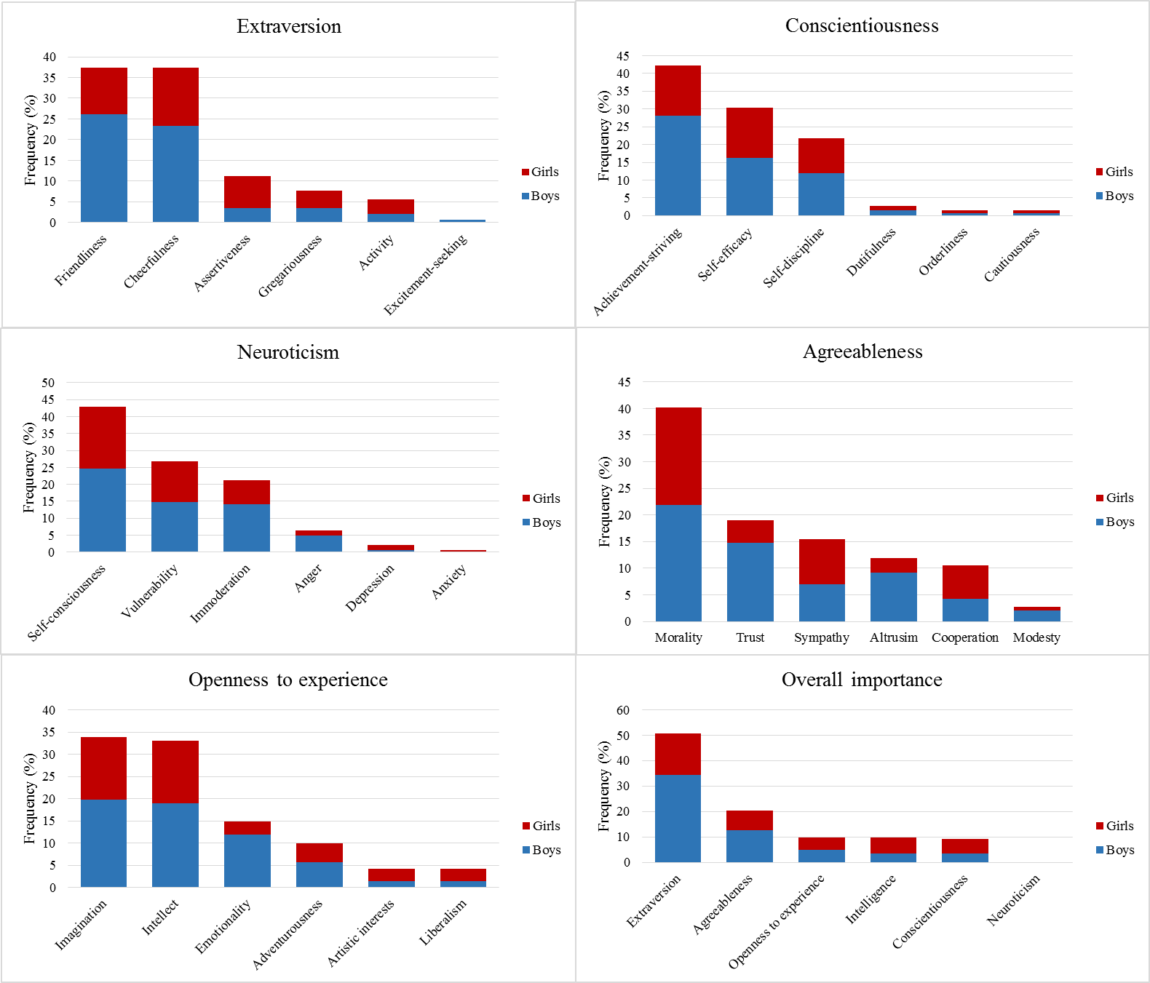
Figure 1 Panels A-E: Frequencies for the facets of Big Five personality traits that mothers identified as being the one they would most like their child to have. Panel F: Mothers’ overall importance ranking of the personality facets they selected together with intelligence.
F
E
DC
C
B
A

Supplementary Material
Table S1 Descriptive statistics for mothers’ rankings of the Big Five personality facets and intelligence by child gender
 | Mothers of girls |  | Mothers of boys
 | Mean ranking | SD | Mean ranking | SD | Cohen’s d
Extraversion facet | 2.14 | 1.19 | 1.83 | 1.23 | 0.25
Agreeableness facet | 3.14 | 1.52 | 2.61 | 1.28 | 0.37
Openness facet | 3.57 | 1.53 | 3.44 | 1.26 | 0.09
Intelligence | 3.28 | 1.64 | 3.77 | 1.28 | 0.34
Conscientiousness facet | 3.40 | 1.36 | 3.55 | 1.36 | 0.11
Neuroticism facet | 5.48 | 1.05 | 5.80 | 0.65 | 0.36
Note. Traits are ranked from most (1) to least (6) important.

