COVER PAGE

Jim Anderson
Senior Lecturer in Languages in Education
Goldsmiths, University of London
Department of Educational Studies
Goldsmiths, University of London
New Cross
London
SE14 6NW

Mobile number: 07903298321
j.anderson@gold.ac.uk

Biography
Jim Anderson
Jim Anderson is Senior Lecturer in Languages in Education at Goldsmiths, University of London. His work at Goldsmiths has built on long experience of teaching Languages in multilingual London secondary schools and it is here that he developed his interest in more integrated and inclusive approaches to language learning. Jim has led the development of the PGCE in Arabic, Bengali, Mandarin, Panjabi and Urdu at Goldsmiths and also leads a Masters module on ‘Teaching language in Multilingual Contexts’. His research interests lie in the areas of language learning pedagogy, including Content and Language Integrated Learning, bilingual development, multilingualism and digital literacies.

Vicky Macleroy (corresponding author)
Senior Lecturer in English in Education
Department of Educational Studies
Goldsmiths, University of London
New Cross
London
SE14 6NW
Telephone number: 0207 919 7351
v.macleroy@gold.ac.uk

Biography
Vicky Macleroy
Vicky Macleroy is Senior Lecturer in English in Education and Head of the Research Centre for Language, Culture and Learning at Goldsmiths, University of London. Vicky has contributed to international research on poetry pedagogy Making Poetry Matter (2013) and transforming the poetry classroom Making Poetry Happen (2015) published by Bloomsbury. She is co-director with Jim Anderson of an international project ‘Critical Connections II: Moving Forward with Multilingual Digital Storytelling’ (2015 - 2017) that uses digital storytelling to support engagement with language learning and digital literacy. Vicky’s research focuses on language development; creative writing practices/teaching; poetry; and multiliteracies.

TITLE PAGE

Connecting worlds: Interculturality, identity and multilingual digital stories in the making

[Jim Anderson and Vicky Macleroy, Goldsmiths, University of London]

ABSTRACTS

Mondes connectés: interculturalité, identité et contes numériques multilingues en progrès
[ … ]

Extrait

Cet article est l’aboutissement d’un projet de cinq ans nommé « Connections Critiques ». Il présente un cadre intégré d’apprentissage des langues dans un contexte de contes numériques multilingues.

Le modèle théorique est illustré par quatre vignettes. En favorisant la gestion de l’apprenant, ce modèle entraîne un mouvement à travers frontières, interfaces, langues, cultures, alphabétisation et apprentissage (connecté ou non) à l’école, à la maison ou dans la communauté.

Les identités des jeunes sont reflétées dans ces contes et notre conclusion identifie le potentiel de construire un programme d’études orienté vers l’interculturel.

Connecting worlds: Interculturality, identity and multilingual digital stories in the making

[Jim Anderson and Vicky Macleroy, Goldsmiths, University of London]

Abstract

Based on findings from a 5-year research project called Critical Connections, this article sets out an integrated framework for language learning in the context of multilingual digital storytelling. Following an explanation of the theoretical approach, four vignettes are presented which illustrate the principles in practice. Prioritising learner agency this model involves moving across borders and foregrounding interfaces between languages, cultures and literacies and learning (online and offline) across school, home and community contexts. Young people’s identities are reflected in the digital stories shared here and final conclusions identify the affordances of multilingual digital storytelling in building an interculturally oriented curriculum.

Keywords
Interculturality, identity, multilingual digital storytelling, language learning, creativity

Connecting worlds: Interculturality, identity and multilingual digital stories in the making

Jim Anderson and Vicky Macleroy, Goldsmiths, University of London

Introduction

How can language learning move beyond a narrow, instrumental approach to one which is based on principles of dialogue, personalised meaning-making and intercultural exchange? How can synergies between foreign and community/heritage language learning¹ as well as English mother tongue and English as an additional language be realised in practice? Specifically, in what ways can the creation and sharing of multilingual digital stories contribute to this and offer a dynamic space for investment in and shaping of identity? These are questions explored in this article drawing on data from a funded project led by researchers working in Goldsmiths’ Department of Educational Studies.

Collaboration between the present authors began in 2011 with an article (Anderson and Obied/Macleroy, 2011) in which we set out to understand and respond to deep tensions between monocultural and intercultural orientations towards education in the UK. We saw these tensions reflected not only in government policy (DES, 1985; DfES, 2002; DfES, 2007), but also through our regular contact with teachers working in London secondary schools. These schools were also sites where our students, aiming to become teachers of English and Languages, were being sent to on placement to prepare them for a career in teaching. We had concerns on various fronts: the narrow and highly fragmented nature of the curriculum both in the area of language and more widely; the limited support for students’ home languages and cultures combined with ignorance on the part of senior managers and teachers in schools about the advantages of promoting harmonious bilingual development; the lack of clear policy on the development of critical digital media skills, including multimodal composition and the use of mobile technologies (an increasingly significant feature of daily life and of youth culture); and the disregard of learning taking place in out-of-school contexts, including online, and the missed opportunity here for engaging students in more personalised and authentic forms of learning.

As we reflected on these issues in the light of significant developments in literacy pedagogy in the field of multiliteracies focussing on intersections between multilingualism and multimodal design (Cope & Kalantzis, 2000), we noticed growing work on digital storytelling, taking place mainly in the United States (Miller & Borowicz, 2005). We learnt how digital storytelling had its roots in community arts and oral history projects, aiming to give ordinary people a chance to have their stories told, and how it was being used in education (Lambert, 2013). Stories offer a powerful means both for language development and for engaging with culture. Digital technology extends the range of semiotic resources available for the way stories are constructed, facilitates their distribution, and allows an integrated bilingual approach through the use of voiceover and subtitles. Thus, the seeds of an idea were sown for a project around multilingual digital storytelling, extending work by Cummins and Early (2011) amongst others, and one in which interculturality would be central.

The Critical Connections project and border crossings

In designing our Critical Connections project, enabled by two rounds of funding from the Paul Hamlyn Foundation (2012-14; 2015-17), we had in mind the issues identified above and envisioned a means of developing an integrated and inclusive approach to language and culture learning which would extend and enrich the multiliteracies model and would prepare young people for active participation in an increasingly interdependent and interconnected, yet conflicted, world.

The project has involved young people, across primary and secondary age ranges (6 – 18 years old), in creating and sharing digital stories in bilingual version. Goldsmiths researchers have worked with schools and universities in London, elsewhere in England, and in eight other countries (Algeria, Cyprus, Ecuador, Greece, Luxembourg, Palestine, Taiwan, and the United States of America) where lead teachers and members of the project team had strong links and the languages were part of the project (Arabic, French, German, Greek, Mandarin Chinese, and Spanish). Altogether, at least 500 students and 50 teachers have been involved in the project. With regard to schools in England, both mainstream and community based complementary schools² have been included.

Classes involved have been focussed on different forms of language learning: foreign, community/heritage, English as an Additional Language and English mother tongue. Regular meetings with teachers, including digital media training, have enabled appropriate pedagogical strategies to be discussed and developed and a Handbook for Teachers (Anderson, Chung and Macleroy , 2014) has been written as a guide and reference source. In the digital media training provided for both teachers and students, we have benefitted from support from the British Film Institute. Since the project began, a wide range of stories have been created around different themes (inside out, journeys, fairness and belonging) with a greater emphasis in the second phase on issues of social justice. These stories have been shared within classrooms and schools, but also more widely across schools through the project website. They have also been presented by students and teachers at annual film award events, which, in the second phase of the project, have taken place at the British Film Institute.

As a means of representing students’ bilingual repertoires as well as making the digital stories accessible to everyone, the voiceover was produced in the target language and subtitles in another language (usually English). Although the principle of language separation has been strongly embedded in theory within immersion and communicative language teaching methodology, research evidence indicates that this has rarely been fully observed in practice (Hall & Cook, 2012). In fact, there is now growing evidence that some flexibility in language use or ‘translanguaging’ (Garcia, 2009; Garcia and Kleyn, 2016) can support learning, particularly where higher level cognitive demands are involved such as in the generation and structuring of story ideas. There are various factors which may play a part here. For those from bilingual backgrounds, living with and mixing two languages may be part of everyday experience and so artificial separation may feel like a denial of an natural way of being within family and community. For those without this personal connection, however, the value of an approach which views language development holistically and recognises the potential for constructive interlingual and intercultural interactions, is also relevant (Phipps and Gonzalez, 2004). This was very much the perspective embraced and developed through the Critical Connections project, though in different ways depending on context and levels of proficiency in different languages. One important way in which students moved across languages in the course of creating their digital stories was through script translation and this activity proved valuable in stimulating discussion around differences between languages as well as an awareness of interfaces between language and culture.

Throughout the project emphasis was placed on a staged and collaborative approach, involving generation of initial ideas, planning, storyboarding, scripting, creating, reviewing and editing. Particular attention was given to the critical dimension of the project and teachers were encouraged to integrate this in various ways: firstly, by having students compile their own set of criteria for what makes a good digital story; secondly, by having them peer review each other’s work at different stages, both in the classroom and then across schools; thirdly, through a student co-researcher strand whereby student volunteers formulated and investigated questions related to the project from their own perspective.

Returning now to the educational aims behind the Critical Connections project, summarised in Figure 1 below, we illustrate how the vision of multilingual digital storytelling fits within a broader communication landscape and educational context. This vision emerged from our experiences of doing the research during the first two years of the project (2012-14) and helped shape how we conceptualised the second stage of the research (2015-17). Multilingual digital storytelling is at the centre of how we conceptualise our research and it is these three elements that combine to provide teachers and students with alternative ways into literacy. We argue that the multilingual element brings to the forefront the range of languages in the project; digital recognises the importance of developing new literacies; and storytelling acknowledges that stories are at the root of culture and help us to understand alternative ways of seeing. This builds on research (Bruner, 2003; Lambert, 2013; Carmona and Luschen, 2014) where making, crafting and sharing of stories is at the heart of human experience and social transformation. Moving out to the next circle in the diagram, we wanted to reflect on how language(s), culture and identity are able to combine in the process of creating digital stories and we included ‘other curriculum areas’ to emphasise the thematic nature of this approach to language learning with a particular focus on the arts. Moving further outwards, the next circle captures the idea that this approach fosters learner autonomy and by using technology in this way can foster creativity and critical thinking. The outer circle represents the wider reach of the project when students form communities of storytellers and digital storytelling provides a platform and flexible tool to interpret both local and global issues and develop active citizenship. This model helped us to integrate important elements in the project and keep a sharp focus on how language, culture and identity become intricately linked when students are engaged in the learning process. The model represents key features within our approach and it also makes clear how movement across borders is embedded in the space it affords for personal and critical perspectives, its transformative purpose. We hope it is a model that others could adopt in the field of multiliteracies. Teachers, students, parents, technicians, film educators and researchers have worked across school, home, community and countries to connect the different elements of the research work and blur traditional boundaries between sites of learning.

Communities of practice
Global
Local
Autonomy

Language(s)
Other curriculum areas

Multilingual Digital
Storytelling
Critical thinking
Technologyy

Identity(ies)
Culture(s))

Creativity

Student voice
Active citizenship

Figure 1. Multilingual digital storytelling in context

[Diagram adapted from version first published in Critical connections: Multilingual digital storytelling project. Handbook for Teachers, 2014, Anderson et al.]

Literature review

In this section we explore the theoretical framework for the analysis of the four vignettes and focus on the notion of interculturality and identity in relation to language learning and in the context of digital storytelling.

Interculturality and identity

In the past two decades there has been a major shift in the perceived relationship between language and culture in the context of language learning. As Kramsch (1993, p.1) explains, the view of culture as an ‘expendable fifth skill, tacked on, so to speak, to the teaching of speaking, listening, reading, and writing’ is misplaced, for ‘it is always in the background, right from day one ’. What is more, engagement with another culture is a two-way process; in other words, how we see another culture is shaped, consciously or unconsciously, by the relationship we have to our own. Upholding this stance, Byram’s (1997, p.71) model of Intercultural Communicative Competence 'does not depend on a concept of neutral communication of information across cultural barriers, but rather on a rich definition of communication as interaction, and on a philosophy of critical engagement with otherness and critical reflection on self'. This involves a recognition that, beyond manipulation of a new linguistic code, language learning is fundamentally about meaning-making and that there are ‘inherent intercultural processes in language learning in which meanings are made and interpreted across and between languages and cultures and in which the linguistic and cultural repertoires of each individual exist in complex interrelationships’ (Liddicoat and Scarino, 2013, p.2). In entering any new linguistic experience, therefore, we are always interacting with and extending an existing personal ‘linguaculture’ and reshaping identity in the process (Risager, 2011).

This perspective is far removed from the narrow, instrumental understandings of the nature and purpose of language learning dominant in early interpretations of communicative language teaching (Littlewood, 1981). Moreover, the static, essentialised, unidimensional view of culture, whereby the role of teachers is seen as imparting a prescribed body of cultural knowledge, has been replaced by a view which is ‘dynamic, relational and plural’ capturing ‘individual and shared phenomena that are expressed, constructed and mediated through ways of behaving, thinking, feeling, and speaking’ (McAlinden, 2014, p.74-75). Viewed through this socio-constructionist lens, the pedagogogical emphasis shifts towards process and a stance which ‘treats culture as something people do or which they perform’ (Piller, 2011, p.15).

Significant here is the part played by individual agency in the process of negotiating culture and identity (Pavlenko & Blackledge, 2004) and the way in which prevailing discourses influence how subjects choose to position themselves (Davies & Harré, 1990). Within this post-structuralist frame, Norton’s (2000) construct of ‘investment’ takes account of the unequal distribution of linguistic and cultural capital within different societies and the tensions that can arise as a consequence of this (Bourdieu & Passeron, 1977). More specifically it makes clear that choosing to speak in any given language is about more than a neutral exchange of information. It is also ‘an investment in a learner’s own identity which is constantly changing across time and space’ (Norton, 2000: 10-11).

Seeking to capture the complexities of meaning-making between languages and cultures, whilst overcoming traditional dualities, Kramsch has proposed metaphors of third place (Kramsch, 1993) and third culture (Kramsch, 2009a). Here the concern is moving beyond essentialised perspectives by focussing on syncretic possibilities within a context of multiplicity and ongoing change. Conceived as a ‘symbolic place’ the third place is seen as a subject position which is ‘multiple, always subject to change and to the tensions and even conflicts that come from being ‘in between’ (Weedon, 1987)’ (Kramsch, 2009b, p.200). Sharing this perspective on the complex, multi-layered nature of intercultural engagement, Holliday argues that ‘it is at the level of discourse that individuals are able to negotiate, make sense of and practice culture; and it is within this process that imaginations about culture are generated and ideology is both experienced and manufactured’ (Holliday, 2011, p.1). Holliday argues for a ‘critical cosmopolitan’ approach to culture and this is seen as providing the necessary basis for effective global education (Osler & Starkey, 2005). This resonates strongly with the aims and principles underlying our approach to multilingual digital storytelling, which prioritises learner agency and voice, encourages connections to be made across different contexts, supports participation in democratic processes and seeks to promote social justice.

Related to this, an important skill developed in the project is that of empathy. This is an aspect of the intercultural approach to foreign/second language teaching which has attracted growing interest in recent years in the context of a sociocultural view of learning (Mercer, 2016). Empathy comprises both the ability to ‘put yourself in the mind of the other’ (Mercer, 2016, p.100) and the ability to ‘view one’s own culture from the viewpoint of outsiders’ ( McAlinden, 2014, p.72) and, as Byram (1997) has also noted, these are seen as making a significant contribution to the development of intercultural competence and thus to overall linguistic communicative competence. Moreover, it is recognised that the arts, and drama in particular, can play a valuable role in the development of empathetic skills (Arnold, 1999), for, as Mercer explains, ‘… it can be powerful for learners to actively imagine other lives through literature, films, role-plays, photos and art; to this end, learners should be encouraged not only to read, discuss and interpret it, but also to write it or enact it themselves’ (Mercer, 2016, p.104-105).

Engaging learner agency, creativity, and interculturality is central to the transformative pedagogical approach contained in the term ‘identity texts’ (Cummins and Early, 2011). This engagement takes account of the need to extend notions of literacy to embrace diversity on the one hand and the affordances of the digital media on the other (Cope and Kalanzis, 2000). Aimed at fostering collaborative relations of power, identity texts are seen as the products of work which allows the full expression of students’ intercultural life experience, including their linguistic repertoires, and the construction of multiple and fluid identity positions. Taking multiple forms, ‘… written, spoken, signed, visual, musical, dramatic, or combinations in multimodal form’ this creative work demands maximum cognitive engagement and maximum identity investment and ‘holds a mirror up to students in which their identities are reflected back in a positive light’(Cummins and Early, 2011, p.3). Importantly, work is shared with multiple audiences, ‘peers, teachers, parents, grandparents, sister classes, the media, etc’ which is likely to lead to ‘positive feedback and affirmation of self in interaction with these audiences’. Whilst technology is not seen to be an essential component, it serves ‘as an amplifier to enhance the process of identity text production and dissemination’ (Cummins and Early, 2011, p.3).

The resonance of this work with the project focussed on in Critical Connections is evident in the following ways. Through the creation and sharing of multilingual digital stories, space has been made for students to cross boundaries of language, culture and curriculum and in the process to extend sites of learning, building bridges between school, home and community and capitalising on the extended possibilities for collaboration and communication opened up by the digital media. A key principle underlying the approach has been to allow students to represent themselves and their bilingual/plurilingual repertoires positively through their work. It must be emphasised here that, in our experience as teacher educators and researchers, opportunities for students to be involved in tasks which involve the use of more than one language are rare within the British education system. The Critical Connections project has sought to challenge this monolingual bias and to see a more integrated and inclusive approach to the different forms of language learning (first, second, foreign and heritage) as both natural and desirable in preparing young people for constructive engagement with different cultural perspectives and for navigation of global networks. As explained above. by viewing linguistic competence holistically and normalising translanguaging (Garcia and Kleyn, 2016) both as a communication strategy and as a means of supporting development of the less developed language, the Critical Connections approach has provided a context in which investment in bilingual/plurilingual capital is seen to reap rich dividends and to promote confidence in the performance of multilingual selves (Kramsch, 2009b).

Interculturality and identity in the context of digital storytelling

Digital storytelling is at the core of our research work: we continually return to the concept of storying and why it is crucial to our approach, and see digital stories as places where students can experiment and explore their intercultural identities. Our approach to storytelling builds on the work and ideas of Lambert (2013) who discusses how digital storytelling can capture lives and create community. Lambert recognises how digital storytelling can transform and empower people and lead to a critical awareness of their social reality: ‘we became aware that one small story in the form of film has totemic power for the storyteller’ (Lambert, 2013, p.12).

As mentioned in the description of the Critical Connections model above, in researching and working in the field of digital storytelling, we recognise that young people have to learn to handle the complexity of multimodal composition with its tensions, different voices and multiple perspectives. Nyboe & Drotner (2008) use the term ‘competences of complexity’ to describe what they see as an aesthetic practice of sense-making, perception and manipulation in which young people push boundaries of self and others. They found students are often not used to working creatively through aesthetic practices as this process involves failure and frustration, as well as having to discard ideas and start anew. The process of creating digital narratives runs counter to much educational experience ‘since much school-based learning builds on pre-given assumptions and answers, it falls short of preparing pupils to work innovatively and creatively in processes that involve give and take and openness towards the uncertain’ (ibid., p.173).

In our work, whilst still staying true to the idea of digital storytelling as a ‘memorial tool to facilitate community storytelling’ (McWilliam, 2008, p.154), we wanted to move beyond these personal narratives to see digital storytelling as a wider transformative process. This ties in with the belief in the ‘power of stories to engage, transform and catalyse social action’ (Carmona & Luschen, 2014, p.1). We also wanted to challenge language barriers and create space for multilingual narratives as this is an area of student identity that has often been neglected in the field of new literacies.

Opening up spaces for imagining, hypothesising and transforming knowledge lies at the core of our work in digital storytelling. With our focus on multilingualism and creation of bilingual texts, the young people, as well as making choices about mode, had to imagine how to use language in new contexts and negotiate interfaces between different cultural landscapes. Darvin & Norton (2014) argue that digital storytelling is a powerful medium for affirming identities for ‘migrant learners who traverse transnational spaces and ways of thinking’ (p.61). This ties in with current research exploring youth, theatre, radical hope and the ethical imaginary that looks at how concepts of care and hope can develop young people’s broader civic engagement (Kushnir, 2017).

Digital storytelling also provides a legitimate space for young people to experiment with, critique and transform popular culture and begin to shape their own narratives. A growing body of research is emerging which shows that young people feel empowered when they are in control of the production process and can represent their own experiences and knowledge (Mills, 2011). Due to the nature of digital storying - which incorporates a range of forms such as moving image, still photographs, art work, dance, drama and music - young people are able to bring together disparate elements from their lives and in the making of their stories question their cultures and identities and construct enriched or alternative narratives.

Research into literacy and popular culture demonstrates the importance of looking at the relationship of popular culture with identity construction and it is argued that if literacy is viewed as a social practice then it must draw from ‘cultural landscapes in its meaning-making’ (Marsh & Millard, 2000). In our work, we recognise the importance of examining the processes by which young people draw on and represent their cultural landscapes as ‘the co-option of what children know outside of school into school will always entail transformation’ (Moss, 2006, p.146).
Urbach and Eckhoff (2012) discuss how children borrow, manipulate and transform elements from popular culture to build ‘novel associations’ and create their ‘own new product’ (p.33).

In further exploring how digital storytelling provides spaces for interculturality to happen, it is important to look in more depth at shifts in literacy theories for the digital age and the emergence of a strong body of work on sensory literacies. Mills (2016), in defining sensory literacy as ‘emplaced practice’, foregrounds the role of place and its ‘connection with the senses in human experience and learning’ (p.143). Our work recognises the importance of exploring literacy through a sensory lens and this is also emphasised in the digital storytelling work of Lambert (2013) who argues that ‘our sense of place is still the basis of many profound stories’ (p.21). Literacy from this perspective is viewed as an embodied practice that needs movement and action: through digital storytelling we investigated how students slowly learn how to create real and imagined places that are meaningful to them and their audiences.

Pahl & Rowsell (2010) in their work on artifactual literacies and digital storytelling view literacy as shaped by ‘context, power and history’ and that artifacts ‘link to students’ everyday lives and cultural histories’ (p.3). They coin the phrase ‘sedimented identities in texts’ (p.9) and, when discussing digital storytelling as artifactual, demonstrate how identity is embedded ‘shard-like’ within the digital story. They use the expression that ‘identities reside on a sea of stuff and experiences’ (p.8). In their theory of artifactual literacies they put forward the idea that every object tells a story and that objects remain powerful in our memories especially in stories of loss, displacement and migration. Pahl & Rowsell discuss how migrant stories often contain spatial and artifactual qualities and ‘center on objects, spaces, fences, shops, and specific, physically bounded experiences’ (p.11). Their work on artifactual literacies and narratives of migration has informed the way that we have investigated representations of identity within the digital storytelling work emerging from our project. Although Pahl & Rowsell acknowledge the potential for other languages to be let in through engagement with artifactual literacy, the focus in their digital storytelling research is on the young people’s passionate interests, childhood memories and cultural narratives.

Our work foregrounds language as a vital part of creating intercultural narratives and we believe this focus on multilingualism has to be made explicit, if it is to become an integral part of what Pahl and Rowsell call a ‘circle of digital storytelling’. We argue that multilingualism has to be part of developing multiliteracies and engaging the many voices of young people. Part of this multilingual process is considering alternative points of view and exploring multiple perspectives as a key issue of diversity and social justice. Silvers & Shorey (2012) discuss students’ identities and the importance of new literacies enabling young people to become socially responsible, critically literate and authentically engaged. In listening to their students they discovered that ‘what mattered most to them was their authentic involvement in real life experiences where they felt they made a difference, or their voices could be heard’ (p.149).

In our digital storytelling work we have sought out spaces to nurture a more interdisciplinary and collaborative approach towards literacy and viewed digital stories as a focus for meaningful intercultural engagement. Janks, in her work on critical literacy, examines multiple modes for making meaning and builds on the notion that critical literacy is a ‘pedagogy of hope’ because ‘it believes in its own ability to transform the conditions in which we find ourselves’ (2013, p.145). As our confidence has grown and the engagement of young people in digital storytelling has become more assured, we have pushed the boundaries of these digital stories and enabled live experience of culture to be captured. This has led to the focus of students’ work shifting from a personal story of their lives to how their stories can be seen as a force to catalyse social action (see vignettes below).

We have seen how, from its roots, digital storytelling has been concerned to give people a voice and allow alternative views to be heard. Pedagogically, this has necessitated a learner centred, collaborative and inquiry based approach, in which the teacher’s role is to facilitate rather than to dictate. Whilst it has taken time for some teachers to adapt to this way of working, all have noticed the increased levels of engagement, creativity and critical thinking when students feel a sense of agency and ownership, when in other words there is an investment of self (Dörnyei, 2009; van Lier, 2007) and students are given the right to speak (Darvin & Norton, 2015). Critical skills have been strongly promoted, both by having students develop their own criteria for evaluating work and through ongoing peer assessment procedures (Anderson & Krathwohl, 2000). The project has further provided a context for creative use of technology encouraging active engagement and facilitating multimodal communication and collaboration (Craft, 2005). This accords with the view of education in the Internet age as essentially dialogic whereby ‘meaning is never singular but always emerges in the play of different voices in dialogue together’ (Wegerif, 2013, p.3).

Methodology

The main focus of the research was deliberately broad and sought to examine the significance of multilingual digital storytelling for young people and their learning paying attention also to pedagogy, policy and teacher professional development. Specifically, the research questions posed were:
- What is the significance of multilingual digital storytelling for young people and their learning?
- What is an appropriate pedagogical framework for carrying out multilingual digital storytelling work in schools?
- What are the implications for policy and teacher professional development?

Given the exploratory and complex nature of the study, it was decided to adopt an ethnographic approach which would support the qualitative, context-based, participatory, multi-perspectival and interpretive emphasis we favoured. In order to capture the social justice dimension to our work this was refined to ‘critical ethnography’ and further links were made to ecological, collaborative and multimodal perspectives (Anderson & Macleroy, 2016, p.134). Data was collected from a range of sources: video recordings and photographs (observing the making of digital stories in schools; presenting digital stories at film festivals; interviews with students, teachers, parents and community members; video/audio recordings of team meetings with researchers and teachers); documentary material (school policies; schemes of work; teaching plans and materials; students’ work including notes, storyboards, PowerPoints; film festival review booklets; field notes; and digital stories in draft and final versions).

A key strand emerging from analysis of the data related to interculturality and identity and the vignettes below strongly reflect these aspects. It should be noted also that all the research participants in our project have taken part with consent and teachers and schools have been named and students acknowledged as filmmakers in the research. This fully-funded research project had ethical approval from the university and signed consent from all research participant that their digital stories, photographs, recorded interviews and film footage could be used for educational purposes.

Introduction to the vignettes

We now turn our focus to the multilingual digital stories and how classes in four project schools (including mainstream and complementary, primary and secondary, and overseas) created touching and powerful intercultural narratives. The digital stories discussed below are moving across borders, for example, illustrating the blurring of boundaries between sites of learning, and shifting between students’ personal, home and community knowledge and interests and issues of equity.

The four vignettes have been selected from the range of schools in the Critical Connections project: mainstream secondary school; mainstream primary school; complementary school; and overseas school and across a range of languages (Arabic, English as an Additional Language, French, Greek and Mandarin Chinese). As mentioned above, these digital stories are particularly representative of interculturality and identity because they stem from agentive engagement, bringing authentic and personalised perspectives. They are striking also in the sense of responsibility shown by students
through the process of collaboratively developing their work. They were aware that their work would be seen by an international audience and it mattered them that they should make their voices heard in a way that was convincing and memorable. This was achieved in no small part through the way in which various art forms (drama, dance, visual arts) combined with the creativity involved in the film-making process to enable powerful, multimodal communication infused with an aesthetic sensibility. Which art forms were drawn on varied across contexts depending on particular interests and skills available amongst students and staff.

Vignette from Broomfield School (a mainstream secondary school in London)

Here we focus on the work of two Greek background students and their digital story, Migration, selected here because it illustrates a deep personal engagement with culture as well as an affirmation of student voice facilitated through drama. The students concerned were part of an English as an Additional Language (EAL) withdrawal group and at the time of the project had been living in England for one and a half to two years. Fluent in Greek the students were, according to the class teacher, also making good progress in developing their English. For this project the class teacher, a Greek speaker, had the support for a number of sessions of a drama specialist, also a Greek speaker although of Greek Cypriot origin. At the beginning of the project two drama workshops were conducted with the class on the topic of migration, which all students in the group could relate to and fitted with the overall project theme of belonging. The drama workshops, which took place in the school’s drama studio, followed an applied theatre model (Althruz, 2016) and were conducted in English. The first session began with the whole class viewing and responding to selected video clips on the theme of migration. This was followed by a series of group work tasks focusing on the development of ideas, the creation and performance of short scenes, interspersed with feedback, questioning and discussion led by the drama teacher but involving the whole group.

Image 1: A drama workshop on the theme of migration

Students were highly engaged in these workshops. One of the Greek background students under discussion here mentioned the ‘huge influence of the workshops’ and how the drama teacher ‘… really helped us to find a way and really decide what we wanted to do for the project’. In the drama workshops, their attention had been drawn to news reporting in the media and the formal register used in presenting. This inspired them to adopt a documentary style for their digital story.

With regard to scripting, after some initial discussion on content, Student 1 and Student 2 worked separately to create a piece of text. Student 1 wrote what she described as ‘strong statements’ in the form of prose, working firstly in English and then translating into Greek. Student 2, on the other hand, wrote his text as poetry, working in Greek first and then translating to English. Their text is in turn factual (‘Migration, what does it actually mean?’), questioning (‘I wonder who is to blame. Is it my fault?’), critical (‘Many leaders speak and promise for a better tomorrow, but who turns talks into actions?’), and lyrical (‘Just as the winter wears a grey cloak and then the distant hopeful spring with an optimism awaits’). They found that their two texts complemented each other well and they decided to combine them, alternating sections from each other’s texts. In both cases the students employed sophisticated vocabulary to convey their message and learnt to appreciate the dangers of trying to translate literally, deepening their understanding of word meanings and of variation in the way sentences are constructed in different languages.

Having learnt about green screen (a simple but powerful technique for digitally replacing the background in any video or image by shooting it against a green screen) as part of their digital media training, the two students decided to make use of this software in creating their digital story.

Image 2 and Image 3: Screen shots from the Greek-English digital story Migration

In their film the two students appear prominently to the left of the screen against the backdrop of a series of harrowing scenes reflecting the migrant situation unfolding in the news media. They speak in Greek and their delivery is clear and full of expression.

What comes across particularly strongly is the students’ empathy (Mercer, 2016) both for the migrants and for the situation of the Greek people as well as the transnational literacies (Darvin & Norton, 2014) they are displaying and to which they attach great importance. Student 1 proudly affirms that ‘… we represented our country and this is the best thing we could possibly do as Greeks in England’. She goes on to stress that moving to England will not mean their losing their Greek roots: ‘… yes we moved but we never gonna forget where we came from or what language we spoke or what country we were born so that’s something deep in our heart and that’s never gonna change’.

Vignette from the Peace School (an Arabic complementary school in London)

Image 4, Image 5 and Image 6: Screen shots of the Arabic-English digital story Freeze

Based on a popular form of street dance, the Arabic-English digital story Freeze was made by a 13 year old, Malaysian background boy at the Peace School with the help of his sister. It is a personal account in which he appears proud to present himself through Arabic and English as a talented freeze dancer and instructor. Through his dress - jeans, trainers and baseball cap, bearing the gangland slogan ‘Obey’ - he projects a cool image, showing attitude in tune with contemporary youth culture. This is enhanced by the hip-hop music in the soundtrack fitting with freeze dance style.

The main set for the film is a brick wall and pavement in a street near to the boy’s home and this is in keeping with freeze as a form of street dance. The boy is the main participant appearing in front of the camera. The voice of his sister is heard putting questions to which he responds. The story is presented in three sections: firstly, he introduces himself and answers questions about why he loves dancing, when he started and why. This is brought alive through a short clip in which he is dancing with two friends in a shopping mall and a family photo showing him at a younger age in an American style diner restaurant with his cousin, who had inspired him to take up freeze dancing. This is followed by a tutorial and demonstration in which various skills are displayed. Finally, he again responds to questions from his sister, this time focussing on his plans for the future and what his next steps will be. At this point a scene is shown at a talent show with some older boys who have taken part in a competition.

In spite of its rough edges, the personal and authentic quality of the film has made it engaging for teacher and student audiences alike. Responding to it, a girl from a project school in Taiwan commented ‘I am a dance-lover in Taiwan, dancing in hip-hop style. You have such great dance skills, but looking a little shy. I hope you will be a good dancer’.

There is a sense of fun running through the film showing that he does not take himself too seriously. However, his passion is also evident. Interestingly, there is also a significant Arab/Muslim reference in the last part of the film where he adresses his audience as ‘brothers and sisters’.

Looked at through an artifactual literacy lens we see how creating his story has offered a space in which this student has been able to draw on various aspects of culture and personal experience across a range of semiotic resources to craft his work. He has been empowered as a writer and as an active member of a community of practice because he has been given the right to speak as a multilingual and multicultured subject, crossing boundaries of traditional and popular culture (Marsh & Millard, 2000) and learning in school and home/community contexts (González, Moll & Amanti, 2005). This type of creative process involves a ‘sedimentation of identities into the text’ (Pahl & Rowsell, 2010) in other words new resources for learning are opened up which support meaning-making and give students an individual sense of worth. In terms of Mills & Levido’s (2011) iPed model for digital pedagogy, this reflects the ‘link’ strand which ‘emphasises cultural inclusiveness, negotiating differences among learners, and creating bridges for those who have the greatest distance to travel to make links to new competencies’ (Mills, 2016, p.12-13).

Vignette from Europa School (a mainstream bilingual primary school in Oxfordshire)
The bilingual French-English digital story Abandonnée, created by 28 10-year olds at the Europa Primary School, ends with the proud lines that the digital story was written, filmed and edited by all members of their class and then lists their 28 names. In the making of this digital story within their French class, but in the bilingual environment of this school, children started to work across their languages and cultures to develop story ideas before voting on one idea to focus on together. This looked at unfairness and friendship through the story of two girls – one French, one Syrian – who meet on a journey to France. War and migration were seen as a ‘burning issue’ by the children that they wanted to explore through their own ideas and by developing their perspectives on how children might feel and think in this situation of uncertainty. The children were given the opportunity to produce a text that mattered to them (Janks, 2011).

The emerging notion of empathy in language learning and the children’s ability to view their culture and social identities from ‘the other’ is striking in the imagined story these children created and the way they constructed their reality. Complex ideas about fairness and belonging were translated into a simple moving story where human connections were at the heart of making meaning of traumatic and difficult situations. The students imagined the situation of a child reaching out, thinking about how others should respond, and offering a hand of friendship. Play and the colour and music of children’s daily lives enlivened this digital story, but the students were also very mindful of barriers, both physical and psychological, placed in others’ way and borders that are not crossed.

These children actively sought each other’s ideas to think of ways to represent their intercultural narrative to a wider international audience and understand ‘the other’ in a more meaningful way. Mercer (2000) in his work on words and minds emphasises the importance of educators making space in schools to develop collective thinking in structured, creative and systematic ways and for children to be guided ‘into ways of using language collectively’ (p.170

Abandonnée is a strong resonating word for the children to have chosen for the title of their bilingual digital story working well in the context of their bilingual classroom and linking to ideas of being abandoned and homeless. The class worked out the overall framing of the story and then started to work in small groups on the storyboarding process and negotiate how to represent their ideas through the different modes (visual, audio and verbal). Mills (2011) employs the term ‘dialogic space’ to describe the intertextual and interdiscursive nature of storyboarding and sees this form of composition as providing creative multi-voiced spaces.

Image 7: Students storyboarding for the French-English digital story Abandonnée

In composing bilingually and multimodally, the children were learning to make complex decisions about space and time and how to use their languages to represent a clear and powerful message about war and migration. Dixon writes about how ‘the arrangement of space and objects in space can tell us a lot about values and power’ (2013, p.104) and how narratives of migration often contain spatial and artifactual qualities (Pahl & Rowsell, 2010). The children used stop motion animation and green screen to create their narrative of migration. Their use of Playmobil figures to represent the Syrian girl and the French girl enabled them to tell this traumatic story in a hopeful and caring way.

The migration narrative moves across borders from the desert in Syria to a harbour where the faces of the people have been individually drawn by the children. The Syrian girl weaves between these faces and the audience hears the sound of the sea and then the next part is represented by hand-painted depictions of the sea and the ship. The two girls meet on the ship and it is here that the children, as filmmakers, represent the friendship and trust between the girls. There is a moving exchange between the two girls where the children capture the deep empathy between the characters and through gestures and language demonstrate sharp perceptions of another’s emotions (Mercer, 2016). The scene ends with the words:‘Tu pourras venir chez moi!’ (subtitled ‘Come play with me!).

There is a poignant directness in the questions asked and their imagined future together where music, dance and play are used to show that other lives are possible. However, this narrative is thoughtfully and almost shockingly bounded by an abrupt change in mood and hope. The ship arrives in port to the sound of a police siren and pictures of a police car and playmobil police figures. The barrier is put up, the police have come to control the passengers, and the Syrian girl is in a line with no passport hearing the French words: ‘Vos papiers, s’il vous plaît!’ (Your passport please!). The narrative does not have an end – the audience is left with the words ‘to be continued’ - an apt way for such young children to capture the ongoing situation of migration and stories of struggle and hardship.

Image 8: Screen shot of the French-English digital story Abandonnée

Vignette from Laonong School (a mainstream elementary school in Taiwan)
In looking at other dimensions of interculturality and identity it is important to question whose social identities get constituted and who has access to being in a text (Boje, 2001). In the vignette from Laonong School in the mountains of Taiwan these questions are reflected in the narratives of culture that are presented. The lead project teacher is a Humanities teacher and he integrated multilingual digital storytelling into a course about local culture for these 10-year-old students. Laonong School is situated in a remote place in the mountains, students are often cared for by extended family members, and many have very low levels of literacy. Their intercultural narrative represents the different ethnic groups in Laonong before focusing on the story of the Pingpu tribe and their local culture. The Aboriginal status of the Pingpu tribe is not yet recognised by the government and the digital story became a vehicle to present a strong message about land rights, culture and language. This is a story of displacement and movement from the plains of Taiwan to the mountains as their indigenous rights were not recognised.
The project teacher reflected that in a ‘school like Laonong, no-one expected that the pupils would be able to take the initiative to learn to do research, or use media and computer-based tools, and compose something’. He explained that in the mountains it is not easy for the young people to physically reach other places; collecting data and doing research allowed them ‘to find solutions for their problems, face their own difficulties, and have their voice heard’. The young people went out into their local community to photograph and research its stories and develop a greater sense of local cultural identity. In constructing their intercultural narrative, they presented the river linking their homes to other places, the fruit and trees and animals in their environment, and the people. They translated a traditional saying: ‘the most beautiful scenery in Taiwan is its people’. Their intercultural narrative was full of care and hope captured in these lines from their story: ‘we also hope that every ethnic group in the world can be respected and treated equally’. Their hand-drawn figures, maps and paintings alongside photographs taken on their research in the field gave the story a very personal and sociable texture and feel.
In presenting their bilingual Mandarin Chinese-English digital story Fairness in Ethnicities, the students, led by their teacher, demonstrate how a sense of place and culture are deeply intertwined in their story. Their digital story embodies how young people who have experienced migration, displacement or lack or power within their communities, can draw on home and cultural artefacts as learning resources in the classroom. Pahl & Rowsell (2010) talk about how artefacts can create communities and how they ‘would like to see artifactual literacies lever more power for meaning makers’ (p.14). Fairness in Ethnicities presents a powerfully situated message about local cultures which is both intensely personal and wide reaching as the lead teacher captures in his words: ‘it is ever so cheerful for us … to tell our story to people on the other side of the world’.

Image 9: Screen shot of the Mandarin Chinese-English digital story Fairness in Ethnicities
Fairness in Ethnicities combines civic engagement with a real sense of pleasure and play to present a digital story that has a powerful intercultural message. This digital story of movement and displacement ends with an abrupt barrier placed on hope, but a strong voice that the fight will continue. At the end of their digital story, the young people switch from Mandarin Chinese into English to announce: ‘At the time we finished the film we received the message … the lawsuit of Pingpu Tribe Legalization failed again on May 19th 2016 … We will keep fighting’. Feedback received from teachers in other Taiwan schools involved in the project demonstrated the huge impact that the digital story made on them and their students.

Conclusion

Taken as a whole, what stands out in these vignettes is the in-between-ness of students’ positioning as they actively negotiate where they stand in the world. In all four vignettes there is a reaching out, a heartfelt empathy with the Other. There is also a powerful sense of ‘having ‘the right to speak’ (Darvin & Norton, 2014: 57) and to resist essentialised, monocultural views of citizenship and identity which deny their multiple affiliations, and the attitudes and values arising from them. For there is no one reality and no single story. Instead ‘… how we project ourselves and the cultural identities we ascribe to ourselves have become more open-ended, variable and problematic, such that identities have become contradictory, continuously shift about and pull individuals in different directions’ (Holmes, 2014, p.78-79). Through the agency allowed to learners in composing their bilingual digital stories, exclusionary barriers have been removed, borders of culture and curriculum have been crossed and a creative space for identity investment has been opened up. Seen through an artefactual literacy lens (Pahl & Rowsell, 2010), the digital works produced are texts which have arisen organically over time and in the process of which identities have become ‘sedimented’, illuminating the object of interest but also telling a story about those behind its creation and about the performance of multilingual selves.

By involving both mainstream and complementary schools in the project, we have crossed traditional boundaries of education and recognised that learning is not confined to the mainstream school classroom. We have encouraged family involvement in the making of films and have seen how ‘funds of knowledge’ in the home (González, Moll & Amanti, 2005) can contribute to students’ learning and enhance confidence. Family support has taken various forms: sharing and discussion of (cultural) content, assisting with translation, participating in films, providing technical help, attending screenings and giving general moral support. The project has been greatly enhanced by the participation of schools overseas which has brought new dimensions to the project, presenting differing views of cultures, broadening students’ horizons and developing their sense of themselves as global citizens.

In developing digital storytelling, we have been surprised and emboldened by the work of the young people and their teachers. The students have tackled complex and delicate subjects in hopeful, caring and empathetic ways and created intercultural narratives that are interwoven with their own voices, histories and memories. Janks points out that what is missing from the critical literacy model is ‘the territory of desire and identification, pleasure and play, the taboo and the transgressive’ (2010: 212). The young people engaged in multimodal composing in our project began to learn how to combine pleasure and play with critique and create intercultural narratives that were creative, entertaining and empowering. Digital storytelling has enabled young people to explore their sense of self, and as the project has progressed, a sense of their shared social reality and intercultural identity.

Central to this article has been an interrogation of interfaces between language, culture and identity and of the affordances of multilingual digital storytelling in building an interculturally oriented curriculum. There are clear messages here for the way educators seek to engage young people with language learning, moving beyond a narrow, instrumental approach to one which prioritises learner agency and voice and harnesses the power of digital media to expand possibilities for meaning-making and world-wide communication. This points to a more holistic and humanistic vision and one in which creativity and criticality play a central role. It also show the important role that the digital media can play in advancing these aims, although further research is needed to explore how online participation can be maintained and developed. Given the emphasis on performativity in current educational discourse, there are also issues to be addressed in relation to curriculum policy, sites of learning and teacher professional development.

Importantly, the students whose work is captured in the vignettes included in this article were able to extend their literacy practice by working dialogically and collaboratively with a wider range of linguistic and cultural resources than is normally seen as appropriate in the school setting. This pedagogy offered new pathways to learning, but more than this opened up new identity positions and a sense of empowerment in becoming part of an online community of storytellers.

Acknowledgements

We would like to express our sincere gratitude to all the teachers, students and university colleagues involved in this project in the UK and overseas as well as to our partners, the British Film Institute and the National Resource Centre for Supplementary Education. We would also like to thank the Paul Hamlyn Foundation for supporting our work through two rounds of funding.

Project website
For further information about the project and to see multilingual digital stories created in the project, visit the project website:
https://goldsmithsmdst.wordpress.com/

Multilingual Digital Stories in the 4 Vignettes

Migration
https://vimeo.com/channels/mdstawards16/168321455
Freeze
https://goldsmithsmdst.wordpress.com/showcase/peace-school-showcase/
Abandonnée
https://vimeo.com/channels/mdstawards16/168903509

Fairness in Ethnicities
https://vimeo.com/channels/mdstawards16/168321438
Notes
- Community/Heritage language

Various terms are used to refer to the languages of minority groups. In the US and Canada, the term that tends to be used most commonly is ‘heritage languages’, whereas in the UK and Australia the most widely used term is ‘community languages’ and that is the term that we use in this article.

- Complementary school
The term “complementary” school (also referred to as “supplementary,” “mother tongue” or “community” schools) is used here to refer to voluntary community-based schools which operate mainly at weekends. This term is favoured as work carried out in these schools is viewed as having a positive ‘complementary’ function in relation to mainstream education.

References

Alrutz, M. (2015) Digital Storytelling, Applied Theatre, & Youth: Performing

Possibility. Oxford: Routledge.
Anderson, J. & Obied/Macleroy, V. (2011) Languages, literacies and learning: From monocultural to intercultural perspectives. NALDIC Quarterly, 8(3), 16-26.
Anderson, J., Chung, Y., & Macleroy, V. (2014). Critical connections: Multilingual digital storytelling project. Handbook for teachers. London, UK: Goldsmiths, University of London. Retrieved from https://goldsmithsmdst.wordpress.com/handbook/
Anderson, J. & Macleroy, V. (Eds) (2016) Multilingual Digital Storytelling: Engaging creatively and critically with literacy. Oxford: Routledge.
Anderson, L., & Krathwohl, A. (2000) Taxonomy of Teaching and Learning: A Revision of Bloom’s Taxonomy of Educational Objectives. Educational Psychology, 479-480.
Arnold, J. (Ed.) (1999) Affect in Language Learning. Cambridge: Cambridge University Press.
Boje, D. M. (2001) Narrative methods for organizational and communication research.
Thousand Oaks, CA: Sage.
Bourdieu, P. & Passeron, J.C. (1977) Reproduction in education, society and culture.
London: Sage.
Bruner, J. (2003) Making Stories: Law, Literature and Life. New York: Harvard University Press.
Byram, M. (1997) Teaching and assessing intercultural communicative competence,
Clevedon: Multilingual Matters Ltd.
Carmona, J. & Luschen, K (Eds) (2014) Crafting Critical Stories: Towards Pedagogies
and Methodologies of Collaboration, Inclusion and Voice. New York: Peter Lang.

Charalambous, C. & Yerosimou, M. (2015). Drama, Music and Media in Heritage

Language Learning. Journal of Education, Culture and Society (2), 370-381.
Cope, B. & Kalantzis, M. (2000) Multiliteracies: Literacy learning and the design of social
futures.London: Routledge.
Craft, A. (2005) Creativity in Schools: Tensions and Dilemmas. Oxford: Routledge.
Cummins, J. & Early, M. (Eds) (2011). Identity texts: The collaborative creation of power
in multilingual schools. Stoke on Trent, UK: Trentham Books.
Darvin, R. & Norton, B. (2014) Transnational Identity and Migrant Language Learners: The
Promise of Digital Storytelling. Education Matters, 2(1), 55-66.
Darvin, R. & Norton, B. (2015) Identity and a Model of Investment in Applied Linguistics.
Annual Review of Applied Linguistics (Cambridge University Press), 35, 36-56.
Davies, B. & Harré, R. (1990) Positioning: The discursive production of selves. Journal for
the Theory of Social Behaviour, 20(1), 43-63.
DES (1985). Education for All: The Report of the Committee of Inquiry into the Education of
Children from Ethnic Minority Groups (The Swann Report). Department of Education and
Science, London: HMSO.
DfES (2002). Languages for All: Languages for Life. London: DfES. www.education.gov.uk/
publications/eOrderingDownload/DfESLanguagesStrategy.pdf (retrieved June 2017).
— (2007). Languages Review. London: DfES. www.education.gov.uk/publications/standard/
publicationDetail/Page1/DFES-00212-2007 (retrieved June 2017).
Dixon, K (2013) Time, space and bodies. In H. Janks, K. Dixon, A. Ferreira, S. Granville
and D. Newfield (Eds) Doing Critical Literacy (101–112). London and New York:
Routledge.
Dörnyei, Z. (2009) The L2 Motivational Self-System. In Z. Dörnyei and E. Ushioda (Eds)
Motivation, Language Identity and the L2 Self (9-42). Bristol: Multilingual Matters.
Garcia, O. (2009). Bilingual Education in the 21st Century: A Global Perspective. Malden, MA: Blackwell/Wiley.
Garcia, O. and Kleyn, T. (2016) Translanguaging with Multilingual Students. New York: Routledge.
González, N., Moll, L. C. and Amanti, C. (2005) Funds of Knowledge: Theorising Practices
in Households, Communities and Classrooms. Hillsdale, NJ: Lawrence Erlbaum
Associates.
Hall, G. and Cook, G. (2012) Own-language use in language teaching and learning. In Language
Teaching, 45:3, 271-308.
Holliday, A. (2005) The Struggle to teach English as an International Language. Oxford: OUP.
Holliday, A. (2011) Intercultural Communication and Ideology. London: Sage.
Holmes, P. (2014) The (inter)cultural turn in foreign language teaching. In N. Pachler and A.
Redondo (Eds) A Practical Guide to Teaching Foreign Languages in the Secondary School (2nd edn) (76-86). London: Routledge.
Janks, H. (2010) Literacy and Power. London: Routledge.
Janks, H. (2013) Redesign – from literacy to social action. In H. Janks, K. Dixon, A. Ferreira, S.
Granville and D. Newfield (eds), Doing Critical Literacy. London and New York: Routledge.
Kramsch, C. (1993) Context and Culture in Language Teaching. Oxford: Oxford University
Press
Kramsch, C. (2009a) Third culture and language education. In V. Cook and L. Wei (Eds)
Contemporary Applied Linguistics: Language teaching and learning (233-254). London: Continuum.
Kramsch, C. (2009b) The Multilingual Subject. Oxford: OUP.
Kushnir, A. (2017) Youth, Theatre, Radical Hope and the Ethical Imaginary: An intercultural
investigation of drama pedagogy, performance and civic engagement. Accessed on 02.02.17 at: https://www.oise.utoronto.ca/dr/Research_Projects/Youth_Theatre_Radical_Hope_and_the_Ethical_Imaginary/index.html
Lambert, J. (2013) Digital Storytelling: Capturing Lives, Creating Community. (4th edn) New
York: Routledge.

Liddicoat, A.J. and Scarino, A. (2013) Intercultural Language Teaching and Learning.

Wiley-Blackwell.

Littlewood, W. (1981) Communicative Language Teaching: An Introduction. Cambridge: Cambridge

University Press)

Stoke on Trent, UK: Trentham Books.
Marsh, J. & Millard, E. (2000) Literacy and Popular Culture. London: Paul Chapman
Publishing Ltd.
McAlinden, M. (2014) Can Teachers Know Learners’ Minds? Teacher Empathy and learner
Body Language in English Language Teaching. In K. Dunworth and G. Zhang (Eds)
Critical Perspectives on Language Education: Australia and the Asia Pacific. Cham:
Springer.
McWilliam, K. (2008) Digital storytelling as a ‘discursively ordered domain’. In K. Lundby
(Ed.) Digital Storytelling, Mediatized Stories: Self-Representations in New Media (145-
158). New York: Peter Lang Publishing.

Mercer, N. (2000) Words and Minds. London: Routledge.
Mercer, S. (2016). Seeing the world through your eyes: Empathy in language learning and
teaching. In P. MacIntyre, T. Gregersen & S. Mercer (Eds) Positive Psychology in SLA
(91-111). Bristol: Multilingual Matters.
Miller, S. & Borowicz, S. (2005) City Voices, City Visions: Digital video as literacy/learning
supertool in urban classrooms. In L. Johnson, M.Finn, & R. Lewis (Eds.) Urban education
with an attitude (87-108). Albany, NY: State University of New York Press.
Mills, K. (2011) The Multiliteracies Classroom. Bristol: Multilingual Matters.
Mills, K. (2016) Literacy Theories for the Digital Age. Bristol: Multilingual Matters.
Mills, K. & Levido, A. (2011) iPed : pedagogy for digital text production. The Reading
Teacher, 65(1), 80-91.
Moss, G. (2006) Informal literacies and pedagogic discourse. In J. Marsh and E. Millard (Eds.) Popular Literacies, Childhood and Schooling. Oxford: Routledge.
Norton, B. (2000) Identity and Language Learning: Gender, Ethnicity and Educational
Change. Harlow: Pearson Education Ltd.
Norton, B. (2013) Identity and Language Learning: Extending the Conversation. (2nd edn).
Bristol: Multilingual Matters.
Nyboe, N. & Drotner, K (2008) Identity, aesthetics, and digital narration. In K. Lundby
(Ed.) Digital Storytelling, Mediatized Stories: Self-Representations in New Media (161–
174). New York: Peter Lang Publishing.
Osler, A., & Starkey, H. (Eds) (2005) Citizenship and language learning: International
perspectives. Stoke on Trent, UK: Trentham Books.
Pahl, K. & Rowsell, J. (2010) Artifactual Literacies: Every Object Tells a Story. New York:
Teachers College Press.
Pavlenko, A. and Blackledge, A. (2004) Negotiation of Identities in Multilingual Contexts.
Clevedon: Multilingual Matters.
Piller, I. (2011) Intercultural Communication: A Critical Introduction. Edinburgh: Edinburgh
University Press.

Risager, K. (2011) Linguaculture and Transnationality: The Cultural Dimensions of

Language. In J. Jackson (Ed.) The Routledge Handbook of Language and Intercultural

Communication. (101-115). Oxford: Routledge.
Silvers, P. & Shorey, M. (2012) Many Texts, Many Voices: Teaching Literacy and Social
Justice to Young Learners in the Digital Age. Maine: Stenhouse Publishers.
Urbach and Eckhoff (2012) Release the Dragon: the role of popular culture in children’s
stories. Contemporary Issues in Early Childhood, 13(1), 27-37.
Van Lier, L. (2007) Action-based Teaching, Autonomy and Identity. Innovation in Language
Learning and Teaching, 1(1): 46-65.
Weedon, C. (1987) Feminist Pracice and Poststructuralist Theory (2nd edn). Oxford:
Blackwell.
Wegerif, R. (2013) Dialogic: Education for the Internet Age. London: Routledge.

IMAGES

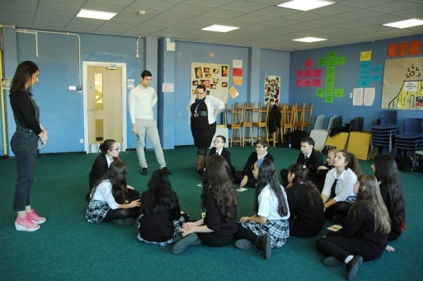

Image 1: A drama workshop on the theme of migration

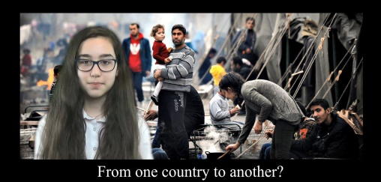

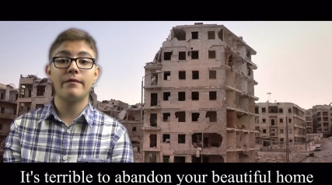

Image 2 and Image 3: Screen shots from the Greek-English digital story Migration

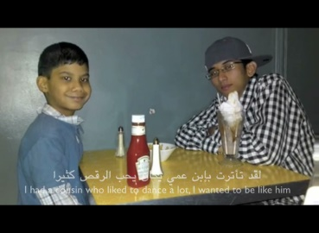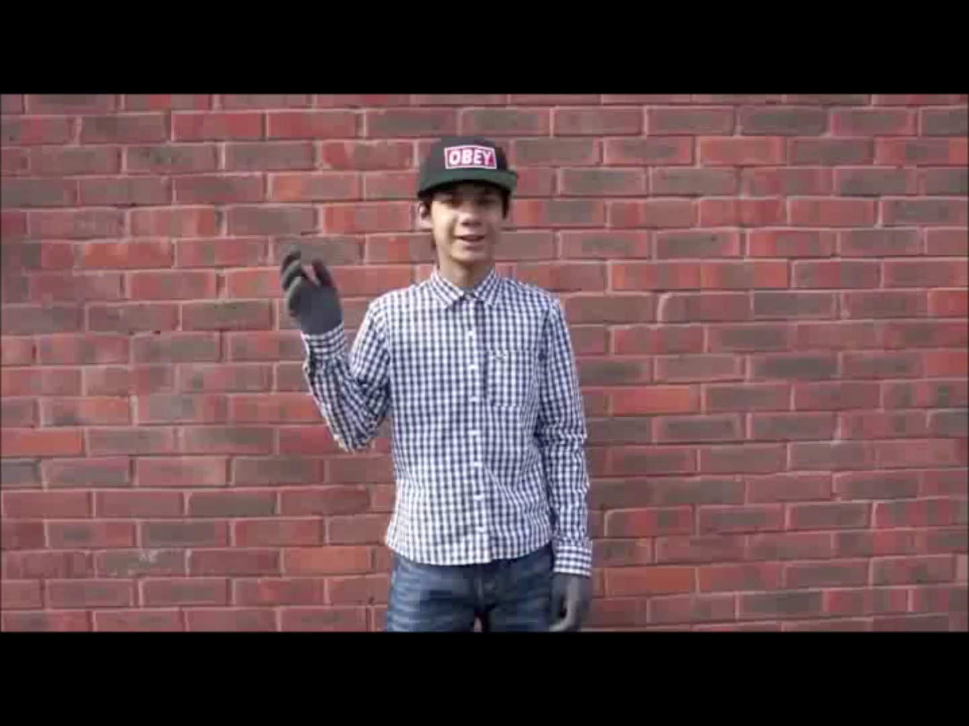

Image 4, Image 5 and Image 6: Screen shots of the Arabic-English digital story Freeze

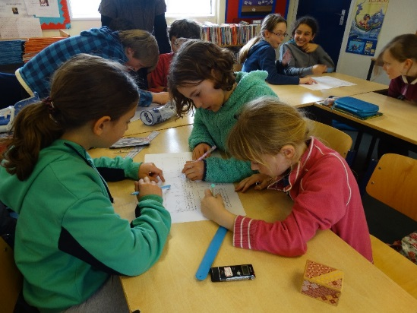

Image 7: Students storyboarding for the French-English digital story Abandonnée

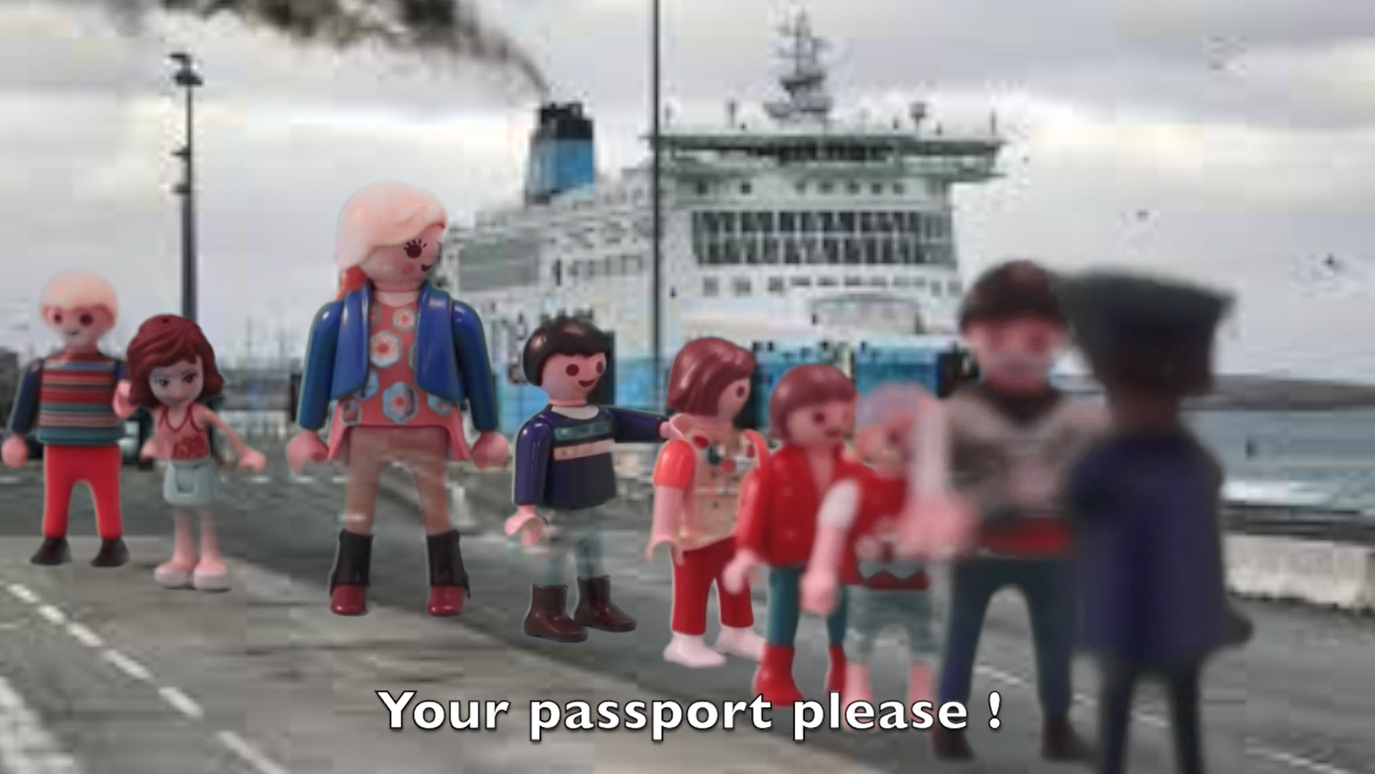

Image 8: Screen shot of the French-English digital story Abandonnée

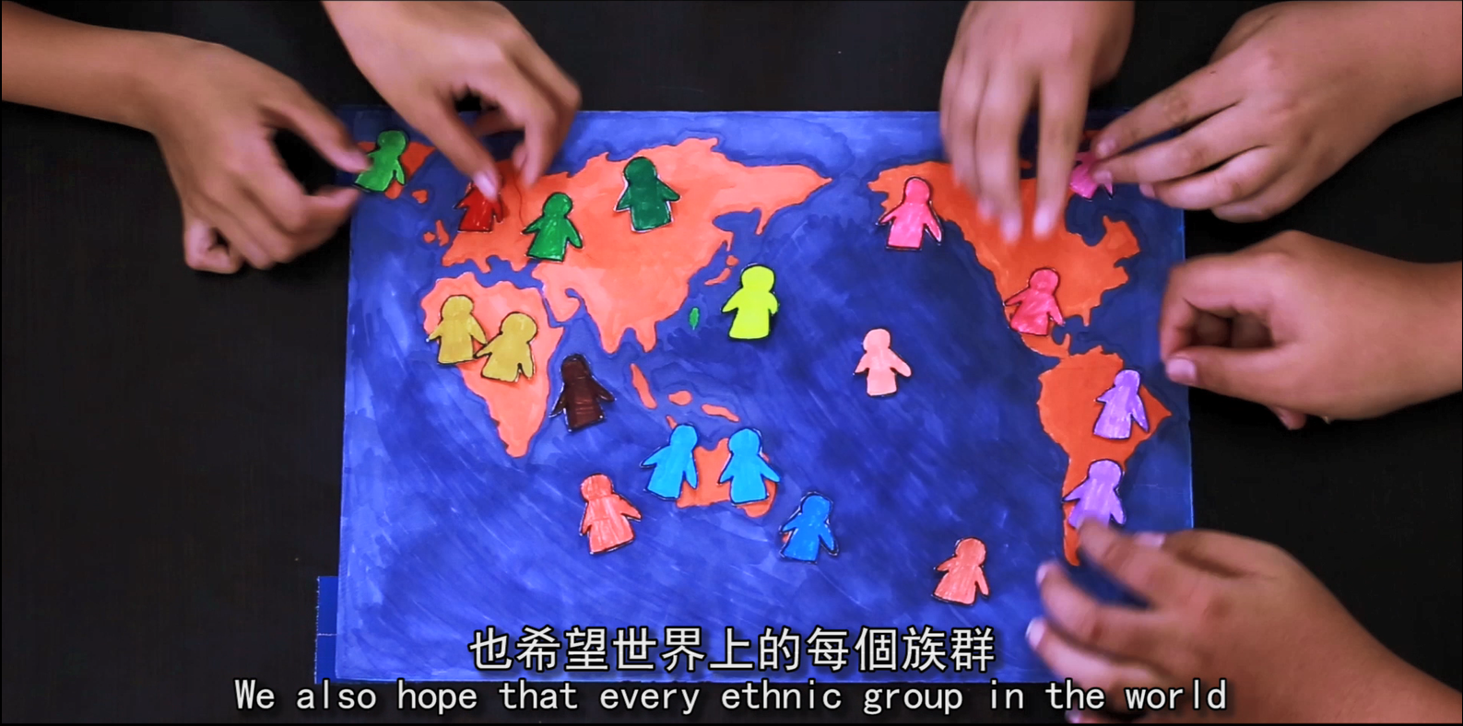

Image 9: Screen shot of the Chinese-English digital story Fairness in Ethnicities

