Linnaeus’ herbarium cabinet: a piece of furniture and its function
Staffan Mueller-Wille

Abridged with permission of the author by Becky Beasley

The Swedish 18th-century naturalist Carolus (Carl) Linnaeus is habitually credited with laying the foundations of modern taxonomy through the invention of binominal nomenclature. However, another innovation of Linnaeus’ has largely gone unnoticed. He seems to have been one of the first botanists to leave his herbarium unbound, keeping the sheets of dried plants separate and stacking them in a purpose built-cabinet. Understanding the significance of this seemingly mundane and simple invention opens a window onto the profound changes that natural history underwent in the 18th century.

Making a herbarium
The Philosophia Botanica, a botany textbook that Linnaeus based on the lectures he gave at the University of Uppsala, contains careful instructions on how to create a herbarium [8]. Linnaeus described how plants should be collected, dried, pressed and glued onto paper, including such details as what materials and glue to use. These instructions were an attempt to standardize botanical procedures and erase the habits and whims of individual collectors.

…Compared to earlier collectors, however, Linnaeus’ instructions contained a decisive innovation. Traditionally, several specimens might be glued in a decorative arrangement on a single sheet of paper. These sheets were then bound into volumes, stored in a library and cited like books. Specimens were thus placed into a fixed order from which they could not be removed without destroying the herbarium or even the specimens. Linnaeus, by contrast, advised readers of the Philosophia Botanica to mount just one specimen per sheet and refrain from binding them together.

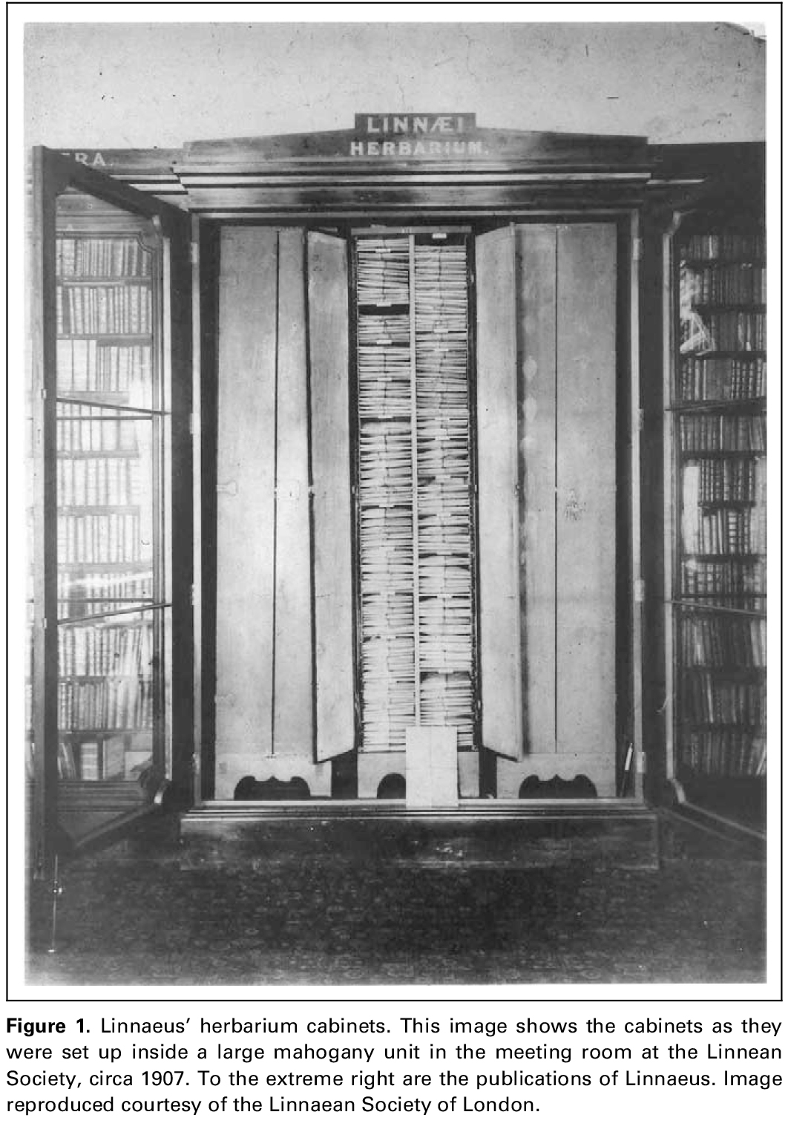

Figure 1. Linnaeus’ herbarium cabinets. This image shows the cabinets as they were set up inside a large mahogany unit in the meeting room at the Linnean Society, circa 1907. To the extreme right are the publications of Linnaeus. Image reproduced courtesy of the Linnaean Society of London.

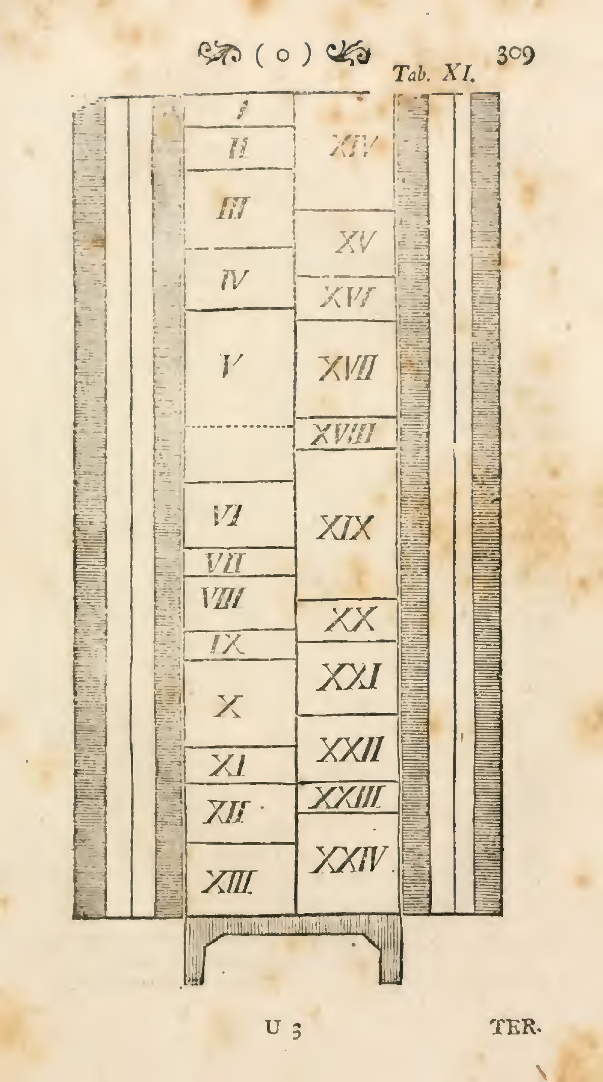

Figure 3. (a) Construction plan by Linnaeus for a herbarium cabinet, reproduced
from Linnaeus’ Philosophia Botanica (1751) (b) Linnaeus’ herbarium cabinets circa 1938 – image reproduced courtesy of the Linnaean Society of London.

For storage of the mounted specimens, Linnaeus suggested a purpose-built cabinet and gave illustrated guidance on how to construct it. These instructions correspond exactly to the three cabinets that Linnaeus possessed. These are rather plain in design – only one of them was adorned with two rows of leaf impressions on the outside of the doors. The doors open onto two narrow columns of shelves and it appears that at least one of the cabinets that returned to Sweden was also equipped with a dense, parallel series of horizontal slits covering its inner walls, into which the shelves supporting the herbarium sheets could be inserted at variable distances [10]. It is impossible to know if these were part of the original design or were added later. However, this detail indicates that the number of shelves and distances between them could be changed easily, either to accommodate new material or to rearrange the collection as a whole. Therefore, although the herbarium of Linnaeus brought his specimens into an order, individual sheets could easily be inserted at any place, removed at any time and reinserted again anywhere in the collection: the herbarium essentially functioned as a filing cabinet.
In contrast to the bound volumes of older herbaria, the order Linnaeus’ herbarium cabinet brought to his collection was not fixed and perpetual. It was designed to accommodate the steady arrival of new material and enabled its user, in principle at least, to repeatedly rearrange that material.

The natural order of plants
How did Linnaeus use his herbarium? Some clues lie in the Philosophia Botanica, where he described how to set up what he called ‘natural’ definitions of plant species and genera…The method that Linnaeus proposed for establishing natural characters was simple and straightforward. The botanist started with a ‘first species’ (prima species) represented by a garden exemplar, a herbarium specimen or a drawing, and drew up a full description of its morphology. In a series of further steps, additional representative specimens were gathered one by one. Characters that deviated from the original were then cancelled from the description. What was left was the set of characters that had proved to be ‘constant’.
In some instances Linnaeus referred to this comparative method as ‘collation’, a legal term for the word-byword comparison of an original document with its copy. This metaphor can be taken literally. Garden exemplars were seasonal, and plant drawings often unreliable. The herbarium, on the other hand, provided a reliable source of concrete evidence: stable and ready at hand throughout the year. Linnaeus’ description of collation enables us to imagine how he actually used his herbarium. In setting up natural characters, he would first take out one herbarium sheet, and then adduce others to compare the mounted specimens systematically, point-by-point, as if comparing two texts.

The design of the herbarium cabinet thus enabled Linnaeus to put together any set of specimens at a time for the purpose of collation. As a result, the relations among plant forms represented by natural characters transcended the local differences exhibited, say, by two specimens permanently fixed on one and the same herbarium sheet. The ‘natural system’ of plants, as Linnaeus saw it, consisted of a two-dimensional web of relations in which ‘all plants exhibit their contiguities on either side, like territories on a geographical map.’ Each species represented by a specimen in Linnaeus’ herbarium was defined by the affinities it exhibited with respect to all the other specimens in the collection. The potential for a complete permutation of specimens, which the herbarium cabinet offered in principle, enabled a global representation of taxonomic affinities [12]. Accordingly, it was the herbarium in its totality, rather than arbitrary type specimens, which served as a tool in the determination of plant species and genera.

The agitated background of 18th century taxonomy
According to some famous remarks that Michel Foucault made in his Order of Things, 18th-century natural history was profoundly shaped by ‘herbaria, natural history cabinets, and botanical gardens.’ These institutions formed the ‘timeless rectangle’ of 18th century taxonomies, in which ‘beings presented themselves side by side with their visible surfaces, without any commentary and surrounding language, approaching each other by their common traits, and thus virtually analyzed, bearers of their sole names’ [20]. To some, this might suggest an 18th-century mentality that preferred order and stability above diversity and variation, measurement above experiment: a static and tendentiously conservative outlook. Indeed, Carl Linnaeus has often enough been portrayed as the prototypical protagonist of this mind-set [21]. However, Linnaeus’ preoccupation with a taxonomy of ‘constant’ characters resulted from his engagement in a dynamic practice of transplantation and exchange, which had deep roots in the rapid and ongoing globalization of European economies [22].

References (the original numbering has been retained)
8 For a recent translation of this textbook see Linnaeus, C. (Freer, S., trans) (2003) Philosophia Botanica, Oxford University Press (Oxford, UK). The instructions on how to make a herbarium are on p. 18 and pp. 329–330 of this edition
10 See the photograph of the cabinet reproduced in Dahlgren, K.V.O. (1951) Philosophia botanica, ett 200-arsminne. Svenska Linnesallskapets Arsskrif 33–34, p.23. Today the cabinets lack this feature, so it must have been removed during some later restoration work, indicating that it was judged to be a post-Linnaean addition
12 Mueller-Wille, S. (2003) Joining Lapland and the Topinambes in flourishing Holland: center and periphery in Linnaean botany. Science in Context 16, pp. 461–488
20 Foucault,M. (1966) Lesmots et les choses. Une arche´ologie des sciences humaines, Gallimard (Paris, France), p. 143; the translation is my own
21 Lesch, J.E. (1990) Systematics and the geometrical spirit. In The Quantifying Spirit in the Eighteenth Century (Fra¨ngsmyr, T. et al., eds), pp. 73–112, University of California Press
22 Koerner, L. (1999) Linnaeus: Nature and Nation, Harvard University Press (Cambridge, MA, USA)

Endeavour Vol. 30 No. 2 June 2006
www.sciencedirect.com

