Racial Hair: the persistence and resistance of a category
Emma Tarlo
This article explores how hair and notions of race are entangled both within anthropology and in the commercial world of the billion dollar global market for human hair. Focussing in particular on detached hair, it explores the recurring dynamic through which hair is racialized on the one hand and resists racialization on the other. This is explored in three inter-related contexts the roots of which are deeply embedded in historic relations of power. The first is that of 19th and early 20th century physical anthropology when hair was thought to provide a key to racial distinctions; the second refers to contemporary black hair cultures in which hair is racialized both in the market place where it is advertised through ethnic signifiers and in the natural hair movement which relies on ideas of authenticity based on biological differences. The third context is that of factories in China where items such as ‘Brazilian’ hair extensions and ‘Afro’ wigs are physically manufactured through combinations of hair and labour that confound ethnic, racial and national boundaries. By shifting attention to the materiality of hair, the article highlights the enduring materiality of race, exposing its shape-shifting qualities and persistent ideologies and providing a unique angle onto the dynamics of nature-culture articulations.

Racial Hair: the persistence and resistance of a category

‘The challenge with studying race is to denaturalize without dematerializing it, and to simultaneously attend to materiality without fixing race.’ Amade M’Charek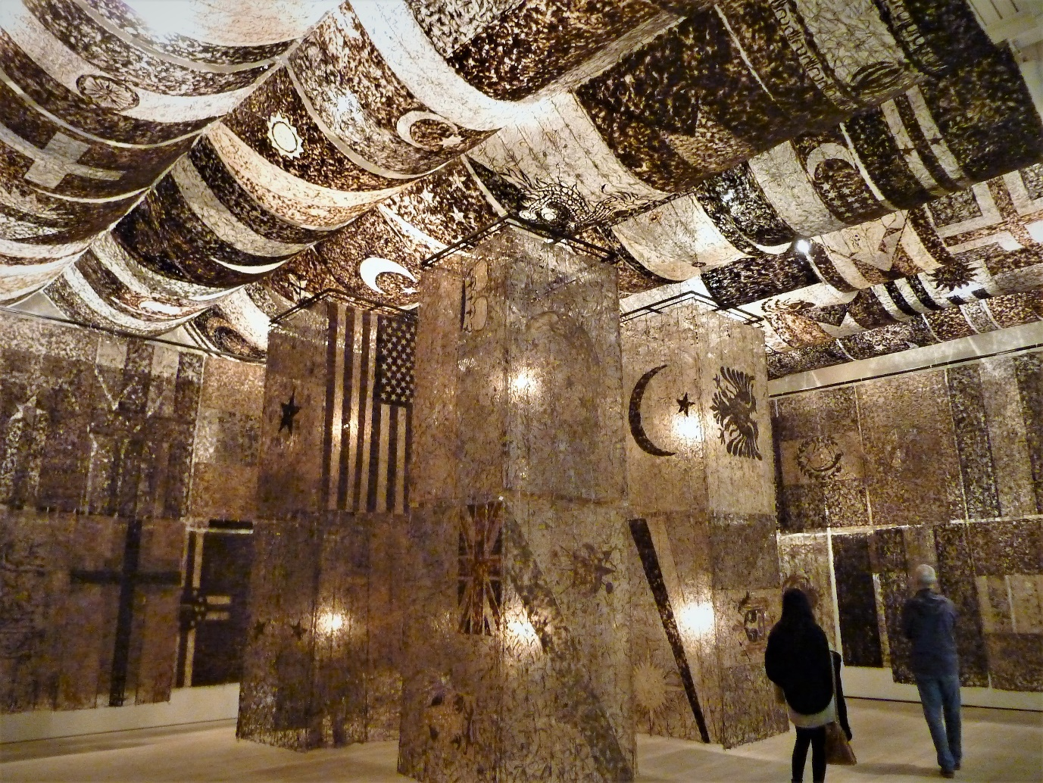
Fig,. 1a United Nations, Wenda Gu, Saatchi Gallery, 2013. Human hair and glue. (Photo: author)

In 2013 the Saatchi Gallery in London housed an exhibition entitled ‘East meets West’. One of the key attractions was a monumental installation by the Shanghai-born artist Wenda Gu. Entitled, United Nations, it was a tent-like structure made from human hair, trapped in transparent glue panels stitched together into a giant patchwork. Many of these panels evoked the appearance of national flags, yet national identities remained indecipherable, pointing to the ambiguity and artificiality of geo-political boundary making. Furthermore the hair, though fixed by glue, displayed a swirling waywardness as if indicating its refusal to be constrained.

United Nations was part of a series of art installations, initiated in 1993 and travelling around the world, taking on different forms in each country and absorbing what the artist referred to as ‘the hair of different races’ in its wake. In its final incarnation it was said to contain the hair of over a million people. The work evokes ideas of race and nation whilst at the same time pointing to the precariousness of both categories, highlighting the human obsession with boundary making and difference in the face of social realities characterised by uncertainty, hybridity and mixing. Gu refers to his work as a three dimensional mirror which reflects bio/geo/culturally shifting environments and heralds the emergence of post-racial identities (Cateforis 2002). By blending hair he is quite literally mixing DNA and pointing to how we have always been more mixed up than we thought. In this sense the ‘post-race’ identity he proposes is not only futuristic and utopian but also descriptive. United Nations is about moving beyond the idea of separate biologically distinct races whilst at the same time reminding us that such entities never really existed in the first place.
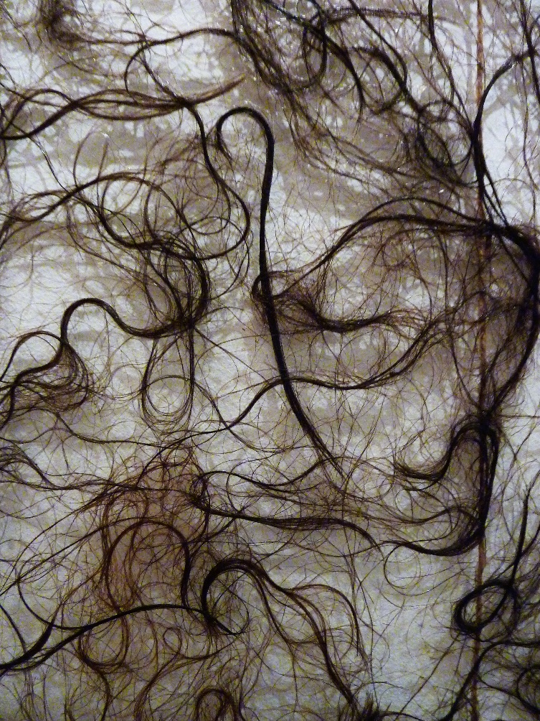
Fig. 1.b Detail of hair panel from United Nations, Wenda Gu. (Photo: author).
Gu ’s artworks also foreground the particularity of human hair – a body substance and product which defies the boundaries between self and non-self, animal and human, life and death. It is a fibre deeply bound up in personal, cultural and religious projects yet capable of being detached and put to a variety of pragmatic uses. Other works by the artist use human hair for making rope, medicine, bricks and ink, reminding us that it is a substance of both biology and culture and problematizing their oft assumed distinction. Gu works with the materiality of hair, exploring its animal and plant-like attributes, exploiting its capacity to evoke feelings of seduction and repulsion, its fragility and its ability to store information. As a register of our genetic inheritance hair tells stories about us that even we do not know. All of this makes it not only ‘good to think with’ to coin that irresistible phrase of Levi Strauss but also good to work with. This is ‘vibrant matter’ (Bennet 2010).
When I visited the Saatchi Gallery I spent some time lingering in this vast hairy monument, imbibing its atmosphere, experiencing its affect and observing people’s responses to it. From a distance the backlit glue panels in which the hair was trapped glowed a goldish colour and could almost have been mistaken for heavily embroidered screens evocative of the décor of Venetian palaces. I watched two teenage school girls, one black, one white, wander into the monument oblivious of the materials from which it was made. I overheard their teacher say, ‘You know, this artwork is made from human hair?!’ The white girl put her hand to her mouth, recoiling in visible shock and repulsion. ‘That’s disgusting!’ she squealed and began searching for an exit. Her black friend was more phlegmatic. ‘Oh good!’ she commented with a mischievous smile, ‘I can use it for my weaves!’
These responses, both delivered in London accents, hinted at the girls’ relationships with different hair practices and milieu connected to the racial geographies of the city. Each had brought their own experiences to the art work. One, apparently unfamiliar with the sight of strands of detached hair beyond perhaps the unsightly tangles that accumulate in the plug hole, saw the panels of swirling hair as alien, nightmarish and threatening; the other, a wearer of hair extensions, familiar no doubt with the dense network of black hair salons and hair shops clustered in areas of the city with a strong black presence, saw in the artwork a vast and untapped reservoir of a valuable commodity - human hair.
Gu’s art work and responses to it introduce the theme of this article which explores how hair is entangled with ideas of race both within anthropology and the commercial world of the global billion dollar market for human hair. It is about the making and unmaking of race through hair and the difficulties of disentangling hair from race. Existing anthropological literature on hair explores its significance as a malleable body part imbued with personal, social, political and symbolic importance in relation to ideas of sexuality (Leach 1958, Obeyesekere 1981), social control (Hallpike 1969), religious and cultural practices (Firth 1973, Hiltebeitel and Miller 1998 ) and black histories and identity (Bryd and Tharp 2001, Wingfield 2008). This article makes a distinctive contribution through shifting attention to the materiality of hair and exploring the relationship between hair and ideas of race through a focus on detached hair and its circulation. Hair – a remnant of persons – is proposed as a medium for investigating the remnants and unanticipated afterlives of scientific theories of race. Such a focus contributes to anthropological projects which disrupt biological understandings of race (Wade 2002) and challenge ideas of body integrity (Carstens 2013, Sharp 2006) whilst offering a unique perspective on the shape-shifting dynamics of nature-culture articulations (Haraway 1989, Latour1993 Descola 2013 ). It does this not by ignoring the spectre of race or simply debunking its legitimacy as a category (Banton 1987) but by rising to M’Charek’s challenge that we need not only to denaturalise race but also attend to its materiality(M’Charek 2013).
The research on which this article draws forms part of a wider project on the global trade in human hair. Conducted between 2013 and 2016, this project combined archival research in museum collections and libraries with multi-cited ethnographic research. In India and Myanmar research focussed on contexts where hair is collected, sold, donated and sorted. In China it was concentrated in hair factories in Qindoa (Shandong Province) and Xuchang (Henan Province) - the two most prominent cities of hair manufacture. In the UK, United States and Senegal, the focus was on contexts where hair is sold, purchased, worn, styled and debated such as salons, trade fairs, exhibitions, films, public discussions and events as well as analysis of digital sources such as hair trading websites, hair reviews and blogs.
The full scope of this research features in the book, Entanglement: The Secret lives of Hair (Tarlo 2016) which follows the global journeys of hair and takes the form of a work of anthropological non-fiction This experimental literary form enabled the simultaneous exploration of many interconnected themes (Hodges 2017). In this article I isolate a single theme - the racialisation of hair – and draw out its ethnographic and theoretical implications in ways that the previous literary genre did not allow. In particular I concentrate on the recurring dynamic through which hair is racialized on the one hand and resists racialization on the other. This dynamic is explored in three interconnected arenas. The first is the historic context of 19th and early 20th century projects of physical anthropology when hair was thought to provide a key to understanding racial distinction, spawning the development of a variety of different criteria and methods for classifying it. Here we see how far from generating racial certainties, differences in hair colour, texture and form pointed to the ambiguity of racial categories. Whilst hair’s diversity might have been used to question the logic of scientific theories of race, it was used by anthropologists and scientists in support of projects of ‘racial hygiene’ and eugenics.
The racialisation of hair has found an unanticipated yet fertile breeding ground in the contemporary trade in human hair where race and ethnicity are used as important marketing devices, particularly in those segments of the market which cater to black women. In the second section of this article I trace the polemics of race as expressed within ‘black hair cultures’ – polemics built on the residue of scientific theories of race and the conditions of slavery and colonialism in which they thrived. Here I show how the market for different ethnic hair types simultaneously disrupts ideas of racial purity by enabling some sort of racial cross-dressing, whilst at the same time reproducing racially based hierarchies, stereotypes and values. Consequently wigs and weaves, like chemical relaxers, are often spurned by advocates of the natural hair movement who see them as signs of racial alienation and the unconscious internalisation of white beauty norms which exclude or devalue natural Afro textures. Here I suggest that whilst the celebration of ‘natural hair’ is a powerful, intimate and visceral means of building and restoring black solidarity and pride it simultaneously plays a role in reinstating and re-naturalising ideas of racial difference based on biology.
Race resurfaces in a different way in the third section which shifts attention to the factory floor in China where the material characteristics of hair are physically manipulated and transformed to suit ethnic desires and stereotypes popular in the global market. Here I show how products such as ‘Afro wigs’ and ‘Brazilian hair extensions’ are produced through complex combinations of hair and labour which tell stories of transcultural enmeshment which defy ethnic, racial and national boundaries. Like Wenda Gu’s installation, they challenge and expose the precariousness of such categories whilst at the same time highlighting their enduring salience. It is suggested that hair’s physical connection to the body and its mutability make it a particularly pertinent medium for exploring the slipperiness of race. At the same time hair’s material rebelliousness helps ensure that its relationship to race is never settled. It is a disobedient fibre.

Race, Hair and Anthropology - a problematic relationship
One of the more curious and less obviously meaningful items to be found in the collections of museums of anthropology, ethnography and natural history whether in London, Oxford, Berlin, Moscow, Boston or Paris, are thousands of samples of human hair clippings, collected from disparate peoples around the world. Crammed into small boxes, envelopes or glass vials and sometimes even individually framed, they offer a strange microcosm of the world in hair. Most of them are labelled with the date and place of their collection, the name of the peoples they metonymically serve to represent and sometimes also the name of the collectors and institutions through whose hands they have passed. These clippings are both the products and remnants of two late 19th and early 20th century anthropological preoccupations – the impulse to collect everything from artefacts to body parts and the obsession with racial classification. Tucked away in the dark recesses of museum storage facilities, they lead us back to elements of the anthropological past some might rather forget.
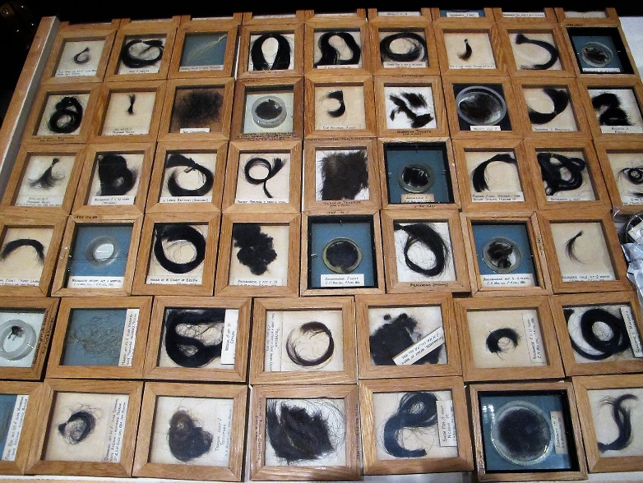
Fig. 2 Drawer of hair samples, Pitt Rivers Museum, University of Oxford Photo: author, courtesy of Pitt Rivers Museum, Oxford)

Much has been written about the nineteenth century quest to identify, measure and classify peoples into racial types and sub groups and the role this played in establishing and affirming ideas of racial hierarchy and difference (Banton 1983, 1987 , Wade 2002, Ahmed 2002, Poole 2005). This was an era in which colonial expansion and technological advances in science, photography and archaeology were enabling unprecedented access to the bodies of both the living and the dead on a global scale, generating new forms of apparently objective data for the comparative study of humankind (Pinney 1991). Bones, skulls and skeletons were all subject to documentation and measurement whilst differences and similarities in external features such as hair, skin and eye colour were meticulously recorded with a view to trying to unlock the secrets of racial distinction and patterns of heredity. Of these external features hair came to occupy privileged position, promising, if never entirely satisfying, the quest for racial clarity (Trotter 1938, Cheang 2008, Hagner 2008).
There are several reasons why hair seems to have played such an important role. As a body product its biological connection to the body was unquestionable, offering visible access to the apparent ‘roots’ of ‘natural’ differences (Cheang 2008). Yet unlike bones and skulls hair’s features were externally observable and relatively accessible for study. Samples of hair were easier to collect than skin, eyes and bone not least because they could be harvested from the living. In addition hair was light and portable and did not decompose in transit, enabling it to be sent home to established places of learning, passed around at scientific meetings and observed under the microscope (ibid). Museum inventories show that hair samples were collected from all over the world on a massive scale through complex networks involving doctors, scientists, anthropologists, colonial officials, police officers, school teachers, grave diggers, auctioneers and travellers and that this practice went on throughout the first few decades of the 20th century (Peers 2003, Zimmerman 2001). In Europe army recruitment posts, hospitals and prison camps also became important sites for hair collection. From hair surveys new statistical data was generated concerning racial differences and distribution. Achievements of the day included the creation of Hair atlases in which the world population was divided up on the basis of hair texture and colour with differences graphically displayed in the form of hair maps (Ripley 1898, Hagner 2008).
Whilst there seems to have been agreement that hair ‘was one of the deciding criteria in the classification of races’ (Trotter 1938:167) there was much less agreement over how to classify it, not least because hair differences were peculiarly difficult to pin down. In an early discussion of ‘hair and race-character’ held in Paris in 1863, the anthropologist and scientist Pruner-Bey proposed that hair should be studied both macroscopically and microscopically (Trotter 1938:169). His work included the inspection of hair from the heads, moustaches, genitals, arm pits and other parts of the body of peoples from around the world. Examining cross sections under the microscope, he identified three distinctive forms: the circular; the oval and the elliptical which corresponded to the three broad racial divisions of mongoloid, caucasoid and negroid into which other sub-races were divided, concluding that such examinations possessed ‘incontestable value for the study of characters inherent in the races of man’ (Pruner-Bey 1864). Yet the hair seemed to tell a different story. Commenting on his work half a century later the American anthropologist, Mildred Trotter, herself an advocate of studying race through hair, asserted, ‘Pruner-Bey presented tables of measurements and figures of cross sections of hair from different peoples which do not always appear to support his theories (Trotter 1938:169).
Looking back at early attempts to read race through hair, one is struck not only by the sheer weight of anthropological attention devoted to this endeavor but also by hair’s resistance to classificatory schema. In 1885 a five part classification of straight, wavy, curly, frizzy or woolly, based on externally observable characteristics, was adopted at the Society of Anthropology in Paris, following the recommendations of the French anthropologist and physicist Paul Topinard. Yet even Topinard seems to have been aware of its limitations. Discussing samples of European hair exhibited at the Trocadero in 1879, he pointed out that although the hair of the European race belonged to the wavy type, there were examples of straight, curly and frizzy European hair in his collection . Furthermore it was ‘difficult to trace with the naked eye the exact line of demarcation between woolly hair and the state that precedes frizzy hair’ for which there seemed to be no adequate term. (Topinard 1879)
Such debates were also entangled in ideas of hierarchy and evolution (Cheang 2008). The naturalist Ernst Haeckel, for example, argued that since woolly hair was found both in animals and humans, then those humans who had woolly hair were clearly further down the evolutionary ladder. It was perhaps for this reason that Topinard considered the term ‘woolly’ inappropriate for European hair even when it displayed excessive frizziness. When a certain Professor Andre Sanson objected that the term ‘woolly’ was ‘improper’ and that it was inadequate for describing the variety of different hair textures found amongst ‘Negros’, his argument was dismissed by Topinard who insisted that the term ‘woolly’, though ‘defective’, remained appropriate in this case (Topinard 1879).
Across Europe scientists strived to improve the terminology and methods of hair studies. In Berlin the Society for Anthropology, Ethnology and Pre-history set up a special committee in 1884 to establish guidelines for hair collection, preparation and examination and to refine and standardize terminology and classification (Hagner 2008:165). Determining hair colour proved particularly challenging. The German scientist Rudolf Virchow made broad distinctions between blond and brown types but conceded that there were as many as 127 different tones under the category of brown. Others noted that people’s hair changed colour with age and according to climate, and that there were variations in colour between the root and the tip of individual strands and even between adjacent hairs on the same head (Trotter 1939). All of these factors made comparison difficult and mediated against establishment of racial certainties.

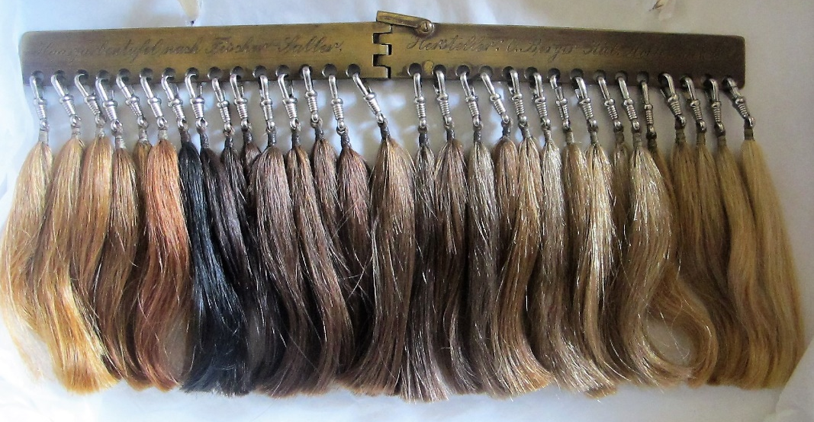
Fig. 3 Fischer-Saller hair gage for measuring and recording hair types, designed in 1928
using human hair samples. Photo: author, courtesy of Museum of Natural History, Vienna.

In Britain Sir Frances Galton pioneered the use of hair samples for standardising measurement at the International Health Exhibition held in London in 1884 but he later abandoned his efforts on the grounds that too many people used hair pomades, dyes and false switches which disturbed results. A more sophisticated device was invented in 1907 by the German scientist, Eugen Fischer. His haarfarbentafel (hair gage) consisted of a silver ruler from which there hung 30 numbered samples of false hair made from cellulose (spun glass) which could be held up to people’s head for direct comparison. However the cellulose was prone to fade, leading some to question its efficacy. By 1928 it had been replaced by the improved Fischer-Saller scale - a foldable hair gage containing samples of real human hair, some natural shades and others dyed. This was often used in conjunction with Rudolf Martin’s eye scale and von Luschan’s skin scale , forming part of the growing technical apparatus through which racial difference was measured and reinforced.
The search for racial clarity was by no means confined to the colonies. It included studies of the European population. In the 1870s Virchow conducted a nation-wide study of over six million German school children, recording their hair, skin and eye colour (Zimmerman 2001). Zimmerman estimates that 81 percent of German children aged between 6 and 14 would have taken part (ibid 2001: 294, fn 37). Teachers were instructed in how to conduct the studies which were designed to distinguish the geographic distribution of blond and dark types as well as recording the number of Jews and non-Jews in each category. Pupils were lined up in order of eye and hair colour and assigned to categories. This massive survey served not only to express anthropological notions of race, but also to teach children ‘how to experience those notions of race.’ (ibid 2001:140) Just as surveys of colonised populations instructed colonial subjects in how to view and experience themselves and others through the lens of racial hierarchy and difference (Ahmed 2002), so Virchow’s survey taught Germans how to internalise ideas of race and to literally judge each other’s race through external attributes.
Looking back at these anthropological endeavours to pin down racial characteristics, it is striking how persistently they threw up anomalies and how these anomalies served not as a basis for questioning the notion of race but as impetus for the development of further studies. For example Virchow’s study consigned Jews to the ‘dark type’ yet 11.7 % of the Jewish children surveyed turned out to have blond characteristics. Such findings stimulated further studies, such as the one conducted by the Jewish anthropologist Maurice Fishberg in 1900 in which he surveyed 2272 Jews in New York, comparing his material to findings in Europe. His concern was not to question Virchow’s classifications but to try to explain the anomaly of the blond Jew. Had blond Jews existed since ancient biblical times as some scholars suggested or were they a product of environmental or of social factors such as religious conversion or intermarriage? Fishberg concluded that blond traits originated not from the physical environment but from ‘the infusion of non-Jewish blood into the veins of modern Jews’, a conclusion which did not disrupt but instead upheld the idea of biologically distinct racial types (Fishberg 1903 ).
A similar respect of racial categories is found in the work of Caroline Bond Day – an American anthropologist of mixed race who conducted a study of ‘Negro-White’ families in the United States in the early 1930s. This was a time when ‘the American Negro’ was considered to be both a racial hybrid and a distinctive racial category of its own (Watson 2012). Whilst the varied facial features and hair of those being surveyed might have provided the impetus for dismantling racial classifications, instead they were used for creating further categories and divisions as proportions of white (W), negro (N) and Indian (I) ancestry were measured and recorded in the form of intricate fractions which included such formulations as 5/32 N, 1/32 I, 26/32 W and 4/8 N, 1/8 I, 3/8 W. Bond Day’s note books, now housed in the Peabody Museum, are accompanied by samples of hair which sprout rebelliously from the archive, their visceral presence distracting from the curious mathematical racial formulas to which the hair has been subjected and reduced (Alexander 2007).
Watson points out that Bond Day’s study was about trying to establish racial specificities rather than racial purity and that these were not equivalents. She reminds us that that the social, scientific and ideological boundaries of racial classification were in constant flux. What is striking however when one looks back at this period with hindsight is the extent to which American anthropological scholarship on hair and race appears to have been cut off from the political and ideological developments taking place in Europe in the 1920s and 30s where ideas of racial specificity, hierarchy and purity were converging with devastating effects.
Just a few years after he had invented the haarfarbentaful Eugen Fischer was using it in German South-West Africa (now Nambia) in his study of patterns of heredity amongst people of mixed Dutch and Hottentot blood. His conclusion was that for the ‘highest’ races to mix with ‘lowest’ was a degenerative act, a pollutant that threatened the health of the ‘higher race’. Once back in Germany he went on to establish the Society for Racial Hygeine in Freiburg and argued for the sterilisation of mixed race children in the Rhineland. Increasingly hair studies were to be put to use in eugenics.
In 1939, the same year that Mildred Trotter was publishing an extensive survey of classifications of hair color in the American Journal of Physical Anthropology where she discussed the advantages and disadvantages of different technical implements for classifying hair and called for the need for yet more studies, anthropologists working for the National Socialist Party in Germany and Austria were busy using the Fischer –Saller standard hair scale for detecting and establishing Jewish traits in the population and assisting in the project of racial cleansing.
Hidden away in the storage cabinets of the Natural History Museum in Vienna is a drawer of hair clipped from the heads of Jews who were rounded up in the Vienna stadium in 1939 where they were kept for 3 days whilst a team of researchers led by the Nazi affiliated anthropologist Josef Wastle from the museum, studied their racial characteristics, taking head and body measurements, photographs and in some cases face masks and hair clippings. Details of these clippings are registered under the heading ‘Juden’ in a vast and intimidating hair catalogue which contains references to 4039 hair clippings collected over several decades, many of them from refugee camps during the first world war. Having been forced to yield their racial characteristics to the scientific record, the Jewish prisoners rounded up in 1939 were deported to Buchenweld where most of them were dead within weeks of arrival. (Berner 2010)
When I visited the museum in 2015 the director of anthropology, Maria Teschler–Nicola, introduced me to the hair collection, expressing her extreme unease at the presence of the Jewish hair clippings collected during the 2nd world war. The clippings exuded an eerie presence, haunted by the circumstances of their collection and by knowledge of the fates of those from whom they were cut whose presence lingered on – a presence which recalled absence. Each sample was contained in a separate semi-transparent envelope marked with the name and reference number of a person soon to be no more. The envelopes appeared never to have been opened raising questions about what purpose they have ever served except to act retrospectively as evidence of now defunct racial theories and of the museum’s participation in National Socialist agendas. Not wishing to disturb these human relics, we laid them out in their sealed envelopes on a backlit screen, allowing the contours of the hair to show through the paper. The effect was a patchwork of hair screens uncannily reminiscent of Wenda Gu’s installation but in miniature. Yet whereas in the modern art work the hair exhibited a certain uniform, here each clipping displayed slight differences in texture and form as if diversity had quite literally been frozen in motion, rendering such appellations as frizzy, curly, wavy and straight uncertain. Though once collected with the presumed intention of demonstrating the specificity of Jewish hair, they seemed to reveal the opposite, resisting the very classifications they were intended to confirm.
This brief and idiosyncratic introduction to a century of Euro-American anthropological research on hair and race shows how physical differences in hair types provided both a basis for racial classification and evidence of the weakness of such classifications. It also gives insight into how a person’s fate could hang precariously on such divisions. In the Austrian context the classification of hair types played an important role in paternity cases. If sufficient levels of Jewish traits were detected this could be enough to justify a person’s deportation. Such cases contributed towards the ‘cleansing’ of the population of Jewish elements. Conversely there were cases elsewhere in Europe where Jews were saved from execution on the basis that their blond hair or blue eyes ‘proved’ their Aryan ancestry. Hair seems to have functioned as a trickster, tempting yet confounding racial classification – a role it continues to play today in the global market for human hair where race is one of the key idioms through which hair is advertised.
Black Hair and the Marketing of Race
Indian, European, Brazilian, Peruvian, Malaysian, Burmese, Russian, Vietnamese, Cambodian, Filipino, Indonesian, Uzbek and Mongolian. These are just some of the ethnic and national descriptors used to advertise human hair in what is a booming billion dollar global industry for wigs and extensions. To anyone familiar with the history of physical anthropology such categories resonate alarmingly with earlier attempts to designate hair to geographically distributed racial groups. They raise questions not only about the geography of the hair trade and the conditions and circumstances under which hair is collected from different parts of the world (Tarlo 2016) but also about the persistence of racially charged ways of categorising, ranking and perceiving hair.

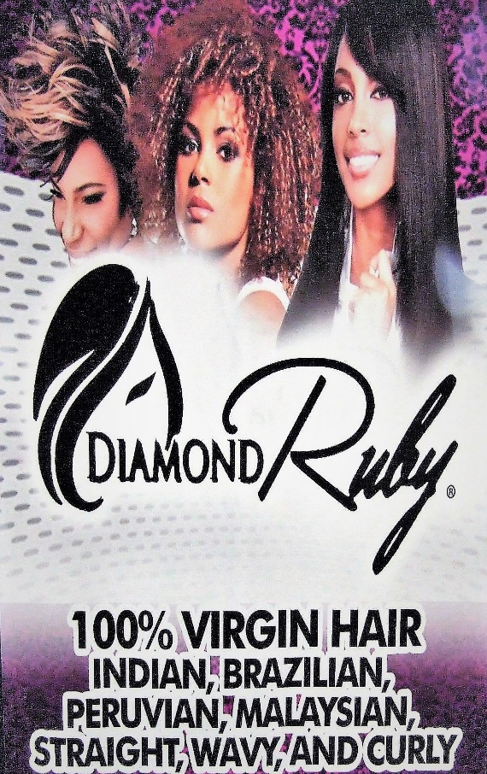
Fig. 4 Hair advert in Jackson, Mississippi, 2013. (photo: author)

The marketing of hair through ethnic and racial categories is particularly apparent in the shops, salons, magazines, hair blogs and websites catering to black women whether in London, Paris, New York or Atlanta. Black women are big consumers of human hair and synthetic equivalents. A recent survey conducted by Mintel in the United States reported that ‘nearly six out of ten black consumers wear a wig, weave or extensions” (cited in Opiah 2014), suggesting that the practice has to a large extent become normalised. At the same time the use of weaves, and more particularly chemical straighteners (known as relaxers), are subjects of intense controversy and debate especially amongst the growing numbers of black women who embrace and advocate natural hair, many of whom decry all practices that radically alter the appearance and texture of Afro hair as culturally and racially alienating, psychologically damaging, physically harmful and economically draining.
Black hair styling has a highly complex historiography, shot through with narratives of pride and humiliation, liberation and oppression, pleasure, creativity and pain. Intimate struggles to control the boisterousness of natural curl and frizz with straightening irons and relaxers are bound up with histories of slavery and imperialism and with struggles for recognition and acceptance in a world where racial inequalities persist and where white beauty norms retain a disproportionate aesthetic hold over definitions of femininity and attractiveness. A deep preoccupation with the politics and emotional and technical challenges of black hair styling choices is expressed in a potent body of academic literature, political debate, film, fiction, exhibitions, poetry and online forums and blogs. Such works draw attention to the historic stigma attached to Afro textures in the contexts of slavery and imperialism, the enduring psychological damage of this legacy, the rise of iconic black hair entrepreneurs and distinctive styling techniques, the role of hair in political struggles against racism, the intimacy of relationships forged between women through hair, the significance of the salon as a social space and of black hair dressing as a ‘racial enclave economy’, and the emancipatory power and potential of ‘natural hair.’ (see for example, Bryd and Tharps 2001, hooks 1989, Mercer 1994, Jones 1994, Battle-Walters 2004, Jacobs-Huey 2006, Alexander 2007, Wingfield 2008). What has received far less attention, however, is the process by which hair is racialized in the global market for hair extensions and wigs and, though in a very different way, through the discourses of the natural hair movement. It is to these questions that I now turn.
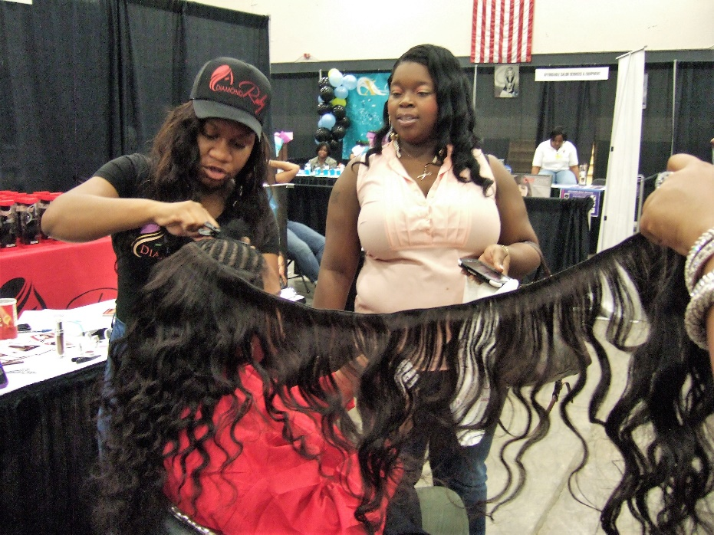
Fig. 5 Stylist, Deedee from Diamond Ruby installing a Brazilian weave at the Mississippi International Hair Show and Expo, Jackson, 2013. (Photo: Emma Tarlo)
What, for example, are we to make of the many ethnic varieties of hair on offer in the global market for wigs and weaves? This is not merely an academic question. It is also a practical one that preoccupies many of the women who regularly purchase hair. Making sense of ethnic labelling is by no means obvious. Type ‘Brazilian hair’ into your search engine and you are confronted by a dizzying array of gleaming bunches of dark hair offered in a variety of curl patterns from wavy, kinky, curly and straight to deep wave, body wave and spring curled. It soon becomes clear that the term ‘Brazilian hair’ does not so much describe a single hair type as convey an idea of lustrousness, exoticism and abundance. Similarly the term ‘Russian hair’ is associated with blondness and a range of light colours, evoking the idea of ‘Russian’ regardless of whether or not it has grown on Russian heads. This is not to say that all hair origins advertised are fictitious but that there is considerable room for creative invention. What is on sale are ethnic and racial mythologies which may or may not correspond to physical origins.
In spite of the precariousness of hair categories, or perhaps because of it, there is no shortage of online dictionaries, glossaries and self-styled experts ready to guide bewildered consumers through the human jungle of hair types on offer. These experts peddle certainties in the face of confusion in what feels almost like a parody of earlier anthropological endeavours to pin racial labels onto errant hair. Just as anthropologists had once struggled to find a language capable of grasping nuanced variations in hair colour and texture, so entrepreneurs and expert bloggers today struggle to differentiate between the ethnic categories they have to a large extent invented. As a result their explanations are – to use a much abused term in hair studies - woolly. For example on the websites of the Love Lavish Hair, Cherished Hair and Vanity Insanity, we are told that Indian hair is versatile, soft with natural lustre; Brazilian hair has beautiful bounce, full body and texture; Burmese hair is healthy and natural - a cross between Indian and Chinese; Malaysian hair is soft, luxurious and irresistible to touch; Mongolian hair is thicker and denser but still soft; Cambodian hair is fine, luxurious and capable of holding curl as well as being straightened; Filipino hair is thick and coarse but with a healthy shine; Indonesian hair is voluminous, bouncy and natural looking; Russian hair is fine, high quality and silky; Uzbek hair is close to Russian hair but more economically priced; Peruvian hair is coarser than Indian or Brazilian hair but compatible both with African-American relaxed textures and medium Caucasian textures. It is, we are told, ‘the ultimate multi-purpose hair.’ This last phrase is a reminder that ethnic descriptions, for all their ingenuity, are ultimately about consumption. Online dictionaries of hair types are supplemented by commentaries from bloggers and reviewers who provide expert critical opinion on particular products. Popular hair reviewers issue regular vlogs in which they can be seen unpacking, installing and test driving hair as well as giving updates on the progress and longevity of particular brands of ethnicised varieties. Most are young black women filming from bedrooms in America and Europe.
Whilst some consumers are highly sceptical about the identity of the hair on offer, others take the descriptions literally or find themselves in a complicated quest to find genuine ‘Indian’, ‘Brazilian’ or ‘Peruvian’ hair. This problem of hair provenance is by no means new to the market. During the wig boom of 1970, the United States Federal Trade Commission published ed ‘Guidelines for Labelling, Advertising and Selling Wigs and Other Hairpieces,’ specifying that the origin of hair products should be disclosed and that wigs made of non-European hair should not be described or advertised as being of ‘European texture.’ These guidelines were introduced at a time when wig manufacture was shifting from European and American workshops to large factories in Hong Kong, Taiwan and South Korea. However by the mid 1990s when the market for hair extensions was taking off and when the production of hair goods was shifting to China where labour was cheaper, these guidelines were rescinded, leaving the industry unregulated and creating space for the expansion rather than restriction of ethnic fictions.
Interesting insight into how ethnic categories proliferate in the market place is provided by Alix Moore - an African American entrepreneur who has written a gritty account of her long career marketing, wearing and promoting hair extensions in the United States. In her self-published book, The Truth about the Human hair Industry: Wake up Black America! she recounts how when she was selling Indian hair on the curbside in Los Angeles in the 1990s she found other women setting up in competition so when she began importing hair from China she decided to call it ‘Malaysian’ partly to hide her sources but also to avoid the negative associations of Chinese hair. However she soon found out that one of her clients was buying this so called ‘Malaysian’ hair from her stall and selling it down the road as ‘Indonesian’ and ‘Brazilian.’ (Moore 2013).
At one level Moore’s description of the diversification of ethnic classifications in the hair trade provides a classic example of how global capitalism thrives on the proliferation of diversity and how race and ethnicity become mere marketing devices which assist in the consumption of otherness. Esther Berry, for example, drawing on the work of bell hooks, considers the consumption of Indian hair by white Western consumers as an act of cultural cannibalism through which exotic elements of the other become tamed and ingested through a system of global capitalism that is rooted in colonialism (Berry 2008). But whilst such analysis draws attention to the unequal power relations on which the hair trade thrives, it fails to capture the complexity of its social geography and pays little attention to the identities and perspectives of people who buy and wear added hair, many of whom are black women.
Alix Moore’s book is a hybrid text – part autobiography, part manual, motivational text, myth buster and advertisement. It has none of the intellectual sophistication of post-colonial scholarship. Moore left school at 15 and writes from the street and the salon rather than the university. Her work has a raw and visceral quality. It has been ignored by scholars partly perhaps because of its lack of intellectual pedigree but also no doubt because it goes against the political grain of all black hair scholarship. The highly racialized language she employs is geared not against the dual enemies of colonialism and capitalism but against Asians whom she accuses of having raped and pimped African Americans by selling them shoddy hair. She also makes the controversial assertion that that the weave is not so much an option for black women as a necessity and entitlement. ‘We have been and will wear weaves for the rest of our lives’ she argues (chap 15)…. ‘Men don’t get it and society just doesn’t get it either. We are not trying to mimic other nationalities, and we aren’t trying to be someone we’re not. We just want maintenance free, fly hair, to wear however we choose to wear it, curly, long, short without any judgement from anyone else.’ (para 846 chap 3). Hair, she argues, ‘changes your life’, ‘changes your attitude’, ‘makes you feel more confident’. Her aim is to encourage all African Americans to buy and stitch their own hair wefts, preferably using Indian hair, and to start their own hair businesses. It is a narrative of social and economic upliftment through global capitalism. Her book begins with The 10 Human Hair Commandments one of which is ‘Thou shalt invest and receive share in the billion-dollar industry.’
Leaving aside the quasi-religious entrepreneurial zeal and her plea for African Americans to grab profits out of the hands of Asians whilst at the same time buying and wearing Asian hair, Moore’s book is interesting for drawing attention to something that often escapes the lens of academics but is of crucial importance to many wearers of wigs and weaves – that is the sensorial pleasures and haptic qualities of flowing hair. Many women desire the sensation of hair that moves when they turn their heads and this desire may not be entirely reducible to the imbibing of culturally defined beauty norms but may also be linked to the seductive and sensuous material properties of hair. Hair extensions, wigs and weaves are not only about looks or politics but also about touch and feel. These performative, transformative, sensorial and expressive aspects of hair have always been an important feature of black hair cultures which have long been characterised by a high degree of flexibility and inventiveness ( Mercer 1994). In this sense Brazilian weaves and Peruvian wigs are as much a part of evolving black hair cultures as Senegalese twists or so called natural hair. As Nyamnjoh and Fuh put it, speaking of African hair practices, ‘With Africans, raw and cooked, natural and cultivated hair are permanent works in progress, ones in which biology just provides the baby steps on a life long journey of creative innovation and renovation’ (Nyamnjoh and Fuh 2014). Viewed in this light hair extensions could be seen as a medium through which one can transcend fixed and constrictive definitions of self which reduce identity to visibly readable signs of biological difference. If hair was used historically to pin people down to fixed racial categories with all the hierarchical judgments and prejudices these implied, today wigs and weaves with their semi-fictional ethnic identities parody such categories, offering the playful possibility of some sort of racial cross-dressing. Might such performances be less about racial appropriation and ingestion than about the possibility of moving beyond what Antony Appiah calls the ‘racial fixation’ and taking a step in the direction of what the artist, Wenda Gu calls ‘post-racial identities’?
Such an interpretation is not shared by the growing numbers of black women who embrace the ‘natural hair movement’, many of whom view attempts to alter the texture and length of hair through chemical relaxers and weaves as a form of racialized alienation which signals the unconscious internalisation of white beauty norms and by extension (excuse the pun) , self-hatred. Drawing on the black power movement of the 1970s when Afro hair became a powerful statement of black beauty and political assertion and on longer histories of slavery and imperialism in which Afro hair textures were devalued and associated with shame, many women have experienced liberation through rediscovering and embracing their natural hair. Writing about this process in her penetrating essay, ‘Straightening our hair’, bell hooks called on black women to resist the temptation to alter the texture of their hair because to so would involve complicity with the structures that oppress and hurt black women. ‘It is more important that black women resist racism and sexism in every way’, she argued even if this sometimes meant having to sacrifice individual freedoms and desires. She herself had sometimes felt tempted to straighten her hair just for a change of style or for fun, but black women could not afford the luxury of taking such action light heartedly. Rather they should struggle daily to stay in touch with their bodies which have so often been devalued and in celebrating their bodies they participate in the liberation of freeing their minds and hearts (hooks 1989).
Many of hooks’ arguments find fertile ground in contemporary natural hair blogs where converts to natural hair share their experiences. Many recall childhood experiences of having had their hair forced into uncomfortable styles by mothers and grandmothers who perceived ‘nappy’ hair as wild and uncouth. Many also recount painful adolescent experiences in which they devoted huge amounts of time and money trying to attain longer straighter hair through relaxers and extensions, suffering not only from financial burden but also from physical side-effects such as burnt scalps and traction alopecia. The decision to put an end to such practices and embrace natural textures is often experienced as an epiphany, offering release from the psychological enslavement of battling against one’s own natural bodily features. ‘I blog about hair everyday’ Honey Williams, performance artist, hair blogger and daughter of a hairdresser announced at a black hair debate I attended at the New Art Exchange in Nottingham. ‘Its about forcing myself to love myself. I’m self-medicating my own self-hatred.’ Her reference to ‘post-traumatic slavery syndrome’ was echoed in another blogger’s reference to how she used her hair to defy Euro-American beauty norms on a daily basis.
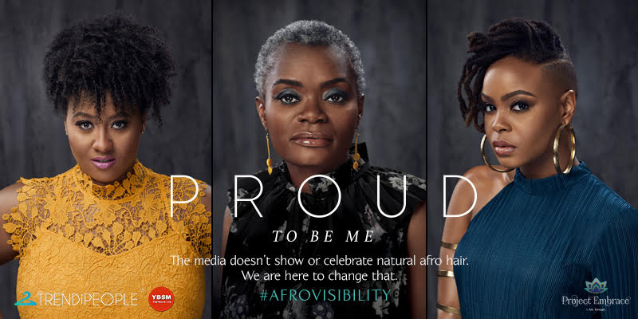
Fig. 6 Afrovisibility Posters for the UK nationwide Project Embrace billboard campaign celebrating empowerment through natural hair, 2018 (courtesy of Lekia Lee, Project Embrace)
‘Going natural’ has undoubtedly become a powerful means of combatting historic prejudice and escaping from hair practices that can be costly, exploitative and in some cases harmful and addictive. Through finding beauty and pleasure in natural textures and experimenting with the aesthetic possibilities these offer rather than feeling that such attributes must be tamed, hidden or disguised, many black women in different parts of the world have established a powerful politics of presence. It is a politics that gives free reign to the boisterous, springy and sculptural qualities of Afro textured hair with its potential to occupy space in particular ways and defy processes of passification that have long been levied against it. As Kobena Mercer pointed out over two decades ago, black hair has long been a means through which people find aesthetic solutions to a range of problems created by the ideologies of race and racism (Mercer 1994). That racism continues to be played out through hair is confirmed by two recent cases reported in the British press, the first involving the exclusion of a boy from secondary school classes on the grounds that his dreadlocks breached uniform rules in spite of the fact that they were neatly tied up (Evening Standard 3.11.2017); the other involving the digital airbrushing of the actress Lupito Nyongo’s Afro hair when she posed for the front cover of Grazia magazine (Grazia November 2017). But Mercer also points out that both the Afro and dreadlocks – the two styles most associated with a return to African roots - did not in fact have their roots in Africa but in black confrontations with racism outside the continent. Mercer is not suggesting that such styles are inauthentic; rather he is warning against the dangers of equating Africa and Africanness with the ‘natural’ to the detriment of ignoring the rich diversity and improvisational genius of black hair cultures ( Mercer 1994 ).
‘‘Race is something we make. Its not something that makes us’, Anthony Appiah claimed in his 2016 Reith Lecture but he also pointed out the enduring nature of racial categories and how ‘we keep tracing the same contours with different pens.’ With the idealisation of natural hair, ideas of racial difference based on biology are inadvertently reproduced. This can have curious effects, not only through obliging black women to define themselves through their bodily features which are expected to remain in a natural unaltered state (Ny mnjoh and Foh 2014) but also by igniting forms of internal racism whereby those who do not have sufficiently nappy hair are considered inferior and somehow ‘less black’ by those who do (Compaore 2011). At the same time there is growing online debate about how many of the most popular natural hair bloggers have hair and skin which correspond to a ‘mixed race’ look and that continues to pander to white aesthetics. Perhaps more liberating than the veneration of the natural are the playful experiments with the unnatural exhibited in the emerging Afro punk scene where pink and turquoise braids, purple Afros and peroxide twists juggle for attention, exploiting the material and sculptural possibilities that Afro hair invites and developing experimental black aesthetics without resorting to literalist understandings of what is natural.
Natural hair, like nature itself, is a floating signifier that accrues different meanings in different contexts. When Senegalese women in Dakkar spoke to me of their desire for ‘cheveux naturel’ they were referring not to their own hair but to imported human hair on sale at prohibitive prices in the market. It was clear that in this context to leave one’s hair in a so called natural state would be considered anything but natural. As Bryd and Tharp (2009) point out, in many African countries hair that has not been carefully groomed, reshaped or styled is associated with the state of mourning or madness.
Walking around the Afro Hair and Beauty show in London, an event which takes place annually, my attention was caught by a range of dolls called ‘Mixed Chicks.’ They come with different hair types which are intended to represent different mixed race permutations and are targeted at the parents of mixed race children. I couldn’t help thinking that whilst these dolls might offer confidence to children whose hair does not fit the racial codes of the media and the market, they also have the effect of creating new racially based divisions and demarcations just as Caroline Bond Day’s racial fractions did in the past. Can hair ever escape the prism of race?

The Physical Manufacture of Racial Hair
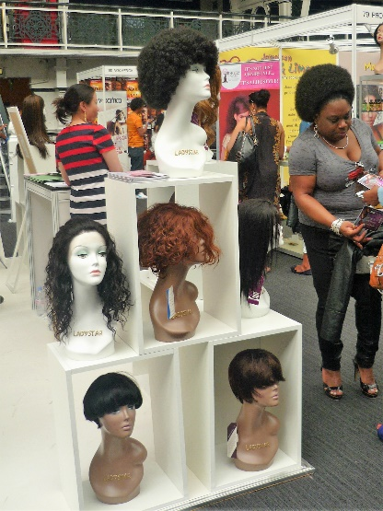
Fig. 7 Chinese manufactured wigs and weaves on display at the Afro Hair and Beauty Show, London, 2013. (Photo: Emma Tarlo)
It was on my first visit to the Afro Hair and Beauty show in London in 2012 that I became aware of the role of China as the largest manufacturer and exporter of human hair goods. This fact is not immediately apparent in hair shops, salons and online hair stores where the Chinese identity of hair products tends to be obscured by ethnic labelling which suggests alternative origins. Hair advertised as Chinese would not sell, I was frequently told, owing to prejudice against Chinese products. This prejudice is not new. As early as 1875 a journalist visiting the hair market at Mincing Lane in London described Chinese hair as ‘black as coal and thick as cocoa nut fibre’ (New York Times 12.9.1875 ). In the decades that followed Chinese hair was periodically blamed for bringing fatal diseases to Europe (Tarlo 2016: 56-7). Both exporters and importers of Chinese hair told me that they felt obliged to market it as something else. One prominent company’s ‘Indian range’ of hair extensions was made from a blend of Indian and Chinese hair whilst their ‘European range’ was made entirely from Indian hair. They also had a range of products made entirely from Chinese hair which was never marketed as such. ‘Chinese doesn’t have the right reputation,’ I was told. Interestingly this company received fewer complaints about its unidentified Chinese hair than about its Indian ‘European’ range. This was because the Indian hair was ‘less resilient’ to bleaching and dying. Chinese hair tends to be thick and straight owing to its densely packed cuticle, reminding us that physical differences in hair structure are not entirely fictional even if they do not map neatly onto racial categories. Complaints about the quality of products made from Indian hair were no doubt also linked to the fact that most of the hair China imports from India is combings (fallen hair) which has to be untangled and have its cuticle chemically stripped before it can be used for extensions and wigs. This processing weakens the structure of the hair. These examples point to the fact that hair is culled from thousands of heads in different parts of the world before being physically transformed, recombined and refashioned in factories in Asia where it is often given a new texture and assigned a new identity.
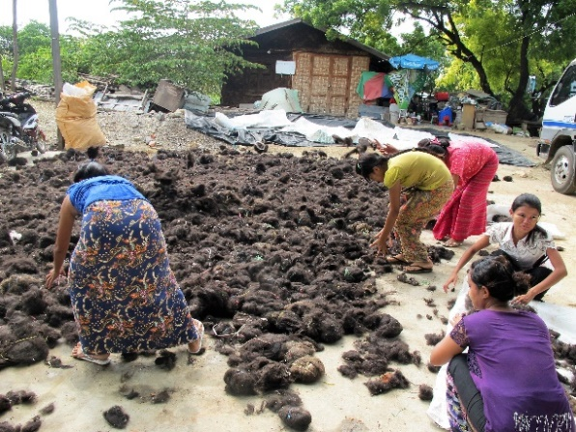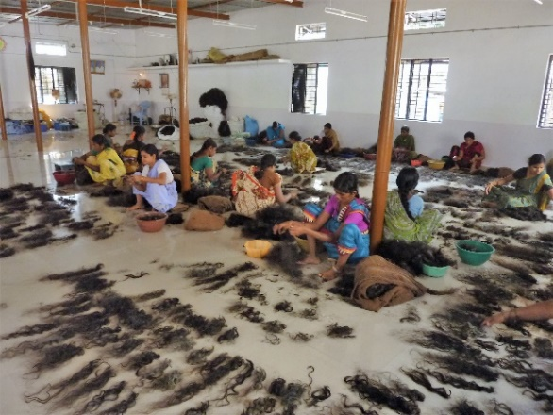
Fig. 7 Left: Combings airing in Mandalay (Myanmar, 2015) and right: combings being untangled and sorted in Koppal (India, 2013) before being sent to China for use in the hair extension industry. (Photos: Emma Tarlo)

At a trade show in Jackson Mississippi when I first began embarking on research into hair, I was surprised to come across a full head of Afro hair lying on a table with remnants of dried glue attached to the seam. One of the stall holders had just removed her weave. I had been conversing with this trader the day before and had automatically assumed that her Afro hair was growing naturally from her head, especially since she was advertising a product called Gro-natural. Seeing it discarded alerted me to some of the complexities of ‘natural hair.’ If maintaining one’s own Afro textured hair can be hard work owing to its propensity to tangle and dry out or if one’s hair does not make a good-sized Afro, or if one simply wants to give one’s hair a temporary ‘rest’ from abrasive treatments or styles, then it is always possible to wear an Afro wig. At a hair warehouse in London I was told by the sales rep of a big Chinese company that the Afro was their ‘evergreen wig’ because it sold steadily all year round. Later when I visited a hair factory in Chennai I was shown a delicate freshly frizzed weft of Afro hair that had been ingeniously created out of Indian hair. But it was when I visited the industrial city of Xuchang in central China that I was able to see first-hand how different curl patterns, textures and ethnicities are physically produced on an industrial scale.
In Xuchang I was taken around many factories and workshops, the largest of which employed 5000 workers. This factory procured hair mainly from India, China, Bangladesh and Myanmar and exported wigs, wefts and extensions to the United States, Europe, Africa, Korea and Japan. Its show room was divided up into these different regional markets with the mannequins and hair products on display corresponding to the presumed tastes of consumers in each location.
The bleaching and dying rooms of these factories resembled school kitchens with huge aluminium vats and plastic tubs filled with hair which exuded eye-watering toxic fumes. It is in these factories that black hair from across Asia is coloured and retextured for the world market. In one factory glamorous long blond wigs destined for Manchester were drying on a rack in the courtyard.. In another factory which specialised in hair for black consumers in Africa, Europe and the United States workers were winding wefts of hair around thin wooded sticks and different widths of aluminium pipe to attain different curl sizes. The curls were then baked or steamed into the hair using specialist ovens. When the hair was first unwound from the wooden sticks, it was tightly coiled resembling old fashioned telephone wires. These coils were loosened to different degrees by being suspended by hand in a chemical solution for different lengths of time to achieve different effects. The popular texture known in the black hair market as ‘yaki’ was produced through pressing and baking hair between layers of mesh, to attain a crinkly texture said to resemble that of Afro hair after it has been chemically relaxed – a texture reminiscent of the natural frizz of yak belly hair, from which the term ‘yaki’ derives. Yak hair was commonly used for the cheaper range of Afro wigs in the 1970s but today it is cheaper to simulate the texture using human or synthetic hair fibre.
The factory floor in China draws attention to the material qualities of hair and its role as a malleable fibre from which different ethnic and racial hair types are quite literally hand crafted. It offers a fresh vantage point through which to view processes of racialisation. Here the artificiality of race is not something to be discovered; rather artifice is intrinsic to the production process. From the perspective of hair manufacturers, the question is not how to obtain hair from a wide range of ethnic groups but how to produce a wide range of ethnic varieties of hair from the mostly black hair obtainable in different Asian countries and how to keep up with the rapidly changing tastes of the market with its seemingly endless thirst for variety.
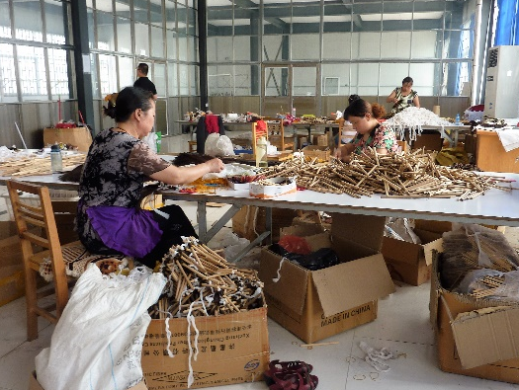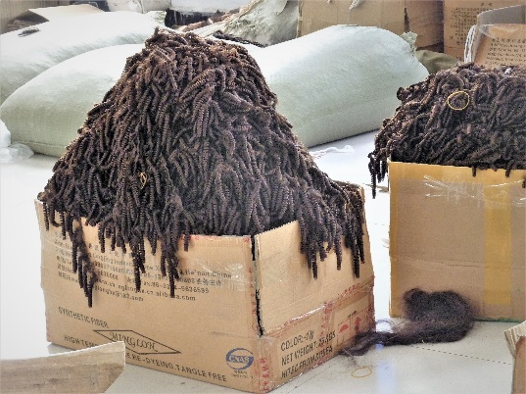
Fig. 8 Curling hair for export to West Africa in a factory in Xuchang, China, 2014. (Photos: Emma Tarlo)
What also became clear from my observations in Chinese factories is that hair for all its qualities of strength, fineness, flexibility and porosity, is not an easy fibre to work with. Manufacturers frequently bemoaned its waywardness and the fact that it was impossible to standardise beyond a certain point. ‘You can put what looks like the same hair in the same dye for the same amount of time but it reacts differently,’ I was told in a factory in Qindoa. Not only was hair disobedient and rebellious but it was also notoriously complicated to obtain. Hair procurement relies on networks of large and small traders who in turn rely on itinerant hair collectors who operate across Asia, gathering hair from long haired women in exchange for small amounts of money. Manufacturers make a big distinction between ‘remy hair’ (hair that has been cut or shave directly from the head and where the cuticles remain aligned from root to point) and comb waste ( hair that has fallen out during washing and combing) which is collected up in the form of dusty hair balls which have to be painstakingly untangled, hackled and sorted and eventually stripped of their cuticle layer to avoid tangling. Remy hair is considerably more desirable and costly than combings. One significant source of remy hair is Hindu temples in South India where women undergo the ritual of tonsure (shaving) in fulfilment of vows (Tarlo 2016: 63-84). But none of the manufacturers I met in China imported Indian temple hair because it was too expensive. They relied instead on the much larger market for combings which are referred to in Chinese factories as ‘standard hair’. Between 70 and 80% of the hair exported by India consists of combings, the majority of which are purchased by Chinese companies for use in wigs and extensions.
Whilst hair can in theory be gathered from anywhere in the world, and small amounts are collected from countries such as Russia, Ukraine and Romania, in practice most hair flows into the market from those Asian countries where women keep their hair long and where many are poor enough to want to sell it. India, Bangladesh, China and Myanmar all yield significant amounts. Often manufacturers will blend Indian and Chinese hair together, combining, they say, the strength and resilience of the Chinese hair with the shine of the finer Indian hair. Manufacturers catering to the cheapest end of the market sometimes bulk up their human hair products with horse hair and synthetic fibre.
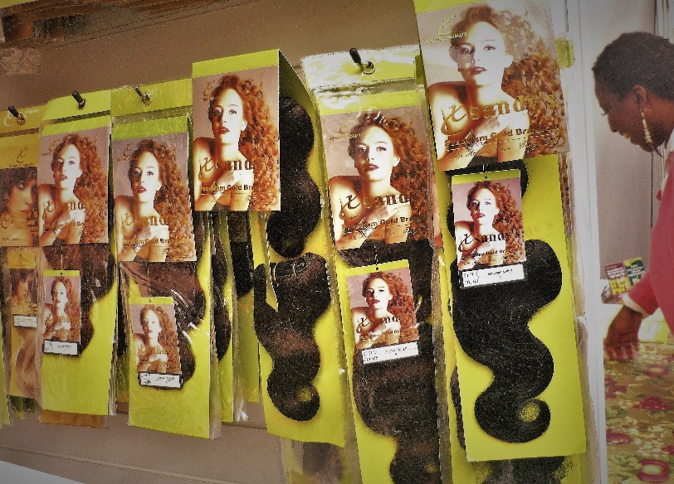
Fig. 9 Display selling ‘Premium Gold Brazilian, 100% human hair’,
Afro Hair and Beauty show, London 2013. (Photo: Emma Tarlo)

The bunches of Brazilian hair so widely advertised on the internet can be made up of hair from any of these sources. The cheapest bunches are likely to be made from combings – fallen hair that has been collected up, untangled and re-mixed from multiple heads across Asia, defying any mythical notions of racial purity or bodily integrity. Such hair tells tales of the mixing and blending of body substances as suggested by Wenda Gu’s art work and of labour practices involving high levels of transcultural enmeshment. What counts from the perspective of the manufacturer and the wholesaler is not so much the origins of the hair as the effects. What they are after is hair that fulfils the expectations and stereotypes of Brazilian.

Conclusion
Hair has long acted as a medium through which understandings of race are expressed, debated, transformed, performed and enacted. In physical anthropology it was used to create and solidify ideas of racial difference; in the market it promises exoticism and ethnic variety; in the natural hair movement it signals ideas of authenticity in response to histories of suppression and experiences of racism, and in the factory its colour and texture are physically transformed to conform to racially based national stereotypes. Forever haunted by its multiple and overlapping pasts, race too is subject to endless replay and reinvention with material consequences which make its ongoing significance as a category impossible to ignore. What emerges in all of these various reincarnations is the flexibility of both hair and race, for if the shape-shifting nature of race is a re-current theme so too is hair’s refusal to be pinned down to the strictures of racial classification. Hair is a rebellious fibre. It resisted elaborate scientific typologies in the past and today it continues to defy classification in the market and refuses to be standardised in factories. It is its material qualities of waywardness and maleability combined with its enduring connection to bodies and persons that make detached hair such an apt medium for exploring something as nebulous yet persistent as race.

Acknowledgement:
I would like to thank the Leverhulme Trust for supporting this research through a Major Research Fellowship and to thank those who generously participated in the research by sharing their time, expertise and experiences. I am grateful to Frances Pine, Pauline von Hellermann, Gabriel Dattatreyan and anonymous reviewers for their helpful comments.

Bibligraphy
Ahmed Sara, 2002, ‘Racialized Bodies’ in Evans Mary and lee Ellie eds. Real Bodies: A Sociological introduction, New York: Palgrave.
Alexander Elizabeth 2007, ‘My Grandmother’s Hair, in Power and Possibility, Essays, Reviews, Interviews, Ann Arbor: University of Michigan Press.
Apiah Kwame Anthony, 2016, Reith Lecture: Colour, http://www.bbc.co.uk/programmes/b080t63w
Banks, Ingrid , 2000 Hair Matters: Beauty, Power, and Black Women’s Consciousness. New York: New York University Press.
Banton Michael, 1983, Racial and Ethnic Competition, Cambridge: Cambridge University Press.
Banton Michael, 1987, Racial Theories, Cambridge: Cambridge University Press.
Battle-Walters, 2004, Sheila’s Shop: working-class African American Women talk about Life, Love, Race and Hair, Lantham: Rowman and Littlefield.
Bennett Jane, 2010, Vibrant Matter, a political ecology of things, , Durham: Duke University Press.
Berner Margit, 2010, Race and physical anthropology in interwar Austria, Focaal – Journal of Global and Historical Anthropology 58: 16-31.
Berner Margit, 1998, ‘The Nazi Period Collections of Physical Anthropology in the Museum of Natural History, Vienna, in ‘Col Tempo,’ The W. Project, www.coltemp.hu
Berry Esther B., 2008, ‘The Zombie Commodity: hair and the politics of globalization’, Postcolonial Studies 11:1, 63-84.
Bryd Ayana D. and Tharps Lori L., 2001, Hair Story: untangling the Roots of Black Hair in America, New York: Saint Martin’s Griffin.
Carstens Janet, ed. 2013, Blood Will Out, Special issue of JRAI, vol 19, issue S1.
Catforis David, 2002, transcript of interview with Wenda Gu, Augest 16th 2002.
Cheang Sarah 2008, ‘Roots: Hair and Race’ in Biddle-Perry Geraldine and Cheang Sarah, , Hair: styling Culture and fashion, Oxford: Berg
Compaore Nadege w. r. , 2011, ‘Indian Hair, the After-Temple Life: Class, Gender, Race Representations of the African American Woman in the Human Hair Industry’, Nokoko, vol 2:143-170.
Descola Philippe, 2013, Beyond Nature and Culture, Chicago: university of Chicago Press.
Firth Raymond, 1973, ‘Hair as Private Asset and Public Symbol’ in Firth ed., Symbols Public and Private, London: Allen and Unwin.
Fishberg Maurice ‘Physical Anthropology of the Jews ii – Pigmentation.’ 1903, American Anthropologist , vol5, no 1: 89-106.
Hagner Michael, 2008, ‘Anthropology and Microphography: Gustav Frisch and the Classification of Hair’, in Dietrich Keith and Bank Andrew (eds), An Eloquent Picture Gallery, Aukland Park, South Africa: Jacana Media.
Hallpike C. R., 1969, ‘Social Hair’, Man vol.4, no. 2: 256-264.
Haraway Donna, 1989, Primate visions: gender, race and nature in the world of modern science, New York: Routledge.
Harvey-Wingfield, A (2009) Doing Business with Beauty: Black Women, Hair Salons, and the Racial Enclave Economy. Plymouth: Rowman Littlefield.
Hodges Matt, 2017, ‘Becoming Entangled’, AOTC issue 20.
hooks bell, 1989, ‘Straightening our Hair’, in Talking Back: Thinking Feminist, Thanking Black, New York: South End Press.
Hiltebeitel Alf and Miller Barbara, eds., 1998, Hair: It’s Power and Meaning in Asian Cultures, New York: Suny.
Gu Wenda , artist’s statement
Jacobs-Huey Lanita, 2006, From the Kitchen to the Parlour: Language and Becoming in African American Women’s Hair Care. New York: Oxford University Press.
Latour Bruno, 1993, We have Never been Modern, Cambridge: Harvard University Press.
Leach Edmund, 1958, ‘Magical Hair’, JRAI, vol 88, no. 2: 147-164.
M’charek Amade, 2013, ‘Beyond Fact or Fiction: On the Materiality of Race in Practice’, Cultural Anthropology, 28, no. 3: 420-442.
Mercer Kobena, 1994, ‘Black hair/Style Politics in Welcome to the Jungle , London: Routledge.
Moore Alixe, 2013, The Truth About the Human Hair Industry: Wake up Black America! Florida: self published book
Nyamnjoh Francis and Fuh Divine, 2014, ‘Africans Consuming Hair; Africans consumed by hair, Africa Insight 44(1): 52-68.
Obeyesekere Gananath, 181, Medusa’s Hair: An Essay on Personal Symbols and Religions Experience, Chicago: Chicago university Press.
Opiah Antonia, 2014, ‘The Changing Business of Black Hair’, https://www.huffingtonpost.com/antonia-opiah/the-changing-business-of-_b_4650819.html
Peers Laura, 2003, ‘Strands which refuse to be braided: Hair samples from the Bratrice Blackwood’s collection at the Pitt Rivers Museum, Journal of Material Culture 8 (1): 75-96.
Pinney Christopher, 1991, ‘Colonial Anthropology in the ‘Laboratory of Mankind’, in Bayly C. A. ed. The Raj, India and the British 1600-1947, National Portrait Gallery.
Pruner-Bey, 1864, ‘On Human Hair as a Race-Character, Examined by the Aid of a Microscope, Anthropological Review 2 (4): 1-23.
Ripley William Z, 1898, ‘The Racial Geography of Europe’, Popular Science Monthly, vol 52, p 1-10
Sharp Lesley A., 2006, Strange Harvest: Organ Transplants, Denatured Bodies and the Transformed Self, Berkely: University of California Press.
Tarlo Emma, 2016, Entanglement: The Secret Lives of Hair, London: Oneworld.
Topinard Paul, 1878, ‘On a hair of Europeans collection exhibited in the Anthropology Gallery of the Trocadero,’, address to the Anthropology Society of Paris, 16.1.1879.
Trotter Mildred, 1938, A Review of Classifications of Hair, American Journal of Physical Anthropology, vol xxiv, no 1, 105-126.
Trotter Mildred, 1939, Classifications of Hair Color, American Journal of Physical Anthropology, vol xxv, no 2, 237-260.
Wade Peter, 2002, Race, Nature and Culture: An Anthropological Perspective, London: Pluto Press.
Watson Rachel J., 2012, ‘Biohisorical Narratives of Racial Difference in the American Negro’, Current Anthropology 55, supplement 5: s196-s209
Zimmerman Andrew, 2001, Anthropology and Antihumanism in Imperial Germany, Chicago: University of Chicago Press.

http://www.lovelavishhairboutique.com/differing-types-of-virgin-hair (consulted 14.10.2015), http://cherishedhair.com/faq.html (consulted 14.10.2015), ‘LET’S TALK VIRGIN HAIR TEXTURES’, https://www.youtube.com/watch?v=_0YqHXlUZ4g (consulted 16.10.2015)

