The News Telescope
NEWS TELESCOPE
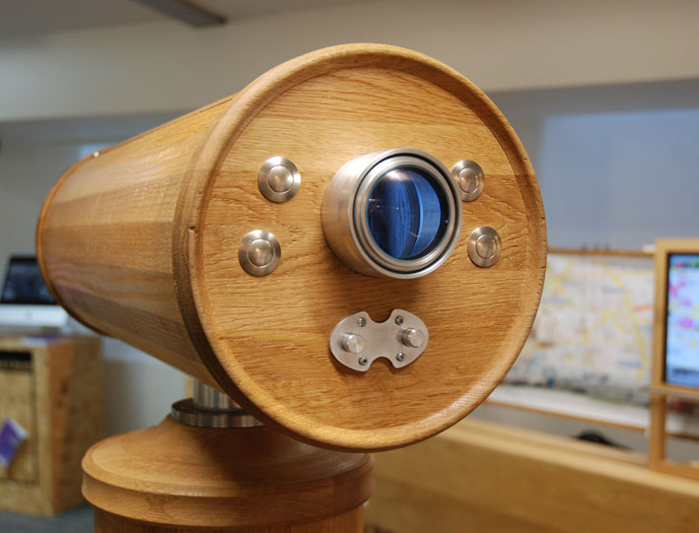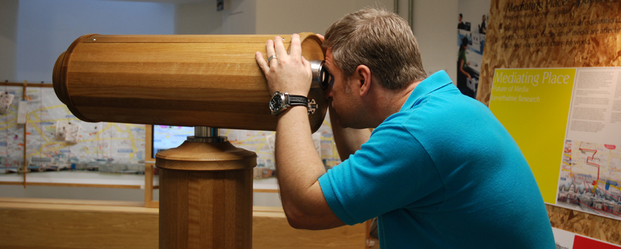
‘The visual array has always been impregnated with non-visual data (notated in various ways), but with the advent of technologies like electronic sensors/readers, GPS, RFID tags (etc.), we are now able to install – and have installed - information and infomatics into the spaces and objects in the cone of the visible; in a sense mediatising vision.
Our ‘velo’ of sight (veils of optical threads) is intersected by matrices of information that lie ‘invisible’ in the view (but are there nevertheless). The telescope allows one to draw some of this invisible information into view. The ‘news telescope’ is a located device which may be oriented and focused on different places and draw down different kinds of news from those places – setting them in contrast one to another. Thus, the demotic news of twitter feeds makes comment on traditional forms of news publication – organs of publication like newspapers. The ‘news telescope’ places the news and asks the viewer to physically, and, by extension, in other ways, relate their place in the world to the places and different constructions of news. News becomes for the reader/viewer a collage of different news views. It (re)presents opportunities to produce news as a quilt of different viewpoints; and offers the potential for a more rounded understanding of the news and those that ‘invest’ in the news.
The news telescope acts as a focus for critical reflection on the way we currently present and consume news. It also provides clues for the development of new devices that allow one to bring this collage of news accounts together. The research group are currently developing an i-app, a news compass, that allows one to co-ordinate the news through geographical points.

We have shown the News Telescope in the following exhibitions:
ATACD Conference/Exhibition; Changing Cultures: Cultures of Change 10-12 December 2009 at the University of Barcelona, Barcelona, Spain
(http://www.atacd.net/index.php?option=com_content&task=view&id=174&Itemid=78)
The Exhibition is curated around the theme of ‘topology and culture’. The organizers have selected work that articulates a ‘topological approach to cultural dynamics’ – work that ‘draws inspiration from mathematical theories of topology, networks and complexity’ in order to look at ‘cultural change’ – emphasizing ‘links, driving forces and modes of change’ (quoted from ATACD website).
The News Telescope appears in the catalogue :
‘Cultures of Change: Social Atoms and Electronic Lives’
Publishers ACTAR/Arts Santa Monica- Ministry of Culture and the Media Government of Catalonia
ISBN
978-84-92861-14-9 ACTAR
78-84-393-8191-4 Arts Santa Monica
‘MAKEBELIEVE’ Exhibition in the London Design Festival – 19 - 27
September, 2009 at Kinnarps, Dryden Street, Covent Garden,
London
(http://www.londondesignfestival.com/events/goldsmiths-makebelieve)
The ‘Mediating Place’ group (one of the five groups in the Leverhulme funded Spaces Of Media Research Programme) exhibited two prototypes in this exhibition - described as ‘an exciting and innovative showcase of emerging design talent from Goldsmiths, University of London’.
In the ‘Mediating Place’ project we are designing propositional objects; objects which propose new practices in media production (and reception). These propositional objects (props) aim to re-programme spaces in the city (the performativity of the spaces) by using an assemblage of different technologies to locate, dislocating and relocate ‘media’ in the city. These props are intended to make apparent possible future engagements, practices and experiences educed in these assemblages of technologies.

