Catalysing Network Consciousness in Leaderless Groups: a metadesign tool

Paper Submitted for the 12th Consciousness Reframed International Research Conference
PRESENCE IN THE MINDFIELD: Art, Identity and the Technology of Transformation

John Backwell John Wood
Department of Design Department of Design
Goldsmiths, University of London Goldsmiths, University of London
j.backwell@gold.ac.uk maxripple@gmail.com

ABSTRACT
This paper refers to one of a number of metadesign methods that were developed to facilitate non-hierarchical teams. It describes how a matrix framework was used to help teams to create, maintain and develop their self-identity. The primary aim is to increase what the authors call 'network consciousness' (Backwell & Wood, 2009), in which consciousness is described as a ‘low-grade system for keeping records’ (Minsky, in Horgan, 1993). This concept may be controversial as it embodies a digital, therefore, coarse-grained methodology for mapping (shared) consciousness. Also, by depicting animate and inanimate entities as agencies that are dynamic and equal in status; and by emphasizing relations rather than players, we aim to develop an emancipatory approach that transcends the dualistic mindset. Using this digital approach, data about all relations and their interdependencies are recorded as a set of signature 'profiles'. These are then aggregated as a macroscopic snapshot of the whole system. Whenever the community’s salient characteristics grow into a self-similar form that can be made acknowledged by each agent, irrespective of location, we describe this as a ‘self-organized criticality’, or ‘SOC’ (Bak, Tang & Wiesenfeld, 1987). Its fractal nature also makes it easier for the team to envisage what might happen if their environment were to be scaled-up, or down. It thus renders the system suitable for attracting implicit consensus within a given team. Furthermore, it inherently considers impact upon that beyond the remit of the team and, thereby, ‘seeding’ new and coherent behaviour without the need for top-down management.

KEYWORDS: metadesign, holarchy, synergy, network-consciousness

Introduction
What we call ‘network consciousness’ was a useful, if crude, method that supported our AHRC & EPSRC-funded metadesign research that began in 2005. We define ‘metadesign‘ as a self-reflexive framework within which teams of designers, and other experts, can re-direct the context, purpose and role of their practice, in order to orchestrate more comprehensive and integrated outcomes. (see http://metadesigners.org/tiki/Metadesign-Introduction). It would, for example, reconcile top-down and bottom-up initiatives to create ecological design solutions that might otherwise be overlooked by politicians and scientists. One reason why ‘design thinking’ would complement politics and science is that designers are trained to change behaviour in ways that are more imaginative, direct and remedial than that of politicians and scientists. Donella Meadows has shown that the methods used by governments, i.e. agreeing targets, fiscal measures and legislation, are the least effective (Meadows, 1999). Similarly, while open-minded evidence gathering and ‘objective’ truth claims are vital aspects of science, a great deal of time has been wasted on the scientific debate about whether human activities have caused climate change, rather than on the more designerly question of how to proceed in case there is climate change. Imaginative reform is urgently needed. While current species losses exceed all levels detected at any time in the last 63 million years, it is extremely unlikely that we can meet targets agreed at the 2010 Nagoya World Biodiversity Summit (Gross & Williams, 2010; Harrop, 2011). Even if we could, there are practical reasons why this would fail to achieve their intended aims (c.f. Mora, Tittensor, Adl, Simpson & Worm, 2011). A recent scientific census showing that between 86% and 91% of species are undiscovered or uncharted (Mora, et al, 2011). This shows that the biosphere is far too emergent, complex and dynamic to be managed using bureaucratic terms of reference to find expedient political deliverables.

Mapping network consciousness
In order to achieve a necessary paradigm change, we need a radical revision of the traditional professional roles and responsibilities that keep everyone within own comfort zone. This would entail integrating managerial and epistemological issues by ‘re-languaging’ everything (c.f. Nieuwenhuijze & Wood, 2006) to achieve what we call a higher ‘network consciousness’. By this we mean the state of reciprocal awareness among critical parts of a paradigmatic system (c.f. Backwell & Wood, 2009). ‘Network consciousness’ is a prerequisite to communication and ‘structural coupling’ (Maturana & Varela. 19**) and these are pre-requisites to the survival of any living system, whether it is a biological organism, society, or corporate brand. It is therefore surprising that, in the era of ‘open source’, ‘crowd-sourcing’ and ‘sharealike’ communities we know more about individual creativity than network consciousness. Our practical experiments combine intellectual theories with somatic practices, and therefore we describe it as a field of knowing (c.f. Koestler, 1967; Wood, 2010). However, we have chosen to model it using a simplified, atomistic model of consciousness. In this respect, the authors were inspired by Marvin Minsky’s controversial claim that certain computer programs are more conscious than individual humans (Minsky, 1988). While some may find it shocking to make a direct comparison between inanimate, digital machines and living human organisms, Minsky’s approach enables us to map heterogeneous entities within a common framework. We think it can help metadesigners to map relational aspects of the biosphere, rather than identifying it as a set of ‘resources’.

An ecological and evolutionary context
In developing their Gaia hypothesis (1966) Lynn Margulis and James Lovelock found that the distinction between living and inanimate entities was unhelpful. They showed how a coalescence of complex physical, chemical, biological, ecological, phenomenal, cognitive and metacognitive elements enables the biosphere to maintain homeostasis. Rupert Sheldrake’s (1981) work confirms that evolution not only operates at biological levels but, also, at physical and chemical ones. Similarly, Vladimir Vernadsky’s term ‘noosphere’ (1926) depicts the biosphere as a geological entity shaped by life (i.e. including collective human cognition). The popular idea of an emerging global consciousness (e.g. Pierre Teilhard de Chardin, 1959) serves to hastens its own emergence by attracting interest and investment in digital networks, etc. Philosophically speaking, it also needed its own framework of thought. Nicholas of Cusa’s (1401-1464), theory of the universe as an infinite, de-centred or omni-centric whole. Cusa believed that, while each viewpoint carries some truth, it is only true when seen in relation to other parts in the whole. Ultimately, this insight resists full description using symbolic codes of communication. However, twentieth century science has made it easier to map the consciousness of networks, with developments in connectionism, chaos theory, emergence, swarm intelligence, and network theory.

Learning from ecosystems
One benefit of mapping network consciousness is its application to (design) management. Although humans have an ancient familiarity with top-down forms of management, the authors believe that fixed hierarchies are suboptimal in terms of their adaptability. There are several reasons for this. For one thing, the language/s by which a given problem is addressed tend to be chosen, or modified, by those at the top of the hierarchy, rather than by those closer to a given task in hand. An obverse of hierarchy is what Arthur Koestler called ‘holarchy’, in which each part regulates its actions to maintain the unity of the whole. Functionally speaking, this requires each player, or agent, within a given ‘whole’ (or ‘holon’) to feel accountable, and to act accordingly. Since the Enlightenment, researchers have spent far more time thinking about individual experience, individual creativity and individual emotions than they have in coming to terms with the essentially collaborative nature of all human endeavours. In terms of increasing biodiversity, we will need to focus on whole systems and emergent outcomes, rather than focus on leaders, ideologies and ‘truths’.

Designing for synergy
Our methodology applies some systemic mapping methods first used in medicine (Kvitash & Gorodetsky, 2003). Our basic building block for these maps uses the synergistic outcome gained by combining different ‘resources’, which may be animate or inanimate, virtual or actual. By choosing and combining, say, two existing resources we may expect to find three, where the third represents the relationship between the two. Metadesigners would seek to orchestrate relationships in such a way that the relations are synergistic. Obviously, the more variables we have, the more combinations (and possible synergies) we get. However, this process cannot be scaled up too far without limiting the efficacy of the process. Mathematically speaking, the 20 in the diagram below would produce up to 190 relationships. Even with fewer links (as in this diagram), manageability reduces as complexity increases. This problem is compounded if we also combine the outcomes (synergies) with other agents to create second, third, or subsequent orders of synergy.
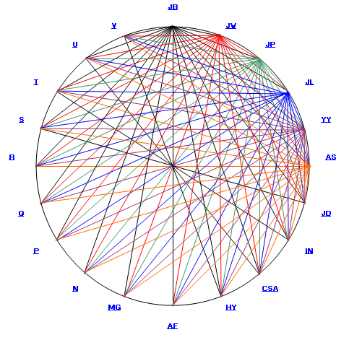
The diagram illustrates an example of a metadesign navigation tool highlighting the linking of selected resources and resultant relationships.

It is therefore sensible to design for maximum benefits from minimum resources. A simple mathematical analysis of the triangle and tetrahedron (see figure 2) shows that, for example, where 3 players (nodes) are used they may be combined to produce the same number (3) of possible synergies (lines). However, 4 players can be combined to produce 6 synergies - i.e. twice this number.

Four is also an optimal number in cognitive terms because the human mind finds it hard to grasp more than four interdependent variables at the same time (Fuller, 1949; Cowan, 2001). These figures we begin to appreciate not only the relationships generated but the number of metarelationships that can be elicited at the 2nd, 3rd or subsequent orders of combination.

All it really achieves is to simply illustrate that complexity exists. Utilising this number of independent entities clouds the analysis. There is therefore much need of an alternative approach., Although team consciousness is easily catalysed in small, trained teams it may easily become too inwardly focused. This is evident in the topology of the tetrahedron (c.f. Euler, 1751; Fuller, 1969; Nieuwenhuijze, 2005; Wood, 2005), because it is the smallest polygon that will enclose a fully bounded space (Fuller, 1969). For this reason we have adopted a team format of 4+1, in which the rotating fifth member acts as an external context for inwardly directed discussions and decisions. The diagram below begins to highlight the fluidity and adaptability of such a view.

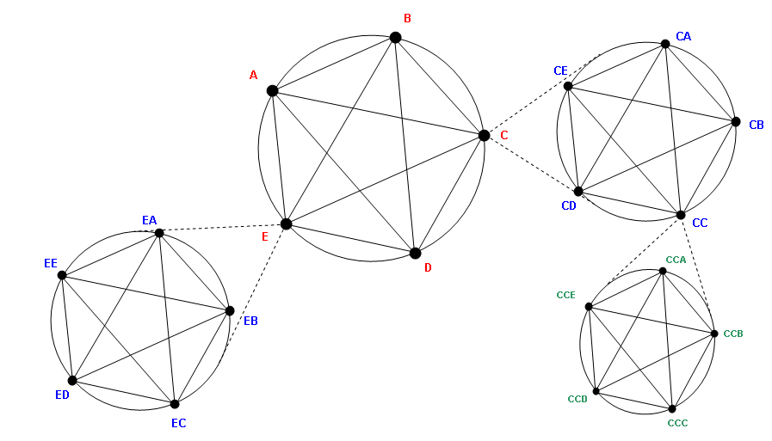

Here {A.B.C.D.E.} represents a broad initial view of a metadesign group of five entities each with a particular role; each having needs to enable that role function; each with assets that to some degree are at the disposal of the group. The illustration takes this further indicating that two entities, C and E have links into other groups {CA.CB.CC.CD.CE.} and {EA.EB.EC.ED.EE.} providing a deeper view of the metadesign group and allowing a more detailed profile to be determined or analysed. {CCA.CCB.CCC.CCD.CCE.} simply illustrates the possibility of further drilling into the group. Note also that [A.B.C.D.E.] might be later viewed as a composite, established metadesign ‘node’ within a larger system.

The views thus described are part of a scalar continuum, hence the ‘fractal’ nature of the analysis. This may be a little misleading since groups and subgroups do not have to comprise a fixed or similar set of nodal entities. It would be the focal schema that would begin to determine this enabling a tailored nested model to emerge. An example is shown below:

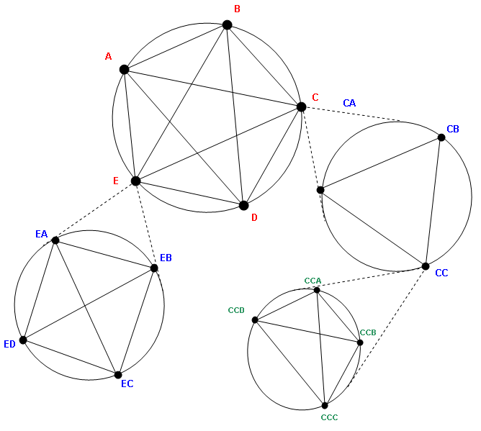
xccv

Our research has shown that there are many implications and effects of such analysis at each of the levels determined. The main group should be viewed at the ‘focal’ group with other levels providing depth, understanding and purpose to the work of the entities within this group.. The tool seeks to highlight strengths, dominancy, weaknesses, redundancy etc. within the group by maintaining the work pattern of four engaged in core work plus one

The entities may participate in any and indeed many, of the deeper group structures. There is no assumed, imposed or supposed hierarchy here. The intention is to fulfil a need, identify further need and related groups/subgroups to meet these and so on. The concept of a fluid continuum at the macro level begins to emerge mirroring the interplay of sociological human coexistence and the big wide world. There is a creative, holistically determined, possibly somatic framework necessary to make this operate – this becomes the synergy seedbed.

Communication is critical hence the need to embed this within the ‘experiencing’ of the relationships between entities. The difficulty is knowing what to communicate, when and to whom, particularly whilst immersed in the process. Herein lies part of the role of the fifth entity.

As introduced earlier, engaging with the five entity model, we can view this auspiciously as a tetrahedral group +1.

The additional member we will refer to as the ‘Rotating Interface’. This will be an individual with a particular role in the group or a resource having a communicative attribute (eg database with a web presence, digital bulletin board etc) that is ascribed to fulfil the extended function of interfacing the group with the world beyond it. This position can be ascribed to any one of the five members at any time where the group state believes it to be necessary or of benefit to a sought goal.

The relationships, and hence group dynamic, will change many times and may be diagramised as below:

E
D
B
A
C
E
D
C
B
A

… and here entity E takes on the role.
Here entity A takes the role of the ‘Rotating Interface’ …

Let’s look at this role more closely. The role typically has three phases:

1 – ‘Taking stock’
Initially this is observational with a critically low participation rate – the role demands a passive stance: look, listen, record and summarise. The summation requires a degree of consensus. Can include categorisation of elements of the group work to facilitate external targeting/testing etc.

2 - Externally compare and contrast
The entity steps outside of the group to gain an external perspective. Views beyond the group might be used to ‘ground’ the work, gain feedback, client/context testing of ideas/tools/practices/processes. Collect, collate and compare findings.

3 - Internal review and steer
Feedback to the group should follow the ‘excursions’ detailed in 2, with the opportunity to ‘fine tune’ recommendations, provide a ‘real world’ steer. The group as a whole may seek to rotate this role at this point, nominating another to take over or decide to retain the current entity.

Movement between these roles is not a linear progression but more that based upon trial and group need. For example the stance of the group and it’s interim recommendation for particular action may be challenged many times following several points of ‘comparing and contrasting’ what is perceived to be the world or regional practice before phase 3 impacts internally upon what the group has considered/recommended i.e. provides a steer. (See diagram below)

Internal:
Observe, record, summarise, categorise
Internal:
Declare a context

Internal:
New entity nominated for role
Rotating Interface
‘Life cycle’
External:
Compare, contrast, test, communicate

Internal:
Feedback, review, retune (context), provide a steer

The elements for need and resource that pertain to the group entities can be easily summarised in matrix form:

Entity Matrix

A |  | Need | Asset
r₁ |  | % of need required to be met to operate in group | % of overall assets that are being made available
r₂ |  | Indicates the impact of needs met | Balance of assets (the ‘currency’ is likely to be time)

r1 – Initial conditions prior to any group ‘transactions’
r2 – Balance or present status following ‘transactions’

When each entity is so represented a group profile can be similarly constructed as the matrix sum of the entities.
If we consider the relationship A~B, a benefit/loss matrix is generated that impacts upon both entities and shown as a balance in r2 providing a resultant profile following a transaction. This in itself provides for an A~B emergent resource. If we map the group transactions in discreet moments in time the net needs and assets would highlight the intra-group processes. This is particularly pertinent for the 4+1 model. We can map the transactional impact of the tetrahedronal subgroup with its six resultant synergetic outcomes. The subgroup profile can be determined as stated previously and then considered in transaction with the ‘Rotational Interface’ entity. This powerfully provides the engagement of a fifth group member without excess complexity but with stage-wise development consciousness throughout the whole process. A link to our prototype tool can be found at:

https://docs.google.com/spreadsheet/ccc?key=0Ahbauzia5fRIdENRQU9RUDdlNThvVjNaRFFDNXNIWWc&hl=en_US

References
- Arthur, B. (1996) ‘Increasing returns and the new world of business’, Harvard Business Review, July/August 1996, p. 100
- Ascott, R., (1994) quoted in Giaccardi, Elisa "Metadesign as an Emergent Design Culture", Leonardo Journal, Volume 38, Number 4, August 2005, pp. 342-349
- Bateson, G. (1979), 'Mind and Nature a Necessary Unity', London, Wildwood House
- Bateson, G., (1973), “Steps to an Ecology of Mind”, Paladin Books
- Belbin, R. M. (1993). Team Roles at Work. Oxford: Butterworth-Heinemann.
- Bradley, I., Meek, R.L., (1987), “Matrices and Society: Matrix algebra and its applications in the social sciences”, Harmondsworth, UK: Pelican Books
- Bussracumpakorn, C., (2006), “Design Innovation Networks: Critical Factors that can Contribute to Successful Collaborative development of Innovative Products”, PhD Thesis, Goldsmiths, University of London
- Corning, P., (1983), “The Synergism Hypothesis”, McGraw-Hill, UK [see also http://www.complexsystems.org/publications/pdf/synselforg.pdf]
- De Chardin, P., T., (1959), L'Avenir de l'Homme (1959) essays written 1920–52
- Dewey, J., (1939), “Freedom and Culture”, New York, Putnam
- Franklin, J.N., (2000), “Matrix Theory”, Mineola, New York: Dover Publications
- Fuller, R. B., (1969), and “Operating Manual for Spaceship Earth”, Carbondale, IL: Southern Illinois University Press.
- Fuller, R. B., (1975), “Synergetics: Explorations In The Geometry Of Thinking”, in collaboration with E.J. Applewhite. Introduction and contribution by Arthur L. Loeb. Macmillan Publishing Company, Inc., New York.
- Galloway and Rabinowitz, (1983), quoted in Giaccardi, E. (2005). “Metadesign as An Emergent Design Culture”, in Leonardo, Volume 38, Number 4, August 2005
- Giaccardi, E. (2004), “Principles of Metadesign: Processes and Levels of Co-Creation in the New Design Space”, PhD thesis, University of Plymouth, UK
- Giaccardi, E. (2005), “Metadesign as an Emergent Design Culture”, in Leonardo, Volume 38, Number 4, August 2005
- Hollis, A. (2001), “Co-authorship and the Output of Academic Economists”, Labour Economics, vol. 8, p. 503-530
- http://www.bioteams.com/
- Jones, J., C., (1980). “Design Methods”, Chichester, UK: John Wiley & Sons
- Jones, J., C., (1991), "Designing Designing", Architecture Design & Technology Press, 1991
- Jones, J., C., (1998), “Creative democracy, with extended footnotes to the future”, Futures Journal, Volume 30, Number 5, June 1998, pp. 475-479
- Koestler, A., (1967). The Ghost in the Machine. London, Penguin reprint 1990
- Kvitash, V. I., Gorodetsky G. M., (2003) “Relonics Systems Information Modeling in Clinical Depression” in M. H. Hamza (Ed.): Proceedings of the IASTED International Conference on Modelling and Simulation (MS 2003), February 24-26, 2003, Palm Springs, California, USA. IASTED/ACTA Press 2003, pp264-269
- Lovelock, James (2006). The Revenge of Gaia: Why the Earth Is Fighting Back - and How We Can Still Save Humanity. Santa Barbara (California): Allen Lane. ISBN 0-7139-9914-4.
- Lovelock, James [1988] (1995). Ages of Gaia. Oxford University Press. ISBN 0-393-31239-9.
- Manzini, E., (2001), From Products to Services. Leapfrog: Short-Term Strategies for Manzini, E., Cullars, J., (1992). “Prometheus of the Everyday: The Ecology of the Artificial and the Designer's Responsibility”, Journal of Design Issues,
- Margulis, L (1998) “The Symbiotic Planet: a New look at Evolution”, Science Masters, New York
- Margulis, Lynn, 1998, Symbiotic Planet : A New Look at Evolution, Basic Books, ISBN 0-465-07271-2
- Marzano, S., (1999), “Thoughts and Facts: Creating Value by Design”, Lund Humphries
- Maturana, H. R. (1997) “Metadesign”, available at: http://www.hum.auc.dk/~rasand/Artikler/metadesign.htm
- Meadows, Donella H., (1999), Leverage Points: Places to Intervene in a System, Hartland, VT, USA, The Sustainability Institute
- Miller, George A. (1956), ‘The Magical Number Seven, Plus or Minus Two: Some Limits on Our Capacity for Processing Information’, originally published in The Psychological Review, 1956, vol. 63, pp. 81-97
- Minsky (1994), interview in Horgan, J. (1994), Can science explain consciousness? Scientific American, July, pp. 88-94)
- Mora, C., Tittensor, D., Adl, S., Simpson, A., Worm, B., (2011), How Many Species Are There on Earth and in the Ocean? PLoS Biology, 2011; 9 (8): http://www.plosbiology.org/article/info%3Adoi%2F10.1371%2Fjournal.pbio.1001127 [accessed August 2011]
- Newman, M. E. J., (2004), “Co-authorship networks and patterns of scientific collaboration”, Proc. National Academy of Science, USA 101, pp. 5200-5205
- Nieuwenhuijze, O., & Wood, J., (2006), “Synergy and Sympoiesis in the Writing of Joint Papers; anticipation with/in imagination” International Journal of Computing Anticipatory Systems, edited by Daniel M. Dubois, published by the Centre for Hyperincursive Anticipation in Ordered Systems, Liège, Belgium, Volume 10, pp. 87-102, August 2006, ISSN 1373-541 (11,693 words)
- Ponting, C., (1991), "A Green History of the World", Penguin
- Rittel, H. & Webber, M. M. (1984) ‘Planning Problems are Wicked Problems’ in Developments in Design Methodology, N. Cross (ed.), John Wiley & Sons, New York, pp. 135-144.
- Romer, P. M., (1986), Increasing Returns and Long-Run Growth, Journal of Political Economy, V.94, N.5, pp.1002-1037
- Trivers, R., L., (1978), 'The Evolution of Reciprocal Altruism', Quarterly Review of Biology, 1971, 46, (4), 35-57, quoted in Wilson, E., O., 'The Genetic Evolution of Altruism; psychological and sociological principles', chapter in 'Altruism, Sympathy and Helping', edited by Lauen Wispé, Academic Press, New York and London, 1978, pp. 33-35
- Wood, J., (2005) “The Tetrahedron Can Encourage Designers To Formalise More Responsible Strategies”, for the "Journal of Art, Design & Communication", Volume 3 Issue 3, Editor, Linda Drew, UK, ISSN: 1474273X
- Wood, J., (2007:1), “Design for Micro-Utopias; making the unthinkable possible”, Ashgate, ISBN 0 7546 4608 4
- Wood, J., (2007:2), “Relative Abundance; Fuller’s discovery that the glass is always half full”, a chapter for “Designers, Visionaries and Other Stories: A collection of sustainable design essays”, (eds. Jonathan Chapman & Nick Gant), book, Earthscan, London, 2007
- Wood, J., (2008), “Auspicious Reasoning”, The Journal of Writing in Creative Practice, (Eds. Julia Lockheart & John Wood), Intellect, Vol. 1, Issue 3, June, 2008 (at press)
- Wood, J., & Backwell, J., (2009), “Mapping Network Consciousness: syncretizing difference to co-create a synergy-of-synergies”, chapter in New Realities: Being Syncretic, I0th Consciousness Reframed Conference Vienna, 2008. Series: Edition Angewandte Ascott, R.; Bast, G.; Fiel, W.; Jahrmann, M.; Schnell, R. (Eds.) 2009, ISBN: 978-3-211-78890-5
- Young, A. A., (1928) Increasing Returns and Economic Progress, The Economic Journal, December 1928, pp. 527-542

