Pre-print: Published in Cognition

Title: ‘Am I moving?’ An illusion of agency and ownership in mirror-touch synaesthesia.

Authors: Maria Cristina Cioffi _{a} *, Michael J Banissy _{a}, James W Moore _{a}
Affiliations:
a. Department of Psychology, Goldsmiths, University of London, London, UK
* Corresponding author:
Maria Cristina Cioffi
Department of Psychology
Goldsmiths, University of London
Lewisham Way
London
SE14 6NW
e-mail: m.cioffi@gold.ac.uk

Abstract
Mirror-touch synaesthesia (MTS) is a condition that leads people to experience tactile sensations on their own body when watching at someone else being touched. Recent accounts postulate that MTS is linked with atypical self-other representations. It has been suggested that this may be associated with disturbances in two main components of self-awareness: sense of agency and sense of ownership. This study investigates changes in sense of agency and sense of ownership in MTS. Using a paradigm that deliberately blurs the boundaries between the self and the other, we not only found that MTS affects sense of agency and sense of ownership, but that these aspects of self-awareness are affected differently. We suggest that alterations in sense of agency can be linked to more profound disturbances in sense of ownership in MTS, and that MTS may be characterised by underlying difficulties in self-other processing.

Keywords: mirror-touch synaesthesia, agency, ownership, self-other distinctions, self-awareness.

Word Count: 3082

- Introduction
Recent findings have shown a near universal tendency for us to vicariously represent the actions and sensations of others. For example, similar neural networks are recruited when we experience touch directly on ourselves or when we observe another person being touched (e.g. see Keysers et al. 2010 for a review). This vicarious activation is normally implicit, in that it does not lead to an explicit sensation of the observed event on the body of the observer, however, in mirror-touch synaesthesia (MTS) the vicarious experience of touch is overt (Banissy, 2013; Ward & Banissy, In Press). In MTS individuals feel a tactile sensation on their own body simply by observing touch being applied to someone else (Blakemore, Bristow, Bird, Frith, & Ward, 2005). This experience is thought to occur in approximately 1.6% of individuals (Banissy, Cohen Kadosh, Maus, Walsh & Ward, 2009) and there is growing interest in using MTS as a vehicle to provide insights on mechanisms of social perception and cognition. For example, prior has examined facial affect processing in MTS in order to examine theoretical accounts on the role of simulation processes in affect recognition (Banissy, Kusnir, Duchaine, Walsh, & Ward, 2011).
Prior neuroimaging studies suggest that MTS is linked to over-activity within neural regions supporting normal mirroring of touch. In people with MTS, observation of touch recruits a similar network of areas to those activated in non synaesthetes, but compared to them, they show a hyper-activation (Blakemore et al., 2005; Holle, Banissy, & Ward, 2013). Recently, it has been suggested that a breakdown in self-other processing may contribute to this over-active tactile mirroring in MTS. More specifically, mechanisms responsible for controlling self-other representations may be impaired in MTS, and this would lead to a difficulty in inhibiting the experiences of others (Banissy & Ward, 2013; Ward & Banissy, In Press) .
In line with this, prior behavioural work has shown that bodily self-awareness is altered in MTS (Aimola Davies & White, 2013; Maister, Banissy, & Tsakiris, 2013). Here, we sought to build on these findings by investigating the effects of MTS on the two main aspects of self-awareness: the sense of ownership (SO) and the sense of agency (SA). SO refers to the feeling that one’s body is one’s own, whereas SA refers to the feeling that one’s actions are one’s own. As noted above, prior work from Aimola Davies et al. and Master et al. have suggested that SO is atypical in MTS, but nothing is known about changes in SA in MTS. There are good reasons to predict SA changes in MTS (see Cioffi, Moore, & Banissy, 2014, for a review). First, theoretical accounts of agency processing argue that the positive experience of agency is predicated on feeling that the body part that is moving is one’s own (Gallagher, 2000). Second, two brain regions associated with SA, namely the temporo-parietal junction (TPJ) and the anterior insula (Decety & Lamm, 2007; Farrer & Frith, 2002), have also been implicated in MTS (Blakemore et al., 2005; Holle et al., 2013). By extending the investigation of self-awareness to include SA, our aim was to improve our understanding of the extent of self-awareness changes in MTS, and to shed light on how these two features of self-awareness interact more generally.
To do so, a group of participants with MTS and non-synaesthete controls were tested on a vicarious agency paradigm that deliberately blurs the boundaries between the self and the other: we used a modified version of a paradigm created by Daniel Wegner and colleagues (Wegner, Sparrow, & Winerman, 2004) to induce an illusion of agency and ownership. We predicted that people with MTS will be more vulnerable to the illusion, indicating greater sense of ownership and a more malleable experience of agency.

2. Method
2.1 Participants
A group of eight adult mirror-touch synaesthetes (age range = 19-60, average age = 36. 3, SD = 16.8, one male) and a group of eight non-synaesthetes controls (age range = 19-38, average age = 26.5, SD = 8.33, four males) were recruited. All participants were right-handed. All mirror-touch synaesthetes were confirmed as individuals with MTS using the Visuo-Tactile Stroop task, designed to detect the authenticity of the condition (Banissy et al., 2009; Banissy & Ward, 2007). All MTS participants significantly differed on a single subject basis (using Crawford’s modified t-test; Crawford, J. R. & Howell, D. C.,1998) to previous published control data on this task (Banissy et al., 2009; Banissy & Ward, 2007). All controls were interviewed with a synaesthesia questionnaire (including a question on MTS; adapted from Banissy et al., 2009) and did not report any synaesthetic experiences. Three of the mirror-touch synaesthetes self-reported other types of synaesthesia. All participants gave consent to participate in the study and were paid £10/hour to take part in the experiment. The study was approved by the local ethical committee.
2.2 Procedure
The procedure is a modified version of the paradigm developed by Wegner at al. (2004). Participants sat on a chair facing a full-length mirror. Participants wore over-ear headphones on which were played action previews. A blue sheet covered the participants’ body from the shoulders downwards. A curtain with two holes was placed behind the participant in order to block their view of the experimenter.
Participants’ arms were placed out of view under the sheet. The experimenter wore another set of headphones to hear the instructions, a blouse that was the same colour as the sheet covering the participant, and a pair of white gloves that were sewn on to the blouse. The experimenter sat behind the curtain in a comfortable position and inserted his arms through the holes in the curtain. The experimenter placed his arm (either left or right) forward so that it appeared where the participant’s own arm would have been (Figure 1). Participants were asked to look at the mirror in front of them while the experimenter performed the gestures with either the left or the right hand. They were also asked to remain still during the experiment.
A tape with a list of 16 unimanual action instructions was played (e.g., “make a waving gesture,” “snap the fingers twice”, “point to the mirror”). The experimenter performed each action just after the end of each instruction. Each trial, consisting of one instruction and one action, lasted between eight and ten seconds, with a three second break between trials. The list of 16 instruction-action trials was repeated three times from the beginning to the end without interruption for each condition (see below) and each hand, so as to augment the effects of this manipulation.
There were two within-subject conditions. In the match condition the action corresponded to the instruction; whereas in the mismatch condition each instruction was randomly matched with a different action (for example, after the instruction “make a waving gesture” the examiner snapped their fingers). In this mismatch condition, the gesture was different for every repetition of the same instruction (e.g., on the second repetition, after the instruction “make a waving gesture” the examiner pointed to the mirror). The actions performed during the mismatch conditions were previously established and the presentation order was differently randomised for each of the three repetitions. The conditions were completed for both the left and right hand. The order of match – mismatch conditions and the order in which each hand was tested were counterbalanced across participants.
After the third repetition of the instruction-action list for each condition, the participants were asked to report their experiences by answering three questions on a 7 point scale with 1 being “not at all” and 7 being “very much” (this was done for each hand). In total, each participant was given 12 trials and provided four ratings for each of the questions reported below.
The questions were adapted from Wegner et al.’s (2004) study. We asked:
- Anticipation: ‘’To what degree did you feel you could anticipate the movements of the arm?”
This control question assesses the success of the manipulation and whether the primes were attended to. This was included because a failure to attend to the primes may explain any putative performance differences in the two groups.
- Agency: ‘’How much control did you feel you had over the arm’s movements?”
- Ownership: ‘’To what degree did the arm feel like it belonged to you?’’
A practice session consisting of 3 match and 3 mismatch trials was performed at the beginning of the experiment.

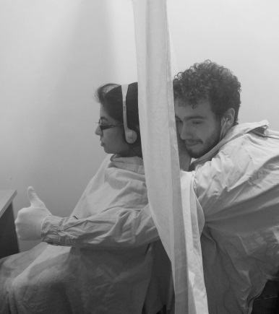
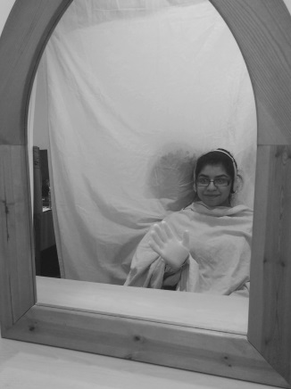

Fig. 1
Experimental set-up. Pictured side view (left) and participant view (right). The experimenter sits behind the curtain hidden from the participant’s view. Here, the experimenter places his arm forward, where the participant’s arm would normally appear. The participant sits in front of the mirror where she can see the arm as her own. The participant hears instructions through the headphones and observes the action being performed by the arm. In the match condition instructions and actions are congruent, while they are incongruent in the mismatch condition.

3 Results
A preliminary analysis on left and right hands were carried out for each condition using a paired sample test to see if their results could be distinguished. As no significant differences emerged, the mean judgements for left and right hands were collapsed into a single score (for example: (Anticipation match condition Left hand + Anticipation match condition Right hand)/2). These were entered into mixed design ANOVAs. Any interactions were explored using planned paired comparisons or where relevant post-hoc tests (corrected for multiple comparisons using a Bonferroni correction). In any cases where individual variables did not meet assumptions of normality non-parametric paired comparisons were used.
The mean ratings were entered into a 3 (Question) X 2 (Condition) X 2 (Group) mixed measure analysis of the variance with ‘Question’ (Anticipation/Agency/Ownership) and ‘Condition’ (Match/Mismatch) as within-subjects factors and ‘Group’ (MTS/Controls) as a between-subjects factor. The ANOVA showed main effects of Question (F (2, 28) = 11.2, p < .001, η²_{partial} = .445), Condition (F (1, 14) = 87.3, p < .001, η²_{partial} = .862) due to higher ratings overall in the match condition and Group (F (1, 14) = 41.3, p = .009, η²_{partial} = .392), this was due higher ratings showed by the MTS group compared to controls (figure2a). The interaction between Question and Group was significant (F (2, 28) = 10.32, p < .001, η²_{partial} = .424) as well as the interaction Question by Condition (F (2, 28) = 24.855, p < .001, η²_{partial} = .640). A three way interaction between Question, Condition and Group was also significant (F (1, 14) = 4.35, p < .023, η²_{partial} = .237). The three way interaction was explored by running separate 2 (Condition) X 2 (Group) mixed measures analysis of the variance for each question (Anticipation/Agency/Ownership). Further analyses exploring this interaction can be found in the supplementary results.
3.1 Anticipation
The analysis of the mean ratings for Anticipation showed a significant main effect of Condition (F (1, 14) = 295.7, p < .001, η²_{partial} = .955). Participants reported significantly greater anticipation in the match condition, where the gesture corresponded to the voiced instruction, than in the mismatch condition. There was no significant interaction (p > .250) and no main effect of Group (p > .250), (Figure 2b). This shows that both groups attended equally well to the prime-action relationship.
3.2 Sense of Agency
The analysis of the mean ratings for Agency also showed a main effect of the Condition (F (1, 14) = 37.03, p < .001, η²_{partial} = .726). Participants reported significantly greater SA in the match condition, than in the mismatch condition. A significant main effect of Group (F (1, 14) = 8.09, p = .013, η²_{partial}= .366) was found showing that, overall, the SA was stronger in the MTS Group. A significant Group by Condition interaction was also found (F (1, 14) = 4.64, p = .049, η²_{partial} = .249), indicating that the effect of the manipulation was different for the two groups. In order to further explore this interaction, we performed planned comparisons on the mean ratings for each group: the Agency ratings were significantly different in the match condition (t (14) = 2.60, p = .021), (Figure 2c).
3.3 Sense of Ownership
The analysis of the mean ratings for Ownership showed a main effect of Condition F (1, 14) = 15.37, p < .001, η²_{partial} = .523). Participants reported significantly greater SO in the match condition, than in the mismatch condition. A significant main effect of Group (F (1, 14) = 12.008, p = .004, η²_{partial} = .462) was found: as predicted people with MTS reported an overall greater SO during the task (Figure 2a). Interesting, there was no significant interaction between Condition and Group (p > .250) suggesting that the differences in the SO between mirror-touch synaesthetes and controls were similar across the match and mismatch conditions. In line with this, planned comparisons on ownership ratings revealed that mirror-touch synaesthetes reported a higher SO compared with controls in the match conditions (t (14) = 2.56, p = .046) and a higher SO in the mismatch condition (U = 34.00, p = .03). Overall, these results suggest a heightened SO on this task in the MTS group (Figure 2d).
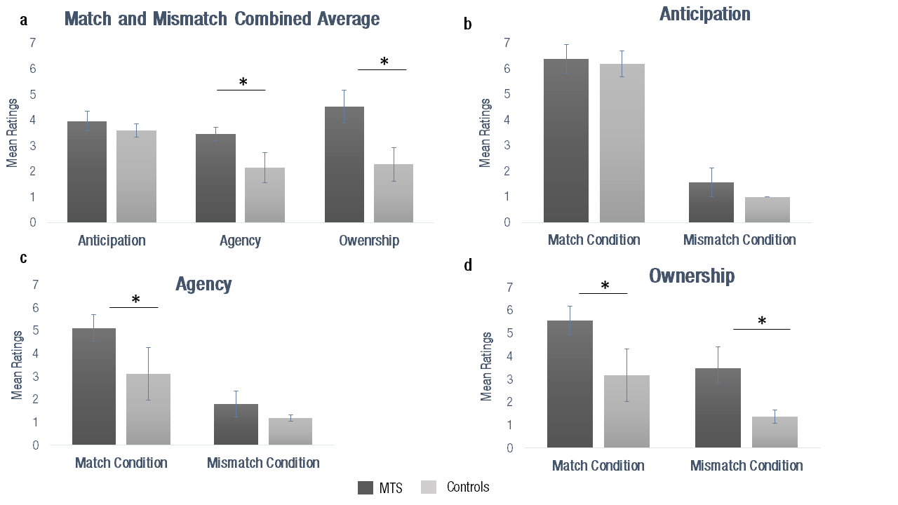
Fig. 2
Overall mean ratings of match and mismatch conditions for each of the three questions (a); mean ratings plotted as a function of condition (‘Match’, Mismatch’) and group (‘Mirror-touch synaesthetes (MTS)’, ‘Controls’), for Anticipation (b), Agency (c) and Ownership (d). The error bars show Standard Deviation across participants. * = p < .05. The results show that mirror-touch synaesthetes reported overall higher ratings in both match and mismatch conditions for Agency and Ownership but not for Anticipation (a). Mirror-touch synaesthetes (MTS) reported greater sense of agency compared to controls in match conditions (c) and greater sense of ownership in both match and mismatch conditions (d). No differences between MTS group and controls were found in the ratings of anticipation.

4. Discussion
We used a modified version of a well-established paradigm developed by Wegner et al (2004) to investigate changes in self-awareness associated with mirror-touch synaesthesia. During this vicarious agency paradigm, participants look at actions performed in a mirror placed in front of them while listening to action instructions that match or mismatch with the actions performed. Our results show that people with MTS experienced higher SA over the movements when in the match condition. With respect to SO, synaesthetes showed a stronger feeling of ownership towards the hand compared to controls, in both match and mismatch conditions. These findings are consistent with suggestions that self-other processing may be atypical in MTS (e.g. Banissy & Ward, 2013; Ward & Banissy, In Press) and prior work suggesting differences in the SO in MTS (Aimola Davies & White 2013; Maister et al. 2013). They extend them by demonstrating for the first time an atypical SO in MTS.
Our findings suggest that the experience of agency in MTS may be more malleable than in controls, and shows that the previously reported alterations of self-awareness in MTS extend to SA. In doing so, the findings are in line with the hypothesised deficit in the control of self-other discrimination in MTS (Banissy & Ward, 2013), where the breakdown in the self-other distinction processes in MTS would lead to a blurring of the boundaries between the self and the other. However, whilst our findings demonstrate a clear change in explicit agency and ownership experiences in MTS, an important distinction has been made between implicit and explicit aspects of these self-experiences (Gallagher, 2000; Synofzik, Vosgerau, & Newen, 2008). What is not clear from our data is whether there are also changes at the implicit level in these individuals. Indeed it would be of considerable interest to examine whether or not the higher level self-other discrimination issues associated with MTS have an impact on lower level agency and ownership processes.
In addition to providing insights into self-other processing in MTS, the findings also help to shed light on the relationship between SA and SO. Previous findings showing exaggerated ownership effects in MTS (Aimola Davies & White 2013; Maister et al. 2013) are in keeping with the elevated SO on our task. Speculatively, this elevated SO might underpin the increased illusory experience of agency in MTS that we observed. This would support previous theoretical accounts of agency processing in neurotypical populations, which argue that the positive experience of agency is predicated on the feeling that the body part is one’s own (Gallagher, 2000). Further work is needed in order to elucidate the exact nature of the relationship between SO and SA. This is especially pertinent in light of other empirical data suggesting that the relationship between agency and ownership can work in the opposite direction (Ma & Hommel, 2015; Tsakiris, Prabhu, & Haggard, 2006), with agency playing a fundamental role in the construction of SO. Whatever the precise nature of this relationship, we have demonstrated that MTS is likely to be especially informative in this regard.
The results can also be interpreted in relation to the models of the SA that postulate a cue integration approach. This approach contends that multiple cues, i.e. internal and external, have a relative influence on the SA. Their importance is affected by their reliability. Together, they interact and contribute to the SA (see Moore & Fletcher, 2012 for a review). As MTS is characterised by altered self-other representations and a specific difficulty in inhibiting the others (Santiesteban, Bird, Tew, Cioffi, & Banissy, 2015), the exaggerated SA seen here could be the result of stronger weighting placed on external cues than on internal signals.
The findings also speak to broader debates about the classification of MTS as a form of synaesthesia. Moreover, while originally labelled as synaesthesia in the first single case report of the condition (Blakemore et al., 2005), more recently the extent to which MTS is a form of synaesthesia has been questioned (e.g. Rothen & Meier, 2013). While an extensive discussion of this debate is beyond the scope of this paper, our current findings and those of other studies (e.g. Aimola Davies & White, 2013; Maister et al., 2013; Santiesteban et al., In Press) of atypical self-other processing in MTS raise the possibility that difficulties in self-other processing may be a fundamental disturbance in MTS. With this in mind, future work should focus on self-other processing abnormalities associated with MTS. This in turn will shed light on the neural and cognitive constituents of self-awareness more generally.
In summary, we have shown, for the first time, that alterations in self-awareness in MTS extend to SA. Our results suggest that these agency processing changes are linked to more fundamental disturbances in SO. These findings further our understanding of the relationship between these two core aspects of human self-awareness and how changes in this relationship can explain disturbances in self-awareness associated with certain conditions.

Author Contributions
All authors contributed to the study design. Testing and data collection were performed by MCC. MCC performed the data analysis and interpretation under the supervision of MJB and JWM. All authors contributed to manuscript preparation.

Acknowledgements
Our work is supported by a BIAL foundation grant to MJB and JWM (74/12). MJB is also supported by an ESRC Future Research Leaders Award (ES/K00882X/1).

References
Aimola Davies, A. M., & White, R. C. (2013). A sensational illusion: Vision-touch synaesthesia and the rubber hand paradigm. Cortex, 49(3), 806–818. doi:10.1016/j.cortex.2012.01.007
Banissy, M. J., Kadosh, R. C., Maus, G. W., Walsh, V., & Ward, J. (2009). Prevalence, characteristics and a neurocognitive model of mirror-touch synaesthesia. Experimental Brain Research, 198(2-3), 261–272. doi:10.1007/s00221-009-1810-9
Banissy, M. J., Kusnir, F., Duchaine, B., Walsh, V., & Ward, J. (2011). Superior Facial Expression , But Not Identity Recognition , in Mirror-Touch Synesthesia, 31(5), 1820–1824. doi:10.1523/JNEUROSCI.5759-09.2011
Banissy, M. J., & Ward, J. (2007). Mirror-touch synesthesia is linked with empathy. Nature Neuroscience, 10(7), 815–6. doi:10.1038/nn1926
Banissy, M. J., & Ward, J. (2013). Mechanisms of self-other representations and vicarious experiences of touch in mirror-touch synesthesia. Frontiers in Human Neuroscience, 7(April), 112. doi:10.3389/fnhum.2013.00112
Blakemore, S.-J., Bristow, D., Bird, G., Frith, C., & Ward, J. (2005). Somatosensory activations during the observation of touch and a case of vision-touch synaesthesia. Brain : A Journal of Neurology, 128(Pt 7), 1571–83. doi:10.1093/brain/awh500
Cioffi, M. C., Moore, J. W., & Banissy, M. J. (2014). What can mirror-touch synaesthesia tell us about the sense of agency? Frontiers in Human Neuroscience, 8(April), 256. doi:10.3389/fnhum.2014.00256
Crawford, J.R. & Howell, D.C. (1998). Comparing an individual's test score against norms derived from small samples. The Clinical Neuropsychologist, 12 (4), 482/486 . doi:10.1076/clin.12.4.482.7241
Decety, J., & Lamm, C. (2007). The role of the right temporoparietal junction in social interaction: how low-level computational processes contribute to meta-cognition. The Neuroscientist : A Review Journal Bringing Neurobiology, Neurology and Psychiatry, 13(6), 580–93. doi:10.1177/1073858407304654
Farrer, C., & Frith, C. D. (2002). Experiencing oneself vs another person as being the cause of an action: the neural correlates of the experience of agency. NeuroImage, 15(3), 596–603. doi:10.1006/nimg.2001.1009
Gallagher, S. (2000). Philosophical conceptions of the self: implications for cognitive science. Trends in Cognitive Sciences, 4(1), 14–21. doi:10.1016/S1364-6613(99)01417-5
Holle, H., Banissy, M. J., & Ward, J. (2013). Functional and structural brain differences associated with mirror-touch synaesthesia. NeuroImage, 83, 1041–50. doi:10.1016/j.neuroimage.2013.07.073
Keysers, C., Kaas, J. H., & Gazzola, V. (2010). Somatosensation in social perception. Nature Reviews. Neuroscience, 11(6), 417–28. doi:10.1038/nrn2833
Ma, K., & Hommel, B. (2015). The role of agency for perceived ownership in the virtual hand illusion. Consciousness and Cognition, 36, 277–288. doi:10.1016/j.concog.2015.07.008
Maister, L., Banissy, M. J., & Tsakiris, M. (2013). Mirror-touch synaesthesia changes representations of self-identity. Neuropsychologia, 51(5), 802–8. doi:10.1016/j.neuropsychologia.2013.01.020
Moore, J. W., & Fletcher, P. C. (2012). Sense of agency in health and disease: a review of cue integration approaches. Consciousness and Cognition, 21(1), 59–68. doi:10.1016/j.concog.2011.08.010
Rothen, N., & Meier, B. (2013). Why vicarious experience is not an instance of synesthesia. Frontiers in Human Neuroscience, 7(April), 128. doi:10.3389/fnhum.2013.00128
Santiesteban, I., Bird, G., Tew, O., Cioffi, M. C., & Banissy, M. J. (2015). Mirror-touch Synaesthesia: Difficulties Inhibiting the Other. Cortex, 71, 116–121. doi:10.1016/j.cortex.2015.06.019
Schaefer, M., Heinze, H.-J., & Rotte, M. (2012). Embodied empathy for tactile events: Interindividual differences and vicarious somatosensory responses during touch observation. NeuroImage, 60(2), 952–7. doi:10.1016/j.neuroimage.2012.01.112
Synofzik, M., Vosgerau, G., & Newen, A. (2008). Beyond the comparator model: A multifactorial two-step account of agency. Consciousness and Cognition, 17(1), 219–239. doi:10.1016/j.concog.2007.03.010
Tsakiris, M., Prabhu, G., & Haggard, P. (2006). Having a body versus moving your body: How agency structures body-ownership. Consciousness and Cognition, 15(2), 423–32. doi:10.1016/j.concog.2005.09.004
Wegner, D. M., Sparrow, B., & Winerman, L. (2004). Vicarious agency: experiencing control over the movements of others. Journal of Personality and Social Psychology, 86(6), 838–48. doi:10.1037/0022-3514.86.6.838

Prior work suggests that ANOVA is less sensitive to moderate deviations from normality (e.g. Glass et al., 1972; Harwell et al., 1992; Lix et al., 1996).

