Investigating the effects of caffeine on executive functions using traditional Stroop and a new ecologically-valid virtual reality task, the Jansari assessment of Executive Functions (JEF©).

Authors: Soar K^{1*}, Chapman E¹, Lavan N ¹, Jansari AS², Turner JJD¹

¹School of Psychology
University of East London
Water Lane
London, E15 4LZ
² Department of Psychology
Goldsmiths, University of London
Lewisham Way, London SE14, 6NW

*Corresponding author:
Dr Kirstie Soar
School of Psychology
University of East London
Water Lane, London, E15 4LZ
Email: k.soar@uel.ac.uk
Tel: 0208 223 4082
Fax: 0208 223 4937

This research was supported by internal funds only and there are no known conflicts of interest.
ABSTRACT
Objective: Caffeine has been shown to have effects on certain areas of cognition, but in executive functioning the research is limited and also inconsistent. One reason could be the need for a more sensitive measure to detect the effects of caffeine on executive function. This study used a new non-immersive virtual reality assessment of executive functions known as JEF© (the Jansari Assessment of Executive Function) alongside the ‘classic’ Stroop Colour-Word task to assess the effects of a normal dose of caffeinated coffee on executive function.
Method: Using a double-blind, counterbalanced within participants procedure 43 participants were administered either a caffeinated or decaffeinated coffee and completed the ‘JEF©’ and Stroop tasks, as well as a subjective mood scale and blood pressure pre- and post condition on two separate occasions a week apart. JEF© yields measures for eight separate aspects of executive functions, in addition to a total average score.
Results: Findings indicate that performance was significantly improved on the planning, creative thinking, event-, time- and action-based prospective memory, as well as total JEF© score following caffeinated coffee relative to the decaffeinated coffee. The caffeinated beverage significantly decreased reaction times on the Stroop task, but there was no effect on Stroop interference.
Conclusion: The results provide further support for the effects of a caffeinated beverage on cognitive functioning. In particular, it has demonstrated the ability of JEF© to detect the effects of caffeine across a number of executive functioning constructs, which weren’t shown in the Stroop task, suggesting executive functioning improvements as a result of a ‘typical’ dose of caffeine may only be detected by the use of more real-world, ecologically valid tasks.

Keywords: caffeine, JEF©, executive function, cognitive, mood, Stroop
INTRODUCTION

Caffeine is consumed by eighty-seven percent of the world’s population on a daily basis making it the most frequently used psychoactive drug (Addicott et al., 2009), with indications that consumption has also increased over the last 10 years (McIlvain et al, 2011). Average consumption in the United Kingdom of a regular caffeine user varies between 170-210 milligrams per day; the equivalent of 3-4 regular cups of instant coffee. Caffeine content in beverages varies dependent upon factors such as volume, strength when brewed, the use of additives such as milk which reduces caffeine absorption, and the source of caffeine used (Koppelstaetter, et al., 2010). Caffeine is rapidly absorbed, with drug peak effects seen after as little as fifteen minutes (Fredholm, et al., 1999) and has a half-life of between 3-6 hours (Rogers, 2007). Caffeine’s primary effect is as an adenosine antagonist; specifically blocking inhibitory adenosine A₁ and A_{2A} receptors, stimulating the central nervous system and producing excitatory effects (Rosso, et al., 2008). Changes are thus seen in a number of neurotransmitters e.g. dopamine, adrenaline, serotonin and acetylcholine (Dixit et al, 2012), which are associated with alterations in attention, mood and physiological function, thus accounting for the many psychological changes caffeine consumers often report; heightened energy levels, clearer thought processes such as creativity, certain memory processes and perception, and a greater feeling of being well (Koppelstaetter et al, 2010).

Indeed, there is an extensive body of research which demonstrates that caffeine has been shown to reduce mental fatigue and improve alertness (e.g. Brice & Smith, 2002; Haskell et al, 2005), increase attention and reduce reaction times (e.g. Smith, 2009; Adan and Serra-Grabulosa, 2010), increase concentration, improve response accuracy (e.g. Roger & Dernoncourt, 1998), focus attention and enhance short- term memory (see Nehlig, 2010 and Glade 2010 for more details). It has also been argued that whilst caffeine does not affect long-term memory, it can facilitate performance in tasks involving working memory to some extent (Nehlig, 2010).

Whilst the majority of research studies however have focussed upon cognitive function in a broad sense and generally showed consistent findings, research on specific ‘higher order’ brain function which rely on frontal lobe function, is not so consistent. Such functions include the ability to plan, organize, conceptualize, initiate and sustain behavior towards a goal, self-monitoring and adaptive responding (shifting), inhibition, and emotional control and working memory; cognitive constructs which are often collectively known as the executive functioning (EF).

Evidence suggests that caffeine has been shown to improve some areas of EF for example task switching and maintenance (Tieges et al, 2006; Tieges et al, 2007), response inhibition (Barry et al, 2007), conflict monitoring (Tieges et al, 2004), the visual attention network functions; alerting, orienting and executive control (Brunyé et al 2010) and inhibitory control (Lorist et al, 1994, 1996). However, others have failed to find an effect (e.g. Kenemans & Verbaten, 1998; Tieges et al, 2009), or only shown effects in light caffeine users after the consumption of a relatively large dose (300mg) despite using what is argued to be a sensitive measure of prefrontal cortical functioning (the Wisconsin Card Sorting Task; WCST) (Lyvers et al, 2004). In particular, several studies assessing inhibitory control using the Stroop colour-word test (also regarded as a frontal lobe task) have shown inconsistent findings with regards to caffeine’s effects. Edwards et al (1996) found no effect of two different caffeine doses (125mg and 250mg) on Stroop performance (computerized or traditional card version), Bottoms et al (2013) found no change in time to complete the Stroop task after caffeine consumptions. Whereas Kenemans et al (1999) showed caffeine to reduce interference during this task in one of their studies but not the other. Hasenfratz and Battig (1992) reported a reducing effect/improvement of caffeine on the Stroop, and time to complete the task has also been shown to be decreased following caffeine (Patat et al, 2000; Dixit et al, 2012; Pilli et al, 2013; Paulus et al, 2015), whereas Foreman et al (1989) found caffeine to actually increase Stroop interference. This inconsistency in the literature could be caused by the reliability of the task to detect the subtle changes in of a mild stimulant such as caffeine on EF. It has also been suggested that such classic tests of EF lack ecological validity (Chaytor and Schmitter-Edgecombe, 2003).).

A recently developed measure of EF, which has been considered to be more ecologically valid and addresses the multidimensional aspect of EF, by assessing a variety of EF constructs, is the Jansari assessment of Executive Functions or JEF© (Jansari, et al., 2004). JEF© is a non-immersive virtual reality paradigm run on a standard laptop whereby an individual performs tasks in an office setting before a meeting takes place, overcoming certain problems which arise during the programme. This test divides the tasks into eight constructs portraying the different aspects of EF on which individuals are marked, such as planning, adaptive thinking; prospective memory, etc. (see Method section for more detail on the individual constructs). The assessment has been argued to be a more ecologically valid measure of EF than other ‘classic’ neurological measures, i.e. ‘Stroop’ task (Jansari et al, 2012). JEF© was initially designed to assess individuals with frontal lobe damage but has been used to identify subtle changes in executive function associated with certain drugs of abuse, such as ecstasy/MDMA (Montgomery et al, 2010), alcohol (Montgomery et al, 2011), cannabis (Montgomery et al, 2012) and nicotine (Jansari et al, 2013), suggesting its potential for use in assessing the effects on executive function of other stimulant drugs such as caffeine.

The current study therefore aimed to assess whether caffeine administration via a caffeinated beverage (coffee) had an effect on EF as measured by the classic Stroop Colour-Word task, and also the potentially more ecologically valid EF task, JEF©. Both tests will extend knowledge of caffeine’s effects further by clarifying whether caffeine indeed influences inhibitory control as measured by the Stroop and whether caffeine’s subtle effects can be detected by the JEF©. Additionally, by using JEF©, the effects of caffeine on a range of EF constructs can also be assessed.

Using a within participants design caffeine was administered via an ‘average’ cup of instant caffeinated coffee so as to attempt to clarify the effects of a typical cup of caffeinated coffee on executive function. It was hypothesised that if a typical cup of caffeinated coffee can facilitate EF then it would be expected that performance on both the tasks may be superior after consumption of caffeinated coffee compared to decaffeinated coffee. However if such effects are more subtle, these effects are expected to be found in measures of the JEF© only.

Given that caffeine has also been shown to improve hedonic tone and affect other mood states such as anxiety, calmness, nervousness and jitteriness (Smith, 2002; Brunyé, et al. 2010; Nehlig, 2010), the current study also assessed subjective mood using the 16 item Profile of Mood States scale (POMS; Wald & Mellenbergh, 1990) over the period of coffee consumption.
METHOD

Design
A double-blind repeated measures design was used with two conditions, caffeinated and decaffeinated. The dependent variables were outcome measures for the separate JEF© constructs and total score; reaction time and number correct on the Stroop task, for both congruent and incongruent trials; and scores for each mood on the POMS scale.

Participants
Forty-three regular caffeine users (26 female), mean age 28.05 years, were recruited via opportunity sampling from the University of East London and contacts known to the researchers. 44.2% (n=19) self-reported their ethnicity as white; 23.3% (n=10) as black; 30.2% (n=13) as mixed; 2.3% (n=1) as other. Mean daily intake of caffeine in the sample was 305.78 + 113.8 oz. 70% (n=30) of the participants reported weekly alcohol; use 21% (n=9) reported using nicotine and 7% (n=3) participants recorded past use of cannabis. Other than regular use of caffeine, inclusion criteria included normal or corrected to normal vision and fluency in the English language. Exclusion criteria included self-reported history of brain damage, epilepsy and current pregnancy. Participants were asked to abstain from caffeine for two hours prior to the study. The research was approved by The University of East London’s Ethics Committee.

Measures
Preparation of Caffeinated and Decaffeinated beverages
In the caffeinated condition participants were given 1.8 grams of Nescafe® coffee granules (containing in total approximately 50mg caffeine) dissolved into 200ml hot water. In the decaffeinated condition participants were given 1.8 grams of Nescafe® decaffeinated coffee granules dissolved into 200ml hot water (containing in total approximately 1.8mg caffeine). The amounts were chosen to reflect an average sized cup of instant coffee so as to attempt to clarify the effects of a ‘typical’ cup of caffeinated coffee on executive function.

JEF© (The Jansari assessment of Executive Functions, Jansari et al, 2014): Delivered on a laptop, this test was based in a virtual reality office and meeting room. Participants were given a scenario to read detailing their role as an employee left in charge whilst their manager was away, requiring the completion of several tasks to prepare for a meeting. All documents represented in the virtual office requiring completion were provided in hard copy next to the participant. Functioning sound on the computer was necessary to allow for the fire alarm and memo announcements.
Performance on JEF© tasks were manually scored by a researcher, using a standardised sheet. Tasks were categorised into eight constructs which assessed different executive behaviours:
- Planning – Tasks, such as those left by the ‘manager’ were to be arranged in a logical order rather than perceived importance.
- Prioritisation – Items were to be arranged in order of perceived importance, e.g. items on the ‘Agenda’ for the day’s meeting.
- Selection – Appropriate choices were to be made from a set of options, e.g. the selection of appropriate companies to send each item of post, correlating companies’ sending criteria with the importance of each mail item.
- Creative thinking – Problems appearing during the course of the test should have been solved by participants independently using non-obvious methods and thinking creatively, e.g. placing the whiteboard in front of a permanent ink message in the meeting room that could not be rubbed off using the whiteboard rubber.
- Adaptive thinking – When a problem arose which resulted in initial actions being insufficient to effectively complete that task, participants were to adapt to changing conditions by changing the way they accomplished a task, e.g. sending the post a different way when the postman does not arrive twenty minutes into the test.
- Action-based prospective memory – Participants were to remember to complete a task when prompted by a cue which occurred whilst carrying out another task, e.g. recording on ‘my notes for manager’ when any equipment broke.
- Event-based prospective memory – Participants had to remember to carry out a task when prompted by an event which occurred whilst carrying out another task, e.g. recording the times of the fire alarm which sounded at different times during the program.
- Time-based prospective memory – Participants had to remember to carry out a certain task at a specified time, e.g. turning on the overhead projector ten minutes before the start of the meeting.

Each construct comprised of two tasks which was scored individually from ‘0’ for any task that was not sufficiently attempted, ‘1’ for partial completion or a satisfactory attempt at the task, and ‘2’ for the required action and completion of that task. Scores for each task are summed and a percentage score calculated for each construct. An average of the eight construct percentage scores provides an indication of overall performance.

Stroop Colour-Word Task: A computerised version of the Stroop was presented, which consisted of sixty-four colour words appearing on the screen in quick succession; half were congruent with their coloured font and half incongruent. The order of these words was randomised. Participants responded by pressing the relevant key on the keyboard which corresponded with the coloured font of each word. Words appeared for 1000 milliseconds or until the participant made a response. The number of correct responses and mean stimulus reaction time in milliseconds were recorded.

Profile of Mood States (POMS; Wald & Mellenbergh, 1990): The short version (16-item) of the POMS questionnaire was used to record participants’ current mood state. Participants indicated the degree to which they currently experienced each mood state by marking an ‘X’ on a 100mm visual analogue scale (VAS); marked at the extremes ‘Not at all’ to ‘Extremely’. Each mood state was therefore scored by measuring the distance from 0 (not at all) to where they had indicated, thus scores could range between 0 (Not at all) and 100 (Extremely).

Blood Pressure: A self-inflating blood pressure monitor (with an upper arm cuff; Omron Ltd.) was used to automatically measure an individual’s systemic arterial systolic and diastolic blood pressure (mmHg), at three time points (T1, T2 and T3; see procedure) during each condition.

Procedure
Conditions were administered double blind and counter balanced. Participants were tested between the hours of 10am and 4pm. During the first testing session participants completed a short questionnaire assessing demographics, caffeine consumption and other alcohol/drug use. This was followed by completion of the POMS and an initial measure of blood pressure (T1). Participants were then administered the caffeinated or decaffeinated coffee. Following this, the researcher read aloud the standardised JEF© instructions, whilst navigating through the virtual reality programme to demonstrate basic usage instructions. Participants were given the JEF© scenario to read, and an opportunity to ask questions, and practice using the task. After 20 minutes, blood pressure was then measured a second time (T2) and participants then completed the JEF© task. Only questions related to technical support were answered by the researcher e.g. how to move an item, any other questions were answered by referring participants to the relevant instruction sheets to avoid leading participants to the correct completion of tasks. A clock was visible to participants throughout the testing session and whilst no time restriction was imposed for the completion of the task, time to complete the task was recorded. Following completion of JEF© participants completed the Stroop task, followed by a second POMS assessment and third recording of blood pressure (T3). The procedure was repeated (except for the questionnaires) for the counterbalanced condition one week later, on the same day and within an hour of the time of the first testing session. On completion participants were thanked and appropriately debriefed.

Data Analysis
All data were processed and analysed using the Statistical Package for Social Science (SPSS) version 18 in Windows Vista. Stroop data (number correct and mean reaction time in milliseconds) and POMS data were analysed using a 2x2 repeated measures ANOVA, with condition (caffeinated/decaffeinated) and congruency (congruent/incongruent) as the within factors on the Stroop data and condition (caffeinated/decaffeinated) and time (pre/post) as the factors on the POMS data. JEF© individual percentage construct scores and overall percentage average score were analysed with a repeated measures ANOVA. Blood pressure data were analysed using a 2x3 ANOVA, with condition (caffeine/non-caffeine) and time (T1, 2 and 3) as the factors. Where sphericity was not assumed the Greenhouse-Geisser statistics were reported.

RESULTS

POMS
Table 1 shows the mean scores for mood states pre- and post- assessment. Significant findings were found in the mood states ‘excited’ ‘feeble’, ‘clear-headed’, ‘tranquil’, ‘relaxed’, ‘amicable’ and ‘bored’. With only a significant main effect of time for ‘excited’, F(1,42) = 4.47, p = 0.04, and ‘bored’, F(1,42) = 5.29, p=1.03; with higher ratings post assessment, and ‘clear-headedness’, F(1,42) = 9.41, p < 0.01, ‘relaxed’, F(1,42) = 5.32, p = 0.03 and, ‘amicable’, F(1,42) = 5.78, p = 0.02; with lower ratings post-assessment, but no effect of condition or interaction. The mood states ‘tranquil’ and ‘feeble’ were the only moods which showed a significant interaction with condition and assessment period; F(1,42) = 5.24, p=0.03 and F(1,42) = 4.85, p=0.03 respectively, with scores increased post-administration of caffeinated coffee and decreased post-administration of the decaffeinated coffee.

Blood Pressure
There was no main effect of condition or time on diastolic blood pressure (p’s > 0.1), but a significant interaction F(2,84) = 5.30, p=0.01; with an increase at T3 in the caffeinated condition and a decrease in the decaffeinated condition. Systolic blood pressure was higher in the caffeinated condition with a borderline significant main effect, F(1,42) = 3.79, p=0.06; but no main effect of time F(2,84) = 0.42, p=0.60 and an interaction of time and condition which was approaching significance (2,84) = 2.91, p=0.07; with blood pressure increasing over time in the caffeinated condition, and decreasing in the decaffeinated condition.

Table 1: Mean POMS rating for each mood state as a function of condition (caffeinated/decaffeinated) and time (pre- and post- condition)

 |  | Caffeinated |  | De-caffeinated |  | Sig.#
 |  | Pre- | Post- | Pre- | Post- | p
Drowsy |  | 23.15 (26.22) | 21.69 (25.17) | 20.13 (25.72) | 16.17 (20.65) | 0.56
Excited |  | 22.63 (23.37) | 27.18 (24.86) | 23.54 (23.14) | 27.80 (28.59) | 0.95
Feeble |  | 9.62 (17.20) | 13.85 (21.78) | 11.93 (20.26) | 9.65 (15.01) | 0.03*
Clear-headed |  | 33.66 (31.03) | 27.51 (26.30) | 34.09 (27.06) | 29.77 (27.68) | 0.54
Clumsy |  | 14.45 (22.42) | 16.45 (23.24) | 12.39 (20.55) | 15.40 (19.87) | 0.80
Energetic |  | 30.42 (31.14) | 32.94 (29.76) | 26.44 (23.25) | 30.48 (30.55) | 0.68
Discontented |  | 17.57 (25.88) | 15.10 (25.13) | 11.92 (19.47) | 13.64 (22.32) | 0.33
Tranquil |  | 23.67 (23.39) | 27.04 (24.70) | 26.08 (27.03) | 21.14 (23.43) | 0.03*
Quick-witted |  | 31.63 (31.20) | 35.34 (33.88) | 28.23 (25.78) | 27.64 (27.26) | 0.09
Relaxed |  | 34.14 (30.18) | 30.71 (25.34) | 32.29 (30.57) | 27.08 (27.89) | 0.68
Dreamy |  | 20.47 (25.88) | 21.70 (24.34) | 19.27 (24.56) | 17.42 (23.85) | 0.36
Proficient |  | 32.43 (27.21) | 31.27 (26.34) | 33.87 (26.14) | 31.46 (28.58) | 0.65
Sad |  | 10.69 (21.72) | 10.62 (17.91) | 11.22 (22.14) | 11.73 (22.98) | 0.88
Amicable |  | 45.14 (33.90) | 42.28 (32.34) | 45.40 (25.62) | 40.73 (30.95) | 0.55
Bored |  | 10.38 (16.62) | 19.26 (27.31) | 15.13 (20.51) | 16.07 (23.06) | 0.07
Gregarious |  | 36.92 (33.75) | 37.70 (33.08) | 37.89 (31.06) | 38.28 (32.77) | 0.91
# Interaction (condition x time) significance levels
* p<0.05

Stroop Colour-Word
Figures 1 and 2 show the mean number of correct scores and mean reaction time for the Stroop. For the number of correct responses, there was no significant main effect of condition F(1,42) < 0.01, p = 0.93. There was a significant main effect of congruency, F(1,42) = 18.26, p < 0.001; with participants recording more correct responses for congruent words compared to non-congruent, with no significant interaction F(1,42) = 0.02, p=0.94. For mean reaction times there was a significant main effect on condition F(1,42) = 4.87, p=0.03; with faster responses in the caffeinated condition. There was no main effect of congruency F(1,42) = 1.68, p =0.20, or significant interaction F(1,42) = 0.23, p=0.63.

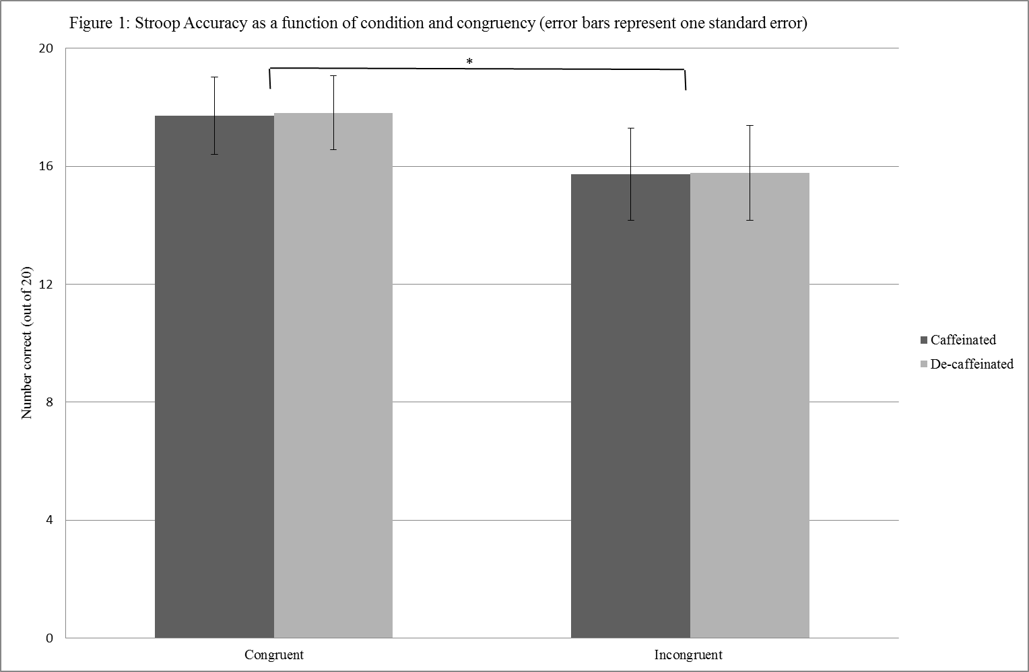
* main effect of congruency p<0.05

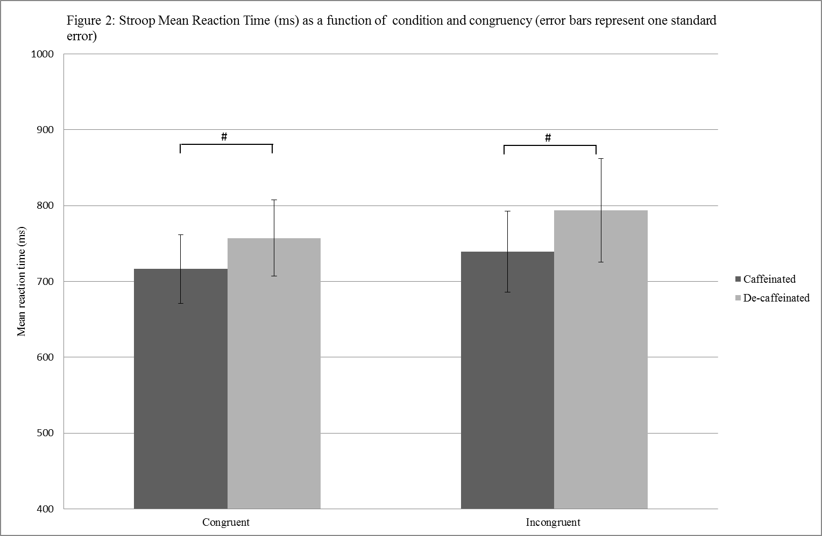
# main effect of condition p<0.05

JEF©
Figure 3 shows the percentage scores for all JEF© constructs and total average performance. Overall average JEF© performance was significantly better in the caffeinated condition than the decaffeinated condition F(1,42) =27.75, p <0.001, in addition performance was better in the caffeinated condition for the following individual constructs; ‘Planning’, F(1,42) = 8.73, p < 0.01; ‘Creative Thinking’, F(1,42) = 21.25, p <0.001; ‘Event Based Prospective Memory’, F(1,42) = 11.58, p = 0.001; ‘Time Based Prospective Memory’, F(1,42) = 4.68, p = 0.04; and ‘Action Based Prospective Memory’, F(1,42) = 10.10, p < 0.01. There was a borderline significant difference in performance between conditions for ‘Adaptive Thinking’, F(1,42) = 3.46, p=0.07. There were no significant differences in performance between conditions for ‘Prioritisation’, F(1,42) = 0.57, p = 0.46, ‘Selection’, F(1,42) = 0.36, p = 0.56

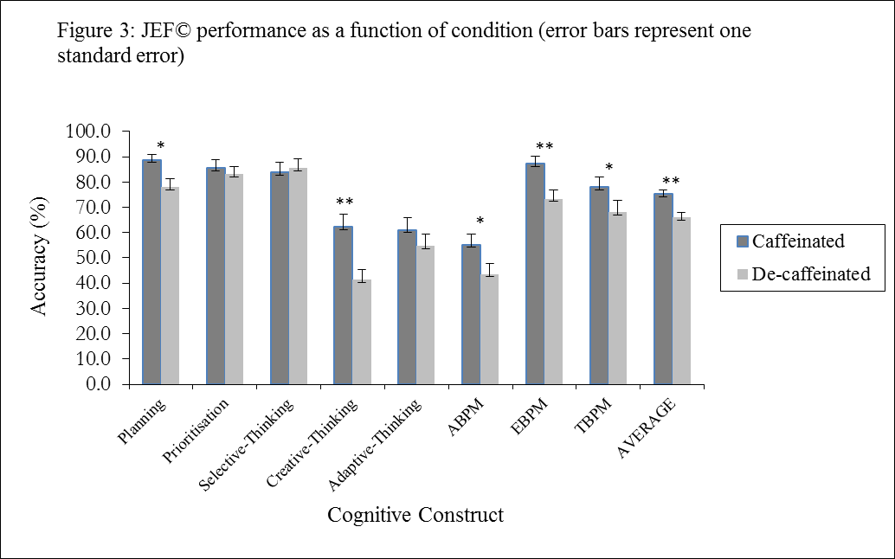
*p<0.05; **p<0.001
ABPM (Action Based Prospective Memory); EBPM (Event Based Prospective Memory); TBPM (Time Based Prospective Memory)

DISCUSSION

The current study aimed to clarify whether a typical cup of caffeinated coffee has an effect on EF in regular caffeine users, using the traditional standardized Stroop Colour-Word task and the new virtual reality paradigm, JEF© (Jansari et al, 214). Specifically, to assess whether caffeinated coffee does indeed affect inhibitory control as measured by the Stroop and other wider aspects of EF, as measured by a potentially more ecologically valid measure of EF; the JEF©(Jansari, et al., 2012). In addition, the effect of caffeinated coffee on subjective mood was also assessed.

The effects of caffeineated coffee are compared throughout to a decaffeinated coffee, although it is acknowledged that decaffeinated coffee does contain caffeine. In the current study, the lowest caffeine concentration for a decaffeinated drink was chosen; equating to 1.8mg of caffeine per beverage, compared to 50mg in the caffeinated beverage. It is unlikely that the low caffeine levels in the decaffeinated beverage exerted any substantive psychoactive effects, and so for the purposes of this discussion the effects of caffeine are made with reference to the caffeinated coffee condition.

As predicted, the present study found that caffeine consumption had a facilitating effect on executive function as measured by JEF©, compared to consumption of decaffeinated coffee. Overall average performance on the JEF© significantly improved following consumption of caffeinated coffee. Performance was also significantly enhanced on the majority of the individual EF constructs; planning, creative thinking, event based prospective memory, time based perspective memory, and action based perspective memory; relative to the decaffeinated condition. Interestingly, these enhancing effects of caffeinated coffee on EF were not seen for inhibitory function, as measured by the Stroop. There was a significant main effect of condition on reaction times (regardless of congruency), providing evidence that following consumption of caffeinated coffee, participants are generally faster at performing this task than in the decaffeinated condition. However, there was no significant interaction between condition and congruency suggesting that this effect relates more to an increase in basic processing speed or reaction time, rather than a specific enhancement of the Stroop interference effect. This is consistent with Edwards et al (1996) who failed to find an effect of caffeine using both the computerised and traditional card versions of the Stroop task, but differs from results found by others (e.g. Hasenfratz and Battig, 1992; Kenemans et al, 1999; Dawkins et al, 2011). Such discrepancies in findings could be related to task presentation (Kenemans et al, 1999) and practice effects (Edwards et al, 1996), or even the validity of the test itself (Jansari et al, 2014). For example, Dimitrov et al. (2003) reviewed a number of cases of individuals with frontal lobe and other brain impairments and found they did not differ in performance on the Stroop Task compared to normal controls, questioning the ability of the task to detect subtle drug-induced frontal lobe cognitive dysfunction.

The fact that Stroop response times increased generally following consumption of caffeinated coffee supports a number of existing studies demonstrating caffeine’s ability to improve reaction times. e.g. Kenemans, et al. (1999) found that caffeine reduced reaction time on both single trials of either congruent or incongruent coloured words, but also when presented with a mixed trial such as in the current study. Also, in other tasks caffeine has been shown to increase attention and reduce reaction times (e.g. Smith, 2009, Adan and Serra-Grabuloas, 2010). It could therefore be argued that caffeine may not influence the EF of inhibitory control or that such a task is not able to detect the subtle effects of the drug, possibly because it lacks ecological validity. The fact caffeinated coffee produced improvements on the JEF© task (both total score and across a number of different EF constructs) suggests that caffeinated coffee does have a facilitating effect on EF, and these improvements are seen across a number of JEF© constructs/EF domains. The effect on EF may be mild and therefore not detected by more traditional potentially less ecologically valid tests, thus explaining the limited research documenting caffeine’s effects on different EF domains. Finally, the fact that each of the traditional tasks assesses a separate aspect of EF in isolation probably contributes to the problem. For example, Stroop assesses inhibition while the Wisconsin Card Sorting Test addresses ability to respond to feedback. Testing these in isolation when EFs are the most complex of cognitive abilities is much like a musical conductor rehearsing each of the different sections of an orchestra in isolation from the rest of the musicians but then expecting the whole group to perform in concert together when required (Jansari et al, 2014). JEF© forces the various different aspects of EF to be required simultaneously which helps to reveal difficulties in areas which when tested alone appear to be unaffected. That JEF© was able to detect these effects does support the somewhat limited work assessing the effects of caffeine on other aspects of EF, e.g. task switching and maintenance following (Tieges, et al, 2006). Specifically, Tieges, et al (2006) found caffeine consumption seemingly enhanced the required executive functions for quick reaction tasks, including planning, organizing, and most notably adaptive thinking. The latter is essential for this task to adapt to rapidly changing stimuli whilst also adapting to individual task ‘rules’ when changing between them. In the present study, although the JEF© task was not a quick response paradigm, participants adapted to a changing environment with improved scores on tasks being carried out in that environment, after consuming a caffeine compared to non-caffeine containing drink..

There is a limited amount of consistent literature assessing the effects of caffeine on executive functions; however the findings from the present study are able to provide further evidence to support caffeine’s effects on executive functioning processes and also indicate which specific executive functioning processes are influenced by caffeine. However it is unfortunate that the JEF does not assess inhibitory control. This means that we are not able to clarify here whether the inability to consistently detect an effect of caffeine on this aspect of EF, is due to a lack of ecological validity in tasks such as Stroop, or whether inhibitory control is simply not influenced by caffeine as consistently and/or to the extent that other areas of cognitive function are. However, the findings do demonstrate and extend the ability of JEF© to assess the mild drug effects of caffeine, which have not been previously been detected.

Caffeine’s effects on mood were assessed at two time points, pre and post beverage. Contrary to previous literature (e.g. Smith, 2002, Brunyé, et al. 2010), the study only showed significant effects of caffeinated coffee on two moods: ‘tranquil’ and ‘feeble’. However, the effects were opposite to that anticipated, with ratings increasing after caffeine consumption, suggesting participants were more tranquil and felt more feeble following the administration of caffeinated coffee. It is not clear why the consumption of caffeinated coffee produced these effects on mood, and indeed why known mood effects of caffeine weren’t reported. The fact that blood pressure was affected by caffeinated coffee intake provides a more objective measure that caffeine was administered and in significant quantities to exert its effects. Whether this was enough to influence mood cannot be determined, but it would be surprising if this were not the case given the cognitive impact that was shown. It’s more likely that the lack of mood effects (and inconsistent mood findings) is the result of a rather crude and subjective measure of mood (POMS); assessing mood states which participants are not always so familiar with.

The current study was designed to clarify the effects of a ‘typical’ cup of caffeinated coffee containing what is argued to be an ‘average’ dose of caffeine, using a similar procedure to that used by Dawkins et al (2011). Relative to other studies the dose administrated could be considered low, whilst this could account for the lack of findings in the Stroop task (however, it is worth noting that Dawkins et al (2011) did find an effect of caffeine using a similar procedure on the Stroop task), that we were able to detect differences on the JEF© further highlights the utility of this test in detecting changes in EF. An important caveat here is that the JEF© task instructions were presented immediately following, and not completely before, administration of the coffee beverages. Although peak absorption of caffeine does not occur until 15-20 minutes post consumption, it is possible that low levels of ‘pre-peak’ caffeine may have enhanced comprehension of the instructions and thus contributed to the cognitive effects shown here.

What is considered a ‘typical’ dose of coffee will vary between individuals based on their daily consumption patterns and their tolerance to caffeine, which can in itself influence individual’s responses to caffeine (Lyvers et al, 2004). Whilst daily average intake of caffeine was recorded, and participants indicated they were regular users of caffeine, there was no detailed history of caffeine use to determine and control for this, nor was there any record of pre-test caffeine consumption in terms of timing of last consumption or quantity. The limited nature of the self-report data on caffeine consumption meant that controlling for daily and pre-test caffeine use (if recorded) could not be factored into the analyses and would need further exploration in a future study. A further limitation was there was no objective measure to confirm participants had met the two hour abstinence requirement prior to the study. If some participants were indeed regular users of caffeine or even heavy users (which some may well have been given the variance in daily caffeine intake reported), this abstinence period may have induced caffeine withdrawal in these users, which may have influenced their mood and cognitive performance. There is a debate as to whether the cognitive effects associated with caffeine administration are simply a result of the reversal of abstinence induced withdrawal effects (e.g. James, 2005; Haskell et al, 2005), especially given most studies assess habitual caffeine users. The two hour abstinence period, as used in this current study, is considered to be shorter than the estimated period necessary for caffeine withdrawal symptoms to develop (Nehlig et al, 1992), and thus it could be argued the effects are unlikely to be a result of reversal of withdrawal effects. However, with no indices of pre-test caffeine consumption it is possible participants could have abstained for longer than the two hours, and thus we cannot rule out that the effects shown are a result of a reversal of withdrawal.

Coffee also contains several other substances which have been identified as potential psychoactives (e.g. chlorogenic acid; Camfield et al, 2013). The comparison of caffeinated and decaffeinated coffee partly controls for the possible confounding effects of such substances, though clearly not possible interactions of these with caffeine. The point is also raised earlier that decaffeinated coffee is not caffeine free, though again the product used had a very low caffeine content and so the differences we have found between conditions are most readily explained as caffeine effects. Additionally, whilst there was a specific requirement for caffeine abstinence, there was no specific requirement for abstinence of other drugs (e.g. nicotine). Participants did note other drug use (mainly alcohol, nicotine and cannabis), and whilst none of the researchers suspected any participant to be under the influence from cannabis or alcohol at the time of testing, the influence of nicotine cannot be ruled out.

To conclude, the present study provides further support for the effects of caffeine on executive functioning. In particular, it has demonstrated the ability of the JEF© to detect the effects of caffeinated coffee across a number of executive functioning constructs following a relatively low dose of caffeine. Additionally, at this dose, changes in inhibitory control, as measured by Stroop interference, were not observed, suggesting that either a ‘typical’ dose of caffeinated coffee may not lead to improvements in this aspect of executive function, or relative to the use of more real-world, ecologically valid task, such as the JEF, the Stroop is unable to detect caffeine’s effects on inhibitory function.

References

Addicott, M. A. Yang, L.L., Pieffer, A,M., Burnett, L.R., Burdette, J.H., Chen, M.Y., Laurienti, P.J., 2009. The Effect of Daily Caffeine Use on Cerebral Blood Flow: How Much Caffeine Can We Tolerate?. Human Brain Mapping, 30(10): 3102-3114.

Adan, A., Serra-Grabulosa, J.M., 2010. Effects of caffeine and glucose alone and combined on cognitive performance. Human Psychopharmacol Clin Exp, 25:310-317.

Barry, R.J., Johnstone, S.J., Clarke, A.R., Rushby, J.A., Brown, C.R., McKenzie, D.N. 2007. Caffeine effects on ERPs and performance in an auditory Go/NoGo task. Clinical Neurophysiology, 118:2692-2699.

Bottoms, L., Greenhalgh, A., Gregory, K. 2013. The effects of caffeine ingestion on skill maintenance and fatigue in epee fencers. J Sports Sci. 31(10):1091-1099.

Brice, C. F. & Smith, A. P., 2002. Effects of Caffeine on Mood and Performance: A study of Realistic Consumption. Psychopharmacology, 164: 188-192.

Brunyé, T. T., Mahoney, C. R., Lieberman, H. R. & Taylor, H. A., 2010. Caffeine Modulates Attention Network Function. Brain and Cognition, 72:181-188.

Camfield DA, Silber BY, Scholey AB, Nolidin, K, Goh A Stough C.(2013). A Randomised Placebo-Controlled Trial to Differentiate the Acute Cognitive and Mood Effects of Chlorogenic Acid from Decaffeinated Coffee PLoS One. 2013; 8(12): e82897. Published online 2013 Dec 9. doi: 10.1371/journal.pone.0082897

Chaytor, N. & Schmitter-Edgecombe, M. (2003). The ecological validity of neuropsychological tests: A review of the literature on everyday cognitive skills. Neuropsychology Review, 13, 181-196.

Dawkins, L., Shahzad, F.-Z., Ahmed, S. S. & Edmonds, J. C., 2011. Expectation of Having Consumed Caffeine Can Improve Performance and Mood. Appetite, 57(3): 597-600.

Dimitrov, M., Nakic, M., Elpern-Waxman, J., Granetz,J., O'Grady, J., Phipps, M., Milne, E., Logan, G.D., Hasher, L., Grafmana, J. 2003. Inhibitory attentional control in patients with frontal lobe damage. Brain and Cognition, 52(2): 258-270.

Dixit, A., Goyal, A., Thawani, R., Vaney, N., 2012. Effect of caffein on information processing: evidence from the Stroop task. Indian J Psychol Med. 34(3):218-222.

Edginton, T., Dawkins, L., Bradon, L., Nikolla, D., Herbert, C., & Jansari, A.S. 2008. An investigation of the effects of nicotine on executive processes using a virtual reality environment. Brain Impairment, 9(2), 207.

Edwards, S., Brice, C., Craig, C. & Penri-Jones, R., 1996. Effects of caffeine, practice, and mode of presentation on stroop task performance. Pharmacology Biochemistry and Behavior, 54(2): 309-315.

Fredholm, B. B., Bättig, K., Holmén, J., Nehlig, A., Zvartau, E.E. 1999. Actions of Caffeine in the Brain with Special Reference to Factors That Contribute to It's Widespread Use. Pharmacological Reviews, 51(1): 83-133.

Glade, M. 2010. Caffeine-not just a stimulant. Nutr J. 26(10):932-938.

Hasenfratz, M., Battig, K., 1992. Action profiles of smoking and caffeine: Stroop effect, EEG, and peripheral physiology. Pharmacol. Biochem. Behav. 42:155-161.

Haskell, C.F., Kennedy, D.O., Wesnes, K.A., Scholey, A.B., Cognitive and mood improvements of caffeine in habitual consumers and habitual non-consumers of caffeine. Psychopharmacology, 179:813-825.

Jansari, A.; Agnew, R.; Akesson, K.; Murphy, L. [JAAM], 2004. The Use of Virtual Reality to Assess and Predict Real World Executive Dysfunction: Can VR Help for Work Placement Rehabilitation? Brain Impair, 5:110.

Jansari, A.S., Froggatt, D., Edginton, T., & Dawkins, L. 2013. Investigating the impact of nicotine on executive functions using a novel virtual reality assessment. Addiction, 108(5), 977–984.

Jansari, A., Devlin, A., Agnew, R., Akesson, K., Murphy, L. & Leadbetter, A. (2014). Ecological assessment of executive functions: a new virtual reality paradigm. Brain Impairment, 15, 71-87

James, J.E., 2005. Caffeine-induced enhancement of cognitive performance confounding due to reversal of withdrawal effects. Australian Journal of Psychology, 52(3):197-200.

Kenemans, J.L., Verbaten, M.N. 1998. Caffeine and visuo-spatial attention. Psychopharmacology, 135:353-360.

Kenemans, J. L., Wieleman, J. S., Zeegers, M. & Verbaten, M. N., 1999. Caffeine and Stroop Interference. Pharmacology Biochemistry and Behavior, 63(4):589-598.

Koppelstaetter, F., Poeppel T.D., Siedentopf, C.M., Ishcebeck, A., Kolbitsch, C., Mottaghy, FM., Felber, S.R., Jaschke, W.R., Krause, B.J. 2010. Caffeine and Cognition in Functional Magnetic Resonance Imaging. Journal of Alzheimer's Disease, 20: S71-S84.

Lorist, M.M., Snel, J., Kok, A., Mulder, G. 1994. Influence of caffeine on selective attention in well-rested and fatigued subjects. Psychophysiology, 31:525-534.

Lorist, M.M., Snel, J., Kok, A., Mulder, G. 1996. Acute effects of caffeine on selective attention and visual search processes. Psychophysiology, 33:354-361.

Lyvers, M., Brooks, J., Matica, D., 2004. Effects of caffeine on cognitive and autonomic measures in heavy and light caffeine consumers. Australian Journal of Psychology, 56(1):33-41.

McIlvain, G.E., Noland, M.P., Bickel, R., 2011. Caffeine consumption patterns and beliefs of college freshman. Am. J Health Edu. 42(4):235-244.

Montgomery, C., Ashmore, K. V. & Jansari, A., 2011. The Effects of a Modest Dose of Alcohol on Executive Functioning and Prospective Memory. Human Psychopharmacology, 26: 208-215.

Montgomery, C., Hatton, N.P., Fisk, J.E., Ogden, R.S., & Jansari, A.S. (2010). Assessing the functional significance of ecstasy-related memory deficits using a virtual paradigm. Human Psychopharmacology: Clinical and Experimental, 25(4), 318–325

Montgomery, C., Ashmore, K. & Jansari, A. (2011). The effects of a modest dose of alcohol on executive functioning and prospective memory. Human Psychopharmacology: Clinical & Experimental, 26, 208–215.

Montgomery, C., Seddon, A.L., Fisk, J.E., Murphy, P.N., & Jansari, A.S. 2012. Cannabis-related deficits in real-world memory. Human Psychopharmacology, 27(2), 217–225

Nehlig, A., Davala, J-L., Debry, G., 1992. Caffeine and the central nervous system: mechanisms of action, biochemical, metabolic and psychostimulant effects
Brain Research Reviews 17(2): 139–170

Nehlig, A., 2010. Is Caffeine a cognitive enhancer? Journal of Alzheimer’s Disease. 20:S85-S94

Patat, A., Rosenzweig, P., Enslen, M., Trocherie, S., Miget, N., Bozon, M.C., Allain, H., Gandon, J.M. 2000. Effects of a new slow release formulation of caffeine on EEG, psychomotor and cognitive functions in sleep-deprived subjects. Human Psychopharmacology 15(3): 153-170.

Paulus, R., Roth, A., Titus, L., Chen, R., Chad Bridges, M., Woodyard, S., 2015. Impact of various caffeine vehicles on mood and cognitive neurpological and physiological function over five hours. The Ohio Journal of Science, 115(2): https://library.osu.edu/ojs/index.php/OJS/article/view/4607 Accessed 6 November 2015.

Pilli, R. Mur, N., Rani Pinhali, U., Shobba, J., Reddy, A. 2013. A computerised Stroop test for the evaluation of psychotropic drugs in health participants. Indian J of Psychol. Med. 35(2):180-189.

Rogers, P. J. & Dernoncourt, C., 1998. Regular Caffeine Consumption: A Balance of Adverse and Beneficial Effects for Mood and Psychomotor Performance. Pharmacology Biochemistry and Behaviour, 59(4):1039-1045.

Rogers, P.J. 2007. Caffeine, mood and mentel performance in everyday life. Nutrition Bulletin 32:84-89.

Rosso, A., Mossey, J. & Lippa, C. F., 2008. Caffeine: Neuroprotective Functions in Cognition and Alzheimer's Disease. American Journal of Alzheimer's Disease & Other Dementias, 23(5): 417-422.

Smith, A., 2002. Effects of Caffeine on Human Behaviour. Food and Chemical Toxicology, Volume 40:1243-1255.

Tieges, Z. Snel, J., Kok, A., Plat, N., Ridderinkhof, K.R., 2007. Effects of caffeine on anticipatory control processes: evidence from a cued task-switch paradigm. Psychophysiology, 44:561-578.

Tieges, Z. Snel, J., Kok, A., Plat, N., Ridderinkhof, K.R., 2009. Caffeine does not modulate inhibitory control. Brain and Cognition, 69:316-327.

Tieges, Z. Snel, J., Kok, A., Wijin, J.G., Lorist, M.M., Ridderinkhof, K.R., 2006. Caffeine Improves Anticipatory Processes in Task Switching. Biological Psychology, 73:101-113.

Tieges, Z., Ridderinkhof, K.R.,Snel, J., Kok, A., 2004. Caffeine strengthens action monitoring: evidence from the error-related negativity. Cognitive Brain Research, 21(1):87-93.

Wald, F. & Mellenbergh, G., 1990. De Verkorte Versie Van de Nederlandse Vertaling Van de Profile of Mood States (POMS) [The Short Version of the Dutch translation of the Profile of Mood States {POMS}]. Nederlands Tijdschrift Voor de Psychologie, 45:86-90.

