Moving Sounds, Controlled Borders: Asylum and the Politics of Culture

Les Back1

Abstract
This article reviews some of the key political interventions by black and Asian theo- rists on the migrant experience and the politics of culture. Stressing the political dimensions of this work, it argues for a reconnection to the interventions made by Stuart Hall and Paul Gilroy who introduced a repertoire of theoretical tools to understand migration, new ethnicities and multiculture. A case study of an anti- racist musical project based in Kent during the early 2000s is used to illustrate this argument. This initiative brought Asian dance music DJs from east London together with Czech and Polish Roma musicians and culminated in the making of a CD called Asylum. The article documents how the CD provided a resource used in anti-racist education in predominantly white schools in Kent. It argues that music is politically important because it can challenge the way migration and identity is understood and offer alternative expressions of multiculture and belonging. The article also stresses musical culture’s capacity to organize social life differently in a way that bridges cul- tural differences and establishes a shared form of likeness and commonality.

Keywords
New ethnicities, music, youth culture, racism, migration

Introduction
In the 1980s critics such as Stuart Hall and Paul Gilroy formulated a different understanding of the itinerant culture of so-called ‘migrants’ in Britain (Gilroy, 1987; Hall, 1987, 1988). Through ideas such as ‘new ethnicities’, ‘hybridity’ and ‘cultural syncretism’, they developed a new paradigm for understanding youth and human mobility that foregrounded historical conjuncture, attentiveness to local circumstances and a diasporic critical imagination (Gilroy, 1987; Hall 1987, 1988). These interventions prised open the cultural logic of racially coded nationalism

1 Department of Sociology, Goldsmiths, university of London, New Cross, London.

Corresponding author:
Les Back, Department of Sociology, Goldsmiths, university of London, New Cross, London Se14 6NW. e-mail: l.back@gold.ac.uk

and the ‘either/or’ models of identity that made black and British mutually exclusive categories (Hall, 1992). Youth culture and musical movements became both a key focus and an interpretative resource. From the ska revival of The Specials and the two-tone movement to the London lyricism of Rebel MC, a different politics of culture was unfolding. The logic of racism was challenged and interrogated both explicitly and tacitly within popular culture. These ideas offered a way to understand what it meant to grow up in postcolonial Britain and as a result a series of researchers conducted studies that tested these ideas ethnographically (Alexander, 1996; Back, 1996; Harris, 2006; Jones, 1988). This intervention was not a bland gesture towards encouraging ‘hyphenated identities’ or ‘happy multiculturalism’ but an ambitious attempt to unsettle the cultural politics of race and nation, while offering a way to comprehend the complex coexistence of youth, racism and convivial multicultural life (Gilroy, 2004).
Stuart Hall wrote in 1992 that new ethnicities are a distinctive aspect of coming of age in late-modernity and that ‘there [are] more examples of them to be discovered’ (Hall, 1992: 310). Answering Hall’s invitation, I argue for the importance of apply- ing and augmenting these perspectives today. To illustrate this argument, the article focuses on the case study of a music project called Asylum. The Asylum album— completed in 2001—was not commercially released but produced as an experiment in anti-racist education. It was an extraordinary transcultural production involving Asian dance music performers, Czech and Polish Roma asylum seekers and white anti-racist activists. From 2001 to 2002 I documented this initiative through extended ethnographic fieldwork, qualitative interviews and visual sociology. I have subse- quently tracked the course of the initiative and the involvement of key activists and musicians over more than a decade. In a sense, this article documents a historical case study that I argue has an enduring significance for two reasons. Firstly, the Asylum project is valuable precisely because it was not a spectacular commercial release but rather an unpretentious initiative that linked everyday music making with education and anti-racism. Recording projects like this—that all too often go undocumented— add local historical texture to our understanding of the cultural politics of race in the first years of the twenty-first century. Secondly, the literature on new ethnicities has largely focused on the children of postcolonial migrants, with little attention paid to the relationship between postcolonial history and the more recent experience of refugees and asylum seekers. This article is novel because it takes that relationship as its focus: between the legacy of colonial migration from the Caribbean, India and Pakistan and new migrants largely from Eastern Europe who have settled in the UK in the past decade. I want to use the making of the Asylum CD to illustrate both how music and youth culture become political and how politics itself becomes music, rhythm and rhyme.

Music and the Multicultural Question
For Stuart Hall (2000), the multicultural question has a series of dimensions. The first of these is what he calls the ‘untimely emergence of the margins in the centre’ (Hall, 2000: 217). At the heart of the historic fact of multiculture (as opposed to the political ideology of multiculturalism) is the overlapping and intertwining of an imperial and global elsewhere within British society. The second dimension of the

multicultural question for Hall is how we develop an understanding of culture in such a context. In Hall’s conception, new ethnicities embody forms of hybridity that are created in a space of cultural overlapping, translation and incommensurability.
The critical dimensions of this process are not necessarily at odds with the process of commodification and commerce. This issue was foregrounded importantly in the landmark text by Ash Sharma, John Hutnyk and Sanjay Sharma Dis-orientating Rhythms: The Politics of the New Asian Dance Music (1996). The varied critical voices in this collection sounded a note of caution about the liberatory or alternative political opportunities of hybrid cultural productions. The dangers of a re-oriented exoticism remain as Ash Sharma described pointedly: ‘this Othered music becomes a deterritorialised site in which liberal notions of cultural diversity and difference are incorporated within the terroristic violence of racialialised capitalism’ (A. Sharma, 1996: 16).
In a sense, this critique caused a hesitation, perhaps even a stalling, in making easy claims about political efficacy and a serious reflection on the scavenger-like marketing of difference. In addition, Sanjay Sharma, while valuing the potential for cultural translation is sceptical of the way the idea of ‘hydrid cultures’ presup- pose that ‘traditional cultures’ are essentially stable prior to cultural combination and fusion. The danger is that theoretically hydridity reifies and simplified antecedent traditions and simplifies their complex history (S. Sharma, 1996: 38).
These writers shared a commitment to questioning the terms of the debate about the multicultural question. In a sense, the public excitement in the 1990s about what came to be called ‘Asian cool’ came with strings attached. Sharma et al. (1996) are sceptical about the ways in which record companies and cultural theorists alike accommodated these new cultural productions, skimming the surface of hybrid youth cultures to their own end. What is farsighted in the analysis is the suggestion that musical multiculture contains no political promise in itself and that both exclusive nationalism and corporate culture can quickly take on a youthful multicultural face. Anamik Saha’s recent contribution to this debate offers an important and useful way forward. Through a discussion of British-born Sri Lankan musician and visual artist MIA, Saha argues that it is important to see how the process of commodification enables as well as constrains. This requires a ‘focus on the politics of production, and recognition that the production process as a critical site in the struggle over cultural meanings’ (Saha, 2012: 740). Saha characterizes this as a shift from a politics of representation to a politics of production, which by implication requires a more careful attentiveness to the role of producer and artist as well as the
part played by marketer, journalist and critic.
Saha’s call to understand the politics of the production process is not only confined to commodified forms and within the culture industries. It suggests the importance of paying more attention to the process of making and the musical practices and communities of listeners. He argues rightly for more attention to be paid to context and the situated nature of the production of music and the cultural politics that result. This helpfully focuses on the unfolding of particular situations and a greater atten- tion to form and the making and listening to music itself (see also Marshall, 2011). I will apply this sensibility to an example of musical politics facilitated by Asian Dub Foundation (ADF) in the unlikely context of Britain’s southern seaside towns. Throughout the 1990s ADF established themselves as an important musical force who were outspoken on political issues. In particular, they campaigned overtly for

Satpal Ram who had been serving a life sentence since the mid-1980s, for defend- ing himself against an attack by a group of white racists during which one of his attackers received two stab wounds and died. ADF released records to raise funds for the defence campaign and to raise awareness about racism in the criminal justice system. ADF’s intervention contributed to Satpal Ram’s release on parole in 2002.
An important result of Asian Dub Foundation’s higher profile came in the form of funding from the London Arts Board. With the board’s support, Asian Dub Foundation was able to establish ADF Education (ADFED), a project designed to promote the teaching of music and technology to young people. ADFED later became an inde- pendent organization running various musical workshops around London but also, and relevant to our concerns here, reached out beyond London to its hinterlands.
The last decade of the twentieth century and the first of the new millennium saw perhaps the most intense phase of migration in world history. The UN esti- mates that the ‘global stock’ of migrants is 200 million people—and this is a con- servative estimate excluding temporary, irregular or undocumented migrants. In the ‘developed world’ the share of migrants in the total population more than doubled between 1960 and 2005. This has certainly been the case in Britain. In 1951 the ‘foreign born’ population of Britain was 4.2 per cent of the total population, totalling some 2.1 million people. By 2001 that figure had increased to 8.3 per cent, number- ing some 4.9 million people. The distribution of human experience also takes on a different quality in the context of a hyperconnected world where we live on screen as much as offline. Mobility takes on a radically different set of coordinates and so does musical creativity, as I will show. Mobile humanity includes asylum seekers and refugees, often coming from countries such as Afghanistan and Iraq where Britain has fought recent wars; people moving across Europe as a result of the enlargement of the EU to include Accession 8 (or A8) and subsequently A10 countries from Central and Eastern Europe; and a growing number of international students. An asylum seeker in Britain cannot work while their claim is being processed: they are stuck in dead time. Paradoxically they have all the time in the world and yet time for them is running out. Creativity for people in this situation is not a choice but rather a matter of survival.
I want to use this case study to link these debates by exploring four key issues. Firstly, I want look at the ways in which an attentiveness to cultural forms such as music offers a context to understand the complex relationship between place, migra- tion and community. I argue that music loosens or challenges stereotypes and pre- sumptions that are projected onto the lives of migrants and their children. Secondly, musical expression provides a space where alternative claims to belonging can be made that challenge racially inflected nationalism. Thirdly, I argue that within musical culture social life can be re-composed and organized in alternative ways. Lastly, I argue that musical collaborations can establish bridges and connections that transcend divisions and re-align social affinities and alliances. It is with these argu- ments in mind that I now turn to the case study that forms their basis.

Asylum: Music as Political Bridging
By the turn of the twenty-first century the geography of the debate within the UK about immigration had shifted. The inner cities were no longer the only place of ‘dangerous’ difference, rather racists trained their ire on peripheral coastal towns

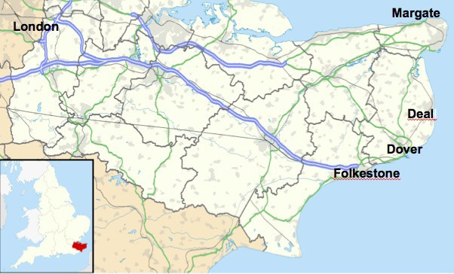
Figure 1. Coastal Towns in South east england
Source: Author’s own.

such as Margate, Folkestone or Deal (see Figure 1) where asylum seekers and refu- gees lived in the unwanted housing stock and decaying hotels. Kent is also the ‘Garden of England’ and there is a long history of a Romany contribution to local agriculture from seasonal hop picking to knife sharpening. The intensification of the ‘moral panic’ about asylum seekers in Kent—some of whom were Czech Roma— articulated emergent forms of xenophobia and the longstanding racism directed at Roma more broadly.

The Making of the Asylum CD
The Asylum project (see Figure 2) was an attempt to create a resource that would have a kind of affective grip on the young Roma who were experiencing racism and also constitute a critical opening for young working-class whites caught up in the racist cultural maelstrom. The driving force behind this was the Kent-based educator and activist Richard Robinson. The project was funded from educational grant of
£15,000 from a charity called the Prince’s Trust. The charity stipulated that it had to be a non-profit-based initiative and the project promised to create a free educational website. The Asylum album provides a historical narrative linking the Porajmos (the Romany holocaust) during the Third Reich with the contemporary circumstances of refugees. While addressing the specificity of this experience, the project also aimed to address universal rights and dimensions of human experience.
The sleeve notes of the CD expressed its political intent: ‘At the heart of all human experience there is a fundamental need we all share, to be safe and secure in the place and space we inhabit. The concept of asylum is fundamental to any discussion about basic human rights and basic human needs ...’ (Asylum, 2001). Its utopian rhetoric is reminiscent of Paul Gilroy’s attempt to open up the historiography of the debate

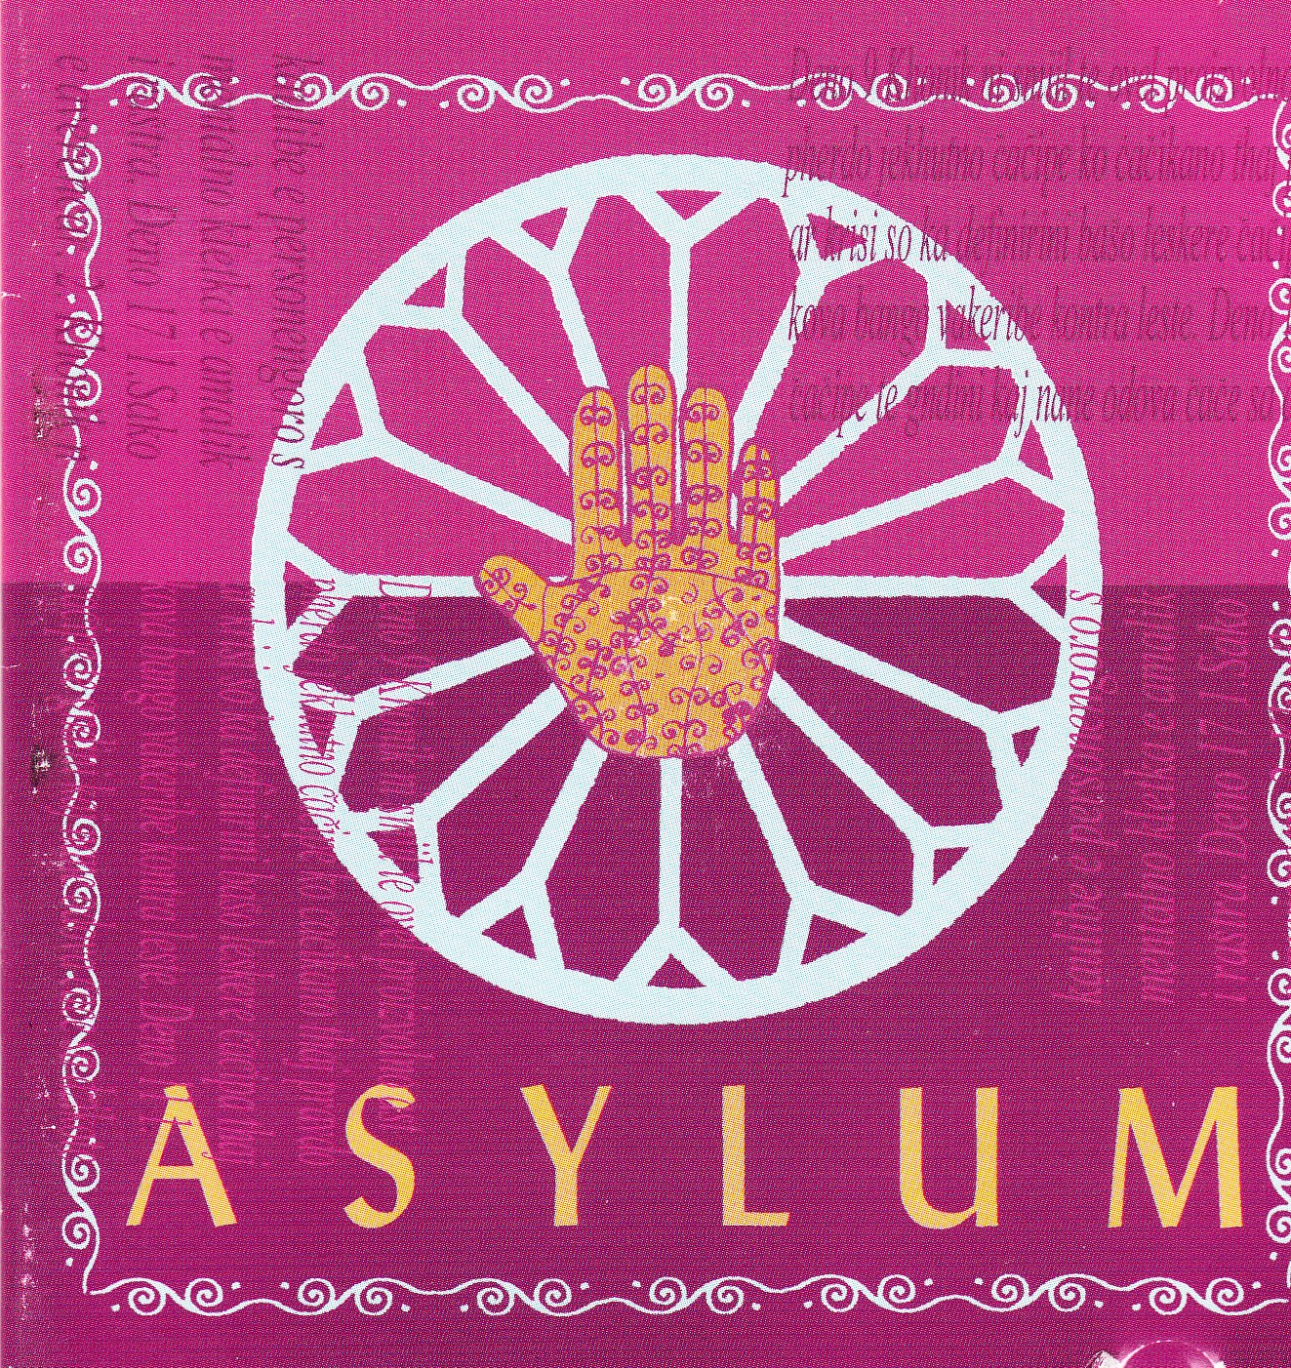

Figure 2. Asylum, 2001
Source: Reproduced, permission by Richard Robinson.

about human rights and its relationship to anti-slavery and anti-racist movements (Gilroy, 2010). Aesthetically, the project was inspired by the Asian dance music that emerged in the 1990s. Richard Robinson explained where the idea came from: ‘The whole journey really started accidentally when a friend brought to my atten- tion a £2.50 tape he had purchased in Brick Lane of Bengali Baul music illegally remixed by twenty-two-year-olds from east London.’ This contemporary music used the voice of the Baul singer Kala Miah. Inspired by the idea, Richard Robinson met with members of the East End London collective Asian Dub Foundation who had visited his school in Deal, Kent, to perform for the young people.
At the heart of Asian Dub Foundation was an ethos of combination creating link- ages between dancehall reggae and MCing with hip-hop and drum and bass, and the cultural resources drawn from the south Asian diasporic experience. They refused to be exoticized or orientalized. ADF emerged out of Community Music in Farringdon, London, at the Community Music House, an organization/music laboratory for established and aspiring musicians where bassist Aniruddha Das—Dr Das—taught music technology. He teamed up with one of his students, rapper Deeder Zaman and civil rights worker John Pandit—DJ Pandit G.—to form a sound system to play at anti-racist gigs. They described their music in the following terms: ‘ADFs distinctive sound is a combination of hard ragga-jungle rhythms, indo-dub bass lines, searing sitar-inspired guitars and “traditional” sounds gleaned from their parents’ record

collections, shot through with fast-chat conscious lyrics’ (quoted from Asian Dub Foundation Website http://www.asiandubfoundation.com/?page_id=204, accessed 22 September 2012). It was three of these young MCs, a group named Invasian, that principally worked on the Asylum record. These east London-based DJs—Spex aka Afjal Miah, Aktar Ahmed and ‘Lord’ Camacho—collaborated on making the music with Czech and Polish Roma musicians such as the Miko Brothers and Polish Romany collective Romani Rad.
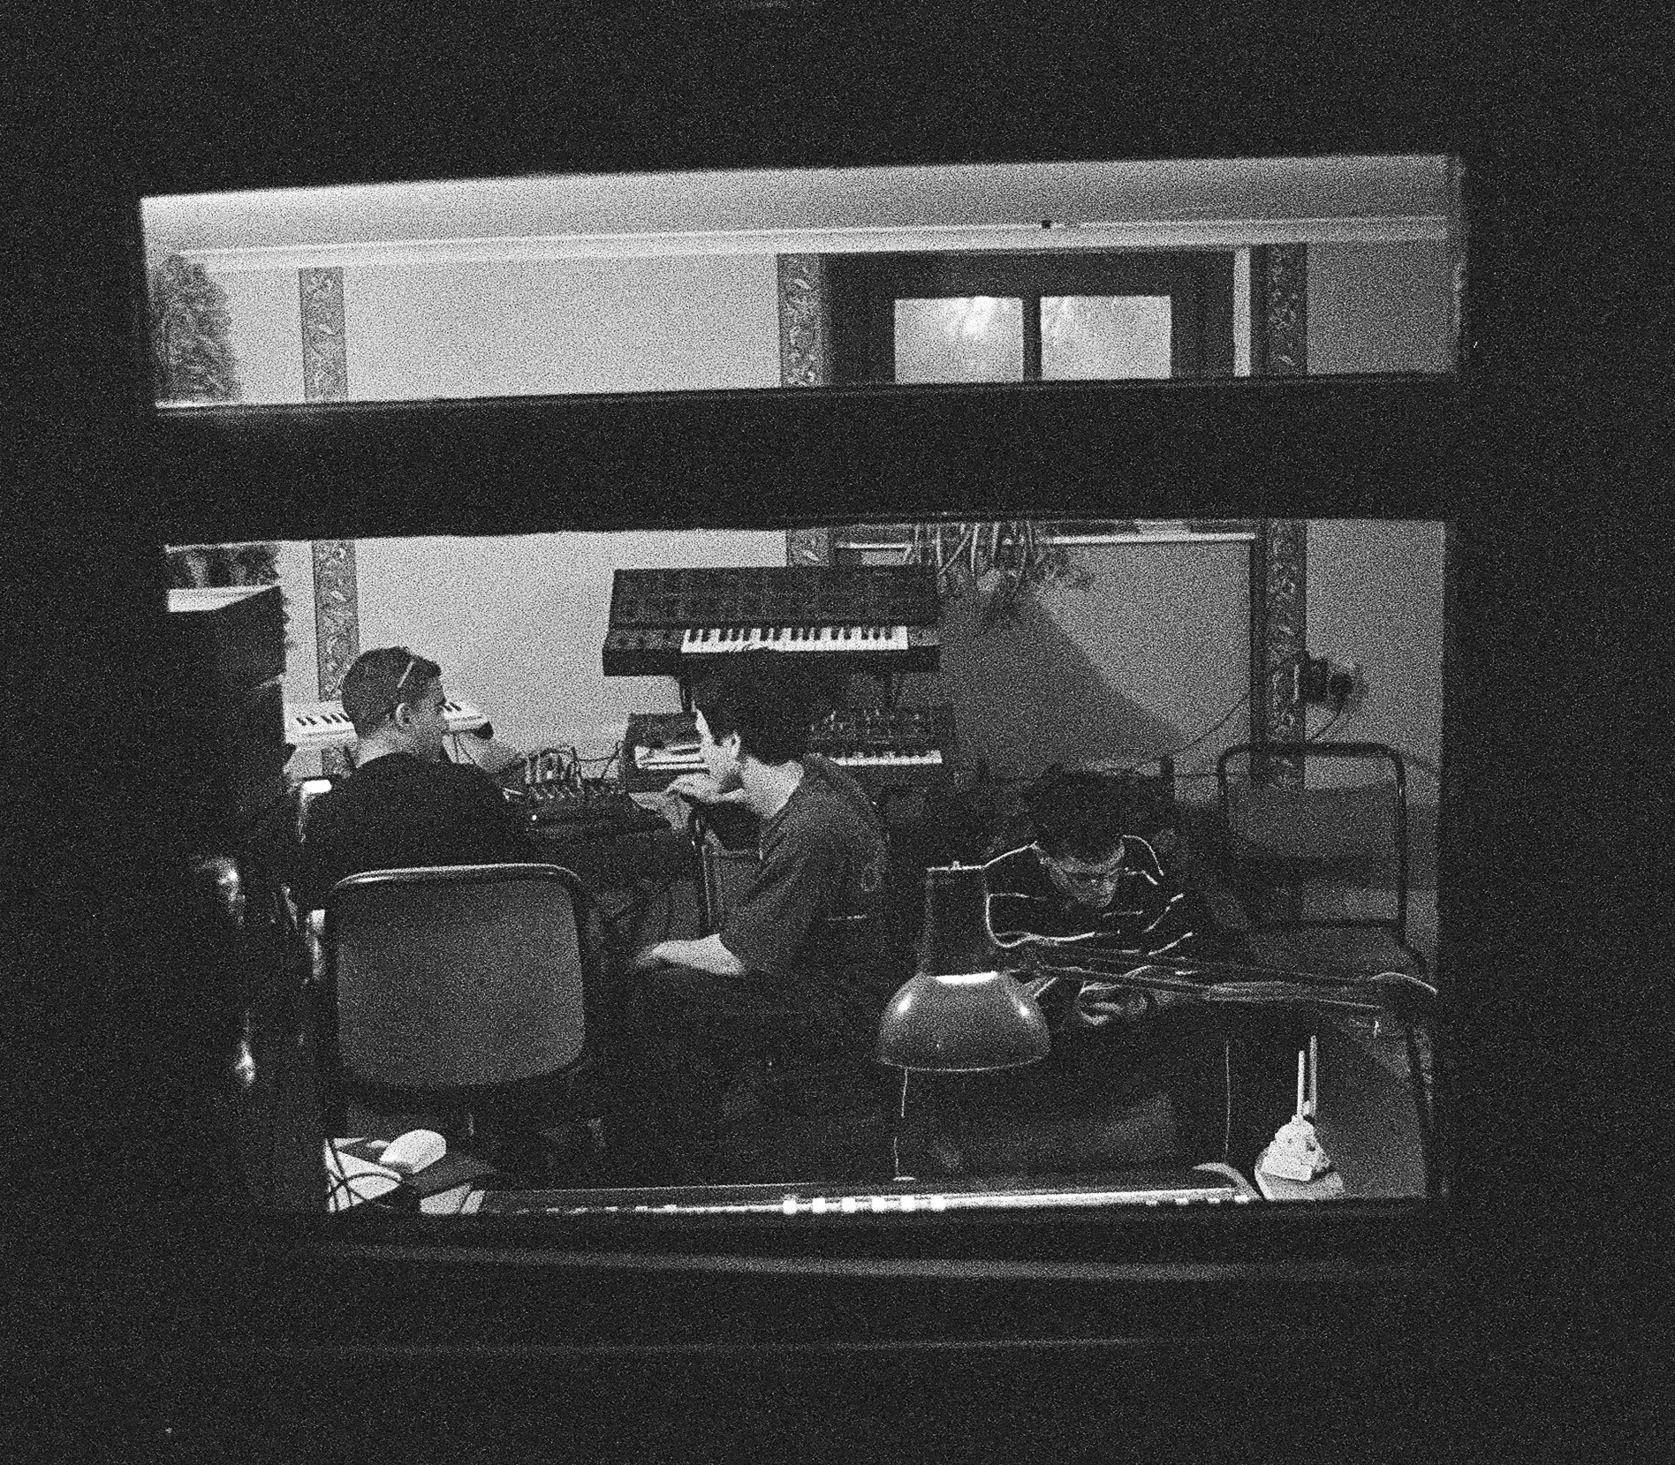
In setting up the connections between people, music was being sent by email attachments and ideas generated through a virtual network. In July 2000, Romani Rad—a 40-strong group of dancers and musicians—came to Kent with Aktar, Spexs and Lord and the Miko Brothers from the Czech Republic and played music together. In addition to this, DAT tapes were sent from Budapest, Hungary, where musicians such as the Silvassy folk band were involved. They were also remixing traditional folk music and using traditional instruments and percussion on milk churns to create music that sounded like garage music with a Romany accent. Also, DJ Mango of Anima Sound System—a Hungarian electronic band founded in 1993—worked on some of the samples and Transglobal Underground donated samples that did not make it onto the album. Then, after this extraordinary trafficking of sampled sounds, Aktar, Spexs and Lord remixed the record in a day (see Figure 3).

Figure 3. In the Studio, 2001
Source: Photograph by Peter emptage, permission by Richard Robinson.

This music—which was about the impact of immigration control and xenophobia— was being made ‘without borders’. While musicians could not always move freely, the music did, creating links between London, Deal and Budapest. Richard Robinson explained humbly: ‘I have no musical expertise. What I just did was put people together. I sent the DATs to Hungary ... and then it came back and it was re-mixed’ (Interview, 12 July 2002). As the tapes containing the sounds moved across borders, they articulated the connection between a diverse range of people, many of whom never met and com- municated only through emails.
As the sounds moved from place to place, they were also sequenced differently and recomposed. Asked about his favourite track Richard Robinson replied:

It has to be ... something called Czech this Out. I remember it very well because we had a musician who was Czech Roma called Stefan Miko who was very influenced by Stephan Grapelli’s jazz music and basically had a very beaten up old guitar that he used and he brought it to the studio. Then a guy Aktar—who was one of the members of the Asian Dub Foundation—put it all through an MPC 2000—that’s like a mixing desk [Akai MPC 2000 Sampler/Sequencer]—and he sampled his guitar and then speeded it up and made it into like a drum and bass track ... What was amazing about it was you’ve got this man who is Czech Roma background playing jazz that then gets sped up by this guy from a drum and bass background and it made this incredible track called—Czech this Out. (Interview, 29 October 2013)

The music that was created by Aktar Ahmed from the transformed guitar sample in Deal became a commentary on Czech racism: ‘The original intention behind the track was to make a comment about an extremely right wing TV programme called Radio Nova that was encouraging Czech Roma to come over to Britain and was representing the UK as a kind of Garden of Eden to Czech Roma so that they would leave the Czech Republic en masse’ (Interview, 29 October 2013). The focus on issues of racism was signalled from the first track on the CD entitled Po Drom, which is a remix of a traditional Romany song about prejudice and racism. Cultures and musical traditions are recombined in a way that both challenges Czech racism and speaks to the cultural experience of young people in the UK.
Richard Robinson (see Figure 4) played a key role, regardless of his characteristic humility. It is the combination of his skill in bringing people together and the kinds of cultural capital he can work with (musical, subcultural, local and intellectual) that made the project possible. In the spirit of Anamik Saha’s (2012) emphasis on the ‘politics of production’, it is important to dwell on this for a moment. Robinson is a local school teacher, DJ and dance music enthusiast, a reader of cultural theory able to enlist and access the alternative institutions of musical production like ADFED, educationalists and school teachers, Roma community activists and also the odd professor of sociology. He is not doing this for commercial gain but throwing himself into a project that is invested in the idea of using music to bring people together: ‘I had the idea of creating an album of “conscious remixes” of Romany music that would try to challenge ... racist ideologies through music’ (Robinson, 2005: 5).
Community activist Sylvia Ingmire pointed out, when first I met her in 2002, there were other complexities here relating to the politics of Roma music. She explained that the Roma Support Group started in 1997 and Romani Rad began to perform as a group in 1998. Sylvia started as a volunteer at weekends working with asylum

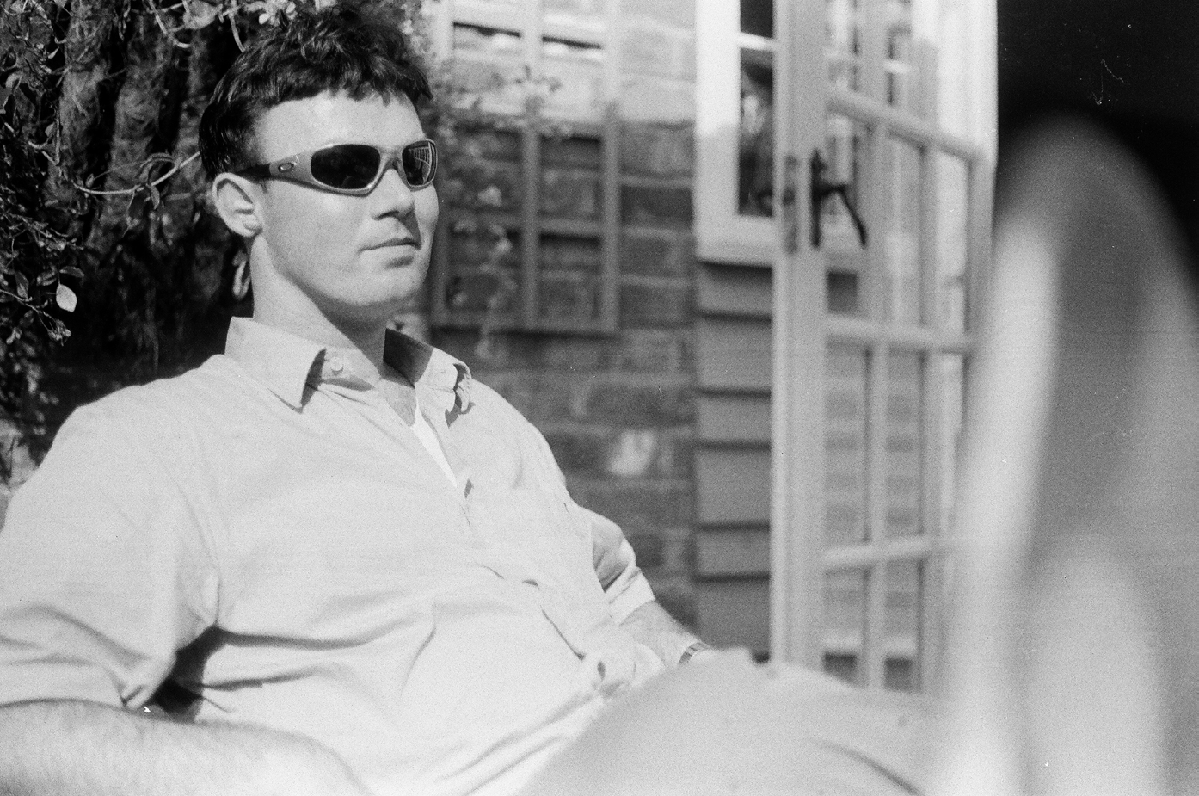

Figure 4. Richard Robinson in Deal, 2001
Source: Photograph by Peter emptage, permission by Richard Robinson.

seekers. She could speak Polish and her Polish language skills were the entry point to working with many of the Roma who came from Poland. She met lots of people very quickly.

Our work was immediately to assist the asylum seekers. People were being really exploited ... There was no way of guaranteeing good reliable legal advice. Crooked lawyers just took the money and didn’t offer anything. So there was a huge outcry and a huge need in the community. And the people involved were really suffering very badly. (Interview, 16 September 2002)

Sylvia continued: ‘We weren’t thinking about culture in those days. We were more thinking how to get people out of detention centres, how to get people the most basic rights and protections ....’ When the organization got premises in a church, two of the Slovak Roma started to play music and the music drew others in: ‘We had the Polish Roma, and they came and said “Hold on a minute, why can’t we do something?” And that was the beginning of Romani Rad’ (Interview, 16 September 2002).
When asked about her involvement in the CD project Ingmire said:

Yes, Asylum was really great. It was innovation and tradition at the same time—it was so cool. But the thing was, the music wasn’t real Gypsy music. The thing about Roma culture is that the music they play is the same as their grandfathers played and their grandfathers before them. In this sense, Roma cultures have their own identity.

When asked if the older Roma liked the CD Sylvia shook her head. She said, ‘It’s the young ones that really like it, the young ones really love the CD.’ Sylvia thought

for a minute and turned to Roza Kotowicz, who was sitting in the room. Sylvia spoke to her in Polish, then Roza replied in Polish ‘Katastrofa!’ ‘Had she said catastrophe?’ I asked. ‘Yes, she did,’ explained Sylvia.
For Roza the remixes were ‘intervening’ in the music of the Roma. Many middle- aged Roma did not like the idea of Roma and rap or street music being mixed together. Sylvia explained:

The young people really like it, it is exactly what they could relate to and have done. It wasn’t that Richard was taking things away; it wasn’t that Roma people hated it or anything like that, but it wouldn’t have been the kind of music that Roma people would have made them- selves. So in that sense what Roza’s saying is right, it was a kind of intervening.

Sylvia continued:

We were very committed, and the Roma website that Richard set up was brilliant, and it had a kind of agenda. And the music that they made had some Roma elements in it, and it was good, and it addressed the teenagers. What we play could be called very traditional. The CD, the Asylum CD, it’s not traditional. For them, that’s a very important thing to play, that is traditional, it’s real. It can’t be subjected to assimilation, to be used by others for their own reasons. So there were some people who weren’t so sure about the CD. But to be employed to make the music, to be paid for it was brilliant.

It is important not to gloss over the tensions within these musical collaborations. The fact that older Roma had reservations about this experiment points to how age and generation position, limit and specify the music’s affective power. As Stuart Hall commented there are always incommensurabilities within forms of cultural hybridity because they are forms of cultural translation that are rarely, if ever, complete (Hall, 2000: 226; see also Alexander et al., 2012). The question that remains is not simply whether or not Roza is right to characterize—even playfully—the CD aesthetically as a ‘Katastrofa’. Rather, it is more relevant for my concerns to ask—within these limitations—what the music did politically.

How Did Making the Asylum CD Become a Matter of Politics?
Within cultural studies the debate about popular culture has often been dogged by radical gestures and inflated or exaggerated political claims. The result is that poli- tics can become everything and nothing. As Jodi Dean points out: ‘The cliché that everything is political occludes how things are political. It does not tell us what makes an event or text, for example, a matter of politics’ (Dean, 2000: 6). Also, the notion of ‘cultural hybridity’ had been criticized for fetishizing fusion and for assum- ing that political transformation somehow follows from the fact of cultural dyna- mism (see Werbner and Modood, 1997).
In order to get beyond the rather tired terms of the debate, I want to argue for a careful evaluation that is situated in the context of production. Accordingly, I argue that one might understand the Asylum project at three different levels of political significance.
Firstly, this initiative brought different histories of migration—post-imperial, itinerant and globalized freedom seeker—into a conversation with one another. This

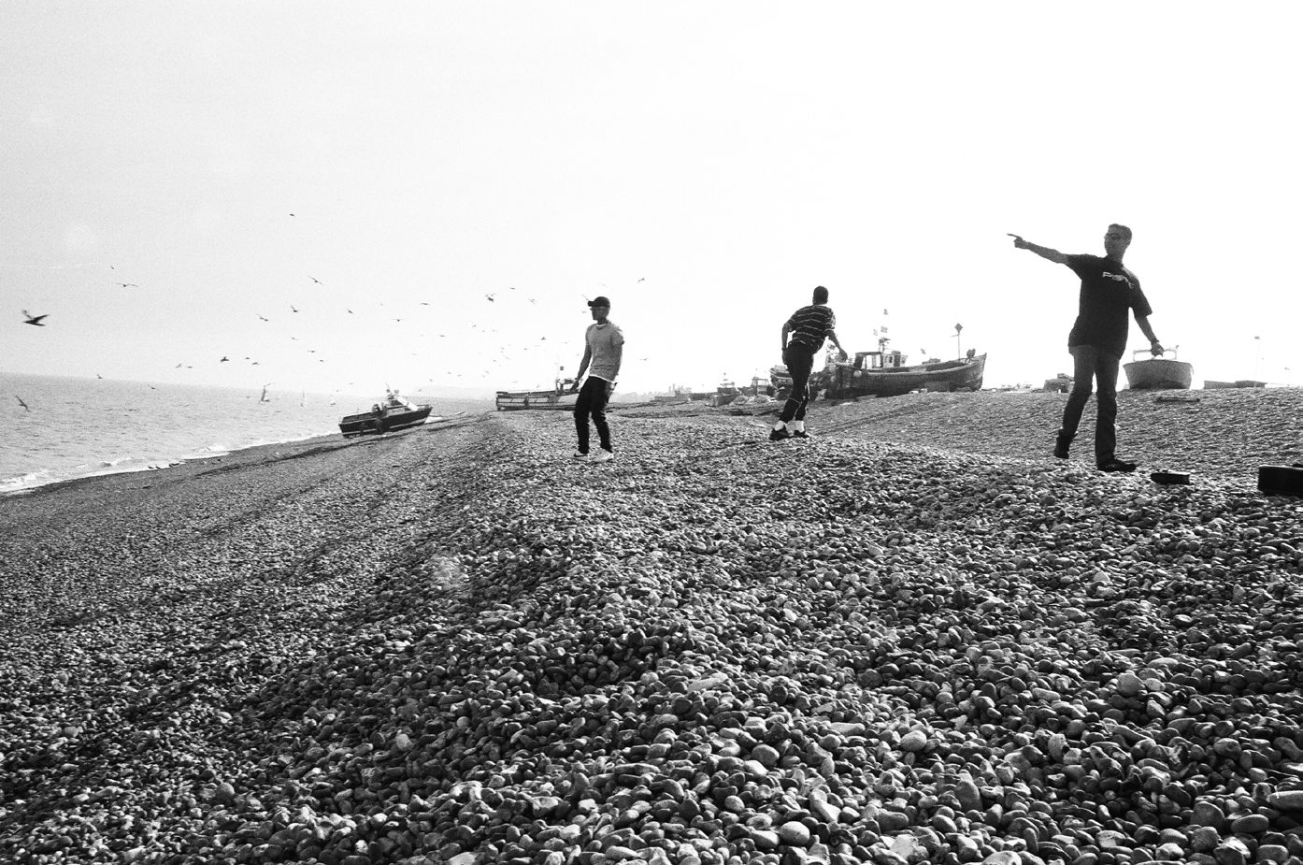

Figure 5. Aktar, Spexs and Lord Throwing Stones on Deal Beach, 2001
Source: Photograph by Peter emptage, permission by Richard Robinson.

actually challenged and transcended the political logics outlined earlier that seek to separate the colonial past from the current debate about global population mobility. As Street (2012: 165–67) notes, part of music’s power is its deliberative capacity. Here, at the heart of the productive process, music was being made by young people that brought together different histories and experiences of migration.
The relationship between the music’s cultural politics and racism was brought to life starkly in the midst of completing the album. The three young Bengali DJs took a break in the recording session to throw stones on the beach (Figure 5). As they did they witnessed the British National Party marching along the seafront on their way to lay a wreath in Deal (see Figure 6). The march was commemorating the bombing of the Royal Marine School of Music in Deal by the IRA (Irish Republican Army) in 1989, an incident that killed 10 soldiers. Richard Robinson remembered:

It was a surreal situation ... As they were walking past I had this moment where eye contact was made and they saw three Bengali lads who really stood out in Deal. It was really poi- gnant to be doing all this music in Deal and then to have a reality check coming out. It was all very well talking about unity and everyone getting on—dissolving cultural boundaries. Then you had—right in your face you had—the BNP walking past. I was with Romany and Bengali Bangladeshi guys who really did stand out. (Interview, 12 July 2002)

Secondly, for the asylum seekers, making music provided a way to establish tenure within British society and cope with the out of time ‘bare life’ of the asylum experience. The education grant helped buy musical instruments and it also meant that letters could be written to the Home Office and the UK Border Agency in support of each musician’s asylum claim. In this sense, the project contributed to

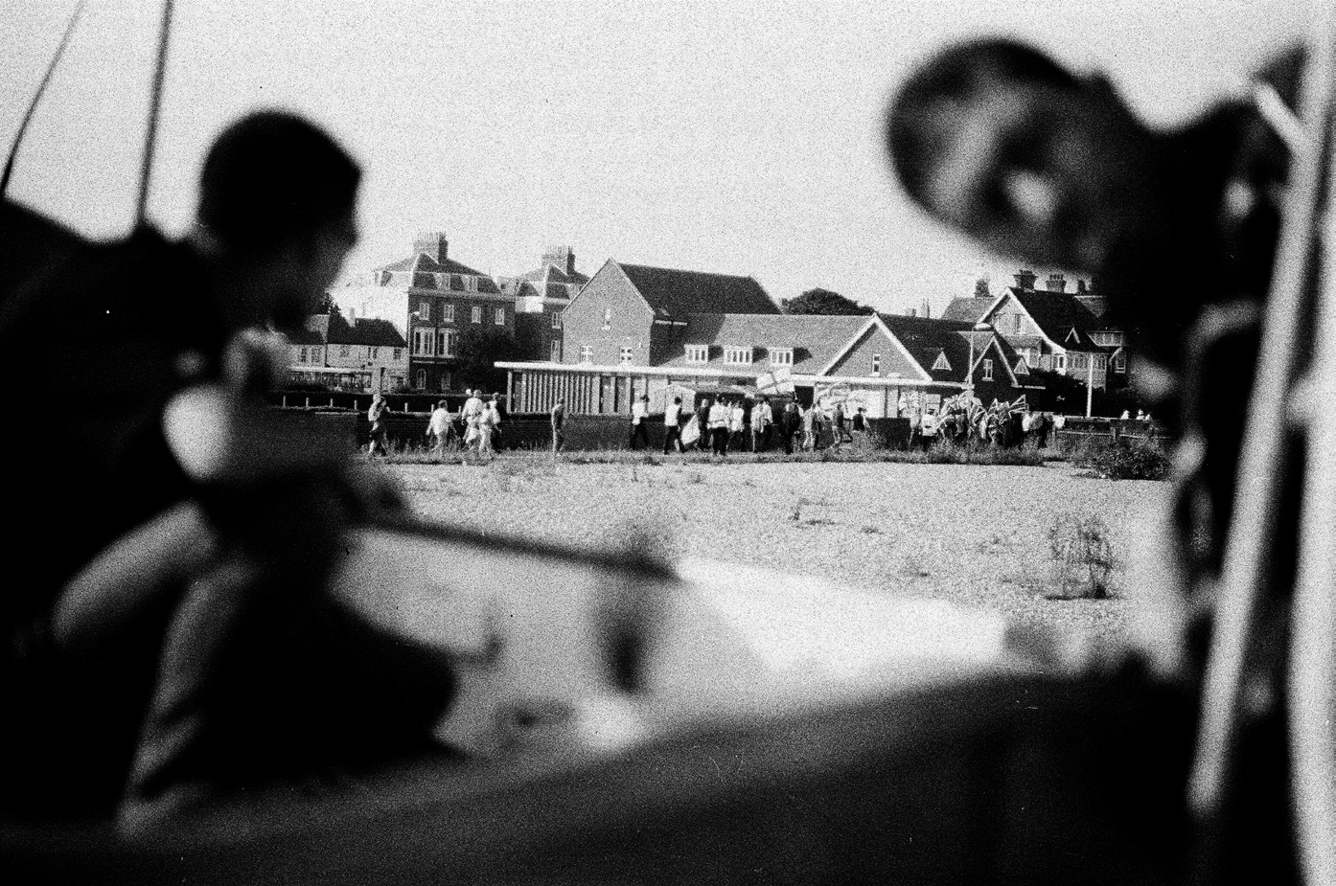

Figure 6. The British National Party Marching in Deal
Source: Photograph by Peter emptage, permission by Richard Robinson.

the securing of asylum as well as representing the experience of being a refugee. The musicians themselves were people who had been written out of the system and were defined politically as unwanted human waste (Bauman, 2004). Making the album helped create and extend a network of performers and artists. The Miko Brothers, for example, appeared briefly in Last Resort a film released in 2000 by Paul Pawlikowski about the plight of asylum seekers in Britain.
Many of the musicians involved in the Asylum CD were offered sessions and employment as a consequence. Richard Robinson takes up the story.

One day I was on my computer and there was an email from someone I didn’t recognize and it was Terry Hall’s manager and he asked if it was possible for me to put him in contact with the musicians from the [Asylum] album. All I simply did was pass on the Romani Rad’s manager’s details to Terry Hall’s manager. Never thought anything of it, then in 2003 The Hour of Two Lights came out and I realized when I happened to open the CD. Inside it were pictures of Romani Rad. My part in that was just literally putting them in contact with Romani Rad and the management but for me personally I had grown up lis- tening to The Specials and it was kind of ... a moment. Terry Hall had some experience of migration in his ancestry ... and that’s what linked the whole thing together. He said about his tangled roots and for me that was the whole thing behind the album—all our tangled roots. (Interview, 29 October 2013)

Terry Hall had been led to the Asylum project through the website set up to accom- pany it. The Hour of Two Lights was in a sense the realization of a similar vision for the twenty-first century. It was made in collaboration with producer Mushtaq— formerly of Fun-Da-Mental who were part of the new Asian dance music move- ment, and born in London of Bangladeshi and Iranian parents. The album’s title was

inspired by the three years of Mustaq’s childhood that he spent in Iran. He explained: ‘There’s a folklore which prohibits young children from playing out during a certain hour because negative spirits come out. It’s the hour of two lights: the end of day and the beginning of night, not quite settled’ (Lynskey, 2003: 1). It is an appropriate metaphor for the opportunities that open briefly even at a moment of looming danger and risk.
The album included a wide range of performers—from a 12-year-old Lebanese singer, a blind Algerian rapper, a septuagenarian Jewish clarinettist and members of Romani Rad recruited from the Asylum project. Terry Hall told journalist Dorian Lynskey:

There was a huge political statement being made with The Specials. You just had to look at a photo and you got it. That’s exactly what we feel about this. If you have Arabic and Hebrew on the same record, you’ve made a political statement. I’ve been through the whole standing-on-a-box thing and it’s great, but it gets sort of dangerous. The idea of suggestion sometimes is good. (Lynskey, 2003: 1)

Hall was handed a Star of David as a child but did not realize at the time that his grandfather was a German Jewish watchmaker.
The Hour of Two Lights album in many respects was another realization of the ethos of the Asylum project. As Terry Hall points out, playing music kept the Romany musicians in the country and provided a means to support them against the scrutiny of the immigration system. Hall continued:

With Romani Rad, we were playing with people who had been firebombed out of their houses in Poland. The stories are very, very upsetting. Things like they don’t like bank holidays because their solicitor might go away at the weekend and that’s when they swoop and get deported. When I was growing up bank holidays were about ice cream and going to the river. (Lynskey, 2003: 1)

Music making provided a mechanism for political organization that is ‘summoned into existence’ in the face of hostile anti-immigrant times (see Street, 2012: 170).
Music making became a bridge to securing a future in Britain. Sylvia Ingmire said that for asylum seekers being involved in music routinely made a very real difference:

It was always helpful to be involved. We would write support letters saying that the person under review was a musician and contributing, and an important member of the Roma community. It’s often crucial for them in their cases .... And also we can help with writing letters and putting together their cases, and on the adjudication side with the Home Office. (Interview, 16 September 2002)

Thirdly, the music made as part of the Asylum project created a cross-cultural bridging or meeting point. During 2002, I followed Romani Rad around Kent to watch them perform in schools and community venues. One performance in particu- lar in Deal took place during a summer school ‘Cultural Diversity’ event. I was told that the white driver of the coach charged with taking Romani Rad to the school had been spouting racism throughout the journey. Arriving at the venue, the musicians and dancers disembarked and prepared for the show.

The show lasted about 40 minutes and included traditional Roma music and dance performed in full costume dress. It was uncomfortable to watch as here Romany culture was staged as an exotic form of culture diversity and otherness. There were murmurs of ‘fucking Afghans’—the latest in a long list of shifting racist epithets— among the assembled group of exclusively white 13-year-old boys and girls. There seemed more ambivalence in some of the reactions: I saw a young woman rehears- ing the swirling hand gestures of the Roma dances she watched perform on stage.
At the end of the performance Richard Robinson brought out the Asylum CDs. He mentioned there were ‘some drum and bass remixes on them’. The information spread quickly and the stage was rushed by a group of 15 white teenagers eager to grab a free copy. I want to argue that this is not just ‘sari and samosa’ decorative diversity identified so ably by the critics of multiculturalism (Sivanandan, 2006). Afterwards, the young Roma women said how much they liked the CD and the re- mixes offered them an extended way to link across their past and present. While the producers of the music were largely young men—which limited its inclusiveness around questions of gender—for the young women dance music and popular culture also offered them alternative and supplementary ways to embody, try out or express their femininity.
Sylvia Ingmire recounted similar stories of racism and hostility faced by Romani Rad when they performed at events and festivals, even ones that proclaimed liberal views on diversity and anti-racism. She also described moments where music facili- tated a space for dialogue and recognition: ‘The good thing about the Asylum CD and the music meant that we also got involved in the classes in music technology that were set up by Asian Dub Foundation and others.’ She described taking one of the young men, John, to a music technology session to meet the tutor and the other students. Sylvia explained:

We walked through the door and John turns to me straight away, ‘Oh, I don’t like it,’ he said. ‘I don’t want to go inside. I almost had a fight with that boy.’ He pointed to a black boy, a black English boy who was sitting in the corner. I said to John ‘No, let’s stay, we’ll just stay and see your tutor, that’s all we need to do,’ and I had the CD in my bag, the Asylum CD. Then the tutor asked me about it, and I picked the CD out of my bag, and I gave it to him.

Sylvia continued:

John isn’t really a musician in Romani Rad, he dances, he mainly dances. He’s an accordion player too. So the tutor played the music, and then what happens? We had this kid, the kid that John had been in a fight with and was afraid of, he listened to the CD and he liked it. He said to John ‘Oh I like it’. He wanted to know what the instruments were and how they were played. And so this black kid starts to ask John, a young Roma, about the music. And so it was a kind of bridge, it was amazing really. (Interview, 16 September 2002)

The music worked, not because it was a vehicle for tolerating or understanding dif- ference but because through the sequencing of Roma music, drum and bass, garage and electronic rhythms the two boys became comprehensible to each other. It tapped into a shared likeness—producing a kind of vernacular anti-racism—that formed a bridge between them.
In another setting back in Kent, Richard Robinson spoke of how a young hip-hop- loving white man, a fisherman from Deal, got involved in the project. Previously this

young man had been involved in violence between local white youths and asylum seekers. He loved rap star Tu Pac Shakur—something in the script of subordinate black masculinity and hip hop spoke to his own post-industrial experience. Richard Robinson said:

There was him sat with the Romany guys talking about drum and bass music ... He would say to me, ‘I strongly believe they shouldn’t be in this country but then I realize a lot of things I like are from other cultures.’ He was starting to re-assess the hold that the BNP and others had on him. That was what persuaded me of the rightness of what I was doing. (Interview, 12 July 2002)

Then, on the other hand, young Romany men were drawn to the same sounds. Richard continued:

You had young Romany kids from the Czech Republic with a Tu Pac album. What can experience of an African American rapper mean to a young Romany kid? Is it so different from the popularity amongst some of the older Romany for Johnny Cash? There is a kind of identification with the wanderer, the displaced and ‘the man in black’ and the travelling minstrel. (Interview, 12 July 2002)

Through their musical tastes, the young people were sharing a sense of likeness and commonality across their differences. As Street argues: ‘Music can help con- stitute identities and communities; it can create organisation and institutions; it can embody ideals and values’(Street, 2012: 173). However fleetingly, the Asylum project provided an instance where the music itself is the doing of anti-racist politics.
In the decade that followed Asian Dub Foundation retained its commitment to anti-racism and addressing the political issues through their music. They toured the world to international acclaim, while retaining grassroots connections to local com- munities in east London and the plight of young people growing up in Britain’s damaged cities. Afzal Miah, who worked on the Asylum CD, performed with ADF as MC Spex and made three albums, toured Brazil and Japan and performed at Glastonbury three times. Spex left ADF in 2007 passing on the mic to his fellow Asylum collaborator Aktar Ahmed. Spex now works as a behaviour mentor with young people in east London.
As ‘MC Aktarv8r’, Aktar Ahmed continues to perform with ADF whose music is as political urgent as ever. In March 2012, ADF performed live at a screening of the film La Haine at Broadwater Farm Estate in north London on the eve of the London Mayoral elections. This area had been the scene of rioting the previ- ous summer after the shooting of Mark Duggan by the police in Tottenham on 4 August 2011. Original bass player and ADF founding members Dr. Das and drummer Rocky Singh rejoined the band for the performance. The live screening of La Haine was repeated at Le Trianon in Paris on the eve of the French Presidential elections. The screening of the film on the eve of the French Presidential election was provocative.
Looking back, Richard Robinson reflected on whether it would be possible to do projects like Asylum today:

I think it is still possible but I think it is more difficult than before. If I consider it’s now 2013 and when I did that it was 2001—in all that time things have got harder to do, not

only because of the funding being cut. I just think it’s much harder to work at that grass- roots level now.

In the years that have intervened he has remained actively involved in anti-racist education and continues to use the Asylum CD in his teaching. In 2008, he received Heritage Lottery funding to buy a Romany caravan or vardo and refurbish it with newly crafted wooden panels depicting different aspects of east Kent heritage.
The work of Asian Dub Foundation Education was severely affected by the loss of Arts Council funding in 2007/08. John Pandit—a founder member of ADF and anti-racist activist—reflected: ‘The problem with New Labour was that they never really thought through the legacy and there was no real thought about the long-term’ (Interview, 22 December 2013). As a result, community projects like Asylum were scaled down and now there is even less money for arts funding for projects like this one in the face of cuts in public sector funding.
‘I think the interesting question is: would the album from 2001 be possible now? It would be very interesting to re-do the album in 2013 or 2014’, Richard reflected. ‘It would be interesting to see if things have changed or if the issues have moved on. I think to some extent things have. The issue about Czech or Polish Roma coming over to Britain is an issue as much as it was in 2001. I guess the story doesn’t change really ....’ The Asylum CD project captured the new conjuncture of population mobil- ity, the ending of postcolonial migration and the new era of anti-immigrant politics. The Asylum story serves as a reminder for why music matters in a situation where refugees and globally displaced people are not allowed access to basic political rights or protection as citizens. In such a situation, playing music can make the dif- ference, as Terry Hall notes, between looking forward to another next gig or being
arrested and deported.

Conclusion
For intellectuals like Stuart Hall and Paul Gilroy, the flows of culture that move across national boundaries produce cultural systems that cannot be confined to a single place (Gilroy, 1987; Hall, 1992). The movement of the DAT tapes and the transnational coordinates—London, Deal and Budapest—of the music of the Asylum CD made by young people illustrates the connections between the close at hand and transnational linkages. This example also brings into focus the divisions that are being created within globally mobile humanity and hierarchies of belonging that are established as a result. To end, I want to return to the key arguments about why cul- ture matters in the discussion of the politics of migration.
Firstly, taking artistic expression seriously challenges the ways in which migra- tion and belonging are understood and how distinctions between immigrant and host are socially and politically produced. The cultural creativity emerging out of the experience of migration and multiculture as it is experienced by young people offer a challenge to ethnic exoticism and a superficial understanding of diversity.
It is in the cultural domain where we can also understand nationalism’s accommoda- tion with multiculture, as some black and brown threads are woven into the Union Jack while at the same time other minorities are excluded and vilified. Music and art prac- tices can talk back to the discourse of the ‘death of multiculturalism’ and ‘postcolonial

melancholia’ (Gilroy, 2004). They offer a very different de-centred notion of how we might understand the idea of ‘culture’ or ‘community’ as contested terms. Additionally, this kind of sensitivity challenges the presumption that ‘social inclusion’ is a stable and coherent arrival point. These expressive forms unsettle political common sense, or transrupt cultural norms, to use Barnor Hesse’s phase (Hesse, 2000).
Secondly, art and music can also constitute a space where alternative claims to belonging can be made within particular localities and it is in the cultural domain that a politics of presence is also contested. Around music, alternative forms of public life and youthful creative association were established that enabled a public life on different and more amenable terms. However, these alternative public spheres can also be subject to forms of neoliberal surveillance and regulations as they evolve. For example, Helen Kim shows that the commercial success of club spaces runs parallel to the use of neoliberal surveillance technologies (Kim, 2014). Here ‘clubscan—id recognition systems’ that scan identity details are used to police Asian male bodies on certain nights where the middle-class clientele and the police/local authority fear there might be ‘trouble’.
Thirdly, musical culture has a capacity to organize—be it the rhythm of the drum at a demonstration or Romany musicians gathering to support each other. In contrast to the political demands for ‘integration’ and ‘cohesion’, there is a value to the loose and unstable associations formed in the ambiguous and complex dialogues discussed in this article. They complicate the linear logic of inclusion and the idea that the boundaries are stable insides as well as outsides.
Fourthly, music can offer a politics of bridging. A cultural space of bridging combines difference and likeness, that which is common and yet not the same. Philosopher Martha Nussbaum called this a capacity to ‘live with and towards others’ (Nussbaum, 2006: 77). As Sanjay Sharma points out, music has the potential to act as a ‘site for translation’ (S. Sharma, 1996: 40). It is equally a site of incom- mensurability, a compound of those cultural qualities that can be interpreted and those that defy translation.
The value of the cultural creativity within these alternative public spheres is that it introduces plurality of young voices and experiences that cannot be easily contained by singular or even hyphenated categories of identity. The music sings a different song and suggests a more complex sociology of belonging that reflects how young people of migrant heritage actually live. Different terms of inclusion are established, albeit temporarily, as a result. In these paradoxical but vital moments we might also find a different model of what a functioning, unruly and noisy form of multiculture feels like, where freedoms are struggled for that are incommensurably tied to unfree circumstances.
As Jodi Dean argues, the process of how things become political is occluded in the claim that everything is a matter of cultural politics (Dean, 2000). Rather, I argue for a more modest claim for the politics of culture, at the same time as insisting that it is essential to broaden the understanding of politics itself. What become admissible in this approach are micro-political moments that establish a connection between youth, politics and everyday life including emotions and movements of imagination. Returning to the theoretical and empirical traditions of cultural studies offers a greater attentiveness to the doing of cultural politics, the politics of production and the capabilities and forms of collective flourishing (Hesmondhalgh, 2014) that can result from the formation of new ethnicities.

Acknowledgements
Special thanks Richard Robinson and Sylvia Ingmire for their help and tireless patience with this project. Also, special thanks to John Pandit and also Anamik Saha whose insights improved this article greatly. Some of the initial research for this article was made possible by a research grant from the Economic and Social Research Council Grant entitled Democratic Governance and Ethnic Minority Political Participation in Contemporary Britain ((L215252046) with Professor John Solomos, Professor Michael Keith and Dr Kalbir Shukra. I would like to thank the ESRC and my colleagues for their support. Finally, I would like to thank Jenn Tomomitsu, the editors and referees for their insights and recommendations.

References
Alexander, Claire (1996) The Art of Being Black. Oxford: Oxford University Press. Alexander, Claire., Kaur, Raminder and St Louis, Brett (2012) ‘Identities: New Directions in
Uncertain Times’, Identities: Global Studies in Culture and Power 19(1): 1–7.
Back, Les (1996) New Ethnicities and Urban Culture: Racisms and Multiculture in Young Lives. London: University College London Press.
Bauman, Zygmunt (2004) Wasted Lives: Modernity and its Outcasts. Cambridge: Polity Press.
Dean, Jodi, (ed.) (2000) Cultural Studies and Political Theory. Ithaca and London: Cornell University Press.
Gilroy, Paul (1987) Ain’t No Black in the Union Jack: The Cultural Politics of Race and Nation. London: Hutchinson.
——— (2004) After Empire: Multiculture or Postcolonial Melancholia. London: Routledge.
——— (2010) Darker than Blue: On the Moral Economies of Black Atlantic Culture.
Cambridge, MA: Belknap Press of Harvard University Press.
Hall, Stuart (1987) ‘Minimal Selves’, in Homi K Bhabha (ed.) Identity: The Real Me, Institute of Contemporary Art Documents 6, pp. 44–46. London: ICA/BFI.
——— (1988) ‘New Ethnicities’, in Kobena Mercer (ed.) Black Film British Cinema, Institute of Contemporary Arts, Documents 7, pp. 27–31. London: ICA/BFI.
——— (1992) ‘The Question of Cultural Identity’, in Stuart Hall, David Held and Andrew McGrew (eds) Modernity and Its Futures, pp. 274–316. Cambridge: Polity Press.
——— (2000) ‘Conclusion: The Multicultural Question’, in Barnor Hesse (ed.) Un/settled Multiculturalisms, pp. 209–41. London and New York: Zed Books.
Harris, Roxy (2006) New Ethnicities and Language Use. Basinstoke: Palgrave Macmillan. Hebdige, Dick (1979) Subculture: The Meaning of Style. London: Methuen.
Hesmondhalgh, David (2014) Why Music Matters. Oxford: Blackwell.
Hesse, Barnor (2000) ‘Introduction: Un/Settled Multiculturalisms’, in Barnor Hesse (ed.)
Un/settled Multiculturalisms, pp. 1–30. London and New York: Zed Books.
Jones, Simon (1988) Black culture, White Youth: the Reggae Tradition from JA to UK.
Basingstoke: Macmillan Education.
Kim, Helen (2014) Making Diaspora in a Global City: South Asian Youth Cultures in London.
London: Routledge.
Marshall, Lee (2011) ‘The Sociology of Popular Music, Interdisciplinarity and Aesthetic Autonomy’, British Journal of Sociology 62(1): 154–74.
Lynskey, Dorian (2003) ‘Fun Boy Free’, The Guardian, Tuesday, 22 July, URL (consulted 24 April 2015): http://www.theguardian.com/music/2003/jul/22/artsfeatures.popandrock Nussbaum, Martha (2006) Frontiers of Justice: Disability, Nationality, Species Membership.
Cambridge, MA and London: The Belknap Press of Harvard University Press.
Politics.co.uk (2005) ‘Cricket Test “Could Have Prevented Terror Attacks’’’, Politics.co.uk (consulted 19 August 2005): http://www.politics.co.uk/news/2005/8/19/cricket-test- could-have-prevented-terror-attack

Robinson, Richard (2005) ‘Romany Music’, presentation at University Greenwich, London, 1 July.
Saha, Anamik (2012) ‘Locating MIA: “Race”, Commodification and the Politics of Production’, European Journal of Cultural Studies 15(6): 736–52.
Sharma, Ashwini (1996) ‘Sounds Oriental: The (Im)possibility of Theorising Asian Musical Cultures’, in Sanjay Sharma, J. John Hutnyk and Ashwini Sharma (eds) Dis-orienting Rhythms: The Politics of the New Asian Dance Music, pp. 15–31. London: Zed Books.
Sharma, Sanjay (1996) ‘Noisy Asians or Asian Noise?’ in Sanjya Sharma, J. John Hutnyk and Ashwini Sharma (eds) Dis-orienting Rhythms: The Politics of the New Asian Dance Music, pp. 32–60. London: Zed Books.
Sharma, S., Hutnyk, J. and Sharma, A. (1996) Dis-orienting Rhythms: The Politics of the New Asian Dance Music. London: Zed Books.
Sivanandan, A. (2006) ‘Britain’s Shame: from Multiculturalism to Nativism’, Institute of Race Relations URL (consulted 22 May 2006): http://www.irr.org.uk/news/britains- shame-from-multiculturalism-to-nativism/
Street, John (2012) Music and Politics. Cambridge: Polity.
Werbner, Pnina and Modood, Tariq (eds) (1997) Debating Cultural Hybridity: Multicultural Identities and the Politics of Anti-racism. New York: Zed Books.

Author’s Bio-sketch

Les Back is a Professor of Sociology at Goldsmiths, university of London. His books include Live Methods with Nirmal Puwar (Wiley-Blackwell, 2012), Cultural Sociology: An Introduction with Andy Bennett, Lauar Desfor edles, Margaret Gibson, David Inglis, Ronalds Jacobs and Ian Woodward (Wiley-Blackwell, 2012), The Art of Listening (Berg, 2007), and New Ethnicities and Urban Culture: Racisms and Multiculture in Young Lives (university College Press, 1996). In 2011 he published a free online book called Academic Diary (http://www.academic-diary.co.uk/) that argues for the values of scholarship and teaching. He also writes journalism and has made documentary films.

