Title: Action preparation modulates sensory perception in unseen personal space: an electrophysiological investigation.

Xavier E. Job¹, Jan W. de Fockert¹, José van Velzen¹

Affiliation:
¹Department of Psychology
Goldsmiths, University of London
Lewisham Way
New Cross
London
SE14 6NW
United Kingdom

e-mails: x.job@gold.ac.uk
j.de-fockert@gold.ac.uk
j.vanvelzen@gold.ac.uk

Corresponding author:
José van Velzen
e-mail: j.vanvelzen@gold.ac.uk
Abstract
Behavioural and electrophysiological evidence has demonstrated that preparation of goal-directed actions modulates sensory perception at the goal location before the action is executed. However, previous studies have focused on sensory perception in areas of peripersonal space. The present study investigated visual and tactile sensory processing at the goal location of upcoming movements towards the body, much of which is not visible, as well as visible peripersonal space. A motor task cued participants to prepare a reaching movement towards goals either in peripersonal space in front of them or personal space on the upper chest. In order to assess modulations of sensory perception during movement preparation, event-related potentials (ERPs) were recorded in response to task-irrelevant visual and tactile probe stimuli delivered randomly at one of the goal locations of the movements. In line with previous neurophysiological findings, movement preparation modulated visual processing at the goal of a movement in peripersonal space. Movement preparation also modulated somatosensory processing at the movement goal in personal space. The findings demonstrate that tactile perception in personal space is subject to similar top-down sensory modulation by motor preparation as observed for visual stimuli presented in peripersonal space. These findings show for the first time that the principles and mechanisms underlying adaptive modulation of sensory processing in the context of action extend to tactile perception in unseen personal space.
Keywords: Action, perception, visual, tactile, personal, body.
- Introduction
Planning and executing adaptive movements requires the relevant sensory and motor systems to work in concert. Before movement can be carried out information from the senses needs to feed into the movement plan and sensory motor transformation needs to be carried out. Despite this, perceptual and motor processes have classically been understood as individual and isolated processes, with perception serving to provide information about the external environment and action serving in the selection, preparation and execution of goal-directed movements. Recent behavioural (Deubel, Schneider & Paprotta, 1998) and electrophysiological (Eimer, Forster, van Velzen & Prabhu, 2005; Eimer, van Velzen, Gherri & Press, 2006; Gherri & Eimer, 2010; Gherri, van Velzen & Eimer, 2009; Baldauf & Deubel, 2009) studies however have demonstrated that preparation of reaching or hand movements alters the sensory processing at or near to the goal location such that visual perception is facilitated. This suggests a tight coupling between action and perception as sensory perception is facilitated by the action that is being planned.
The top-down modulation of sensory processing by movement preparation is interpreted as a mechanism that prioritises the processing of action-relevant stimuli in the environment. Top-down modulation of task-relevant sensory information has typically been attributed to mechanisms of attentional selection, whereby attending to a location in space facilitates responses to stimuli presented in the attended versus unattended location (Posner et al, 1980; Posner & Dehaene, 1994; Heinze, Luck, Munte, Gös, Mangun & Hillyard, 1994). There is a remarkable similarity between the enhanced perceptual processing of stimuli at attended locations during covert spatial attention tasks and the enhanced perceptual processing of stimuli at locations of upcoming eye movements during saccade tasks (e.g. Deubel & Schneider, 1996; Hoffman & Subramaniam, 1995, Irwin & Gorden, 1998; Shepherd, Findlay & Hockney, 1986). The similarity between these effects suggests movement preparation and attention share common control mechanisms. Investigations with non-human primates have also shown that spatial attention and eye-movements rely on overlapping brain structures as stimulation of frontal eye field (FEF) neurons results in saccades towards the receptive fields of the neurons stimulated (Shiller & Tehovnik, 2001), whilst subthreshold stimulation of the same neurons facilitates target detection at those locations without causing saccades to be executed (Moore & Fallah, 2004). Analogous evidence in human subjects is made possible with the use of non-invasive techniques of brain stimulation. Stimulation of the FEF with trans-cranial magnetic stimulation (TMS) can result in the selective facilitation (van Ettinger-Veenstra et al, 2009) or impairment (Neggers et al, 2007) of behavioural responses to targets presented at the location of upcoming saccades. fMRI studies have also identified overlapping brain regions activated during tasks of attentional orienting and movement preparation (Astafiev et al, 2003; Corbetta et al, 1998; Perry & Zeki, 2000).
Several theoretical accounts have been drawn up to conceptualise the links between attention and motor preparation. For example, the premotor theory of attention (Rizzolatti, Riggio, Dascola, & Umiltá, 1987; Rizzolatti, Riggio & Sheliga, 1994) accounts for the coupling of action and attention by challenging the idea that separate control mechanisms govern the two processes. Behavioural evidence suggests that control mechanisms of spatial attention cannot be separated from the control of action (Rizzolatti et al, 1987 Rizzolatti et al, 1994; Sheliga et al, 1995; Deubel & Schneider, 1996), suggesting that attention may derive from the activity of sensorimotor circuits rather than from a dedicated ‘attention centre’. The premotor theory assumes that the cortical circuitry in which space is represented is also responsible for the programming of movements relevant to different effectors (i.e. eye, hand or arm). These cortical circuits responsible for spatial representation and motor programming are termed ‘spatial pragmatic maps’ and refer to dedicated dorsal brain structures primarily located in the inferior parietal lobule that have also been suggested to be responsible for the processing of action (e.g. Goodale & Milner, 1992). The theory posits that attention is derived from the activation of neurons within spatial pragmatic maps responsible for the programming of spatially guided actions.
The majority of evidence for shared control mechanisms of attention and action is concerned with saccadic eye movements and shifts of visual-spatial attention. Other forms of spatially guided movements, however, are similarly accompanied by shifts of attention. Performing pointing movements facilitates visual perception at the goal location of the movement (Deubel, Schneider & Paprotta, 1998; Linnell, Humphreys, McIntyre, Laitinen & Wing, 2005), suggesting attention shifts towards the goal before the movement is executed. Enhanced early ERP components such as the N1 elicited by visual probe stimuli presented near the location of a planned manual movement have been identified (Eimer, van Velzen, Gherri & Press, 2006; Gherri & Eimer, 2010). Preparing a reaching movement similarly enhances the early probe-evoked N1 at the goal location of the movement (Gherri, van Velzen & Eimer, 2009) as well as at the multiple goal locations of sequences of reaching movements (Baldauf & Deubel, 2009). The probe-evoked ERP technique is well suited to investigating modulations of perception at early processing stages. The technique is based on the assumption that stimuli presented within an attended region of space elicit enhanced early sensory ERP components compared to stimuli presented within an unattended region of space, irrespective of the task relevance of the stimulus (Heinze et al, 1994). For instance, enhanced amplitude of early components evoked by task-irrelevant visual probe stimuli have been reliably used as an indication of increased processing resources allocated to a region of space during visual-spatial attention tasks (Hillyard, Vogel & Luck, 1998). These modulations of sensory processing (within the first 200ms post stimulus) provide supporting evidence for an early mechanism of selection involving the amplification or sensory gain of processing within attended regions. The probe evoked ERP technique has therefore demonstrated that shifts in visual-spatial attention are not only tightly linked to oculomotor programming, but also to the programming of manual, reaching and pointing movements.

The majority of studies investigating effects of manual movement preparation on sensory processing have taken place in peripersonal space; the area of space around the body but within arms’ reach. Sensory information in these areas of space can arise from touch, vision and audition and actions made into peripersonal space can involve reaching, grasping as well as eye movements. The demonstrated links between visual processing at action relevant locations and movement preparation establish a profile of spatial processing that facilitates the planned action. This profile is temporally dynamic (Mason, Linnell, Davis & van Velzen, 2015) and has been shown to highlight goal locations and the location of the effector, suggesting a mechanism that adaptively facilitates processing at several action-relevant locations ahead of action execution.
An open question remains whether the observed links between action preparation that have been established in peripersonal space can also be observed for personal space; the area of space directly on the body surface. Depending on the area of the body surface, locations in personal space are not always accessible to vision and in this case information about these areas arises primarily from touch. Movements towards these areas of personal space are functionally different to those in peripersonal space; they often serve to touch the body, e.g. to scratch an itch, or to bring food toward the mouth. Further, when movements are directed toward unseen locations on the body, for example the upper chest, these movements are mainly guided by proprioception. There have so far been no systematic investigations into modulation of perception at the goal of movements towards the body surface. Whilst visual input has an important role to play in preparing movements towards peripersonal space, vision of the goal location is usually not available for movements into personal space, which rely more on tactile and proprioceptive information.
A number of recent findings have extended the links between movement preparation and perception to include the processing of tactile stimuli, for example enhanced behavioural performance to tactile events presented at the location of an upcoming saccade has been reported (Rorden, 2002; Juravle & Deubel, 2009). Gherri and Eimer (2008) also provided electrophysiological evidence for enhanced processing of tactile stimuli presented at the goal location of a saccade, as demonstrated by increased amplitude of the somatosensory N140 component elicited by tactile stimuli presented at the location of an upcoming saccade, relative to the opposite location. The preparation of manual movements also modulates the somatosensory N140 elicited by tactile stimuli presented to the effector hand (Forster & Eimer, 2007). Although tactile processing on the hands was investigated in these studies (Rorden, 2002; Gherri & Eimer, 2008), the stimulated hands were positioned in peripersonal space in front of participants and thus occupied a region of space that is also accessible to vision.
An unanswered question remains whether tactile processing in personal space is modulated by movement preparation toward the body, in a similar fashion to visual processing in peripersonal space. If the programming of all spatially directed movements results in shifts of attention, then the preparation of a movement towards personal space should modulate tactile processing at the goal location, irrespective of the availability of visual information about the goal location. This hypothesis is addressed with the use of event-related potentials in response to stimuli delivered during the planning of goal-directed movements towards personal and peripersonal space. This study employs a motor task in which participants are cued to prepare a reaching movement to a goal location in either personal or peripersonal space. Tactile processing in an unseen area of personal space is assessed during movement preparation using task-irrelevant tactile probes delivered to the sternum area of the chest. Tactile probe-evoked ERPs elicited during personal movement preparation are compared to ERPs elicited by the same tactile stimulus during peripersonal movement preparation. The somatosensory N140 ERP component is expected to show enhanced amplitude during the preparation of a movement towards personal space, relative to peripersonal space. Similarly, task-irrelevant visual probes are presented at the goal location of the peripersonal movement. Visual probe evoked ERPs elicited during peripersonal movement preparation are compared to ERPs elicited during personal movement preparation. Early visual ERP components such as the P1 and N1 are expected to be enhanced during movement preparation towards peripersonal space relative to personal space, similar to previously reported findings (Eimer et al, 2006; Gherri et al, 2009, Gherri & Eimer, 2010). Thus, this study will address for the first time whether the previously observed effects of movement preparation on visual processing in peripersonal space extend to tactile processing in unseen space.
- Method
  - Participants
Sixteen participants volunteered to take part in the experiment (five male and eleven female aged between 22 and 33 years old, M = 25.5, SD = 3.9). All participants were right handed and reported normal or corrected to normal vision. All participants provided written informed consent in accordance with the ethical guidelines presented in the 1964 declaration of Helsinki and approved by the Department of Psychology at Goldsmiths, University of London.
  - Stimuli and Task
A GO/NOGO task was implemented using E-Prime software (Schneider, Eschman & Zuccolotto, 2002) and consisted of auditory cues presented through speakers symmetrically aligned 35cm in front of participants. The auditory cue and the response required were counterbalanced across participants; half of participants prepared a movement towards the peripersonal goal after the presentation of a high tone (1 kHz) and a movement towards a personal goal following a low tone (0.4 kHz) and the reverse was true for the remaining half of participants. Eight hundred milliseconds after the presentation of the auditory cue either a visual probe was delivered at the peripersonal goal or a tactile probe was delivered at the personal goal (see Figure 1 for illustration of trial procedure). The visual probe consisted of an LED (2cm in diameter, subtending 1.91° in visual angle) presented for 200ms. The tactile probe was delivered by two solenoids, driving a blunt ended metal rod that contacted the skin when a current was passed through them. The tactile device was attached with an adhesive sticker to the upper sternum. White noise (62 dB SPL) was played throughout the experiment in order to mask any sounds made by the tactile device. Recorded vocalisations of “Go” and “Stop” served as Go and Nogo stimuli. Responses were collected using a custom-made response panel. This panel consisted of two infrared response devices embedded at 30cm and 60cm from the panel’s edge. The infrared device situated closest to the body (30cm) acted as the starting point for movements and as the fixation point. The device registered the moment the hand was lifted from the central starting point of the movement. Responses made towards peripersonal space were recorded using the further infrared response device (60cm from the participant), which registered a response when the hand landed on the device. A touch sensitive device attached to the chest recorded the time at which the hand arrived at the personal goal. A total of 480 trials divided into blocks of 60 trials were run with self-timed breaks between blocks. There were 120 trials per condition (peripersonal/visual probe, peripersonal/tactile probe, personal/visual probe, and personal/tactile probe. Within each condition, there were 96 Go trials and 24 No-Go trials. The arm with which participants completed the movement was also counterbalanced across the eight blocks of trials. The total duration of the experiment was approximately 45 minutes.
  - Procedure
Participants were seated in a sound-attenuated, dimly lit and electrically shielded chamber. Responses were made with an arm movement to a cued goal location in front of the participant or on their chest whilst fixating their eyes on a central starting location between the two goals (see Figure 1). Participants were asked to prepare a movement according to the auditory cue and to subsequently execute the movement as fast and accurately as possible following the auditory GO signal. They were instructed to return their hand to the middle location after reaching the goal location and await the next trial. Participants first completed a practice block of 40 randomised trials, followed by a block of 480 trials with a pause every 60 trials after which participants verbally informed the experimenter to continue with the next 60 trials. With each block of 60 trials participants were instructed to change the arm with which they completed the movement. Stimulus onset asynchrony (SOA) between the response and the cue of the following trial was varied to be 1000ms, 1100ms or 1200ms.
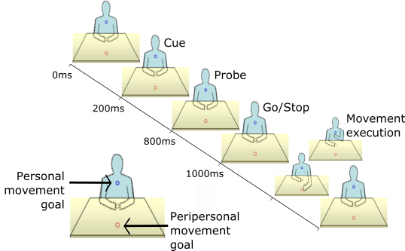
Figure 1. Schematic illustration of the movement goal locations (lower left) and trial procedure. At 200ms an auditory movement cue was presented, followed by either a visual or a tactile probe at 800ms. At 1000ms a GO/Stop stimulus signalled movement execution after which participants returned their hand to the middle location. Visual and tactile probes were delivered to the peripersonal and personal goal locations, respectively.
  - EEG recording and processing
EEG was recorded from 64 Ag–AgCl electrodes at a digitisation rate of 512Hz and referenced to the average of electrodes placed on the left and right earlobes. Activity from horizontal eye movements was recorded from pairs of electrodes placed on the outer canthi of the eyes. Vertical eye movement activity was recorded from electrodes placed above and below the left eye. All electrode impedances were kept below 5 k Ω.
Horizontal eye movement artefacts were identified as a difference exceeding +30 μV between the electrodes placed above and below the left eye. Epochs including eye blink artefacts or voltages exceeding + and/or - 100 μV as well as trials where an error was recorded were automatically rejected prior to analysis.
ERPs were segmented into 700ms epochs including a 200ms pre-stimulus baseline. Segmentations were made by condition: 1) visual probe during peripersonal movement preparation 2) visual probe during personal movement preparation 3) tactile probe during peripersonal movement preparation and 4) tactile probe during personal movement preparation. The peak amplitudes of ERP components were automatically detected using pre-defined time windows. For the visual probe a time window of 50 – 150ms was used to detect the positive (P1) peak and a time window of 100 – 200ms was used to detect the negative (N1) peak. The tactile N140 peak was detected using a time window of 80 – 170ms.
  - Statistical analysis
For behavioural data, the time elapsed between the onset of the GO signal and the time at which the hand left the central position (reaction time) was recorded. In addition to the reaction times, the time elapsed between the hand leaving the central position and the landing at the goal location (movement duration) was also recorded. These behavioural measures were analysed with separate two-way repeated measures ANOVAs with factors of movement goal (personal/peripersonal) and probe (visual/tactile).
For ERP component analysis the average peak amplitude values were analysed. Electrodes were divided into three regions (posterior-occipital, central and frontal) and pooled for analysis of the distribution of ERP components. Visual and tactile ERPs were analysed separately in three-way repeated measures ANOVAs with factors of movement preparation (personal/peripersonal) electrode hemisphere (left/right) and region (posterior-occipital/central/frontal). Conditional on identifying significant main effects and interactions with the factor of electrode region separate repeated measures ANOVAs were then run for each region with factors of movement preparation (personal/peripersonal) and hemisphere (left/right). Greenhouse-Geisser estimates were used where the assumption of sphericity was violated and corrections for multiple comparisons were made using Bonferroni adjustment for post-hoc t-tests.
- Results
  - Behavioural
The mean time (milliseconds) from the onset of the Go signal to the participant’s hand leaving the central fixation area (reaction time) was faster for movements towards personal space (M = 519, SD = 77) compared to movements towards peripersonal space (M = 549, SD = 64, F(1, 15) = 18.02, p = .001, η_{p}² = .546 ). Mean movement durations (milliseconds) were faster for movements towards personal (M = 277, SD = 222) compared to peripersonal (M = 510, SD = 168) space (F(1, 15) = 28.36, p < .001, η_{p}² = .654). Mean error rates (ER) did not significantly differ between movements towards personal (ER = 0.78%, SD = 1.35) and peripersonal (ER = 0.72%, SD = 1.06) space (F(1, 15) = .05, p = .822, η_{p}² = .003). Participants were therefore somewhat faster to respond to the Go signal for a personal movement relative to a peripersonal movement (~30ms), while their movement durations were considerably faster for personal movements (~230ms).
Unsurprisingly, the presentation of a probe at the goal location of the upcoming movement facilitated performance relative to presenting a probe at the opposite (non-goal) location. This was reflected by a significant interaction between movement goal and probe on reaction times (F(1, 15) = 11.46, p = .004, η_{p}² = .433). Reaction times were faster when a tactile or visual probe was presented at the goal location (M = 529, SD = 72) relative to the opposite location (M = 540, SD = 71). Although this interaction was not present for the movement durations (F(1, 15) = 2.52, p = .113, η_{p}² = .144), error rates were significantly lower when a probe was presented at the goal location (ER = .52%, SD = .99) relative to the opposite location (ER = .98%, SD = 1.43, F(1, 15) = 5.79, p = .029, η_{p}² = .278). This facilitatory effect of the probe on reaction times and accuracy was expected, however was not the primary concern of this study. The probes were not used in order to influence behavioural performance per se, but instead were used to index early stages of sensory processing during movement preparation.

  - Visual probe evoked potentials
Figure 2 shows the ERPs elicited at frontal, central and posterior sites by the visual probe stimuli. As can be seen the early visual P1 and N1 ERP components are posteriorly distributed and larger in amplitude during movement preparation towards peripersonal space.
Statistical analyses confirmed the posterior distribution of the P1 component (main effect of electrode region, F(2, 30) = 13.54, p = .001, = η_{p}² .474) and overall the P1 was more pronounced over the right hemisphere (main effect of electrode hemisphere, F(1, 15) = 10.13, p = .006, = η_{p}² .403). Post-hoc comparisons confirmed that the P1 was significantly larger in amplitude at posterior-occipital electrode sites (M = 3.40μV, SD = 2.2) compared to central sites (M = 1.90 μV, SD = 1.5, p = .001, d = .51) and frontal sites (M = 1.70μV, SD = 1.56, p = .008 d = .77). Movement preparation did not modulate the visual P1 component and no significant interactions involving movement preparation were present, therefore indicating that the visual probe evoked P1 component was largest at posterior-occipital electrode sites, but was not significantly modulated by movement preparation.
Statistical analysis of the visual N1 component revealed a main effect of electrode region (F(2, 30) = 7.98, p = .006, η_{p}² = .347) as well as a significant interaction between movement preparation (personal or peripersonal) and electrode region (F(2, 30) = 6.76, p = .009, η_{p}² = .311). Post-hoc comparisons confirmed that N1 amplitudes were significantly more negative at posterior-occipital electrodes (M = -5.43μV, SD = 1.72) compared to frontal electrodes (M = -3.64μV, SD = 2.34, p = .035). Frontal N1 component amplitudes were also significantly smaller than central N1 amplitudes (M = -5.12μV, SD = 1.85, p = .005). Overall, the N1 component was larger over the right hemisphere (main effect of hemisphere, F(1, 15) = 4.89, p = .043, η_{p}² = .246) and a significant interaction between hemisphere and electrode region was found (F(2, 30) = 9.58, p = .001, η_{p}² = .390). Next, separate repeated measures ANOVAs with factors of movement preparation and hemisphere for each region (posterior-occipital, central and frontal) were carried out.
At posterior-occipital electrode sites (see Figure 2 lower panel) movement preparation significantly modulated the amplitude of the visual N1 component (F(1, 15) = 4.83, p = .044, η_{p}² = .243). Preparing a movement towards peripersonal space elicited a significantly more negative probe evoked N1 component (M = -5.80μV, SD = 1.68) compared to movement preparation towards personal space (M = -5.07μV, SD = 2.00). Post-hoc t-tests confirmed that the N1 was more negative during peripersonal movement preparation compared to personal movement preparation at left hemisphere electrodes (t(15) = 2.52, p = .024, d = .62), however this difference did not reach significance at right hemisphere electrodes (t(15) = -1.66, p = .117, d = .42). No main effect of hemisphere was found, (F(1, 15) = .25, p = .625, η_{p}² = .016).
No effects of movement direction or interactions involving this factor were observed at central or frontal electrode sites.
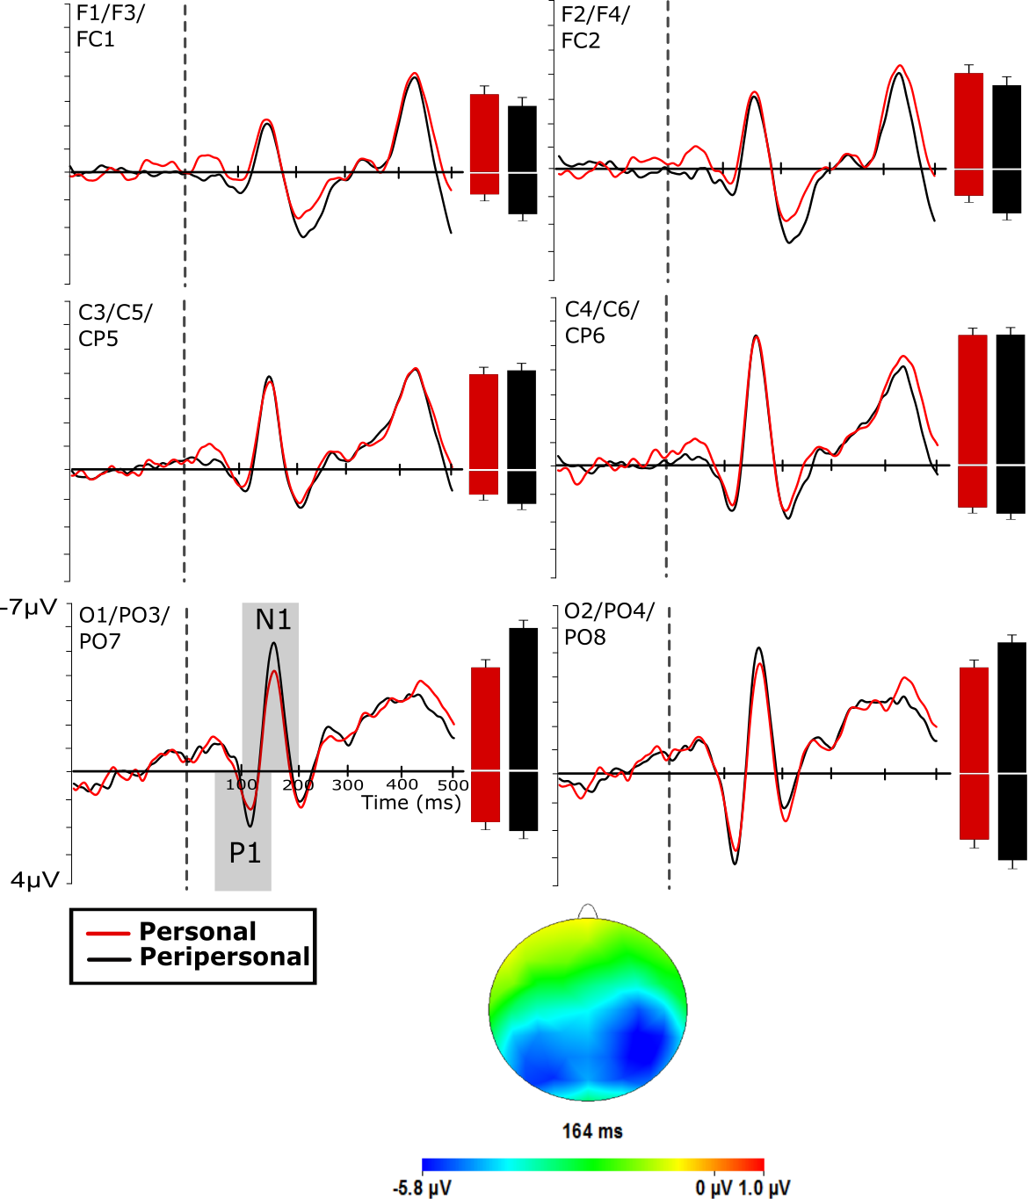

Figure 2. Grand averaged visual probe-evoked potentials across selected frontal, central and posterior-occipital electrodes. Dotted line indicates the onset time of the visual probe. Shaded areas represent the times with which the component peaks were detected. Bars show component mean peak values (error bars: +/- 2 SE), with P1 amplitudes showing as positivities and N1 amplitudes as negativities. Scalp map shows the distribution of the N1 component at the average peak latency.
  - Tactile probe-evoked potentials
Figure 3 shows the somatosensory ERPs elicited by the tactile probes at frontal, central and posterior-occipital sites. As can be seen, the N140 component is most pronounced at central sites and further enhanced amplitudes can be observed for probes presented during movement preparation towards personal space on the body. These observations were confirmed by a significant interaction between movement preparation and region (F(2, 30) = 7.15, p = .003, η_{p}² = .323), indicating that the N140 component was differentially effected across the regions included in the analysis. A main effect of movement preparation was also observed, (F(1, 15) = 6.92, p = .019, = η_{p}² .316). Next, separate ANOVAs with factors of movement preparation and hemisphere for each region (posterior-occipital, central and frontal) were carried out.
At central electrode sites the tactile probe evoked N140 component was significantly more negative during movement preparation towards personal space (M = -6.03μV, SD = 4.34) compared to the N140 component elicited during peripersonal movement preparation (M = -4.40μV, SD = 3.78, F(1, 15) = 9.30, p = .008, = η_{p}² .383). Both the main effect of hemisphere and the interaction between movement preparation and hemisphere were non-significant (F(1, 15) = 3.19, p = .094, η_{p}² = .175 F(1, 15) = .32, p = .860, = η_{p}² .002, respectively).
At frontal sites, N140 amplitudes were also significantly modulated by movement preparation (F(1, 15) = 6.89, p = .019, = η_{p}² .315) as N140 amplitudes were more negative during movement preparation towards personal space (M = -5.14μV, SD = 2.61) compared to the N140 components elicited during peripersonal movement preparation (M = -3.68μV, SD = 2.87). A significant main effect of hemisphere was found (F(1, 15) = 15.22, p = .001, = η_{p}² .504) however there was no interaction between movement preparation and hemisphere, F(1, 15) = .001, p = .982, η_{p}² < .001. No significant effects were observed over posterior-occipital electrode sites.
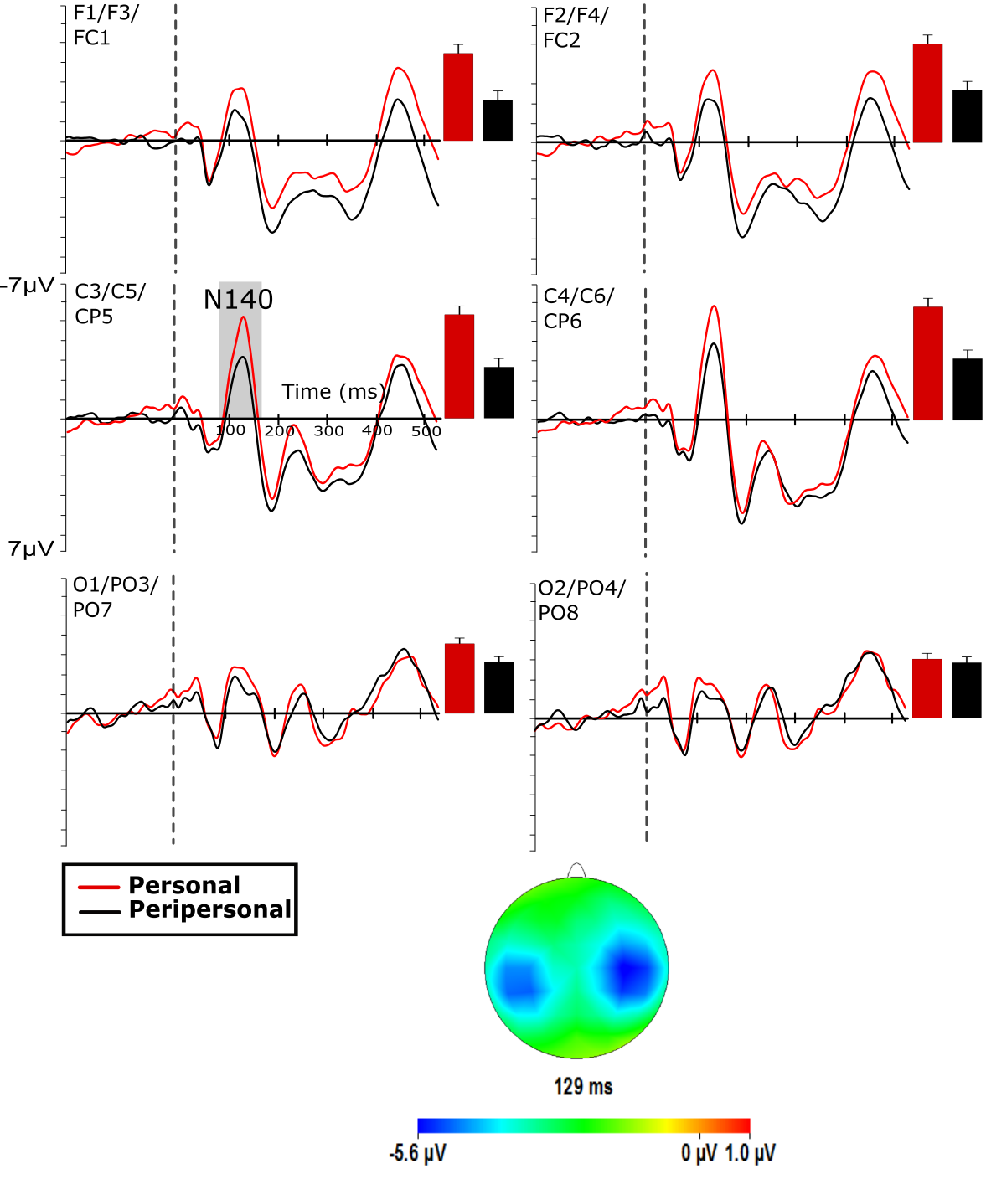
Figure 3. Grand averaged somatosensory probe-evoked potentials across selected frontal, central and posterior-occipital electrodes. Dotted line represents onset of the visual probe. Shaded area represents the times with which the component peaks were detected. Bars show component mean peak values (error bars: +/- 2 SE), with P1 amplitudes showing as positivities and N1 amplitudes as negativities. The scalp map shows the distribution of the N140 at the average peak latency.
- Discussion
This study investigated the coupling of action and perception by measuring modulations in sensory perception at the goal of movements towards different areas of space. A cue instructed participants to prepare reaching movements towards goal locations in personal space on the body surface and peripersonal space in front of them. During movement preparation, visual task-irrelevant probe stimuli were presented at the goal location of the movement towards peripersonal space and tactile task-irrelevant probes were delivered at the goal of the movement towards personal space. Sensory perception at the goal locations was measured as the amplitude of event-related potential (ERP) components elicited by the probe stimuli. ERP components elicited during personal and peripersonal movement preparation were compared in order to assess the sensory consequences of movement preparation towards different areas of space. The key question was whether known links between movement preparation and visual sensory processing would generalise to somatosensory processing on unseen areas of the body surface.
For the first time, we show that somatosensory processing at the goal of a movement towards the body shows a similar enhancement as observed previously in the visual domain (e.g. Gherri, van Velzen & Eimer, 2009); the somatosensory probe evoked N140 component was enhanced in amplitude during the preparation of a movement towards personal space compared to peripersonal space. This suggests that during movement preparation towards a goal on the body surface, tactile perceptual processing is facilitated near to the location of the movement goal. Although previous behavioural (Rorden, 2002) and electrophysiological (Eimer, Forster, van Velzen & Prabhu, 2005; Gherri & Eimer, 2008) findings have shown that preparing spatially directed movements results in enhanced responses to tactile stimuli presented at the goal locations relative to opposite locations, ours is the first demonstration of such links at the unseen goal of a movement towards the body.
The evidence provided here explores facilitation of sensory processing during spatially directed movements towards peripersonal as well as personal space. Previous studies demonstrating modulations of the somatosensory N140 component by movement preparation delivered tactile stimulation to the hands, which were positioned in front of the participant (Eimer, Forster, van Velzen & Prabhu, 2005; Gherri & Eimer, 2008). Although in some cases the hands were occluded (Gherri & Eimer, 2008) the goal of the movement was still situated in a location of space that is typically seen, and therefore located in visible space. Many of the movements made towards personal space involve goal locations that cannot directly be viewed unless aided by the use of a mirror, for example movements towards the face, neck or upper chest. Control mechanisms for such movements presumably rely not on visual information but predominantly on tactile and proprioceptive information. The modulation of the N140 component by movement preparation reported here provides evidence that preparation of movements that rely on nonvisual sensory input leads to similar top-down effects on sensory processing. This, together with the fact that such modulations are observed when action is directed towards an unseen goal suggests that the top-down mechanisms driving these effects do not require visual access to task-relevant locations. Although the goal location of the movement toward personal space was not visible to participants, it is worth noting that the hand was not occluded from vision. Visual information was therefore partly available during movement preparation toward personal space. It is therefore not known whether the same pattern of effects arises when visual information of the effector limb is removed entirely. In order to strengthen the claim that such movements rely more on tactile and proprioceptive information, future investigations should occlude the hand and arm from participants view.
It is also noteworthy that reaction times as well as movement durations were faster when movements were directed towards the personal goal compared to the peripersonal goal, suggesting additional processing requirements for preparation of the latter. Whilst well known visual-motor transformations support movement planning towards visual targets in peripersonal space (Soechting and Flanders, 1992) less is known about the equivalent transformations required for movements towards body targets in personal space. However, reaching movements towards body targets rely on proprioceptive inputs already defined in intrinsic body coordinates, rather than more complex visual-motor transformations required for movements toward visual targets. This difference in the sensorimotor demands required to successfully complete the movements may explain the slower reaction times for movements towards the peripersonal goal relative to the personal goal. The findings here are a first step towards clarifying the mechanisms involved in movements towards unseen body space.

As expected, visual processing near the movement goal in peripersonal space was enhanced when a reaching movement away from the body was prepared. This was evident from enlarged early ERP components over posterior-occipital scalp areas. These early components reflect activity of extrastriate visual cortices and their modulation confirms the links previously observed of enhanced probe evoked N1 amplitudes near to the goal location of planned reaching movements (Gherri, van Velzen & Eimer, 2009) as well as manual responses (Eimer, van Velzen, Gherri & Press, 2006; Gherri & Eimer, 2010) and at the location of upcoming saccadic eye-movements (Eimer, van Velzen, Gherri & Press, 2007). Note that in these previous studies a goal location had to be selected from multiple possible goals in peripersonal space. By contrast, the current study had only one possible goal in peripersonal space. Our findings suggest that competition between possible visible goals is not a necessary condition in order to demonstrate enhanced visual processing at the goal location.
Perception-action coupling research often demonstrates the remarkable similarities between the modulations of sensory perception resulting from shifts of covert attention and movement preparation. These similar modulations of sensory processing support the claim that attention and action share common control mechanisms (Rizzolatti et al, 1987). Much of the evidence has focused on the shared control mechanisms of eye-movement preparation and visual-spatial attention. Growing evidence is suggesting that this coupling of action and perception extends beyond the oculomotor and visual attention domains. The preparation of eye, manual and reaching movements have been shown to reliably alter the processing of not only visual, but also tactile sensory processing. Our results extend the supporting evidence for tight coupling between action and perception by demonstrating that motor planning affects sensory processing in a previously unstudied functional area of space, in particular at locations on the body surface. Further, we show that the mechanisms that set up the spatially specific modulation of sensory processing across the movement space (see Baldauf and Deubel, 2009; 2010, Mason et al, 2015) do not require visual access of that movement space. These ‘attentional landscapes’ that have previously been identified for visual processing in peripersonal space may have an equivalent for somatosensation on the body surface. Determining the specific features of such landscapes in terms of spatial and temporal dynamics requires further investigation.
- References
Astafiev, S. V, Shulman, G. L., Stanley, C. M., Snyder, A. Z., Essen, D. C. Van, & Corbetta, M. (2003). Functional Organization of Human Intraparietal and Frontal Cortex for Attending , Looking , and Pointing, 23(11), 4689–4699.
Baldauf, D., & Deubel, H. (2009). Attentional selection of multiple goal positions before rapid hand movement sequences: An event-related potential study. Journal of Cognitive Neuroscience, 21(1), 18-29.
Baldauf, D., & Deubel, H. (2010). Attentional landscapes in reaching and grasping. Vision research, 50(11), 999-1013.
Corbetta, M., Akbudak, E., Conturo, T. E., Snyder, a Z., Ollinger, J. M., Drury, H. A, Linenweber, M.R., Petersen, S.E., Raichle, M.E., Van Essen, D.C., & Shulman, G. L. (1998). A common network of functional areas for attention and eye movements. Neuron, 21(4), 761–73.
Deubel, H., & Schneider, W. (1996). Saccade target selection and object recognition: evidence for a common attentional mechanism. Vision research, 36(12), 1827-37.
Deubel, H., Schneider, W., & Paprotta, I. (1998). Selective dorsal and ventral processing: Evidence for a common attentional mechanism in reaching and perception. Visual Cognition, 5(12), 81-107.
Eimer, M., Forster, B., Velzen, J. V., & Prabhu, G. (2005). Covert manual response preparation triggers attentional shifts: ERP evidence for the premotor theory of attention. Neuropsychologia, 43(6), 957-966.
Eimer, M., Van Velzen, J., Gherri, E., & Press, C. (2007). ERP correlates of shared control mechanisms involved in saccade preparation and in covert attention. Brain research, 1135(1), 154-66.
Eimer, M., Van Velzen, J., Gherri, E., & Press, C. (2006). Manual response preparation and saccade programming are linked to attention shifts: ERP evidence for covert attentional orienting and spatially specific modulations of visual processing. Brain research, 1105(1), 7-19.
Forster, B., & Eimer, M. (2007). Covert unimanual response preparation triggers attention shifts to effectors rather than goal locations. Neuroscience letters,419(2), 142-146.
Gherri, E., & Eimer, M. (2008). Links between eye movement preparation and the attentional processing of tactile events: an event-related brain potential study. Clinical neurophysiology, 119(11), 2587-2597.
Gherri, E., & Eimer, M. (2010). Manual response preparation disrupts spatial attention: an electrophysiological investigation of links between action and attention. Neuropsychologia, 48(4), 961-969.
Gherri, E., Van Velzen, J., & Eimer, M. (2009). The instructed context of a motor task modulates covert response preparation and shifts of spatial attention. Psychophysiology, 46(3), 655-667.
Goodale, M., & Milner, A. (1992). Separate visual pathways tor perception and action. Trends in Neurosciences, 15(1), 20-25.
Heinze, H. J., Luck, S. J., Munte, T. F., Gös, A., Mangun, G. R., & Hillyard, S. A. (1994). Attention to adjacent and separate positions in space: An electrophysiological analysis. Perception & Psychophysics, 56(1), 42-52.
Hillyard, S. A., Vogel, E. K., & Luck, S. J. (1998). Sensory gain control (amplification) as a mechanism of selective attention: electrophysiological and neuroimaging evidence. Philosophical transactions of the Royal Society of London. Series B, Biological sciences, 353(1373), 1257-70.
Hoffman, J. E., & Subramaniam, B. (1995). The role of visual attention in saccadic eye movements. Perception & psychophysics, 57(6), 787-795.
Irwin, D.E., & Gordon, R.D. (1998). Eye movements, attention, and trans-saccadic memory. Visual Cognition, 5, 127–155.
Juravle, G., & Deubel, H. (2009). Action preparation enhances the processing of tactile targets. Experimental brain research, 198(2-3), 301-311.
Linnell, K. J., Humphreys, G. W., McIntyre, D. B., Laitinen, S., & Wing, A. M. (2005). Action modulates object-based selection. Vision research, 45(17), 2268-2286
Mason, L., Linnell, K. J., Davis, R., & Van Velzen, J. (2015). Visual processing at goal and effector locations is dynamically enhanced during motor preparation. NeuroImage, 117, 243-249.
Moore, T., & Fallah, M. (2004). Microstimulation of the frontal eye field and its effects on covert spatial attention. Journal of neurophysiology, 91(1), 152-62.
Neggers, S F W, Huijbers, W., Vrijlandt, C. M., Vlaskamp, B. N. S., Schutter, D. J. L. G., & Kenemans, J. L. (2007). TMS pulses on the frontal eye fields break coupling between visuospatial attention and eye movements. Journal of neurophysiology, 98(5), 2765-78.
Perry, R. J., & Zeki, S. (2000). The neurology of saccades and covert shifts in spatial attention: an event-related fMRI study. Brain : A Journal of Neurology, 123 ( Pt 1, 2273–88.
Posner, M. I., & Dehaene, S. (1994). Attentional networks. Trends in neurosciences, 17(2), 75-79.
Posner, M., Snyder, C. R. R., & Davidson, B. J. (1980). Attention and the Detection of Signals. Psychology, 109(2), 160-174.
Rizzolatti, G., Riggio, L., Dascola, I., & Umiltá, C. (1987). Reorienting attention across the horizontal and vertical meridians: evidence in favor of a premotor theory of attention. Neuropsychologia, 25(1A), 31-40.
Rizzolatti, G., Riggio, L., & Sheliga, B. (1994). Space and selective attention. In C. Umilta & M. Moscovitch (Eds.), Attention and performance XV (pp. 231-265). Cambridge: MIT.
Rorden, C., Greene, K., Sasine, G. M., & Baylis, G. C. (2002). Enhanced tactile performance at the destination of an upcoming saccade. Current Biology, 12(16), 1429-1434.
Schiller, P. H., & Tehovnik, E. J. (2001). Look and see: how the brain moves your eyes about. Progress in brain research, 134, 127-142.
Schneider, W., Eschman, A., & Zuccolotto, A. (2002). E-Prime user’s guide. Pittsburgh: Psychology Software Tools.
Sheliga, B. M., Riggio, L., & Rizzolatti, G. (1995). Spatial attention and eye movements. Experimental Brain Research, 105(2), 261-275.
Shepherd, M., Findlay, J. M., & Hockey, R. J. (1986). The relationship between eye movements and spatial attention. The Quarterly Journal of Experimental Psychology, 38(3), 475-491.
Soechting, J. F., & Flanders, M. (1992). Moving in three-dimensional space: frames of reference, vectors, and coordinate systems. Annual review of neuroscience, 15(1), 167-191.
Van Ettinger-Veenstra, H. M., Huijbers, W., Gutteling, T. P., Vink, M., Kenemans, J. L., & Neggers, S. F. W. (2009). fMRI-guided TMS on cortical eye fields: the frontal but not intraparietal eye fields regulate the coupling between visuospatial attention and eye movements. Journal of neurophysiology, 102(6), 3469-80.

