Waiting Subjects: Social media inspired self-portraits as gallery exhibition in Delhi, India.

Abstract:
In this article I reflect on a gallery exhibition of self-portraits by young Somali refugees. These images were selected from a collection of digital photographs that were shot while producing a collaborative ethnographic film project on the racialization of African nationals in Delhi, India. The images that my youthful interlocutors produced while shooting for our collaborative film project, however, were not originally intended for display but were an extension of their already prolific visual and textual self-documentation on social media. Utilizing select images and texts from the exhibition we culled from this ‘accidental’ photographic archive to evoke what it means for these young Somalis to wait for asylum in Europe or North America while they make their lives in India, I argue for an attention to the digital image-making practices of young people as a site where subjectivities are self-fashioned and ethnographic insights emerge.

Biography:
Ethiraj Gabriel Dattatreyan is an anthropologist, filmmaker, and photographer based in the United States. He is currently completing a project that attends to how youthful migrants living in the diverse urban villages in Delhi, India utilize globally circulating popular cultural forms and digital communications technology to visualize themselves as part of Delhi’s changing urbanity. His next project focuses on the Pan- African migrant enclaves of Delhi, documenting the ways African students, entrepreneurs and refugees imagine, experience and self-document their relationship to India, to Delhi, and to Africa.

In May of 2014 a group of young Somali men and I showcased a photo exhibition at Khoj International Gallery, Delhi as part of a screening of a feature length ethnographic film we collaboratively produced over the course of the previous year. Titled Waiting Subjects, the exhibition was comprised of a series of self-portraits and short texts produced by the young men. The texts and the photographs, taken together, were meant to evoke a sense of what it meant for these young men to wait in Delhi, in some cases for over a decade, while their appeals for asylum for permanent stay in Europe or North America were processed. The photos and texts were also meant to highlight the experiences of the young Somali filmmakers who appeared in the film but weren’t central to its narrative.
The portraits that comprised Waiting Subjects, however, were not originally intended for display. Rather, they were a curated sampling from an accidental photographic archive that emerged while my youthful participants shot video footage for our collaborative film project. These photos, nestled amidst the digital files that held their video footage, were evidence of my participants’ already prolific visual and textual self-documentation on social media. Mostly self-portraits, they were strikingly similar to the smart phone enabled images I would see pop up daily on their Facebook pages and their Twitter accounts, images that depicted these young men in the various social milieus they inhabited in Delhi while they waited for unknown futures elsewhere. I begin this article by discussing how the self-portraits that appeared serendipitously in our shared digital files became a site for us to imagine a collaborative photographic representation of their unfolding lives in Delhi in ways that mirrored their documentary practices for social media circulation but occupied different spaces and hailed different audiences. More broadly, I argue that these portraits, redeployed as a gallery exhibition that explored waiting as an active self-making project, reveals how the extant digital practices of our participants in the age of social media offer an opportunity to extend anthropological theorizations of photography as a mediating practice, a means to explore relationships between self and world (Edwards, 2012, Hevia, 2009; Poole, 1999).
I then share a selection of photographs and short texts from Waiting Subjects to drive a discussion regarding how these young men navigate the warp and weft of everyday life in Delhi even as they extend themselves towards the Somali diaspora, transnational Islam, and the global hip hop ‘nation’ in their digital play. For these young refugees who seek the opportunity of legal citizenship in the global north, waiting, then, can be seen as a process that unfolds in documentary practice in ways which put into conversation their lived present in Delhi, their undetermined futures in the ‘West’, and their nostalgia for Somalia. I conclude by discussing how my participants and I came to select the images for the gallery exhibition from the hundreds of photographs that formed their shared photographic archive. I discuss how, even though the exhibition was meant to highlight my participant’s agentic negotiations of subjectivity through image production, a seemingly insignificant decision around representation reinforced a power dynamic that recalls an enduring bias in the social sciences towards categorically legible social experience.

Facebook self-portraits as subject-making

When I met the young Somali men who feature in this article, they had been living in India for over a decade while they waited for asylum in Europe or North America. While they waited, they lived their lives, going to school, making friends, playing football, consuming popular cultural forms, and producing and circulating American hip hop inspired music on the Internet. We initially got to know each other while recording hip hop inspired music in a small makeshift studio I and another researcher had set up to engage with aspiring musicians in Delhi’s emergent youth popular culture scenes. Over the course of several months, during walks through the streets Delhi, while we loitered in the plazas of the mall across the street from their settlement colony, in the instances we trespassed the various historical ruins within walking distance from their homes; these young men shared their stories of life in Delhi, their longing for home, and their aspirations for the future. On each occasion I met with them, as with all of the young people I got to know in Delhi, I had my DSLR camera strapped around my neck or on my back in the rather large camera bag I used to carry around my equipment. The camera and its accouterments, at least initially, became the means by which I gained access to worlds of the the young people I got to know while researching why young people in Delhi’s migrant colonies were taking up global hip hop’s musical, dance, and visual practices. The DSLR, seemingly, offered the promise of professional photographic and videographic documentation and made me a useful companion when they decided to do impromptu and improvised visual, dance, or musical performances on the streets of Delhi.
In the long hours I would spend with these young men and women, I would pass around the camera so that they could either watch what I had just shot of their performances or could experiment with shooting their peers’ improvisational flourishes. As I spent time with the Somali ‘crew’, several of the young men became interested in digital video production as a result of our initial camera ‘play. One of the young men, Assad, eventually suggested we make a film together after I told him I was, in addition to being a researcher, a filmmaker. After some deliberation, we decided would make a film that focused on the pan-African community in the migrant colony where they lived in Delhi, Khirki Extension. On a short trip back to the U.S., I purchased a small but high quality camera and microphone that I passed onto Assad and the ‘crew ‘when I returned to Delhi. Along with the camera and mic, I conveyed a few basic instructions for its use as we started our shared video project. Hold the camera steady. Make sure you use the microphone if you are recording video, so that we have ‘good’ sound. Choose, with some care, with whom you talk to and how you will discuss with them the issues you wish to raise. In the months that followed, these young men brought back footage that they had shot with Africans from several nation-states – Nigeria, Cameroon, Uganda, Sudan, Somalia – who lived in Khirki Extension. They also shared their interviews that they had conducted with small business owners who had been in the neighborhood since partition and the formation of the Indian state as well footage they captured of themselves in informal conversations with recent Bihari laborers who were their neighbors. We reviewed these filmic rushes weekly at my house located a few kilometers away. In these sessions we discussed what we were seeing and not seeing and what we might need to shoot for the following week, thereby reformulating Jean Rouch’s notion of playback-feedback such that they had the opportunity to operate the camera and we, together, worked through the implications of our shared documentation (Henley, 2009). In these playback-feedback sessions we discussed the complicated nature of the interview itself, its intersubjective and ontological conditions – all of which forms the subject for another essay on the pedagogy of shared video production in a 21st century shared anthropological project (Dattatreyan, in preparation).
As I perused the rushes of video footage they shot after our playback/feedback sessions were over, I came across hundreds of photographs taken as they moved through the city on their daily jaunts. Blurry photos of rooftops in Khirki, street scenes in Old Delhi, images from inside auto rickshaws as they careened through the broad tree lined roads that formed the connective tissue of South Delhi, group portraits of their diverse set of friends that they had met in school and in their neighborhood, and images of their friends in the refugee youth groups organized by an NGO working in partnership with the United Nations Human Rights Commission (UNHCR). The majority of their photographs I found amidst their video footage, however, were portraits, either taken by one of the crew, or self-portraits, selfies in contemporary parlance.
These portraits, several of which were posted onto Facebook by the young men in the weeks that followed, reveal that their interest in self and world documentation didn’t simply begin when I gave these young men the prosumer camera to develop our shared film project. Indeed, for several years the young Somali men had been exploring their subject positions and the place where they lived, Delhi, India, by taking self-portraits and group photos on their cell phone cameras and posting these images onto Facebook to be seen and to engender commentary within their networks. In a nutshell Facebook, now a globally utilized social media site with over a billion active users (Facebook, 2015), afforded these young men, and the other young people I met in Delhi’s nascent global popular cultural scenes, an opportunity to engage in iterative multimodal circulations that utilize original images and texts as well as remixed found material, to create composite virtual selves and places. While their experimentations with the prosumer camera coupled with our weekly conversations on photo and pro-filmic diegesis no doubt created a greater degree of reflexivity around their image-making practices, these photos, by and large, had many of the same qualitative features as the images that they had been circulating on their Facebook feeds. The images that they produced while working on the filmic project were, in effect, an extension of the self-making practices that hinged on visual and text productions brought about by the digital age. Their naturalized practices with photo and text for the purpose of creating or strengthening social relationships through self-documentation, I argue, offered an important site to explore how these young men were making sense of their unfolding lives in the virtual spaces of social media. Moreover, their prolific image production offered an opportunity for a shared exposition of their experiences in spaces they normally wouldn’t have access to, the gallery, and this journal article.
However, as David MacDougall (2006) has eloquently argued, photographic images can be frustratingly mute even as they offer a tantalizing entry point into the worlds of others. This was evident during the gallery show as the images, even with the short poetic texts that accompanied them, were an ambiguous addition to the film screening which took center stage precisely because its narrative thrust. The remainder of this article gives a selection of the photos and their accompanying captions from Waiting Subjects pride of place while offering an ethnographic context for their production and a reading of their semiotic significance within the social worlds in which they are emplaced. My move to provide an ethnographic context for and a brief analysis of the included portraits reclaims the role of the ethnographer in a visual project driven by the auto-ethnographic expositions of participants. However, as I discuss in my conclusion, this, perhaps, newly configured role of researcher to explicitly amplify and contextualize the self-productions of participants, is not without pitfalls.

Global Blackness, Fractured Pan-African Solidarity

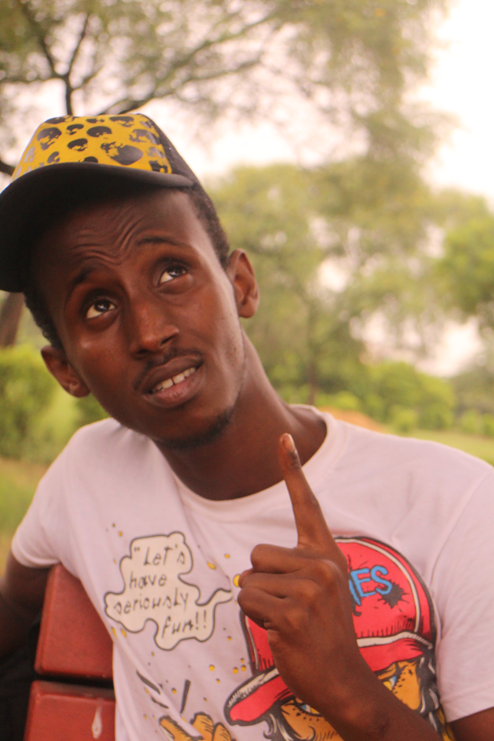

Figure 1:Nobody can go back and start a new beginning but anyone can start today and make a new ending

Alif’s image, above, is exemplary of how American hip hop’s discourse on Blackness and masculinity shapes the self-fashioning processes of the young Somali men in Delhi. The baseball cap, his print t-shirt and a bodily comportment all reflect what Damani Partridge (2013) has referred to as the unanticipated effects of Black diasporic aesthetics as they circulate globally. These circulations are unanticipated simply because the reach of popular cultural and artistic discourses like hip hop, rooted in the Black American experience, have found interest amongst those who do not have direct experience of the Black Atlantic (See also Anthony Neale, 2014). Alif and his peers deep engagement with American Black aesthetics while growing up in post-liberalization urban India is indicative of the kind of spread and influence that hip hop has had in the forty years since it appeared in the east coast urban centers of the U.S. What the image doesn’t reveal, however, is how my participants’ uptake and reiteration of hip hop’s aesthetics shapes and is shaped by their experiences in Delhi, India.
When I came into contact with Alif and the rest of his crew, I found them, in addition to having Indian, Nepali, and Afghan friends, interacting with the pan-African community in Khirki comprised predominantly of French and English speaking West Africans. They would meet and engage with nationals from several countries in the African kitchens and speakeasies that lay hidden their migrant colony’s dense urban landscape. In these speakeasy/kitchens, performances of African belonging and difference steeped in hip hop’s imaginary of masculine bravado were performed by young men from several different national contexts as they sat in semi-circles in front of a flickering television set. In these social spaces members of the Somali crew were constantly questioned as to what ‘kind’ of African they were by the West Africans they met. In most of the interactions I witnessed and in the conversations I had afterward with the Somali crew about their interactions in the speakeasies, the West Africans either had no idea where Somalia was or immediately associated Somalia with pirates or terrorists. Moreover, West Africans, particularly Nigerian nationals, liked to point out the slight build of the Somali youth as a way of emasculating them in a social space primarily taken up by West Africans. The Somali youth deployed hip hop’s stylistic sensibilities and its oral-musical tradition of ‘rapping’ to simultaneously claim a robust masculinity that pushed back on ethnicized tropes of the Somali while hailing a common Black aesthetic field. One of the young members in the crew, for instance, Azeem, got the nickname Biggie from his West African peers after he talked back forcefully to them utilizing hip hop inflected English (what sociolinguist Samy Alim (2001), calls HHNL, Hip Hop Nation Language), and Nigerian Pidgin. Azeem, by learning Nigerian Pidgin slang and the physical gestures that went along with its linguistic repertoires and coupling it with hip hop associated English phrases, earned the respect of the West African men who were regulars in the kitchens.
The Somali youth were also perceived as different by the other African nationals because they spoke Hindi and other South Asian languages fluently. Azeem and his crew all had grown up in India, in Pune and Hyderabad respectively, before moving to Delhi to move forward with their third country petitions to gain refugee status in Europe or North America. Their language skills noticeably set them apart from the other Africans living in Delhi because they were able to conduct daily transactions in shops and the like with ease. As importantly, they were able to immediately challenge those who spoke about them on the street in Hindi who imagined they, like the other African nationals, didn’t speak the language. Inside the African kitchens the Somali youth would switch from Hindi-English (which they spoke with me) to a mixture of Hindi and Somali, sometimes punctuated with English phrases. In their conversations with each other and with me they would quite regularly refer to the notion of Pan-African solidarity with some degree of contempt. “My African brother,” a term used by Nigerians to hail all African males in Khirki, when spoken by the Somali youth amongst each other embedded in a syncretic Hindi-Somali-English, became a way to innocuously mock Nigerian English speakers linguistic constructions of solidarity, to question the very notion of Pan-African brotherhood. Their skepticism of African solidarity hinged, in part, because of their recognition of cultural, linguistic, and religious difference. However, it was also was, in part, a recognition of the differential legal status of Africans who resided in Delhi. West Africans, because of several cases where nationals from Nigeria, Cameroon, and so on, were found to have dubious or non-existent visas, were regularly rounded up and put into detention by Delhi police while their visa situations were scrutinized. The question surrounding the legal status of West Africans in Delhi impacted the Somali refugee community as authorities thought they were also ‘illegal’, particularly if they spent time in the public spaces frequented by West Africans. The perception of Africans as illegal fractured the pan-African imaginary in Khirki. Somalis, because they could speak Hindi and provide official refugee papers, could challenge police officials with some authority and avoid detention. Of course, the Somali’s negotiation of what it meant to be African in Delhi extended beyond legal status.
In Khirki Africans were referred to either as Nigerians or as Habshis by Indian migrants who lived in the colony. Habshi is a term that had two distinct glosses, the first being cannibal, and second, as a term used to refer to East Africans, particularly in Muslim communities, since the Mughal period. Nigerian, of course, could mean a national of Nigeria. But, in this speech context, it also took on a second gloss that associated Africans with criminal behavior and illegality. These two terms, derogatory when used on the street, ultimately became folk categories that were used by South Asian Khirki residents (Indians, Pakistanis, Bangladeshis, and Afghans) to classify all Africans. Nigerians and Habshi, ultimately, were synonymous with gendered constructions of Africans as criminals, prostitutes, and, ultimately, categorized Africans as ontologically ‘illegal’. This linguistic ‘Othering’ created a degree of solidarity amongst Africans regardless of national, regional, or religious association. However, the Somalis could refute these terms deployed by anonymous speakers on the street in Hindi and, in dialogue, argue for a distinct identity for themselves as Muslim Somalis. As such, they were able to interrupt the simple narratives of Africans that emerged in public spaces of the settlement. Their linguistic proficiency not only offered them opportunities to fight for their social enfranchisement but facilitated the development of relationships with Hindi speakers that the West African residents of Khirki didn’t have access to, relationships that allowed them to identify with India and Delhi in intimate ways, ways that ultimately created a distance between them and other African nationals who made temporary homes in the city.

Desi Niggas: Hybridity, global hip hop, and Islam

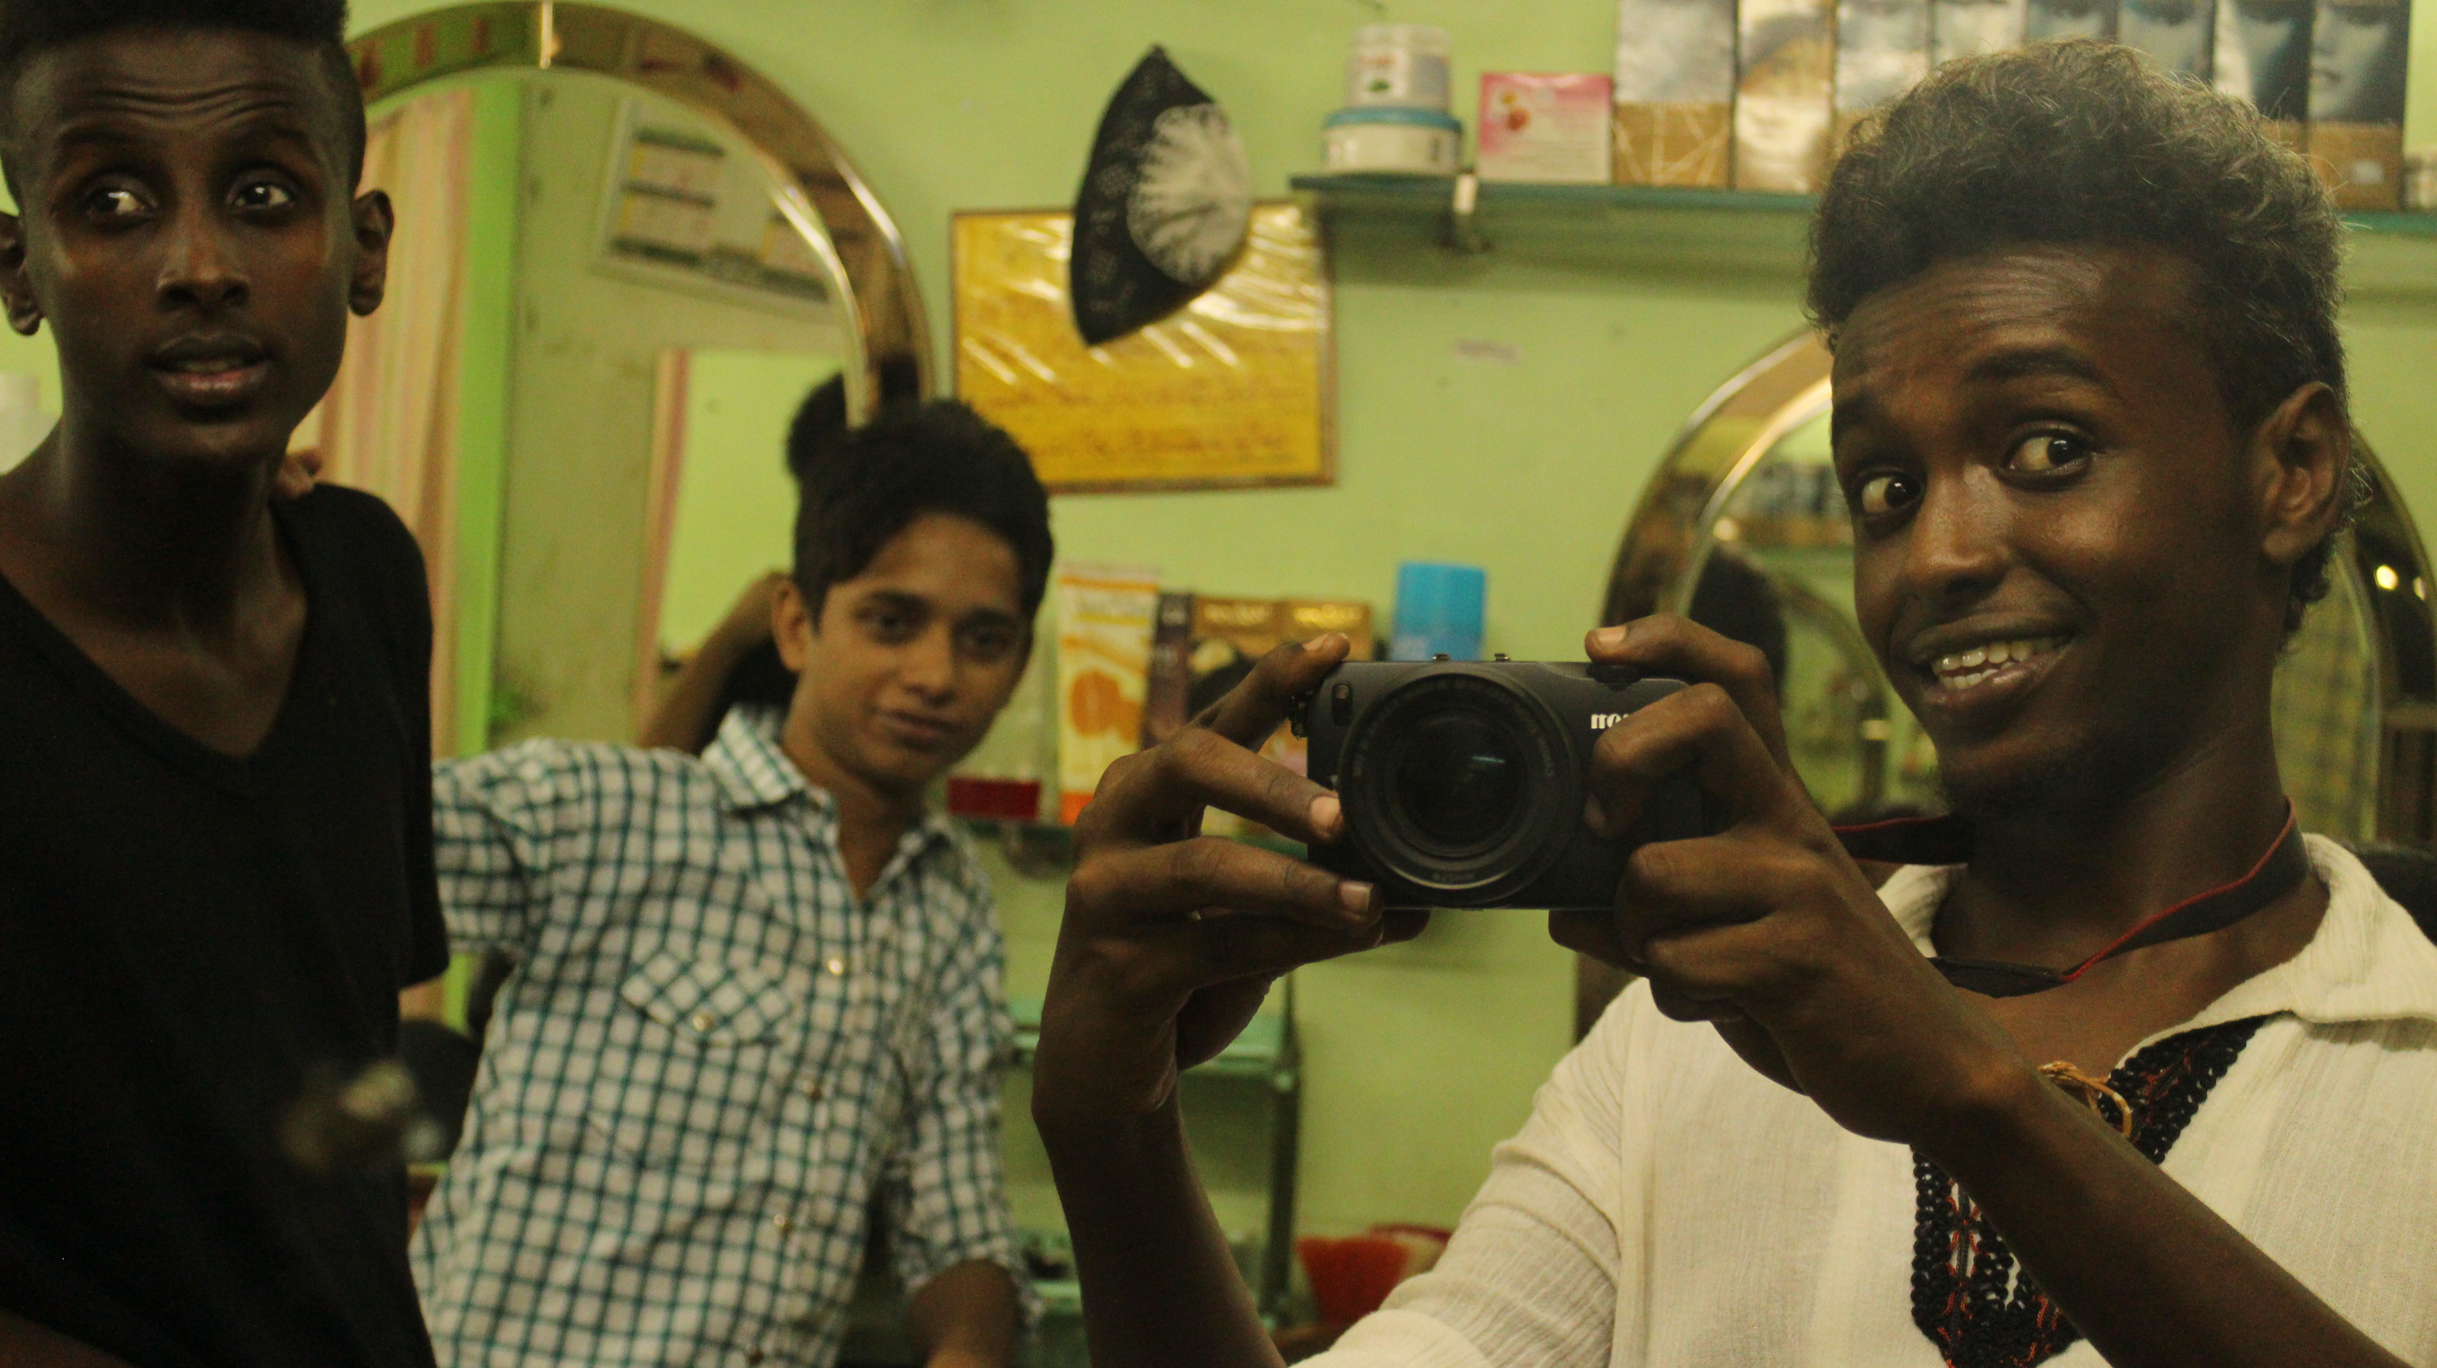
Figure 2: Being in India I found a new shelter under this flag, know it from the roots to the leaves even the slang

Many of the self-portraits that appeared in the ‘accidental’ archive depicted a close connection to Delhi, to India, and to the Hindi speakers they came into contact with in various institutional, commercial, public, and private settings. Friendship was thematized as a part and parcel of the self-portrait as were the built environments where they were taken, such as the Muslim-owned barbershop pictured above. These young men, like Assad pictured above, while they begrudged Delhi and its rampant racism, reveled in the cultural milieus the city offered to them as fluent Hindi speakers capable of traversing the cities sprawl and meeting and developing relationships with Hindi speakers from India, Nepal, and Afghanistan who shared their interest in hip hop and world football. In my meetings with these young men we discussed their relationship to Delhi and to India at length. They told me stories of Hyderabad, Pune, and Delhi, comparing the cities and wistfully sharing their misadventures. These stories echoed a deep epistemological and ontological relationship with urban India, as Assad’s caption of the photo intimates above, a relationship that was also reflected in the playful bantering with their diverse group of friends on Facebook around the selfies that they would post in regular intervals.
Tucked between a music video of a mainstream or underground hip hop star and a story on Somalia, these young men’s self-portraits would emerge with captions or comments that pointed to their status as Somali refugees in Delhi. One of Assad’s selfies that he shot with the shared camera and that appeared later on Facebook, for instance, revealed him in the back of a car with a New York Yankees cap with a caption that read “desi nigga.” Desi is a term utilized in South Asia and amongst its diaspora to signal belonging to South Asia (Marr Maira, 2002) and Nigga, a word that is the reappropriation of the term nigger in the Black Atlantic that is utilized in hip hop to signal solidarity, connection, and a shared experience of racialized oppression (Anthony Neale, 2014). The two terms, taken together, offer an important self-reflection on what it means to be a Somali who has grown up in India. Assad, by casting himself as Desi and a Nigga underneath the image of him looking into the camera donning a red and black Yankees hat cocked to the side, resists the kinds of racialized exclusions that he faces as an African in Delhi by making his experiences of difference central to his image making project as a hybridized subject who is part of and, strikingly, divorced from an image of contemporary urban India.
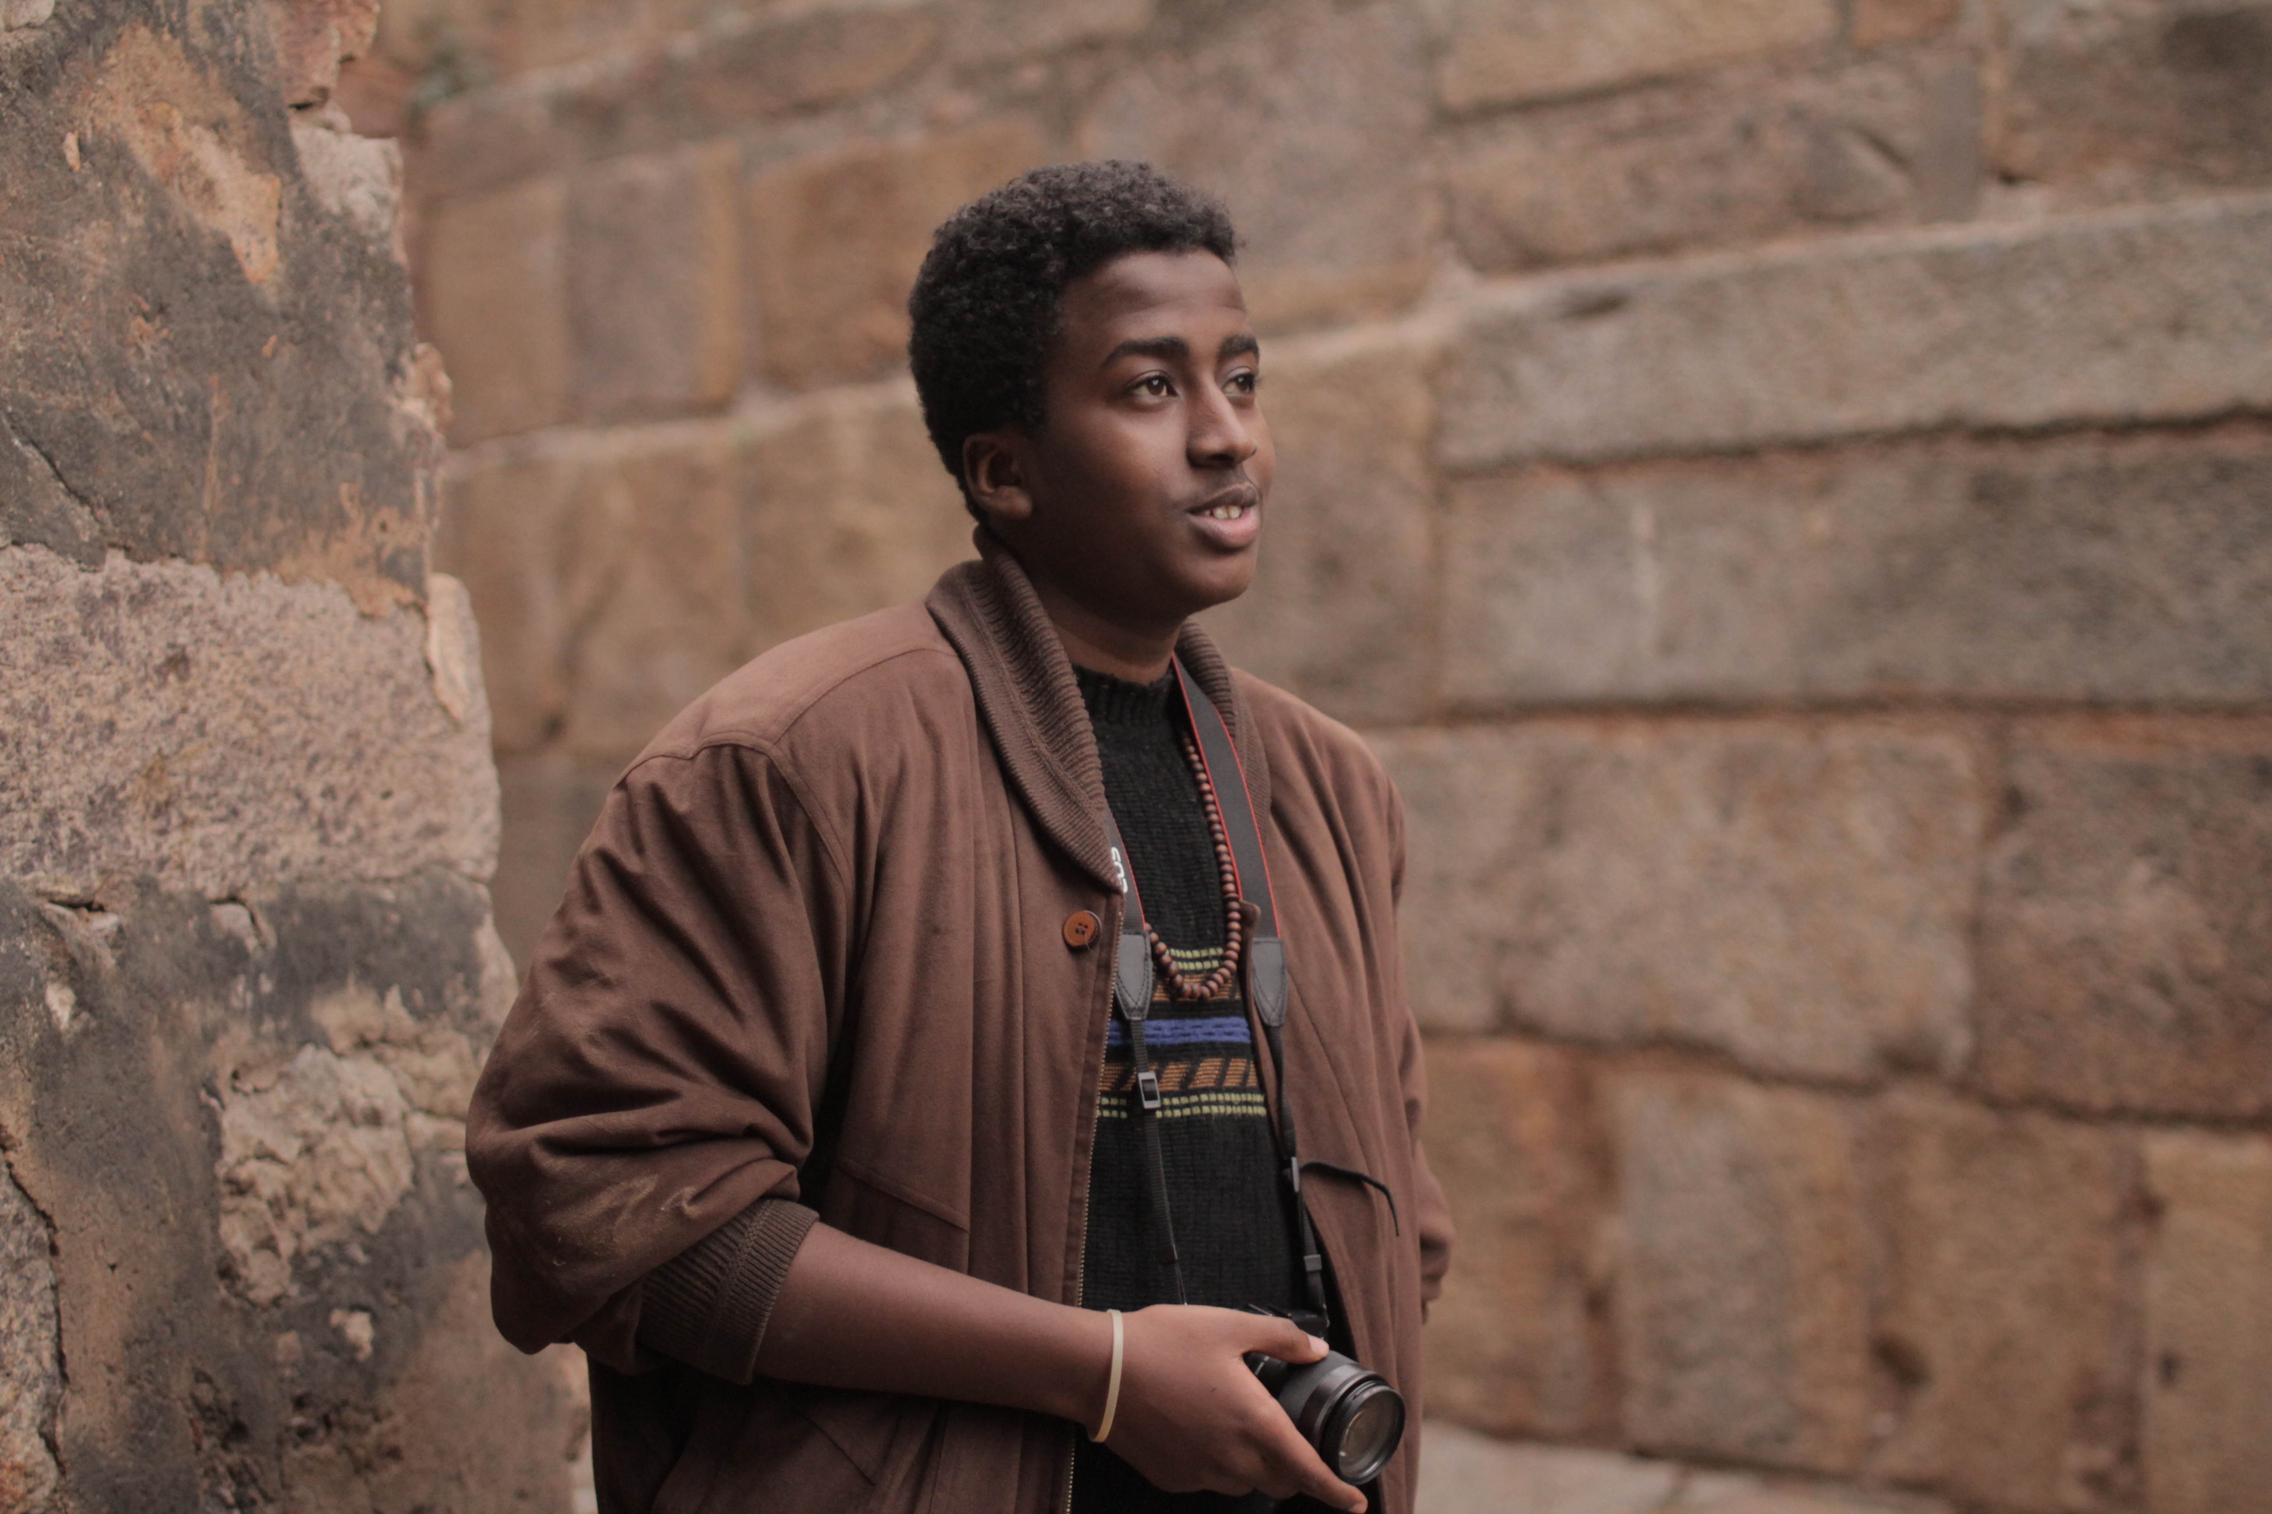
Figure 3: As the years go by and time fades away what used to be good days are now filled with dismay. Tomorrow comes and, then again, it goes and my ambition to become something more grows and grows.

An integral part of these young men’s urban Indian identity, in addition to their linguistic prowess and their representation of a ‘cool’ hybridity vis-à-vis hip hop, is located in their claims to a shared Muslim identity. We can see their relationship to Islam metaphorically wrought in the first image, which depicts Alif with his index finger pointing to the sky and his gaze following the unseen objects that are outside the frame of the photo. We can also see it in Azeem’s photo above, where his tusbax (Somali term for prayer beads) that he wears on top of his shirt and sweater becomes a visible symbol of his connection to Islam. We can also visualize it in the sites that these young men choose to ‘hang out’ in – the abandoned mosques and ruins of the Mughal era, evident in the photo above where the stone work of a 14th mosque stands as the backdrop for Azeem’s portrait.
Khirki Extension and the adjacent urban village of Haus Rani, both share a history as pre-colonial centers for Islam and as a postcolonial haven for Muslim pilgrims in the city after partition. As such, they play an interesting role as a historical backdrop for the construction of a transnational, Muslim Umma, or community of faith. One more than one occasion as we walked through the street I heard these young men reprimand someone who was putatively Indian for not holding up Islam in their deeds and words. On several occasions this moral discourse, which found its power in asserted religious belonging, allowed these young men to protect non-Muslim, non-Hindi speaking Africans who were with them when spontaneous violent interactions fomented. There were also instances I witnessed where young Somali men recruited fellow Muslims who were from the subcontinent to help them repel attacks from the Hindu Bihari day laborers that lived side by side the pan-African and Muslim South Asian communities of Khirki and Haus Rani. By performing a shared Islamic religiosity in Hindi-Urdu, Somali refugees also gained access to housing that was unavailable to other African migrants and, in some cases, avoided paying exorbitant prices for necessary household commodities. Alif, the oldest of the young men I spent time with, related to me a story of how their landlord, because he was Muslim and had lived in the Khirki area for a decades, took pride in protecting him and his family from theft, verbal abuse, and the petty ‘cheating’ that often happened to ferengi (foreigners) in local markets. This shared Muslim identification, while revealing the ways in which Somalis could nurture alternate structures of belonging in Khirki, also draws attention to the ways in which Christian West Africans were situated as ‘Others’. In one interview the Somali crew shot for our shared film project, they talked to a local Muslim pardhaan (provisional leader) in Khirki. The leader was very comfortable referring to West Africans as cannibals and differentiated them from his Somali interlocutors by categorizing them as Christian Africans. The pardhaan’s sentiments, given our previous discussion, reveal the ways in which the Somali youth constantly moved between religious, ethnic, racial, and linguistic borders. However, it became painfully evident that while the Somalis’ ability to cross borders had its marked advantages, their perceived difference as Africans still left them vulnerable.

Constructing the waiting subject: The role of the United Nations Human Rights Commission
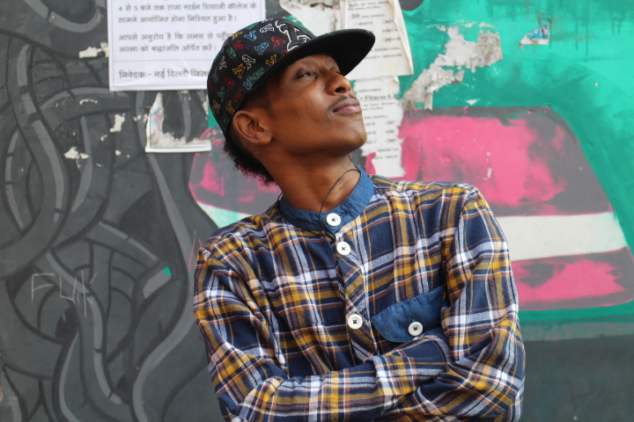

Figure 4: “Everyday I wake up late and think about my fate. Will I get a call today, will UNHCR make my day? Getting texts from my homies, I go to the balcony and see Africa staring back at me.”

Their relationship with the United Nations Human Rights Commission (UNHRC) and the associated non-governmental organizations sub-contracted by the UNHRC to provide services to the refugees, however, mitigated some of the threat they faced in their everyday lives. During an informal interview I conducted with a UNHRC NGO affiliate staff member, I was told that workers from the NGO labored to let the local business leaders and residents in the community know that the Somalis and the few West Africans who were legal refugees and under their charge were not like the other Africans in Khirki Extension and were to be treated differently. The UNHRC also intervened if there was an issue concerning the local authorities. In one case, a young Somali man named Farod who lived in Khirki got into a fight with a local butcher. Farod, because he had arrived recently to India from Kenya, didn’t know how to speak Hindi. As a result of miscommunication the butcher began to swing his cleaver at Farod while several young men related to the butcher ran into the butcher’s shop and began to beat him. Someone on the street called the police even as some of the Somalis in the neighborhood called UNHRC officials. The police arrived to the scene first, and took the butcher and the young Somali to the police station for questioning. The UNHRC employees met the boy and the butcher at the police station and coaxed the butcher to sign a letter saying that there would be no further attacks on the young man and, after some mediation with the police, both the butcher and Farod were released.
During my time in Delhi, tensions mounted in Khirki Extension as community members and the police felt that the African residents were the root cause of a drug and prostitution problem in the neighborhood. This led to an uptick in violence against the Pan-African community and, as the UNHRC and affiliate non-governmental agencies worked to protect their African charges, they increasingly differentiated them from the larger pan-African migrant population.

The legal status of refugee, thus, created an invisible barrier between the Somalis and the majority of the Pan-African population in Khirki. Yet, the young men I spent time with refuted this discursive division by continuing to frequent the African speakeasies and kitchens to pass time with each other and with members of the larger pan-African community in Khirki. While the UNHRC did not dissuade any of Somalis from spending time in the speakeasies, they actively promoted alternatives. By providing educational, recreational, and social outlets for the refugees under their charge, they sought to keep their charges productively occupied and to develop a sense of camaraderie and connection across the diverse groups of legal refugees under their care.
The Somali youth joined the Afghan and Burmese youth refugees in taking classes and engaging in regular events and activities sponsored by the UNHRC and affiliates. These activities became a part of the young men’s everyday routine as they went from their homes to school, for those who were enrolled in school, and then to the activities that the UNHRC offered. By spending quite a bit of time within the social spaces that the UNHRC created, the Somali youth became well versed in the human rights rhetoric of the transnational organization. Often they would speak of rights in our conversations with each other and the hip hop inflected poetry several of the young men wrote and performed, thematized conceptions of rights and of ‘the human’. During the year we spent making our shared filmic project they also utilized the camera I had given them to make a short film that celebrated International Women’s Day. For several weeks I would go with them to the UNHRC office and work with them as they thought through who they should talk to and how they should edit the film to best tell a story that drew connections between Women’s Day and the notion of universal human rights. Through this project I got to know several staff in the organization and some of the older Somali and Afghan residents of Khirki who I had not yet had a chance to meet. My time in the UNHRC offices gave me a sense of how the Somali men fit their experiences within the worlds of the UNHRC in their broader experience of Delhi, their memories of Somalia, and the global imaginaries made possible through hip hop practice and the internet.
What became evident was that, even as they developed a sense of belonging vis-à-vis a shared refugee experience while in the safe spaces that the UNHRC provided, these young men felt that their experience of India was markedly different than their Afghan or Burmese peers. Racialized difference was central to their explanations of how their experience was unique. For instance, they argued that while the Afghan community to could go to school in Delhi, learn the language, and pass as Delhites because they phenotypically looked South Asian, they would never be able to do that. Spatial proximity was also a huge factor in the ways they imagined other refugees as different than them. The Afghans or Burmese, because their home countries were in the region, could go back to their countries while the Somalis felt they couldn’t so easily make the journey back home. Finally, they argued that to stay in India would mean they would never have the right to own property or to vote. They pointed to the Tibetan refugee community to make their point. Tibetans, they argued, have been in India since the late 1960s. Yet, Tibetans, even those that have been born on Indian soil, don’t have citizenship. They still carry refugee cards and have to register at what the Indian government calls the Foreigner Regional Registration Office (FRRO) once a year. The young Somali men, while they had an intimate relationship with India, wanted to go to a place where they could eventually become naturalized and have the opportunities to own property and vote as citizens. The UNHRC, thus, was not only a place that offered protection, community, learning opportunities, and a welcome distraction from their everyday lives, but functioned as a node in an international network where petitions for asylum to countries where they could acquire full citizenship were managed.
Farod, pictured above, poses for the camera standing in front of one of the many street art and graffiti murals in Khirki. Farod, like all of the young men who I worked with on the film, moved to Delhi from other cities in India so that they could be closer to the central UNHRC office and actively petition for asylum. While they could file their applications for asylum from Hyderabad or Pune, the two cities that all 5 of the young men lived with their families before they moved to Delhi, access to the main office in Delhi sped up the process. Thus, Delhi, in contrast to Hyderabad or Pune, became closely associated with active waiting that led to the possibility of departure. Indeed, during the year that I got to know these young men, waiting for the phone call from the Delhi office of the UNHCR became a central theme that punctuated their and other Somali refugees’ daily lives. As is evident in the few lines of poetry that Farod chose to accompany his portrait, he suggests that his first waking thought is whether and when his life will change. That change, asserts Farod, is mediated through the UNHRC and their officials as they negotiate potential sites of asylums for Somali refugees living in Delhi. Over the course of the year and half I spent with these young men, several of them had calls to come into the office for an interview for a potential third country move. Assad, the young man I became closest to while working with this group of young men, told me that these phone calls, when the came, did not necessarily mean that a third country option would follow. These calls simply meant that an individual or family case was under review by an undisclosed third country. Yet, the calls, even the expectation a call might come, became a way to mark an end to waiting -- an invitation to imagine life elsewhere. Assad, along with his family consisting of his mother and 8 siblings, was the only one of the 5 young men who comprised the crew of Somali youth I worked closely with on the film, who got the call while I was in Delhi. In April of 2014, several months after he received the original call, he got the news that his family would receive asylum in Finland. The screening of Cry Out Loud and the small exhibition of photos Waiting Subjects happened soon after he found out he and his family’s time in India would soon come to an end.

Producing Waiting Subjects –Final thoughts
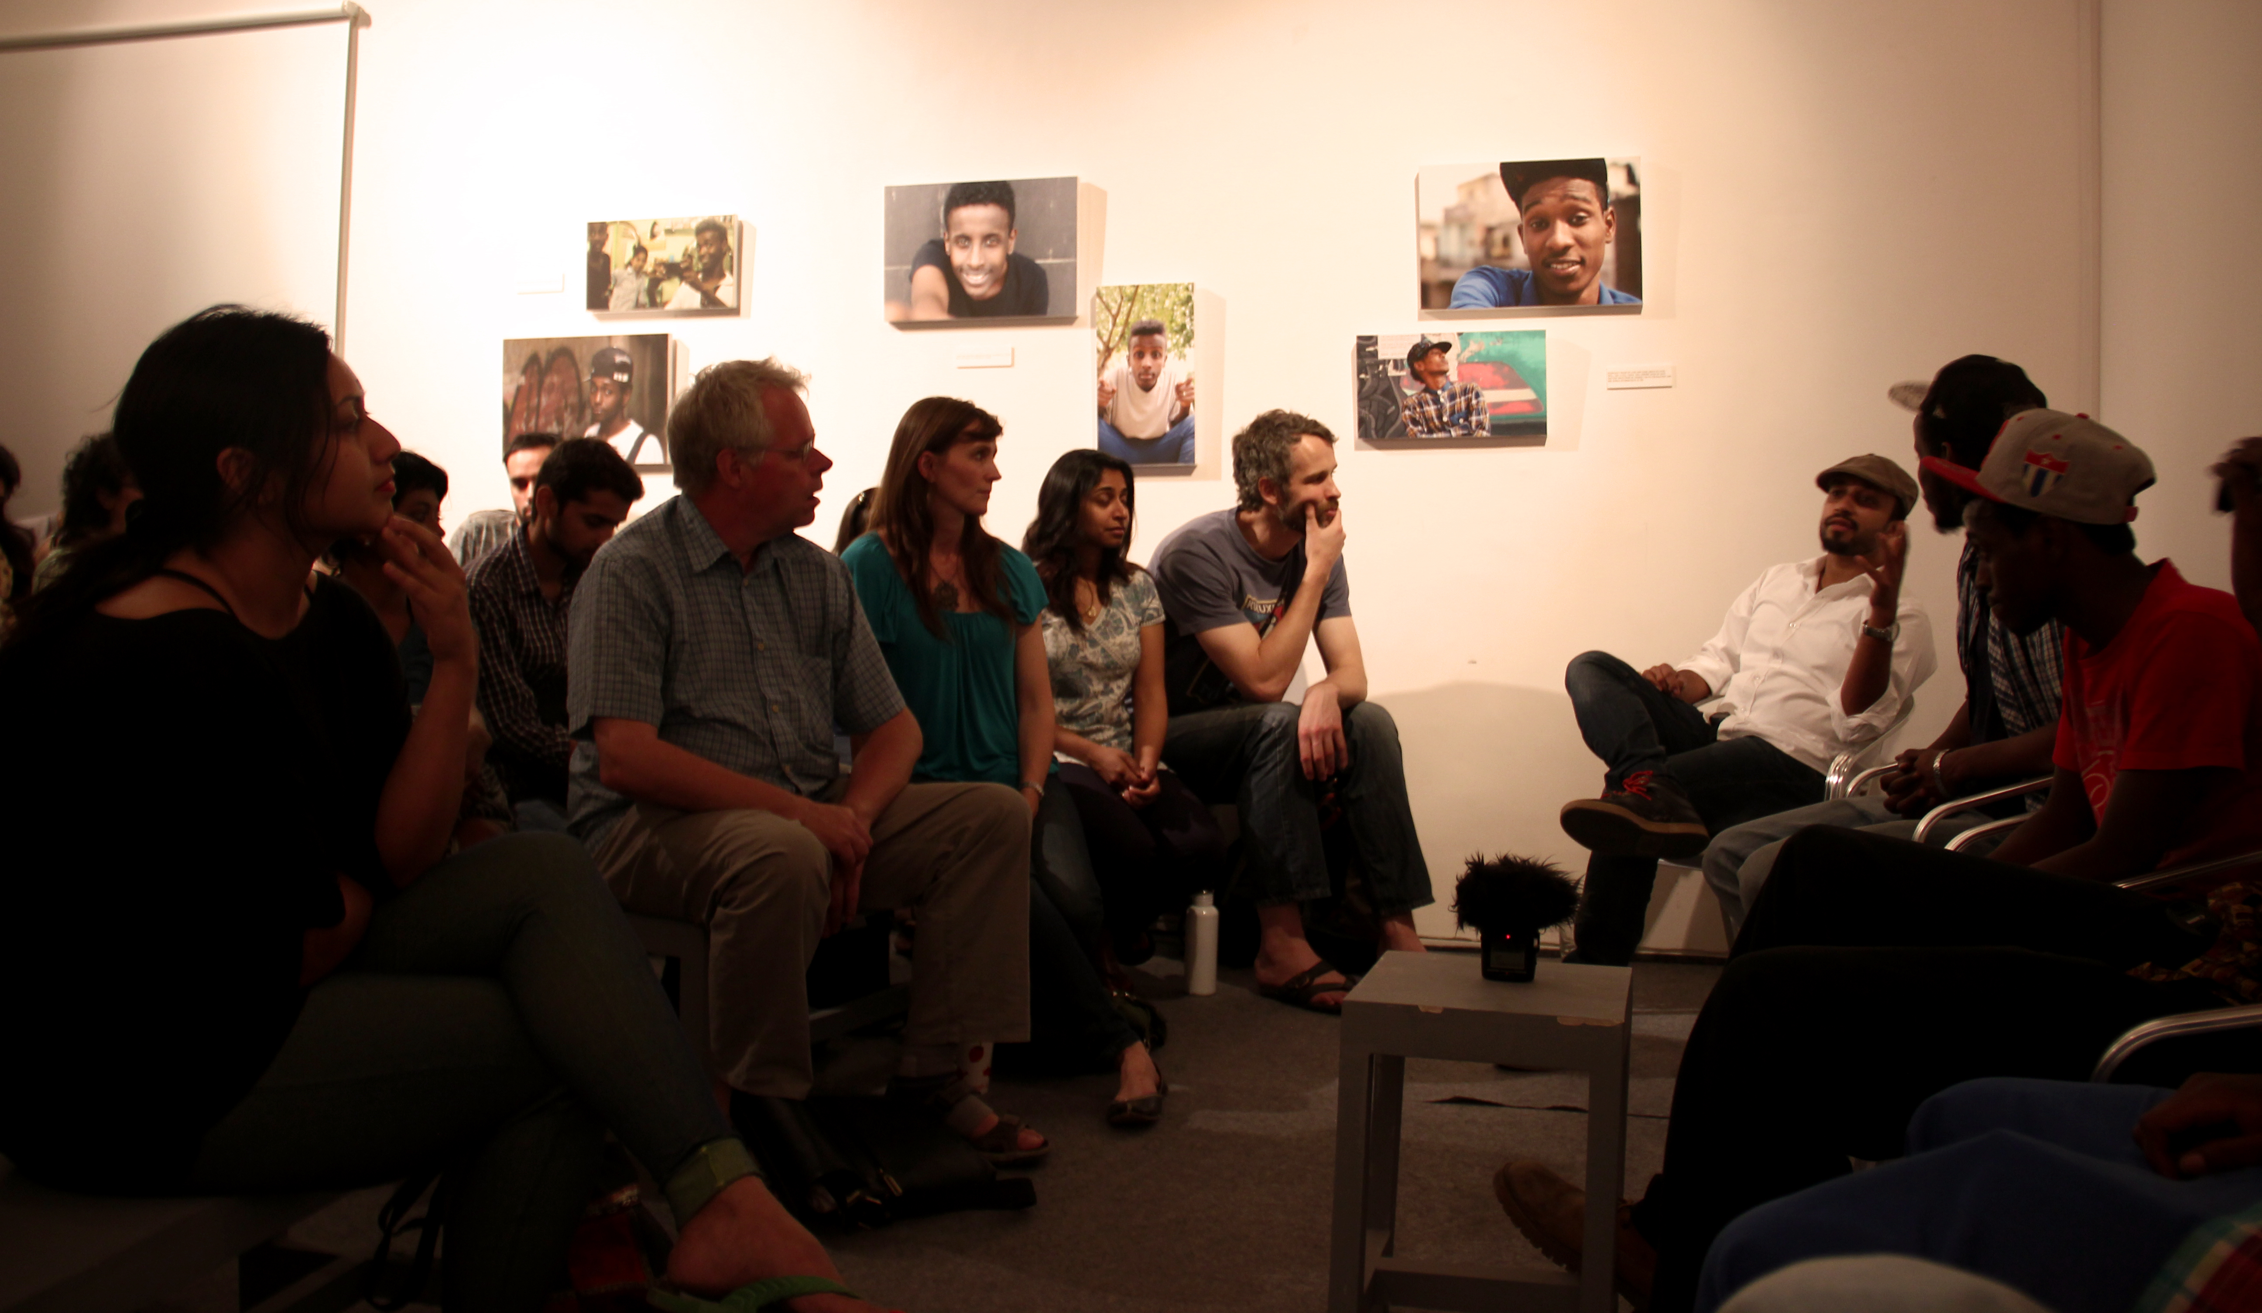

Figure 5: The talkback

It was a few weeks before the premiere of Cry Out Loud at Khoj Gallery. As we gathered daily to work on film edits, the idea of utilizing the photos to create a conceptually driven exhibition that showcased the young men and their experiences, something we had playful discussed over the course of several months, became a serious topic. The photos, for me at least, created a way for the Somali crew, who were only glancingly narrated into the film, an opportunity to show some of their photos as products of their artistic and ethnographic self- inquiry. I told them my thoughts regarding the inclusion of a photo show to the screening and they were immediately excited by the idea. However, after looking through the photos I had narrowed down for us to begin a conversation about a photo exhibition – over 60 portraits or more than 10 for each of them – they wanted to re-shoot the portraits to make sure they capture the best possible self-images for the show. I argued that the spontaneity that the existing shots provided would be lost if we went ahead and reshot all of their portraits for the show. They felt that if the photos were going to be displayed they needed to be the ‘best’ images they could be. After much discussion we compromised, deciding to select two self-portraits for each of them, one image from the archive of photographs that had created over the course of the year, one image that we would shoot together before the show using my DSLR. In the process of shooting new portraits and choosing selfies from the archives they had created, many conversations emerged about Somalia and the circumstances of their exile.
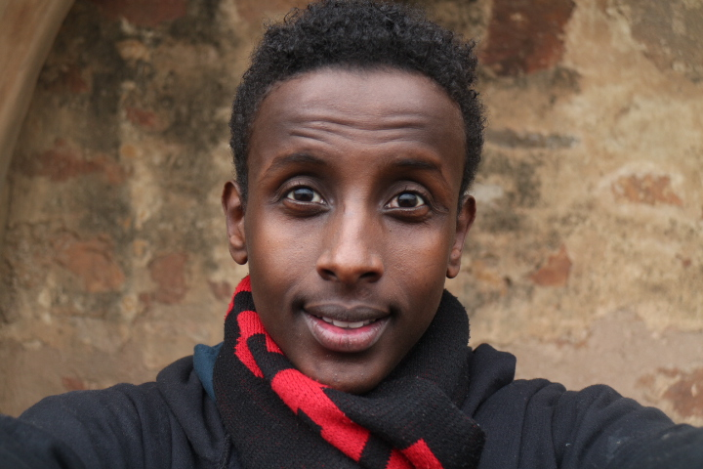
Figure 6: I hide the struggle behind my smile. Oh Somalia, when Will I Be Able to Come Back Home?

In this image above, for instance, Salim peers into the camera with a smile, and underneath the photo he exclaims that his smile hides the struggle of not being able to return home. This photo marks the importance of highlighting their experience of waiting in Delhi as the defining feature of their experience of diasporic displacement. While, certainly, these young men shared the experience of dispersal and movement with the pan-African community, the Afghan community, the Burmese community, and with many of the (im)migrants they were friends with in Delhi, the salience of their inability to return home and their perception that India could never be a permanent home, marked their experience as unique.
With this in mind, I assumed that the portraits in the show would necessarily be of them, that we could thematize through their portraits waiting and the complex subjectivities that emerge in the process of being emplaced in Delhi while not having access to Somalia except through memory. However, when I suggested that we just include portraits of them for the show they were reluctant, countering that we should display portraiture of one member of their crew who is Afghan, as well as images of me. While the young Afghan, Sharif, didn’t have a prominent role in the making of the film they felt the need to include him because he is their close friend and was along for many of the shoots. With regards to me, they argued that since we did the photo exhibition and the film together, it was only right that we include portraits of me in the exhibit. I countered by arguing that including Sharif and I would take away from the exhibits power to visualize the story of youthful Somali’s and their experiences in Delhi. In the end, I got my way and the show only included images of these 5 young Somali men, images that we together called Waiting Subjects – a rumination on their experience of waiting in Delhi, in between home and a third country option.
In hindsight, my decision to leave images of Sharif and myself out of the exhibition reveals an intractable problem at the heart of collaborative visual representation. In their argument for an inclusion of our portraits in the show, I realized much later, was a reluctance to define their experiences in Delhi within the limited categories of Somali and refugee. Rather, they were interested in showing a social context for waiting in their images, a social context that included their longstanding relationship with Sharif and their growing relationship with me. If we consider that Facebook profiles provide a platform for individuals to produce oneself in multiplicity while simultaneously representing an iterative record of how several social networks coincide in ones life, then the images that would have most accurately represented their image-making practices for Facebook would have also included group photos and portraits of friends who were not Somali.
Waiting Subjects, however, wound up visually representing a more ‘traditional’ categorically determined social scientific endeavor, one where expert formulated markers of sociality fashion the epistemological and ontological limits of representation. By choosing to display these young men’s portraits as Somali refugees in Delhi and to title the show Waiting Subjects, I pushed an agenda that perhaps erased an opportunity to showcase a set of images that represented their visual archive as something more than a rumination on waiting and subjectivity, one that included a visualization of intersubjective engagement made possible through digital technologies and global circulations of the popular. As a result, I unwittingly reproduced the implicit expert-novice ethos of photovoice, a termed coined to describe collaborative image making as research and pedagogy (Delgado, 2015; Learmonth & Huckvale, 2013). Photovoice, as the term suggests, utilizes image production as a means to explicitly ‘give voice’ to those who seemingly don’t have the means to articulate themselves in public spheres (Johnson, 2011; Kester, 2013; Phelan & Kinsella, 2011). ‘Voice’, however, is shaped not only in processes of production but in acts of representation (Mand, 2012). As several proponents of photovoice as method have warned, power differentials between expert researcher/artist and novice participants have the potential to subvert hopeful claims that the method promotes self-representation.
Waiting Subjects drew from a very differently situated image making process than the most photovoice projects insofar as it was participant driven, pre-existent in the realms of social media, and an accidental by-product of a collaborative filmmaking endeavor. As such, it offers a different methodological possibility by which to imagine a collaborative image-making project as it disturbs the ways ‘expert ‘seeing leaks into novice image production. Yet, this alternate take on photovoice, one underwritten by the digital proclivities of my participants, still fell prey to some of the problematic constructions of social categories that have historically confounded the social sciences. The ethnographic text that accompanies the images in this article, in some sense, is a move to rectify the limits of the exhibition and reveal something of the complex social worlds that the images inhabit.

References
Alim, H. Samy
2009 Straight outta Compton, straight aus München: global linguistic flows, identities, and the politics of language in a Global Hip Hop Nation. In Global linguistic flows: Hip Hop cultures, youth Identities, and the politics of language. H. S. Alim, A. Ibrahim and A. Pennycook, eds. Pp. 1-24. New York: Routledge.

Anthony Neale, Mark
2013 Nigga: The 21st Century Superhero. Cultural Anthropology 28:3, pp. 556-563.

Banks, Marcus and Morphy, Howard
1997 Rethinking Visual Anthropology. New Haven, CT: Yale Univ. Press

Dattatreyan, Ethiraj Gabriel
(In preparation) The Filmic Cipha: Collaborative Video Ethnography in Delhi, India.

Delgado, Melvin
2015 Urban Youth and Photovoice: Visual Ethnography in Action. Oxford, England: Oxford University Press.

Edwards, Elizabeth
2012 Objects of Affect: Photography Beyond the Image. Annual Review of Anthropology 41, pp. 221-234.

Facebook Newsroom
2015 Stats. http://newsroom.fb.com/company-info/, accessed April, 2015.

Henley, Paul
2010 Adventures of the Real: Jean Rouch and the Craft of Ethnographic Cinema. University of Chicago Press: Chicago, London.

Hevia, James
2009 The photography complex: exposing Boxer-Era China 1900–1. In R. Morris ed. Photographies East: The Camera and its Histories in East and Southeast Asia, pp. 79–99. Duke University Press: Durham.

Johnson, Ginger
2011 A Child’s Right to Participation: Photovoice as Methodology for Documenting the Experiences of Children Living in Kenyan Orphanages. VAR 27(2) pp. 141-161.

Kester, Grant H.
2013 Conversation Pieces. Berkeley and Los Angeles: University of California Press.

Learmonth, Malcolm & Huckvale, Karen
2013 The Feeling of What Happens: A Reciprocal Investigation of Inductive and Deductive Processes in an Art Experiment. In S. McKiff ed. Art as Research: Opportunities and Challenges, pp. 95-106. Chicago: University of Chicago Press.

Marr Maira, Sunaina
2002 Desis in the House: Indian American Youth Culture in NYC. Temple University Press: Philadelphia.

Mand, Kanwal
2012 Giving Children a ‘Voice’: Arts Based Participatory Research Activities and Representation. International Journal of Social Science Research Methodology, 15(2) pp. 149-160.

Partridge, Damian
2013 Occupying Black Bodies and Reconfiguring European Spaces – The Possibilities for Non-Citizen Articulations in Berlin and Beyond. Transforming Anthropology Vol. 2 (1), pp. 41-56.

Phelan, Shanon & Kinsella, Elizabeth Anne
2013 Photoelictation Interview Methods and Research with Children. In J. Higgs, A. Titchen, D. Horsfall, and D. Bridges, eds. Creative spaces for qualitative research: Living research.

Poole, Deborah
1999 Vision, Race, and Modernity: A Visual Economy of the Andean Image World. Princeton University Press: New Jersey.

Biggie is short for Biggie Smalls, the stage name of Christopher Wallace, one of the most acclaimed American rappers of all time who passed away in the late 1990s.
On several occasions I noted how these young men made a subtle register shift with Muslims in their spatial community, speaking Hindi-Urdu, with an increased Arabic and Farsi vocabulary, rather than the Hindi they normally spoke to their friends from outside Khirki.

