Don’t get misdirected! Differences in overt and covert attentional inhibition between children and adults.

Gustav Kuhn & Robert Teszka
Goldsmiths, University of London

Address for correspondence:

Department of Psychology
Goldsmiths University of London
New Cross, London SE14 6NW
United Kingdom
g.kuhn@gold.ac.uk

Key words: Attentional Control, Inhibition, Development, Overt attention, Covert Attention, Misdirection

Word Count: 3855

Abstract:

Previous research has revealed marked improvements in cognitive control between the age of 10 years and adulthood. The aim of the current study was to explore differences in attentional control between adults and children within a natural context, namely whilst they were watching a magic trick. We measured participants’ eye movements whilst they watched a misdirection trick in which attentional misdirection was used to prevent observers from noticing a salient visual event. Half of our participants failed to detect this event even though it took place in full view. Children below the age of 10 were significantly less likely to notice the event than the adults, and were also more reliably overtly misdirected (i.e. where they looked). Our results illustrate that within a more naturalistic context children are significantly more distracted than adults, and this distraction can have major implications on their visual awareness.

Introduction:

We heavily rely on our eyes to interact with the world around us, and our visual system has developed effective strategies that provide us with detailed sensory information, as efficiently as possible (Findlay & Gilchrist, 2003). This process is only possible because our attentional systems systematically select relevant information, which allows us to focus our neural resources on parts of the world that are important, and thus avoid wasting precious resources on less important aspects (Corbetta & Shulman, 2002; Desimone & Duncan, 1995). Our attentional selection is driven by bottom-up stimulation from the external world (Itti & Koch, 2001), and top-down internally generated endogenous processes (Folk, Remington, & Johnston, 1992; Land & Hayhoe, 2001). These endogenous processes are predominantly driven by frontal cortical areas, but many of these brain systems are not fully matured until we reach adolescence (Booth et al., 2003; Bunge, Dudukovic, Thomason, Vaidya, & Gabrieli, 2002; Durston et al., 2002). The late development of these neuronal structures predicts that top-down attentional control does not fully develop until late into adolescence (Colombo, 2001).

Much of what we know about developmental changes in cognitive control comes from studies measuring oculomotor behaviour (Colombo, 2001). For example, newborn infants will automatically orient their eyes towards faces (Farroni, Csibra, Simion, & Johnson, 2002), but as they grow older, they start exerting more top-down cognitive control over where they look (Luna, Velanova, & Geier, 2008). The anti-saccade task is a popular paradigm used to measure oculomotor control and participants must execute a volitional saccade whilst inhibit looking at an attention-grabbing stimulus. Children aged 10 years and lower struggle to inhibit eye movements towards the salient distractor (C. Klein & Foerster, 2001; Luna et al., 2008; Munoz, Broughton, Goldring, & Armstrong, 1998), but their performance greatly improves as they grow, and reaches adult like performance by late adolescence (Fukushima, Hatta, & Fukushima, 2000). Children below the age of 11 years also have more difficulties inhibiting erroneous eye movements towards task irrelevant distractors whilst searching for a visual target (Kramer, Hahn, Irwin, & Theeuwes, 2000), and are more likely to erroneously follow a person’s gaze when instructed to look elsewhere (Kuhn et al., 2011).

As children grow older they also systematically change where they look whilst exploring pictures (Helo, Pannasch, Sirri, & Rämä, 2014; Kooiker, van der Steen, & Pel, 2016). For example, Açik et al., (2010) measured participants’ eye movements whilst they viewed natural images and found that children under the age of 10 years focused more on local detail (i.e. low level saliency), whilst adults are more tuned to global aspects of the scenes. The authors suggest that children’s viewing strategies are particularly influenced by bottom-up processes, and that they start relying more heavily on top-down processes as they enter adolescence.

Much of the research on attentional control has focused on oculomotor behaviour, and whilst some have suggested that overt (i.e. eye movements) and covert attentional orienting (i.e. attention that is independent of eye movements) are intrinsically linked (Rizzolatti, Riggio, Dascola, & Umilta, 1987), overt and covert attention may be driven by different mechanisms (R. Klein, 1980; for review see D. T. Smith & Schenk, 2012). Supporting this latter view we have recently shown that within a more naturalistic context (i.e. whilst watching a magic trick), people have more direct top-down control over where they look than where they attend to covertly (Kuhn, Teszka, Tenaw, & Kingstone, 2016).

Numerous studies have investigated developmental differences in covert attentional orienting, and most of these studies have used a Posner cueing task (Posner, 1980), in which participants are required to identify targets as rapidly as possible in peripherally cued or non-cued locations (Enns & Brodeur, 1989; Schul, Townsend, & Stiles, 2003). This paradigm has been effectively used to measure covert shifts of visual attention, and these studies demonstrate that from an early age, children are faster to detect targets in the cued location (peripheral cues), even when the cues are non-predictive of the target location (e.g. Enns & Brodeur, 1989; Schul et al., 2003). Manipulating the cue/target contingency allows us to measure strategic/volitional shifts of attention, and the period between 6 and 10 years appears to be particularly important for the development of endogenous covert attentional control. For example, Leclercq et al., (2013) manipulated the frequency by which the targets appeared in the peripherally cued location, and found that children below the age of 8 years generally fail to orient attention towards a predictable, yet not cued location. However, by 10 years this ability to override an exogenous cue becomes adult like.

Most of the past research on attentional control has used tightly controlled experimental paradigms, but in recent years doubts have been raised over the extent to which these findings generalize to the “real” world (Kingstone, Smilek, & Eastwood, 2008; Smilek, Birmingham, Cameron, Bischof, & Kingstone, 2006). This criticism is particularly poignant for social attention research, but it also applies to more general attention research. For example, much of the research on covert attentional control is restricted to studies in which participants are explicitly instructed to attend to targets, and children may struggle to follow these complex instructions. It is thus often not entirely clear whether the observed changes in attentional control reflect genuine differences in attentional control, or whether they simply result from difficulties in understanding/following the task instructions. Another potential problem lies in the simple visual displays that are typically used. There are many instances in which it is necessary to control the experimental stimuli in terms of low-level visual features (for full discussion see Cole, Skarratt, & Kuhn, 2016), but these experimental contexts share little resemblance with the complex environments we typically find ourselves in (Risko, Laidlaw, Freeth, Foulsham, & Kingstone, 2012). For example, in the “real” world it is very rare to search for the same target over and over again (whilst tying to ignore a single visual distractor) as most of our day-to-day activities involve navigating though complex visual environments, whilst inhibiting lots of different distractors simultaneously. Very little is known about how children deal with these complex forms of distraction, and our aim was to investigate developmental change in attentional orienting in a more naturalistic and challenging environment.

We have developed a novel paradigm that allows us to examine overt and covert attentional processes within a more naturalistic context, namely whilst watching a magic trick. In the misdirection paradigms attentional misdirection is used to prevent observers from noticing a highly salient event, namely the dropping of a lighter (Kuhn, Caffaratti, Teszka, & Rensink, 2014; Kuhn & Martinez, 2012). In this “magic trick” the magician uses a range of misdirection cues, such as his gaze and movement gestures to draw the observer’s attention away from the lighter so that it can be dropped without being noticed (Kuhn, Tatler, Findlay, & Cole, 2008). One of the advantages of this paradigm is that it provides insights into different forms of attentional orienting, within a tightly controlled, yet natural context.

Looking at an object is not sufficient to detect it, and much of the research on inattentional blindness has revealed that if covert attention is allocated elsewhere people fail to detect highly salient events (Simons & Chabris, 1999), even when fixated (Mack & Rock, 1998; Memmert, 2006). In the context of misdirection, numerous studies have revealed that detection of a change (Kuhn et al., 2016; T. J. Smith, Lamont, & Henderson, 2012; T. J. Smith, Lamont, & Henderson, 2013) or transient event (Barnhart & Goldinger, 2014; Kuhn & Tatler, 2005; Kuhn, Tatler, & Cole, 2009) is independent of fixation. In these paradigms, attention is necessary to perceive the event, and thus participants who detect the event without fixating it, are likely to be attending to it covertly (for full discussion see Kuhn et al., 2008; Kuhn et al., 2016). In our misdirection paradigm the detection of the lighter drop thus provides a valuable measure of attentional processes that are independent of eye movements (i.e. covert attention).

Misdirection involves hijacking our focus of attention, which naturally creates a conflict between our internally driven attentional focus and the magician’s misdirection strategy (Kuhn et al., 2014). Many of these attentional misdirection strategies are extremely effective and participants often fail to inhibit misdirection even when explicitly instructed to avoid doing so (Kuhn et al., 2016). The extent to which people can avoid being misdirected therefore provides us with a natural way of measuring their attentional control.

The aim of the current study was to explore differences in attentional control between adults and children within a natural context, namely whilst they were watching a magic trick. We chose children below the age of 10 years of age, since this is the point during which top-down attentional inhibition has not yet reached adult levels (e.g. Kramer et al., 2000). Participants’ eye movement and detection rates were used as measures of overt and covert attention. If children have less top-down control over their attentional mechanisms, we predict that children should be more reliably misdirected than adults, both in terms of where they look and whether they detect the lighter being dropped.

Methods:

Participants:

Thirty-one children (M = 8; SD = 1.5; Age range 7 – 10 years) and 31 of their parents/carers (M = 41; SD = 8.3; Age range 17 - 51) were recruited to participate at a primary school. The study was conducted at a local primary school, and all of the children were pupils of the school, and the adults were either staff or parents/carers. Socioeconomic status was therefore comparable across groups as they were from the same family groups and catchment area. Data from three of the children were excluded as they exceeded the required age (11 years, 14 years).

Ethics and Consent
The study was given full ethical approval from the Brunel University School of Social Sciences Ethics Committee according to guidelines stipulated by the British Psychology Society, and parents gave formal consent for themselves and their children.

Material and Procedure:

Participants were asked to watch a video of a magic trick and to try and discover how it was done. The video featured a magician who used misdirection to apparently vanish a lighter (Kuhn & Findlay, 2010). The magician is seated at a table across from the viewer, and a lighter is on the table (fig.1 & supplementary video). He then looks at the lighter, picks it up, lights it, and pretends to take the flame away with his right hand. He follows his right hand with his gaze, and shakes it to show that the flame has “disappeared”. This movement and his social cues provide misdirection for his left hand to visibly drops the lighter behind the table. Importantly this dropping action takes place in full view. After the drop, the magician looks back at this hand and shows that the lighter has apparently vanished.

After viewing this video, participants were asked to describe what they saw happen. If they did not freely mention seeing the lighter drop, they were further asked if they saw what happened to the lighter, and then finally if they saw how it disappeared. Their answers were recorded by an assistant, and later coded according to whether participants reported seeing the lighter being dropped.

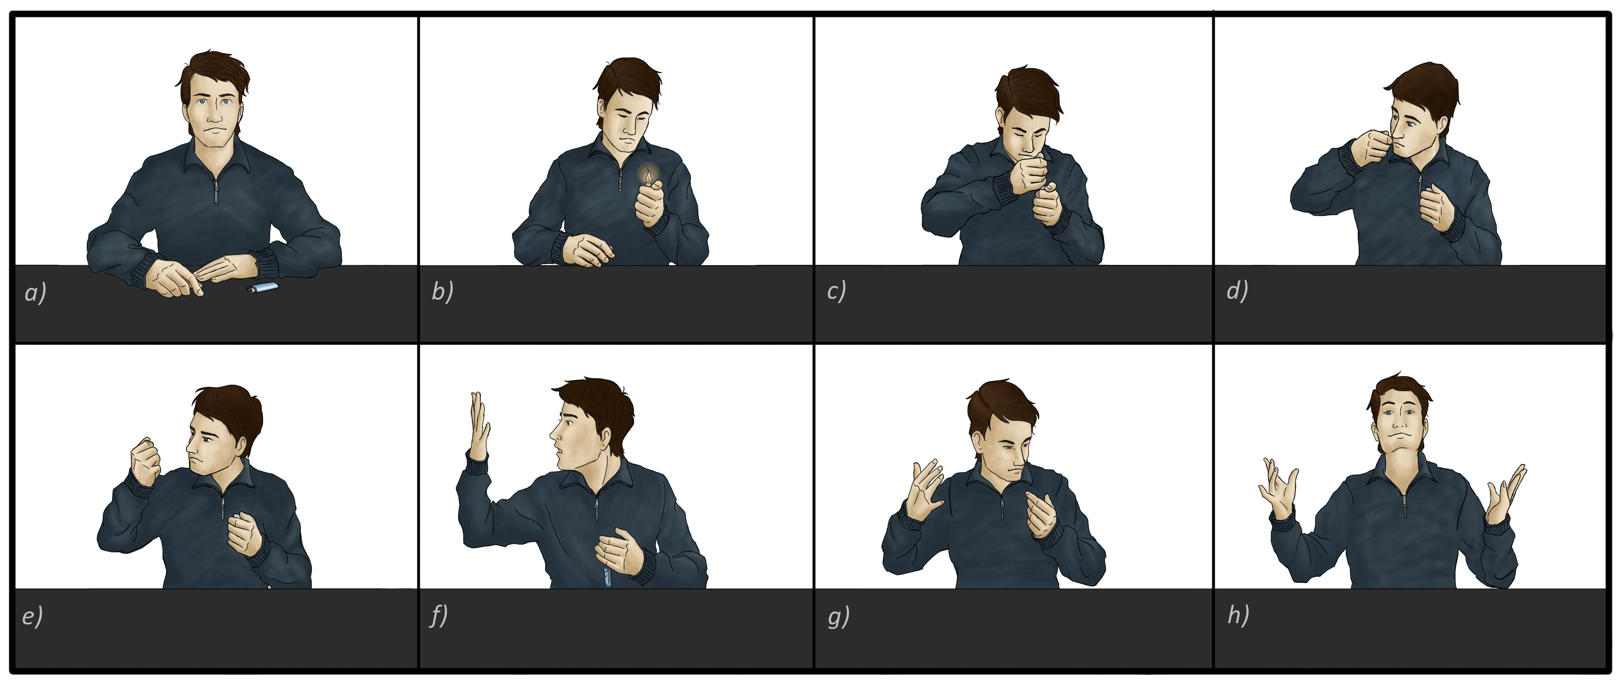

Fig 1. Timeline of disappearing lighter trick. Misdirection movement from c) to f), at which point lighter is dropped.

Eye movement data were recorded monocularly at 1000 Hz with the SR Research EyeLink 1000 desktop eye tracker (SR Research). The video was presented on a 21in CRT Monitor with a 800x600 screen resolution, and the video was presented at 25 frames per second and a 720 x 576 resolution. Participants were seated with their head held stationary on a chinrest approximately 57cm from the computer monitor. Eye movements were calibrated for each participant using a nine-point calibration procedure. Each trial started with a drift correction and was initiated once participants fixated the centre of the screen. Eye movements were analysed using Data Viewer analysis were conducted using Data Viewer 2.4.0.198 (SR-Research).

Results:

Overt Misdirection
Figure 2 shows participants’ fixations at the point at which the lighter is dropped (see supplementary videos for eye movements across entire video). Seven adults fixated the lighter hand, at the time of the lighter drop, whilst none of the children did so. The adults were significantly more likely to fixate the hand dropping the lighter (22%) than the children (0%) Fisher’s Exact test = 9.89, p = .01. As none of the children fixated the lighter hand detection was independent of where they were looking. In the adults, participants who fixated the lighter hand were significantly more likely to detect the lighter drop than those who fixated elsewhere. Fischer’s exact test = 9.06, p = .025.

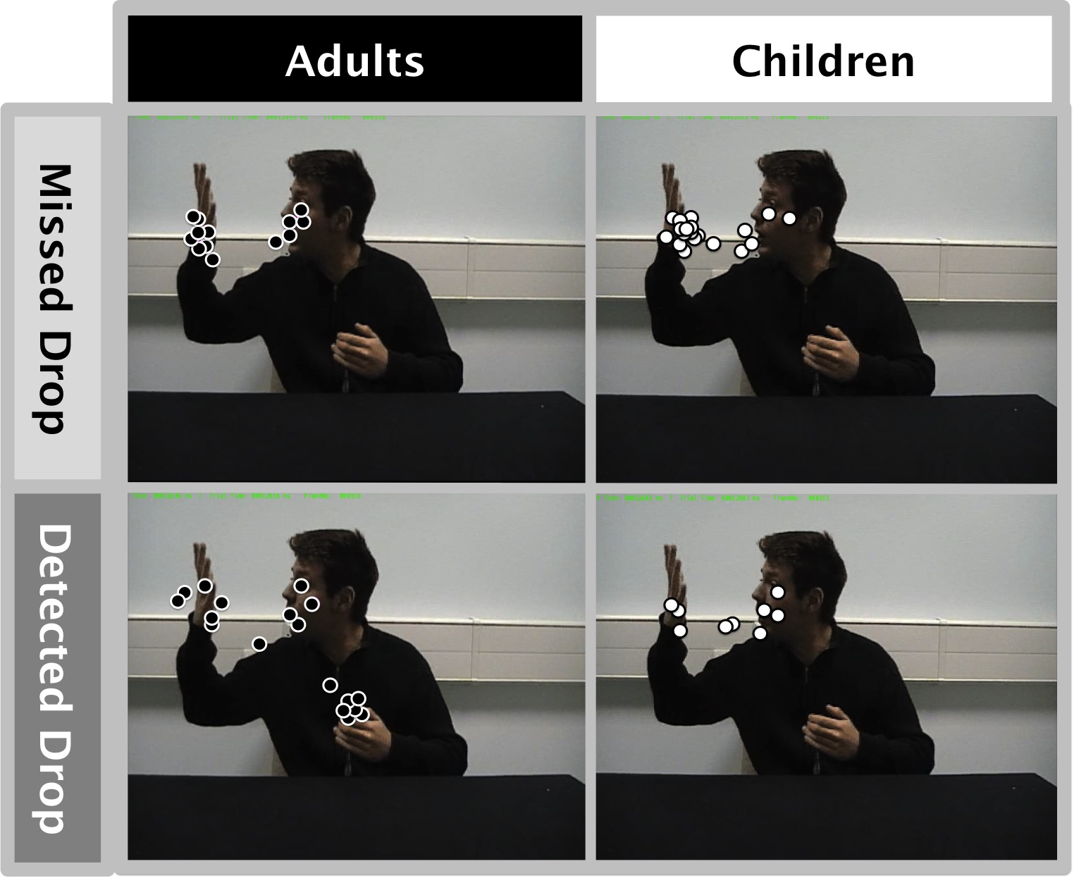

Figure 2: Fixation points at the time of the lighter drop as a function of whether the lighter was detected or not, for children and adults. The left panels show fixation points for the adults (black dots) and the right panels show the fixation points of the children. The top two panels are fixation points for individuals who missed the drop (i.e. covertly misdirected), and the bottom panels are fixation points for individuals who detected the drop (i.e. not covertly misdirected).

Covert Misdirection
Our second analysis compared the proportion of adults and children who failed to notice the lighter drop. Participants were classified as having detected the lighter drop if they claimed to have seen how the trick was done and also came up with the correct method (the lighter was dropped, rather than simply that “it went up the sleeve”). 42% of the adults failed to see the lighter drop, compared to 68% of the children, thus illustrating the children were significantly more covertly misdirected than the adults X²=3.98, p = .046. However, seven of the adults detected the lighter while fixating it, thus indicating that they were attending to it overtly and covertly.

Discussion:

Our aim was to compare children and adult’s inhibition of attentional distraction, by measuring the extent to which they were misdirected. Attentional misdirection works by systematically misdirecting people’s attention away from the method (i.e. the dropping lighter), and thus the only way in which the method can be detected is by inhibiting this attentional manipulation. Similar to previous research half of our participants failed to notice the lighter being dropped, even though this occurred in full view. However, children under the age of 10 years were significantly less likely to notice the lighter drop, which illustrates that children have greater difficulties inhibiting the attentional misdirection.

Using a sustained inattentional blindness task Neisser (1979) reported that children were more likely to notice an unexpected event, and he suggested that children show less inattentional blindness because they are less able to maintain their focus of attention on the primary task, and thus are more likely to shift their attention to the unexpected event. Using the Gorilla Illusion (Simons & Chabris, 1999), Memmert (2006) on the other hand revealed higher levels of inattentional blindness in children under the age of 8 than adults, and he suggested that the age between 8 to 13 years shows a particular improvements in detecting unexpected events. There has been much debate about the similarities and differences between inattentional blindness and misdirection (Kuhn & Tatler, 2011; Memmert, 2010), but our results support Memmert’s findings that detection of unexpected events improves, rather than deteriorates with age.

One could potentially argue that these differences in detection rate result from an immature verbal ability or reflect lack in confidence. We believe that this is unlikely, then the children were very quick to express their opinion on how the trick was done. The children who were classified as not detecting the drop usually incorrectly stated that it “went up his sleeve”, whilst the children who did detect the drop said that they saw it drop immediately after the video. Indeed anecdotal evidence from child entertainers confirms that children are not shy about expressing their opinion about how they think a magic trick is done (Kaye, 2005). This anecdotal evidence also highlights that children are probably just as motivated as adults to discover how the trick was done. It is also conceivable that the adult participants have more experience with magic and thus are simply guessing/deducing the method, rather than seeing it. However, this is unlikely, as the method of dropping a lighter is very counter-intuitive, and participants who are asked to guess the method typically claim that the lighter went up the magician’s sleeve and very rarely guess that it was dropped (for full disucssion of this issue see Kuhn & Findlay, 2010).

The children were also more likely to be overtly misdirected. None of the children fixated on the magician’s hand that was dropping the lighter and instead they all looked at his waving hand or his face. Seven adults did manage to inhibit the magician’s misdirection and despite his efforts to draw attention away from the drop, fixated the hand that was dropping the lighter. These results further illustrate that the children were less able to inhibit the misdirection, and thus have less top-down control over where they are looking. Further analysis of our eye movement data provided additional evidence to support this view. At the beginning of the trial all participants were required to fixate the centre of the screen before the video was displayed. Once the video appeared all participants immediately fixated the magician’s face, which coincides with a large body of research illustrating that faces are prioritised (Birmingham, Bischof, & Kingstone, 2008; Fletcher-Watson, Leekam, Benson, Frank, & Findlay, 2008; Yarbus, 1967). The time to fixate on the face provides valuable insights into the automatic nature of this social attentional orienting (Fletcher-Watson et al., 2008; Freebody & Kuhn, 2016; Kuhn, Kourkoulou, & Leekam, 2010; Zwickel & Vo, 2010). Our children were significantly faster to fixate on the face (M = 260 ms; SD = 53) than the adults (M = 319 ms; SD = 122)[t(57) = 2.36, p = .022], which further supports the view that children’s eye movements are more strongly driven by bottom-up processes..

Much of the previous research suggests that from the age of 10 till adulthood, children develop better top-down control over their attentional resources (Federico, Marotta, Martella, & Casagrande, 2016; Fukushima et al., 2000; Helo et al., 2014; C. Klein & Foerster, 2001; Kramer et al., 2000; Kuhn et al., 2011; Luna et al., 2008; Munoz et al., 1998) and our results support this interpretation. However, it is also possible that adults know more about magic tricks in general, and were therefore more likely to attempt avoiding the attentional misdirection. Thus, the adults may not only be better at controlling their attention, but they are also more effective at using their knowledge about the world to guide their attentional resources to locations they though were critical to work out how the trick was done. Research in other domains, such as chess, has revealed how domain specific expertise leads to more effective perceptual encoding strategies (Reingold, Charness, Pomplun, & Stampe, 2001), and it is therefore likely that our attentional strategies in general change, as we learn more about the world around us.

The misdirection paradigm offers the advantage that we can measure both overt and covert attentional processes under more naturalistic viewing conditions. Amongst the children there was no systematic relationship between where they were looking at the time of the drop and whether they detected the drop or not, which is in line with much of the previous research (Barnhart & Goldinger, 2014; Kuhn & Findlay, 2010; Kuhn & Tatler, 2005; Kuhn et al., 2009). We can therefore assume that the children who detected the drop did so because they were attending to it covertly. Amongst the adults, seven participants fixated the lighter at the time of the drop, and these participants also detected it. As shown by Kuhn et al., (2008) fixating the event does not necessarily imply that participants will detect it (Mack & Rock, 1998; Memmert, 2006), but as these seven participants reported seeing the lighter we can conclude that they attended to it both overtly and covertly. For the remaining 24 adult participants there was no systematic relationship between where they fixated and whether the saw the lighter-drop, suggesting that for them detection was independent of where they were looking. Interestingly, if we remove the seven participants who detected the lighter drop from the analysis, the children were still more likely to miss the drop (68%) than the adults (54%), though this difference is no longer statistically significant.

Much of the research on covert attention illustrates that we can dissociate overt and covert attentional processes when we are explicitly asked to fixate our eyes on one location and process information in the periphery (R. Klein, 1980; Posner, 1980). However, it is generally assumed that this dissociation only occurs under tightly controlled situations and that when we move our eyes more freely we attend covertly to locations that are fixated (Findlay & Gilchrist, 2003), which is why eye movements are thought to be a useful tool to study attentional processes in the real world (Henderson, 2003). In our task participants were free to move their eyes, and yet we still found a strong dissociation between looking and seeing, and this dissociation was particularly strong for the children. We showed that even when participants are not given any explicit instructions to fixate their eyes, overt and covert attentional processes are often dissociated, which potentially undermines the use of eye movement measurement to evaluate information processing in the real world.

Our results are unique in that they illustrate a significant improvement in attentional control between the ages of 10 to adulthood, using a simple naturalistic paradigm that is not confounded by complex task instructions. These findings dovetail a growing body of work which highlight developmental changes in attentional control between this age and adulthood, (Enns & Brodeur, 1989; Leclercq & Siéroff, 2013; Schul et al., 2003), which most likely results from maturations in the prefrontal cortex (Booth et al., 2003; Bunge et al., 2002; Durston et al., 2002). However, studying attentional control in a more naturalistic context highlights further developmental differences that are typically missed in the more tightly controlled designs. Our study illustrates that children as well as struggling to inhibit distractors, are probably also less able to use knowledge about the world to help guide their attentional control, and thus avoid being further distracted by task irrelevant features (Ruth, Patai, Duta, Nobre, & Scerif, 2017). Controlling your attentional resources and avoiding distraction are crucial for many every day activities, such as learning, or simply navigating trough busy environments. Indeed our results are a stark reminder of the important role that covert attentional processes play in determining our visual awareness, and the detrimental consequences failures of attention have. Most importantly though, our results illustrate that children under the age of 10 years are far more prone to attentional distraction, and this distraction has direct implications on how they experience the world around them. For example, our results predict that within a classroom setting younger children will find it much harder to inhibit distractions, and these distractors will severely influence how they experience their surroundings. Understanding the development of these attentional control mechanisms provides valuable insights into children’s attentional limitations and will help us design more safer and engaging learning environments.

References

Açik, A., Sarwary, A., Schultze-Kraft, R., Onat, S., & König, P. (2010). Developmental changes in natural viewing behavior: bottom-up and top-down differences between children, young adults and older adults. Frontiers in Psychology, 1. doi: 10.3389/fpsyg.2010.00207
Barnhart, A. S., & Goldinger, S. D. (2014). Blinded by magic: Eye-movements reveal the misdirection of attention. Frontiers in Psychology, 5. doi: 10.3389/fpsyg.2014.01461
Birmingham, E., Bischof, W. F., & Kingstone, A. (2008). Social attention and real world scenes: the roles of action, competition, and social content. Quarterly Journal of Experimental Psychology, 61(7), 986-999.
Booth, J. R., Burman, D. D., Meyer, J. R., Lei, Z., Trommer, B. L., Davenport, N. D., . . . Mesulam, M. M. (2003). Neural development of selective attention and response inhibition. Neuroimage, 20(2), 737-751. doi: http://dx.doi.org/10.1016/S1053-8119(03)00404-X
Bunge, S. A., Dudukovic, N. M., Thomason, M. E., Vaidya, C. J., & Gabrieli, J. D. E. (2002). Immature Frontal Lobe Contributions to Cognitive Control in Children. Neuron, 33(2), 301-311. doi: 10.1016/S0896-6273(01)00583-9
Cole, G. G. , Skarratt, P. A., & Kuhn, G. (2016). Real Person Interaction in Visual Attention Research. European Psychologist, 21(2), 141-149. doi: doi:10.1027/1016-9040/a000243
Colombo, J. (2001). The development of visual attention in infancy. Annual Review of Psychology, 52, 337-367. doi: 10.1146/annurev.psych.52.1.337
Corbetta, M., & Shulman, G. L. (2002). Control of goal-directed and stimulus-driven attention in the brain. Nature Reviews Neuroscience, 3(3), 201-215.
Desimone, R., & Duncan, J. (1995). Neural mechanisms of selective visual attention. Annual Review of Neuroscience, 18, 193-222. doi: 10.1146/annurev.ne.18.030195.001205
Durston, S., Thomas, K. M., Yang, Y., Uluğ, A. M., Zimmerman, R. D., & Casey, B. J. (2002). A neural basis for the development of inhibitory control. Developmental Science, 5(4), F9-F16. doi: 10.1111/1467-7687.00235
Enns, J. T., & Brodeur, D. A. (1989). A developmental study of covert orienting to peripheral visual cues. Journal of Experimental Child Psychology, 48(2), 171-189. doi: http://dx.doi.org/10.1016/0022-0965(89)90001-5
Farroni, T., Csibra, G., Simion, G., & Johnson, M. H. (2002). Eye contact detection in humans from birth. Proceedings of the National Academy of Sciences of the United States of America, 99(14), 9602-9605.
Federico, F., Marotta, A., Martella, D., & Casagrande, M. (2016). Development in attention functions and social processing: Evidence from the Attention Network Test. British Journal of Developmental Psychology.
Findlay, J. M., & Gilchrist, . I. D. (2003). Active Vision. Oxford: Oxford University Press.
Fletcher-Watson, S., Leekam, S. R., Benson, V., Frank, M.C., & Findlay, J. M. (2008). Eye-movements reveal attention to social information in autism spectrum disorder. Neuropsychologia, 47, 248-257.
Folk, C. L., Remington, R. W., & Johnston, J. C. (1992). Involuntary Covert Orienting Is Contingent on Attentional Control Settings. Journal of Experimental Psychology-Human Perception and Performance, 18(4), 1030-1044.
Freebody, S., & Kuhn, G. (2016). Own-age biases in adults’ and children’s joint attention: Biased face prioritization, but not gaze following! The Quarterly Journal of Experimental Psychology, 1-9. doi: 10.1080/17470218.2016.1247899
Fukushima, J., Hatta, T., & Fukushima, K. (2000). Development of voluntary control of saccadic eye movements - I. Age-related changes in normal children. Brain & Development, 22(3), 173-180.
Helo, A., Pannasch, S., Sirri, L., & Rämä, P. (2014). The maturation of eye movement behavior: Scene viewing characteristics in children and adults. Vision Research, 103, 83-91. doi: http://dx.doi.org/10.1016/j.visres.2014.08.006
Henderson, J. M. (2003). Human gaze control during real-world scene perception. Trends in Cognitive Science, 7(11), 498-504.
Itti, L., & Koch, C. (2001). Computational Modelling of Visual Attention. Nature Reviews Neuroscience, 2(3), 194-203.
Kaye, D. (2005). Seriously silly. Washington, DC: Kaufman & Co.
Kingstone, A., Smilek, D., & Eastwood, J. D. (2008). Cognitive Ethology: A new approach for studying human cognition. British Journal of Psychology, 99, 317-340.
Klein, C., & Foerster, F. (2001). Development of prosaccade and antisaccade task performance in participants aged 6 to 26 years. Psychophysiology, 38(2), 179-189.
Klein, R. (1980). Does oculomotor readiness mediate cognitive control of visual attention? In R. S. Nickerson (Ed.), Attention and Performance VII (pp. 259-276). Hillsdale, NJ: Erlbaum.
Kooiker, M. J., van der Steen, J., & Pel, J. J. (2016). Development of salience-driven and visually-guided eye movement responses. J Vis, 16(5), 18. doi: 10.1167/16.5.18
Kramer, A. F., Hahn, S., Irwin, D. E., & Theeuwes, J. (2000). Age differences in the control of looking behavior: Do you know where your eyes have been? Psychological Science, 11(3), 210-217. doi: 10.1111/1467-9280.00243
Kuhn, G., Caffaratti, H. A., Teszka, R., & Rensink, R. A. (2014). A psychologically-based taxonomy of misdirection. Frontiers in Psychology, 5, 1392. doi: doi: 10.3389/fpsyg.2014.01392
Kuhn, G., & Findlay, J. M. (2010). Misdirection, attention and awareness: Inattentional blindness reveals temporal relationship between eye movements and visual awareness. Quarterly Journal of Experimental Psychology, 63(1), 136-146. doi: 10.1080/17470210902846757
Kuhn, G., Kourkoulou, A., & Leekam, S. R. (2010). How magic changes our expectations about autism. Psychological Science, 21(10), 1487-1493. doi: 10.1177/0956797610383435
Kuhn, G., & Martinez, L. M. (2012). Misdirection - past, present, and the future. Frontiers in Human Neuroscience, 5. doi: 10.3389/fnhum.2011.00172
Kuhn, G., & Tatler, B. W. (2005). Magic and fixation: Now you don't see it, now you do. Perception, 34(9), 1155-1161. doi: 10.1068/p3409bn1
Kuhn, G., & Tatler, B. W. (2011). Misdirected by the gap: The relationship between inattentional blindness and attentional misdirection. Consciousness and Cognition, 20(2), 432-436. doi: 10.1016/j.concog.2010.09.013
Kuhn, G., Tatler, B. W., & Cole, G. G. (2009). You look where I look! Effect of gaze cues on overt and covert attention in misdirection. Visual Cognition, 17(6), 925-944.
Kuhn, G., Tatler, B. W., Findlay, J. M., & Cole, G. G. (2008). Misdirection in magic: Implications for the relationship between eye gaze and attention. Visual Cognition, 16(2-3), 391-405.
Kuhn, G., Teszka, R., Tenaw, N., & Kingstone, A. (2016). Don’t be fooled! Attentional responses to social cues in a face-to-face and video magic trick reveals greater top-down control for overt than covert attention. Cognition, 146, 136-142. doi: http://dx.doi.org/10.1016/j.cognition.2015.08.005
Kuhn, G., Tewson, L., Morpurgo, L., Freebody, S. F., Musil, A. S., & Leekam, S. R. (2011). Developmental changes in the control of saccadic eye movements in response to directional eye gaze and arrows. Quarterly Journal of Experimental Psychology, 64(10), 1919-1929. doi: 10.1080/17470218.2011.592592
Land, M. F., & Hayhoe, M. (2001). In what ways do eye movements contribute to everyday activities? Vision Research, 41, 3559-3565.
Leclercq, Virginie, & Siéroff, Eric. (2013). Development of endogenous orienting of attention in school-age children. Child Neuropsychology, 19(4), 400-419. doi: 10.1080/09297049.2012.682568
Luna, B., Velanova, K., & Geier, C. F. (2008). Development of eye-movement control. Brain and Cognition, 68(3), 293-308. doi: 10.1016/j.bandc.2008.08.019
Mack, A., & Rock, I. (1998). Inattentional Blindness. Cambridge, MA: MIT Press.
Memmert, D. (2006). The effects of eye movements, age, and expertise on inattentional blindness. Consciousness and Cognition, 15(3), 620-627.
Memmert, D. (2010). The gap between inattentional blindness and attentional misdirection. Consciousness and Cognition, 19(4), 1097-1101. doi: Doi 10.1016/J.Concog.2010.01.001
Munoz, D. P., Broughton, J. R., Goldring, J. E., & Armstrong, I. T. (1998). Age-related performance of human subjects on saccadic eye movement tasks. Experimental Brain Research, 121(4), 391-400.
Neisser, U. (Ed.). (1979). The control of information pickup in selective looking. Hillsdale, NY: Lawrence Erlbaum Associates.
Posner, M. I. (1980). Orienting of Attention. Quarterly Journal of Experimental Psychology, 32, 3-25.
Reingold, E. M., Charness, N., Pomplun, M., & Stampe, D. M. (2001). Visual span in expert chess players: Evidence from eye movements. Psychological Science, 12(1), 48-55.
Risko, E. F., Laidlaw, K. E., Freeth, M., Foulsham, T., & Kingstone, A. (2012). Social attention with real versus reel stimuli: toward an empirical approach to concerns about ecological validity. Frontiers in Human Neuroscience, 6. doi: 10.3389/fnhum.2012.00143
Rizzolatti, G., Riggio, L., Dascola, I., & Umilta, C. (1987). Reorienting Attention across the Horizontal and Vertical Meridians - Evidence in Favor of a Premotor Theory of Attention. Neuropsychologia, 25(1A), 31-40.
Ruth, D. B., Patai, E. Z., Duta, M., Nobre, A. C., & Scerif, G. (2017). The functional consequences of social distraction: Attention and memory for complex scenes. Cognition, 158, 215-223. doi: http://dx.doi.org/10.1016/j.cognition.2016.10.015
Schul, R., Townsend, J., & Stiles, J. (2003). The development of attentional orienting during the school-age years. Developmental Science, 6(3), 262-272. doi: 10.1111/1467-7687.00282
Simons, D. J., & Chabris, C. F. (1999). Gorillas in our midst: sustained inattentional blindness for dynamic events. Perception, 28(9), 1059-1074.
Smilek, D., Birmingham, E., Cameron, D., Bischof, W., & Kingstone, A. (2006). Cognitive ethology and exploring attention in real-world scenes. Brain Research, 1080, 101-119.
Smith, D. T., & Schenk, T. (2012). The Premotor theory of attention: time to move on? Neuropsychologia, 50(6), 1104-1114. doi: 10.1016/j.neuropsychologia.2012.01.025
Smith, T. J., Lamont, P., & Henderson, J. M. (2012). The penny drops: Change blindness at fixation. Perception, 41(4), 489-492. doi: 10.1068/p7092
Smith, T. J., Lamont, P., & Henderson, J. M. (2013). Change blindness in a dynamic scene due to endogenous override of exogenous attentional cues. Perception, 42(8), 884-886. doi: 10.1068/p7377
Yarbus, A.L. (1967). Eye movements and vision. New York: Plenum.
Zwickel, J., & Vo, M. L. (2010). How the presence of persons biases eye movements. Psychonomic Bulleting & Review, 17(2), 257-262. doi: 17/2/257 [pii]
10.3758/PBR.17.2.257

