Simon O’Sullivan, Goldsmiths College, University of London

Myth-Science as Residual Culture and Magical Thinking

In two recent essays I have sketched out an idea of myth-science as a ‘fictioning’ of reality (with its concomitant calling forth of new subjectivities adequate and appropriate to this) and as a kind of libidinal engineering (involving the construction, following Felix Guattari and Jacques Lacan, of new and different patheme-matheme assemblages). In the first of these essays I offered up my definition in contra-distinction to ‘hyperstition’ (as defined by the Centre for Cybernetic Research Unit); in the second against an overly rational Prometheanism (especially in its renewed ‘accelerationist’ form). For this special issue on ‘Quantum Medievalisms’ I want to develop my idea of myth-science in relation to how the past, and especially previous modes of existence, might be utilised as a resource against the impasses of the present (and the production of an increasingly homgenised subject that is attendant on this). This is not from any nostalgic desire to return to an idealized moment (or to dream of ‘escape’ from the complexities and pressing concerns of today). Neither is it, strictly speaking, to do history. Rather it is to view the past and present as entwined, with the former a living archive and possible repository of materials (broadly construed) that might well provide alternative points of subjectification today, especially when the latter are mobilised in contemporary aesthetic productions.

The article begins with a brief re-vision of Raymond Williams’ writing on hegemony, before going on to offer a commentary on a recently translated extract from Gilbert Simondon’s On the Mode of Existence of Technical Objects. Throughout, I make some references to other theoretical resources (especially Felix Guattari and Henri Bergson) and, in the footnotes, draw on a larger archive of writings (especially around magic). My commentary ends with four case studies – one longer look at a work of literature, then three more brief: two from filmic art practice and one from film per se – that exemplify this syncretic attitude and orientation towards the past.

1. Residual Cultures

In his essay ‘Base and Superstructure in Marxist Cultural Theory’ Williams presents a compelling matrix of the contemporary, or, more simply, an account of the way in which any present moment is always already made up of different ‘times’. In particular, he writes about how the dominant – and thus effective – culture (or, in William’s terms, hegemony) is never complete, that there are always ‘left overs’ from previous hegemonies that might offer alternative and even oppositional cultures (opposition here naming the possibility of a challenge to the dominant). Williams terms these kinds of cultures ‘residual’, differentiating them from ‘archaic’, which, rather, names those aspects of the past that have been effectively incorporated within the dominant and thus effective culture (Williams mentions religion, rural culture and monarchy, each of which might have both residual and archaic aspects (though the last – unless you are a Neoreactionary – would seem to offer little in terms of alternative or oppositional culture).

Williams goes on to write about more future-orientated cultures, what he calls ‘emergent’ – often the expression of a new class, but not necessarily so. The emergent is simply a new area of human activity as yet unrecognized by the dominant (hence its importance, politically speaking). In fact, Williams is attuned to what we might be called a logic of deconstruction here: the danger that an emergent culture needs must express itself in terms of the dominant, hence he also suggests the importance of a pre-emergent scene. Elsewhere, in a development of the themes of this particular essay, Williams goes one step further (or one step back) suggesting that it might even be a question of what he calls ‘structures of feeling’ that are, as it were, pre pre-emergent. It is within art – literature in fact – that Williams identifies these new forms, or proto-forms, of life, and, indeed, it seems clear that aesthetic practice in general is often involved in what we might call this affective register.

I briefly mentioned Neoreaction above and clearly there is a resonance here with the ‘NRx’ self-definition (or, at least, Nick Land’s definition): as ‘time-twisted vector that spirals forwards into the past, and backwards into the future’. Equally clear, however, is that Williams’ thesis is on the Left, which is to say is progressive rather than reactive. Again, the source of emergent culture is often a new class and the dominant and effective culture is identified as the bourgeois ideology of capitalism itself. That said both Williams and Neoreaction gesture to other times that might be utilised against the present (and, indeed, there is a sense that both identify a hegemonic effective culture, albeit for Williams this is not a Left orientated ‘Cathedral’ (understood by Neoraction as the broadly left-wing parliamentary-media-academic institution). For Neoreaction these ‘other times’ are often a Science Fiction futurism (that is also apparent in Left accelerationism). Williams also writes on Science Fiction elsewhere, and especially its tendency to technological determinism (it is, we might say, overdetermined by the capitalist mode of production). I will attend to this in a further essay on myth-science and Science Fiction, but we might note here Williams’ own idea of a form of utopian writing adequate and appropriate to our time: a fiction of the ‘wasteland’, as Williams calls it, that involves a ‘voluntary deprivation’, at least for ‘those who have known affluence and known with it social injustice and moral corruption’. I will return to this idea – and, indeed, to a concrete example of a fiction of the wasteland – towards the end of my article, but we might note here that this utopian impulse to a post-capitalism necessarily echoes aspects of a pre-capitalist past.

2. Magical Thinking

I want now to deepen this account of the complexity of the present by looking at the Simondon extract I mentioned above. Although from a different intellectual tradition to Williams (broadly continental philosophy as opposed to British cultural studies) Simondon is likewise highly attuned to the residues of the past within the present. Indeed, at the very beginning of the extract Simondon offers his own temporal matrix in terms of phase shifts between, precisely, different modes of existence. The idea of phase shifts is used so as to move away from any dialectic or idea of simple temporal progression in so far as it suggests the possible co-existence of different phases as well as their interpenetration and specific points of genesis. In relation to Science Fiction, this particular perspective – of the whole as it were – also means the extract reads like a report on human consciousness from a transhuman (or even alien) point of view.

To very briefly reconstruct Simondon’s argument. The original mode of existence of primitive man was one of magical unity. This was a state before any subject-object split and before any concomitant division into religion and what Simondon calls technicity. For Simondon aesthetics is a kind of future-orientated ‘reminder’ of this originary unity:

We suppose that technicity results from a phase-shift of a central,
original and unique mode of being in the world, the magical mode; the
phase that balances technicity is the religious mode of being. Aesthetic
thinking emerges at the neutral point between technics and religion, at
the moment of the division of primitive magical unity: this is not a phase
but, rather, a permanent reminder of the rupture of the unity of the
magical mode of being and a search for a future unity.

In fact, things are more complex than this, with the two modes – technicity and religion – split further in to theoretical and practical aspects. The distance between the two theoretical aspects characterises scientific knowledge, the distance between the two practical aspects characterises ethics, or ‘ethical thinking’ (these divisions are themselves divided, with morality and theology representing the practical and theoretical aspects of religion; and action-results and theoretical schema representing the practice and theory aspects of technicity). We might diagram this constellation of different modes and phases as in Fig. 1.

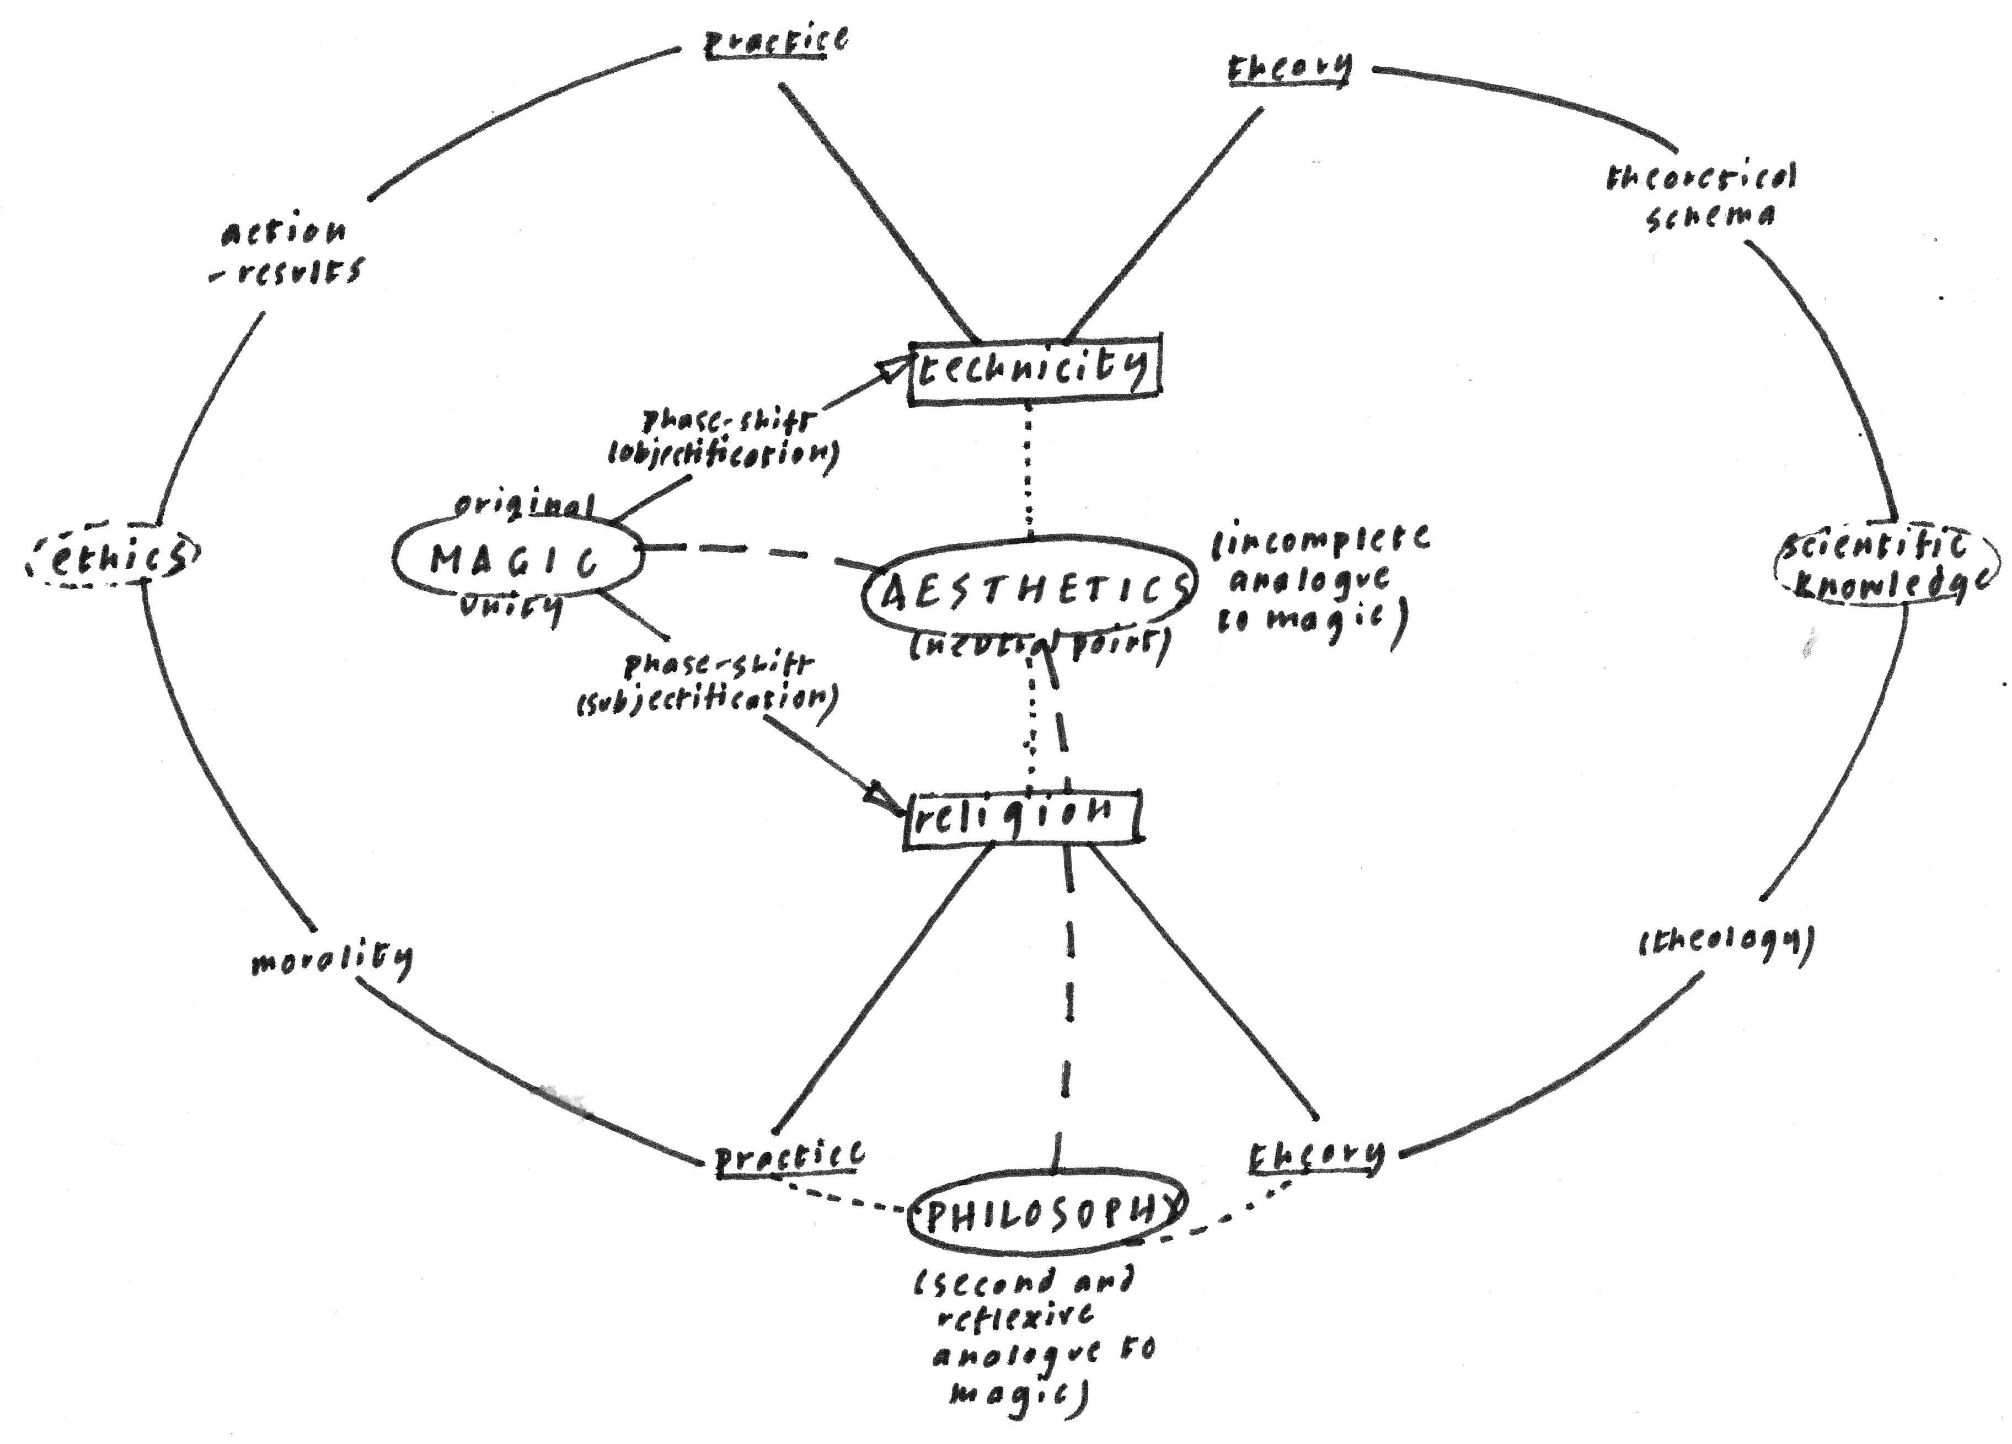
Fig. 1. Diagram of Gilbert Simondon’s modes of existence to highlight connections between magic, aesthetics and philosophy

As well as the various circuits and relays the diagram foregrounds the connection – or resonance – between magical thinking (arising from the originary unity) and aesthetics (the neutral point). Again, as Simondon remarks: ‘aesthetic thinking is truly situated at the neutral point, extending the existence of magic’. In fact, Simondon also mentions philosophy here that, as it were, apprehends the totality (in order to ‘redress and refine the successive waves of genesis’) and, as such, philosophy is ‘inserted between theoretical thinking and practical thinking in the extension of aesthetic thinking and of the original magical unity’. As I mentioned above, Simondon’s own writing has this philosophical character (a kind of view from the outside).

For Simondon magical thinking, as mode of existence, involves a unity of man and world, but also itself involves a certain organization: figure/ground relations which structure the very milieu of living beings. It is this originary figure/ground relation that is then isolated and fragmented in the shift away from magic. Figure is abstracted and cut off from its ground, just as the ground itself is ‘freed’ from its relation to any specific figure. This is then an objectification resulting, ultimately, in technical objects (that can be manipulated) and a subjectification that results in religious mediators (and, ultimately, the subject).

There is more to be said about how religious mediators (and religion more generally) actually produce this subject, and, indeed, about the whole co-dependent relation of technicity and religion (insofar as they are two halves of a whole), but here I want to go further into the definition of the prior ‘primitive magical unity’, which, as Simondon suggests, is ‘the vital relational link between man and the world’ in order to see if something might remain of it which, in Williams’ terms, offers up an alternative to a more dominant and effective technical-religious mode of existence. Put bluntly, is magical thinking residual?

Simondon suggests that the magical mode (again the ‘fundamental structuring of the milieu of a living being’) involves ‘the birth of a network of privileged points of exchange between the being and the milieu’. This is the figure-ground relation I mentioned above in which certain points are, precisely, foregrounded from a background. To quote Simondon:

A privileged place, a place that has a power, is one which draws into itself all the force and efficacy of the domain it delimits; it summarises and contains
the force of a compact mass of reality; it summarises and governs it, as
a highland governs and dominates a lowland; the elevated peak is the
lord of the mountain, just as the most impenetrable part of the wood
is where all its reality resides. The magical world is in this way made
of a network of places and things that have a power and are bound to
other things and other places that also have a power. Such a path, such
an enclosure, such a temenos contains all the force of the land, and is
the key-point of the reality and of the spontaneity of things, as well as
of their accessibility.

For Simondon these key points of exchange and communication between human and world might be characterised as knots in which there is an unmediated relation – a point of passage – between two realities. Again, as Simondon remarks: ‘The magical universe is made up of the network of places providing access to every domain of reality: it consists of thresholds, summits, boundaries and crossing points that are connected to one another by their singularity and their exceptional nature’.

In fact, this magical landscape is doubled by a similar reticulation in time. Privileged locations are accompanied by privileged moments – specific dates – on which it is auspicious to act, or to begin an action (and, in both these cases, we can clearly see the influence on Gilles Deleuze and Felix Guattari’s A Thousand Plateaus, not least on its novel structure with specifically dated plateaus). Indeed, these notable dates are linked back through time in a temporal topography that doubles the spatial one. In a nod to Henri Bergson and his own diagramming of the relationship of the past to the present in Matter and Memory we could perhaps diagram this magical structure as in Fig. 2.

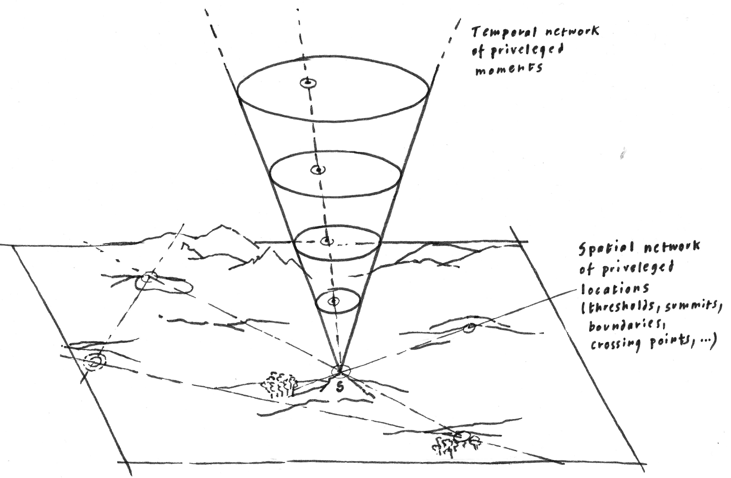
Fig. 2. Diagram of magical structure (following Henri Bergson) to highlight connections between privilege points in space and time

Festivals (and rituals more broadly) performed at a specific time and place mark – and enact – a privileged link between these key points (see point S in the diagram). They are the special kinds of space-time foregrounded out of the more ordinary and mundane. Following Bergson we might also suggest that a suspension of habit is important here (again, at point S). A hesitation, or pause. A ‘stopping of the world’ that allows other times to be ‘accessed’ (the past has not gone anywhere in Bergson’s thesis – it subsists – albeit it tends to be occluded by habit and utilitarian interests). In fact, Simondon suggests that with vacations we might have a version (watered down as it were) of this desire for privileged points (a certain time to journey to the city for the countryside dweller – and to the countryside for the city dweller).

Once again, the shift from this magical unity and structure involves these key points becoming detached from their ground, made mobile, hence technical objects which retain ‘only their functionary mediatory characteristics, becoming instrumental, mobile, capable of efficiency in any place and at any time’. At the same time the characteristics of the ground itself become detached, able now to ‘hover over the whole universe, throughout space and throughout time, in the form of detached powers and forces above the world’. Once more, this is the splitting of magical unity into two subsequent modes of existence: technicity and religion (returning to our Bergsonian cone, we might say that point S becomes unfixed, mobile – detaching itself from the ground, just as the base of the cone itself expands to cover the universe). Simondon suggests that this very split gestures towards a further ideal unity, a meeting of science and religion, though, for Simondon, this is precisely merely a tendency.

For myself, to be clear, myth-science does not name this tendency as such (the oft mooted marriage of science and religion), nor does it call for any simple return to an originary unity. Rather it can be equated with the aesthetic neutral point – a point which reminds of a previous magical unity but also suggests an extension of it, a ‘new’ phase yet-to-come (in terms of my cone diagram, aesthetics might also be a name for the pause – or hesitation – in and of the reactive sensory-motor apparatus that allows ‘access’ to other planes of existence). It also partakes of the second ‘reflexive analogue’ to magic, philosophy, when this is an attempt to grasp the whole phase space and to intuitively follow the different modes beyond what is apparent to what we might call typical subjectivity. Myth-science might then be characterised as both an intuitive perspective of the whole and a kind of future-orientated pre-modernism (itself ‘actualised’ through a certain stopping of the world). Or, more simply, a form of magical aesthetics.

In terms of this latter point, we might note in passing Guattari’s own thesis on the new aesthetic paradigm and on a third ‘processual’ assemblage of the production of subjectivity. The latter involves a mediated return (at least of sorts) to a first pre-capitalist and transpersonal assemblage, one that is marked by its passage through our own capitalist assemblage with its reduction and standardisation of subjectivity (not least through transcendent enunciators). The third assemblage involves a kind of folding-in of transcendence so as to produce autopoetic nuclei around which a different subjectivity might crystalise. In fact, in many ways Guattari’s three assemblages are analogous to Simondon’s phase shifts in so far as they are not, strictly speaking, to do with a linear progression, but might well coexist (as in the hyper-modern, but also animist culture of Japan). The role of aesthetics – as neutral point/future-reminder of unity and as point around which a different subjectivity might coalesce – is also remarkably similar.

To return to Simondon, the phase shift from magic then produces the first objects and subjects and with that the beginnings of the modern world:

This phase-shift of the mediation into figural characteristics and ground characteristics translates in to the emergence of a distance between man and world. The mediation itself instead of being a simple structuring of the universe, takes on a certain density; it becomes objectified in technics and becomes subjectified in religion, making the first object appear in the technical object and the first subject appear in divinity.

In both technical and religious mode then the individual is distanced from the world, always less than the original unity, or totality, that, in some senses preceded them (and, indeed, their very formation as individual). In religion ‘particular being is understood in relation to a totality in which it participates, but which it can never completely express’. Here, the individual is, as it were, cut off from the infinite of which it is a part (a curtain has been drawn between man and his world). In technicity there is always a lack of ‘absolute adequacy’ to the world insofar as the technical object ‘is localized, particularized’, and, as such, for Simondon, ‘adding technical objects one to another can neither remake the world nor regain contact with the world in its unity’. Ultimately, religion affixes the powers of the ground to various personfications of the divine and sacred, and, eventually, the figure of the priest (with his subjects) arises as privileged mediator. In technicity mediation is provided by the technical object. Iphone or Mullah.

It is in this sense, for Simondon, that both technicity and religion are the heirs of magic – not degraded forms but two tendencies abstracted from an original unity. Although Simondon does not address this it seems to me that this might also account (at least in part) for the reason that advanced technology, alongside the very primitive, can seem magical, just as the older a religion the more it takes on a magical character (one thinks specifically of non-monotheistic religions such as paganism). Is there such a thing as an ‘advanced’ form of religion (in a form different to dominant monotheistic ones)? And would this also appear magical in some sense (or, at least, not necessarily about mirroring and securing a centered and cohesive (or facialised) subject?). Myth-science, to return to my brief definition above, might be a name for those practices that attend to the connections between primitive and advanced technology alongside pre-and postmodern religion. A Science Fiction paganism perhaps?

Is it also the case that advanced technicity might in and of itself produce a different mode of existence beyond a more typical alienated one (for example the advanced operations of neuroscience producing the transparent in-the-world-ness of the nemocentric subject or ‘subjectivism without self’)? In relation to this, and in another recently translated extract – ‘Technical Mentality’ – Simondon suggests that technicity ‘has not yet properly emerged’ and thus to judge it in its partly complete form is to miscomprehend it. For Simondon, in this essay: ‘If one seeks the sign of the perfection of the technical mentality, once can unite in a single criterion the manifestation of cognitive schemas, affective modalities and norms of action: that of the opening’. Simondon continues: ‘Technical reality lends itself remarkably well to being continued, completed, perfected, extended. In this sense, an extension of the technical mentality is possible, and begins to manifest itself in the domain of the fine arts in particular’ (Simondon mentions the modular architecture of Corbusier as case in point here). Technicity’s lack of unity – its fundamental character as alienated mode of existence – is, in this sense, productive, creative and always future-orientated.

In terms of this future Simondon suggests that the open character of technical reality is also manifest in a ‘virtual network’ to come (a ‘multifunctional network that marks the key points of the geographical and human world’). There is a profound resonance with the magical structuring of the universe here (the privileged points) – as there is also in the way in which technicity, ultimately, involves an ‘appeal to forces that do not depend on the human being’). This is the discovery and harnessing of the ‘infinite reserve’ of nature. In the same footnote from where the above quote is taken Simondon also gestures to certain activities – ‘agriculture, nursing and navigation with sails’ – that might also be seen as industrial insofar as they involve a relation to these non-human forces, albeit not, strictly speaking, their manipulation. In fact, ‘they commodulate the human operation of preparation and the cosmological action’. We might note Deleuze and Guattari’s own writings on industry here, and especially the emergence of metallurgy with its nomadic smiths (Simondon himself suggests metallurgy as the first industry). Technicity (if this is the right name for this particular mode of existence) is, in this sense, not a domination of nature by man, but involves a tracking of the singularities present in nature. Indeed, as Simondon remarks these kinds of operation can ‘give rise to a magico-religious thinking’.

That said, this thinking is still, clearly, the result of an alienation from the world. Technical mentality in general cannot overcome this alienation insofar as it is the progenitor of it. This also implies – as I mentioned above – that technical objects themselves (and science more generally) are not enough to remake the world insofar as technicity itself is just one half of a prior phase (and a prior unity). Simondon’s thesis implies a limit to the Promethean impulse in this sense (for example as laid out by both Ray Brassier and Reza Negarestani), or, put differently, there is, in Simondon’s writings a sanctity of the given over the made.

In fact, to return to the extract from On the Mode of Existence of Technical Objects, Simondon suggests that technicity can only ever attend to the how of things and not the why. It certainly provides knowledge, but one that is inevitably piecemeal, lacking any overview. Or, in Simondon’s words: ‘The application of schemas drawn from technics does not account for the existence of the totality, taken as a unity, but does account for the point by point and instant by instant functioning of that totality’. Technicity, in this sense, is characterised by induction, defined as any process whose ‘content is inferior to the status of unity, if it strives to attain unity or, at least, it if tends towards unity from a plurality of elements, each of which is inferior to untity’. Induction, ultimately the method of any reason-based Prometheanism, is forward moving and productive, but always blind in this sense.

Any ethics that develops from this technicity (for example, ‘to want the whole duration of life to be a series of moments, to extract from each situation what is pleasant in it, and to want to construct the happiness of life by accumulating its agreeable element’) also falls short of unity, and, for Simondon, invariably, involves the denigration – even elimination – of the passions ‘since they cannot be treated as elements; they are larger than the unity of the subject; they dominate it; they come from farther away than it and tend to go farther on than it, obliging it to exceed its limits’. Conversely any morality developed from religion derives its significance from a totality of which the subject does not coincide (the subject is always forsaken in this sense).

We might note, again, a resonance with Bergson here and with the idea of duration as an intensive multiplicity that cannot be divided (and, indeed, can only be intuited). We might also note a further resonance with Deleuze and Guattari’s idea of an impersonal affect that takes the subject out of themselves. When the latter is organized – structured as Williams might say – we have aesthetic productions (compositions of affect). In terms of my comments above we might say that art is that privileged point that produces a shift or gap, a passage to other Universes of reference (or, indeed, to the infinite whole). In terms of ethics we might note a further resonance with Spinoza and with the idea (contra typical religious thinking) of a finite-infinite continuum that the subject can traverse (the programme of The Ethics). We might also note once more Guattari’s new aesthetic paradigm that names, precisely, an ethico-aesthetics different to more typical techno-scientific thinking, and, indeed, to any ethics derived from transcendent enunciators (or that treats life as an object). For Guattari, as for Deleuze and Guattari, art points the way to this other non-technical mode of existence.

3. Case Studies

i. Riddly Walker. In Russell Hoban’s post-apocalyptic novel (a fiction of the wasteland if ever there was one) there is a mixing, or syncretism, of the magical and technical modes of existence insofar as the story is about a future in which technicity is in crisis and thus all sorts of other practices and ways of thinking come in to play. These do include the technical, especially when these are pre-modern (there is, for example, the excavation – with shovels and pulley systems – of ‘past’ machinery), but also various proto-religious practices (such as the Eusa show, a strange kind of divinatory Punch and Judy) and, towards the end of the novel, practices and scenarios that could only be described as magical (various supernatural happenings and visions at ‘Cambray’ (the city of Canterbury)).

In terms of a magical structuring of the world Riddly Walker is also organized around the central point – and pilgrimage to – Cambray (following The Canterbury Tales) and, indeed, the book as a whole might be said to be organised around passages and thresholds, privileged locations and times. There is also, again, the question of the Eusa show (and, more generally, of story telling as fabulation) with its involvement of ‘real’ human intercessors (that ask the puppets questions) in a kind of sympathetic and incantory magic. The Eusa show is certainly a residual culture (in Riddly’s world), but, for the reader, the Eusa show is also a story within a story (Riddly’s own telling of his tale) that is itself ‘within’ Hoban’s novel. This nesting of fictions produces what might be called a fictioning of reality (or, simply, a questioning of our own reality as just one more fiction).

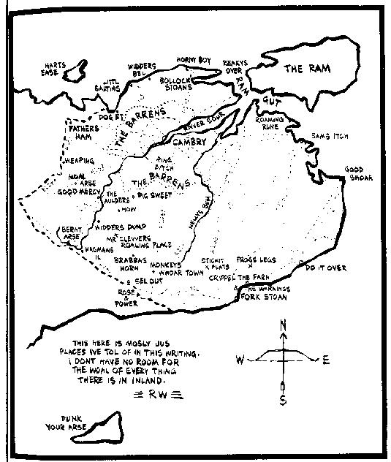
Fig. 3. Map from Riddly Walker

But Riddly Walker is also an aesthetic work itself, constructing its narrative, characters and startling images through language. The very particular use (and abuse) of syntax resonates with pre-modern (and colloquial) use, but also contains remnants of the modern and, indeed, constructions that gesture forwards to a language yet to come. In fact, ultimately, it is this strange future-past syntax that produces a very particular scene – or structure of feeling to use Williams’ term. Like a Burroughs or a Ballard the book is an embodiment of a different kind of consciousness: a fragment of another world thrown backwards/forwards in to our own time.

In this sense, the book is about a form of aesthetic thinking (insofar as this is a reminder of, and incomplete analogue to, magic) but is also a form of aesthetic thinking itself. In terms of some of my comments above we might also say that it stops the world (as this is habitually understood), not least in the way its syntax calls for an alteration of our speeds (of typical ‘communication’). Fiction operates here to point to something ‘outside’ technicity and religion (again, it operates at and as the neutral point). In Simondon’s terms Riddly Walker is also about the different phase shifts of different modes of existence; their co-dependence and inter-penetration, as well as their specific points of genesis – but also their de- and then re-genesis. It is also about the living of this temporal hybridity. The novel portrays a broken world, bleak and dystopian, but also with a strange affirmation and joy (not least of Riddly himself) of something-to-come.

In terms of Williams the book is then clearly about the survival of residual culture (and the relation of this to more archaic aspects that also survive). But this is also nested in a strange manner. The residual culture is mainly from a further back past (a pre-modern and pre-industrial time), with the more recent past (the modern age that brought about the unnamed catastrophe) operating as a trauma event which has been passed over (and, indeed, ‘survives’ only in a kind of occult knowledge – and in terms of archaeological relics). In fact, this event is clearly connected to the atomic, that apotheosis of a certain kind of scientific mentality (if not the apex of technicity itself). This strange temporality is itself doubled insofar as the actual present of Riddly Walker is our own imagined future with the threat of human produced catastrophe (the novel is of its time in this sense – in terms of the omnipresent fear of nuclear holocaust that haunted the 1970s – but, read today, it is also highly prescient in terms of the fears and anxieties of the anthropocene). The power of Riddly Walker, it seems to me, is in part about the nesting of these different times (which itself includes a mixing of residual, dominant and emergent cultures). This syncretism of times and phases – the co-presence of different futures and pasts within the present – is an example of what I have been attempting to define as myth-science.

ii. Journey to Avebury. In terms of Simondon’s magical structuring of the universe, Derek Jarmen’s film also focuses on a certain privileged point (or threshold) but also, like Riddly Walker, on a journey – or pilgrimage – across a sacred landscape. Indeed, although Simondon does not address this, it seems to me that standing stones and henges – such as Avebury – are markers of the key points of the magical mode of existence, or, at least, they are on the cusp between this magical unity and the new technical mode of being about-to-come (the stones are static place markers, but they have also been moved – and often otherwise manipulated – by man). They are also, of course, visible reminders – or themselves residues – of the pre-historical within the contemporary, markers that subsist in space and through time.

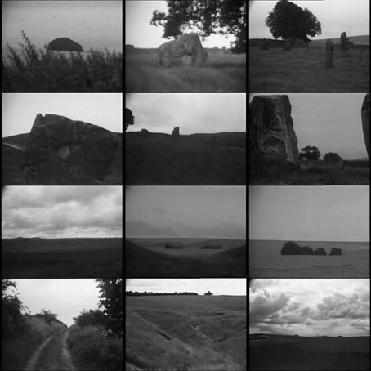
Fig. 4. Stills from Journey to Avebury

Jarmen’s film is then a modern work about a pre-modern site. It evidences the co-presence of our own technical mode of existence with a prior magical one in both its subject, Avebury, and in the subjectivity of its auteur, Jarmen himself. But it is also, again, specifically an aesthetic work. As such, we might say it is ‘about’ a magical mode of existence, but also, as art work, a future calling to a different mode of existence (one that resonates we the pre-technical). In Williams’ terms the power of the film – that doubles the power of the stones themselves – arises from mobilising a certain residuality (the survival of a kind of paganism in the present), achieved through a specific composition of affect – or structure of feeling. Paradoxically, the film is also only possible because of a technical object – the camera. Magical thinking precedes technicity, but, here, technicity itself begets aesthetic thinking that then operates as reminder and extension of magic.

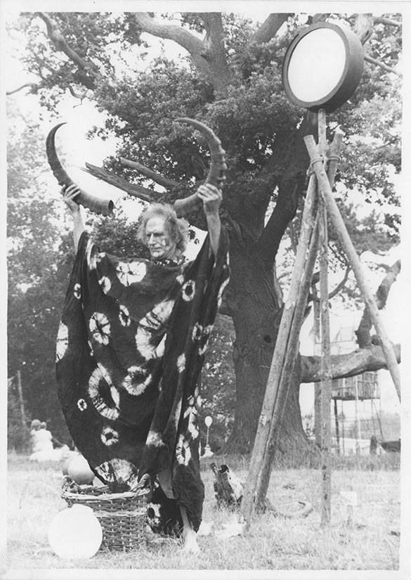
Fig. 5. Bruce Lacey

iii. Castlerigg. In Bruce Lacey’s film we find similar themes to those above in relation to stone circles, their residual power and aesthetic thinking. The film – that records a visit to Castlerigg in Cumbria in the UK – conjures a very specific affective scene, produced, in part, by its analogue nature (especially for a contemporary viewer immersed in the digital), by the weather and other atmospherics of the site that the film captures, and, crucially by the point of view it provides (the hand held camera, the selection of certain shots). Especially interesting in this respect is the time-lapse photography: the technology itself allows us to ‘see’ a different world beyond the habitual and typical, allowing a mode of perception (and thus gesturing to a mode existence) beyond the human.

There is also the figure of Lacey himself performing a ritual of sorts at the stones (Lacey’s other films more explicitly involve him re-animating, but also re-inventing these pre-modern rituals). Lacey exemplifies the importance of participation when it comes to residual culture (indeed it is partly this that gives the latter its oppositional character as opposed to our dominant culture of passive spectatorship), but also operates as a kind of residual subjectivity in and of himself, one that was part of the larger counter cultural ‘movement’ of the 1960s and 70s that turned away from industralisation and a more typical techno-scientific paradigm. Indeed, Lacey was attuned to the specific problems of modernity and, especially to the increasingly pressing ecological issues of the late twentieth century. He was also interested, especially earlier on in his career, in a kind of future-orientation, in Science Fictions and other cosmic dramas which, again, were performed and enacted. Lacey, we might say, was a myth-science practitioner in this sense, a pre-industrial post-modern figure – one attuned to residual culture and magical thinking but also to future cultures and fictions of a world to come.

iv. The Wicker Man. Finally a feature film about the encounter of a modern individual (indeed, a Christian policeman) with a pre-modern, pagan world. On Summerisle a past culture survives and operates alongside the present, but also offers various alternatives to it (with aspects that are both residual and archaic). Indeed, this is the fascination of the film: besides the compelling and macabre story line it shows a modern working and integrated pagan society, complete with school lessons and village rituals. The film, in part, is about a clash between transcendent enunciators (the law, Christianity) and a culture of immanence (with its focus on magical thinking). The horror, but also joy, arises from the inadequacies (and ultimate irrelevance) of the former in a culture which is, in this sense, irreligious and lawless. Indeed, the pagan culture – with its liberated notion of sexuality and its respectful participation in and with the natural world – comes over less as an aberration than as the successful imagining of an alternative mode of existence.

In one particular scene of the film the idea of the festival – in this case the Maypole dance – exemplifies this magical mode of existence and especially the idea of key points existing in space and time. The dance is a repetition of all previous dances as well an echo forwards to those dances yet to come. It is also specifically communal and participatory. In the film it stands out as an especially important moment, not least in the protagonist’s realisation that there is something not quite right about life on the island (the dance is accompanied by a song about fertility and a heretical pathogenesis).

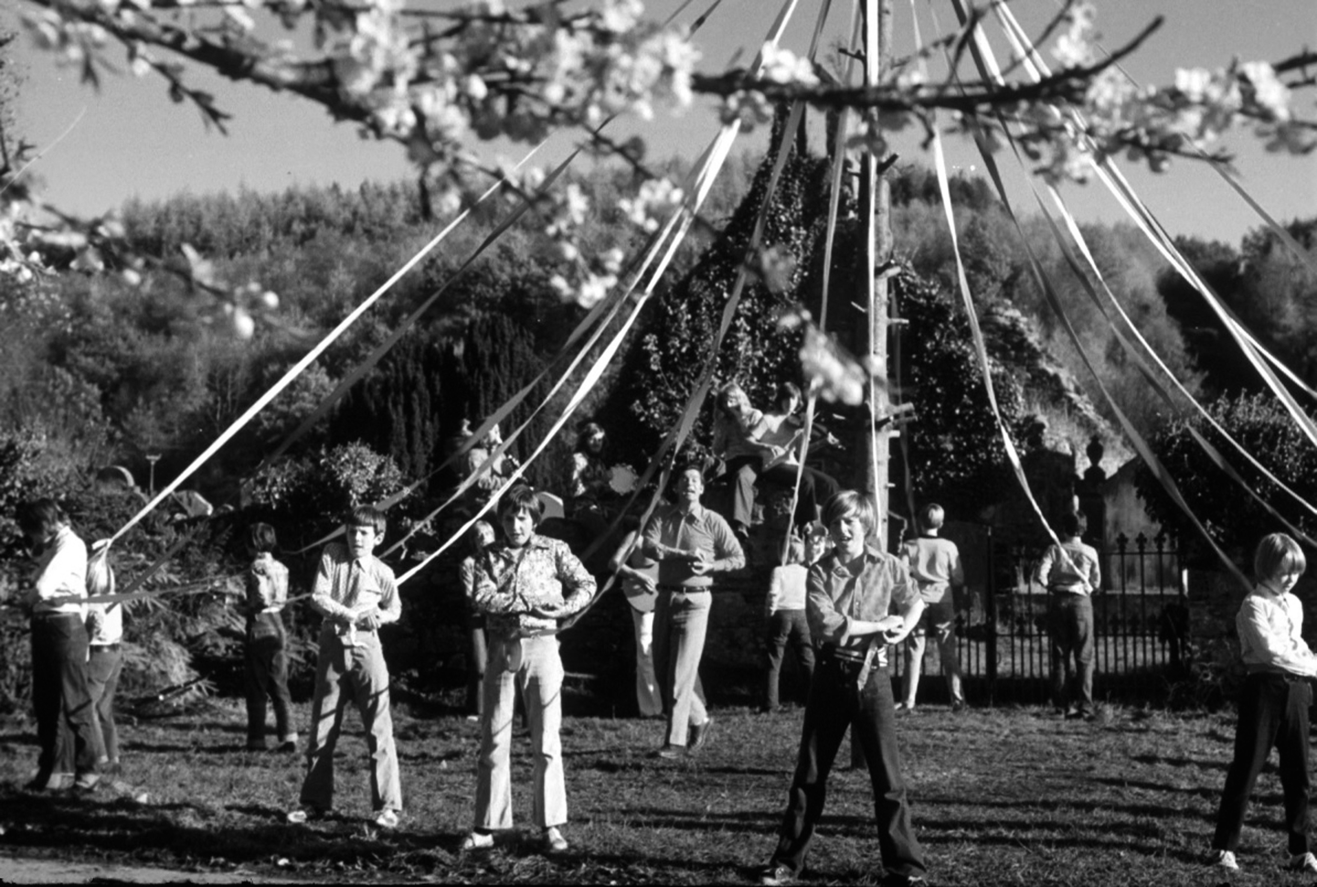
Fig. 6. Still from The Wicker Man

The film also evidences the link I made above between a pre-modernism and a 1960s and 70s counter-culture, a time in which new and alternative subjectivities were being produced and experimented with. Immanence was, as it were, being activated. Indeed, the power of the film comes from this nesting of different times, a co-existence of different modes of existence – and, especially, the affirmation of something, well, different (including a different form of consciousness). This temporal syncretism that is never less than convincing means the film itself offers up a different world (it is not simply about a return to the past). In fact, as with the above case studies this is achieved as much through the form of the film – its aesthetic composition – as through its manifest content. It is especially the colours and sounds – the songs in particular – that produce a kind of Spinozist joy, and, indeed, transport the viewer to a different space-time. Might myth-science also be a name for these kinds of future-past fictions that offer up – almost as side effect – different affective scenes and potential modellings for a subjectivity increasingly hemmed in by neoliberalism?

See ‘Accelerationism, Hyperstition and Myth-Science’, Accelerationism and the Occult, eds. T. Matts, B. Noys and D. Sutherland (New York: Punctum Books, 2015) and ‘Accelerationism, Prometheanism and Mythotechnesis’, Aesthetics After Finitude, eds. A. Ireland, B. Brits and P. Gibson (Melbourne: re:press, 2015). The term myth-science is taken from Sun Ra (and Afrofuturism more generally). See Kodwo Eshun’s More Brilliant than the Sun (London: Quartet, 1988), and especially Chapter 9 ‘Synthesizing the Omniverse’ (154-63). Mike Kelley, in an essay on Olaf Fahlstrom, links the term more particularly to the fictioning aspect of contemporary art practice, especially in its expanded form (see Mike Kelley, ‘Myth Science’, Oyvind Fahlstrom: The Installations (Ostfildern: Hatje Cantz, 1995), 19-27).
In terms of the first of these see the definition of hyperstition (and other writings on it) in Ccru: Writings 1997-2003 (Shanghai: Time Spiral Press, 2015); in terms of the second see the essays collected in the final section of Robin Mackay and Armen Avanessian’s Accelerate: the Reader (Falmouth: Urbanomic, 2015).
My essay arises from my own context, broadly, European. In a further essay – on, amongst other things, Afrofuturism – I will attend to residual practices, not least magic, in the global south and their particular subaltern character (for an example of this kind of analysis, see John Cussan’s forthcoming Undead Uprising (London: Strange Attractor, 2015)).
Gilbert Simondon, (extract of) ‘On the Mode of Existence of Technical Objects’, trans. N. Mellamphy, D. Mellamphy and N. B. Mellamphy, Deleuze Studies, vol. 5, no. 3 (2011), 407-24.
Raymond Williams, ‘Base and Superstructure in Marxist Cultural Theory’, Problems in Materialism and Culture: Selected Essays (London: Verso, 1980), 31-49.
Mark Fisher, following Derrida’s Spectres of Marx, develops a similar idea of the survival of future-orientated past cultures within the present in terms of a general hanutology (see as indicative Fisher’s Ghosts of my Life: Writings on Depression, Hauntology and Lost Futures (London: Zero Books, 2014)).
I have written more about the possibility of ‘residual subjectivities’ in my book On the Production of Subjectivity: Five Diagrams of the finite-Infinite Relation (Basingstoke: Palgrave, 2012). There I staged an encounter between Williams’ writings on the residual and emergent with Deleuze and Guattari’s A Thousand Plateaus, trans. B. Massumi (London: Athlone, 1988), and more particularly the plateau ‘587 B.C.-A.D. 70: On Several Regimes of Signs’ (111-48), with its laying out of the possibility of a mixed semiotic (and, in relation to the themes of the present article, the possible transportation in to the present of a proposition from a previous regime that might then operate as an alternative point for subjectification).
See Raymond Williams, Marxism and Literature (Oxford: Oxford University Press, 1977).
See http://www.xenosystems.net/neoreaction-for-dummies/ (accessed: 16 September 2015). In many ways the present article is an attempt to reclaim this particular ‘time-twisted vector’ away from the Right and, in particular, Neoreaction.
The thesis on and against Cathedral is laid out in detail in Land’s series of essays on ‘The Dark Enlightenment’ available at: http://www.thedarkenlightenment.com/the-dark-enlightenment-by-nick-land/ (accessed: 17 September 2015).
See for example Nick Srnicek and Alex William’s ‘♯Accelerate: Manifesto for an Accelerationist Politics’,♯Accelerate: the Reader, eds. R. Mackay and A. Avanessian, (Falmouth, Urbanomic, 2015), 349-78 and Laboria Cubonik’s recent ‘Xenofeminsm: A Politics for Alienation’, available at: http://www.laboriacuboniks.net (accessed: 17 September 2015).
Raymond Williams, ‘Utopia and Science Fiction’, Problems in Materialism and Culture: Selected Essays (London: Verso, 1980), 212.
In fact On the Mode of Existence of Technical Objects is written against a certain ideological hangover from the past that views the technical as distinct (and inferior) to culture. Simondon’s aim, in this sense, is to explain technical consciousness and, indeed, gesture towards its future possibilities (see the unpublished translation (by N. Mellamphy) of what was one of Simondon’s two doctoral dissertations (available at https://english.duke.edu/uploads/assets/Simondon_MEOT_part_1.pdf (accessed: 16 September 2015)). My own article reads Simondon (or at least the extract in question) somewhat against the grain in so far as I am interested in the resistant and oppositional quality of a pre-technical mode of existence that might exist alongside the technical (and, indeed, resonate with a mode yet to come).
Simondon, ‘On the Mode of Existence’, 408.
Simondon, ‘On the Mode of Existence’, 408.
Simondon, ‘On the Mode of Existence’, 409.
See Deleuze and Guattari’s discussion of the white face of Christ in ‘Year Zero: Faciality’, A Thousand Plateaus (167-91) and my own discussion of alternative modes of subjectivation in ‘Pragmatics for the Production of Subjectivity: Time for Probe-heads’, Journal for Cultural Research, vol. 10, no. 4 (2006), 311-22.
It is worth highlighting here that other definition of magic as a ‘regression in thought’ as Adorno and Horkheimer understood it, and, as such, a form of thinking that is pre-capitalist, but also subsumed by late capitalist forms (Williams’ term archaic would also be relevant here) (see Adorno and Horkheimer’s Dialectic of the Enlightenment, trans. J. Cummings (London: Verso, 1969)).
Simondon, ‘On the Mode of Existence’, 412.
Simondon, ‘On the Mode of Existence’, 412.
Simondon, ‘On the Mode of Existence’, 414. In terms of Europe, the seminal text on these privileged points and their lines of connection is Alfred Watkins’ The Old Straight Track: Its Mounds, Beacons, Moats, sites and Mark Stones (London: Abacus, 1974).
See Henri Bergson, Chapter Three, ‘On the Survival of Images: Memory and Mind’, Matter and Memory, trans. N. M. Paul and W. S. Palmer (New York: Zone Books), 133-78.
See also Deleuze’s discussion of the repetition of festivals at the very beginning of Difference and Repetition, trans. P. Patton (New York: Columbia University Press, 1994, 1.
See my ‘A Diagram of the Finite-Infinite Relation: Towards a Bergsonian Production of Subjectivity’, Bergson and the Art of Immanence, eds. John Mullarkey and Charlotte De Mille (Edinburgh: Edinburgh University Press, 2013), 165-86.
Simondon, ‘On the Mode of Existence’, 415. It is worth addressing a key issue here – that of the differences between Simondon’s idea of magical unity as prior mode of existence (that itself involves magical thinking) and the more typical understanding of magical causality operative in the practices of magic. In The Golden Bough: A Study in Magic and Religion (London: Macmillan, 1957), Frazer suggests two ways in which such a ‘manipulation’ of nature might be achieved, by a law of similarity and one of contact (16). The term ‘sympathetic magic’ brings these two laws together.
Simondon, ‘On the Mode of Existence’, 415.
Tim Dixon develops a convincing and compelling thesis on what he calls magical aesthetics (through recourse to Simondon, Guattari and the concept of animism) and relates it especially successfully to the expanded art practice of Mark Leckey (see the unpublished MA thesis, ‘Magical Aesthetics: Subjectivity, Simondon, Animism and the Aesthetic’, Goldsmiths, 2015).
This formulation of a ‘folding-in’ of transcendence is my own take on Guattari. For a more detailed discussion of the latter, and of the three assemblages more generally, see my ‘Guattari's Aesthetic Paradigm: From the Folding of the Finite/Infinite Relation to Schizoanalytic Metamodelisation’, Deleuze Studies, vol. 4, no. 2 (2010), 256-86.
Simondon, ‘On the Mode of Existence’, 415.
Simondon, ‘On the Mode of Existence’, 419.
Simondon, ‘On the Mode of Existence’, 421.
Erik Davies in his chapter on ‘The Spiritual Cyborg’ in Techgnosis: Myth, Magic and Mysticism in the Age of Information (New York: Serpent’s Tail, 1988), 129-63, makes a compelling case for understanding Scientology as a very particular modern and technological religion (or spiritual Prometheanism as he calls it). Dianetics – ‘the modern science of modern health’ that is the Church’s ‘Tech’ – involves an application of Norbert Wiener’s ‘new’ cybernetic theory to the mind, as well as the use of technical machines in its therapeutic practices (and in this sense of mobilising technicity alongside an understanding of the fiction of a self scientology might itself be described as a form of myth-science).
In relation to this see Lucy A. Sames’ booklet (published to accompany a group exhibition) Sci Fi Paganism (London: Enclave, 2014).
See Ray Brassier’s ‘The View from Nowhere’, Identities: Journal of Politics, Gender and Culture, vol. 8, no. 2 (2011), 7-23.
See Gilbert Simondon, ‘Technical Mentality’, trans. A. De Boever, Gilbert Simondon: Being and Technology, eds. A. De Boever, A. Murray, J. Roffe and A. Woodward (Edinburgh: Edinburgh University Press, 2012), 1-15.
Simondon, ‘Technical Mentality’, 14.
Simondon, ‘Technical Mentality’, 14.
Simondon, ‘Technical Mentality’, 9.
Simondon, ‘Technical Mentality’, 15 (foot. 5).
Simondon, ‘Technical Mentality’, 15 (foot. 5).
See Deleuze and Guattari, ‘1227: Treatise on Nomadology: –The War Machine’, A Thousand Plateaus (351-423).
Simondon, ‘Technical Mentality’, 15 (foot. 5).
See the essay ‘Accelerationism, Prometheanism and Mythotechnesis’ mentioned in footnote 1.
Simondon, ‘On the Mode of Existence’, 422.
Simondon, ‘On the Mode of Existence’, 423.
Simondon, ‘On the Mode of Existence’, 423.
In terms of a practice – or mode of existence – that involves these impersonal affects, or becomings, Deleuze and Guattari invoke (and themselves identify with) sorcerers. For more detail on this particular idea of magic – as involving inhuman transformation – see the three ‘Memories of a Sorcerer’ sections of the Becoming plateau of A Thousand Plateaus (239-52) and also my own commentary on these in ‘Memories of a Deleuzian: To Think is Always to Follow the Witches Flight’, Henry Somers-Hall, Jeff Bell and James Williams (eds.), A Thousand Plateaus and Philosophy (Edinburgh, Edinburgh University Press, 2016).
Russell Hoban, Riddly Walker (London: Jonathan Cape, 1980).
We might diagram this complex nesting of fictions as in Fig. 3: Fig. 3 Diagram to show nesting of fictions in Riddly Walker A complicating factor here is that the Eusa show, the innermost circuit, is also ‘explanatory’ of Riddly’s world. The Eusa show, as divinatory technology, allows an exiting and passage to a larger circuit. Indeed, this is the role of fiction in Riddly Walker and of Riddly Walker as fiction (or, Riddly Walker is for us what the Eusa show is for Riddly).
Hence, ultimately, the difference between fiction (and art more generally) and philosophy: the first is on the ground as it were, from the point of view of an embodied subject (albeit imagined); the second is more abstract – a disembodied view from above.
To utilize Bergson’s cone we might diagram this temporal nesting as in Fig 4: Fig. 4 Diagram (following Henri Bergson) to show temporal circuits in Riddly Walker If we add the fact that Riddly Walker is a fiction of a future world (from our perspective as modern readers) we get a more complex diagram of nested circuits as in Fig. 5. Fig. 5. Diagram (following Henri Bergson) to show nested temporal-fiction circuits in Riddly Walker
Journey to Avebury (dir. Derek Jarmen, 1971).
For a compelling art historical account of the resonances between standing stones – and prehistoric objects and images more generally – with contemporary art, see Lucy R. Lippard’s Overlay: Contemporary Art and the Art of Prehistory (New York: The New Press, 1983). For a more recent account of modern and contemporary art’s connection and resonances with the past – in a British context (and concerning magic more specifically) see Michael Bracewell, Martin Clark and Alun Rowlands (eds.), The Dark Monarch: Magic and Modernity in British Art (London: Tate Publishing, 2009).
For a different fiction – that produces a different structure of feeling – in relation to pilgrimages to standing stones see Stewart Home’s Sixty-Nine Things to do with a Dead Princess (London: Canongate, 2002).
Castlerigg (dir. Bruce Lacey, 1981) (available in The Lacey Rituals: Films by Bruce Lacey (and Friends), London: BFI, 2012).
See David Alan Mellor, The Bruce Lacey Experience: Paintings, Sculptures, Installations, Performances (London: Camden Arts Centre, 2012).
The Wicker Man (dir. Robin Hardy, 1973).
I attend further to the Maypole – and its dance – as an alternative point of subjectification in my article, written with Ola Stahl, ‘Contours and Case Studies for a Dissenting Subjectivity (or, How to Live Creatively in a Fearful World)’, Angelaki, vol. 11, no. 1 (2006), 147-56.

