Perceptual flexibility is coupled with reduced executive inhibition in students of the visual arts
Rebecca Chamberlain¹²*, Lena Swinnen², Sarah Heeren² & Johan Wagemans²
¹Psychology Department, Goldsmiths, University of London, UK.
²Laboratory of Experimental Psychology, KU Leuven, Belgium.
*corresponding author: r.chamberlain@gold.ac.uk, 8 Lewisham Way, New Cross, London SE14 6NW
Acknowledgements
We would like to thank Pieter Moors and Andrew Humphrey for their help with construction of the ambiguous figure and executive switching tasks and Aaron Kozbelt and Jennifer Drake for assisting with participant testing. We would also like to thank our funding agencies: The Methusalem program of the Flemish Government (METH/08/02 and METH/14/02) to Johan Wagemans, as well as The Research Foundation of Flanders (FWO) to Rebecca Chamberlain.

Perceptual flexibility is coupled with reduced executive inhibition in students of the visual arts

Abstract
Artists often report that seeing familiar stimuli in novel and interesting ways plays a role in visual art creation. However, the attentional mechanisms which underpin this ability have yet to be fully investigated. More specifically, it is unclear whether the ability to reinterpret visual stimuli in novel and interesting ways is facilitated by endogenously generated switches of attention, and whether it is linked in turn to executive functions such as inhibition and response switching. To address this issue, the current study explored ambiguous figure reversal and executive function in a sample of undergraduate students studying arts and non-arts subjects (N=141). Art students showed more frequent perceptual reversals in an ambiguous figure task, both when viewing the stimulus passively and when eliciting perceptual reversals voluntarily, but showed no difference from non-art students when asked to actively maintain specific percepts. In addition, art students were worse than non-art students at inhibiting distracting flankers in an executive inhibition task. The findings suggest that art students can elicit endogenous shifts of attention more easily than non-art students but that this faculty is not directly associated with enhanced executive function. It is proposed that the signature of artistic skill may be increased perceptual flexibility accompanied by reduced cognitive inhibition, however future research will be necessary to determine which particular subskills in the visual arts are linked to aspects of perception and executive function.

Introduction
A cornerstone of the artistic process is to see the novel in the everyday. Pablo Picasso’s bull head sculpture (Picasso, 1942; Figure 1) is a good example of this phenomenon. Picasso’s insight into the creation of this artwork suggests that, through a spontaneous act of visual imagination, he integrated disparate visual objects into a powerful new form: ‘One day, in a pile of objects all jumbled up together, I found an old bicycle seat right next to a rusty set of handlebars. In a flash, they joined together in my head. The idea of the Bull's Head came to me before I had a chance to think. All I did was weld them together.’ (Brassai, 2002, p. 61).
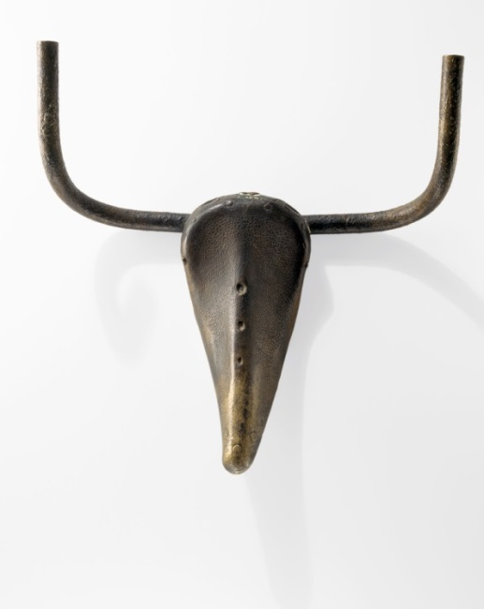
Figure 1. Pablo Picasso ‘Tête de taureau’ (1942), made from a bicycle seat and handlebars.
Few studies have addressed artists’ ability to reinterpret the visual world in varied and novel ways, in the way that Picasso describes. A growing body of evidence suggests that visual artists outperform novices on visual and spatial tasks (Kozbelt, 2001; Ostrofsky, Kozbelt, & Seidel, 2012; Perdreau & Cavanagh, 2014, 2015). It seems likely that these abilities do not represent a perceptual bias toward particular aspects of visual stimuli but flexibility of attention toward the aspects most pertinent to the artist from moment to moment (Chamberlain & Wagemans, 2015, 2016). This emphasis on perceptual flexibility might also explain the visual leaps of logic performed by artists such as Picasso, as they are able to expose new interpretations when they flexibly attend to different stimulus attributes. However, the different kinds of perceptual flexibility that artists engage in have yet to be thoroughly mapped out. A previous study assessed artists’ ability to switch between global and local aspects of Navon hierarchical stimuli, representing their flexibility in terms of exogenously elicited visual attention; attentional shifts induced by changes in the external stimulus from trial to trial (Chamberlain & Wagemans, 2015). In this study, it was found that art students’ response times were less affected by switches between local and global stimulus levels than non-art students. Endogenous switches of attention on the other hand have not yet been explored but appear pertinent to the kinds of processes artists frequently engage in. For example, in a protocol study an artist commented that, “The pattern of plaster on the ceiling: when I first would look at it, it seemed 3-D coming out of the ceiling toward me, but if I stared at it long enough, it seemed to turn the other way and become inverted into the ceiling… I would do the same thing with wallpaper patterns…” (Schlewitt-Haynes, Earthman, & Burns, 2002). In this instance, the external stimulus remains constant but the artist’s attentional focus changes in a way that causes the depth order relations of the visual scene to be reversed.
Bottom-up and top-down influences on perceptual reversal. The phenomenon described by the artist in the previous quote is an example of perceptual reversal, which is typically investigated in perceptual psychology using ambiguous figures such as the Necker Cube, Rubin’s face/vase and Boring’s young girl/old woman (Figure 2). Previous research indicates that individuals can exert voluntary control over reversal rates and percept duration of ambiguous figures, by actively switching between two competing percepts or holding one alternative in conscious perception longer than another (Strüber & Stadler, 1999; Suzuki & Peterson, 2000; Toppino, 2003; van Ee, van Dam, & Brouwer, 2005). In an investigation of voluntary control effects over ambiguous figures, Toppino (2003) found that participants could change the duration of their percepts but not the number of reversals when asked to hold one interpretation in mind, whilst the number of reversals could be increased when participants were asked to switch between interpretations. The rate of perceptual reversal is also subject to large individual differences (up to an order of magnitude) and correlates with individual differences in the structure of the parietal cortex (Kanai, Bahrami, & Rees, 2010), making it a good candidate for investigating perceptual performance in relation to artistic expertise.
Figure 2. Commonly used ambiguous figures (left to right): Rubin’s face/vase, the Necker cube and Boring’s old/young woman.
Executive function and perceptual reversal. Toppino (2003) suggested that voluntary control over perception of ambiguous figures functioned via processes that were independent of focal-feature processing, implying that reversal is controlled in part by central executive processes. Wimmer and Marx (2014) also emphasised the role of executive inhibition in perceptual reversal by stating that ‘reversal requires inhibitory insight and inhibitory strength’ (p. 418). Inhibitory insight represents awareness that there is more than one interpretation available while inhibitory strength is the degree to which one interpretation can be suppressed (Wimmer & Doherty, 2011). In support of a link between perceptual reversal and executive function, Bialystok and Shapero (2005) found a link between performance on the dimensional card sort task and the ability to see an alternative interpretation of an ambiguous figure. In a recent fMRI study, Sekutowicz et al (2016) found a weak but significant correlation between reversal of a Necker cube lattice and task switching performance, both of which related to activation in the right putamen. This suggests that the ability to initiate percept reversal resides in the ability to suppress one perceptual representation and switch to another by engaging inhibitory and switching mechanisms at the executive level.
Executive inhibitory function has been linked to musical expertise and training (Bialystok & DePape, 2009; Moreno et al., 2011; Moreno, Wodniecka, Tays, Alain, & Bialystok, 2014) but similar studies have not been conducted with visual artists. Data on inhibitory capacity in musicians suggests that these domains of expertise train the individual to inhibit salient responses, which may also be the case for visual artists in which they must inhibit salient conceptual and perceptual interpretations of incoming information. While previous findings associate artistic skill with attentional flexibility (Chamberlain & Wagemans, 2015), it remains unclear whether this flexibility is expressed only in the perceptual domain or implies higher-level cognitive control from executive function mechanisms, which may link it to higher-order creative processes. However, it can be hypothesised that attentional flexibility begins in the perceptual domain, with possible transfer to the conceptual domain, such that perceptual games later support creative insights like Picasso’s bull’s head.

Aims. The current research aimed to assess perceptual reversal of ambiguous figures and executive function in a sample of art students and non-art students (N=138). In doing so it aimed to illuminate the kind of perceptual flexibility that is associated with artistic skill and to determine whether perceptual flexibility translates into enhancements in executive function, providing a potential bridge between technical perceptual skill and conceptual creative ability. Art students and non-art students viewed a dynamic ambiguous figure while passive and voluntary perceptual reversals and percept duration were measured. A subsample of participants (n=63) also completed response shifting and inhibition tasks of executive function to assess between-group differences in executive inhibitory and switching ability.

Hypotheses. It was hypothesised that art student participants would show greater voluntary control over perceptual reversals and percept duration in an ambiguous figures task leading to more frequent reversals and shorter percept durations in a switching condition, and fewer perceptual reversals and/or longer percept durations in a hold condition relative to a control group of non-art students. As there is no existing evidence associating artistic skill with executive function, this aspect of the study remained exploratory. A tentative hypothesis put forward was that there would be a link between artistic skill and executive function which may be mediated by perceptual flexibility, as shown in Figure 3.
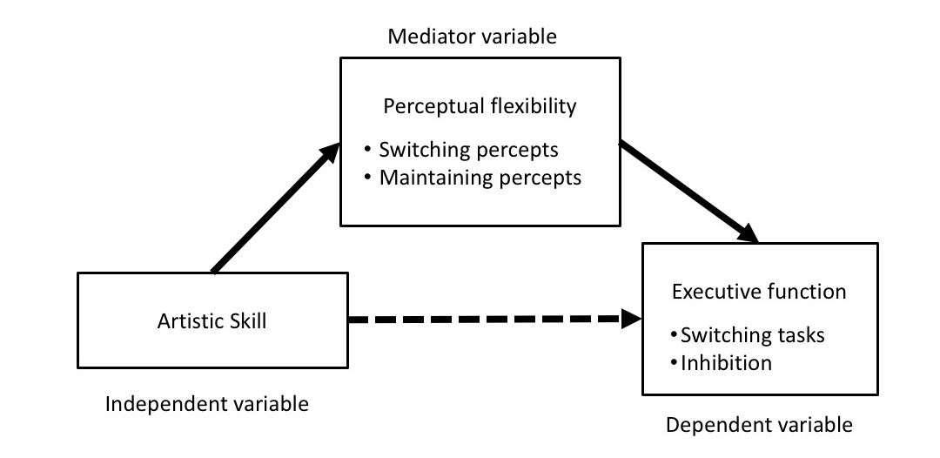
Figure 3. Model of mediation of correlation between artistic ability and executive function by perceptual flexibility.

Method
Power analysis. A power analysis was conducted using the ‘pwr’ package in R (Champely, 2009). The power analysis was based on a previous study which found an effect size of d =0.80 for between group differences in attentional flexibility in a Navon shape task in art students and non-art students (Chamberlain & Wagemans, 2015). The analysis indicated that a total sample of 66 participants (n=33 per group) would be needed to detect an effect of d=0.80 with 80% power using an independent-samples t-test with alpha at .02 (corrected for anticipated comparison of groups on three different conditions of the ambiguous figure task: passive viewing, switching and holding percepts). For the executive function tasks with only two within-subjects conditions per task, a total sample of 52 people would be needed to detect an effect size of d=0.80 with 80% power using an independent-samples t-test with alpha at the standard .05 level.
Participants. The total sample size was 141, of which 71 participants were art students and 70 participants were non-art students. The study was run in two separate locations (Belgium, n=63; USA, n=78: participants in this location were also participating in a longitudinal study evaluating the relationship between artistic training and a range of visuospatial skills)).
Within the art student sample, one group consisted of bachelor’s level students from Royal Academy of Fine Arts, Antwerp (n=30) who were studying illustration (n=13) and graphic design (n=17) and the other group consisted of foundation-level students from the Pratt Institute of Art and Design, New York (n=41) registered for a wide range of artistic majors: animation (n=7), graphic design (n=8), fine arts (n=6), illustration (n=5), industrial design (n=4), interior and fashion design (n=3), photography and film (n=3), advertising (n=4) and art therapy (n=1).
The non-art student sample consisted of bachelor’s students studying a range of degrees including psychology, engineering, economics, pedagogical science, information science, and biomedical sciences at KU Leuven (n=33) and Brooklyn College, City University New York (n=37). There was no significant difference in age between the art student sample (M=21.16, SD=5.40) and the non-art student sample (M=20.00, SD=3.29), t (136) =1.53, p=0.13, d =0.26, 95% CI of difference [-0.34, 2.66].
Procedure. All participants were tested within a 1-1½ hour testing session at their respective institutions in a quiet, dimly lit room. Participants completed a demographic questionnaire and then a series of computer-based visual tasks. Computer tasks were performed on a 13-in. liquid crystal computer screen with a 60 Hz refresh rate. Stimulus presentation was controlled using the Psychopy package (Peirce, 2007). Tasks were administered in the order presented in the experimental procedure. For a subset of the participants (n=78) the executive function tasks were omitted due to time constraints. For the remaining participants (n=63), the executive function tasks and ambiguous figure tasks were counterbalanced between participants to reduce the influence of order effects.
Ambiguous figures task. Participants viewed a structure-from-motion (SFM) rotating cylinder (diameter 6cm, height 7cm) consisting of two transparent planes of random white dots (6 pixels in diameter) moving in opposite directions on a black background, along a vertical axis, from a viewing distance of 57cm. There were 400 dots on screen at any time moving at a speed of 0.20 full cycles per second. The global direction of motion of the stimulus could be perceived as going from left to right or from right to left. Participants were shown a practice stimulus and instructed how to access each percept. Only when participants had reported that they could experience each percept were they allowed to proceed to the experimental trials. Each experimental trial lasted 120 seconds. In each trial participants were asked to fixate on a red point in the centre of the visual stimulus, although eye movements were neither restricted nor recorded. As they viewed the stimulus, they were asked to indicate which of two competing percepts they were currently experiencing. They did this by holding down one of two keys (F and J) on the keyboard for as long as they experienced that percept. If they saw a mixture of the two percepts or no one percept dominated, they were asked to refrain from pressing either of the response keys. Each 120-s trial took place in each of the following three conditions in the same order for all participants:
- Passive fixation: participants were instructed to focus on the stimulus but not try to control which percept they saw at any given time.
- Hold fixation: Participants were asked to hold one percept in mind for as long as possible. This trial was repeated so that each competing percept was held in mind in one trial each.
- Switch fixation: Participants were asked to switch between percepts as quickly as possible.
Participants were encouraged to take breaks between trials to avoid fatigue. Rates of reversal and percept duration were measured by recording the length of time the key corresponding to each percept was pressed as well as the number of times the participant changed keys during each trial. Both percept duration and reversal rates were collected and are reported, as there are likely to be different effects of voluntary control on these two outcome measures (Toppino, 2003).

Executive function tasks.
Response switching task. A switching task with an arbitrary stimulus-response association was used to measure executive cognitive flexibility (Diamond, 2013; Kiesel et al., 2010). A target shape (circle/square) 2cm in diameter/width was presented in the centre of the screen at a viewing distance of 57cm. The background colour of the screen (green/blue) acted as a cue for which stimulus-response association to use. Depending on the background screen colour, participants were instructed to press the UP key when one shape (circle/square) was onscreen and the DOWN key when the alternative shape (circle/square) was onscreen. The type of shape presented (square/circle) varied randomly from trial-to-trial. After a random number of trials between 6-12, the stimulus-response rule changed. There were 20 colour switches of the background screen in total during the task. The number of trials per colour block randomly varied between 6 and 12 repetitions. Accuracy and reaction times were registered from key presses.
Flanker inhibition task. A flanker task was used to measure executive inhibitory ability (Eriksen, 1995; Diamond, 2013). A white arrow (1.5cm by 1.5cm in size) was presented in the centre of a black screen flanker by two shapes (also 1.5cm by 1.5cm in size and 0.5cm apart from each other) to either side with a viewing distance of 57cm. Participants were instructed to indicate the direction that the central arrow was pointing (LEFT or RIGHT arrow key). The response key was mapped directly to the direction in which the arrow pointed. There were three types of trials presented in a randomized order during the task:
- Congruent trials: The central arrow was flanked by arrows pointing in the same direction.
- Incongruent trials: The central arrow was flanked by arrows pointing in the opposite direction.
- Neutral trials: The central was flanked by hollow squares.
There were 20 practice trials followed by 120 experimental trials. After 60 trials participants took a break. Stimuli were presented for 250 ms with an inter-trial-interval of 500 ms. A cross was presented in between trials so that participants fixated in the centre of the screen. The colour of the fixation cross provided feedback on performance. Reaction times and accuracy were registered from key presses.

Results
Ambiguous figure task. Due to positive skew of the distribution of number of reversals and duration of percepts in the ambiguous figure task, data were transformed using a square root (number of reversals) or logarithmic (duration of percepts) transformation before further analysis was conducted. Untransformed descriptive statistics are presented in Table 1 and Figure 4. In total 9 participants were excluded from the analysis due to incorrect percept reporting (e.g., not holding down a response key for the duration of each percept or pressing an inappropriate response key).
 |  | Total |  | Art students |  | Non-art students
 |  | Mean | SD | Mean | SD | Mean | SD
Passive | No. Reversals | 10.07 | 6.86 | 11.98 | 6.54 | 8.15 | 6.67
 | Duration (s) | 13.41 | 10.09 | 10.96 | 6.87 | 16.11 | 12.23
Hold | No. Reversals | 9.61 | 6.28 | 10.76 | 6.39 | 8.47 | 6.00
 | Duration (s) | 19.44 | 20.79 | 19.50 | 22.24 | 19.37 | 19.37
Switch | No. Reversals | 16.43 | 11.99 | 20.53 | 13.01 | 12.33 | 9.28
 | Duration (s) | 10.32 | 12.14 | 6.82 | 4.89 | 13.76 | 15.72
Table 1. Untransformed reversal rates and percept durations in the ambiguous figure task (n=132)
Between-group differences in perceptual reversal and percept duration. As can be seen from Figure 4, the two participant groups (art students and non-art students) showed different reversal rates and percept durations in the three conditions of the ambiguous figure task. Before further analysis was conducted, a comparison between testing locations was made to check that participants responded similarly across the testing sites. A 3X2 mixed-model ANOVA was conducted with condition (passive, hold, switch) as a within-subject variable, testing location (Belgium, USA) as the between-subject variable, and number of reversals as the dependent variable. There was no significant main effect of location, F (1, 130) =0.064, p=0.80, η²=0.00052, a significant main effect of condition, F (2, 260) =32.91, p<.001, η²=0.20, and a significant interaction between location and condition, F (2, 260) =4.19, p=0.02, η²=0.025. However, post-hoc planned comparisons revealed no significant difference in the number of perceptual reversals between the two testing locations in each of the experimental conditions (passive: t (130) =0.99, p =0.32, d =0.17, 95% CI of square-root transformed number of reversals [-0.20, 0.59]; hold: t (130) =-1.77, p =0.08, d =0.31, 95% CI of square-root transformed number of reversals [-0.04, 0.75]; switch: t (130) =1.10, p =0.27, d =0.19, 95% CI of square-root transformed number of reversals [-0.23, 0.82]).
Having confirmed that there were no significant differences in response to the ambiguous figure task according to testing location, two 3X2 mixed-model ANOVAs were conducted with condition (passive, hold, switch) as a within-subject variable, participant group (art student, non-art student) as the between-subject variable, and either reversal rates or percept duration as the dependent variable.
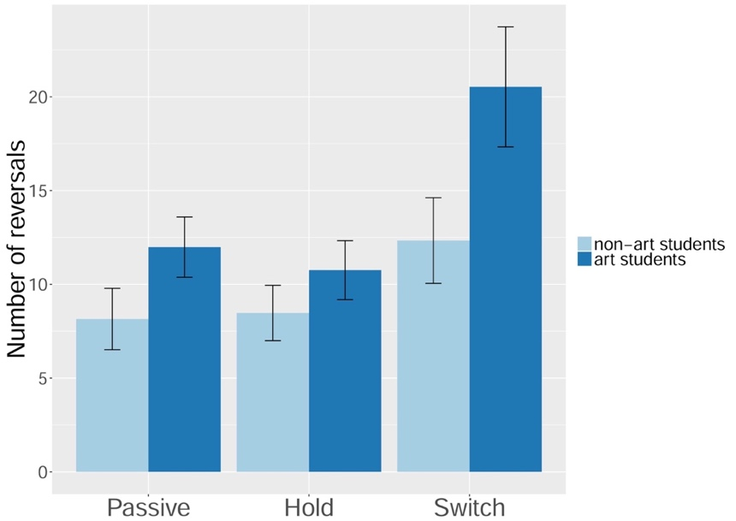
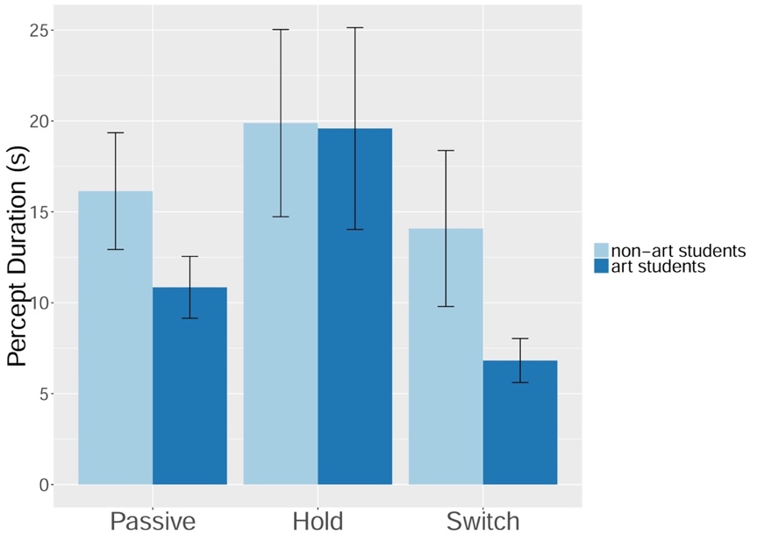
Figure 4. Between-group differences in untransformed reversal rates per minute (top) and percept duration (bottom) in the passive, hold and switch conditions of the bistable cylinder task. Error bars represent 95% CI around the mean.
There was a main effect of condition on the number of perceptual reversals, F (2, 260) =32.65, p<.001, η²=0.20, as reversal rates were highest in the switching condition, then the passive condition followed by the hold condition (Table 1). There was also a main effect of artistic group, F (1, 130) =21.77, p<.001, η²=0.14, as artists showed higher reversal rates compared with non-artists, and a significant interaction between condition and group, F (2, 260) =3.12, p=0.046, η²=0.018. In a series of planned comparisons per condition of the cylinder task, the art students showed significantly higher reversal rates in the passive condition, t (130) =3.94, p<.001, d=0.68, 95% CI of square-root transformed number of reversals [0.37, 1.10] and switch condition, t (130) =4.26, p<.001, d=0.74, 95% CI of square-root transformed number of reversals [0.57, 1.55]. After Bonferroni correction for multiple comparison (p<0.017), the group difference in the hold condition was not significant, t (130) =2.30, p=0.022, d=0.40, 95% CI of square-root transformed number of reversals [0.06, 0.85].
In a similar manner to the reversal rates, there was a main effect of condition on percept duration, F (2, 260) =32.35, p<.001, η²=0.20, where percept durations were longest in the hold condition, followed by the passive and then switch condition (Table 1). There was also a main effect of artistic group, F (1, 122) =9.64, p=0.0023, η²=0.07, as art students showed shorter percept durations compared with non-art students, and a significant interaction between group and condition, F (2, 260) =5.36, p=0.0053, η²=0.03. Planned comparisons within each level of the condition variable revealed a significant difference between the art student and non-art student group for percept durations in the passive condition, t (124) =2.75, p=0.0068, d =0.49, 95% CI of log transformed duration [0.09, 0.55], and the switch condition, t (129) =4.26, p<.001, d =0.74, 95% CI of log transformed duration [0.29, 0.79], but not in the hold condition, t (129) =0.03, p=0.98, d =0.0044, 95% CI of log transformed duration [-0.30, 0.29].
In summary, data from reversal rates and percept durations in the ambiguous figure task revealed statistically significant differences between art students and non-art students in the passive and switch conditions, with art students reporting higher reversal rates and shorter percept durations in both conditions.
Executive Function. A flanker inhibition task and a response switching task were used to assess executive function in a subset of participants (n=63).
Flanker inhibition task. Analysis of the flanker task was performed on RTs for correct trials only, as overall accuracy was high (M =0.94, SD = 0.13). To assess the impact of flanker congruency on participants’ RTs, a one-way ANOVA was performed on RTs for neutral, congruent and incongruent trials. The ANOVA revealed a significant effect of flanker congruency, F (2, 122) =147.90, p<.001, η²=0.71, with pairwise comparisons revealing significant differences between the neutral (M=0.54, SD=0.08) and the incongruent (M=0.62, SD=0.10), t (61) =12.22, p<.001, d=1.55, 95% CI [0.07, 0.09] and the congruent (M=0.54, SD=0.07) and incongruent conditions, t (61)=13.75, p<.001, d=1.75, 95% CI [0.07, 0.10]. There was no significant difference in RTs between the congruent and neutral conditions, suggesting no RT facilitation in congruent flanker trials. To estimate inhibitory ability per individual, RTs for accurate trials in the congruent and incongruent condition were divided by RTs for all accurate trials on the neutral condition to create normalised RTs. A difference score between the congruent and incongruent conditions was then calculated based on the normalised RTs. The following between-groups analyses were performed upon this normalised ‘flanker effect’ as the art students (M=0.61, SD=0.09) were significantly slower than the non-art students (M=0.53, SD=0.05) in the flanker task, t (57) =4.27, p<.001, d=1.11, 95% CI of mean difference [0.04, 0.12]. As can be seen in figure 5, art students (M=0.18, SD=0.09) showed a reduced ability to respond with distracting flankers than non-art students (M=0.13, SD=0.05) by showing a larger flanker effect on normalised RTs, t (57) =2.60, p=0.011, d=0.68, 95% CI [0.01, 0.09].
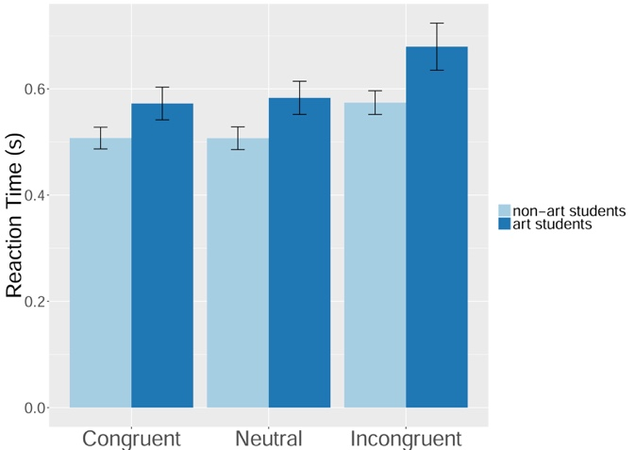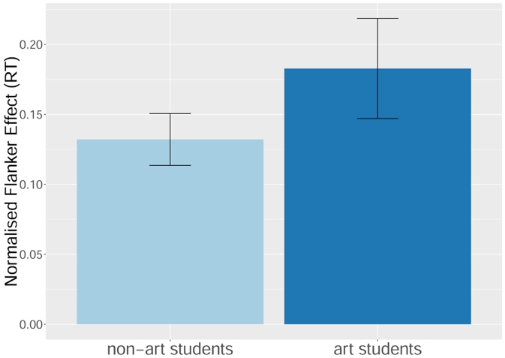
Figure 5. Between-group differences in the flanker task. Raw RTs by participant group in the congruent, neutral and incongruent conditions (left) and the effect of incongruent flankers on normalised RTs (right). Error bars represent 95% CI around the mean.
Response switching task. Accuracy and RTs were calculated for both maintain trials (no rule change) and switch trials (immediately after a rule change). Participants who scored below chance levels across all experimental trials were excluded from subsequent analysis (n=2). Analysis of the switching task was performed on RTs for correct trials only, as overall accuracy was high (M=0.96, SD=0.04). RTs on switch trials (M=1.33, SD=0.45) were slower than RTs on maintain trials (M=0.62, SD=0.11). As the distribution of the difference in RTs between maintain and switch trials was non-normal, a Wilcoxon signed-ranks test was used to statistically assess the difference between the two conditions. There was a significant difference suggesting an impact of response switching on RTs, W=30.00, p<.001, 95% CI [0.53, 0.68]. To estimate the cost of switching on RTs per individual, the RT for accurate maintain and switch trials were divided by the RTs for all accurate trials to create normalised RTs. A difference score between maintain and switch trials was calculated based on the normalised RTs. The following between-groups analyses were performed upon this normalised switch cost because the art students (M=0.77, SD=0.14) were significantly slower than non-art students (M=0.63, SD=0.11) in the switching task, t (58) =4.10, p<.001, d=1.06, 95% CI of mean difference [0.07, 0.20]. As can be seen in figure 6, art students (M=1.07, SD=0.48) were not significantly different from non-art students (M=0.97, SD=0.30) in terms of their normalised cost in RT induced by response switching, t (56) =0.93, p=0.35, d=0.25, 95% CI of mean difference [-0.11, 0.31].
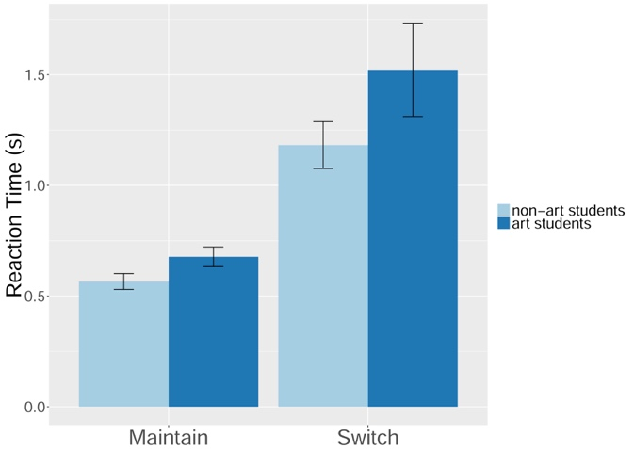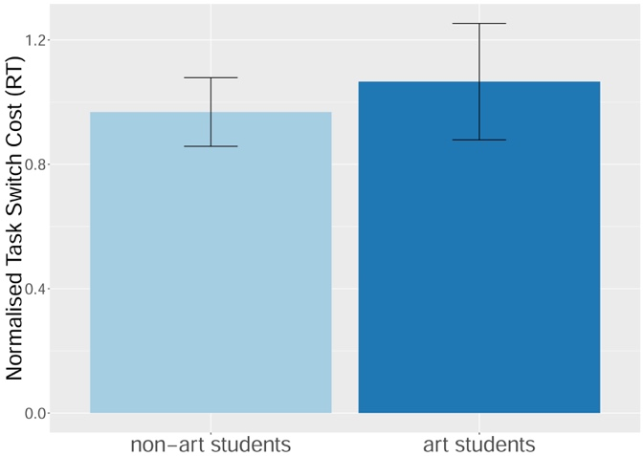
Figure 6. Between-group differences in the switching task. Raw RTs in maintain and switch trials by group (left) and the effect of rule switches on normalised reaction times (right). Error bars represent 95% CI around the mean.
Correlation between perceptual reversals and executive function. To test the hypothesis that perceptual flexibility and executive function correlate, reversal rates for the three conditions of the ambiguous figure task were correlated with normalised switch cost in the response switching task and the normalised congruency effect in the flanker task. There were no significant correlations between reversal rates in the ambiguous figures tasks and inhibitory or switching ability in the executive function tasks (all r<.18; Table 2). Since there were no reliable correlations between perceptual flexibility and executive function, a mediation analysis for links between artistic flexibility and executive function (visualized in Figure 3) was not performed.

Table 2. Correlations between number of reversals in the ambiguous figures task, and normalised flanker effect (RT) and normalised switching cost (RT) in the executive function tasks (n=63)
 |  | Ambiguous figures |  |  | Executive Function
 |  | Passive | Hold | Switch | Flanker | Switch
Ambiguous figures | Passive reversals | - | 0.43* | 0.45* | 0.18 | 0.02
 | Hold reversals | - | - | 0.36* | 0.03 | 0.18
 | Switch reversals | - | - | - | 0.07 | 0.00
Executive Function | Flanker effect | - | - | - | - | 0.10
 | Switch cost | - | - | - | - | -
Notes: *p <0.002, Bonferroni corrected value for multiple comparisons

Discussion
The aim of the current research was to assess whether ambiguous figure perception and executive function was enhanced in students of visual arts, to understand the characteristics and underlying mechanisms of artists’ flexible attention. The current study investigated whether art students are better able to produce endogenous switches of visual attention in an ambiguous figure task, and whether this is linked to enhancements in executive function as previous studies have suggested (Bialystok & Shapero, 2005; Wimmer & Marx, 2014). It was hypothesised that art students would show greater voluntary control over perceptual reversals in an ambiguous figure task, leading them to make more frequent reversals and display shorter percept durations in a voluntary switching condition and fewer perceptual reversals and/or longer percept durations in a voluntary hold condition. In addition, it was predicted that there would be group differences in executive function, with art students putatively performing better on tasks of inhibition and response switching, which may in turn be linked to increased perceptual flexibility.
The hypotheses were partially supported by the experimental data. Art students showed more frequent reversals than non-art students when asked to switch between percepts in the ambiguous figure task, suggesting that they have more voluntary control over perceptual reversals. This provides support for the notion that artists have more flexibility in endogenous visual attention, extending previous findings on exogenous attentional switches between local and global visual properties (Chamberlain & Wagemans, 2015). Art students also reported more frequent reversals in the passive condition than non-art students, suggesting that bottom-up processes supporting perceptual reversal are also associated with artistic skill. However, effect sizes for between-group differences in the ambiguous figure task were consistently larger in the switch condition than the passive condition. Finally, there was a non-significant difference in perceptual reversals and percept duration between art students and non-art students in the hold condition of the ambiguous figures task, suggesting the inhibition of unwanted perceptual representations is not associated with artistic skill.
On the basis of findings on musical training and expertise it was suggested that the art student sample may show enhancements in executive function, which would be accounted for by their perceptual flexibility. However, the current study finds no evidence to support this notion, as there were no significant correlations between the degree to which participants switched between response mappings and inhibited distracting stimuli in the executive function tasks and the degree to which they could voluntarily control reversal rates in an ambiguous figure task. While art students were better at switching between percepts in the ambiguous figure tasks, they were actually worse at suppressing a distracting flanker in an executive inhibition task and no better at switching between response mappings in an executive shifting task. This result broadly aligns with a musical training study that found improvements in executive functioning as a result of musical but not visual arts training (Moreno et al., 2011) and has implications for the domain-specificity of artistic expertise. It suggests that while artistic training confers flexibility for a range of visual stimuli, there is little transfer from the perceptual to the conceptual domain, at least in the manner tested in the current study. The executive function tasks used in the current study were selected because they were simple and non-verbal, to be as concomitant with the ambiguous figure tasks as possible. However, to test the reliability of impoverished executive inhibition in art students it would be worthwhile performing group comparisons on art students and non-art students on a range of executive function tasks.
The current findings indicate that art students are better able to switch their attention to an alternate representation of a stimulus and show higher passive switching rates, but seem to be no better at inhibiting a competing stimulus when asked to hold one interpretation in mind. This suggests that art students are as prone to bottom-up influences (such as neural fatigue) on perceptual reversal as non-art students, but can exert more control over switches of attention to induce perceptual reversals. However, it remains unclear whether art students induced more frequent perceptual reversals through mechanisms of top-down (internal modulation of attention) or bottom-up (attentional modulation via eye movements) attentional control. It should be noted that we did not explicitly measure eye movements in the current study so we cannot be certain the art students were not orienting their gaze to maximise the chance of shifting their percept. It will be possible to test the mechanisms by which art students induce perceptual reversals by allowing participants free or restricted eye movements, thereby manipulating the degree of top-down and bottom-up control available in the task.
The current findings corroborate subjective reports of perceptual games which artists play with the visual environment. However, it was not possible in the context of the current study to test whether increased attentional flexibility in the ambiguous figures task is a result of prior artistic training or is an inherent individual difference which predisposes individuals to pursue artistic activities. A longitudinal study is currently being undertaken, which will clarify whether training plays a role in the development of voluntary control over perception of ambiguous figures, while further cross-sectional analyses involving more experienced artists would also be worthwhile, as the participants in the current study had only received a few years of formal artistic training.
The domain-general nature of attentional flexibility in the visual arts was not supported by the current findings, with art students showing reduced cognitive inhibition relative to non-art students. The findings indicated that there are no robust relationships between artists’ voluntary control over perception of ambiguous figures on the one hand and their executive function capacity on the other. It can be concluded that, while artistic skill is associated with flexible visual attention, this does not transfer to conceptual flexibility at the executive level. However, it is possible that the coupling of reduced executive inhibition, which has recently been associated with enhanced creative fluency (Radel, Davranche, Fournier, & Dietrich, 2015), with enhanced perceptual flexibility found in the current study, could account for artistic insights. This implies that the creative process may function via the production of multiple perceptual representations of stimuli in conjunction with a loosening of semantic associations with those representations. This is a fruitful avenue for further research, in which it will be necessary to isolate specific aspects of the artistic process to evaluate when perceptual and executive flexibility is most significant.

References
Bialystok, E., & DePape, A.-M. (2009). Musical expertise, bilingualism, and executive functioning. Journal of Experimental Psychology: Human Perception and Performance, 35(2), 565–574. https://doi.org/10.1037/a0012735
Bialystok, E., & Shapero, D. (2005). Ambiguous benefits: The effect of bilingualism on reversing ambiguous figures. Developmental Science, 8(6), 595–604.
Eriksen, C. (1995). The flankers task and response competition: A useful tool for investigating a variety of cognitive problems. Visual Cognition, 2(2–3), 101–118.
Chamberlain, R., & Wagemans, J. (2015). Visual arts training is linked to flexible attention to local and global levels of visual stimuli. Acta Psychologica, 161, 185–197.
Chamberlain, R., & Wagemans, J. (2016). The genesis of errors in drawing. Neuroscience & Biobehavioral Reviews, 65, 195–207. https://doi.org/10.1016/j.neubiorev.2016.04.002
Champely, S. (2009). pwr: Basic functions for power analysis. R package version 1.1.1. Vienna, Austria: The R Foundation.
Diamond, A. (2013). Executive Functions. Annual Review of Psychology, 64(1), 135–168. https://doi.org/10.1146/annurev-psych-113011-143750
Kanai, R., Bahrami, B., & Rees, G. (2010). Human Parietal Cortex Structure Predicts Individual Differences in Perceptual Rivalry. Current Biology, 20(18), 1626–1630. https://doi.org/10.1016/j.cub.2010.07.027
Kiesel, A., Steinhauser, M., Wendt, M., Falkenstein, M., Jost, K., Philipp, A. M., & Koch, I. (2010). Control and interference in task switching—A review. Psychological Bulletin, 136(5), 849–874. https://doi.org/10.1037/a0019842
Kozbelt, A. (2001). Artists as experts in visual cognition. Visual Cognition, 8(6), 705–723. https://doi.org/10.1080/13506280042000090
Moreno, S., Bialystok, E., Barac, R., Schellenberg, E. G., Cepeda, N. J., & Chau, T. (2011). Short-Term Music Training Enhances Verbal Intelligence and Executive Function. Psychological Science, 22(11), 1425–1433. https://doi.org/10.1177/0956797611416999
Moreno, S., Wodniecka, Z., Tays, W., Alain, C., & Bialystok, E. (2014). Inhibitory Control in Bilinguals and Musicians: Event Related Potential (ERP) Evidence for Experience-Specific Effects. PLoS ONE, 9(4), e94169. https://doi.org/10.1371/journal.pone.0094169
Ostrofsky, J., Kozbelt, A., & Seidel, A. (2012). Perceptual constancies and visual selection as predictors of realistic drawing skill. Psychology of Aesthetics, Creativity, and the Arts, 6(2), 124–136. https://doi.org/10.1037/a0026384
Peirce, J. W. (2007). PsychoPy—Psychophysics software in Python. Journal of Neuroscience Methods, 162(1–2), 8–13. https://doi.org/10.1016/j.jneumeth.2006.11.017
Perdreau, F., & Cavanagh, P. (2014). Drawing skill is related to the efficiency of encoding object structure. I-Perception, 5(2), 101–119. https://doi.org/10.1068/i0635
Perdreau, F., & Cavanagh, P. (2015). Drawing experts have better visual memory while drawing. Journal of Vision, 15(5), 5. https://doi.org/10.1167/15.5.5
Radel, R., Davranche, K., Fournier, M., & Dietrich, A. (2015). The role of (dis)inhibition in creativity: Decreased inhibition improves idea generation. Cognition, 134, 110–120. https://doi.org/10.1016/j.cognition.2014.09.001
Schlewitt-Haynes, L. D., Earthman, M. S., & Burns, B. (2002). Seeing the World Differently: An Analysis of Descriptions of Visual Experiences Provided by Visual Artists and Nonartists. Creativity Research Journal, 14(3–4), 361–372. https://doi.org/10.1207/S15326934CRJ1434_7
Sekutowicz, M., Schmack, K., Steimke, R., Paschke, L., Sterzer, P., Walter, H., & Stelzel, C. (2016). Striatal activation as a neural link between cognitive and perceptual flexibility. NeuroImage, 141, 393–398. https://doi.org/10.1016/j.neuroimage.2016.07.046
Strüber, D., & Stadler, M. (1999). Differences in top - down influences on the reversal rate of different categories of reversible figures. Perception, 28(10), 1185–1196. https://doi.org/10.1068/p2973
Suzuki, S., & Peterson, M. A. (2000). Multiplicative effects of intention on the perception of bistable apparent motion. Psychological Science, 11(3), 202–209.
Toppino, T. C. (2003). Reversible-figure perception: Mechanisms of intentional control. Perception & Psychophysics, 65(8), 1285–1295.
van Ee, R., van Dam, L. C. J., & Brouwer, G. J. (2005). Voluntary control and the dynamics of perceptual bi-stability. Vision Research, 45(1), 41–55. https://doi.org/10.1016/j.visres.2004.07.030
Wimmer, M. C., & Marx, C. (2014). Inhibitory processes in visual perception: A bilingual advantage. Journal of Experimental Child Psychology, 126, 412–419. https://doi.org/10.1016/j.jecp.2014.03.004

Pilot data on a range of ambiguous figures demonstrated that the SFM cylinder had relatively low passive switching rates in comparison to other semantically or structurally based figures, while it also showed good potential for voluntary reversal. Perceptual switches represent a reversal of depth-order relations in a similar manner to reversing the Necker cube (central panel, figure 2).

