Haunted Data, Transmedial storytelling, Affectivity: attending to ‘controversies’ as matters of ghostly concern.

Lisa Blackman
Biography
Lisa Blackman is a Professor of Media and Cultural Studies in the Department of Media and Communications, Goldsmiths, University of London. She works at the intersection of body studies, affect studies, and media and cultural theory and is particularly interested in subjectivity, affect, the body and embodiment. She has published four books, most recently Immaterial Bodies: Affect, Embodiment, Mediation, (2012, Sage). Her other books include Hearing Voices: Embodiment and Experience (2001, Free Association Books); Mass Hysteria: Critical Psychology and Media Studies (with Valerie Walkerdine; 2001, Palgrave); and The Body: The Key Concepts (2008, Berg). Her work in the area of embodiment and voice hearing has been recognised and commended for its innovative approach to mental health research and it has been acclaimed by the Hearing Voices Network, Intervoice, and has been taken up in professional psychiatric context. She is part of a Wellcome-funded project, “Hearing the Voice” and is specifically collaborating on a sub project “Voices Beyond the Self” (2017-2020). She is the co-editor of the journal, Subjectivity (with Valerie Walkerdine, Palgrave) and the Editor of the journal Body & Society (Sage). She is particularly interesting in phenomena which have puzzled scientists, artists, literary writers and the popular imagination for centuries, including automatic writing, voice hearing, suggestion and automatism. Her forthcoming book, Haunted Data: Affect, Transmedia, Weird Science and Archives of the Future is forthcoming in 2018 from Bloomsbury Press.
Abstract
This article will explore the organizational dynamics of knowledge and scientific truths in a digital age and the hauntological implications inherent in such processes. It will consider the concept of haunted data and its methodological and performative force in relation to the question of what accrues power, status and authority within the context of changing conditions of truth-claims within digital archives. The article will focus on a scientific controversy related to priming, which largely took shape within the context of post-publication-peer-review. Post-publication-peer-review (PPPR) is a distributed form of commentary made possible by social and digital media. Different publics can now add their own commentary to published academic journal articles as they circulate across websites, blogs and weblogs, twitter, Google+ posts, in Reddit communities, in comments attached to Wikipedia, online science journalism articles, newspaper articles and so on. For some scientists, the digital disruption of the publishing industry is opening scientific conversation up to new publics and can help contribute to the impact of the article. For others it is dangerous and might damage the integrity of science and the concepts used to adjudicate truth-claims. What is missing from these debates are the hauntological consequences of these new publishing forms and their implications for how we might understand the affectivity and dynamism of data and digital archives once thought fossilized or fugitive. This includes the particular organisation of practices of memory and forgetting, and attention and inattention within digital controversies.

Introduction

This article will explore the organizational dynamics of knowledge and scientific truths in a digital age and the hauntological implications inherent in such processes. It will consider the concept of haunted data and its methodological and performative force in relation to the question of what accrues power, status and authority within the context of changing conditions of truth-claims within digital archives. The article will specifically focus on a scientific controversy related to priming, which largely took shape within the context of post-publication-peer-review. Post-publication-peer-review (PPPR) is a distributed form of commentary made possible by social and digital media. Different publics can now add their own commentary to published academic journal articles as they circulate across websites, blogs and weblogs, twitter, Google+ posts, in Reddit communities, in comments attached to Wikipedia, online science journalism articles, newspaper articles and so on. For some scientists, the digital disruption of the publishing industry is opening scientific conversation up to new publics and can help contribute to the impact of the article. For others it is dangerous and might damage the integrity of science and the concepts used to adjudicate truth-claims. There is much scrambling to shape the potential affordances of this new mode of organizing scientific debate, scrutiny and conversation. This includes challenges to practices of gatekeeping, censorship, secrecy, and anonymity, which characterise some peer review practices across the academic publishing industry.

What is missing from these debates are the hauntological consequences of these new publishing forms and their implications for how we might understand the affectivity and dynamism of data and digital archives once thought fossilized or fugitive. This includes the particular organisation of practices of memory and forgetting, and attention and inattention within digital controversies. I have written about some of what is at stake in the emergence of post-publication-peer-review for humanities scholars elsewhere (see Blackman, 2016). In this article I will explore the implications of these processes for analyses of what haunts modes of scientific knowledge production, and which often remain submerged, displaced, disqualified and foreclosed. The article will make an argument for the importance of attending to what is often rendered insignificant, nonsensical, insufficient or what often exists below the radar never becoming part of accepted narratives or official versions of events. Why might it be important to attend to ghostly data, to those links or traces of ‘something else’ (of what we might call future-potentials) that sometimes open to detours, often to dead-ends and to submerged and displaced actors and agencies? What does the concept of hauntology and haunted data bring to our discussions of time and temporalities (to organisational time, for example), to what is often disavowed, or disqualified, to that which remains unspoken or speaks through different mediums? This is what I call the haunting potential of different organisational structures and processes (what we might call mattering processes), which reveals the close relationships between haunting and affect.

The case study I will use to explore some of these issues is taken from my forthcoming book, Haunted Data: Transmedia, Affect, Weird Science and Archives of the Future. The book engages in a form of transmedial storytelling, which explores how digital archives have the potential to re-move - that is put back into circulation -, marginal agencies, displaced actors and entities, and temporalities once thought fugitive or fossilized. Transmedial storytelling is typically framed as storytelling, which ‘uses multiple media platforms (to) tell a narrative across time. Each media piece—whether it’s a comic, novels, video games, mobile apps, or a film—functions as a standalone story experience—complete and satisfying. Like a giant puzzle, each piece also contributes to a larger narrative. The process is cumulative and each piece adds richness and detail to the story world, such as character backstories and secondary plotlines’.

This version of transmedial story telling underpins new marketing and branding strategies and attempts to amplify and modulate practices of intertextuality, indeterminacy, and non-linear devices and techniques to shape what is considered a more persuasive, immersive and participatory experience. It is sometimes described as a “communication experience” rather than a message. Such an experience is claimed by many to engage the brain at a more sensory and intuitive level (see Kalogeras, 2014). These claims bring together arguments about the potential of media convergence with particular understandings of “media psychology”. It draws on the neuroscience of emotion to explore the relationship between memory, meaning, attention and affect-emotion.
Some of these approaches draw explicitly on the work of neuroscientists such as Antonio Damascio (2000), who has explored the role of affect and emotion in judgement and thinking. Damasio coined the term “somatic markers”, which he suggests help in making decisions and processing information. He suggests that “somatic markers” are affective forms of processing that are rapid, non-conscious forms of perception that allow us to take in a complex range of information that is “much more” than we can explicitly or consciously register. They operate below the threshold of conscious experience and are registered in the body through a visceral sense: what we might term gut feeling or intuition.

Philosophers such as William Connolly (2002) have argued that they provide a kind of “affective energy”, which helps us to understand the force, appeal and allure of specific organisational forms and practices allowing what he calls a serious engagement with the affectivity and dynamism of matter.

“Part of the affective energy mixed into thought becomes available to consciousness as feelings and concept-imbued emotions, but other thought-imbued energies find symptomatic expression in the timbre of our voices, the calmness or intensity of our gestures, our facial expressions, the flush of our faces, the rate of our heartbeats, the receptivity, tightness or sweatiness of our skin, and the relaxation or turmoil in our guts” (Connolly, 2002: 76).

The focus on allure, appeal and what commands attention within a media landscape increasingly shaped through an overload of information and ubiquitous, pervasive, networked media is of interest to organisational life and concerns. How to shape and “grab attention” and the relationship of this to regimes of remembering and forgetting, which govern what can be said and not said, seen and not-seen, felt but not easily articulated, extend studies of organisation and management processes into hauntological and affective realms. With this in mind I will extend some of these introductory arguments by transposing discussions of the affective and the transmedial into more ghostly matters that have been the subject of hauntological analysis and method. This will move discussions of transmedial storytelling beyond a particular media psychology or neuroscience of affect and emotion to explore the new forms of power, status, hierarchy, visibility and invisibility, memory and forgetting, which are shaping practices of attention and inattention.

Hauntology and Ghostly Matters

Hauntological analysis extends across the arts and humanities, has a particular place in philosophy and has entered into discussions of media, such as film, photography and television. Hauntology has a particular place in the lives of oppressed and marginalized peoples and those suffering from traumatic memories that blur the historical and the personal and the past and present. Avery Gordon (2008) suggests that hauntological analysis is a way of focusing on how people sense, intuit and experience the complexities of modern power. It focuses on 'what is usually invisible or neglected or thought by most to be dead or gone' (ibid: 194). There is a sense that 'we' already know, in some form or way, what haunts as a ghostly presence, but that the paradigms we have for animating these ghosts operate at the limits of what is taken to be understandable. Gordon suggests that as researchers, readers, citizens and persons we are implicated in particular hauntings, but that we might need companions in thought, such as novels, photographs and other media to help articulate our concerns (also see Ahmed, 2014).
Hauntologies are also histories of the present; of how particular presents have materialized in relation to specific and contingent normative horizons and what is relegated, excluded, disavowed or consigned to pathology. In that sense, hauntologies have a relationship to work which has explored how social norms become social goods or truths and the social figures who carry what is excluded from such norms; the feminist killjoy, the melancholic migrant, the unhappy queer and so forth (Ahmed, 2010). However, the aforementioned figures might be said to have a hyper-visibility in that they can be found, tracked, analysed and allowed to speak through the animation of particular archives of wilfulness perhaps (see Ahmed, 2014). The ghost might be said to be a different kind of social figure, which is both 'there and not there, past and present, force and shape' (Gordon, 2008: 6). It takes form and crops up in places, relations and shapes, which exert agency or an affective force without obvious definition. The ghost requires a host; someone, something or perhaps a controversy, which allows it to surface and demand our attention. Haunting can impose and then retreat; leave traces of its visit and invite us to take notice and 'imagine beyond the limits of what is already understandable' (ibid: 195).

Media Time(s) and Haunted Socialities

Haunting is an invocation of ghosts, of those entities and things which live among us in both social and imaginary forms. Ghosts and ghostings are often associated with particular places, the haunted house or landscape, and are the stuff of the 19th century Gothic novel. They are particular animations, usually associated with the dead coming alive, or the liminality of death in life when the past lives on in the present as a 'seething presence' (Gordon, 2008). Hauntologies have a particular place within studies of the transmission of intergenerational trauma. There is an assumption within this tradition that 'intergenerational trauma is transmitted from one generation to another without the next generation necessarily even knowing what it is that causes the anxiety they experience' (Walkerdine and Jimenez, 2012: 10). It is assumed that the transmission of trauma often occurs through practices of shame, secrecy and silence, rather than being talked about. To that extent the forms of mediation that are seen to underpin such processes are not symbolic or transmitted through language. The body of a particular host is connected and linked to others (human and nonhuman) who perhaps cannot be known, talked about or articulated in any straightforward way. It is no coincidence perhaps that performative approaches to the question of how to listen to voices, apparitions and ghosts in this context have been developed.
For example, Walkerdine and Jimenz (ibid), take inspiration from the work of the French psychoanalysts Davoine and Gaudilliere (2004) whose work is influenced by dramaturgical enactments of trauma, where they draw an analogy between particular forms of theatre (Artaud and Japanese No Theatre) and the action of analysis. In her piece, The Characters of Madness in the Talking Cure (2007), Davoine equates the position of the analyst as being akin to a conjurer, summoning the characters of madness to speak through another character as a double. She argues that the analytic scene is akin to a stage and the analyst should attempt to create a mis-en-scene through which the analysand's voices or ghosts can speak through another, so that it can be acted out and spoken. She likens this process to interacting with ghosts, hallucinations and apparitions setting in motion a moment or event that is no longer situated in time. The concept of the double, which she takes from Artaud's Theatre of Cruelty (1932), refers to ghosts, which are taken to have a long memory, and require a hospitable host in order to come to the stage. She uses various concepts to describe the experience and enactment of time disclosed by such practices, including 'time quakes', equated to stoppages of time.
Although this practice has primarily been developed to work with people experiencing psychosis within particular therapeutic contexts, there has been some success with the use of social media to extend how we might listen to and interact with the voices of others (see Blackman, 2014). These dramaturgical approaches to staging and re-enacting the voices of others (human and nonhuman) connect with other performative approaches that might allow particular forms of listening and interacting. These might be considered extensive and intensive in the way that media forms are often described. Hauntologies do not conform to a representational logic and are more akin to forms of mediated perception. Grace Cho's (2008) seminal and moving account of her own experience of intergenerational haunting develops how we might understand mediated perception as an assemblage of human and non-human actors and agencies distributed across space and time. The capacity to 'see' the trauma that has been transmitted across generations, often through shame, secrecy and silence, cannot be seen or registered 'in any single place and moment in time, and the act by which this perception occurs is not the result of a single or isolated agency but of several working in concert or parallel' (Cho, 2008: 156).
Thus the I/eye of perception is not a distinctly human and singular eye, but rather is made up of 'an assemblage of eyes, tongues, and other parts distributed in time' (ibid: 157). Cho equates this, following John Johnston (1990), to a form of 'machinic vision', where the ability to see is 'distributed across bodies and generations' (ibid: 57). Cho equates this to a form of haunting, related to traumatic histories that have not been officially documented, or only in particular ways. These disavowed or discredited histories might leave traces, fragments, repetitions of movement, gesture and inchoate feelings, which speak in and through other's bodies - human and non-human – that become distributed across space and time.

This is a form of diasporic machinic vision, which she suggests is perhaps the only means by which haunted histories can be 'seen'. She asks the important question, what does it mean to see, hear and listen through another's voice? This is related to what she terms an 'ethics of entanglement'. This question requires the re-staging of absent-presences through a distribution of the senses. Thus distributed perception brings together a range of actors and agencies, human and non-human, to shape a technology, which might allow one to 'see' what usually remains submerged, displaced or occluded. Such a technology of attention blurs the distinction between fact and fiction, past and present, material and immaterial, and therefore the work that particular media might perform. This might include the conjoining of semi-fictional film images, artwork from second generation subjects, official historical documents, social work literature, memoirs, witness stories and accounts, newspaper accounts, interviews and secondary histories, which all constitute a 'kind of story-telling machine' (ibid: 165). Distributed perception enables a performative re-staging or enactment of what might have been, and therefore could be. It opens to apparitional hauntings in the present and to the production of different possible futures.
Within hauntological approaches the question of what might count as media is extended beyond particular media and technical forms. All of the above actors and agencies, from individual witness accounts, newspaper articles, fictional film, accounts from social workers, an individual and even collective sense of being haunted, and the phenomena of voice hearing, for example, are all forms of media. They all mediate and allow one to see by connecting up a trauma that has been distributed across space and time, and which require an assemblage of relationships to be enacted or staged in order to create the possibility of seeing. Mediated perception should and indeed cannot be judged according to veracity - fact or fiction - as it is how elements are combined and performed as a particular 'story-telling machine'. It is this story-telling machine, which enables vision and the possibility of new understanding to emerge. It is perhaps not surprising therefore that hauntology as a method can be found within art, film, literature, photography, performance, dance and drama for example; where the emphasis on staging, curation, choreography, orchestration and working with, and performing different intensive and extensive imaginaries, has perhaps been more advanced than in studies of media and communications (see Blackman, in press).
Although beyond the scope of this article to include in any detail, there are many different examples and practices of hauntology across the arts and humanities. This includes the seminal work of the black British artist and filmmaker John Akomfrah who has used the term hauntology to describe his own films and aesthetic. Akomfrah's practice combines archival footage (often from sanctioned media archives such as those of the BBC including documentary TV and radio), with imaginative re-stagings and enactments of the gaps, silences and absences in such footage. These require the action of myth, fiction and fantasy as companions in thought. In a commentary in relation to a 2012 art installation of Akomfrah's work, which mobilized hauntology as its title, the author acknowledges Derrida's use of such a term and its reference to those multiple pasts in the present, which remain as absent-presences (Allsop, 2013); what Allsop terms the 'many pasts present in the present'. Akomfrah's subject is the colonial histories of Jamaican and West Indian migrants to the UK and a staging of those stories erased by official histories and forms of mediated perception. Akomfrah's film of Stuart Hall, the late and great Black British cultural studies scholar and public intellectual, whose story is told through the conjoining of archival footage and interviews, punctuated by the music of Miles Davies, shows just how effective and important hauntology as a political and artistic method can be.
Hauntological approaches to the many pasts in the present are also carried by the figure of the ghost as a socio-cultural and political phenomenon. This assumption is part of the curation of an ongoing interdisciplinary arts project led by the British artist Sarah Sparkes. GHost Hostings was initiated in 2008 and has to date curated 14 events, bringing together artists, performers, dancers, academics, filmmakers and other kinds of ghost-hunters to conceptually interrogate and manifest the idea of the ghost. GHost takes its title from Marcel Duchamp's (1953) work, "A GUEST + a HOST = A GHOST". As Sparkes argues, the guest is a host inside the ghost, which points towards the success and effectivity of the experimental apparatus to stage or summon ghosts for interrogation. In March 2014 GHost Hostings 14 staged 3 performance pieces, which all used sound, embodied performance and mediated images in order to conjure the experience of displacement through forced migration and traumatic histories. This included the work of Stasis 73 who animated found archival images and testimonies of people forced to migrate, sometimes by foot, or train or boat, to another place, leaving behind abandoned buildings, homes and villages, personal items, lives and the dead. Through a form of mediated perception they attempt to stage the unspoken trauma of such displacement through image and sound, in order to raise the ghosts and re-animate what they term the dead camera-eye, which captures such images frozen in time. They return perhaps captivation to captivity.

Digital Hauntology

In my forthcoming book, Haunted Data, I have developed an affective methodology that brings hauntological analysis into studies of data and computation. My focus has been on returning storytelling to science or what Rheinberger (1994) has termed historiality. The concept of historiality draws attention to the multiplicity of times that intrude within experimental systems. It also draws attention to science as a story-telling machine, where as he argues; 'an experimental system has more stories to tell than the experimenter at any given moment is trying to tell with it' (Rheinberger, 1994: 77). He equates this dynamic potential to older narratives that persist in the future, as well as 'fragments of narratives that have not yet been told' (ibid: 77). I have explored this in the context of new forms of scientific data that blur fact and fiction, self and other, human and technical, material and immaterial, and the popular and the scientific (see Blackman, 2016). The data that are generated within post-publication-peer-review have provided the archive within which I have worked and have allowed a productive and I hope inventive way of attending to a statement’s liveliness. In the book, Affective Methodologies: Developing Cultural Research Strategies for the Study of Affect (Knudsen and Stage, 2015) I argued that attending to a statement’s liveliness sets in motion an ethnographic orientation, where what a researcher might encounter is not just texts, statements or practices (in the Foucauldian sense), but spectres, displacements, disjointed times, submerged events, and multiple temporalities (perhaps in the more Derridean sense – see Derrida, 1995).
Unlike practices of research located within particular archives and technologies of inscription, including the (paper) book and journal article, (as well as newspaper reports and cuttings; scientific reports held by particular institutional bodies; ethnographic research and interviews with research subjects, etc.), my research data consists of a dizzying array of hyper-links. These links extend across blogs, tweets, on-line science discussion forums, on-line science journalism, comments on websites and open-access science journals. The links are related to specific url's and their after-lives. It is what some media theorists have called cross-platform data, as the data is not generated by particular application programming interfaces. All of the data is digital, in the sense that I am following the fate of particular journal articles as they are transformed post-publication within and across different digital platforms. I liken my role to a ghost-hunter with an obsessive compulsion who focuses on what sometimes appear as insignificant or minor details to the plots that take form.
I specifically attend to outliers, gaps, or links, which insistently return, whilst at the same time they are subject to processes of redaction or recoding. They set in motion trails, which sometimes end at dead-ends and which are often obscured by particular regimes of remembering and forgetting. This kind of method requires the development of new habits of academic attention; what I liken to becoming an embodied instrument open to the rhizomatic quality of digital data. With tenacity, training, perseverance and specific forms of affective comportment (absorption, dissociation, daydreaming, reverie etc) one is able to apprehend multiplicities. These might be conceived as distributed and non-hierarchical entry and exit points. They can be thought of as having no origin, genesis, beginning or end.

These trails are difficult to account for in terms of graphs, data visualizations, index cards, over-views of the data sample, taxonomies of research materials, categorizations of methodological protocols, or as an account of the dispersion of texts as they relate to each other in an archive delimited by particular conditions of possibility and existence. The method is perhaps closest to an example of embodied hauntology (see Blackman, 2015), where the data is shaped and re-shaped by my own actions. I have often experienced this reshaping and re-moving as akin to a form of daydreaming or reverie. It is the closest account I can give for the absorption I have experienced as I move through and experience the logic of what Bolter and Grusin (2000) have termed hypermediation; that is acts of mediation, which draw attention to their construction. Bolter and Grusin explore this logic in relation to the hyper-linked design of the Internet and the remediation of graphic design within its aesthetic construction. This aesthetic is perhaps closest to practices of montage and collage found in modernist and postmodernist art, and is a visual logic that they argue emphasizes process, fragmentation, indeterminacy, and heterogeneity (in that it does not emphasize one unified point of view).

This hypertextual style means that lots of things compete for attention and reverie is perhaps one affective style that is suited to the remediated research environment that digital hauntologies engage. This feeling of syncopation and compulsion is as much about paying attention to absences, gaps, silences, contradictions and places where data trails coalesce and become attractors. Attractors relate to statements, texts, objects, events or entities that become entangled through discord, discontinuity, a temporal clash or collision. These collisions often create moments of affective intensity - anger, incredulousness, disbelief, or an insistent belief that there is something more to say. These entanglements might set in motion a genealogical trail that resurrects the spectre of past controversies. These ghosts might undo the present and open to those lost-futures, which are still very much with us, albeit as repressions, displacements and movements in submerged forms. The method illustrates the challenges of working affectively with particular archives when genealogies explicitly confront hauntologies.
The specific approach I develop to transmedial storytelling based on these ideas is indebted to the work of the post-colonial theorist, Rey Chow (2012). She frames transmedial storytelling as a distributed and performative strategy. The method works with particular entangled relations, or what she calls ‘scenes of entanglement’, entering into the scene and attempting to open up the potential to think otherwise. Transmedial storytelling has the potential she suggests to unfix the past bringing multiple temporalities into discussions of mediation. It also has the potential to blur distinctions between past and present and space and time.

She explores different strategies that might enable this, including montage and de-familiarization. It is what she equates to a post-human form of reflexivity. Chow suggests that 'shadow media' or social and digital media, are both atomized and increase capacities for connectivity and interactivity, which she suggests allow new realities to happen. She equates this to the setting in motion of different times and temporalities; no longer fugitive, fossilized and anachronistic. It is this setting in motion or re-moving that I develop within the context of the writing of the science studies scholar Hans Jorg Rheinberger (1994) as outlined earlier. I will try to illustrate some of this by engaging in a brief transmedial form of storytelling that I hope will highlight what might be at stake in attending to ghostly matters in-formation.

Science Controversies as Matters of Ghostly Concern

The transmedial storytelling I engage in the book takes two contemporary science controversies (John Bargh priming controversy/Feeling the Future), which cross cognitive science, anomalistic psychology and psychic research as its subject matter. They also appear in a different form within the field of affect studies, speculative philosophies and new materialisms (see Blackman, in press). Both controversies also speak to current debates, which cross affect theories, studies of media and mediation and the question of how we can do critical research within the context of computational culture? They also open to some marginal and marginalized ways of articulating what it means to be embodied, a human, a citizen, and to communicate when the singularly bounded and unified psychological subject is displaced from its sovereign status. Both controversies also took form within the context of post-publication-peer-review. They are shaped by a dizzying array of hyper-links, some of which have been assembled and re-assembled into accepted versions of events, and others, which remain as haunted data. My argument in short is that science and computational cultures might be haunted by the history and excess of their own storytelling and that these excesses surface in “queer aggregations” or haunted data to be mined, poached and put to work in newly emergent contexts and settings. The book points to the propensity of straight or legitimate science to sanitize or excise or even exorcise narratives, actors, agents and entities, which “contaminate” it with queerness.
In order to partially illustrate some of these arguments I will make links to work in sociology on controversies as potential sites, which de-stabilise linear conceptions of time. They offer up the potential to disclose what Derrida (1995) called archives of the future; that is the possibilities of imagining alternative futures, which are recovered or re-moved by minor traces found in the past. They exist as absent-presences in the present and therefore as potential-futures. Haunted data I will argue operates according to a kind of re-forming dynamic or tendency that can be modulated, attended to and worked with.

Usually controversies are considered public events, which disclose or reveal patterns of disagreement and opposing viewpoints linked to particular events or issues. It is assumed that controversies can be mapped and there is, for example, an established tradition of work that comes out of Science and Technology Studies linked to the work of the French sociologist, Bruno Latour, which uses digital and other methods to produce a cartography of controversies. Within such approaches, which take data and the digital as their object, it is assumed that controversies can be made visible, that they are mediated in different ways, and that there are human as well as non-human actors and agents who shape what comes to matter. To that extent the controversies that are mapped are not simply considered representative, but rather the mapping also potentially becomes another agent that might enter into and change the setting and scene of the controversy.

However, arguably these approaches are rather rationalistic. Although it is recognised that a researcher is likely to be confronted with an overwhelming array of digital data and traces, it is still assumed that by using digital methods, which remediate quantitative forms of semantic and content analysis, one can map the key players and explore how controversies become shaped as particular matters of concern. As a metaphor for organisational life, controversy or issue-mapping as it is often referred to, assumes that dynamics shaping social life are knowable and can be scraped, attended to and transformed into other kinds of data in order to effect change and transformation. After all, controversy analysis is about making a difference as much as it is about revealing dynamics of public and organisational communication, power and life.
New media environments are seen to disclose the dynamism of controversies and allow for the mapping and representation of the complexity of science, which is usually covered over by positivist forms of science writing. As Venturini (2012) has argued, positivist forms of writing and argumentation often present disagreements as technical points - problems with replication, the experimental set-up, statistical analysis and interpretation -; but rarely as 'conflicting visions of the world' (p. 808).

However, what is missed in these rather rationalistic versions of controversy mapping are the hauntological forces that are not so easily mapped, and indeed which are likely to be obscured by particular digital methods based on semantic and content analysis (see Blackman, 2016). How then does one confront these hauntological forces and what and where might they direct us if only we could listen and attend? In the next section I will open up some of these questions with a short case study, outlining some of the parameters of a science controversy in the area of priming. This more-than-one event opens up interesting questions about behavioural change and transformation linked to versions of behavioural economics that draw from studies of priming. These theories have contributed to understandings of how to effect change and transformation within organisational life. However, as the dust settles and the ghosts retreat the interesting questions and more innovative propositions re-moved by this controversy are largely left going nowhere.

John Bargh priming controversy

Let’s imagine I am Professor John Bargh, an eminent Yale cognitive scientist who recently became the subject of a controversy. As a reader you might never have heard of John Bargh although you might be familiar with a classic psychology experiment known as the elevator walking study, which has been remediated many times on Youtube. This is one of the most highly cited social psychology experiments. This study argued that experimental subjects would walk more slowly to a lift after being shown words associated with ageing on a scrambled language task.

Priming was popularized by Malcolm Gladwell (2005) in his book, Blink: The Power of Thinking without Thinking and is an interesting subject matter for hauntologies as it links hypnosis, subliminal forms of persuasion and behaviour change found in advertising and marketing, with what are often considered unconscious motivations of action, thought and feeling. Priming has also been linked to nudge behavioural economics in Taylor and Sunstein’s (2009) book, Nudge: Improving Decisions About Wealth, Health and Happiness. Gary Gutting (2015) has argued that although the authors draw on scientific studies of priming to authenticate their behavioural economics their approach chimes more with common sense than established science in this area. The controversy under hauntological investigation confirms the epistemic uncertainty surrounding what priming is and how to understand, analyse and even experiment with priming effects as a way of enacting processes of change and transformation.

Priming is already controversial as it unseats the rational cogito from its Cartesian throne and draws limits around the concept of free will. This however is not what became controversial in 2012 about John Bargh and his studies of priming. Rather what became controversial was a particular replication study of his classic elevator study, which failed to replicate the priming effects (see Doyen et al, 2012). This incensed Bargh and led to him writing three posts for his blog for Psychology Today, which had lain dormant for two years. These posts are at the centre of what has been described by many commentators as an ‘Internet drama bomb’. This controversy became somewhat of a media event, creating a reach and traction across social media. However the centre that the blog posts occupy is a bit like a vortex, which has sucked them in and spat them out in a different form. The blog posts were later redacted and what is now left are trails and hyper-links to these redacted blog posts, which end in either detours, dead-ends or re-codings. This trail of haunted data re-activate minor agencies and actors within psychology’s pasts, which have largely been disqualified, disavowed and discredited. These pasts are re-moved and re-activated by this failed replication study and the redacted blog posts. The data invite interesting speculative questions about what it means to communicate when understood through a more distributed, relational and embodied ontology. However, these speculative questions end in dead-ends.

One set of speculative questions and propositions relates to the re-moval of Hans the Horse or “Clever Hans”, an early 20th century equine celebrity who could famously tell the time and solve fairly complex multiplication puzzles by stamping his hooves. The links made between Bargh and Hans the Horse were what incensed Bargh. He was compared to Mr von Osten the owner of Hans the Horse by the science journalist Ed Yong implying not that priming did not exist, but priming effects could only be found when the experimenter knew the aims of the experiment. This equated the priming effects to a curious form of experimental bias or effect associated with the experimenter and not the experimental subject. Bargh’s incensed and uncivil discourse contained in the blog posts became an attractor, which re-moved this earlier entangled controversy. Bargh referred to this comparison as the “Clever Hans slur” in one of his redacted blog posts, and it was this statement that became an attractor, accruing agencies as it moved on from the original scene of enunciation and became lively. This corpus of haunted data raised important questions about what it might mean to enter into suggestive relations with another, and how mind and cognition might be distributed, shared, and extended through registers which exceed conscious awareness and attention. For example, the case of Clever Hans has been revitalized in contemporary cultural theory to ask questions about what it means to affect and be affected and raises important questions about what it means to be open to the other, human and non-human (see Despret, 2004).

As Despret has argued in relation to the case of Clever Hans, ‘Hans provides a wonderful opportunity to explore a fascinating question. Indeed, the horse could not count, but he could do something more interesting: not only could he read bodies, but he could make human bodies be moved and be affected, and move and affect other beings and perform things without their owners’ knowledge. And this could be experimentally studied. Hans could become a living apparatus that enabled the exploration of very complicated links between consciousness, affects and bodies. Hans could play the role of a device that induced new articulations between consciousness, affects, muscles, will, events ‘at the fringe’ of consciousness (Pfungst, 2010: 203); he could be a device that, furthermore, made these articulations visible. Hans, in other words, could become a device that enabled humans to learn more about their bodies and their affects. Hans embodied the chance to explore other ways by which human and non-human bodies become more sensitive to each other'.
These are questions that are considered closed within the history of Psychology’s past and that although consigned to history are re-moved by this controversy. Is this a story about Hans's capacities or the story of a relational connection that extended and distributed mind as a collective, shared process, even if Mr Von Osten was seemingly oblivious to his unwitting participation? As Despret goes on to suggest, ‘if priming alters thought, action and behaviour, where in this case a horse can be made to add or subtract or tell the time through its connection with another, then who is mediating who? In whose mind should the capacity to imitate be located or is this the wrong question to be asking?’ However, these questions are foreclosed by the representationalism that comes to stand in for the controversy, and which appear in a google search of the controversy. What remains in excess to this representationalism is a ghostly trail of haunted data. This data is lively and re-moves minor agencies, unsettled debates and more relevant questions and innovative speculative propositions about the nature of communication, change and transformation. These are largely occluded by the version of events, which have become assembled and that are illustrated by what appears at the top of page 1 when using Google as a search-engine (see Figure 1 below).

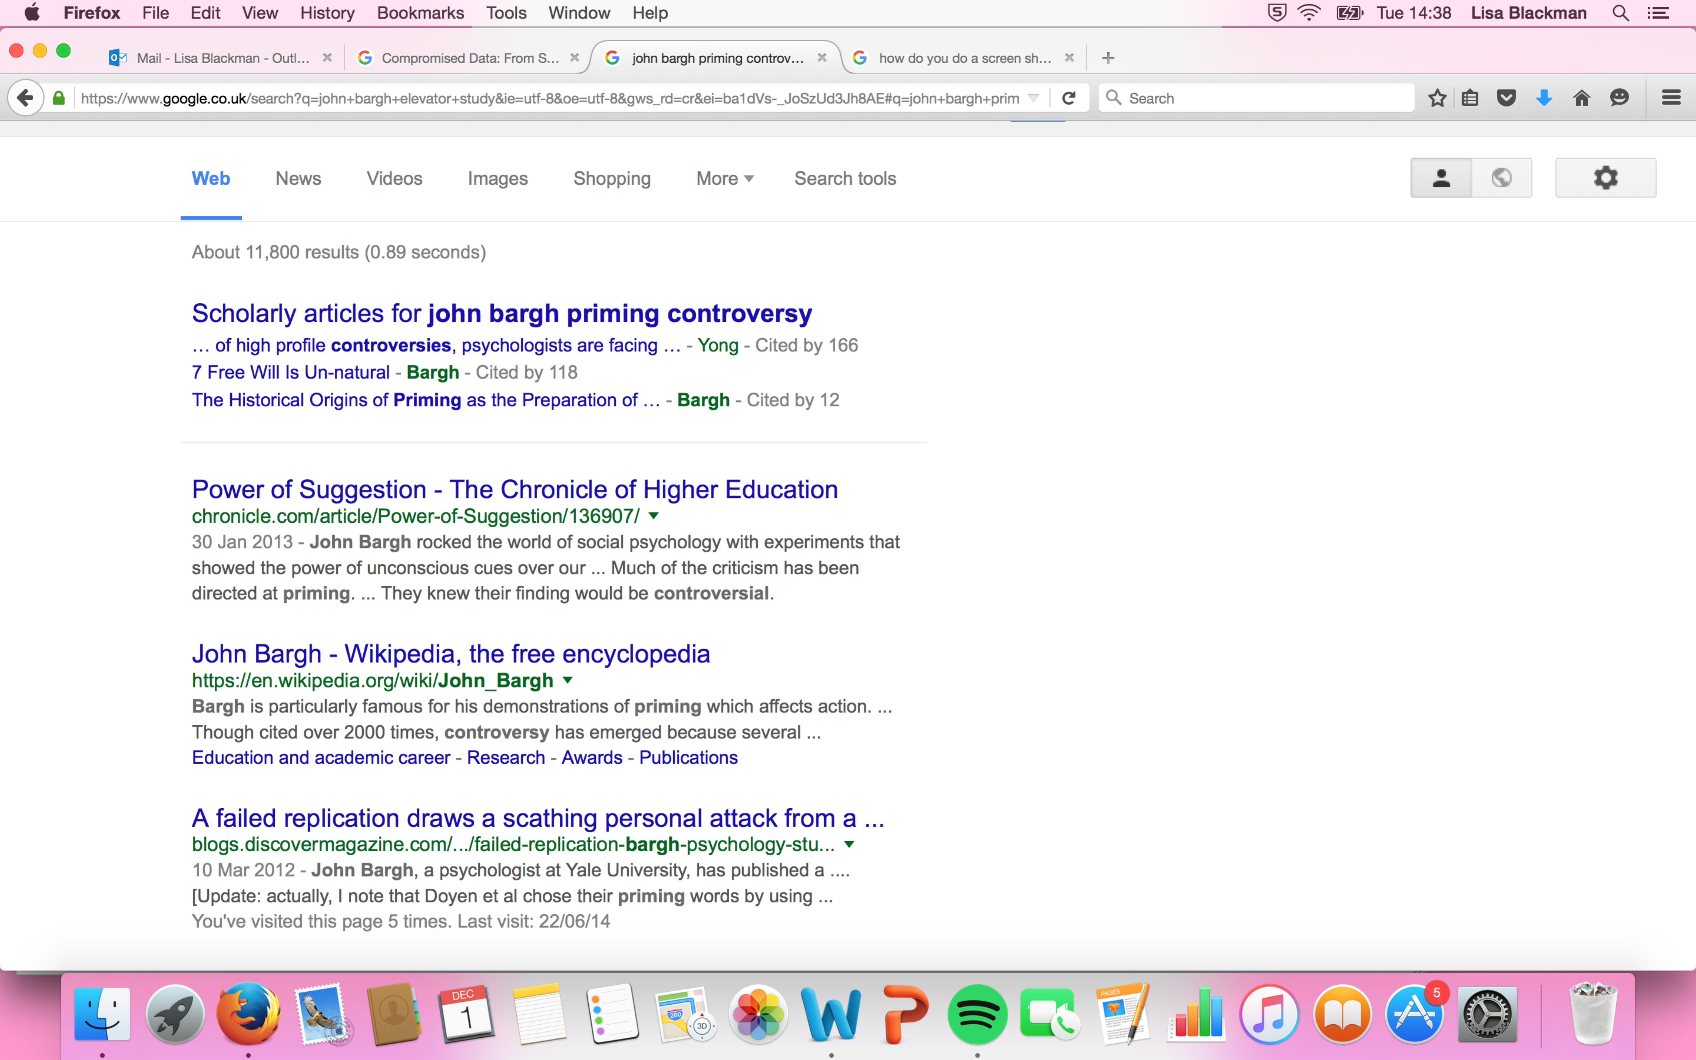
Figure 1

The top article, Power of Suggestion, published in the Chronicle of Higher Education is written in the manner of a confessional or redemption narrative where John Bargh regrets taking down the blog posts and reflects on the series of events, which led to what is constituted by him as being a very bad year. He did go on however in 2014 to win the Distinguished Award for Scientific Contributions by the American Psychological Association, so this was a blip in an otherwise illustrious career! When I started the project on Haunted Data, I like many other people, were looking for the blog posts that had been redacted and like others asked, why had the posts been redacted? Why had there been such a furore over a failed replication study? Surely replication studies and non-replication is part of the cornerstone of the scientific method? I could find links to the posts, particularly via the science journalist Ed Yong who had written about the failed replication study and Bargh’s subsequent posts and their redaction but the posts remained elusive. I did however recover them using digital methods and other users had circulated the posts on digital platforms, such as Twitter. The recovery of the posts and my capacity to attend and re-move marginal and minor agencies and actors, has provided the conditions and source material to engage in this form of transmedial storytelling. Also as an example of my own temporary denouement to what is far from a static version of events, a publication of mine based on my transmedial reading of this controversy now appears on page 2 of a google search using the search terms ‘John Bargh priming controversy’ (see result 4 in figure 2 below).

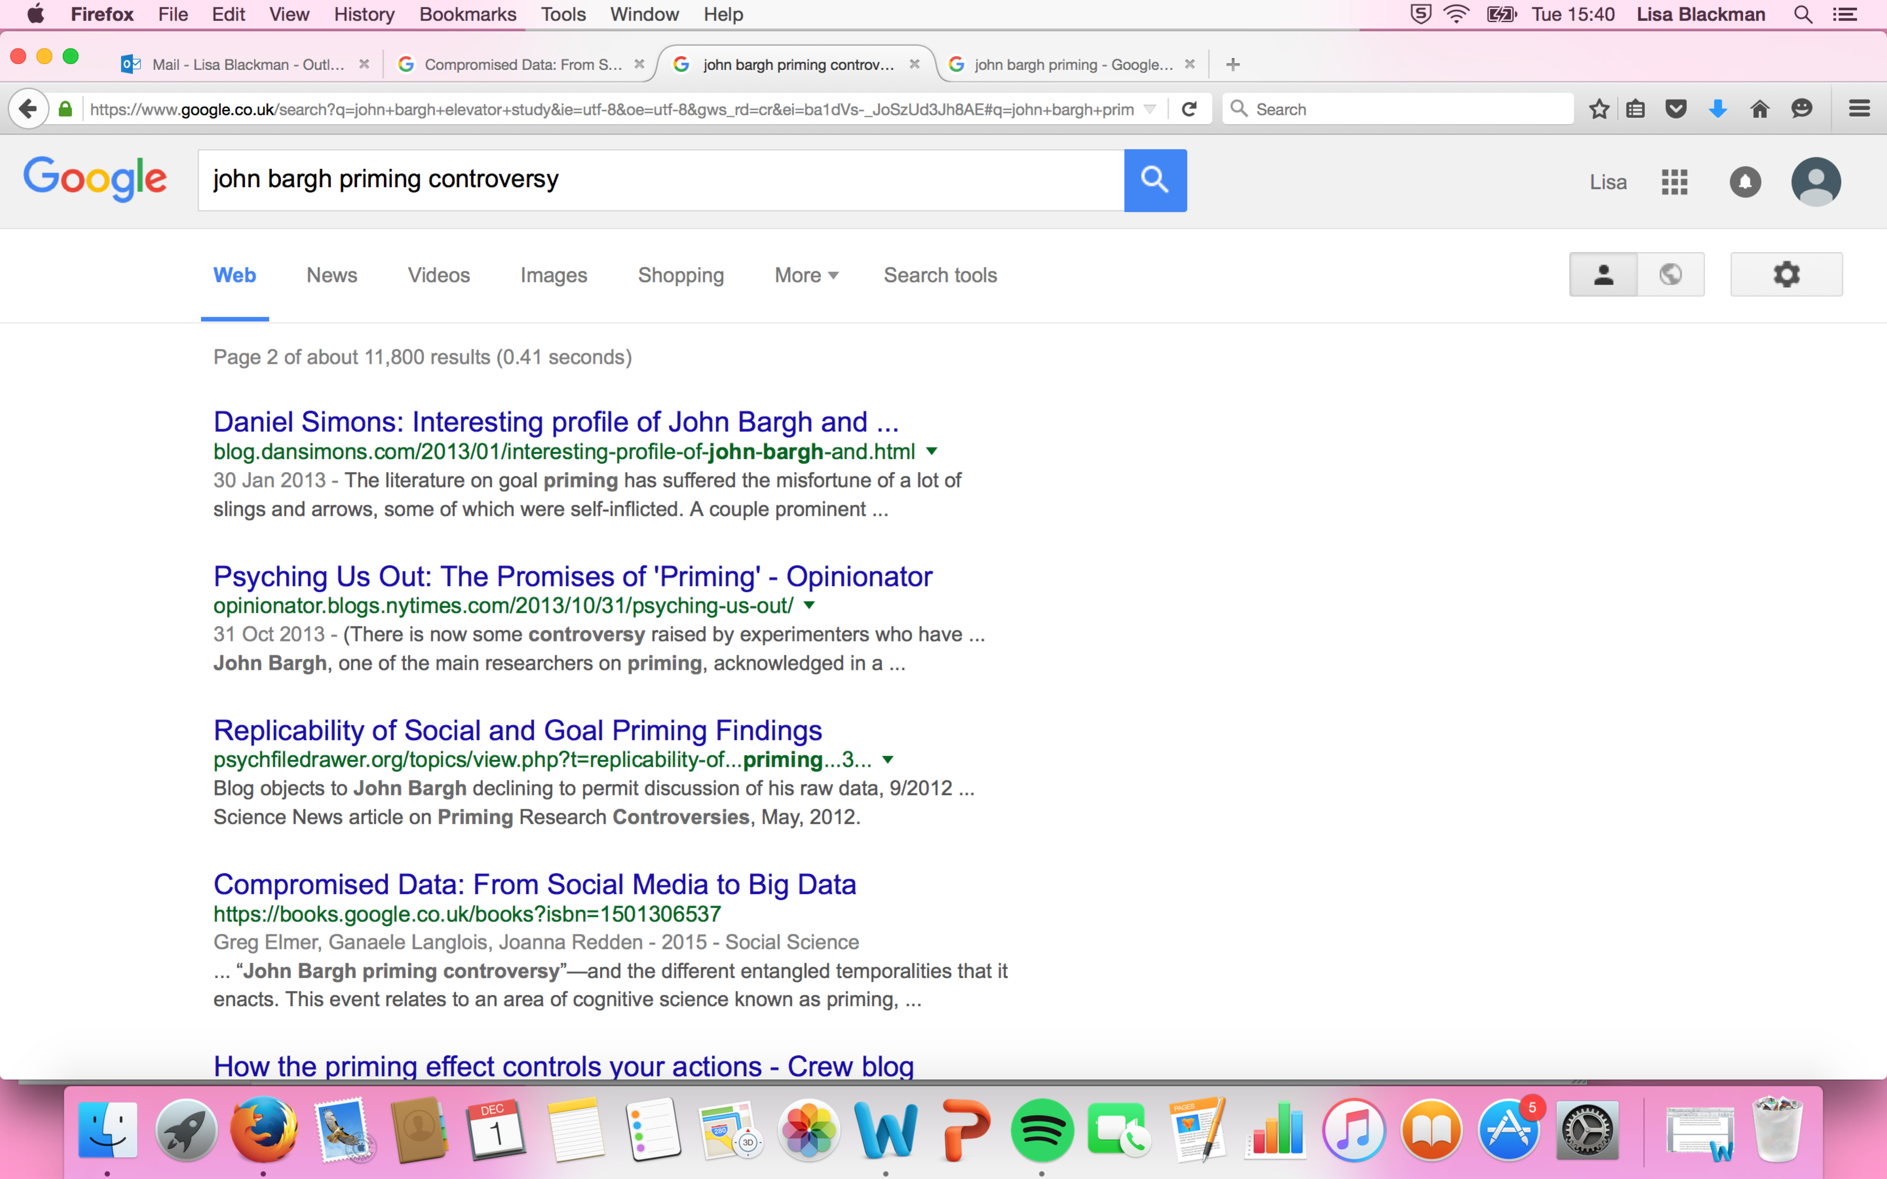
Figure 2.
And on the same page, further down now appears a chapter I wrote for a book edited by Knudsen and Stage (2015), in their already cited collection Affective Methodologies. In the chapter I contributed to the book I also briefly mention the John Bargh priming controversy (see Blackman, 2015). This more-than-one event now extends and makes links to a vibrant Danish context of research and to a symposium on ghostly hauntings, which inspired this special issue of Ephemera on ghostly matters! (see Figure 3 below) It also shows how entering into a scene of entanglement can shape what comes to matter. However, despite the appearance of these publications on a google search, Bargh’s account remains number 1 on google page rank if you search for the controversy. His version of what this means for the field of priming endures. As I argue in Haunted Data, it is largely “business as usual” that continues, where the potential of “Clever Hans haunting” is closed down and disqualified, replaced with discussions of #conceptual replication and the importance of proliferating replication studies. This is despite the epistemic uncertainty surrounding the field of priming and how to conduct science within this area. This haunted potential opens to more speculative and inventive propositions regarding mimetic processes (as I explore in the book), and to the question of what it might mean to enter into suggestive relations with another, human and non-human.

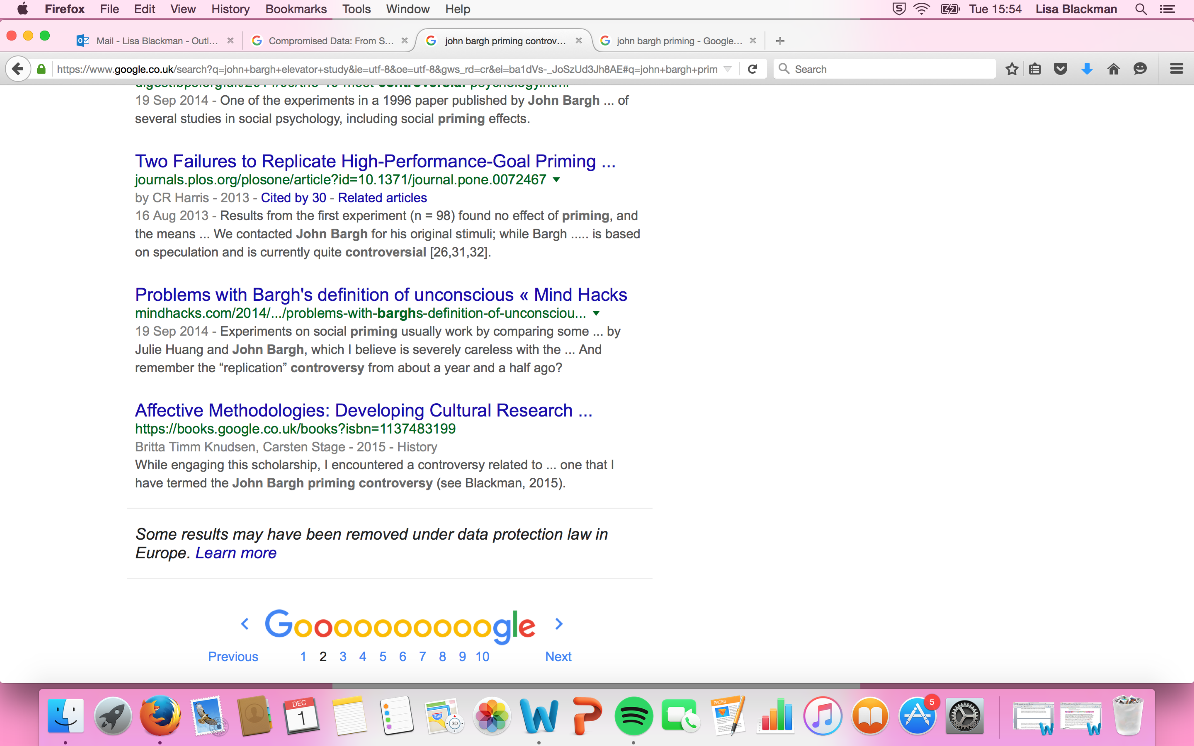
Figure 3

Conclusion

There is of course a lot more to say about this controversy including a possible discussion of the algorithms (specifically Google page Rank) that have allowed Bargh’s versions of events to largely dominate search engines. I have written about this elsewhere (see Blackman, 2016). In relation to the theme of this special issue I will conclude by drawing attention to the traces of the various labours - technical, symbolic and computational -; which Bargh or Bargh’s digital proxy have engaged in in order to try to repair Bargh’s on-line reputational economy. These digital traces have been transformed and translated into a more acceptable data double, which corresponds with his standing as a prestigious Yale cognitive scientist.

This is another way of saying that Bargh’s standing and his own networks of prestige, status and hierarchy have also entered into this particular scene of entanglement, allowing Bargh’s version of events to shape how this controversy is likely to endure and settle in the future. It is these relations of prestige, status and hierarchy that Google page Rank supports, amplifies and modulates, and illustrates the new forms of power that we encounter in digital environments. However, as I hope to have illustrated, as a strategy of research and intervention I have found a hauntological method really important and useful in helping to map what might be at stake in developing the concept of haunted data. By taking in this case a failed replication study in the context of post-publication-peer-review I have shown how the experiments travelled, and in their travels and curious forms of time reversal have accrued their own agencies. They have moved from the original scene of experimentation and become an actor within a mutable scene of entanglement. The experiments and the associated ghostly data trails open to multiple leads, criss-crossings, loopings, back-tracks, movings and re-movings.

As I tease apart the entangled relations set in motion by this controversy, we see how different temporalities and media times are knotted, spliced and enacted. In this respect I follow those traces, deferrals, absences, gaps and their movements within a particular corpus of data, and attempt to re-move and keep alive what becomes submerged or hidden by particular regimes of visibility and remembering. These movements are simultaneously technical, affective, historical, social, political and ethical and are distributed across a variety of social media platforms, actors, publics, agencies, bodies and practices. My own research now has the potential to enter into and change the scene of entanglement opening to those lost-futures, which haunt this controversy.

The research opens to some interesting more speculative propositions about the nature of behaviour change and management and to forms of behavioural economics, which are informed by the field of priming. It also discloses those hauntological forces that govern regimes of visibility and invisibility and remembering and forgetting. It illustrates the need for the creation and shaping of collective apparatuses and modes of storytelling, which might allow for new relations of association to take form and attract attention. It importantly helps to foreground the importance of attending to ghostly matters in the shaping and management of the organisation of scientific knowledge production, and the potential of hauntological analysis to those “truths” which shape specific digital archives. In the case of this specific scientific controversy it allows us perhaps to understand why Clever Hans really is a horse who won’t go away!

Bibliography

Ahmed, Sara (2010) The Promise of Happiness. Durham, MA: Duke University Press.

Ahmed, Sara (2014) Wilful Subjects. Durham, MA: Duke University Press.

Artaud, Antonio (1958) The Theatre and its Double. Grove Press.

Bolter, Jay, David and Grusin, Richard (2000) Remediation: Understanding New Media. Cambridge, MA and London: The MIT Press.

Blackman, Lisa (in press) Haunted Data: Transmedia, Affect, Weird Science and Archives of the Future. London and New York: Bloomsbury Press.

Blackman, Lisa (2016) ‘Social Media and the Politics of Small Data: Post Publication Peer Review and Academic Value’. Theory, Culture & Society, Volume 33(4): 3-26.

Blackman, Lisa (2015) ‘Researching Affect and Embodied Hauntologies: Exploring an Analytics of Experimentation’ in Knudsen Britta, T and Stage, Carsten, (2015) (eds). Affective Methodologies: Developing Cultural Research Strategies for the Study of Affect. Basingstoke and New York: Palgrave, Macmillan.

Blackman, Lisa (2014) ‘Immateriality, Affectivity, Experimentation: Queer Science and Future Psychology’. Transformations: Journal of Media and Culture: http://www.transformationsjournal.org/wp-content/uploads/2016/12/Blackman_Transformations25.pdf

Cho, Grace (2008) Haunting the Korean Diaspora: Shame, Secrecy, Silence and the Forgotten War. Minneapolis: University of Minnesota Press.

Chow, Rey (2012) Entanglements, or Transmedial Thinking about Capture. Durham, MA: Duke University Press.

Clough, P., Gregory, K., Haber, B., and Scannell, J., (2015) “The Datalogical Turn” in Phillip Vannini (2015) (eds) Non-Representational Methodologies: Re-envishioning Research. London and New York: Routledge.

Connolly, William (2002) Neuropolitics: Thinking, Culture, Speed. Minneapolis: University of Minnesota Press.

Damascio, Antonio (2000) The Feeling of What Happens: Body, Emotion and the Making of Consciousness. London: Vintage.

Davoine, Francis and Gaudilliere, J. M (2004) History Beyond Trauma. New York: Other Press.

Davoine, Francis (2007) ‘The Characters of Madness in the Talking Cure’. Psychoanalytic Dialogues, 17(5): 677-638.

Despret, Vincianne (2004) ‘The Body We Care For: Figures of anthropo-zoo-genesis’. Body & Society, Volume 10(2-3): 111-134.

Despet, Vincianne (2015) “Who Made Clever Hans Stupid”. Angelaki: Journal for the Theoretical Humanities, Volume 20(2): 77-85.

Derrida, Jacques (1995) ‘Archive Fever: A Freudian Impression’. Diacritics,
Vol. 25, No. 2: 9-63

Doyen S, Klein O, Pichon C-L, Cleeremans A (2012) Behavioral Priming: It's All in the Mind, but Whose Mind? PLoS ONE 7(1): e29081. doi:10.1371/journal.pone.0029081

Gladwell, Malcolm (2005) Blink: The Power of Thinking Without Thinking. London and New York: Penguin.

Gordon, Avery (2008) Ghostly Matters: Haunting the Sociological Imagination. Minneapolis: University of Minnesota Press.

Gutting, Gary (2015) What Philosophy Can Do, London and New York: W. W. Norton & Company.

Heinzen, Tom, Lilienfeld, Scott and Nolan, Susan (2014) The Horse that Won’t Go Away. Basingstoke and New York: Worth Publishers/Palgrave Macmillan.

Hunter, J. (2012). “Post-Publication Peer Review: Opening Up Scientific Conversation”. Frontiers in Computational Neuroscience, 6, 63. http://doi.org/10.3389/fncom.2012.00063

Johnstone, John (1999) ‘Machinic Vision’. Critical Inquiry, 26: 27-48.

Kalogeras, Stavroula (2014) Transmedia Storytelling and the New Era of Media Convergence in Higher Education. Basingstoke and New York: Palgrave, Macmillan.

Knudsen Britta, T and Stage, Carsten, (2015) (eds). Affective Methodologies: Developing Cultural Research Strategies for the Study of Affect. Basingstoke and New York: Palgrave, Macmillan.

Pfungst, Oskar (2010) Clever Hans (The horse of Mr. Von Osten): A contribution to experimental animal and human psychology. http://www.gutenberg.org/files/33936/33936-h/33936-h.htm

Rheinberger, Hans.-Jorg, (1994) Experimental systems: Historiality, narration and deconstruction. Science in Context 7 (1): 65–81.

Taylor, Richard, H and Sunstein, Cass, R (2009) Nudge: Improving Decisions About Wealth, Health and Happiness. London and New York: Penguin.

Venturini, Thomas (2012) ‘Building on faults: how to represent controversies with digital methods’. Public Understanding of Science. Volume 21(7): 796-812.

Walkerdine, Valerie and Jimenez, Luis, (2012) Gender, Work and Community after De-Industrialization: A Psychosocial Approach to Affect. Basingstoke and New York: Palgrave, Macmillan.

In an interesting article by Jane Hunter (2012) published in Frontiers in Computational Neuroscience, the evolutionary scientist Lynn Margulis is presented as one scientist who did not benefit from conventional practices of peer review. As the article recounts, despite going on to invent the ground breaking endosymbiotic theory, one of the most important articles outlining this theory was rejected from over 15 journals before it was eventually published. Margulis was considered by many scientists to be a rebel and a maverick andwas continually embroiled in controversy https://en.wikipedia.org/wiki/Lynn_Margulis This example of scientific gatekeeping and exclusion is used by Hunter to argue for the importance of new forms of post-publication-peer-review, including what is known as the F1000 publishing platform, which in Hunter’s words “take openness to the next level”.
this is a quote from http://athinklab.com/transmedia-storytelling/what-is-transmedia-storytelling/
http://www.bfi.org.uk/news/review-john-akomfrah-s-hauntologies
The Stuart Hall Project http://www.bfi.org.uk/news-opinion/news-bfi/interviews/stuart-hall-project-john-akomfrah-interview
http://www.ghosthostings.co.uk
www.stasis73.com
Clough et al frame big data as the “performative celebration of capital’s queer captures and modulations”. The queerness of such queer capture and modulation is aligned in the reach of big data beyond number to the incalculable. Haunted Data engages in a different form of “queer capture” and modulation, which attends to those “queer aggregations” which are present in a corpus of data associated with post-publication-peer-review, but which are discarded from attempts to “storify” or modulate the data within specific algorithmic and computational practices, including the Google PageRank algorithm, for example.
https://en.wikipedia.org/wiki/Mapping_controversies
https://www.youtube.com/watch?v=ZAlTlx8lmlQ https://www.youtube.com/watch?v=vI0fFEffDd8
http://journals.plos.org/plosone/article?id=10.1371/journal.pone.0029081
http://blogs.discovermagazine.com/notrocketscience/2012/03/10/failed-replication-bargh-psychology-study-doyen/#.WLl1uhBZrqU
The Horse that Won’t Go Away is the title of a book analysing the endurance of Clever Hans written by three psychologists Tom Heinzen, Scott Lilienfeld, and Susan Nolan (2014). They argue that Clever Hans is an example of a mass delusion showing how even supposedly rational scientists can be fooled. This is a typical example of the psychologist taking up the role of adjudicator and judge closing down on more speculative and inventive propositions (also see Despret, 2015).

