Fictioning the Landscape

For Mark Fisher

Simon O’Sullivan
Goldsmiths College, University of London

The landscape has ceased to be a backdrop for something else to happen in front of; instead, everything that happens is a part of the landscape. There is no longer a sharp distinction between foreground and background.
Brian Eno, On Land (quoted in Mark Fisher, The Weird and the Eerie)

Introduction

In this brief article, I want to look at a particular form of what David Burrows and I call fictioning when this names, in part, the deliberate imbrication of an apparent reality with other narratives. The form I have in mind is what has become known as the film-essay, or what Stewart Home calls, in his foreword to the third of my examples below, the ‘docufiction’ (Home 2011: 3). The latter operates on a porous border between fact and fiction, but also, in the particular articulation I am concerned with, between fiction and theory and, at times, the personal and political. It is an increasingly popular genre in contemporary art practice. In what follows, I will be especially concerned with how the docufiction can involve a presentation of landscape, broadly construed, alongside the instantiation of a complex and layered temporality which itself involves the foregrounding of different pasts and possible futures. Fictioning also refers to the way in which these other space-times need to be performed in some way, for example with a journey through or to some other place as in a pilgrimage.

The Robinson Trilogy

With Patrick Keiller’s London (1994), the first in a trilogy of films involving the invented character of Robinson, we are presented with a fictioning of that city that operates through the overlaying of a fiction on found footage. The film is a case study of mythopoesis – a veritable making-mythic of the urban landscape – as, for example, in the reimagining of the iconic Post Office Tower as monument to Rimbaud and Verlaine, or in the fantastical account of the still existing London Stone, located on Cannon Street in the City, as involved in a foundational myth of the city. The narrative itself involves a drift – or dérive – around different districts (and, as such, is very much in the tradition of the psychogeography of the Situationists), but the film is also a sustained meditation on the state of Britain in the early 1990s and, especially, the political situation. Indeed the two – the personal and the political – are entwined in this already entwined reality-fiction. It is as if the very fiction of Robinson allows for a more pointed reflection on our political reality. The fiction – like the walk itself – offers a specifically different perspective on the real.
There is also a further entwining of different times in the film, with Robinson intent on reading the city so as to remember and understand its different pasts (there are resonances here with Freud’s take on a city that is haunted by the ruins of its pasts; see Freud 2002) but also as a method of divining its possible futures. As Robinson remarks (in the narrator’s account), his walks are an attempt at time-travel, but we might also say that it is through fiction more generally that these time loops are able to operate. London also introduces the important concept and tradition of Romanticism which, as the narrator suggests, involves a particular ‘mode of feeling.’ This is to see one’s life from outside, as a Romance. It seems to me that a certain kind of nomadism, even if it is stationary, is important for producing this perspective. Romanticism denotes a capacity to see life as itself a fiction and, as such, to open up the possibility of shifting perspectives. It is this shift that constitutes the interest of the film over and above its manifest content about the city: it offers up, we might say, a method of sorts for seeing the workings of a certain reality effect.
Robinson in Space (1997), the second in the trilogy, takes Robinson’s enquiry out of the capital city to the town of Reading where Robinson now lives, and then on to the rest of the country – and into what the narrator calls the ‘problem of England’ more generally. As with London, the enquiry is also into capitalism, albeit here it is of a later, more international form, as evidenced by the container ports, distribution centres and foreign car manufacturers which Robinson and the narrator visit. One of the key aspects of this second film is the disjunction between this globalisation (and especially the impact it has had on manufacturing) and a more parochial, insular England (an especially prescient disjunction today with Brexit). But the film also traces the connections between these two, for example with Oxbridge and how this throwback to the past has always produced our political elite, and now often educates our new economic masters.
The fiction of Robinson continues in this film with a reading of the past and future of the British landscape. In terms of the past, there are references to the Levellers and Diggers, but also, at certain moments, the narrative stops and we are presented with certain images – of chalk hill figures, for example – accompanied only by birdsong or, simply, silence. These pre-industrial remnants are not commented on, but are simply presented – quietly – as different. They offer something residual – to use a term from Raymond Williams – to what the film also presents as a banal present of supermarkets and motorway hotels. Indeed, the film ends with an enigmatic sequence of images of Neolithic rock carvings that appear almost alien (again, simply accompanied by birdsong). In terms of the future, the film tracks the massive changes going on in the built superstructure and resonates with a writer such as J. G. Ballard in the attention given to the new non-places that accompany our motorways and container ports. But there are also other, more Science Fiction, references to ‘buckminsterfulleremes’ and to Mars, as well as to other non-human modes of existence – a strange close-up of frogspawn, for example – that are spliced in to an otherwise relatively straightforward narrative.
Fiction, then, is a resource: in fact, the whole narrative structure of the film – with its seven pilgrimages – is loosely based on Defoe’s own journeys in England; but also a method: the spoken narrative and editing of shots fictions the landscape, giving certain features a significance (the signs to a Toyota factory, for example, suddenly become pregnant with meaning and myth). As with London there are also references to other works that blur the fiction/reality boundary, for example Richard Jeffries’ own post-apocalyptic After London (1980) – written a century before Keiller’s film – the first section of which reads more like reportage than fiction. There is a sense, more generally, that like the past, these different fictions might also offer an alternative to our capitalist present. In fact, this fictioning of the landscape dovetails with a certain comic aspect of the film, which is produced by a set of disjunctions between Tesco cafes and the detail of car models – the stuff of everyday Capitalist Realism, to use Mark Fisher’s phrase (Fisher 2009) – with other narratives and more sacred spaces and places. The comic operates here, it seems to me, to foreground fiction as method.
Robinson in Ruins (2010), the third and final film of the series, is more serious, and again involves a reading of the landscape in terms of its hidden present and pasts. In terms of the former the film focuses on the military-industrial complex, and especially oil and the nuclear – and with that the various bases (now abandoned) and filling stations of an occupying US military. The film also looks to the various popular protests against this, for example at Greenham Common, where the camera reveals a reclaimed base that now resembles a pre-industrial monument. A second theme is the banking crisis. Here, the juxtaposition of an account of haemorrhaging markets and diving share prices contrasts with the peaceful scenes of pastoral England. A third theme is agriculture, its importance to the UK economy, but also its increasing mechanisation (much of the film records the harvest process). This particular disjunction of the industrial and mechanised against the natural and organic produces some of the most memorable sequences – for example, the slow, deliberate progress of a combine harvester across a field, or a container train rushing through an idyllic river scene.
As with the other films it is often the pre-industrial residues in the landscape that the camera seeks out; the ancient Ridgeway of Southern England, for example. In terms of this focus on the past, further crucial events in English history (and its landscape) are looked to. Central here is the enclosures act and how this instigation of private property dramatically changed the face of England. The film tells the story of the protests against this, but also the subsequent crackdown by the state. Robinson in Ruins recovers a different history in this sense, one often occluded by more typical state narratives. In this there is a kind of utopianism – as also evidenced by the mention of the ‘Land of Cockaigne’ (a medieval utopia) – a look to the past that then becomes a looping forward to Robinson’s own longings for a new city to be built on the banks of the river Charwell (inspired by his sighting of the ruins of a disused concrete factory). In fact, the future implied by the film, although hopeful, is also haunted by a certain melancholy and, indeed, the threat of extinction.

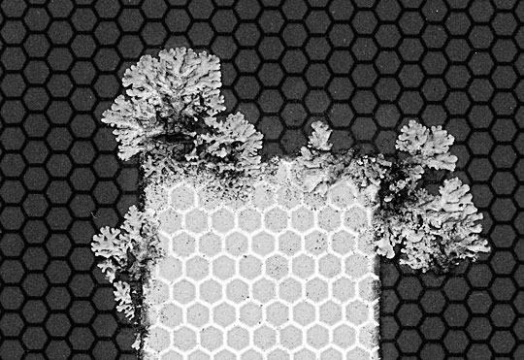
Fig. 1 Publicity shot for Robinson in Ruins (courtesy of Patrick Keiller)

Throughout this last film the fiction of Robinson is maintained, albeit now it is a mysterious Research Institute that has reconstructed his journey, having found a notebook and film canisters in an old caravan. As with the previous two films, Robinson in Ruins still works through overlaying a narrative on the film footage, but, as well as references to the past and present, here, it is especially the Science Fiction themes that predominate and are most compelling. There is, for example, the recurring idea of a meteorite arriving from space, and with that the presence of something different, something from outside human influence or production (and which, possibly, brought life with it). The film also begins with the idea that there is a ‘network of non-human intelligence’ intent on maintaining survival on the planet. As the film progresses, it becomes clear that this is our own plant life – or, rather, our complex organic ecosystem with its molecular events and encounters (evolutionary biologist Lynn Margulis is quoted). In relation to this the camera, at times, lingers on just a flower, or the lichen of a road sign (see Fig. 1). The soundtrack, too, foregrounds and fictions the non-human, especially, again, with birdsong. It is as if a different mode of feeling – or, in this context, a structure of feeling (to use another term from Raymond Williams) – is being fictioned by the film and, with that, also an attempt at the presentation of other non-human worlds. The latter have often been occluded by human arrogance and invention but, paradoxically, here it is the technical apparatus of film itself, with its different speeds and slownesses, alongside different images and registers, that enables this speculative and mythopoetic fictioning of the landscape.

On Vanishing Land and Hidden Valleys

The cultural critic Mark Fisher has written on the Robinson films as an example of what he calls the ‘English Pastoral’, but he has also produced – with the writer Justin Barton – his own docufictions, including On Vanishing Land (2013). This audio dérive along the Suffolk coast (which, in its presentation at the Showroom Gallery in London also included a showreel of images; Fig. 2 is an example) is itself a fictioning of a very particular landscape (the walk goes from the container port of Folkestone to Sutton Hoo), but is also a case study of the genre of the eerie: “understood primarily as an awareness – however fugitive it might be – of unknown forces that could be either positive or negative, and that are both ‘out of sight’ around you, and could perhaps in some sense be stalking you, or moving closer to you.” On Vanishing Land was, in part, inspired by Brian Eno’s recording Ambient IV: On Land (1982) and Eno’s particular take on the landscape and its sometimes strange temporalities. The other key resource are the modernist ghost stories of M. R. James, themselves a key progenitor of the modern genre of the eerie.

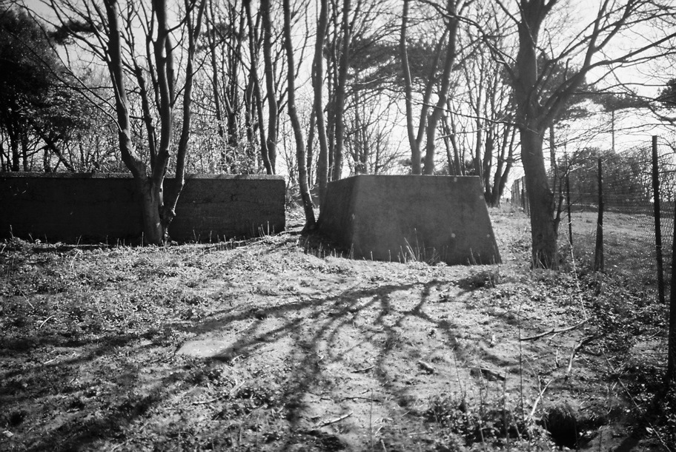
Fig. 2 Image from the showreel accompanying On Vanishing Land (image credit: Mark Fisher, courtesy of Justin Barton)

At play in On Vanishing Land is a sense of haunting and, more generally, an idea of the landscape as composed of different times and, indeed, presences. On the website for the work, Barton and Fisher quote Eno from the On Land sleevenotes, where the musician suggests that “we feel affinities not only with the past, but also with the futures that didn’t materialize, and with the other variations of the present that we suspect run parallel to the one we have agreed to live in.” There is also an interest, here, in how the sonic can itself augment or double the physical landscape. The audio-essay includes various interviews alongside a narration by Barton (reflecting on the geography and history they are walking through) and a reading by Fisher (from M. R. James), but also commissioned electronic music from artists including John Foxx and Gazelle Twin, all of which, cumulatively, produce a very particular structure of feeling, to use Williams’s term once again.
In his book The Weird and the Eerie, Fisher argues that the eerie, beyond being a literary genre (again, one notably associated with, M. R. James) can also be thought of as a mode of being. It is characterised, Fisher explains, by a fascination with both the non-human and the forces of the outside; and, as such, the eerie might "give us access to spaces beyond mundane reality.” In the terms of Fisher’s previous book, perhaps we might even suggest that the eerie works as antidote to Capitalist Realism? But, as Fisher suggests, the eerie is also a particularly philosophically orientated genre of fiction – especially in relation to more recent ‘speculative’ trends in the continental tradition. Indeed, fiction can operate as a kind of forward probe of this conceptual work.
There are also connections here to what has been called the genre of the ‘New Weird,’ with writers such as China Miéville and Jeff VanderMeer (themselves following figures like H. P. Lovecraft and M. R. James). Again, Fisher has tracked through aspects of this genre in his book (and demarcated it from its close cousin of the eerie). We might also note the connections of this genre (or mode) with a more particular kind of theory-fiction that attends to the darker (and bleaker) side of existence, and which has a more acute connection with recent speculative philosophy insofar as both explore an outside to typical human experience and, indeed, a world of non-human beings.

Barton’s own mythopoetic theory-fiction, Hidden Valleys (2015), from where the above quote about the eerie is taken, itself involves a reading of the landscape as inhabited by multiple durations and, indeed, other modes of non-human existence. It also has an overriding interest in the forces of the outside (or what are called in On Vanishing Land ‘planetary thresholds of the Unknown’). Hidden Valleys is written in the tradition of the confession – as a kind of philosophical-biography – that is also a more general account of a very particular space-time: the North York Moors and adolescence. Fiction is used as resource (women writers such as Emilie Brontë, Virginia Woolf and Angela Carter are especially important), but also, again, as method – as, for example, in the book’s particular narrative form, but also in the importance placed on dreams and dreaming as philosophical resources (alongside other experiments in altered consciousness, and, indeed, that other work of theory-fiction, Gilles Deleuze and Felix Guattari’s A Thousand Plateaus).
Hidden Valleys is also directly concerned with the landscape and how this external terrain forms our internal world. It successfully conveys a particular affective scene or, again, a structure of feeling (not unlike that produced by M. John Harrison or Christopher Priest, whom Fisher also discusses in relation to the eerie). Barton’s book is also concerned with a kind of layered temporality and, especially, with a haunting of other future pasts (those futures that were promised, but never came about) as well as the conjunction of ancientism with what the author calls a sci-fi modernism. As with Keiller, a kind of fictioning of reality (here, also including the author’s biography) allows an exploration of these different temporalities. In particular, Barton’s book and the On Vanishing Land audio-essay develop the idea of an inorganic sentience that, as we saw, is also at play, especially in the last of the Robinson films.
A further key conceptual intention of Hidden Valleys – and something that is also present in On Vanishing Land – is the development of an idea of lucidity, which is pitched against reactive thought and, indeed, against any over-emphasis on rationality (what Barton – in an echo of William Burroughs – calls ‘the control mind’). Lucidity is an ‘abstract oneiric system’ that involves the identification of ‘intent-currents’ that are outside – or, at least, at the very edge – of typical human understanding. Again, in accessing this, dreaming, but also drug use, is seen as crucial. There is something reminiscent of Carlos Casteneda here (who is quoted in Hidden Valleys), but also, once more, an affinity with Ballard. Indeed, it seems to me that in laying out this other, alternative mode of being in the world – especially against the dominant techno-scientific model – Barton is writing a kind of mythopoesis that is both radically untimely and also appropriate and adequate to our time of ecological threat.

Voodoo Science Park

My third case study of a fictioning of the landscape is Voodoo Science Park (2011), an audio-visual docufiction (and, later, a book) by Victoria Halford and Steve Beard that resulted from a residency at the Government ‘Health and Safety Laboratory’ in the Peak District (2011). As with the Keiller films, Voodoo Science Park involves an invented narrative laid over found footage – from the site where large-scale industrial accidents are investigated – which effectively and convincingly fictions that particular archive (most of the film is sourced from the Lab’s own collection), drawing in various historical figures, militants and visionaries. If On Vanishing Land resonates with the non-human aspects of the Robinson films, then Voodoo Science Park resonates with the more overtly political and dissident ones. The narrative – told by Blakey (in a reference to William Blake), the last of the Church of Albion – is somehow a more telling and accurate account of what seems to be going on in the archive film than any more factual or scientific account might be. It speaks of Thomas Hobbes and the birth of the Leviathan and the on-going war against Magog, God of chaos and disorder, but also how this war might be understood as a war of liberation – of the forces of freedom, or, simply, the multitude – from the British State. As with the Robinson films, it is fiction that allows a more pointed meditation on politics.
There are then two kinds of resistance at play in Voodoo Science Park, one related to content, the other to form. First then, there is the emphasis on an on-going uprising against the state, which itself involves identifying historical precedents and, in general, the mapping out of a kind of political dissident unconscious of the Peak District. Second there is the setting out of a form of fictioning – a counter-mythology as Home calls it (Home 2011: 5) – against the dominant symbolic order and reality produced by the state (what we might call the narrative form of science and ‘objectivity’). There is a kind of counter-factual paranoid method to the film in this sense, insofar as it suggests a different account of what’s really going on; an alternative script as it were. Indeed, as Burroughs once remarked, what else is any given reality than a particular kind of script?
Landscape is also key here, not just in the opening and closing shots of travel by train to and from the Lab across the moorland (see Fig. 3), but in the subsequent seven locations that are fictioned as where Leviathan gathered clay to build his golems. The seven locations are based on a poem by Hobbes – ‘The Wonders of the Peak’ – written for his land-owning paymasters. In the film there is, then, this overlaying of an older cartography on the modern, just as the modern itself involved an overlay of the industrial on the pre-industrial landscape. One is reminded, as with the Robinson films, of the Situationist practice of psychogeography. It seems to me that it is this complexity – the layering of different times and, indeed, a layering of different fictions – that gives the film its particular structure of feeling (to use this term one last time).

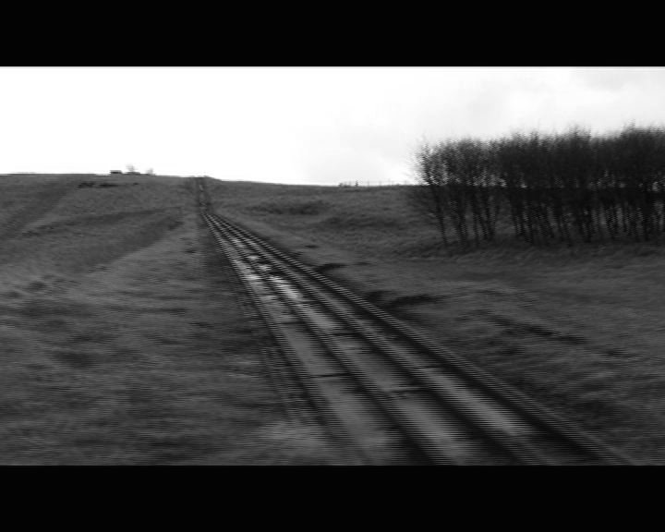
Fig. 3 Still from Voodoo Science Park (courtesy of Steve Beard)

Steve Beard is himself a Science Fiction writer, but in the collaboration with Halford there is this move from fiction to a fictioning of the real: all the footage is, as it were, accurate and factual. It is the narrative – the words spoken over the images – that produce the fictioning; or, more accurately, it is the conjunction – and disjunction – of sound and image. The film also has a very particular affective charge that comes from the editing and the cuts and changes in speed (there is an especially compelling sequence when a test train is released and the cables whirl and snap in slow motion like the tentacles of some giant land kraken). What might be called, following Fisher, this eerie affect is also produced by the soundtrack to the film by the sound artist Scanner. Overall, Voodoo Science Park, it seems to me, is a highly complex and convincing work that is a paradigmatic case study of a fictioning of the landscape.
The book of the film contains the script, but also research notes about the artists’ residency at the Lab. In these notes Halford and Beard refer to Walter Benjamin’s idea that flashes of illumination can occur with politicisation (or “direct encounters with the repressive power of the state”). Such flashes reveal a counter-history that in itself allows connections to be made through time, in this case the trespassing of the ramblers with the protests against the enclosures act and, indeed, a more general and “secret history of popular sedition, buried in the folklore of Dick Turpin and Robin Hood, Queen Mab and the Green Man.” Benjamin’s account of these illuminations – that no doubt he himself experienced in his own encounters with fascism – are not so far from the visions of Blake, but we might also note that such a secret history is itself a fictioning, one that binds and then deploys a different archive against the consensual.
The title of the film and book also refers to a further pre-modern modality: voodoo (and, in this sense, Voodoo Science Park looks back to another precursor of this genre of docufiction: the films of Maya Deren). In the notes, a history is given of the caves and Neolithic shamans of the Peak district, who were involved, especially with their cave paintings of hunted animals, in a sympathetic magic, and were themselves connected to the more recent practice of miners making offerings to the ‘tommyknockers’ who also lived in the underworld. The Labs’ work of accident investigation is also portrayed as itself a form of sympathetic magic where like affects like, and microcosm mirrors macrocosm. Indeed, the Lab is portrayed as the tip of a larger industrial – and state – assemblage and, as such, the tests experiments are also seen as forms of a darker pre-emptive (or homeopathic) magic. But accidents are also a form of trauma and there is a sense in which the making of the film is a way of dealing with the trauma of industrial accidents, not least in its introduction of a more human story, however mythic this might be, into the cold world of tests and statistics.
In the notes, a compelling argument is also made that the Lab’s real purpose is narrative, and the production of a story to fill the gap left in consensual reality by any given accident. The book also makes the intriguing connection between sympathetic magic – and action over a distance – with quantum mechanics: “when two particles are subject to quantum entanglement, then they remain linked even when separated in space.” In fact, Halford and Beard also suggest this can also involve a form of time-travel, as in the sub-atomic particle called the “tachyon" that, it is claimed, can return to the past. The actual work of the Lab – its imitative and pre-emptive research – might then itself be understood as involving a kind of mythopoesis, operating through its own temporal looping from the present to both the past and future. Indeed, it is worth noting here that fictioning can be employed by the state, just as it can be pitched against it.

The Otolith Trilogy

My final example of docufiction moves away from a direct concern with the English landscape (and its attendant subjectivities), to something more postcolonial. It also continues and extends some of the more Science Fiction themes I have already discussed. The film-essays of The Otolith Group – the collective formed by Kodwo Eshun and Anjalika Sagar – often involve a particular take on memory, especially when this is connected to other – and different – futures. In terms of this fictioning of archives – as a counter to other, more dominant histories – and, indeed, the more general layering of a complex temporality, the Otolith trilogy (2003–9) contains many of the tropes and methods used throughout their practice. In these films, fiction is, once again, both content and method: in terms of the former, the films bring together different fictions – as well as inbricating the personal and political – in order to explore various past-potential futures. Otolith 1 (2003), for example, involves a narrative about Sagar’s grandmother meeting the first woman cosmonaut in India and the hopes of a communist Indian space programme, but it also narrates Sagar’s own trip to Star City in Russia to experience micro-gravity (see Fig. 4) – all alongside footage of the London anti-war demonstration of 2003. In terms of method, it is the montaging of imagery and sound, but also the invented Science Fiction narrative of the film – told from the perspective of one of Sagar’s space-dwelling descendants (who reads Sagar’s diary) – which works to hold the film and give the diverse elements a consistency. There is a political aspect and efficacy to the instantiation of these very particular space-times – feedback loops from the past and future – insofar as they operate as resource and archive for other subjectivities in the present. There are also other, more directly mythic elements such as referring to the nuclear Manhattan Project as a ‘return of the old gods’ (in a reference, no doubt, to The Watchmen) or, indeed, in the very idea explored in the film of a future mutation of the human.

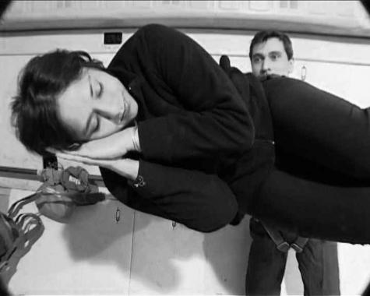
Fig. 4 Still from Otolith 1 (courtesy of The Otolith Group).

The second film in the Otolith trilogy (2007) continues the fictional narrative from Sagar’s ancestor (in the form of letters), bringing this into conjunction with various images of labour from modern India and other places (the references to the artist and film maker Harun Farocki are especially pronounced in this second film). Once again there is the interest in hybrid temporalities, for example juxtaposing Modernism’s architectural promise, as made manifest in Corbusier’s Chandigarh, with existing slums in Mumbai. There is also an explicit interest in fictioning, here most obvious in the sustained focus on film city in Mumbai, where old textile mills have been repurposed as film studios and where we witness the building/dismantling of a set based on London. With the above this film also evidences an interest in the nesting of fictions and, indeed, in the revealing of the apparatus of making fictions. More generally, there is an emphasis on different locations referencing one another but also of other times haunting the present. The shuttling across temporal and spatial zones also relates to the way this film, as well as concerning various relations between communism, feminism and activism, refers to other fictions – Tarkovsky’s Stalker for example (a kind of future-pre-cursor to existing post-industrial spaces), but also Ballard, whose take on architecture is brought to bear on Corbusier.
The third film of the trilogy (2009) is somewhat different, involving as it does a meditation on Satyajit Ray’s un-made movie The Alien. In this film the characters – who are situated in a kind of non-space – meditate on their relation to one another and, indeed, their existence as alienated images who dream of being projected. At one point they also refer to themselves as scripts waiting actualisation. Here fiction is a method for reflection on memory and the future, but also, more generally, for an enquiry in to the nature of fiction itself – as in the search for real people who might play the characters or, indeed, in relation to some of the other real people involved in the intended narrative, for example the Science Fiction writer Arthur C. Clarke. There are further scenes which reference the pre-production of fiction, for example when the camera tracks across a kind of laid out archive containing Science Fiction comic strips, images of altered landscapes and such like. As with the other films of the trilogy, there is also a nesting of fictions at work – in this case an encircling of Ray’s unrealised movie in the The Otolith Group’s own film. This recursive setup – of fictions within fictions – can operate to question the ‘truth’ of our own reality (as simply one more fiction).
The Otolith Group involves collective film-making but also curating and the organization of other events, many of which contain Science Fiction themes and methodologies. This collective character, operating, precisely, as a group, works to disrupt the dominant artistic fiction of the self-possessed individual (something similar might be said of the other collaborations above). Indeed, The Otolith Group exist as much through the conversations they have between themselves and others – constituting a certain scene – as through their artistic output. But the Group, as well as performing different fictions, are themselves, partly fictioned. The nesting and looping of fictions is continuous, we might say, from artwork to the life of the Group. Indeed, it is when the recursive set-ups of fictioning also includes the artists themselves that we begin to see how radical fictioning practices can be in both undermining dominant realities (such as the fiction of the self), but also performing new ones.
In conclusion, then, it seems to me that the above works do indeed constitute a genre of sorts. They are examples of the film-essay – or, again, the docufiction – which moves between fiction and fact, but, more specifically in this case, involves a fictioning of the landscape through spoken narrative and a kind of layering of temporalities – other pasts and futures – alongside an attention to other more non-human durations. Fictioning itself is a larger category and includes other works that more explicitly perform or materialise fictions within the real. This is the subject matter of the larger work mentioned in the first footnote to this article which the artist and writer David Burrows and myself are collaborating on. What is worth saying here, however, is that the instantiation of fictions –whatever form this takes – might have more than just an aesthetic function today. Indeed, it seems to me that in our post-fact and post-truth world it is crucial not only to counteract the fictions and myths presented to us but to also to produce other, and better ones by which to orientate ourselves within our world.

Notes
References

Barton, Justin. Hidden Valleys: Haunted by the Future. Winchester: Zero Books
2015.
Barton, Justin and Mark Fisher. On Vanishing Land, first shown at Showroom
Gallery, London, 2013.
Burrows, David and Simon O’Sullivan. Fictioning: Mythopoesis, Myth-Science,
Mythotechnesis. Edinbrugh: Edinbrugh University Press, 2019.
Demos, T.J.. “The Right to Opacity: The Otolith Group’s Nervus Rerum.” October 129 (2009): 113–128.
Fisher, Mark. Capitalist Realism: Is There no Alternative? London: Zero, 2009.
—————. “English Pastoral,” Robinson in Ruins, booklet accompanying DVD. London: BFI, 2009.
—————. The Weird and the Eerie. London: Repeater, 2016.
Freud, Sigmund. Civilization and its Discontents, translated by David McLintock. London: Penguin Classics, 2002[1929].
Halford, Victoria and Steve Beard. Voodoo Science Park. Winchester: Zero
Books, 2011.
Halford, Victoria and Steve Beard (dir.). Voodoo Science Park, 25 mins., 2011. https://vimeo.com/48746036 (accessed 6 March 2018).
Home, Stewart. “Foreword,” Victoria Halford and Steve Beard, Voodoo Science Park. Winchester: Zero Books, 3–5.
—————. Sixty-Nine Things to do with a Dead Princess. London: Canongate,
2002.
Jeffries, Richard. After London: Or, Wild England. Oxford Paperbacks, 1980[1885].
Keiller, Patrick (dir.). London, 82 mins., 1994. https://player.bfi.org.uk/ subscription/film/watch-london-1994-online (accessed 9 March 2018).
—————. Robinson in Space, 78 mins., 1997.
—————. Robinson in Ruins, 101 mins., 2010. https:// player.bfi.org.uk/rentals/film/watch-robinson-in-ruins-2010-online
(acessed 9 March 2018).
Keiller, Patrick. The Possibility of Life’s Survival on the Planet. London: Tate Publishing, 2012.
McFarlane, Robert. “The Eeriness of the English Countryside.” Guardian, 10 April, 2015. https://www.theguardian.com/books/2015/apr/10/eeriness-english-countryside-robert-macfarlane (accessed 30 January 2018).
O’Sullivan, Simon. “Mythopoesis or Fiction as Mode of Existence: Three Case Studies from Contemporary Art.” Visual Culture in Britain 18.2 (2017): 292-311.
O’Sullivan, Simon. "Myth-Science as Residual Culture and Magical Thinking, Postmedieval,” 2018 (forthcoming.).
The Otolith Group (dir.) (2003), Otolith 1, 22 mins. 25 secs., 2013.
Extract available at: http:// www.youtube.com/watch?v=P3Btba88cxU
(accessed 9 March 2018).
—————. Otolith 2, 47 mins. 42 secs., 2007.
—————. Otolith 3, 48 mins., 2009. Extract available at:
http://otolithgroup.org/index.php?m=project&id=7 (accessed 9 March
2018).
The Otolith Group. A Long Time Between Suns. Edited by A. Colin and E. Pethick. Berlin: Sternberg Press, 2009.
The Otolith Group, 2017. http://www.otolithgroup.org (accessed 30 January
2018).
Sebald, W. G.. Rings of Saturn. New York: New Directions books, 1998.
Williams, Raymond. “Base and Superstructure in Marxist Cultural Theory.” Problems in Materialism and Culture: Selected Essays. London: Verso, 1980. 31–49.
—————. “Structure of Feeling.” Marxism and Literature. Oxford: Oxford
University Press, 1080. 128–35.

What follows is part of a larger collaborative project with Burrows (Burrows and O’Sullivan 2018).
This aspect – the performance of a journey – has an important precursor in Derek Jarman’s film Journey to Avebury. Like my case studies that follow Jarmen’s film also focuses on the residual within the English landscape, in this case standing stones. For a further account of these themes see my two articles ‘Myth-Science as Residual Culture and Magical Thinking’ (O’Sullivan 2018), especially in relation to the survival of the past in the present; and ‘Fiction as Mode of Existence’ (O’Sullivan 2017), especially in relation to the performance of other space-times.
Keiller later developed some of the themes of the film as an installation – ‘The Robinson Institute’ – at Tate Britain in London, using objects and images from the collection alongside the film itself. As with Robinson in Space there was also a book (based on the film and installation), The Possibility of Life’s Survival on the Planet (Keiller 2012), which contained further research notes. The fictioning function of this last Robinson film is, we might say, specifically ‘multi-platform’.
Williams uses the term ‘residual’ to refer to those ‘left overs’ from a previous hegemony that might offer alternative and even oppositional cultures (opposition here naming the possibility of a challenge to the dominant culture). See Williams 1980.
See also Stewart Home’s Sixty-Nine Things to do with a Dead Princess (Home 2002). which also involves a certain deadpan reportage about the menus of Tesco cafes, alongside pornographic adventures amongst the standing stones of Aberdeenshire.
See Williams Marxism and Literature where structure of feeling is defined as a lived sensibility that is ‘emergent or pre-emergent’ (before ‘definition, classification or rationalisation’), but still with a defined structure (‘specific feelings, specific rhythms’) (Williams 1980: 132-3).
Fisher’s essay attends especially to Keiller’s politicisation of the landscape (and what Fisher calls the dialectic between capitalism and environment) but Fisher is also attuned to the Science Fiction nature of the film and especially its utopian exploration of non-human forms of life. Moreover, Fisher also makes the connection between the film’s themes with recent speculative philosophy, including that of Ray Brassier.
Justin Barton, Hidden Valleys: Haunted by the Future (Winchester: Zero Books, 2015), 13–14.
Mark Fisher, The Weird and the Eerie (London: Repeater, 2016), 13. It is also a mode that has been picked up on in more mainstream media, as, for example, with Robert McFarlane’s essay for The Guardian on ‘The Eeriness of the English Countryside’ (that, amongst a roll call of other writers, musicians, filmmakers and artists, also name-checks Keiller and Barton & Fisher) (McFarlane 2015).
The book contains the script, a Foreword by Stewart Home and a series of research notes about the project. It also contains black and white photos from the site and archive interspersed in the text, giving the volume the feel of another pre-cursor to the docu-fiction: W. G. Sebald’s travel writing, for example Rings of Saturn (1998).
Halford, Victoria and Steve Beard (Voodoo Science Park. Winchester: Zero Books, 2011), 14.
Ibid.,, 53.
Ibid., 69.
Ibid.
T. J. Demos also develops a particular concept of ‘fictionalization’ in his take on The Otolith Group’s films. In an article on Nevus Rerum, a film about the refugee camp of Jenin, Demos points out that not only is there a use of fiction as resource (in this case, Genet and Pessoa) but that there is also a refusal of the typical modus operandi of the documentary in terms of truth-telling (fictionalisation involves a ‘denial of a transparent reality’ in this sense) (122). Demos addresses this refusal of representation in relation to Glissant and a ‘cinema of opacity’ (127), but he also turns to Jacques Rancière for whom the term fiction relates to ‘forging’ as much as to ‘feigning’ – and, as such, is a term entirely suitable to a practice like documentary filmmaking (121).
In their particular method the films of The Otolith Group have precursors in the work of Chris Marker. Eshun has written about his own indebtedness to this auteur as well as to two other key precursors: the Black Audio Film Collective and Harun Farocki.
In relation to this there is the catalogue A Long Time Between Suns (The Otolith Group 2009) which records a series of such conversations and itself gathers a very particular archive of images (alongside other essays).

