Life and death at his fingertips: a profile of neurosurgeon Henry Marsh
New Statesman, 20 March, 2014
It is just after lunchtime on a wet Monday in February when Henry Marsh is finally able to return to the operating theatre in the Atkinson Morley Wing of St George’s Hospital in Tooting, south London, and begin the work that will save a young woman’s life.
Jenny is not long out of her teens; the previous week, she had collapsed – from a haemorrhage, the result of an abnormality in the veins and arteries of her brain. She had been close to death: late at night, Henry had operated to remove a blood clot and save her life. But a later scan showed that the abnormality remained. If the problem was not corrected, she could suffer another bleed at any time. So this will be the second time he has been inside her skull.
While Jenny is prepared, Henry paces the hospital’s long corridors. There is time for us to sit and have a sandwich. He is restless: he wants to get on. He didn’t get this right the first time. He needs to get it right now.
I first encountered Henry Marsh late one night on my sofa. I was too tired to go to bed, and so kept the television on as one programme ended and another started. This was The English Surgeon, a 2007 documentary by Geoffrey Smith about the work that Henry has been doing for over 20 years now at the Lipska Street Hospital in Kyiv, Ukraine. Following a meeting with Igor Kurilets, a Ukrainian neurosurgeon struggling against the post-Soviet culture of poor resources and entrenched, old-fashioned thinking about medical care, Henry began volunteering his time in Kyiv. He brought not only his skills but equipment that had been discarded – generally for no good reason – by the NHS, packed up in wooden crates he made himself.
It is a remarkable, moving film and I was struck by the humane, caustic eloquence of its subject, which seemed unusual for a man in his profession. At the time I was running the books pages of the Times; I thought that he would make a fine reviewer. I emailed him, care of the hospital, not really expecting an answer, but he replied by return. Sure enough, he proved an excellent addition to my stable – and this month he’s published a fascinating memoir, Do No Harm: Stories of Life, Death and Brain Surgery, which is why I’m here with him now, waiting to stand beside him as he operates on Jenny.
Henry is 64: he will retire next year. He is tall and white-haired; outside the operating theatre he is given to wearing battered leather boots and a long duster coat. You read in books of people with “surgeon’s hands”, long, tapered and delicate. Henry’s hands are not like that, but rather like the hands of a skilled woodworker, a keen gardener and an energetic beekeeper, all of which he is. He wears round, owlish spectacles that give him the air of the don he might have been; his first degree, from Oxford, was in philosophy, politics and economics. Medicine came later – he didn’t become a junior doctor until the relatively late age of 29, after spells as a teacher in West Africa and a hospital porter in Ashington, Northumberland.
When he finally went to medical school, at the Royal Free Hospital in London, he wasn’t sure about his choice. “I thought medicine was very boring,” he says bluntly. Henry is not a man to refrain from speaking his mind. “I didn’t like doctors. I didn’t like surgeons. It all seemed a bit dumb to me.” In Do No Harm he writes of his revulsion at what much surgery generally entails: “long bloody incisions and the handling of large and slippery body parts”. But while working as a senior house officer, he observed a neurosurgeon use an operating microscope to clip off an aneurysm – a small, balloon-like blowout on the cerebral arteries that can cause catastrophic haemorrhages. It is intensely delicate work, using microscopic instruments to manipulate blood vessels just a few millimetres in diameter. It is also, as Henry says, like bomb disposal work, in that it can go very badly wrong – with the crucial difference that it is only the patient’s life at risk, not the surgeon’s. If this or any other kind of serious neurosurgery goes right, however, the doctor is a hero. “Neurosurgery,” he smiles, “appealed to my sense of glory and self-importance.”
Most senior surgeons are pretty vain; few, in my experience, are as aware of their vanity as Henry is. As Jenny is wheeled in to the theatre, he acknowledges his desire to be “an alpha male”, whether he’s performing surgery or riding his bicycle recklessly along the now-flooded towpaths in Oxford, where he lives with his wife, the anthropologist Kate Fox. (Henry never wears a helmet when he cycles. He has seen too many brain-injured cyclists, even those who’ve been wearing helmets, to wish to survive, should he ever get knocked off his bike.) The young woman’s brain scans are up on the big flat screens on the walls of the operating room; when Henry and his team begin, what they see through the operating microscope will also be projected on these screens.
In black and white, looking like the deltas of a river, are the veins and arteries of Jenny’s brain. The problem is that, in her case, arterial blood can escape into veins, which are not designed to cope with the high pressure of blood as it’s pumped from the heart. Arteriovenous malformation is the proper name for the condition.
“What proportion of the body’s blood goes to the brain?” Henry asks me – and for a moment my own heart is in my mouth, and I feel like one of the interns he questions in the meetings he holds every morning at 8am. He calls these “Hill Street Bluesmeetings”, after the American cop show, which always began with a similar gathering. They are, as far as Henry knows, unique to his hospital. I sat through one this very morning, six hours ago now, and watched a few young doctors quake under his interrogation. But, having read Do No Harm, I know the answer: 25 per cent; a quarter of the body’s blood feeds the engine of the brain. That is why this operation is so necessary, and so dangerous.
It has taken a while to get the patient ready for surgery because Henry has insisted that she have an angiogram – an injection of dye into her bloodstream which will show whether or not Henry has managed to seal off the vessels he is after – while still on the table. If the angiogram were to happen after surgery (which would make things much easier) and Henry hadn’t accomplished what he is setting out to do, he would have to go back in again, something he is less than keen to consider.
But setting up the angiogram so that it can be done during the operation isn’t simple. A few hours earlier, I’d watched Henry insist to another doctor that the procedure really was necessary. It was clear that he wasn’t going to take no for an answer; it was clear, too, just how insistent he had to be.
Henry’s persistence is probably his chief characteristic. “Zing”, he calls it, a restless energy that always looks for another problem to solve. It is this “zing” that got his patient the angiogram; it’s also what got him to Ukraine. It’s the force behind those morning meetings; and it enabled him to raise over £100,000 so that one of the balconies on the ward could be converted into a roof garden for the use of patients and staff.
Another few thousand pounds was raised to convert an unused biohazard lab into an “on-call” room for his fellow surgeons: a quiet place with a bed, and a desk, and a computer where they can rest between rounds and operations. (Most hospitals used to have these; the European Working Time Directive, which states that doctors must not work more than 48 hours a week, other than by choice, supposedly put paid to the need for such places. Unsurprisingly, Henry doesn’t have much truck with the European Working Time Directive, but not merely because he worked long hours in his youth and believes that “if it doesn’t hurt it’s not worth doing”. Shorter hours produce much less continuity of care, and much less training for young doctors.)
Although he is one of the most senior and experienced neurosurgeons in the country, and pioneered surgery performed under local anaesthetic in the UK, Henry insists that he is not a great surgeon. The surgery itself, he says, is not technically difficult. “It’s the decision-making that is complex and difficult; you are making very human decisions, about the quality of life and the way people will be affected.” This in turn requires a considerable emotional investment – in the patients, in the work. He knows that senior management believes neurosurgeons are arrogant. He does not disagree. “Neurosurgeons deal with life and death every day. It makes you pretty impatient with the tick-boxing that exercises managers.”
Do No Harm is in many respects a self-lacerating document: by and large, it contains stories not of triumph, or the author’s skill and expertise, but of the emotional and psychological toll exacted when things go horribly wrong. When patients are left paralysed or blind, or when they die, it is the surgeon who walks away. Because of this, Henry says fiercely: “Doctors cannot suffer enough.”
His understanding of the nature of suffering is deep and personal. When he had just qualified as a junior doctor, his three-month-old son, William, was diagnosed with a brain tumour. It had been a normal birth, but then one night, as Henry tells it, “My first wife felt he wasn’t quite right. His fontanelle, the soft spot, was very tight – which can be a sign of swelling in the brain. So she took him to the clinic, and they measured his head and said it was far too big. He was admitted as an emergency to the local hospital, in Balham, and she rang me to say that he’d been diagnosed as acute hydrocephalus”: swelling in the brain. A brain scan showed the tumour.
“He was operated on a week later – and it was absolutely torment waiting. The main thing I remember was that at the end of the operation we didn’t know what had happened; we had to wait a few hours for the surgeon to find out. I learned a hugely important lesson from that: which is that when your nearest and dearest are undergoing brain surgery, it’s extremely miserable.” William’s tumour was removed, and he is fine. He is the eldest of Henry’s three children; there are also two daughters from the marriage, Sarah and Katharine.
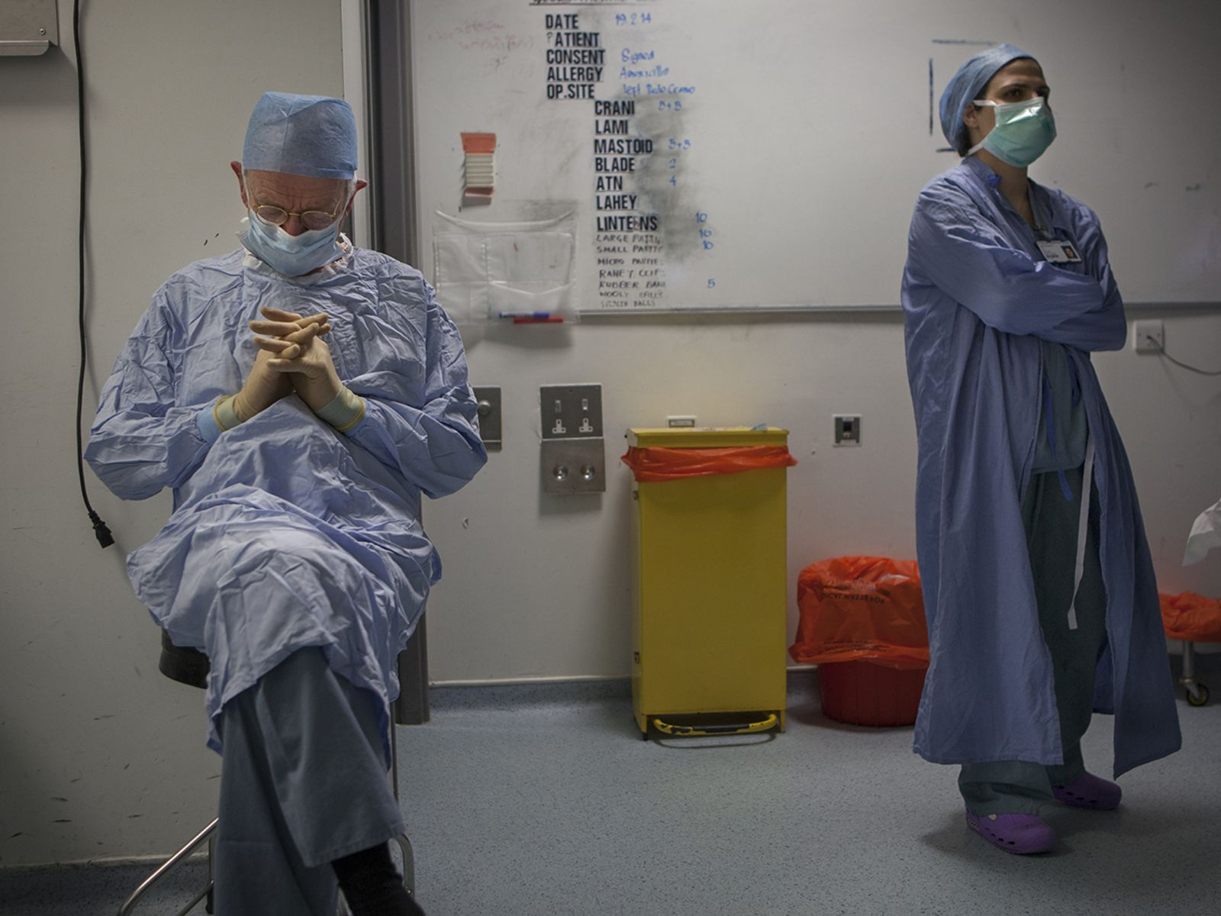
Scrubs up: Marsh’s post-surgery decisions determine his patients’quality of life. (Photo: Tom Pilston)
As a result of this terrible experience with his own son, Henry always rings the family as soon as possible after serious surgery and waits until the patient is awake in recovery. Only then can he be sure that an operation has been wholly successful. He doesn’t think many surgeons make these sorts of calls. “It’s a kindness; it shows you understand what relatives are going through. But also, if things go wrong, mostly people will forgive you.”
He is less willing to forgive himself. Most of the chapters in Do No Harm have titles taken from abnormalities of the brain: “Aneurysm”, “Meningioma”, “Astrocytoma”. But towards the end there is one called “Hubris”, which recounts the story of an operation that took place over two decades ago, on a man with a petroclival meningioma, a benign but extremely large tumour. The procedure took 15 hours – and towards the end of all those hours Henry, attempting to remove the last bit of the tumour, tore the artery that keeps the brain stem alive, causing catastrophic damage and leaving the patient in a permanent vegetative state. He no longer does 15-hour operations.
As Jenny’s prone form is brought into theatre, his team springs into life. “The quality of my working life is largely determined by the quality of my junior doctors. It’s in my interest that they’re happy,” Henry has said to me – and the same applies to everyone he works with: anaesthetists, nurses, technicians. Operating isn’t solitary work, and I am one of at least half a dozen people present. He greets hospital porters by name. He has worked with Judith Dinsmore, his anaesthetist, for over a decade; one of his aides in theatre has been assisting him since he became a consultant in 1987, as has his secretary, Gail Thompson.
This situation is now highly unusual in the NHS; as in so many other organisations, the perception is that centralisation brings benefits of streamlining and cost efficiency. The men and women who work with Henry Marsh think otherwise. A few days after this operation, Gail describes how she is supposed to schedule Henry’s clinics through a central booking service but does not. “A central booking service won’t keep slots aside for emergencies, for instance. I know Henry’s patients, so when they ring I know if it’s serious or not, and I can deal with it appropriately. Centralisation in the NHS is stopping all that.”
Tim Jones, the specialist registrar, begins to set Jenny’s head in a Mayfield clamp, an alarming-looking metal jaw that holds the patient’s head steady during surgery. Sharp pins drill bloodlessly through the scalp and grip the skull tightly.
Tim is 35, and the person Henry sees as his likely successor. A charming and energetic man – tirelessly helpful to a novice like me in the operating theatre – he took three years out of his medical training to do a PhD in physics because he is very interested in imaging technology, such as the scanner he will soon use to pinpoint where Henry will need to get to inside Jenny’s brain. Last year he won the Norman Dott Medal for outstanding performance in the Intercollegiate Specialty Examination in Neurosurgery, a rare honour. It’s worth remarking that four out of the immediate past five winners of the award have worked in the Atkinson Morley unit at St George’s.
Henry stresses that these surgeons have worked with many other doctors besides himself – but clearly Tim, at least, finds his boss an inspiring figure, not least because he is so open about discussing his own mistakes. This is extremely unusual, in Tim’s experience. “He calls it ‘the departmental hairshirt’,” he laughs. When I ask Tim if he is married, he laughs again. “No. I don’t even own a house. I’m a bit of psychopath, I guess. You have to be to do this job.” Performing surgery, he says, is “exhilarating” – a sentiment that Henry seconds.
Because Jenny has been operated on before, the incision in her head is already there. Tim cuts open her stitches. During surgery the patient is almost entirely draped in sterile sheeting, with only the area on which the surgeons will be working left visible, the edges of the wound held tight with small blue clamps that look almost like paper clips. There is a great deal of blood in the scalp, and the clamps keep the incision from bleeding. As Jenny’s head is opened Henry pulls up his chair, and the operating microscope leans over the patient like an inquisitive crane.
“Here,” he says. “Have a look.”
I come close to his shoulder and look down into the microscope’s second eyepiece. A glittering, undulating landscape of shining whites and greys and reds is revealed in vertiginous 3D; to look through this remarkable instrument (each one costs about £120,000) is to feel as if you could step right into the patient’s brain.
“There,” Henry says, pointing with a delicate instrument at a pulsing, slender cord to the right of my field of vision. “Artery. Mustn’t touch that. Touch that, the whole thing’s over.”
Looking down, I find myself thinking how impossible it is, finally, to comprehend that what I am observing – the matter of the brain – is everything we are. Here is the soul, here is the mind, here is every thought we might have or ever have had about the world around us. Nothing more than shining, pulsing matter. It seems far more difficult to consider than the idea that the pinpricks of light we see as stars in the sky are enormous burning balls of gas thousands of light years away. Our understanding of the universe, our understanding of those stars – it’s right here, under this microscope. From my earlier conversations with Henry, I know that despite his years as a surgeon (indeed, perhaps because of his years of work as a surgeon), he finds this notion as remarkable, and as puzzling, as I do.
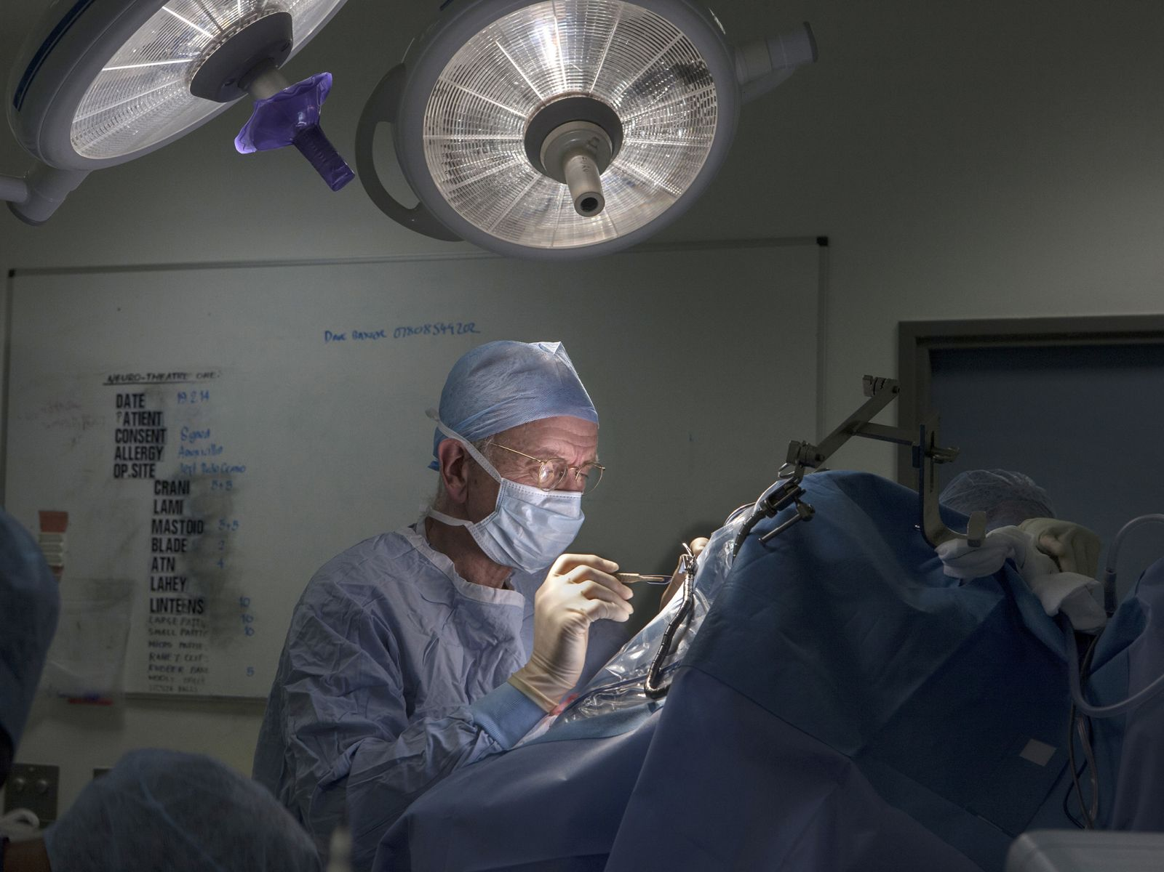
See it through: Marsh performs delicate work inside a patient’s skull. (Photo: Tom Pilston)
When I first met Henry, he planned to work until he was 67. He changed his mind when he was threatened with disciplinary action for wearing a wristwatch as he walked through the hospital last year. The rule now is “bare from the elbows down” – not just in the operating theatre, obviously, but anywhere at work.
The episode still fills him with an ill-disguised anger. “If you treat people like naughty children, they’ll behave like naughty children. I love my work: I have my limits.” But it was the last straw in a long line of grievances he bears against the increasingly unwieldy machinery of the NHS in the 21st century. It’s much harder for him to raise money now, he says, for things such as the roof garden, or the beautiful photographs he has arranged to have hung in the ward so that his patients have something pleasant and distracting to look at, rather than peering out at the cemetery just beyond the building’s walls.
“People were willing to give money when they felt it was more like a charitable organisation – but now that the NHS is being privatised by the dumb fucks who run the government, people think: ‘Why should I give money to the NHS?’ Now the buses are owned privately, you think: ‘Why should I give way to the bus?’ Whereas when it was a public service, you thought: ‘I’ll let the bus go first.’ But I’m not going to do that now! You lose a lot that way.”
It is the failings of the NHS that make headlines, he knows, not its successes. “There’s all this mouthing off about how we have to have a ‘blame-free’ environment – but it’s blame, blame, blame all the time. One is no longer trusted. Of course, in any system there’s a certain small percentage of people who are freeloaders or incompetents; but if you design all your systems to deal with that percentage, you may end up so pissing off the 95 per cent of people who are the good guys that you lose more than you gain. I don’t know what the answer is. I’m glad I don’t run the NHS. But you have to trust people.”
Would I trust Henry if I were a patient, or a patient’s relative? I reckon I would. In the day I spend at the hospital I see two surgeries. Before Jenny’s operation in the afternoon, Henry and Tim work together on an older man, who, by a very peculiar coincidence, is suffering from the same kind of malignant tumour that killed my father a few years ago, a glioblastoma.
My father’s was deep in his brain and inoperable; this patient’s tumour is closer to the surface, though it has already cost him much of his eyesight. The operation will be no cure; Henry has made it clear it might buy him a bit of time, but not much. “More and more of modern medicine is palliative, anyway,” he says. “We are not curing people; we’re keeping people alive. These are quality-of-life issues. They are very hard decisions to make: do I want more chemotherapy? Should I have a double mastectomy? These are hard for patients, too.”
The radiotherapy my father was given was probably useless, Henry tells me as Tim opens the patient’s skull. And indeed, although my father spent nearly six weeks in hospital to have it, it didn’t seem to do much good. I have never discussed this with Henry before; now I consider the six weeks my father might have had at home, rather than in hospital – institutions that Henry compares baldly with prisons.
In the afternoon, Jenny’s operation took longer than expected. Henry had said he thought he would been done in an hour or so; in the end, he was working for about four hours. Not one, but three interoperative angiograms had to be done to check that he’d done the job. Sitting straight in his chair – its arms holding his own arms steady as he moved his instruments with finely calibrated delicacy – Henry peered through his microscope, using an electrical current to cauterise the three tiny blood vessels in her brain which were putting her in such danger. Often, he has said, there are many more blood vessels to seal off in such cases, but Jenny’s were tricky because they were so very tiny, and so close to a major artery, as I saw. (This is the stuff, remember, that he thinks is “not difficult”.) Jenny’s operation was a success. She went home from hospital two days later and her problem will not recur.
The prospect of retirement is rather alarming to Henry. He will keep his bees; he will build bespoke bookcases in his workshop; he will, no doubt, lecture (and continue to work as a surgeon) around the world. He plans to go back to Ukraine at the end of this month despite the trouble there.
His hospital in Kyiv is off Maidan Nezalezhnosti – Independence Square, where the revolutionary protests took place. He is in touch every day with his friends there, all of them Ukrainians who dislike the Russians and hate Vladimir Putin, he says. “I’ve always believed very strongly that Ukraine was an incredibly important country. Because it is the focal point, the pivot between east and west, which goes back hundreds of years. You’ve got Asiatic Russia to the east, and western Europe to the west. It’s one of the most profound fault lines in Europe.”
His colleagues’ concern – for their safety, for their future – is tempered by a certain fatalism. “They’ve always lived in a country where the state is essentially against you. We in the civilised west may criticise our politicians and the state, but the default feeling is that the state is there to help you. In places like Ukraine and Russia, that has never been the case. The state is your enemy. It’s very hard for us to imagine that. It’s very much rulers and ruled.”
Henry says he doesn’t fear for his own safety: but playing it safe has never been his way. His seeming arrogance and self-regard (“Kate and I have been rehearsing a few interviews, so that when I’m asked, ‘Why did you write this book?’ I’ll say: ‘To draw attention to myself.’ That’s the honest answer”) are undercut by his sincere knowledge of his own fallibility – and the price that fallibility can exact. A rueful shrug. “My life is a succession of proving to myself that I’m not as frightened as I think I am.”
“Do No Harm: Stories of Life, Death and Brain Surgery” by Henry Marsh is
Erica Wagner is a New Statesman contributing writer. A former literary editor of the Times, she has twice judged the Man Booker Prize. Her books include Ariel's Gift: Ted Hughes, Sylvia Plath and the Story of “Birthday Letters”, the novel Seizure and, most recently, Chief Engineer: The Man Who Built the Brooklyn Bridge.

