Lytra, V., Gregory, E. and A. Ilankuberan. Summer 2017. “Faith matters: Rethinking home learning of children from different faiths” EAL Journal (Summer), 30-31

Faith matters: Rethinking the home learning of children from different faiths
Vally Lytra, Eve Gregory and Arani Ilankuberan report on a research project that aims to understand how children learn through their faiths.

Faith and religious belief have been traditionally considered a private and individual matter. They are an important force for learning and provide many children with a sense of belonging to a community of shared values and beliefs.
Recent events, though, have catapulted religion into the centre of public debate about democracy, pluralism, social cohesion and citizenship. As schools in the UK are becoming increasingly more linguistically and culturally diverse, the role of religious education in fostering mutual respect and tolerance raises an important question. Given its potential to spread understanding of the values underlying a multi-faith society, how much should teachers know about the home learning of children from different faiths?
Our research project, ‘Becoming Literate in Faith Settings: Language and Literacy Learning in the Lives of New Londoners’, sought to document how children from different faith communities learned through their faiths. Our guiding assumption was that if we aspire to nurture the wealth of our students' languages, literacies and identities then we cannot ignore the home learning of children from diverse faiths.
The BeLiFS project
Faith communities: Bangladeshi Muslim, Ghanaian Pentecostal, Polish Catholic and Tamil Hindu/Saiva.
Settings: home, faith classes, religious services in the Church, Mosque and Temple.
Researchers: a team of eleven from a range of backgrounds.
Duration: from 2009 to 2013
Participants: sixteen children aged between four and twelve, their families, faith leaders and faith teachers as well as older members of the communities.

Thiani
To give a flavour of our findings, we would like to share the story of Thiani, one of our participants. Thiani is the 8-year-old daughter of a devout family of Tamil Hindu/Saiva heritage growing up in East London. At the beginning of our study she was in Year 3. Every Sunday morning Thiani attends a Tamil complementary (community) school and goes to the faith class afterwards with her older brother Tianan. Her parents and maternal grandmother were forced to flee Sri Lanka because of the civil war. They sought refuge first in Norway (where Thiani was born) and then moved to the UK to improve the family's educational and work prospects.
Twice a day, in the morning and evening, Thiani takes a bath and then prays in front of the family alter, with other family members or on her own. The prayer alter is adorned with images of God and religious objects (pictured). By observing other more expert members of her family and her faith community and practicing at home, in faith class and at the Temple, Thiani learns the main act of prayer of her faith, the singing of Thevarams. These are devotional hymns written in a form of old literate Tamil. Thiani learns to perform them accurately and in tune alongside the recitation of mantras in Sanskrit. She also learns to accompany them with an appropriate body demeanour and gestures, such as the joining of the palms over the head and the application of holy ash on the forehead at the end of the prayer. Prayers in Hinduism can be scripted in text and delivery, as in the case of Thevarams and mantras, as well as more spontaneous. The example that follows below is from the interview between the researcher, Arani Ilankuberan, and Thiani. Thiani is explaining to Arani how she prays privately to seek assistance from God in times of need, for example to ensure the good health of family members and her academic success at school. The interview uses both Tamil and English, and Tamil phrases are translated in brackets.

IMAGE 1
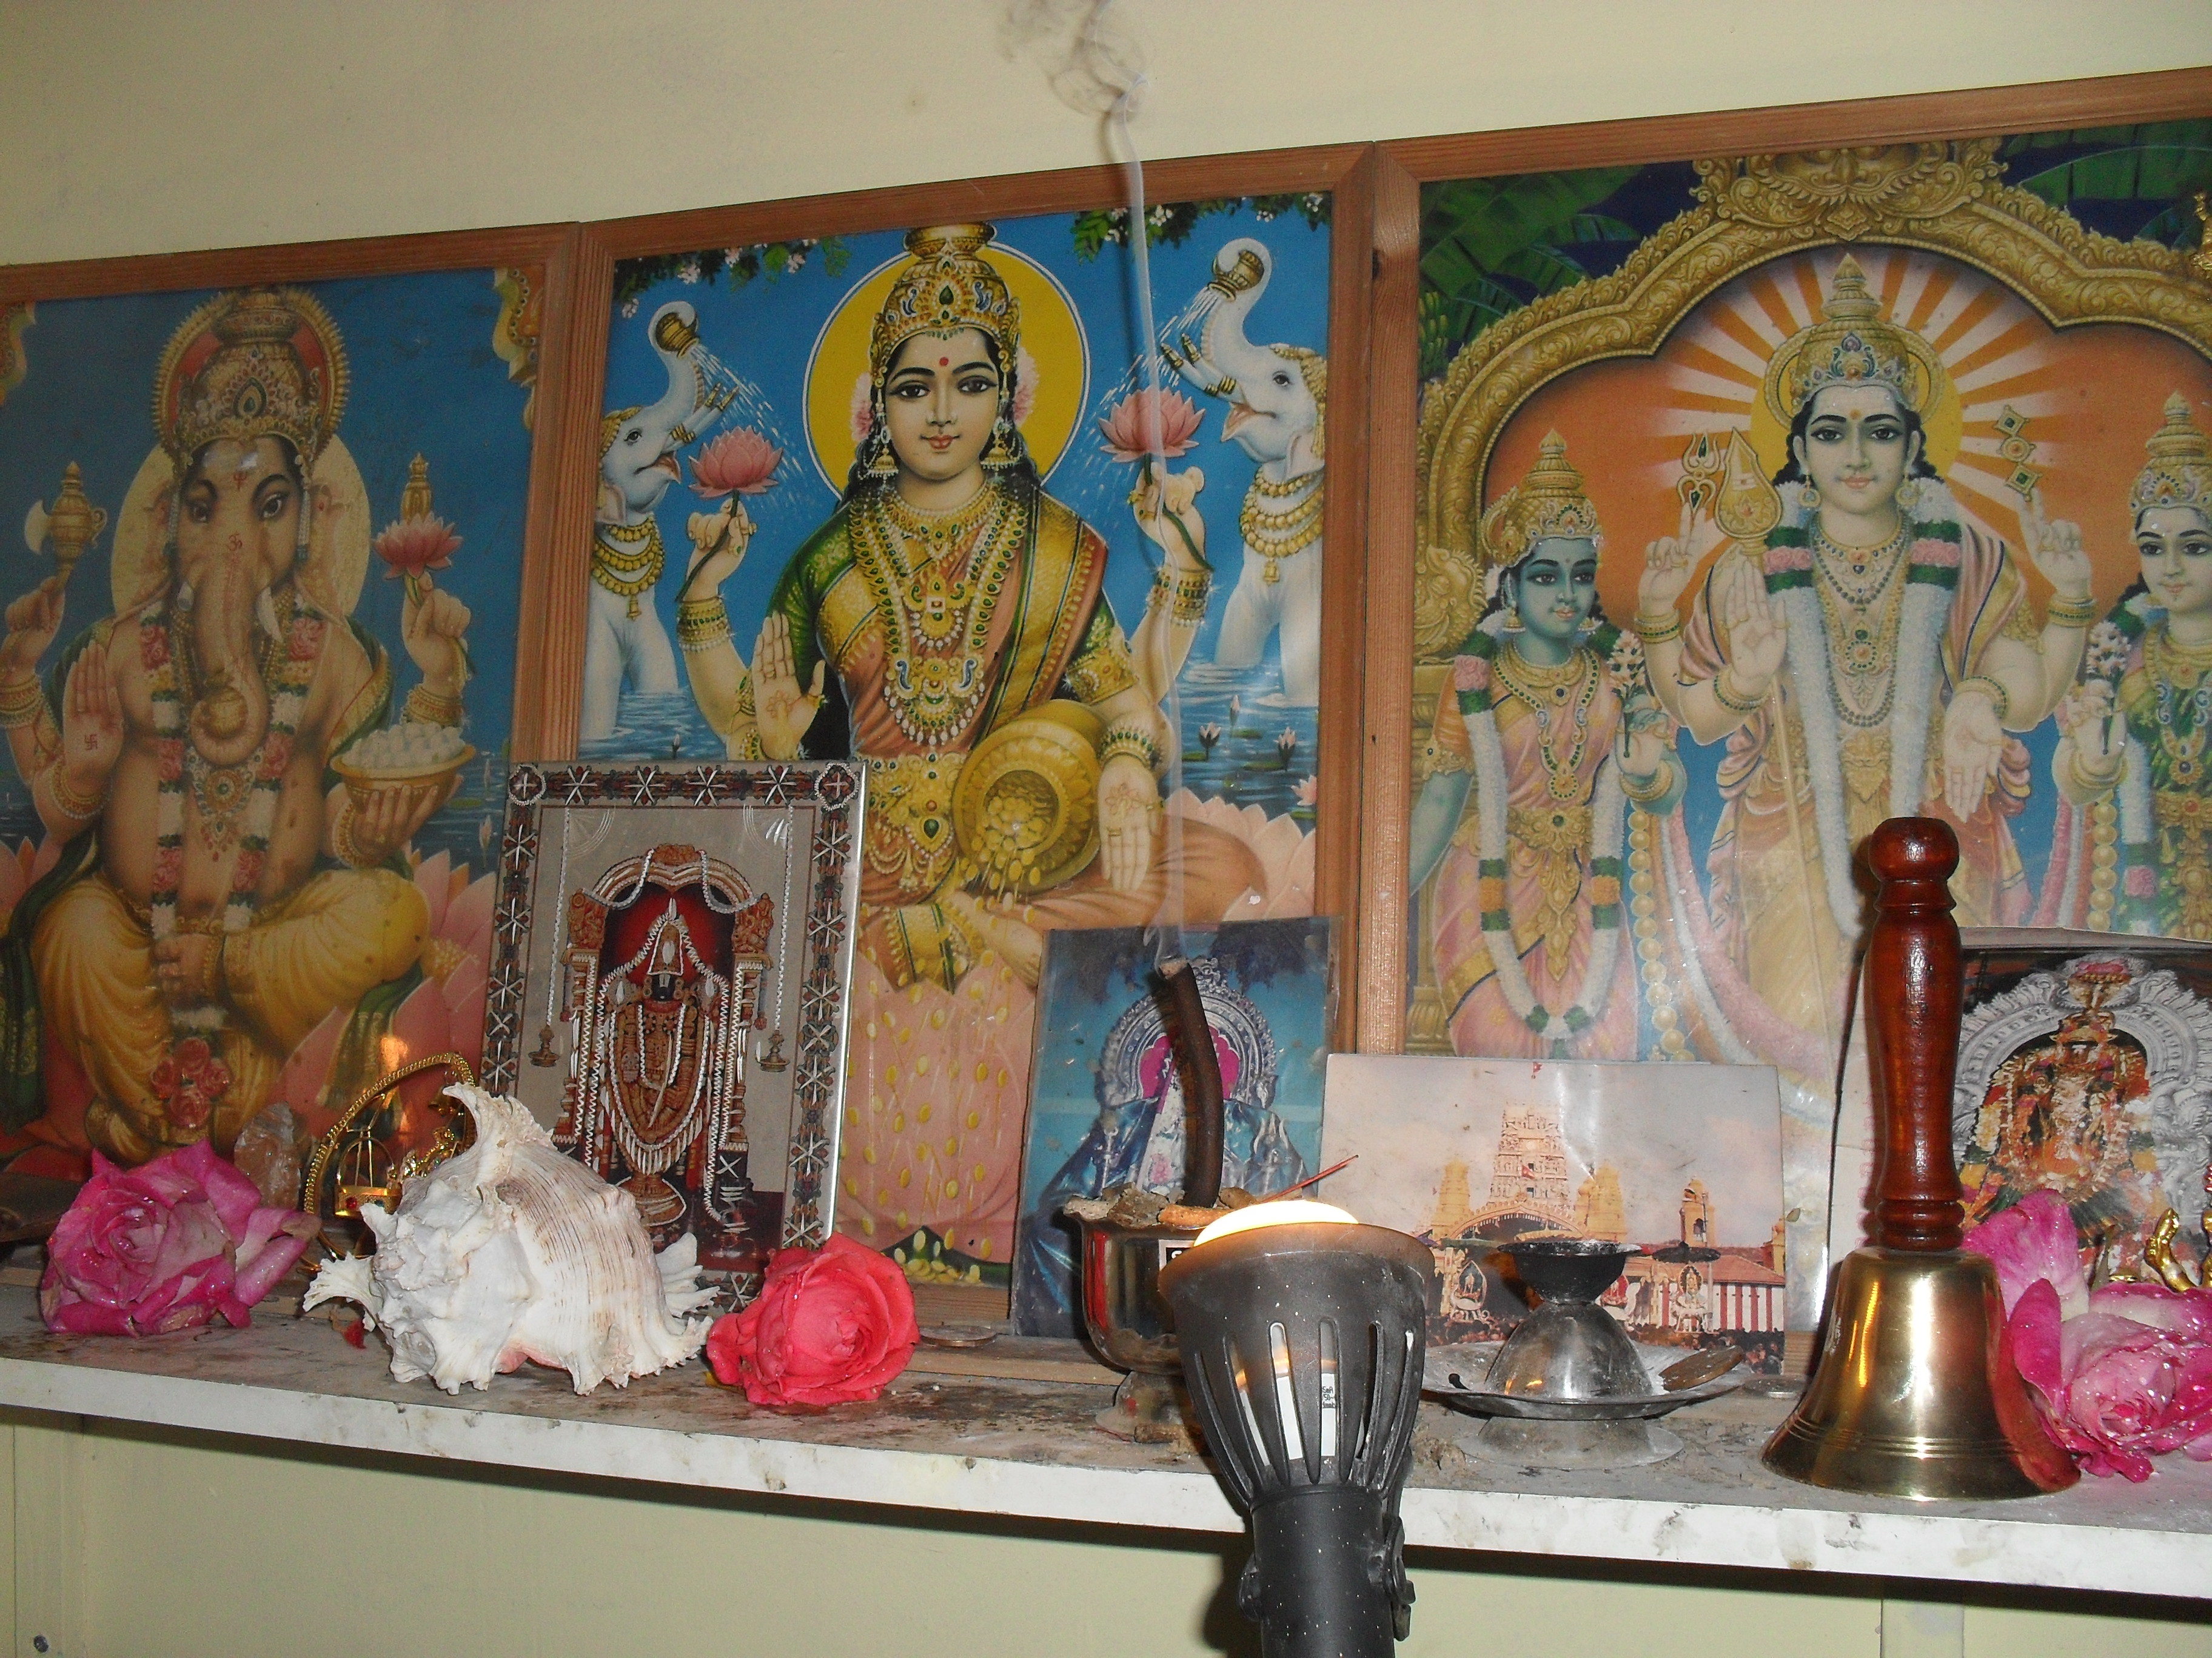

CAPTION: The family prayer alter. In the back from left to right: Images of God (Lord Ganesh, Goddess Lakshmi, Lord Murugan with wives, on the left Valli and on the right Deivanai). In front: a conch shell, pink rose buds, incense burning, a silver pot with holy ash and a bell.

Arani: yeah? And, and what do you say, what do you ask Saami <God> when you pray?
Thiani: I ask for my family to be good, and they won't like, if my family's sick, I'll I pray to God
Arani: you pray to get better? Yeah?
Thiani: to yeah, and I pray to God to win everything!
Arani: aw! (laugh)
Thiani: and win my SATs exams!
Arani: aw! Yeah that's what I do as well, (laugh) so when you pray do you talk in, when you kumbudu <pray>, when you, do you talk to Kadavul <God> in English or Thamil <Tamil>?
Thiani: Thamil <Tamil>
Arani: Thamil enna <Tamil isn't it>? You don't feel right talking in English?
Thiani: yeah, I say "please"
Arani: (laughing) you say "please"!
Thiani: in English, cos I don't know in Tamil
Arani: in English, so you so you say everything in Thamil <Tamil> and then ‘please’ you add in the end, yeah?
Thiani: yeah
Arani: ok (laugh) why do you do that?
Thiani: and ‘thank you’ because I don't know the words
Arani: ok so you say ‘please’ and ‘thank you’
Thiani: mm (nodding in agreement)

Through the act of prayer, Thiani learns to combine a complex set of linguistic resources in culturally appropriate ways: old literate Tamil and Sanskrit for scripted prayers and colloquial Tamil and English for spontaneous prayers. Culturally and socially, she learns the significance of posture, gesture, and gaze, of special diet and cleansing rituals as well as the symbolism of sacred objects used in prayer. Prayer evokes powerful bonds and relationships across generations and continents.

The children also completed scrapbooks as part of the project. These are personal note books where children recorded their own thoughts, stories and feelings about their faith. They also included their photographs and artwork associated with their faith (see www.belifs.co.uk for examples of all the children's scrapbooks). On page 1 Thiani has written a short expository text about her religion entitled ‘What I believe in’ (pictured). Underneath she has drawn the religious symbol of the ‘swastika’. On page 2 she has pasted a colourful image of Sivaperuman, Lord Siva, who Saivites believe to be the ultimate deity and all other deities are incarnations of Him. Underneath she has phonetically written the sacred mantra ‘Oorm Siva’, ‘our’ God, Sivaperuman.

IMAGE 2
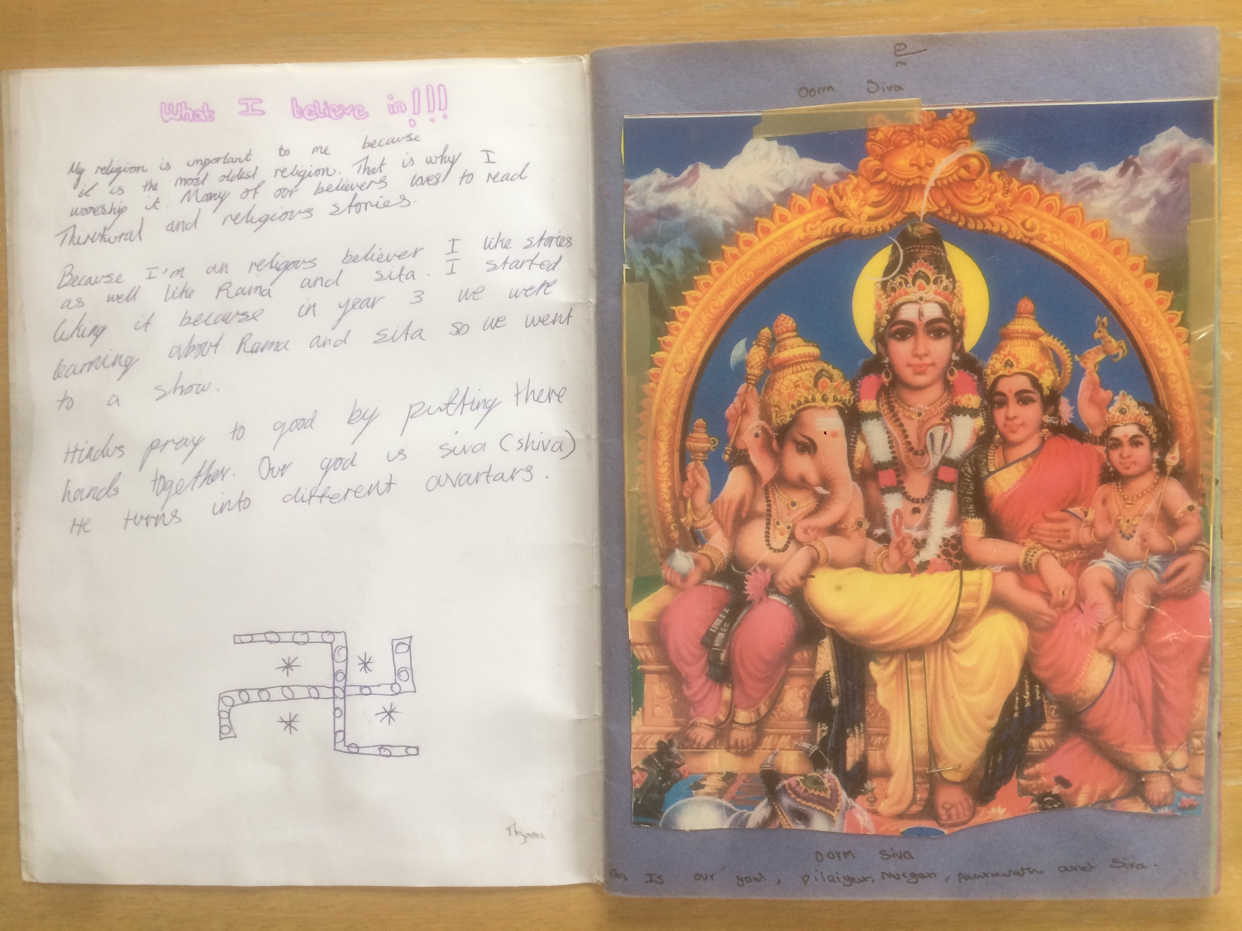

CAPTION: A page from Thiani and Tianan's scrapbook for the project

Morally and spiritually, Thiani connects her family and faith community's past with the present and the future as she comes to make sense of her everyday experiences as a young Londoner in a religious framework that emphasises kindness and compassion to all beings, big and small. This key religious belief is echoed in one of her scrapbook entries: "We never make fun of other religions and we don't hurt people's feelings".

The authors are researchers at Goldsmiths, University of London (contact: Vally Lytra, v.lytra@gold.ac.u). The project was supported by a grant from the ESRC (RES-062-23-1613).

Find out more:
Lytra, Vally, Dinah Volk and Eve Gregory (eds) (2016). Navigating Languages, Literacies and Identities: Religion in Young Lives. Abingdon: Routledge.

