A Bad Night’s Sleep on Campus: An Interview Study of First Year

University Students with Poor Sleep Quality

Foulkes, L.¹*, McMillan, D.² & Gregory, A.M.³
¹Department of Education, University of York, York, UK
²Department of Health Sciences, University of York, York, UK
³Goldsmiths, University of London, London, UK
*Corresponding author. Email: lucy.foulkes@york.ac.uk

Abstract
Background: Poor sleep quality is common in university students, and increases the risk of mental illness and poor academic attainment. It is therefore critical to understand what may cause or aggravate poor sleep in students. First year students living on campus are particularly worthy of attention, due to their distinctive sleeping circumstances: they are adapting to a new lifestyle, sleep in close proximity to new peers, and experience environmental noise and academic stress.
Method: Fifteen first year undergraduates with poor sleep quality completed in-depth interviews, in which they were asked about aspects of university life that might contribute to their poor sleep quality.
Results: Four main themes were constructed from the data using thematic analysis: the social context of noise problems; the lure of socialising with peers; the cost of having an unstructured academic lifestyle; and the wide-reaching impact of poor sleep quality on university life. Flatmates and friends were central to poor sleep quality on campus, because they caused excessive noise and provided an easy opportunity to socialise late into the night. Academic factors, including students working late at night and spending all day in their bedrooms, were also key.
Conclusion: Fundamental aspects of moving to university, including living with peers and adapting to a new academic schedule, may increase the risk of students’ poor sleep quality. When designing interventions to minimise the risk of poor sleep quality in first year students, unique aspects of the campus environment, including the close proximity to new peers, must be addressed.

Keywords

University; college; students; sleep quality; student wellbeing; campus

Introduction
Up to 60% of university students report poor sleep quality¹ – defined as sleep that is not restorative, usually as a result of difficulty falling or staying asleep². Poor sleep quality in students is associated with lower levels of academic achievement³ and can have a causal role in the onset of mental illness⁴. Given the high levels of stress and mental health problems in undergraduates⁵, it is critical to understand factors that can exacerbate poor sleep quality in this population.

First year students, who in the UK typically live on campus in student halls, are especially worthy of research attention. This is because a number of factors put them at risk of poor sleep quality. First, they share accommodation with flatmates. In adults and children, it is well established that sleep can be affected by other people^{6,7}. One study has indicated that social norms around sleep may affect sleep duration in undergraduates⁸, but beyond this the impact of the social context on sleep in university students has largely been overlooked.

Sleeping in close proximity to peers likely means that, at least some of the time, first year students sleep in a noisy environment – especially as students often party in their accommodation⁹. In adults, a wide body of research has demonstrated how noise negatively affects sleep quality and health outcomes¹⁰, but almost no studies have investigated the impact of noise in university halls. One exception is a qualitative study in US students investigating healthy living practices, which reported briefly that noise from peers coming home from a night out can disrupt students’ sleep¹¹, but this issue needs to be explored in more detail.

First year students are also at risk of poor quality sleep because of academic demands. Across all years, academic stress is associated with poorer sleep quality¹², and first year students who spend more time on academic work in the day spend fewer hours sleeping that night¹³. An additional aspect of first year studying has not been addressed to date: the transition from very timetabled studying at school to independent study at university. Many students have few ‘contact’ hours (e.g. lectures and seminars), or start times that vary greatly from day to day (e.g. a 9am start one day and a 2pm start the next). One study has found that students with irregular sleep schedules (sleeping and waking at different times each day) were likely to have poorer academic performance¹⁴, but the possibility that specific academic schedules may cause or exacerbate this irregularity has not yet been investigated.

In the current study, first year students with self-reported poor sleep quality were interviewed. The primary goal of the study was to better characterise unique aspects of first year life and the campus environment that may negatively impact sleep quality.

Participants and Methods

Participants. Participants (N=15; 12 female, three male) were undergraduate students from a public, medium-sized, research-intensive university in North England. The sample size was appropriate for thematic analysis¹⁵. All students were in their first year; interviews were conducted when students had been at the university for 7-8 months. Nine students were studying arts and humanities subjects; six were studying science subjects. They were recruited via departmental mailing lists and social media, with adverts asking for students who lived on campus and experienced poor sleep quality, defined for the purposes of recruitment as trouble falling or staying asleep at least four nights a week. The only exclusion criteria was that participants could not be students in the department in which the first author was based, due to confidentiality concerns.

Participants were aged 18 to 20. Thirteen participants were White British; two reported other ethnicities. All participants lived on campus, sharing their accommodation with between seven and 18 other students. Eight participants reported that they had been diagnosed with at least one psychiatric or neurodevelopmental disorder by a medical professional (further detail withheld here to preserve anonymity¹⁶). Any potentially identifying details have been removed from the quotes used in this manuscript.

Ethics. Ethical approval for the study was obtained from the first author’s departmental ethics committee. After the interview, all participants were given information about sleep hygiene and signposted to other organisations, including student wellbeing services and their GP, for additional support regarding their sleep problems.

Measures. Participants were given the Pittsburgh Sleep Quality Index (PSQI¹⁷) to assess their sleep quality. The PSQI yields seven subscales: subjective sleep quality, sleep latency, sleep duration, habitual sleep efficiency, sleep disturbances, use of medications for sleep and daytime dysfunction. These subscales are summed for the total score; a total score of >5 indicates poor sleep quality. All participants scored above the cut-off; scores ranged from 6 to 14.

Procedure. Semi-structured interviews were conducted to explore the nature of participants’ poor sleep quality, factors that negatively impact their sleep, and the impact of their poor sleep quality at university. Interviews were conducted by the first author in a quiet room at the university, after the participant had completed the PSQI. Interviews were audio-recorded and transcribed by an independent transcription service before being checked for accuracy by the first author.

Analysis. A deductive thematic analysis was conducted¹⁸, using QSR International's NVivo 11 software¹⁹. In the first step, data familiarisation, the first author read through the interview transcripts several times and made notes about potentially interesting themes. Second, the first author and two research assistants independently generated initial codes for the first three transcripts. Codes are labels given to short segments of meaningful data¹⁸; for example, the phrase ‘I’ve tried to make a strict revision timetable and then not been able to stick to it because I’ve been so tired’ was given the initial code ‘private study’. This step of involving multiple researchers helped to reduce any potential researcher bias²⁰, as any discrepancies were discussed and resolved at this stage. The first author then generated codes for the remainder of the transcripts. As new codes emerged in later transcripts, the first author revisited earlier transcripts and recoded as necessary. At this stage, there were 36 codes (see Figure 1).

In the third step, searching for themes, the first author created a set of broader themes (recurrent, important patterns in the data) based on the initial codes. Some codes became themes in themselves, some codes were grouped together to form themes, and some that were not relevant to the main research question were discarded¹⁸. For example, the codes ‘private study’ and ‘missed contact hours’ were subsumed into the theme ‘The wide reaching impact of sleep quality’, and the code ‘bathroom fans’ was discarded entirely as it was only mentioned briefly once by one participant. During this stage, an initial thematic map was created to explore relationships between codes and initial themes; there were eight potential themes at this stage (see Figure 1).

In the fourth step, reviewing themes, the first author refined the set of themes: all coded data extracts were examined, and then the entire data set was re-read. At this stage, the eight initial themes were reduced to four. For example, the theme ‘Physical aspects of accommodation’ was removed, as the key aspects of physical accommodation that were reported to cause poor quality sleep were those related to other people’s noise (slamming doors, corridor noise), so this theme was merged into the ‘Social context of noise problems’ theme. The final step involved defining and naming themes, where the names of themes are checked to ensure they accurately represent the essence of the theme¹⁸. At this stage, there were some minor adjustments: for example, the theme ‘Late night socialising’ was renamed ‘The lure of socialising’ to more adequately capture the importance of how students were tempted by social opportunities in spite of the sleep disruption they caused.
[INSERT FIGURE 1 HERE]

Results
In this section, there is first a summary of the nature of the poor sleep quality that participants experienced, then a description of the four themes that were constructed from the data (see Figure 2 for the final thematic map).
[INSERT FIGURE 2 HERE]

Nature of poor sleep quality. The most common sleep problem reported in the sample was difficulty falling asleep. Other issues affecting sleep quality included waking up frequently in the night, having vivid dreams or nightmares, or having unsatisfying sleep despite sleeping for at least eight hours (note that this number was provided by the participant, not the researcher). In order to compensate for poor quality night-time sleep, participants reported either lying in late in the morning or napping in the day to catch up on sleep. This meant that participants often found themselves in a cycle of poor sleep quality:
“It is just actually, like, falling asleep that is really difficult, and then…it is really difficult for me to wake up, so then I have made sure, like my alarm is on the other side…of the room so I have to, like, walk over, but I go back to my bed and I will just, like, sleep. Yeah. Just go straight back to sleep. And then because then I wake up later, it is harder for me to go to bed earlier and then it is just, like, this vicious cycle.” [ID010]
“I just end up being really tired throughout the day and if I take a nap then that stops me from doing work and then I’ll have to catch up on work later on at night which it, just, it’s a bad cycle.” [ID006]

Theme 1: The social context of noise problems.

Other people as the source of noise. The most commonly reported factor perceived to cause difficulty falling asleep was noise from other students. Participants reported being kept awake by other students playing loud music or musical instruments, playing video games, watching television, talking, shouting, singing, and running up and down corridors.
“There are these guys in my flat… and they’ll be just up every night, screaming and shouting, playing games, and then they run between each other’s rooms so you can hear the stairs, you can hear the slamming doors.” [ID008]
“It was very, like, really loud music, outside was really bad… and then I would go to sleep really late, wake up late and then I think that is how [my sleeping problems] started.” [ID010]

Social challenges of reporting noise. At the university where this study was conducted, there is a formal system in place to deal with noise complaints: if noise continues past 11pm, students can call porters, members of security staff, who will come and ask offenders to be quiet. Students who used this system generally reported that this was effective. However, many were reluctant to use the system because of the social complexities around reporting peers.
“It’s just a bit of a dilemma because… I don’t want to come across as like a proper nerd who doesn’t want you to be having a party.” [ID002]
“I've come very close to [calling the porters], but you kind of just don’t want to be that person.” [ID012]
Others felt that disruptive noise was an inevitable aspect of living in halls, and that involving the porters was in conflict with what first year and university were supposed to be about:
“I think [having porters implement the 11pm rule] would definitely ruin the fun of the first year.” [ID009]
“It’s like you're supposed to be kind of independent living, aren’t you, like going into adulthood kind of thing… So, it kind of defeats the point if you had almost like teacher type people.” [ID007]
Rather than reporting to staff, many participants directly asked their peers to be quiet, either face-to-face or via group messaging apps they shared with their flatmates. The relationship that participants had with their flatmates was critical in determining whether this was successful. Some participants reported having respectful flatmates who would quieten down or move rooms if they were asked to keep the noise down, or would remain quiet if they knew in advance someone needed to go to bed early or had an early start. Others who were not close with their flatmates felt their requests for quiet would be ignored:
“Well I could [try asking them to be quiet], but honestly it is not worth it, I mean I could tell them ‘Could you please shut up?’ or I could be like, ‘Sorry I am trying to sleep,’ and they would be like ‘Oh I am sorry’ and then continue shouting. Like I don’t trust them to listen to me.” [ID003]
Participants often felt too intimidated to ask others to be quiet, especially if they didn’t know them well.
“We get people in the next flat pre-drinking in our flat quite a lot and then they are really loud and then it is quite awkward because if it is just our flat, we can just go in and be like, ‘Guys, please can you turn the music down?’ It’s fine. But it’s really awkward when it is, like, other people as well.” [ID010]
For some participants, noise was a source of serious distress, and they reported that when noise prevented them from sleeping, they became tearful and angry. Some students reported buying noise-cancelling headphones and earplugs to deal with the noise, and others resorted to sleeping in friends’ or partners’ accommodation in order to get some sleep.

Theme 2: The lure of socialising. Even when they weren’t causing noise, friends and flatmates disrupted sleep because they presented an easy opportunity to socialise. Many participants regularly went out late to bars and clubs with flatmates: one participant said that a typical night out in town started at midnight and could last until 5am, which inevitably disrupted sleep. Participants also usually drank alcohol when they went out; although participants reported that alcohol helped them fall asleep very quickly, they also reported that it caused a number of problems for their sleep, from waking up in the night to increasing the frequency of nightmares. However, the disruptive impact of socialising on sleep didn’t always involve going out to bars or drinking:
“If it’s midnight and I'm not sleeping, I’ll just go around the corner and all my mates are still up and they’re just there, awake and chilling, so I’ll stay up for another hour just chilling, and then come back and I’ll be a bit more tired, but I’ll still be alert because I've been outside.” [ID009]
“Sometimes as a house we’ll like stay up late playing like card games or something. So that, like it ended up being 3.00am in the morning one time and we just lost track of the time. And I think that just made everything shift again, so instead of going to bed at like 1.00am in the morning, I’d end up going to bed at like 3.30am and then I’d be sleeping until 12.00.” [ID006]
Interestingly, participants were aware that socialising negatively impacted sleep, but reported that they were willing to sacrifice a good night’s sleep in order to have fun with their peers.
“I think the ruined sleep is worth like the sort of social thing, like I don’t really mind because, yeah, I’m anticipating it, like I know that if I drink that I’m going to have a bit of a crap night but it’s more like having fun and being around people because I’d rather do that than be like, ‘Sorry guys, not drinking’ and staying in.” [ID002]
“Well, I love socialising and I think if there’s something happening, regardless of the time, I’ll want to do it and probably will think I can stay up for an extra hour. I’m very good at convincing my present self to not care about my future self’s lack of sleep.” [ID011]

Theme 3: the cost of an independent academic routine. Participants had considerable freedom to choose their own sleeping and working schedule, particularly those who had very few contact hours (i.e. scheduled teaching, such as lectures, seminars or meetings with academic staff). They reported that this was in clear contrast to going to secondary school and living at home: school timetables forced participants to wake up early each morning, and parents encouraged healthy sleeping and working habits. Participants indicated that this newfound independence had a negative impact on sleep quality.
Working late at night. Several participants reported ‘pulling all-nighters’, in which they stayed up through the night to do work; although each participant that reported this had typically only done it once, due to how tired and unwell it made them feel the next day. However, many participants still worked very late. One participant reported that their cut-off time for doing work at night was 3am; others didn’t impose restrictions:
“I will start work after dinner and just work on an assignment, just go for as long as possible.” [ID009]
Some participants didn’t do this, reporting that they couldn’t concentrate on work in the evening, but for those doing their academic work very late at night, their sleep onset was inevitably delayed.

The effect of few contact hours. Others commented on how the freedom to sleep in late, afforded by a low number of contact hours, contributed to their cycle of poor sleep quality:
“So I might have like a lecture 2.00pm till 4.00pm and that’s the only thing I have that day, so like instantly in your head you're like, “Oh, I’ll just stay in bed till 2.00pm,” but that’s like such a bad thing to think, like you still kind of get up and do something until that thing… I think you’re kind of programmed to think, “If I’m not [in university] and if I don’t need to be in there till 2.00pm then I’ll stay in bed till 2.00pm”. But then I think that then has a knock-on effect that night because then obviously you don’t sleep as well that night.” [ID007]
Importantly, with few contact hours, participants often ended up spending much of the day in their bedrooms. This made it difficult for students to create physical and psychological space between working and relaxing, which made it more difficult for them to wind down and go to sleep at night.
“Your room doesn’t quite feel like your own for sleeping in and purely leisure, because if you work in that room and it’s all, you feel a little bit claustrophobic sometimes.” [ID005]
“[At home] it’s so separate, whereas [at university] it’s just like turning around and, ‘Okay, I need to get into my zone of going to bed now,’ and then that’s really difficult to do.” [ID008]

Theme 4: the wide-reaching impact of poor sleep quality.

Academic impact. Students reported that having sleep problems in the first year had a broad impact on many aspects of university life. The first was that participants often missed contact hours, particularly lectures at 9am, because lectures could be watched later online using the ‘Lecture Capture’ technology used by the university:
“If it’s a workshop I try and get up for it because I don’t like missing them, but if it’s a lecture that I know is going to be on Lecture Capture, I will miss it….Especially when I’ve gone to sleep at like, oh, because it’s been like 4.00am in the morning sometimes and then you have to get up at 8.00am and to like, oh, I just can’t even … I mean, just thinking about the fact that you’ve only had four hours sleep just drives you a little bit crazy.” [ID007]
Not all participants made a conscious decision to miss 9am lectures: others reporting wanting and trying to get up but feeling too exhausted to do so, or setting alarms and unintentionally sleeping through them. Participants were often frustrated about missing contact hours:
“[Missing contact hours is annoying] because I don’t want to miss out on the education that I am paying for, and also that I am enjoying! And I do think that maybe if I went… if I had been able to go to those seminars, I wouldn’t be struggling with [module topic] like I am now, because as much as getting the notes from my course mates might help, it doesn’t – I am still not getting the discussion and the understanding that comes with discussion from the seminars, so it is just very irritating to miss things.” [ID003]
Participants said that daytime sleepiness, as a result of poor night-time sleep, affected their academic performance even if they did attend contact hours, and also affected their ability to engage in private study.
“I physically couldn’t process the things [the lecturers] were saying a lot of the time, so I remember sitting in lectures in September and October, and whatever was going in was not coming out [in] what I was typing. And I read through my notes and they were just complete nonsense! Which was really unhelpful for my exam.” [ID004]
“With revision, I have to take breaks like quite frequently because I honestly, when I get too tired, I will just fall asleep. I can’t even control it. Like I just have to go like and lie down.” [ID007]

Social impact. The impact of poor sleep quality extended beyond academic issues. Participants reported feeling less able to engage in social activities because of their sleep problems, often cancelling plans because they were too tired or because they prioritised using that time to take a nap. Self-confidence around peers was also affected:
“When I’ve had a build-up of a few days of getting even less sleep than I usually would I’m quite quiet and withdrawn and that makes me feel like I don’t participate or contribute anything, so then I generally feel like sort of not worthy of [my friendship group] in a way.” [ID005]
One participant summed up the wide-reaching impact of poor sleep quality in first year:
“[Having sleep problems at university] stresses me out a lot because I think it makes me feel like I’m at a disadvantage to everyone else… like in every sense, so like there’s the academic side I feel like everyone… kind of like no-one’s as tired as I am, they can do more and then there’s little things like if I go on a night out literally I feel like for a few days after like I literally can’t do anything and I feel like I can’t even enjoy the social side as much because I just get that fatigued, so it makes me feel like, I don’t know, maybe a little bit on the periphery of the uni experience because of it.” [ID001]

Discussion
Four main themes were constructed from the data: the social context of noise problems; the lure of socialising with peers; the cost of having an unstructured academic lifestyle; and the wide-reaching impact of poor sleep quality on university life. The fact that multiple factors affected student sleep quality is in line with existing theories that health behaviours, including sleep, are impacted by individual, social and environmental factors²¹. A key finding across themes was that peers were central to poor sleep quality on campus: it was peers creating disruptive noise, and the complexities of peer relationships that prevented noise from being reported or stopped. Even when other students were not making unwanted noise, they were still affecting sleep, with participants reporting a willingness to sacrifice sleep in order to have fun with their friends.

The fact that social relationships tempt students away from sleep is unsurprising, for a number of reasons. First, this population are still adolescents²². During this period, establishing peer relationships is a key developmental task²³. At the start of university, it is critical to get to know peers and to make friends; indeed, failure to do so increases the risk of dropping out²⁴. The current study suggests that sleep quality is inevitably impacted by this social integration process: students’ sleep is disrupted both by the noise of other people socialising, and by their own desire to socialise. During adolescence, executive functioning and decision-making skills are also still developing²⁵, which may additionally affect their ability to make decisions regarding their sleep behaviour.

Second, it is well established that norms set by peers influence adolescents’ health behaviours²⁶. The Theory of Planned Behaviour (TPB), for example, posits that subjective norms, alongside perceived behavioural control and personal attitudes, predict behaviour²⁷. Previous research has found that social norms (e.g. the extent to which individuals endorse ‘My friends think I should sleep 7-8 hours a night’) predicted sleep duration in undergraduates⁸. The current study provides further support for this, suggesting that peers’ tendency to socialise late at night may provide a social norm by which staying up very late becomes normalised. In other age groups, it is well recognised that sleep is affected by social context: studies have investigated the impact of sharing a bed in adults⁶, and sharing a room or bed in children⁷. The possible ways in which other people and social norms affect sleep quality should now be further explored in adolescents. University samples provide an ideal setting for this, as individuals sleep in close proximity to their peers and also have the freedom to choose their own sleeping schedule.

The current study highlighted that students perceive unwanted noise as an important factor affecting their sleep quality. Chronic environmental noise affects health and wellbeing in adults²⁸; assessing this relationship in large student samples is now a critical future research direction. In addition, programmes aimed at improving and supporting sleep on campus must recognise the role of noise. At present, many universities have noise curfews, but these should be advertised and implemented more widely. The social complexities surrounding noise reporting should also be considered, for example by ensuring anonymity for reporters. For low-level noise, high quality earplugs or noise-cancelling headphones could be recommended.

Interventions should also consider the effect of students’ timetables on sleep quality. In the current study, scant contact hours and irregular academic schedules appeared to exacerbate poor sleep quality, as they allowed students to become stuck in a cycle of very late nights and compensatory sleep the next day. Having few contact hours also meant that students spent a lot of time in their bedroom, including working there, meaning they had no separation between their working and sleeping spaces; this is in conflict with common sleep hygiene advice^{29,30}. Universities could address these issues by having more shared social spaces such as living rooms and common rooms where students can socialise outside their rooms. Incoming students could be taught the importance of spending some time outside their bedroom every day, particularly when working, and of using their room for relaxation before bedtime. Students should also be told the importance of waking up at the same time each day regardless of timetable commitments.

Several limitations of the present study should be noted. First, the sample were mostly female. Future studies should evaluate whether similar factors affect sleep quality in male first year students. Second, eight participants reported at least one neurodevelopmental or psychiatric disorder, all of which are associated with poor sleep quality³¹. For these individuals, the impact of these disorders may have had an additive or interactive effect on the causal factors that students reported in the study. Third, participants’ sleep quality was assessed with self-report. Although this is a valid way of measuring sleep quality³², it is important to follow up this research with studies that use objective sleep measures such as actigraphy³³. Fourth, although in line with sample size recommendations for qualitative studies¹⁵, the sample size was small, meaning that some potentially important themes may have been missed. Future studies should also explore the experience of students in other year groups and in those who have good sleep quality, to explore their experience of, for example, noise from peers and irregular academic schedules.

There are a number of important constructs that influence and are influenced by sleep that were not discussed in detail by participants in the current study, and so not included in final themes. However, these should be addressed in future research. First, there is increasing interest in the role that technology plays in sleep quality^{34,35}. Second, poor sleep quality is known to be associated with low mood and behavioural problems. Future studies should focus on these concepts in more detail by explicitly asking participants whether they perceive, for example, technology use to be causing or exacerbating their poor sleep quality.

Conclusions
The effect of poor sleep quality in first year students is extensive, affecting every aspect of the university experience. This is line with studies from other populations demonstrating the impact of sleep on academic functioning³ and social functioning^{36,37}. The current study highlights that fundamental aspects of moving to university, such as living with peers and a lack of academic structure, may be negatively impacting sleep quality. To minimise the risk of poor sleep quality in first year students, unique aspects of the campus environment must be identified and addressed.

Acknowledgements
This project was funded by a University of York Department of Education Small Grant. We thank Kirsty Hensleigh and Ayesha Sheikh for their contribution to the early stages of the thematic analysis.

References
1. Lund, H. G., Reider, B. D., Whiting, A. B. & Prichard, J. R. Sleep Patterns and Predictors of Disturbed Sleep in a Large Population of College Students. J. Adolesc. Health 46, 124–132 (2010).
2. Harvey, A. G., Stinson, K., Whitaker, K. L., Moskovitz, D. & Virk, H. The subjective meaning of sleep quality: a comparison of individuals with and without insomnia. Sleep 31, 383–393 (2008).
3. Gomes, A. A., Tavares, J. & de Azevedo, M. H. P. Sleep and Academic Performance in Undergraduates: A Multi-measure, Multi-predictor Approach. Chronobiol. Int. 28, 786–801 (2011).
4. Freeman, D. et al. The effects of improving sleep on mental health (OASIS): a randomised controlled trial with mediation analysis. Lancet Psychiatry 4, 749–758 (2017).
5. Hunt, J. & Eisenberg, D. Mental Health Problems and Help-Seeking Behavior Among College Students. J. Adolesc. Health 46, 3–10 (2010).
6. Rogojanski, J., Carney, C. E. & Monson, C. M. Interpersonal factors in insomnia: A model for integrating bed partners into cognitive behavioral therapy for insomnia. Sleep Med. Rev. 17, 55–64 (2013).
7. Jenni, O. G., Fuhrer, H. Z., Iglowstein, I., Molinari, L. & Largo, R. H. A Longitudinal Study of Bed Sharing and Sleep Problems Among Swiss Children in the First 10 Years of Life. Pediatrics 115, 233–240 (2005).
8. Knowlden, A. P., Sharma, M. & Bernard, A. L. A Theory of Planned Behavior Research Model for Predicting the Sleep Intentions and Behaviors of Undergraduate College Students. J. Prim. Prev. 33, 19–31 (2012).
9. Pedersen, E. R. & LaBrie, J. Partying Before the Party: Examining Prepartying Behavior Among College Students. J. Am. Coll. Health 56, 237–245 (2007).
10. Stansfeld, S. A. & Matheson, M. P. Noise pollution: non-auditory effects on health. Br. Med. Bull. 68, 243–257 (2003).
11. Walsh, A., Taylor, C. & Brennick, D. Factors That Influence Campus Dwelling University Students’ Facility to Practice Healthy Living Guidelines. Can. J. Nurs. Res. 50, 57–63 (2018).
12. Zunhammer, M., Eichhammer, P. & Busch, V. Sleep Quality during Exam Stress: The Role of Alcohol, Caffeine and Nicotine. PLoS ONE 9, e109490 (2014).
13. Galambos, N. L., Dalton, A. L. & Maggs, J. L. Losing Sleep Over It: Daily Variation in Sleep Quantity and Quality in Canadian Students’ First Semester of University. J. Res. Adolesc. 19, 741–761 (2009).
14. Phillips, A. J. K. et al. Irregular sleep/wake patterns are associated with poorer academic performance and delayed circadian and sleep/wake timing. Sci. Rep. 7, 3216 (2017).
15. Guest, G., Bunce, A. & Johnson, L. How Many Interviews Are Enough?: An Experiment with Data Saturation and Variability. Field Methods 18, 59–82 (2006).
16. Kaiser, K. Protecting Respondent Confidentiality in Qualitative Research. Qual. Health Res. 19, 1632–1641 (2009).
17. Buysse, D. J., Reynolds, C. F., Monk, T. H., Berman, S. R. & Kupfer, D. J. The Pittsburgh sleep quality index: A new instrument for psychiatric practice and research. Psychiatry Res. 28, 193–213 (1989).
18. Braun, V. & Clarke, V. Using thematic analysis in psychology. Qual. Res. Psychol. 3, 77–101 (2006).
19. NVivo qualitative data analysis software; QSR International Pty Ltd. (2012).
20. Noble, H. & Smith, J. Issues of validity and reliability in qualitative research. Evid. Based Nurs. 18, 34–35 (2015).
21. Vézina-Im, L.-A., Moreno, J. P., Thompson, D., Nicklas, T. A. & Baranowski, T. Individual, social and environmental determinants of sleep among women: protocol for a systematic review and meta-analysis. BMJ Open 7, e016592 (2017).
22. Sawyer, S. M., Azzopardi, P. S., Wickremarathne, D. & Patton, G. C. The age of adolescence. Lancet Child Adolesc. Health 2, 223–228 (2018).
23. Crone, E. A. & Dahl, R. E. Understanding adolescence as a period of social–affective engagement and goal flexibility. Nat. Rev. Neurosci. 13, 636–650 (2012).
24. Wilcox, P., Winn, S. & Fyvie‐Gauld, M. ‘It was nothing to do with the university, it was just the people’: the role of social support in the first‐year experience of higher education. Stud. High. Educ. 30, 707–722 (2005).
25. Blakemore, S.-J. & Robbins, T. W. Decision-making in the adolescent brain. Nat. Neurosci. 15, 1184–1191 (2012).
26. Viner, R. M. et al. Adolescence and the social determinants of health. The Lancet 379, 1641–1652 (2012).
27. Armitage, C. J. & Conner, M. Efficacy of the Theory of Planned Behaviour: A meta-analytic review. Br. J. Soc. Psychol. 40, 471–499 (2001).
28. Muzet, A. Environmental noise, sleep and health. Sleep Med. Rev. 11, 135–142 (2007).
29. Mastin, D. F., Bryson, J. & Corwyn, R. Assessment of Sleep Hygiene Using the Sleep Hygiene Index. J. Behav. Med. 29, 223–227 (2006).
30. Brown, F. C., Buboltz Jr., W. C. & Soper, B. Development and Evaluation of the Sleep Treatment and Education Program for Students (STEPS). J. Am. Coll. Health 54, 231–237 (2006).
31. Breslau, N., Roth, T., Rosenthal, L. & Andreski, P. Sleep disturbance and psychiatric disorders: A longitudinal epidemiological study of young Adults. Biol. Psychiatry 39, 411–418 (1996).
32. Benca, R. M. Diagnosis and Treatment of Chronic Insomnia: A Review. Psychiatr. Serv. 56, 332–343 (2005).
33. Ancoli-Israel, S. et al. The Role of Actigraphy in the Study of Sleep and Circadian Rhythms. Sleep 26, 342–392 (2003).
34. Hysing, M. et al. Sleep and use of electronic devices in adolescence: results from a large population-based study. BMJ Open 5, e006748–e006748 (2015).
35. Przybylski, A. K. Digital Screen Time and Pediatric Sleep: Evidence from a Preregistered Cohort Study. J. Pediatr. (2018). doi:10.1016/j.jpeds.2018.09.054
36. Simon, E. B. & Walker, M. P. Sleep loss causes social withdrawal and loneliness. Nat. Commun. 9, (2018).
37. Matthews, T. et al. Sleeping with one eye open: loneliness and sleep quality in young adults. Psychol. Med. 47, 2177–2186 (2017).

Figures

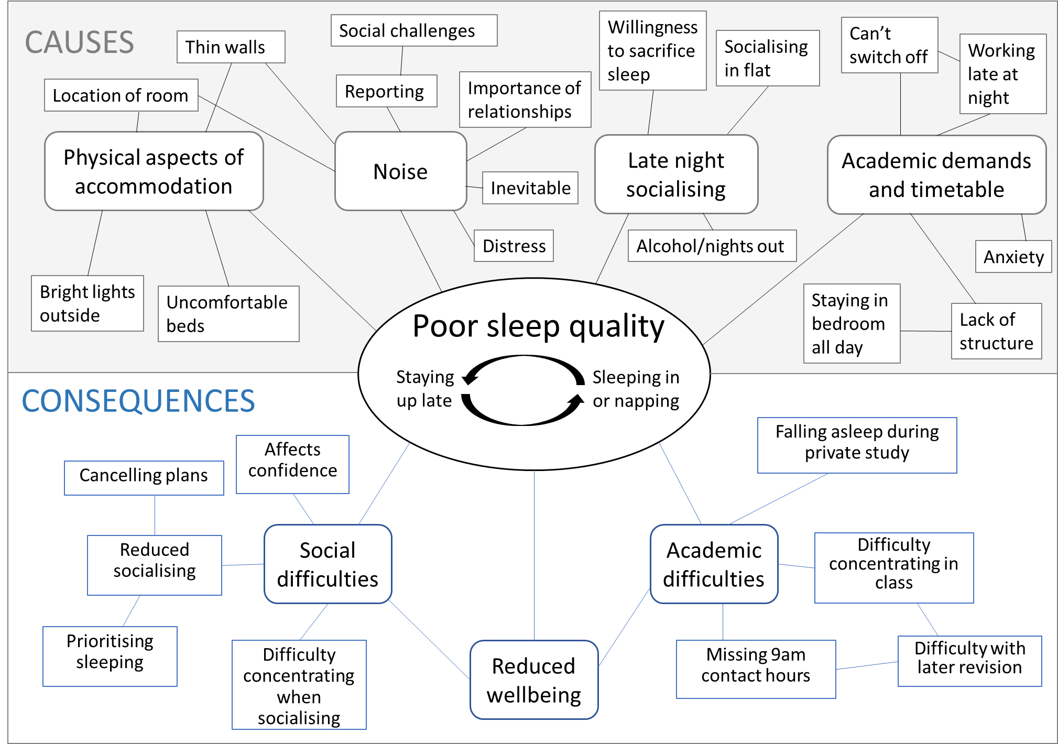
Figure 1. Initial thematic map, showing eight initial themes (shown in rounded rectangular boxes). The themes consist of five reported causes of poor sleep quality: physical aspects of accommodation; noise; late night socialising; academic demands and timetable; and three reported consequences: social difficulties; academic difficulties; reduced wellbeing. Codes related to each theme are shown in rectangular boxes (e.g. ‘distress’ as a code relating to the theme noise).

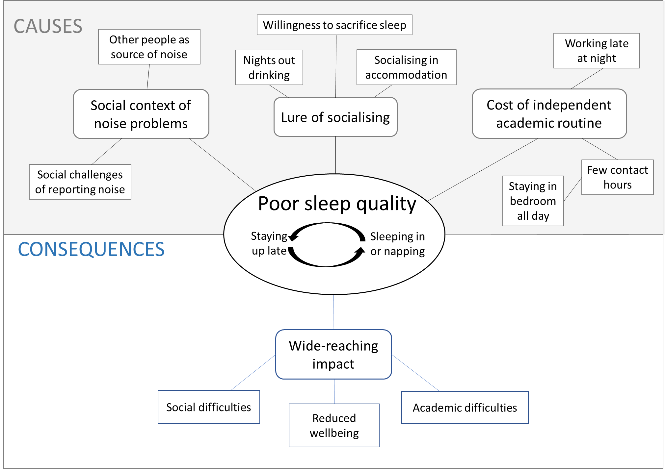
Figure 2. Final thematic map, showing four final themes in rounded rectangular boxes: social context of noise problems; lure of socialising; cost of independent academic routine; and wide-reaching impact. Codes for each theme are also shown in rectangular boxes.

