4. Artist-run spaces in London: artists, spaces and institutions:

Introduction
This chapter focuses on London. I review themes in critical literature on alternative spaces in London after 1995. Following that, I review existing histories of spaces in London from the late 1960s onwards, in order to analyse what kinds of histories are found in existing published sources. Next, I discuss some art events and practices situated in specific urban spaces and institutions in the city between 1995 and 2005, through their ephemeral documentation, considering these questions:
- How has the idea of alternative space remained operative?
- What is artists’ agency directed towards, not only in terms of how alternative and artist-run spaces are set up and run, but in terms of motivations for making an alternative space?
- How is the idea of ‘alternative’ space used, as a different ideological space, as a resource in art practice?
- How do concerns (about institutionalisation), evident in discourse on alternative and artist-run spaces, cross over to or resurface in art practice and how are artists’ attitudes to these themes affected by contingency?

I am concerned in this chapter with some problematic issues: to what extent the alternative is mainstream, whether there are alternatives, and the ways in which the category of ‘alternative’ has been re-presented in retrospective exhibitions and re-used by established art institutions, altering meaning whilst retaining the same categorisation. In chapter 2, I identified mutual support, autonomy/agency, space for innovative art forms, resistance to commodification and radicalism as significant themes in literature on alternative spaces before 1996. In this chapter and the next, I will look at changing preoccupations and growing criticism of these themes.
Alternative activities may have evolved into techniques and strategies for sustaining a career. I have found references to techniques such as irony, commentary, use of everyday matter, and methods such as interaction with organisations, and modes of social engagement in artists’ statements, publications and text works held in the collection. These techniques do not only sustain careers, they sustain art practice. It is a question of context; this is not given, but produced. If ephemera document the inter-relationship of the terms of art and the terms of its place in the world, how do they describe context created, as part of practice? Are the spaces produced by artists in Lefebvre’s terms ‘representational spaces’; mere description, inhabiting “passively experienced space which the imagination seeks to change and appropriate[?]” (39). Or are they created space: ‘contradictory space’, or ‘differential space’. What in this context are, as proposed by Martin Beck the “tight interrelations between the material and symbolic spaces produced as indicators of contingency[?]” (Beck, 276). Looking at such interrelations in practices of the late 1990s in London I have found complex relationships, and some discussion of space produced by a different consciousness, in which historical affiliations may be important, (related to practices of institutional critique and also to the legacies of anti-Establishment, counter-cultural or anti-institutional practices) but which is tightly bound into the complicitous conditions of the contemporary knowledge economy. In this chapter and the next I give an account of some examples that contributed to this understanding, in art practices that negotiate complexity and that operate critically within informational forms.

Literature on alternative and artist-run spaces in London in the 1990s
The starting point in time for my research on the alternative space in London is the mid-1990s. This is, according to much of the literature, after it had disappeared. Many articles appearing between about 1991 and 1997 which discuss Freeze of 1988 and other yBa activies in London are dominated by the theme of ‘the myth of the alternative’ and the argument that the ‘alternative’ became the ‘mainstream’ during the 1990s. Julian Stallabrass (1999) in High art-lite ,chapter 3 Artist-curators and the alternative scene is concerned with London in the late 1980s and early 1990s. His diagnosis is that generally "The tactics were employed without the attendant politics" (Stallabrass, 1999, 68) although he selects Bank and Beaconsfield as organisations with integrity. Another key document is the Life/live (1996) exhibition about artist-run spaces in the UK, curated by Hans Ulrich Obrist. The catalogue includes a partial mapping and directory of the spaces in London, researched by Rebecca Gordon Nesbit and also contains a short history of artist-run spaces in London by her: Surprise me (Nesbit, 1996). Here, Nesbit writes about Transmission in Glasgow as a case study and comments that contemporary alternatives operate outside but not counter to extant culture because they rely on systems of art-world patronage and art is usually for sale. She notes that they are often temporary, with charitable status, their organisation reflect public funding bodies’ requirement for groups. I return to question this phrase “outside but not counter to” later in this chapter and in chapter 5, in considering complicity. The collected essays in Occupational hazard (McCorquodale, Siderfin and Stallabrass, 1998) reflect back on, and forwards from, the assumption that the alternative had become mainstream. Malcolm Dickson (1998) makes observations about the characteristics of alternative spaces historically and introduces changes and ideas specific to Glasgow in the late 1980s-1990s. He identifies tendencies there being art that contributes to community development coming from the Environmental Art course at Glasgow and work in new media from the course at Duncan of Jordanstone College. The spaces in Glasgow he writes about share the originating impulse of the artist space in providing facilities, interaction, collaborations, putting ideas into action, but they have added emphasis on public education and they are actively encouraged by the city council. He suggests that the “notion of alternative does not have the critical import it once had” (84), "The focus upon the ‘artists’ initiative’ and the rhetoric of autonomy is very much symptomatic of its institutionalisation, where a hierarchy of spaces is allocated a slot regarding their proximity to … the cultural mainstream”(82). He refers to the ‘farm system’ as described by Kester, and pragmatic accommodation of public funding structures and artists running alternative/mainstream two-part careers as influences on these conditions. He says that the artist-run space can be “reclaimed as a temporary autonomous zone” (87), because it is free from the curator as (capitalist) boss but his conclusion is that there is no longer a clear inside/outside or centre/periphery either geographically or in roles - the artist initiated project is just as much an institution as the gallery, its value, he states, will be in being more local, specific to context and place. Peter Suchin in the same book trenchantly criticises the nature of alternative spaces, in the essay “After a fashion: regress as progress in contemporary British art” (Suchin, 94-111). The character of the artist-run space in the UK at this time was investigated in a research project funded by the Arts Council, which resulted in two contemporary reports on artist-led organisations. Susan Jones (1996). Measuring the experience: a study of the scope and value of artist-led organisations and Susan Jones (1997). Roles and reasons: the scope and value of artist-led organisations. The only London based organisation case study in Measuring the experience is Space Explorations. Ian Hunter’s essay “More questions than answers: the ethical ground of socially engaged artist-led organizations” (1997) is a short report based on the Measuring the experience research. Hunter’s essay adds critical analysis to the report’s practical data. He distinguishes between alternatives that work in the art-world as context and those that work in the social sphere. Like other commentators, he observes that although the alternative label seems to guarantee integrity and has contributed to the dynamism of the British art scene, autonomy and anti-commodification as strategies have failed. He proposes that collaboration, benefits to communities and supporting regional culture are aspects that remain interesting. Hunter is interested in socially engaged, multidisciplinary practice and regional developments, the ethical ground of ‘fading notions of autonomy and authorship’ and his case study material is, like Nesbit’s and Dickson’s from organisations in Glasgow. Another comparison could be made with Canada, for example in Toronto, artist-run galleries received public funding from the early 1970s to the early 1990s, and it has been commented that these conditions produced an active art scene that was not sales-driven, where it was difficult for artists to get sales (Feinstein, 1994).

In the late 1990s, Chin Tao Wu carried out research on the structure of public funding of alternative spaces in North America and, to some extent, in London. The results of her investigation are published in Privatising Cultur’ (Wu (2001). In Chapter 2, ‘Public arts funding in America and Britain’, in the section headed ‘The National endowment for the arts and alternative spaces’, (41-46), she gives a summary of the evolution of terminology of artist-run and alternative spaces in U.S. and the “direct and close” relationship between the establishment and the practices of alternative spaces and the NEA, with list of references. She points out that in America the establishment of “first generation” alternative spaces coincided with a time when federal art budgets rose meteorically and that there was a continuing close relationship between alternative spaces and the National Endowment for the Arts (NEA) Visual Arts Program: public funding and alternative spaces have a close association. The focus of Wu’s research is corporate financial support of visual art in the UK and the USA in the Thatcher and Reagan periods. She does not cover public funding in the UK in the same detail.

These sources indicate that there is often a continuing relationship between artist-run (or alternative) spaces and public funding, particularly strongly identified in Glasgow and New York. Distinctions between art as commodity and art as socially active are made, but the separation between them is in some ways no longer clear, as I will explain when I reconsider the role of art that operates in the social sphere in the next chapter. The alternative has itself acquired value as a commodity and mixed models of value are used. Questions are raised about what is inside and what is outside the mainstream. It is clear that the terms alternative and artist-run themselves have been sometimes interchangeable, sometimes contested. The term ‘alternative’ implies if not opposition, at least a context (alternative to what?) and locality is one context.

Artist-run spaces in London: a consideration of sources
To what extent do existing published histories of alternative and artist-run spaces in London represent a wide and inclusive history? What other sources are there? While it is not the aim of the present work to present a history of alternative and artist-run spaces in London, nor to assess the alternative credentials of institutions, I am concerned with facilitating the production of an expanding history. It is my intention in the collection that accompanied this research to produce a more contiguous, broad survey than is possible in a text such as this, so, I have compiled a database which contains information on as many galleries as I have been able to find mention of, with references to sources when found. Following a summary of existing sources, I will present some accounts of particular works and attitudes in my readings from ephemera, which indicate diverse and complex aims and intentions using space.

The predominant term used in London in this period is ‘artist-run’, rather than ‘alternative’ and I use it in this section, returning to the question of what this categorisation indicates, compared to ‘alternative’ later in the chapter and in chapter 5. Rebecca Gordon Nesbit (1996) commented that the term ‘alternative spaces’, although used by Time Out from 1993 to 1996, had “outdated anti-Establishment connections” (Nesbit, 1996, 144). During the 1980s, Time Out had listed non-commercial galleries under the heading ‘Fringe’. After 1996, the phrase ‘Up-coming’ was used, a term which implies something new and aspirational and which reinforces a hierarchical view of the gallery system. By 1999 Time Out was listing by geographical area, with the East containing the largest number of new, shorter-lived and possibly alternative galleries. Altshuler (1994, Chapter 13) points out that most historical avant-garde exhibitions had been organised by artists and that growth of the role of the curator was relatively recent. Many artist-run spaces had existed in London in the recent past (when Freez’ is called innovative because of being artist-run, this should be seen in juxtaposition to this tradition) and open studio events managed by artists were held frequently throughout the 1980s and early 1990s, however published sources are not extensive. The sources that do exist provide a series of very partial pictures, as I indicate in the following review.

Some notes on artist-run spaces in London can be found in histories of other subjects. Paul Moorhouse (1998) in a biography of Albert Irvin includes a short description of the starting up of AIR and SPACE. SPACE (space provision artistic and cultural) was a warehouse studio space and the associated AIR (artists’ information registry) was a resource with an associated gallery, they were set up in the late 1960s. Moorhouse tells of a link with Goldsmiths, through the roles of Bridget Riley and Albert Irvin who studied and taught at the College. London is credited as being an earlier site of artist-run spaces than New York, by Nancy Foote (1976) who mentions that Alanna Heiss the director of the Institute for Art and Urban Resources behind PS1 had been influenced by the artist-run SPACE in St Katharine’s dock in London, in that this gallery used a space which was formerly industrial, Foote had described this kind of space as “crummy”. SPACE still existed in 2005, the organisation managed a collection of studio buildings where open studio events were held throughout the 1980s and 1990s, as did ACME. Ephemeral events such as the Art Spectrum fair held in 1971 at Alexandra Palace (Hunt, 1971 and Russell, 1971), which was attended by artists, are harder to trace. Once the name of an event or organisation like this is known, through interview or other primary research, it may be possible to trace it in journals and magazines, using online indexes, but references may be scarce.

SPACE holds its own substantial archives. Other organisations that accumulate extensive archives may deposit them in public archives. The Artists’ Placement Group ran from the mid 1960s (sometimes dated to 1966, APG, 2004) and the archives were deposited at Tate Archives in 2004. In some cases, smaller archives may be deposited in a public archive, but this is rare. For example, Goldsmiths College library has an archive of Engaged Magazine consisting of the magazine issues in various formats and press and an archive that represents the activities of the artist-run space Curtain Road Arts. The archive consists of a folder that contains private view cards, press releases and flyers and some letters relating to the organisation of events and to the processes of funding applications, but not such things as the audited accounts that might be expected in the archives of a more formal institution.

There are a number of research projects on artist-run and alternative spaces, focussed on London. Anne Baker’s online resource Other educated persons contains 24 interviews with artists and art organisations in the East London Boroughs of Hackney and the Tower Hamlets covering the period 1972-1999, galleries and organisations represented amongst these (all operating in 1999) are: Matt’s Gallery (1979), The Approach, Maureen Paley/Interim Art (set up April 1984), SPACE Studios and Carpenter’s Road Studios. Anne Baker (1999) includes primary sources, such as an interview with Maureen Paley. Maureen Paley/Interim Art set up in April 1984, although Paley explains here why she did not consider her gallery to be artist-run, Maureen Paley adapted some aspects of artist-run spaces in the operation of her gallery:
When it first began I had initially been trained in art history and art practice, so I had come to the gallery as an artist. It was not what I considered to be an artist run space, because I made a decision that I was not going to be an artist in order to run the space. The policy has changed and adapted in that when I began the gallery I felt that I was working on a much more project-oriented basis with the artists. …..The gallery was at that time being run to make things possible for artists, (there was no concept of an art market then) and the gallery was perceived to be a public space or quasi public space. Since 1990 we have gone towards representing artists and becoming a commercial space. (Baker, 1999)

John Myles (1997) compiled research data from contemporary spaces Acme, SPACE, Bank, Cubitt Street and The Agency, for his PhD thesis (Myles,1997) Postmodernism and cultural intermediaries: a qualitative study of the English art world. Myles applies Bourdieu's field approach in an empirical study of the British art world and traces the impact of postmodernism on its social and intellectual 'system of relations'. He identifies institutions but not individuals. One more dissertation was Sarah Clarke’s MA (1994) Stepping stones: a study of artist-run galleries.

There have been various exhibitions representing a selection of alternative spaces. The show Fast and loose (my dead gallery) curated by Pierre Coinde and Gary O’Dwyer; Centre of Attention, in October 2006, included documentation produced by the institutions: the New Vision Centre (1956-65), Signals (64-66), London Free School (66), Indica (65-67), Arts Lab (67-69), Gallery House (72-73), The Gallery (72-78), 2B Butler's Wharf (75-78), Fantasy Factory (75-96), Art Meeting Place (74-76), B2 (79-84), NeTWork 21 (86), The Women's Art Library/Make (82-2002), Bank (91-03), workfortheeyetodo (92-98). The Life/live (1996) catalogue includes a short history of artist-run spaces in the UK, and the exhibition included the following contemporary spaces in London: A, Adam Gallery, Annexed, Audio Arts, Bank, Bund, Cabinet Gallery, Cairn Gallery, 50 Caledonian Road Gallery, Catalyst Arts, City Racing, Cubitt Gallery, Cultural Instructions, Curtain Road Arts, Factual Nonsense, Fine Rats (no site), Flag, Gallerette, Gasworks, Hales Gallery, Imprint 93, Independent Art Space, The Institution of Rot (travelling), last order(s), London Electronic Arts (LEA), Lost in Space, Milch, Not Cut (London and Birmingham), O + I (formerly APG) , Open Hand, Plummet, Posterstudio, PPQ, Rear Window, Space Explorations, Strike, The Tannery, The Tracey Emin Museum, 30 Underwood Street, Cathy Wilkes “115 DALRIADA”, workfortheeyetodo, of these only 5 remained running 10 years later, in 2006 (Audio Arts, Cabinet, Cubitt, Gasworks, Hales Gallery: Gasworks being the only one still on the same site). The catalogue contains statements from the galleries in the accompanying volume. A third survey exhibition was The galleries show Royal Academy of Arts, London, 14 September - 12 October 2002, curated by Norman Rosenthal and Max Wigram (Rosenthal, 2002). While galleries represented in that were not selected on the basis of being artist-run or alternative, the statements from some referenced the terms, as I will explain below in the section “Alternative’ as a credo/credential”. The exhibition section on London in the 1990s, curated by Emma Dexter for Century Cities exhibition at Tate Modern included several alternative or artist-run organisations, and her catalogue essay (Dexter, 2001) is another source. The exhibition There is always an alternative at Temporary Contemporary in 1995 invited participants to revisit their own alternative histories, and essays in the accompanying publication (Beech & Hutchinson, 2005) do so too. Although institutions were not represented directly, several are mentioned. I review this source in more detail, and return compare it to fast and loose (my dead gallery’ below in the section ‘There are many alternatives and they all fail’. A different kind of survey which, while it does not identify artist-run or alternative galleries as an area of interest, Pablo Lafuente’s Display: recent installation photographs from London galleries and venues of 2005, approaches the question of the gallery as a context of art:
…this book stresses the role that the context of presentation plays in the experience of art. This is made ….on the awareness of the historical (and therefore, contingent) character of the conditions that determine the modes of production and reception of art. (Lafuente, 2005, 1)
The photographs too, all of installations, taken inside the gallery or venue, contrast with those accompanying this research, which were taken from outside the spaces. Slides from the Contemporary Art Slide Scheme, taken by Donald Smith and held at Chelsea and a number of art libraries are another comprehensive visual resource, that include installation views of some artist-run spaces.

Listings in Time Out, the New Exhibitions of Contemporary Art (neca) monthly guides and other similar listings for East London give brief details of a limited number of alternative galleries and spaces, indicating the numbers of galleries showing contemporary art at any time, and giving addresses, locations and contacts.

Several guides to contemporary galleries in London were published between 1995 and 2005. They include Martin Coomer’s (1999) Art London: a guide to contemporary art spaces, Louisa Buck’s Moving targets (1997) and Moving targets 2 (2001). There were also themed issues of magazines describing new and interesting galleries significantly the issue of ID (2001), from April 2001, Underground London (1999); a themed issue of Contemporary Visual Arts, July/August 1999 and Spring crop, new galleries (1997) in Art Monthly, March 1997, 19, and there are articles which look at selections of galleries in context, in more depth Coomer (2000) and Harding (1998).
The conference ‘Who’s afraid of red, white and blue’ in 1998 was concerned, amongst other issues, with “alternative and critical practice”. Mark Harris’ paper The press release and alternative spaces (Harris, 1998, 62-69) uses press releases as the source material, but is limited to discussion of their textual content and his view is limited also from the elusive nature of ‘alternative’ activities. Harris points out the use of literary forms “descriptive clichés, wry citations and indigestible critical theory, naïve optimism and awkwardly formulated agendas”. Like many critics, he selects Bank to write in detail about, commenting on their work as demonstrating sophisticated understanding of the phenomena he reveals commenting that they have used the “press release as a polemical tool”. He says “on one level their entire production of press releases parodies or lambastes the kind I’ve been discussing”. In 1999 Bank, who also took part in the Who’s afraid of red, white and blue? conference, produced a show called ‘Press release’ consisting of press releases they had lambasted, some examples are illustrated in the book Bank (Bank, 2000). The conference papers are a source, if not for histories of alternative or artist-run spaces, for concerns of some of those involved. Similarly Virginia Nimarkoh’s seminar Indent and the archive compiled to document it provide insights into artists’ view of their role as authorities on art, in this period. Indent was a series of talks held at Camberwell College of Arts during spring 1999. The series set out to discuss the practice of independent publishing as means of art production. (Nimarkoh, 1999). Other histories can be found in case studies. There is a case history of Home (Godfrey-Isaacs, 2000). The publication Opening lines (Raftery, 1997), includes four case histories of projects, incidentally mentioning, in accounts of the recent activities of the participants other artist-led initiatives, branches of histories which are obscured.

Exhibition documentation produced by galleries or institutions is another source, which may include statements on intentions in introductions. Open studios were held regularly in the 1980s and 1990s, some producing catalogues, themselves ‘grey literature’ and fairly ephemeral. Some galleries held retrospective exhibitions of past exhibitions, for example at Matt’s Gallery. Baker (1999) includes an online contribution from Matt’s on the history of the gallery, possibly related to that. However, few of the organisations from London have individual published histories. Two exceptions are the self-written histories, what Ault calls “memory containers,” by Bank (2000) which refers to their relation to the avant-garde, and City Racing (2002), Both mention London Art Board’s artist-run project grant, set up in 1996 as supporting their organisation. A discourse analysis of the City Racing text shows that they present pragmatic reasons supporting initiatives made and decisions taken, coming from the everyday life of the participants, with an implicit acknowledgement that this was an ‘alternative’ practice: City Racing write as ‘we’ to emphasise that they are individuals who worked as a group, valuing argument and making the individual voices heard in society. They describe their organisation as run pragmatically and un-bureaucratically, with a collective self-determining stance. They value the ‘Collective’ group format because it gave individuals the ability to take control of their surroundings. They present their practice running the gallery as a social practice which was informally political, saying that their attitudes came from their position and life-experiences as artists who were poor, and excluded from places that promoted art, also they were squatters and road protesters, people who did not accept authority. They present themselves above all as artists, they invoke empathy for the experience shared with other artists and their aims were to encourage making art, not to assume authority, not to intervene in artists ideas and to provide opportunities for showing art in a way that valued art rather than its monetary value.

Grey literature such as the handouts produced by Beaconsfield for their 10 year retrospective programme (2005) and the series of magazines produced by Info Centre during the year-long course of that institution (2000-2001) document the concerns, interests and activities of those involved in creating these organisations, perhaps most clearly, being written to contextualise their own practices and activities.

Alternative Space revisited

Re-used spaces
Martin Beck’s essay Alternative: space, in Ault’s (2002) Space, place, and community section looks at the function of spatial environment, he identifies different examples of spatial models that “engendered or embodied notions of “alternative” e.g. from “crummy space to white cube”. (Ault. 2002, 4), pointing out that an alternative space is not necessarily “crummy”, adaptations and developments, even the use of the “white cube” also embodied particular notions of ‘alternatives’.

During the 1990s in London there had been, as well as these more publicised exhibitions in warehouse spaces, many artist-led initiatives which inhabited, re-used and transformed spaces, using them as artists’ studios and also for live and performance art, community art, public art and installation. Former public services buildings such as schools, hospitals and transport depots as well as former industrial buildings were used after becoming ‘orphan’ spaces when services were closed down or moved. Material spaces were re-used in this period, in a variety of ways. Stallabrass (1999) in Art lite chapter 3 Artist-curators and the alternative scene describes the ingredients that produce the “aura of authenticity” of the artist-run event; the show in a formerly industrial space, produced partly because the artists worked in a way that was site-specific in an aesthetic sense, responding to the way that the buildings, once warehouses or factories, looked. He says that “Others have tried to break with the atmosphere of pure authenticity surrounding the alternative scene” (Stallabrass, 1999, 75), mentioning Candyman II as a show that was intended to present a critique of the phenomenon, but which was viewed as being like Freeze, Gambler or Modern Medicine and not critical. The case studies in Opening lines (Raftery, 1997) mentioned above describe the spaces used by four initiatives working in the public realm in 1995. In Care and control, 15 artists and 25 patients were involved in a collaboration between Rear Window, the psychiatric services, patients and Hackney Arts Initiative, in Hackney Hospital as it closed down. Strike presented a series of eight projects dealing with site and place at the Public Lavatory in Brick Lane, The seed, the root was a series of installations and performances along Brick Lane and Spitalfields Market presented by Moti Roti and Natural settings was an exhibition of site-specific works by 28 artists in the Chelsea Physic Garden. In ther essay on the projects, Alison Raftery points out the role of artists in developing work in the public realm, and refers to engagement, context and dialogue as key issues raised by these projects. She points out that the “public realm is in essence a metaphorical or ideological, rather than a physical space” (4) and that the work may be made and seen in relation or even in opposition to the location in which it is presented, whether that be in architectural, historical, social, political or aesthetic terms.” Raftery concludes that the value of such projects is in creating points of contact, facilitating exchange, and initiating a process of transformation.” It is probable that these values were appreciated in the later part of the decade, in publicly commissioned and funded projects in the public realm (Opening lines is published by the Arts Council England).
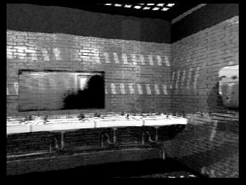

Figure 1: Engaged vol. 3. Public Lavatory [QT Virtual Reality], 1995

The architectural space taken over temporarily may be a municipal space, as in the Public Lavatory (reproduced above in virtual reality in an CD issue of Engaged magazine), a domestic space, at Home, or Sali Gia, or industrial space, like the many galleries in former industrial buildings such as Temporary Contemporary and many studio complex spaces like Curtain Road and Cubitt, or retail premises like Rosie Wilde or Magnani. It may, like Matt’s Gallery have a stated intention to show a particular kind of art, or it may not be a commercial gallery, like Beaconsfield. The reasons why the gallery exists affect the visitor’s experience; whether the art is primarily shown as a side-effect of the commercial business of the gallery or whether the gallery is not commercial, for example. Whether the gallery space is in a home, like Info Centre, or the Top Room; or a gallery which houses a collection, such as the Saatchi Gallery, may affect how the visitor experiences being a guest there; Info Centre offering home-brewed beer (see fig. 19), the Saatchi Gallery saying that canapés will be served. Spaces have been used which are concealed behind other buildings, at 145 Charing Cross Road for Expo Destructo and at the second Fordham space, behind a building in Princelet Street. Not only are buildings built for other purposes taken over as art spaces, but they may be re-used by other art spaces, this happened at a space used by Fordham, which then became a Whitechapel Project Space, or are converted to other uses, as in Underwood Street, where factory buildings housed several galleries in the late 1990s and were then converted to apartments by 2006. Established, commercial galleries have relocated into converted industrial buildings, for example Maureen Paley/Interim Art and Victoria Miro, as they have expanded and galleries move from one area to another, for example Wilkinson Gallery from Great Ormond Street, to Cambridge Heath Road where a shop was converted, to a new premises built in Vyner Street in 2007. The complex alternative that I am identifying, however, although inhabiting spaces, is concerned less with material space, than with ideological space.

Collectives, communities and power-relations
By 1995, strategies of the alternative were being reconsidered. Collectivism is an established anti-hierarchical or ‘democratic’ political strategy, which has been used to address the problem of who gives art value and who is included and excluded, as well as a way of critiquing the solitary nature of art production and providing mutual support, as described in chapter 2. Cubitt Studios, for example, managed their gallery space as a collective, with a rotating chair. Collective names have been used to evade the individual persona of the artist, as by the groups Mongrel and Inventory. Mutual support can be provided by open studios, self-institutionalisation, artist-run spaces, group shows or projects. Cubitt, Curtain Road Arts, Info Centre, City Racing, and the Top Room all provided support of some kind to artists, as part of their position.

Group exhibitions can provide a networking environment for the participants, Words and pictures, A-Z are examples, but any assumption that a group provides support is here more tenuous. The artists and curators, sometimes the same people, are both the producers and the consumers of such networks. At a superficial level, group shows might be seen as temporary collectives, but their interpersonal dynamics are very different. Curators are itinerant, their ‘caring’ relationships a series of very short-term ones and, as John Timberlake puts it, the group shows in the 1990s “had an often quite vicious power dynamic based upon the pecking orders, previous profiles and kudos which participants might or might not bring to the show” (2005, 15). When Harris (1998) says that in his opinion “the artist-run shows in Britain are the artist community speaking to itself”, this statement suggests some kind of isolation, that shows were put on by artists for artists, emphasising an inward-looking aspect of a coherent art network. While exhibition catalogues of high-profile British art shows of the 1990s present a relatively small number of artists, again and again, and published histories of the ‘alternative’ in the same period do the same, although with a different set of artists, suggesting a memorable group of artists from London; the group shows of the period collectively included thousands of artists. The transcription of all the names on cards announcing group shows between 1999 and 2001 in Ephemeris produced a list of thousands, many of whom were only on one, or very few cards.

The other aspect of group shows shown by the cataloguing process is the variety of nationalities participating. There were strong and influential links between projects in Britain, Germany, the USA and elsewhere, and the participants had multi-national origins. Many students who came to London to study art showed actively immediately after leaving college, and in some cases set up galleries, as The Agency, Void, One in the Other, Info Centre and Sali Gia. Other spaces were influenced by spaces in Europe, some of those involved in Posterstudio had come from Friesenwall 120 in Cologne. The statement from Posterstudio in Live/life (v.2, 108-9) is an essay on the current popularised, mediatised story of British art in London, in French only, so presumably speaking not to itself; a reflection on the constant repetition of the mainstream history, in the context of many, different stories. The London ‘alternative’ contained differing power dynamics and was deeply divided.

Academic assimilation
It has been observed that not only is avant-garde art produced in and promoted by the art academies in the UK rather than as an alternative to ‘academic’ art, as I described in chapter 2, but art is not seen as having an autonomous position (which would enable an alternative position) and the academies have assimilated critical theory. Three writers who consider academic assimilation in discussions of the alternative, at the beginning of the period of my research are Roberts (1998), Suchin (1997) and Batchelor (1996), who argue, in different ways, against the possibility of an alternative. John Roberts (1998) in a detailed account of Pop art and the popular, traces the difference made to art theory by discursive practice and by the academic shift to thinking about art as part of the “culture of representations and social practices”, in the work of Stuart Hall, Victor Burgin, Hal Foster, Dick Hebdige etc. and the development of cultural studies. After this shift, he says that the case for autonomy has become muddied by questions of authority, Roberts sees this as “affirmative assimilation”, however Suchin is more pessimistic. Peter Suchin’s (1997) essay in Occupational Hazard tries to “disentangle” several strands of the ‘alternative’, the yBa and associated ‘alternative’ rejection of theory, to the assimilation of theory by institutions of art education, and of the entry of the avant-garde into the academy, “Brit Art’s regimented celebration of the puerile, together with its oxymoronic embrace of the obviously shocking, long guaranteed its place in the Academy. As an officially sanctioned avant-garde it could have no other destination or intent.” (106). A contemporary example he gives of entry into the academy, is the ‘Life/live’ exhibition (1996) previously mentioned. In 1976 the editorial of Art & Language vol. 3, no. 3 contained a tirade against “the privileging of cultural and artistic avant-gardism through forms of academic specialism”. Participants of the 90s were wary of the term avant-garde, although Bank use it of themselves in the book ‘Bank’ (2000). David Batchelor in his introduction to the Life/live catalogue (1996) recognises academic assimilation as part of the terrain, he describes the spaces alternatives occupy as found spaces, with multiple use and multiple occupation. He imagines maps, or a story that establishes levels of differentiation to describe them. "Other spaces to be described would be mental, rather than physical". There will be a dense network of paths to and from the academy, "with special attention to paths in different directions" (19). The academy as an institution has enabled a kind of enclosure - separation from other parts of the the art world that facilitates critical distance on the one hand, as much as having assimilated its artist "residents," as here in Dafna Ganani’s escapist superimposition ‘Jaffa Bollywood’ where culturally hybrid images represent geographical and political positions which otherwise remain difficult to hold together.
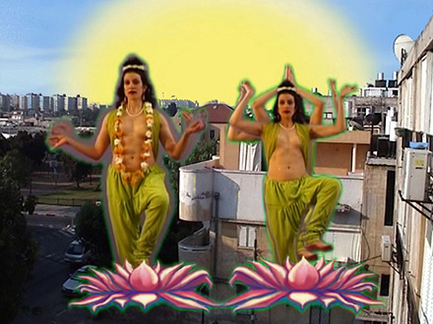

Figure 2: Dafna Ganani 'Jaffa Bollywood', 2005, still

Complicity
While the term ‘assimilation’ suggests that difference becomes subsumed, that the object taken loses its identity, conventions unwittingly set up their alternatives and the practice of complicity may be productive, to the subject who is partly taken in.

The publications Occupational Hazard (McCorquodale, 1998) and Harding (1997) survey critical views of ‘New British Art’ and the ‘alternative’ and artist-curated activities of the early 1990s. The view by the contributors generally is that the new British Art, or yBA, despite the artist-run initiatives that had dominated the London art world in the 1990’s was not meaningful as ‘alternative’ or ‘avant-garde’, but career driven. Here as in (1996) Stallabrass says that although much in this period was artist-organised, using empty industrial buildings and turning to populist themes “this tendency was no avant-garde, for it had no coherent programme and no mission except success” (1997, 79-81). His charges are that the art was based on facile post-modernism, ironic, at once for a self-regarding art elite and for a wider public through the “trivialising forms of the mass media” (1996, 153). These comments seem to refer back to criticisms of populist, or kitsch, art by Greenberg and Benjamin, reviewed in chapter 2. The interdependence between alternative/artist-run initiatives and established institutions has been criticised in terms of participation in the art market: selling out, and the “farm system” being identified as types of collaboration. Stallabrass (1999) explains that he sees the “aura of authenticity” of the artist-run event and need of the art market for marginality produced by alternatives as being mutually exploited. He says that in the late 80s, early 1990s in London, the usual reason for showing in alternative spaces was as an alternative conduit to success, side-stepping the galleries and finding direct access to private funding. London Arts Board funding for individual artists had been withdrawn, only groups were eligible. Stallabrass (1999) reflects on the passing of the alternative that “The most important element in the progress of this system is forgetting…”(83) forgetting that money and aesthetic value were linked, and the art market needs the marginal to feed its appetite for novelty (81), the movement from marginal to central was, he says, just contextual, with some exceptions (Bank, who he says created a parody of a corporate identity, and Beaconsfield). The notions of a ‘farm system’ and collaborations between artist-run spaces and established institutional galleries and museums, noted in chapter 2, are recognised factors after 1995. In 2005, Martin Vincent sums up the situation:
Artist-run projects are commonly known to be exciting, innovative and critical exhibitions. They provide a useful testing ground for young artists, they showcase up and coming talent to feed into the art market (or maybe for the art market to feed on). At the same time they are seen as slightly edgy and occasionally provocative. And for institutions and the organisers of Biennials it also deals with that persistent problem of how to engage with the local artists without having to show their embarrassing provincial work in your lovely gallery.”…..”From an institutional point of view the other big advantage of so-called ‘artist-run’ activity is that artists will do all the work themselves and demand very little money …(Vincent, 2005, p.81).

Vincent cynically describes yet another benefit for the art institutions, a potential complicity. Artist-run spaces have an established role in mainstream art exhibiting processes, as the re-evaluation of the qualities of the ‘alternative’ is accomplished, repeatedly. As Stephan Dillemuth points out “Be aware, they use you, you use them”(1997, 141).

‘Alternative’ as a credo/credential
The re-assessment of the value of the term ‘alternative’ is indicated by the increasing use of the term as a credential. Peter Suchin had been disparaging about the "fashion" for artist-led organisation, not radical and not alternative, and pointed out that "participating in artist-led ventures has become an unexamined convention, the unspoken 'guarantee' of professional artistic status" (Suchin, 1998, 107). Despite Suchin’s charges that the term is used about artist-led organisations that were not radical, had a lack of responsibility towards artists and too much concern with reception, this convention had become established and exploited. Critics such as Vincent (2005) in the statement above identify the marketable value of having participated in an artist-run activity, in the past. Reference to a period in the past when a gallery was alternative, or citation of alternative strategies, are used as a credential by commercial galleries, or artists who are in a more established stage of their career. The galleries show from 2002 provides examples of this in the accompanying book that contains short statements from each of the galleries that took part, and an introduction by Norman Rosenthal and Max Wigram in which they argue that “galleries represent artists who they believe in, providing them with a critical context in which their work can be shown to the public.” (Rosenthal, 2002, 1) They emphasise the role of ‘gallerists’ in supporting canonical artists at an early stage in their career, supporting work that is “ahead of its time” and bringing new work to London. The statements from the galleries are written in the style of a short prospectus. Eleven of the thirty-three galleries refer to being artist-run, or to supporting artist-curators or claim some other alternative quality (political concerns, being in a run-down area or re-using industrial space, running projects outside the gallery, being part of a community of artists), in their texts, as a credential. The Agency “Approaches political and cultural issues e.g. "…trans-nationalism and cultural identity, ...the politics of representation, ...politics of geography", the Approach "Within a year of its inception the gallery made the transition from artist-run space to representing artists commercially....Frequently programmes artist-curated exhibitions." Sadie Coles HQ runs a “Programme of off-site projects”, Magnani represents artists as a commercial gallery, but states that from "September 2002 it also runs a programme of exhibitions "with no commercial aim". One in the Other says that "both the old space and the new have combined Bond Street professionalism with the often short-lived energy of the east-postcoded artist's space." And explains that the gallery was originally built up for the "Dissemination of ideas around new work by a growing community of artists, because there was no need to develop individual careers...more than just a transient artists' forum...", VTO says it was originally artist-run and a project space, then "in the last few years the gallery has increasingly gained a commercial orientation and has participated in numerous art fairs abroad." Vilma Gold says "the gallery began by concentrating on the work of a loosely knit group of artists whose practices had, since the mid-1990s, been closely associated with London's artist-run space phenomenon. It now collaborates internationally with artists and galleries working in a similar vein." (Vilma Gold is described in Moving Targets 2 as being “like an artist-run space, shows planned no more than 3 months in advance.”)
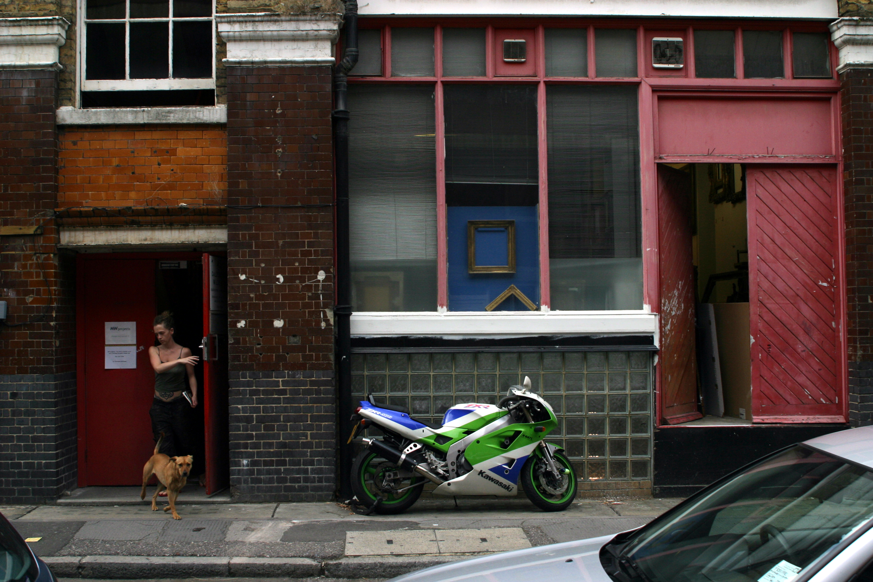

Figure 3: MW Projects, 2005

MW Projects is “actively involved in curating exhibitions outside its space, producing exhibitions curated by its own artists…” so facilitates artist-curated exhibitions. Rhodes & Mann is territorially "in the heart of today's contemporary art community" due to their location. Looking in detail at how Hales Gallery tell their story in Moving Targets 2, and in The galleries book, they present a geographical version of alternative. They say that Matt's Gallery and Interim Art were their models for the gallery. Having decided to stay in south-east London. "where we are is what's made us different", they say they were interested in urban regeneration, sited in the "middle of nowhere." They take part in co-operative collaborations with other galleries and gallery artists show elsewhere (e.g. Tomoko Takahashi) (all Buck, 2000, 172-3). In The galleries book, the alternative quality of their location is played down and its cultural context written up: "The combination of its south-east London location (close to Goldsmiths College) and the personalities of the founders, together with a proven track record of spotting new talent, has made the gallery a major destination for collectors, critics and artists alike." …"The success of these shows (…) between 1992 and 1997 marked the beginning of the transition from an 'alternative space to a dynamic commercial gallery that represents its own artists." (All Rosenthal, 2002). 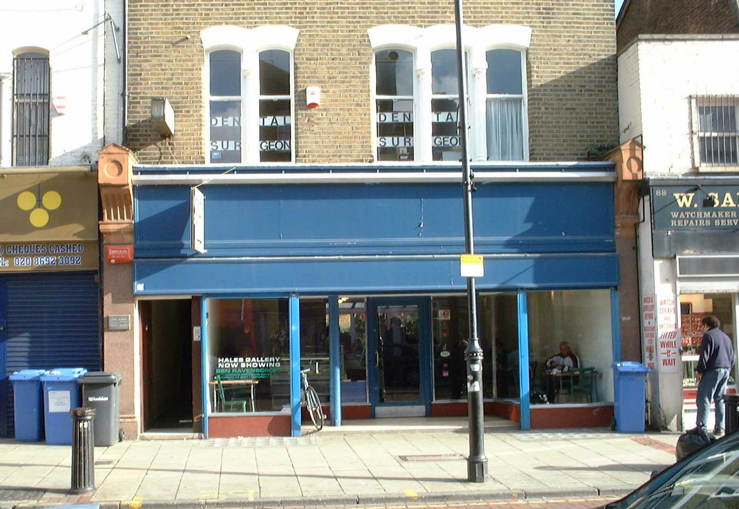

Figure 4: Hales Gallery, Deptford, 2002

Hales Gallery did move from Deptford in 2004, its second site being the Tea Building in Bethnal Green Road, London E1. Like other galleries, Hales’ statements in The Galleries Book reflect recognition of the use of the status of having been alternative, as a credential.

Popular weekly London listings magazine
Not traced, City University discard MA dissertations after 10 years.
Who’s afraid of red, white and blue? Attitudes to popular and mass culture, celebrity, alternative and critical practice and identity politics in recent British art, Birmingham, UCE, 1998
By the author. Keywords: individual artists, collective group, activists, poor, protesters.

